EXPERIMENT-5
Create a simple cloud software application for Library book reservation
system for SIMATS library using any Cloud Service Provider to demonstrate
SaaS.
Aim
To create a simple cloud-based Library Book Reservation System for SIMATS Library using a Cloud Service Provider and demonstrate the Software as a Service (SaaS) model.
Procedure
- Open Zoho Creator and sign in to your account.
- Create a new application using the Blank Application option.
- Name the application SIMATS Library Book Reservation System.
- Create a Book Details Form.
- Add fields such as Book ID, Book Title, Author, Category, Publisher, Edition, Total Copies, and Available Copies.
- Create a Member Registration Form with fields such as Member ID, Member Name, Department, Year, Email, and Phone Number.
- Create a Book Reservation Form with fields such as Reservation ID, Member Name, Book Title, Reservation Date, Expected Return Date, and Status.
- Create a Reservation Report to display the reservation records.
- Enter the required book and member details into the respective forms.
- Submit the book reservation details.
- Save and publish the application on the cloud.
- Access the application through the web browser.
- Verify that book details, member information, and reservation records can be stored and managed online.
- Thus, the application is provided through the Internet without local installation, demonstrating Software as a Service (SaaS).
OUTPUT
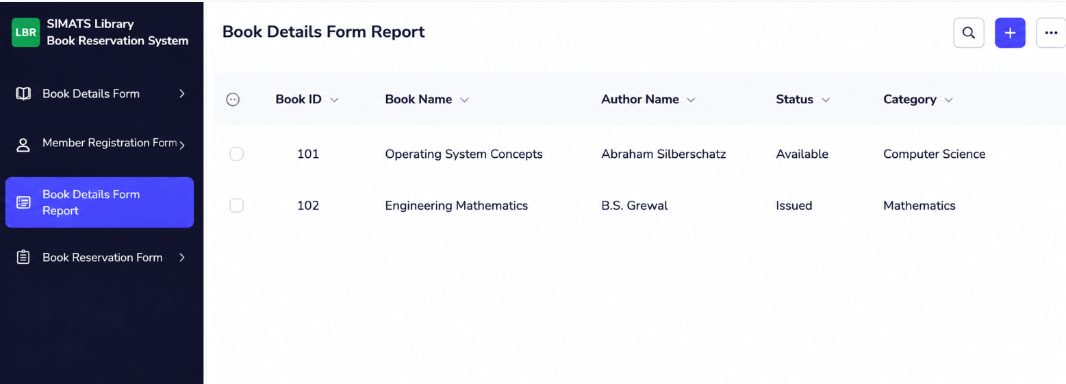
Result
The SIMATS Library Book Reservation System was successfully created using Zoho Creator. The book, member, and reservation details were stored and managed on the cloud, and the application was accessed through the Internet, successfully demonstrating the Software as a Service (SaaS) model.

