**Intelligent Last Mile Delivery Orchestration System**

# Phase 10: Final Presentation & Demo

## Created Objects

Delivery__c: Tracks deliveries with number, status, scheduled time, and assigned agent.

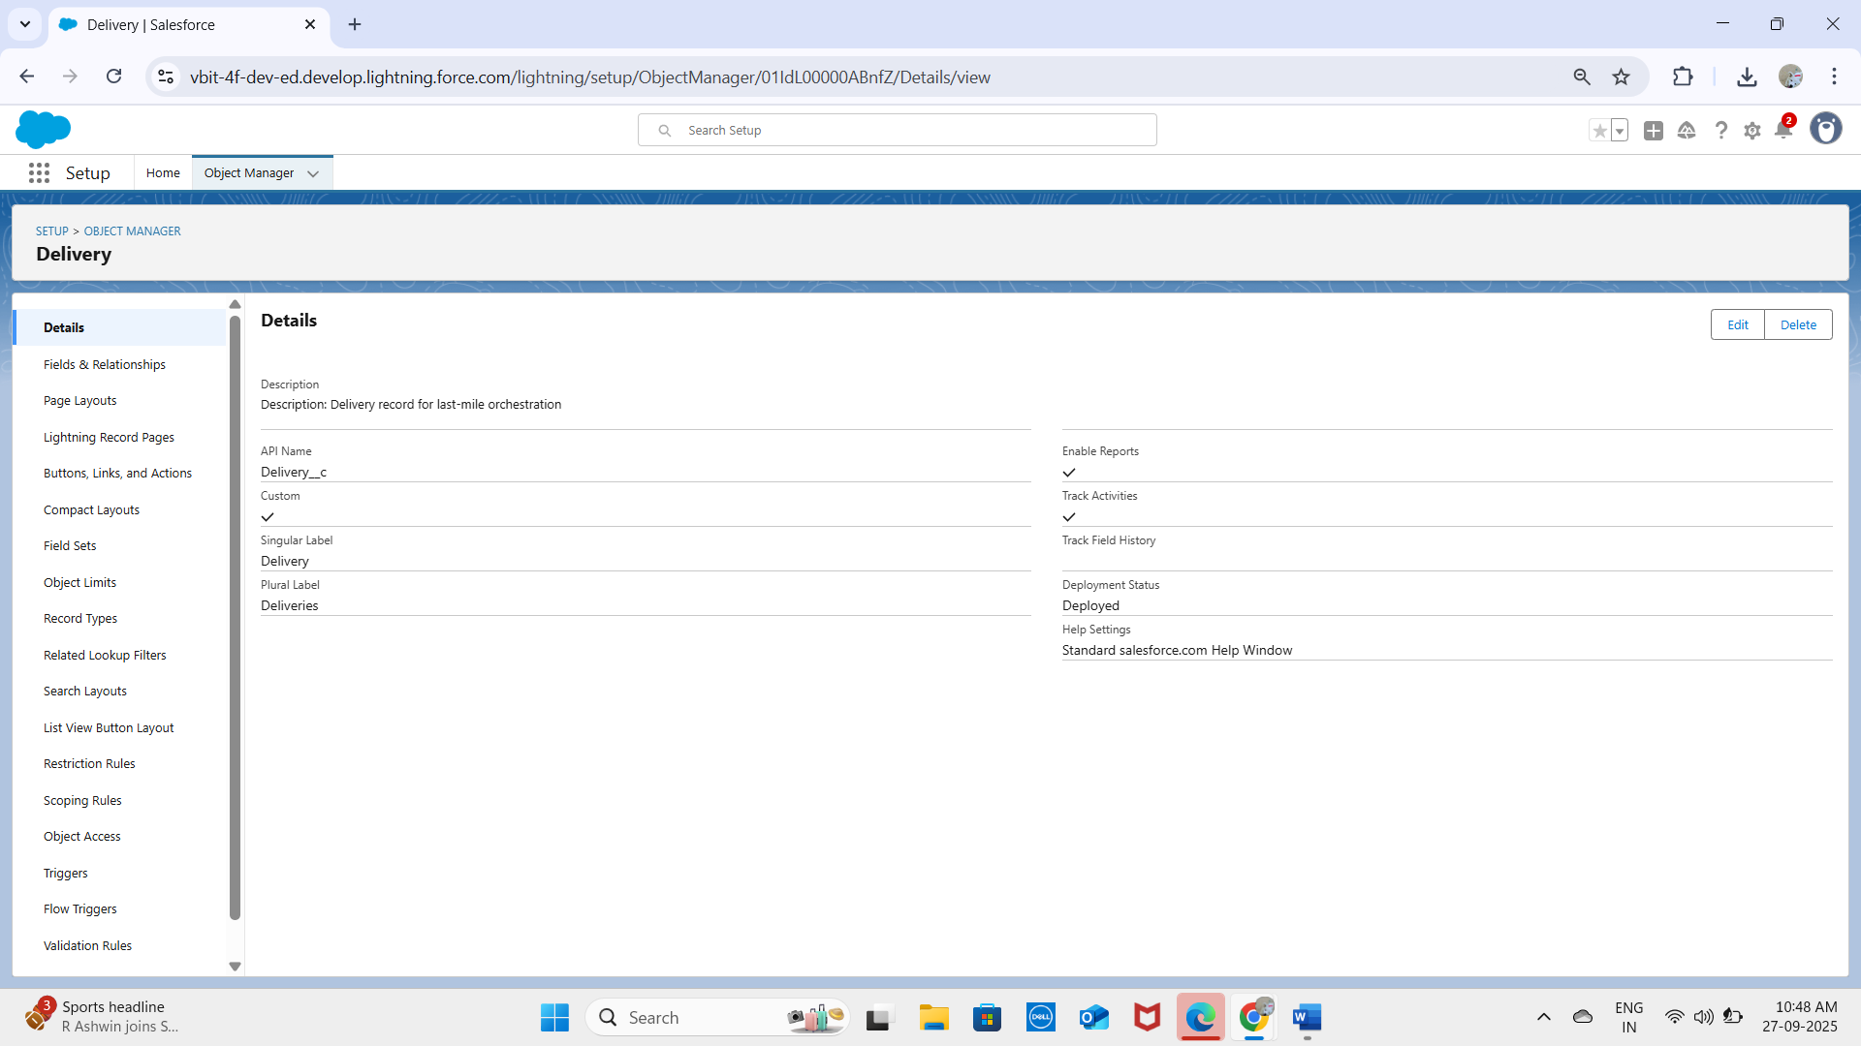  
Route__c: Stores optimized delivery routes with distance and estimated time.

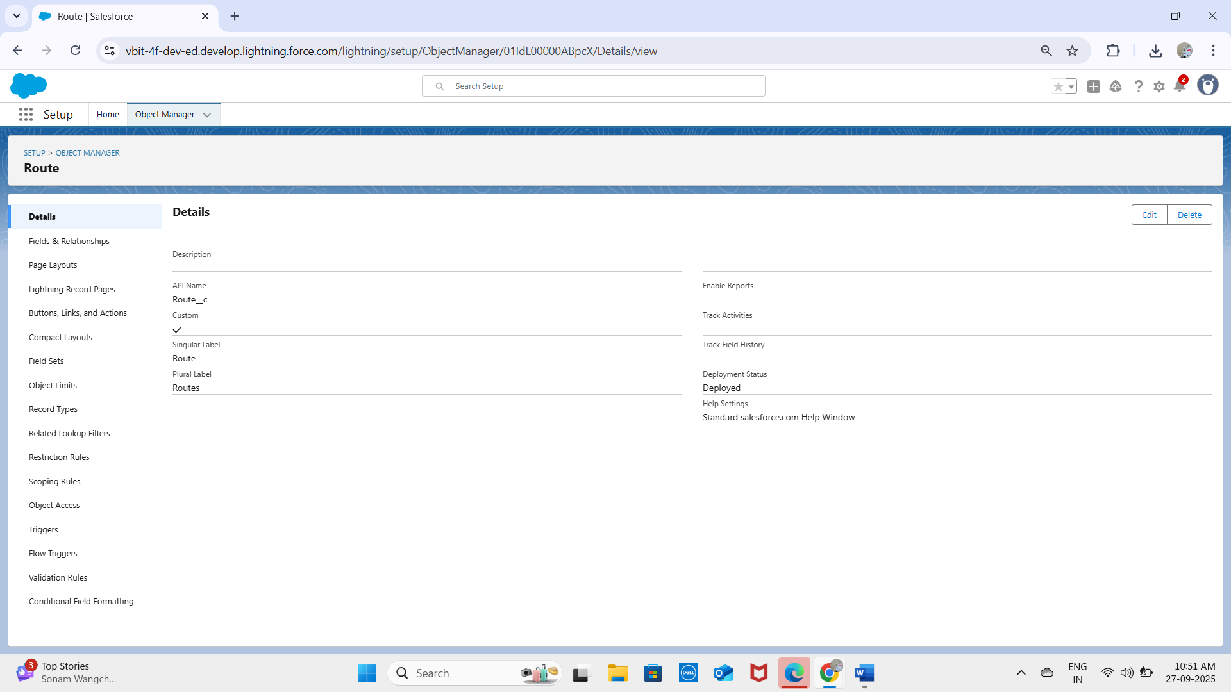

Delivery_Exception__c: Records delays, customer unavailability, traffic/weather issues.

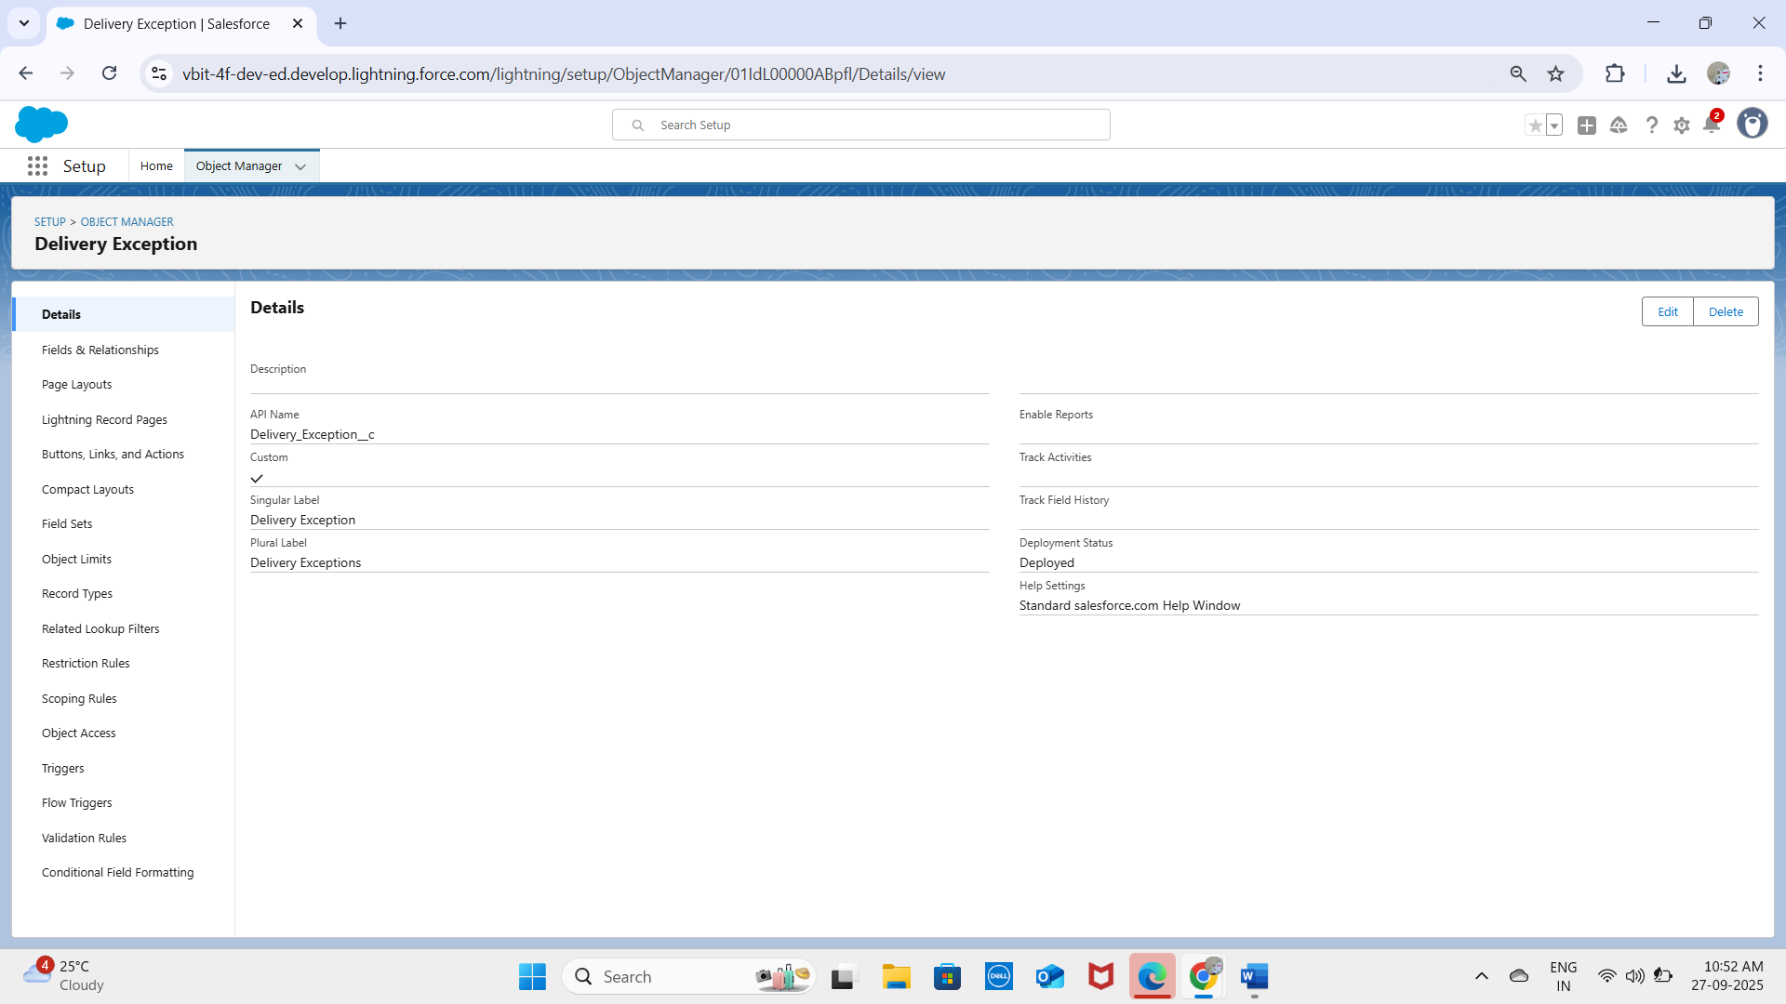  
Notifications__c: Captures alerts (SMS, Email, In-App) sent to customers.  
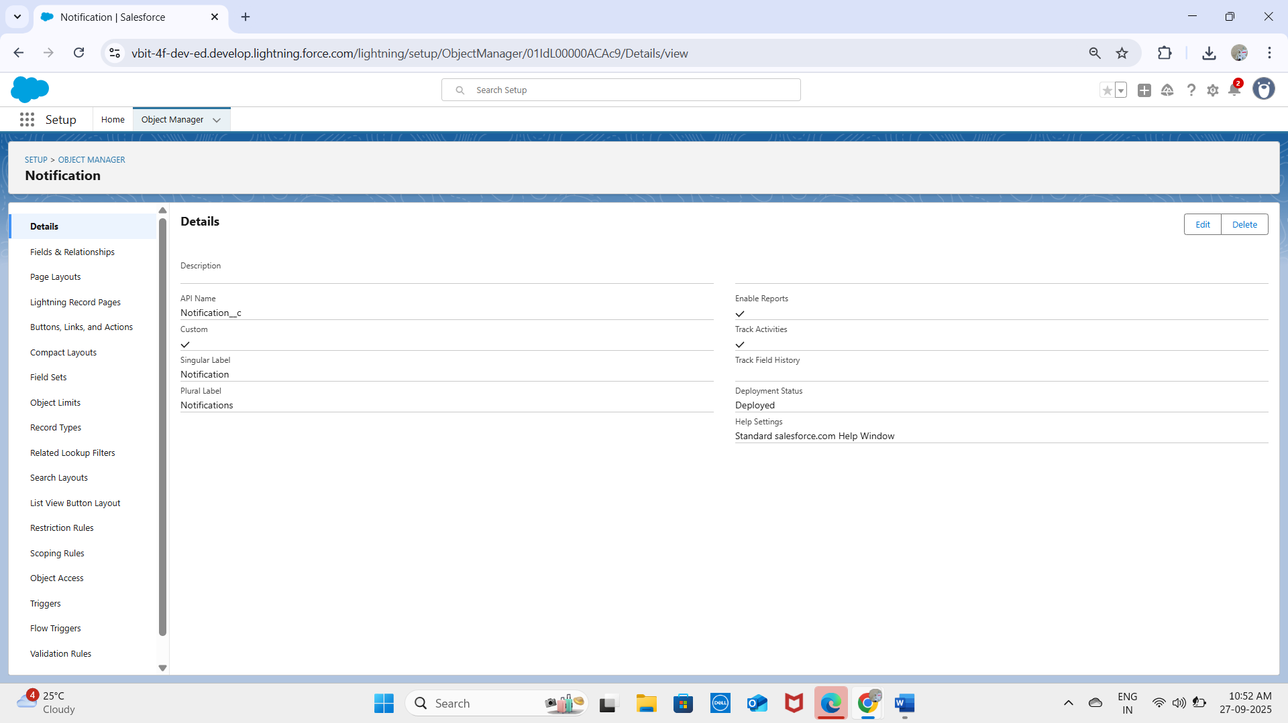  
✅ All fields verified successfully in the platform.

## Record Types

Standard Delivery – Normal delivery process.  
Express Delivery – Priority handling with tighter deadlines.  
Record types appear correctly on the Delivery__c object screen.

## Process Automation

Validation Rule – Delivery_Scheduled_InFuture: Prevents saving a Delivery with Scheduled Time in the past.  
Test Case 1: Entered yesterday’s date → ❌ Validation failed.  
Test Case 2: Entered tomorrow’s date → ✅ Saved successfully.  
  
Validation Rule – Exception_Type_Required: Requires Exception Type to be filled in Delivery_Exception__c.  
Test Case 1: Left blank → ❌ Error shown.  
Test Case 2: Entered 'Traffic' → ✅ Saved successfully.

## Lightning Email Template

Created template for Delivery Confirmation.  
Test Case: Status changed to 'Delivered' → ✅ Email sent to customer.

## Workflow / Flow Validation

Flow triggers notification creation when Delivery__c → Status = 'In Transit'.  
Test Case 1: Status set to Scheduled → ❌ No notification created.  
Test Case 2: Status set to In Transit → ✅ Notification record created.

## Process Builder / Flow Assignment

When Delivery__c is created, Assigned Agent is auto-filled based on Route.  
Test Case 1: Route = 'North Zone' → Agent = Kavya auto-assigned.  
Test Case 2: Route = 'South Zone' → Agent = Laxmi auto-assigned.

## Approval Process

Exception rescheduling requires manager approval.  
Test Case: Rescheduled time entered → ✅ Approval request sent to Logistics Manager.

## Lightning Web Components

Created LWCs:  
- DeliveryTracker – Displays live delivery status.  
- RouteMap – Shows optimized path.  
- ExceptionHandler – Allows rescheduling.  
  
Test Case: Opened DeliveryTracker LWC → ✅ Displayed status + route correctly.

## Data Import (CSV)

Imported sample deliveries via Data Loader.  
Test Case 1: 'Delivery #101' imported successfully.  
Test Case 2: 'Delivery #102' imported successfully.

## Duplicate Rules

Duplicate rule based on Delivery Number.  
Test Case 1: Entered Delivery #101 again → ❌ Duplicate warning shown.  
Test Case 2: Entered Delivery #103 → ✅ Record saved.

## Login IP Ranges

Configured trusted IP range for Delivery Agents.  
Test Case 1: Login from office network → ✅ Success.  
Test Case 2: Login from untrusted IP → ❌ Blocked.