Intelligent Last Mile Delivery Orchestration System

# Phase 3: Data Modeling & Relationships

## Standard & Custom Objects

The data model for the Intelligent Last Mile Delivery Orchestration System combines standard Salesforce objects with newly created custom objects to support delivery operations, routing, and customer communication.

* **Standard Objects:**

- Account: Represents the business customers or clients associated with deliveries.  
- Contact: Represents individual customers receiving deliveries.  
- User: Represents delivery agents, managers, and customer service staff.

* **Custom Objects:**
* **Delivery__c:** Tracks each delivery record with status, scheduling, and completion details.

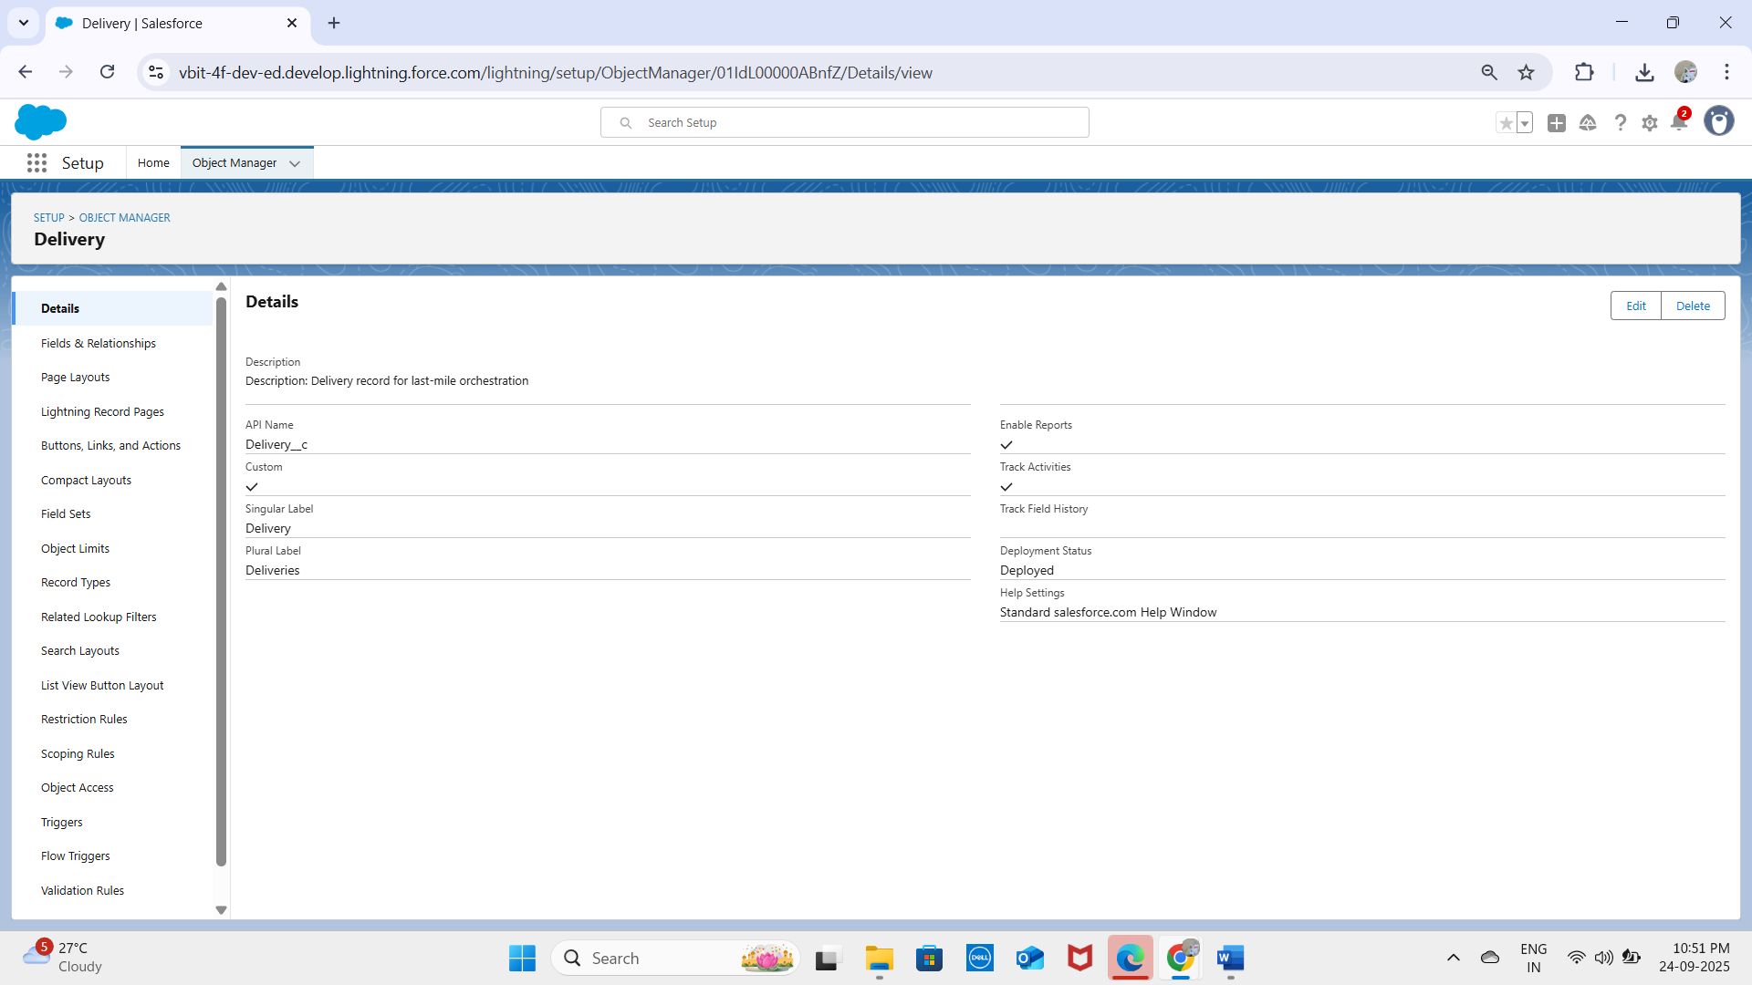  
**- Route__c:** Holds optimized route details for delivery assignments.

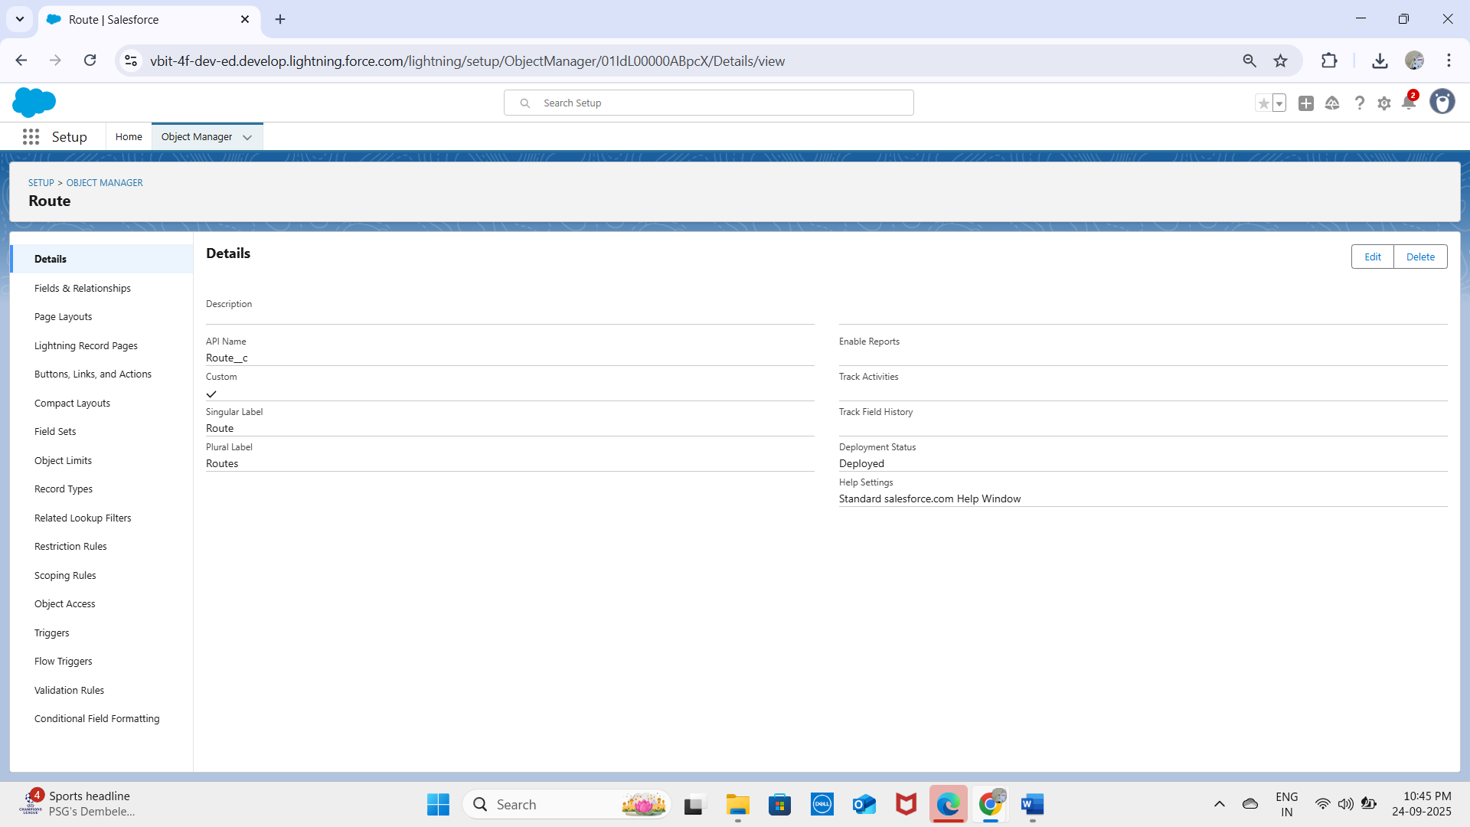  
- **Delivery_Exception__c:** Captures failed or delayed deliveries and rescheduling information.

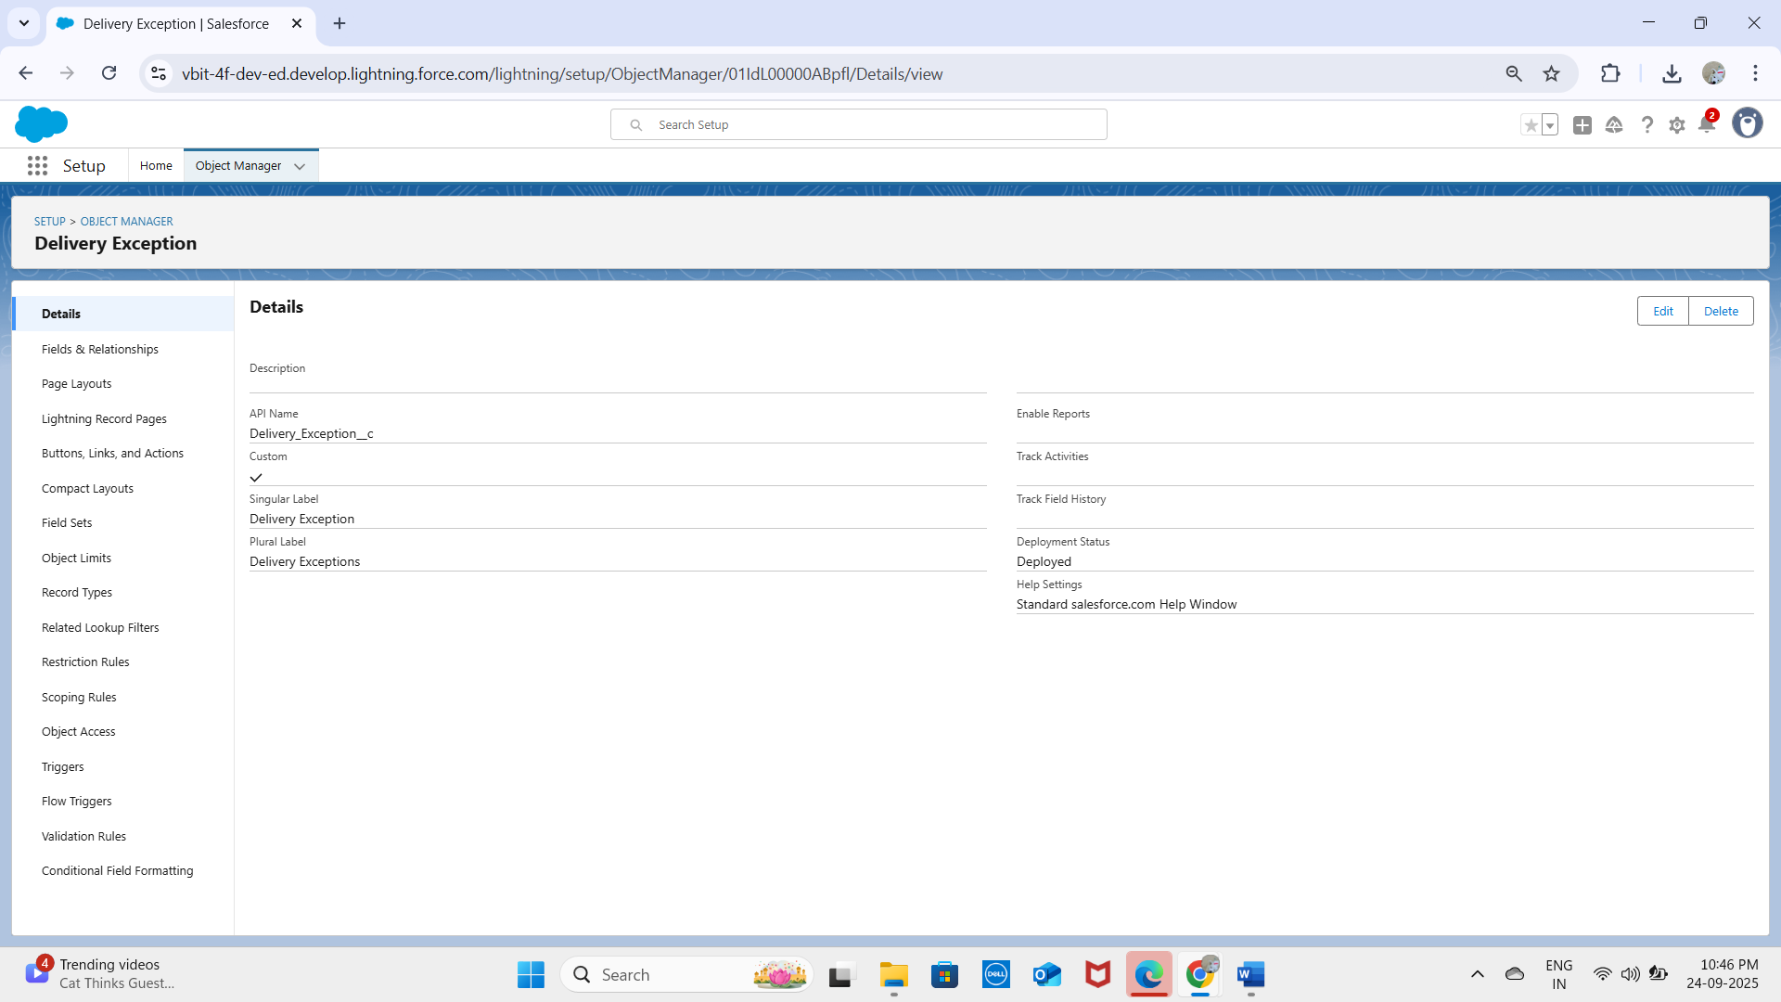

**- Notifications__c:** Stores automated communication alerts sent to customers.

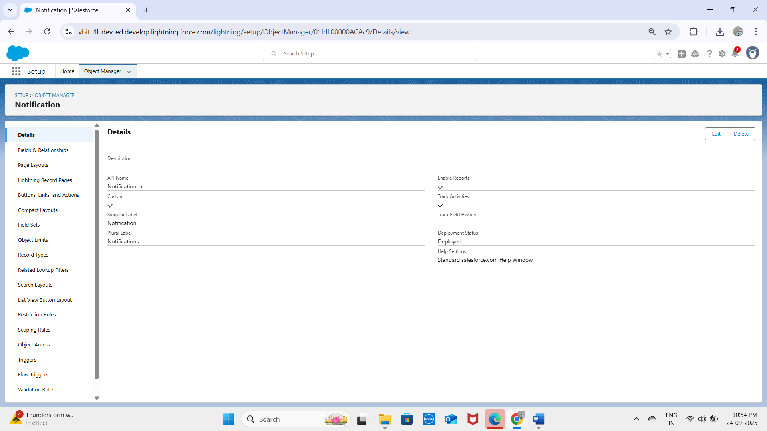

## Fields & Relationships

Custom fields capture the logistics data required to manage deliveries, while relationships link the objects together.

* **Relationships:**

- Delivery__c → Lookup to Account (Customer placing the delivery).  
- Delivery__c → Lookup to User (Assigned Delivery Agent).  
- Route__c → Master-Detail with Delivery__c (one route may cover multiple deliveries).  
- Delivery_Exception__c → Lookup to Delivery__c (each exception tied to a specific delivery).  
- Notifications__c → Lookup to Delivery__c (notifications linked to delivery record).

* **Custom Fields:**

**On Delivery__c:**  
- Delivery_Number__c (Auto Number)  
- Delivery_Status__c (Picklist: Scheduled, In Transit, Delivered, Failed)  
- Scheduled_Time__c (Date/Time)  
- Actual_Delivery_Time__c (Date/Time)  
- Customer__c (Lookup to Account)  
- Assigned_Agent__c (Lookup to User)

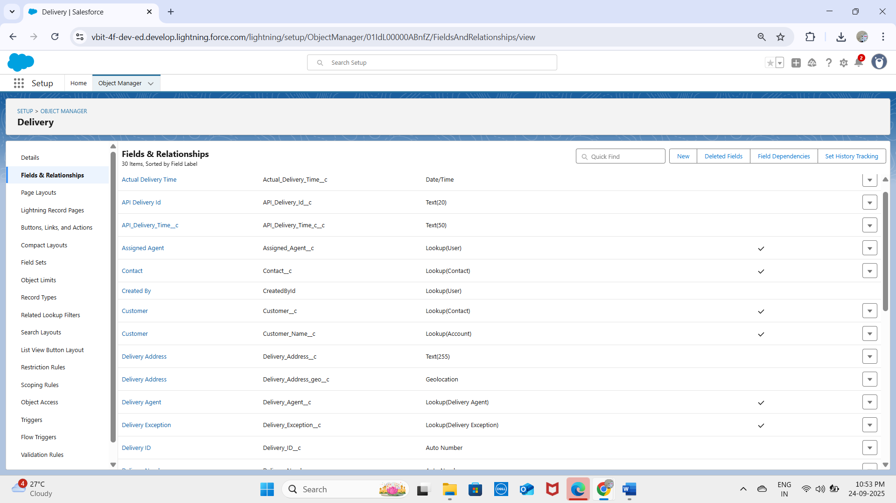  
**On Route__c:**  
- Route_Name__c (Text)  
- Distance__c (Number)  
- Estimated_Time__c (Number)

**-**Start_Location__c(Text)

-End_Location__c(Text)

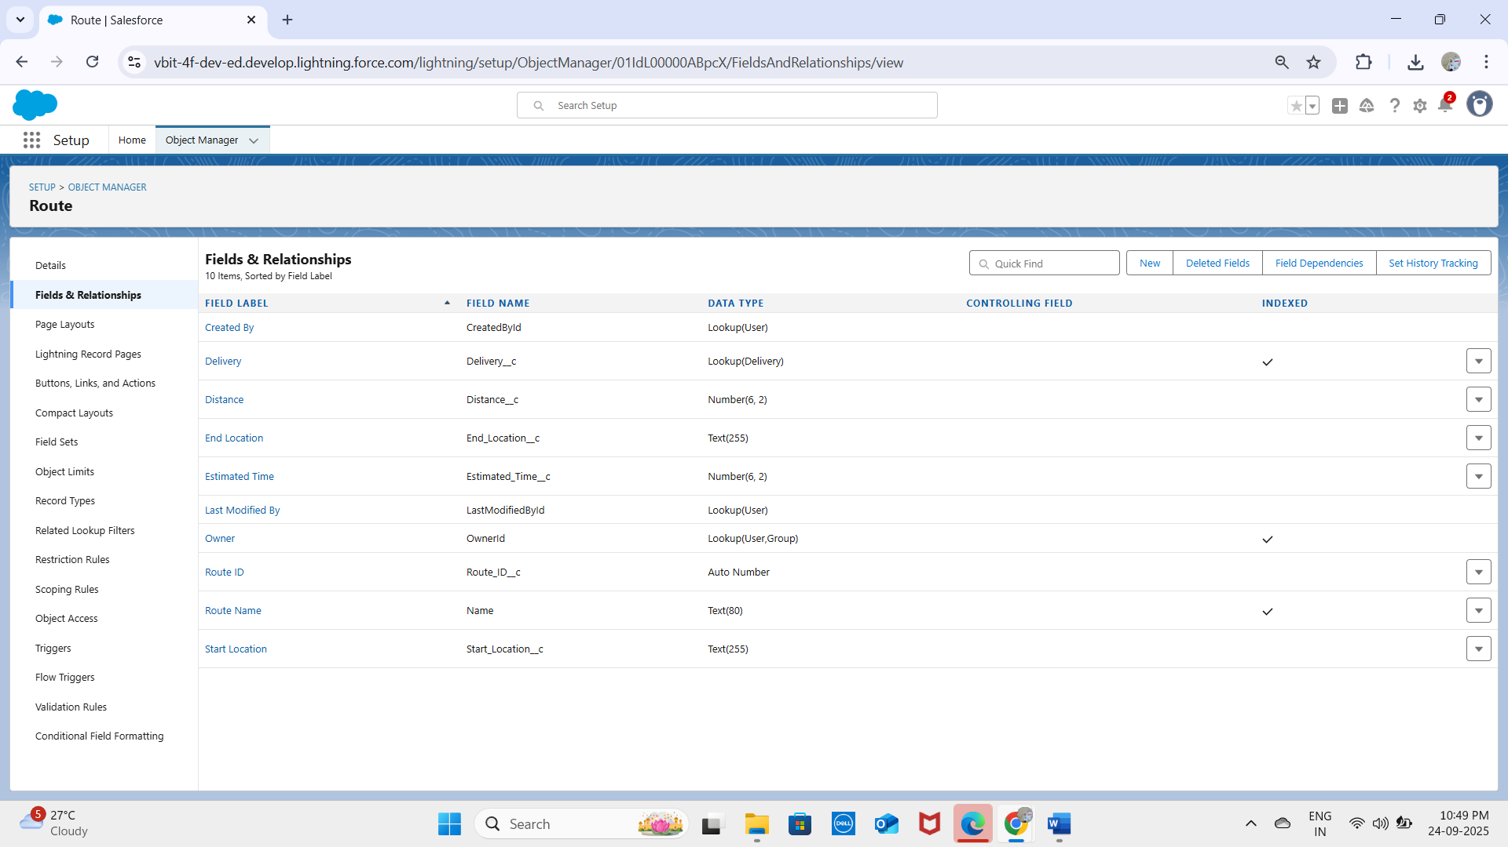  
**On Delivery_Exception__c:**  
- Exception_Type__c (Picklist: Delay, Customer Not Available, Traffic, Weather)  
- Notes__c (Text Area)  
- Reported_Date__c (Date/Time)

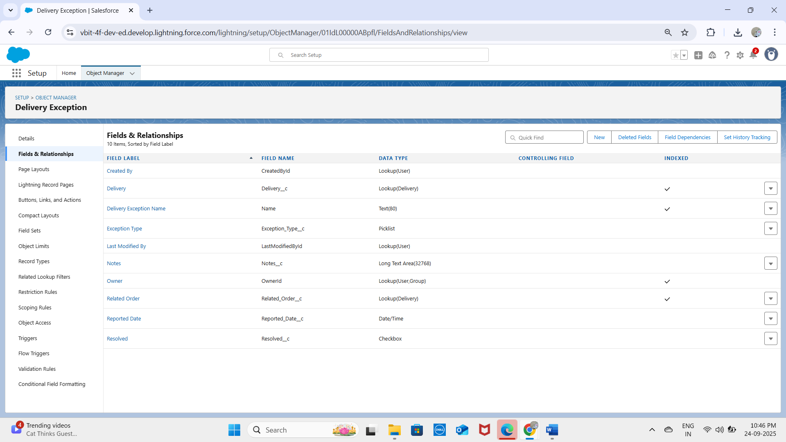  
  
**On Notifications__c:**  
- Type__c (Picklist: SMS, Email, In-App)  
- Message_c__c (Text Area)  
- Name (Text)

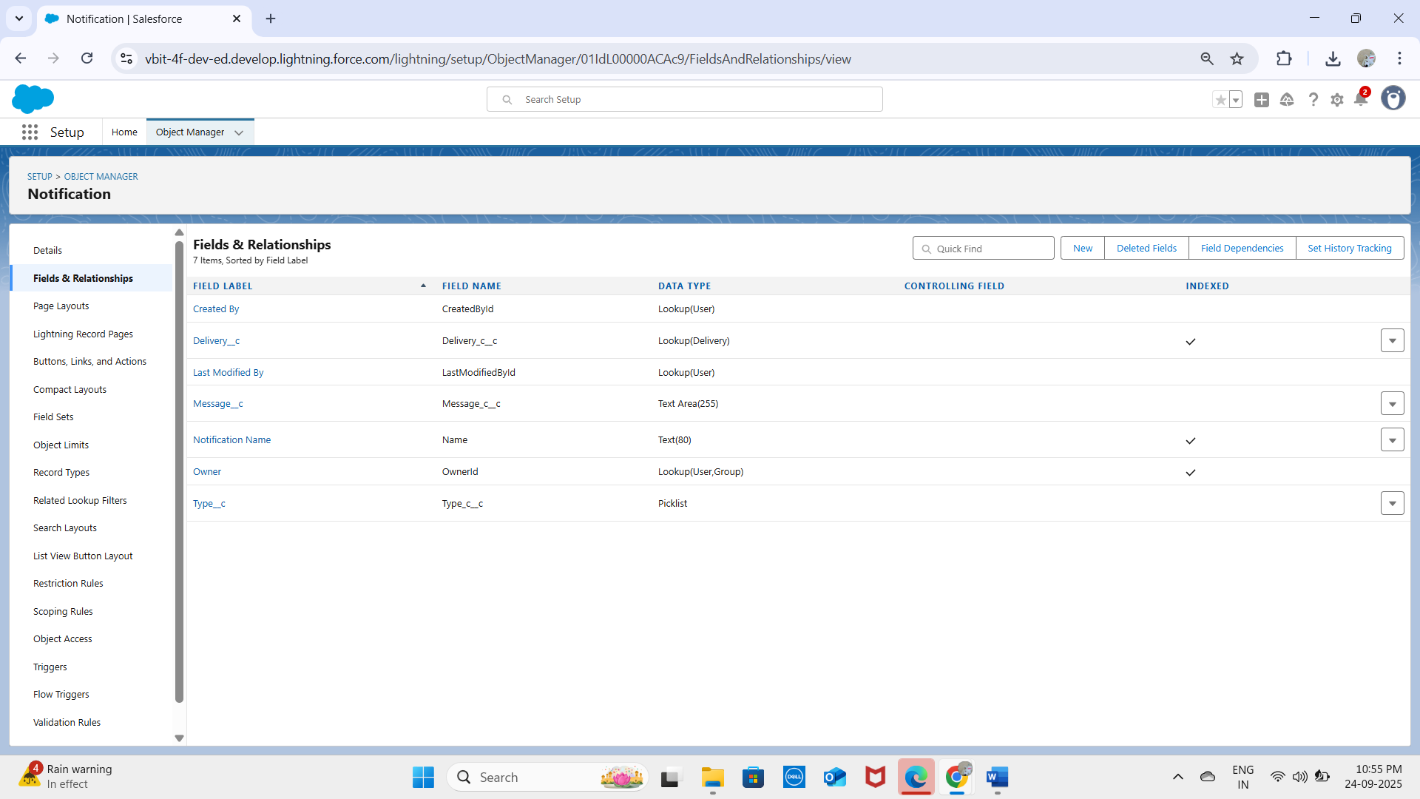

## User Interface & Layouts

**Page Layouts:** Custom layouts were created for Delivery, Route, Exception, and Notifications to display relevant fields and related lists clearly for different roles (Agents, Managers, Service Staff).

* **Delivery Layout:**

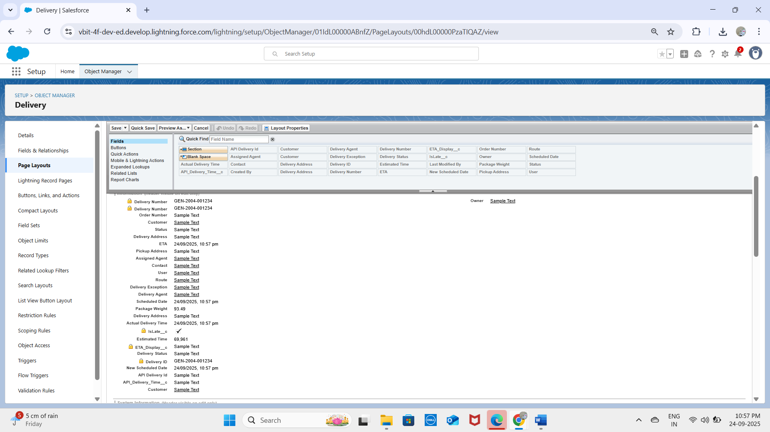

* **Route Layout:**

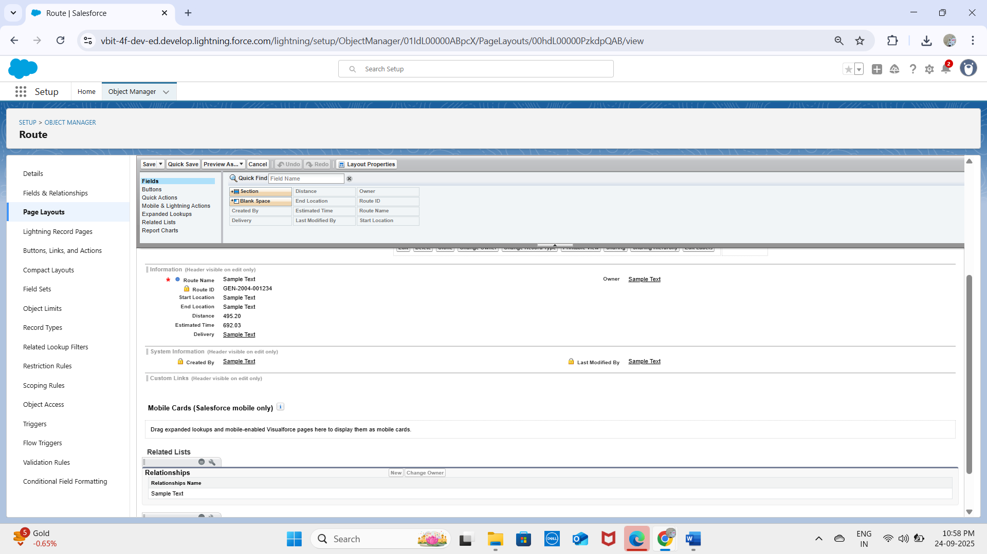

* **Delivery Exception Layout:**

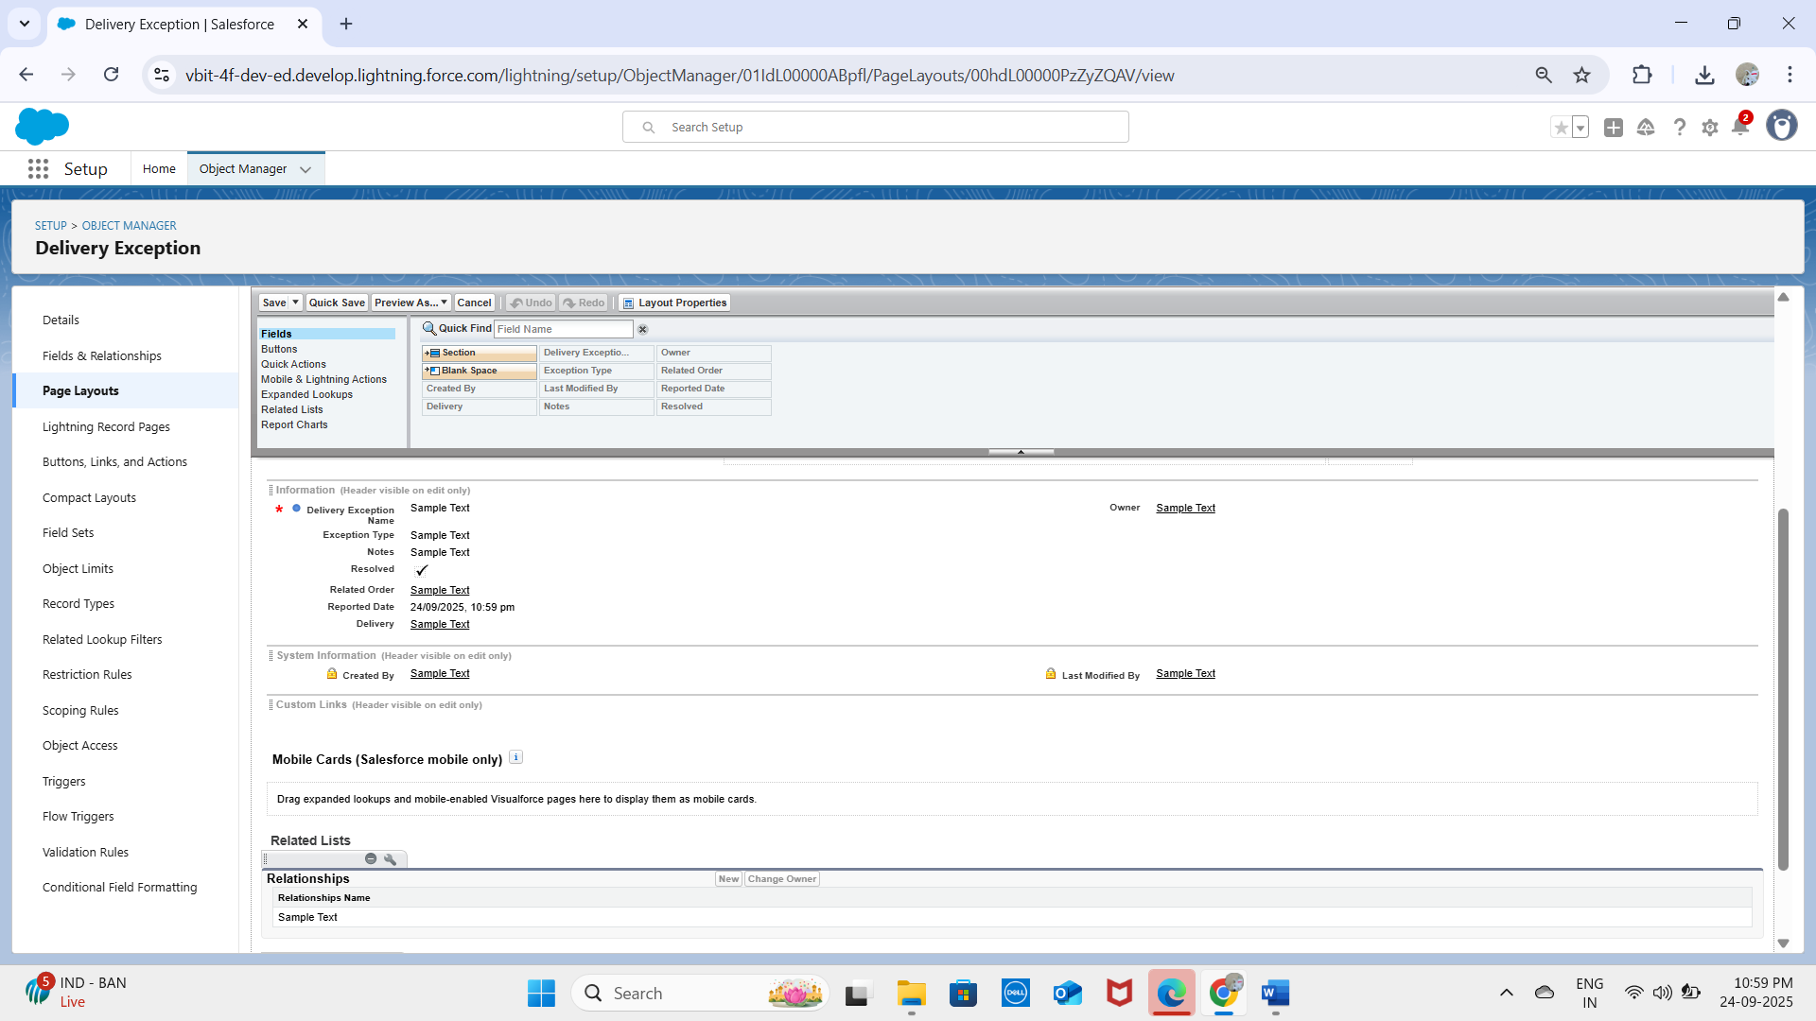

**Notification Layout:**

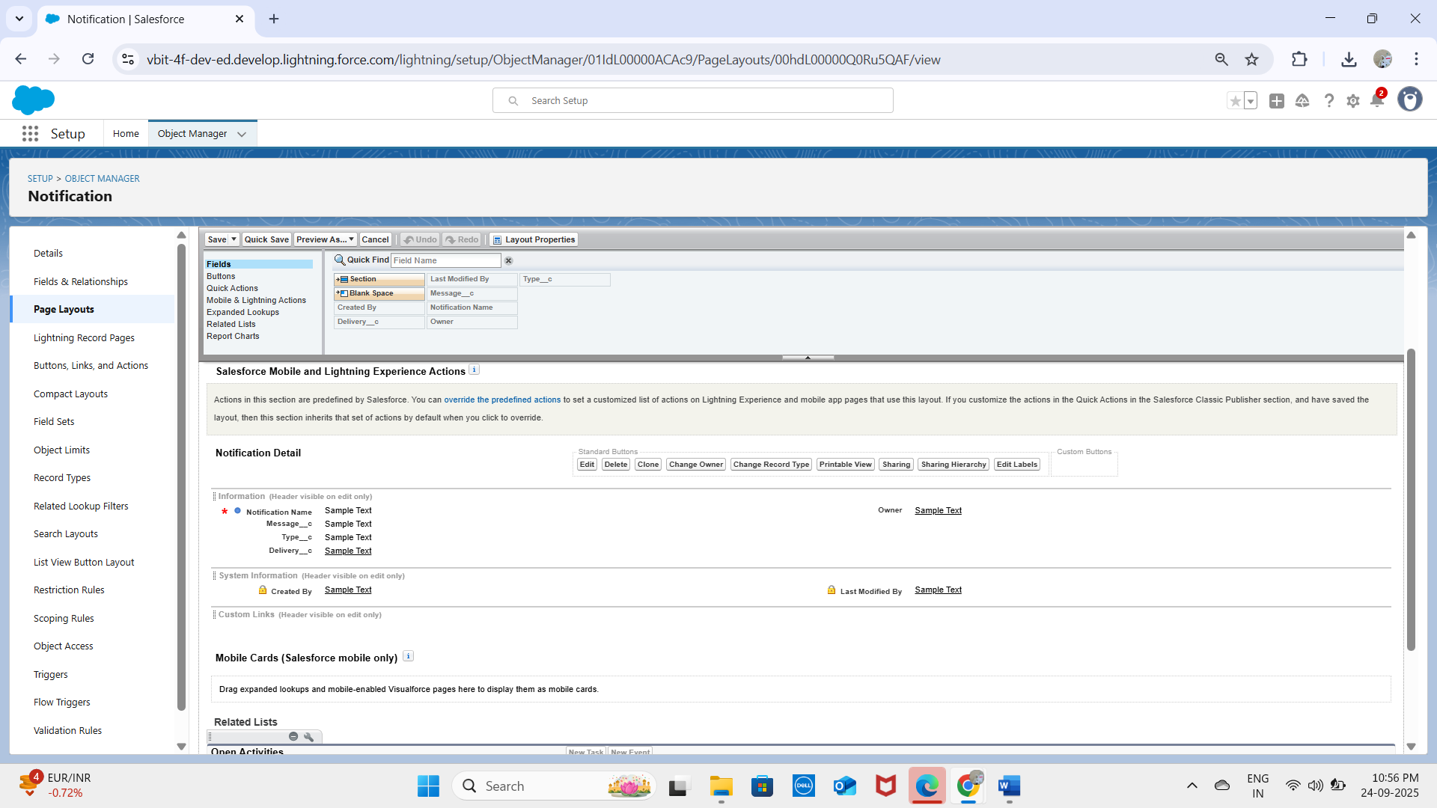  
  
**Compact Layouts:** Configured for Delivery__c to show Delivery Number, Status, and Scheduled Time in highlights panel. Other compact layouts created for Route__c and Delivery_Exception__c.

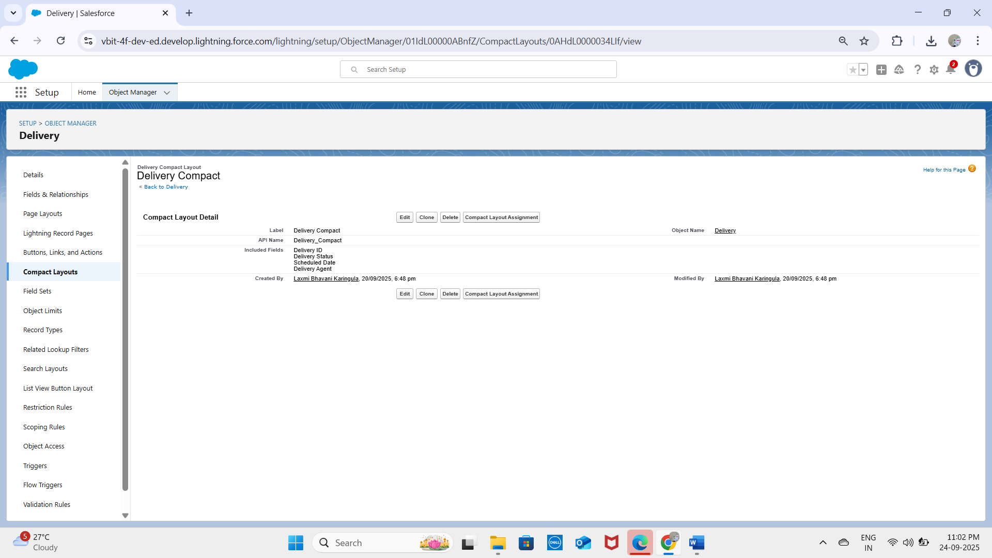  
  
**Record Types:** Not required in the initial phase but can be added later to distinguish different delivery types (e.g., Standard Delivery, Express Delivery).

## Data Architecture

Schema Builder: Used to visualize all objects and their relationships, showing Account and User at the center with custom objects linked for deliveries, routes, and notifications.  
  
Junction Objects: Not required for the current design. However, if a Delivery__c could belong to multiple routes, a junction object such as Delivery_Route_Assignment__c would be created with master-detail relationships to both Delivery__c and Route__c.