# PHASE 4 – Process Automation (Admin)

The goal of this phase is to use Salesforce's declarative tools to automate delivery operations, enforce data quality, and handle business logic using Flows and Validation Rules.

## Validation Rules

Validation rules were created to ensure clean and accurate data entry.

- Object: Delivery__c  
- Rule: Scheduled date cannot be in the past.  
- Formula:  
 Scheduled_Date__c < NOW()  
- Error Message: "Scheduled date cannot be in the past."

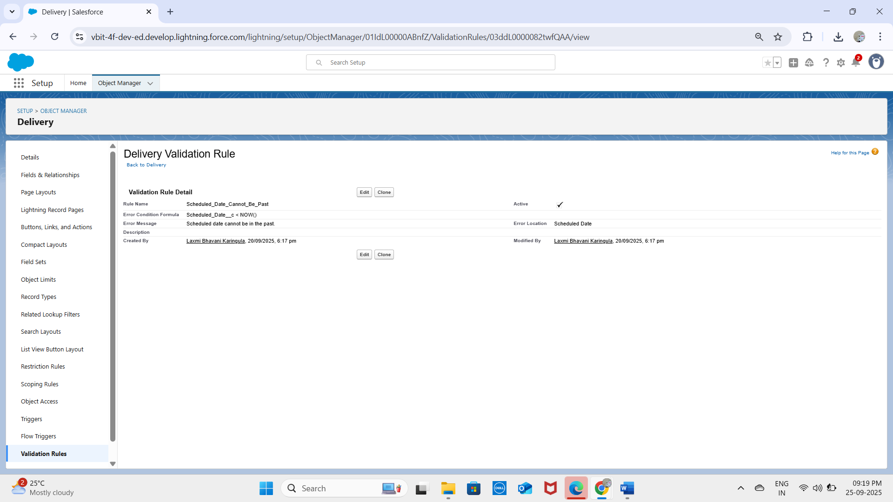

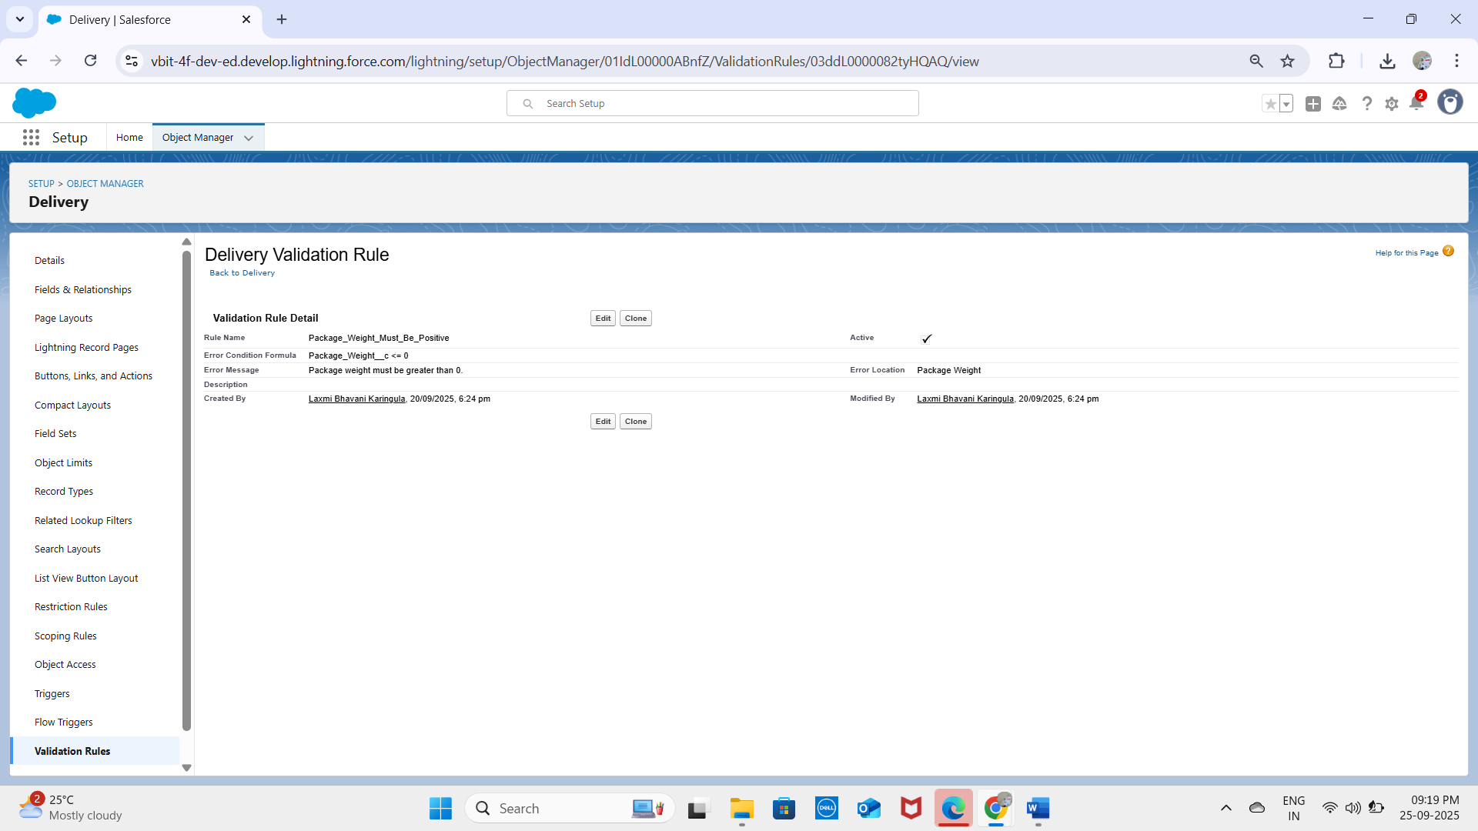

- Object: Order__c  
- Rule: Ensure Total_Amount__c is greater than zero.  
- Formula:  
 Total_Amount__c <= 0  
- Error Message: "Total Amount must be greater than zero."

## Flow Builder (Record-Triggered Flow)

Flows were used as the primary automation tool for project logic.

### Flow 1 – Update Delivery Status

- Objective: Automatically update delivery status when order is marked complete.  
- Trigger: Record-Triggered Flow on Order__c → when Status__c = 'Complete'.  
- Logic:  
 1. Get Records → Find related Delivery__c record using Order__c.  
 2. Update Records → Set Delivery_Status__c = 'Delivered'.

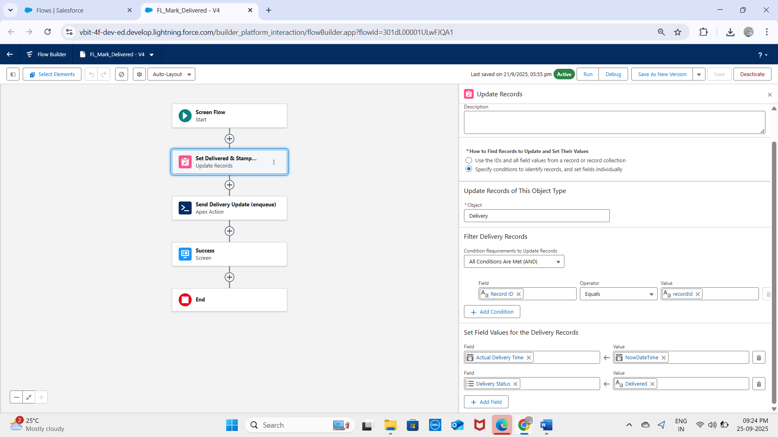

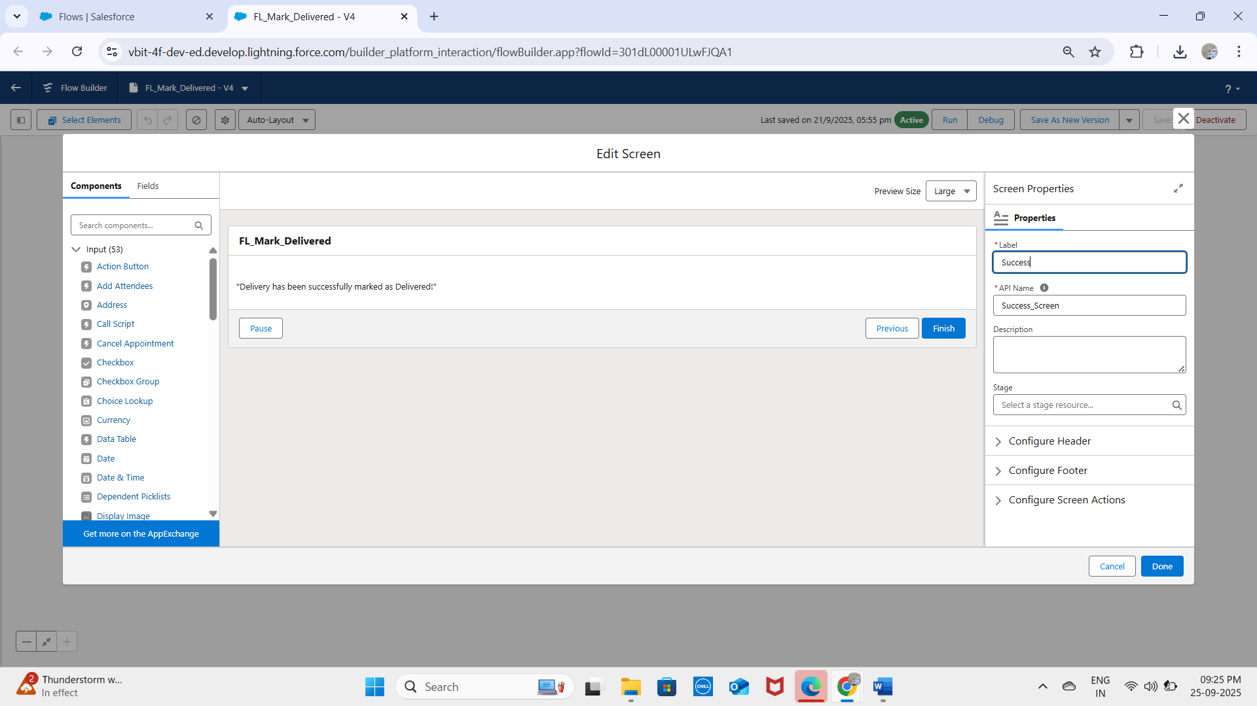

### Flow 2 – AutoStamp ActualDelivery

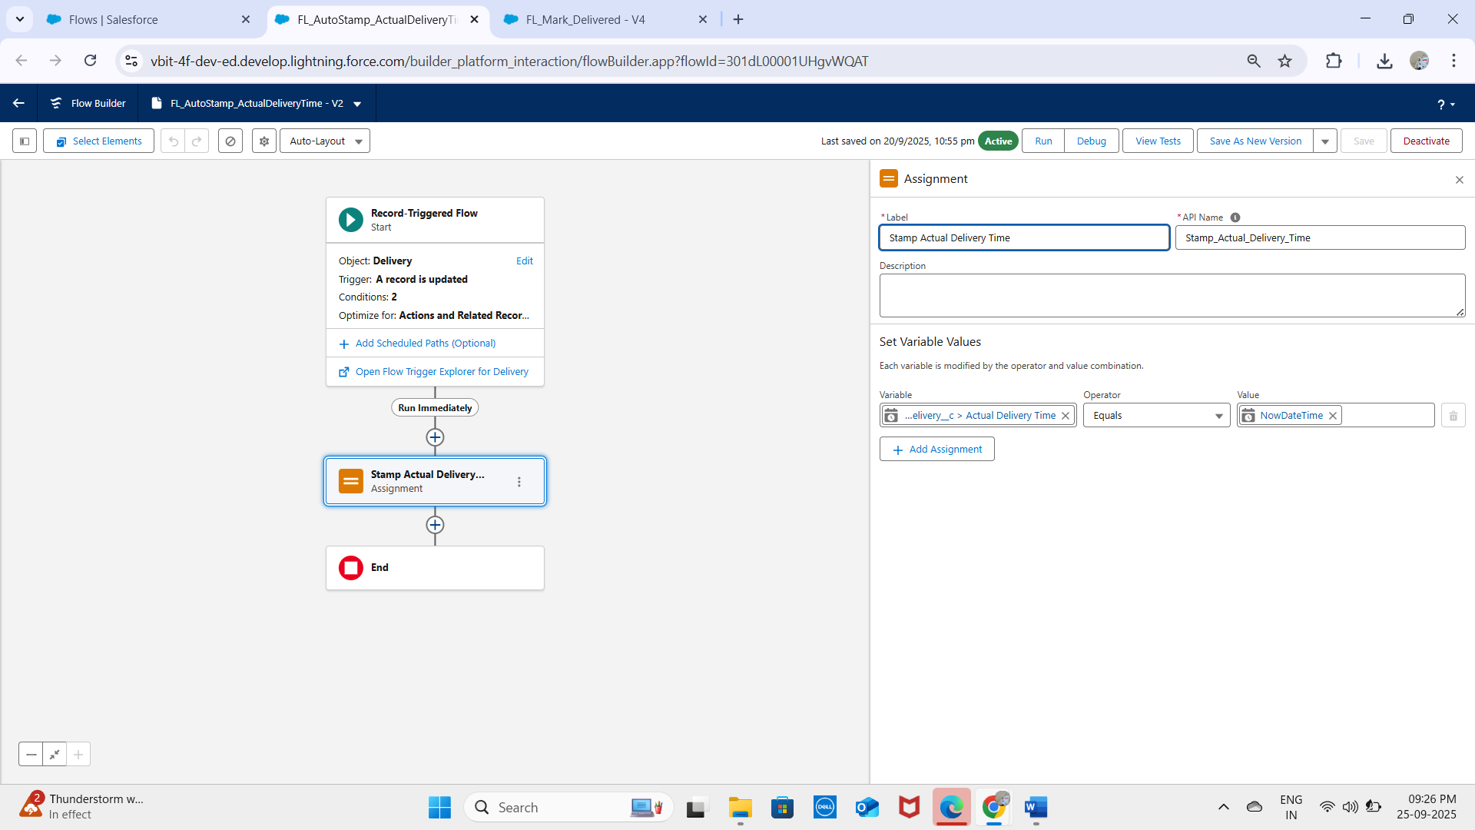

**Flow 3 -Report Exception**

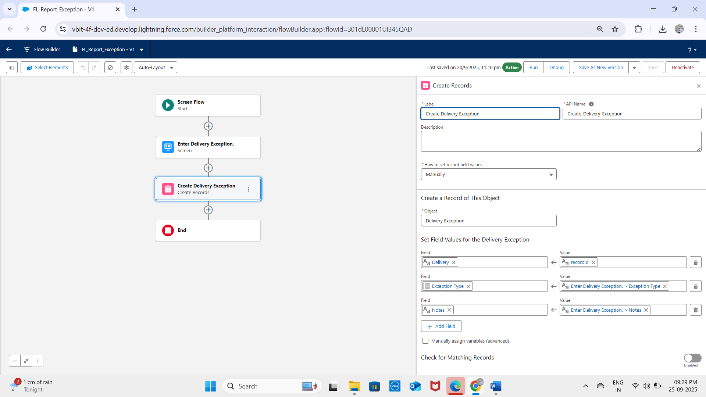

## Approval Process

A future requirement was identified to ensure manager approvals for high-value orders.  
  
- Object: Order__c  
- Criteria: If Total_Amount__c > 10,000 INR  
- Process:  
 • Submit automatically to Manager for Approval.  
 • Manager approves/rejects.  
 • Status updates accordingly.

## Workflow Rules & Process Builder

- No new workflows or Process Builder were created (deprecated tools).  
- All automation for the project (Deliveries, Orders, Loyalty) was implemented with Flows following Salesforce best practices.

## Outcome

With this phase, the project now has:  
- Data quality enforcement (Validation Rules)  
- Business logic automation (Flows)  
- Governance workflow (Approval Process)