# PHASE 5 – Apex Programming (Developer)

In this phase, we extend beyond Salesforce’s point-and-click tools and use Apex programming to implement custom business logic for Deliveries, Orders, and Loyalty Points in the CRM. Apex ensures scalability, efficiency, and complex automation where declarative tools are insufficient.

## 1. Apex Classes & Objects

Apex classes were created to handle reusable logic.

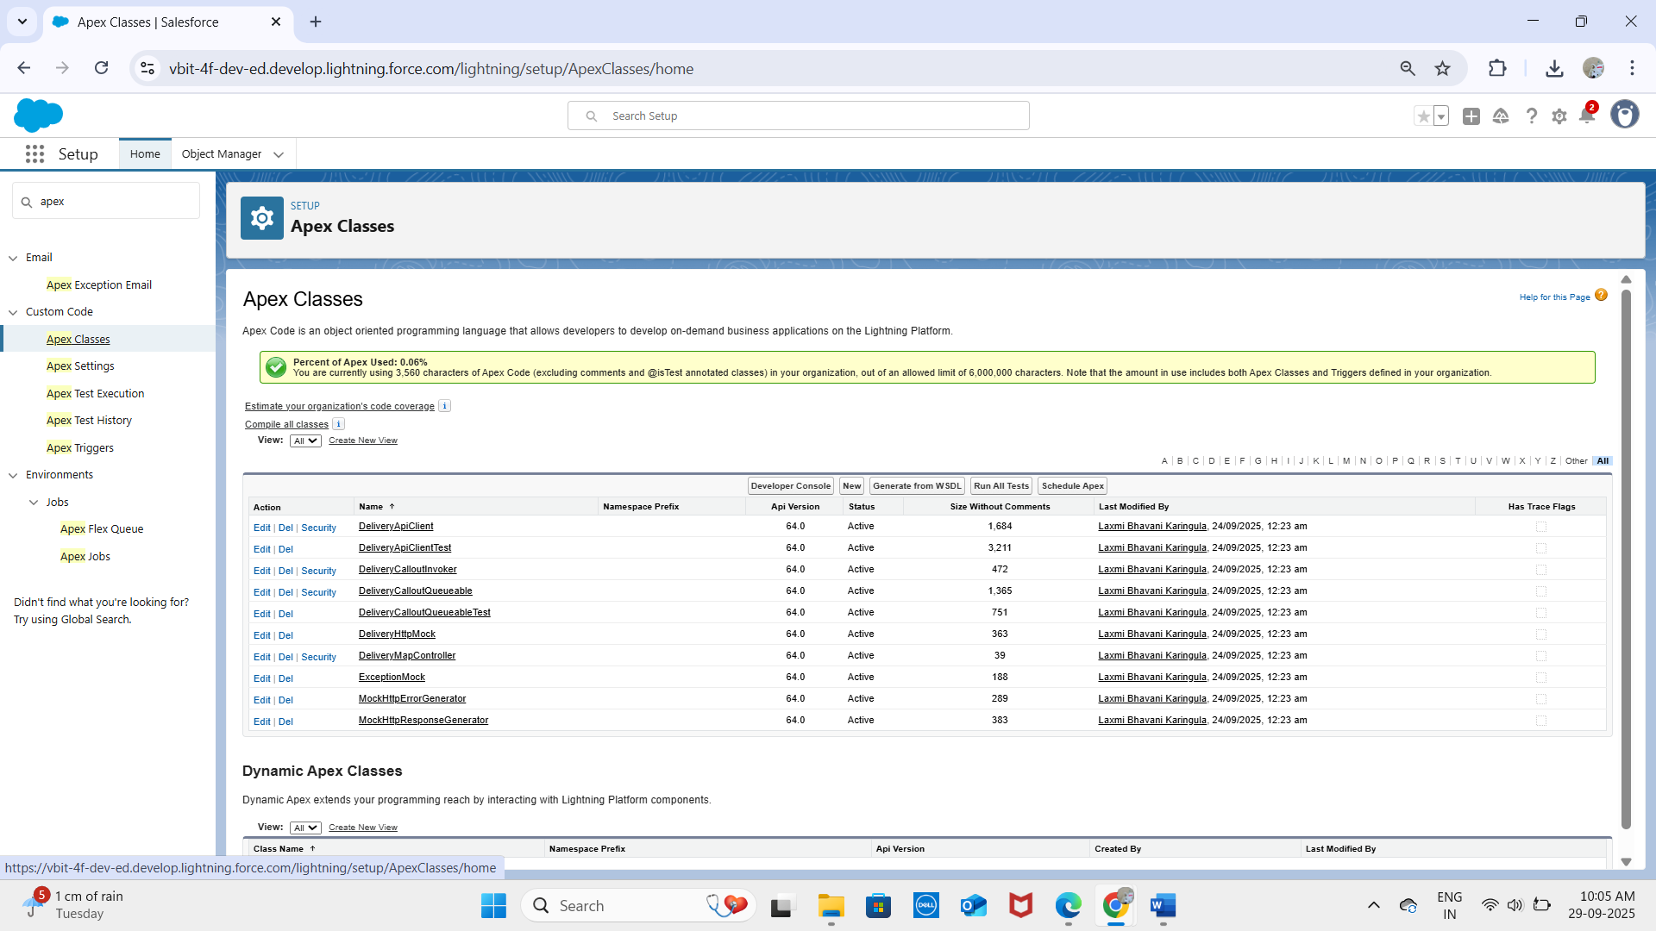

**DeliveryAPIclient:**

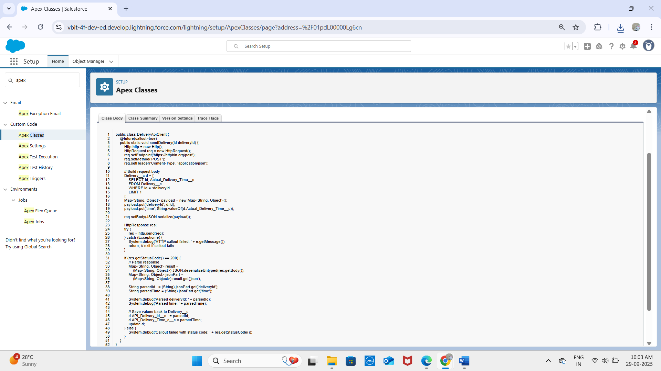

**DeliveryApiClientTest:**

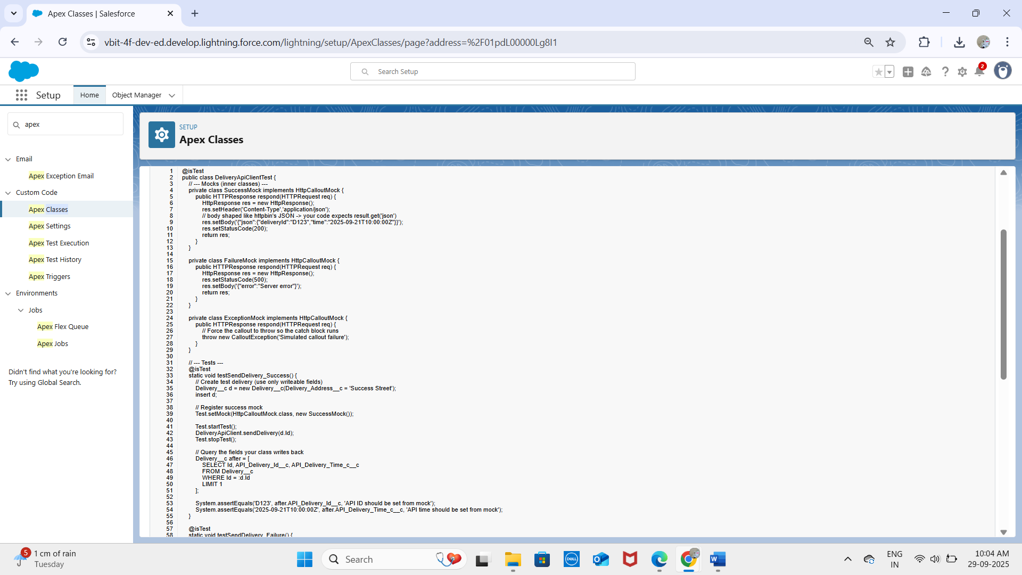

**DeliveryCalloutInvoker:**

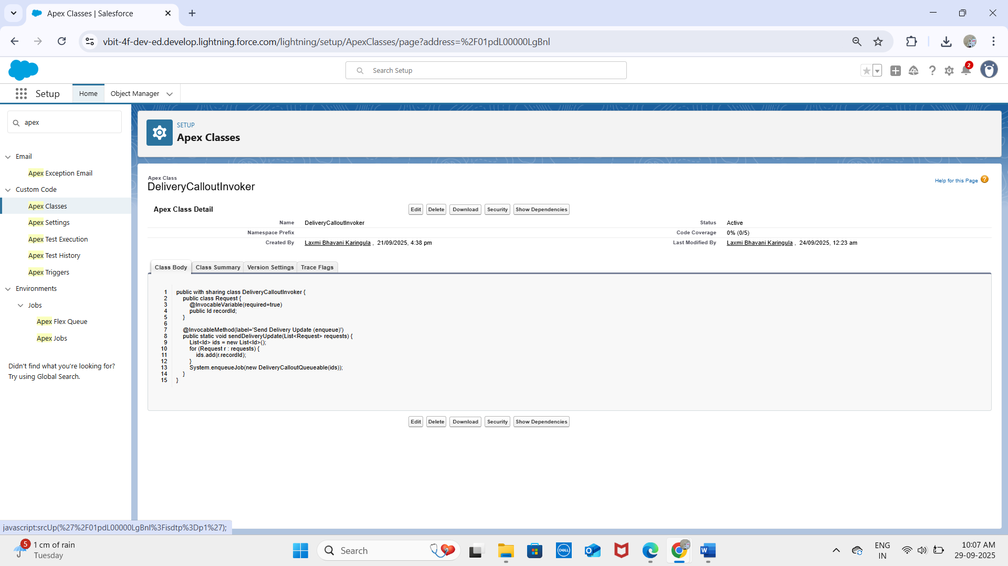

**DeliveryCalloutQueuable:**

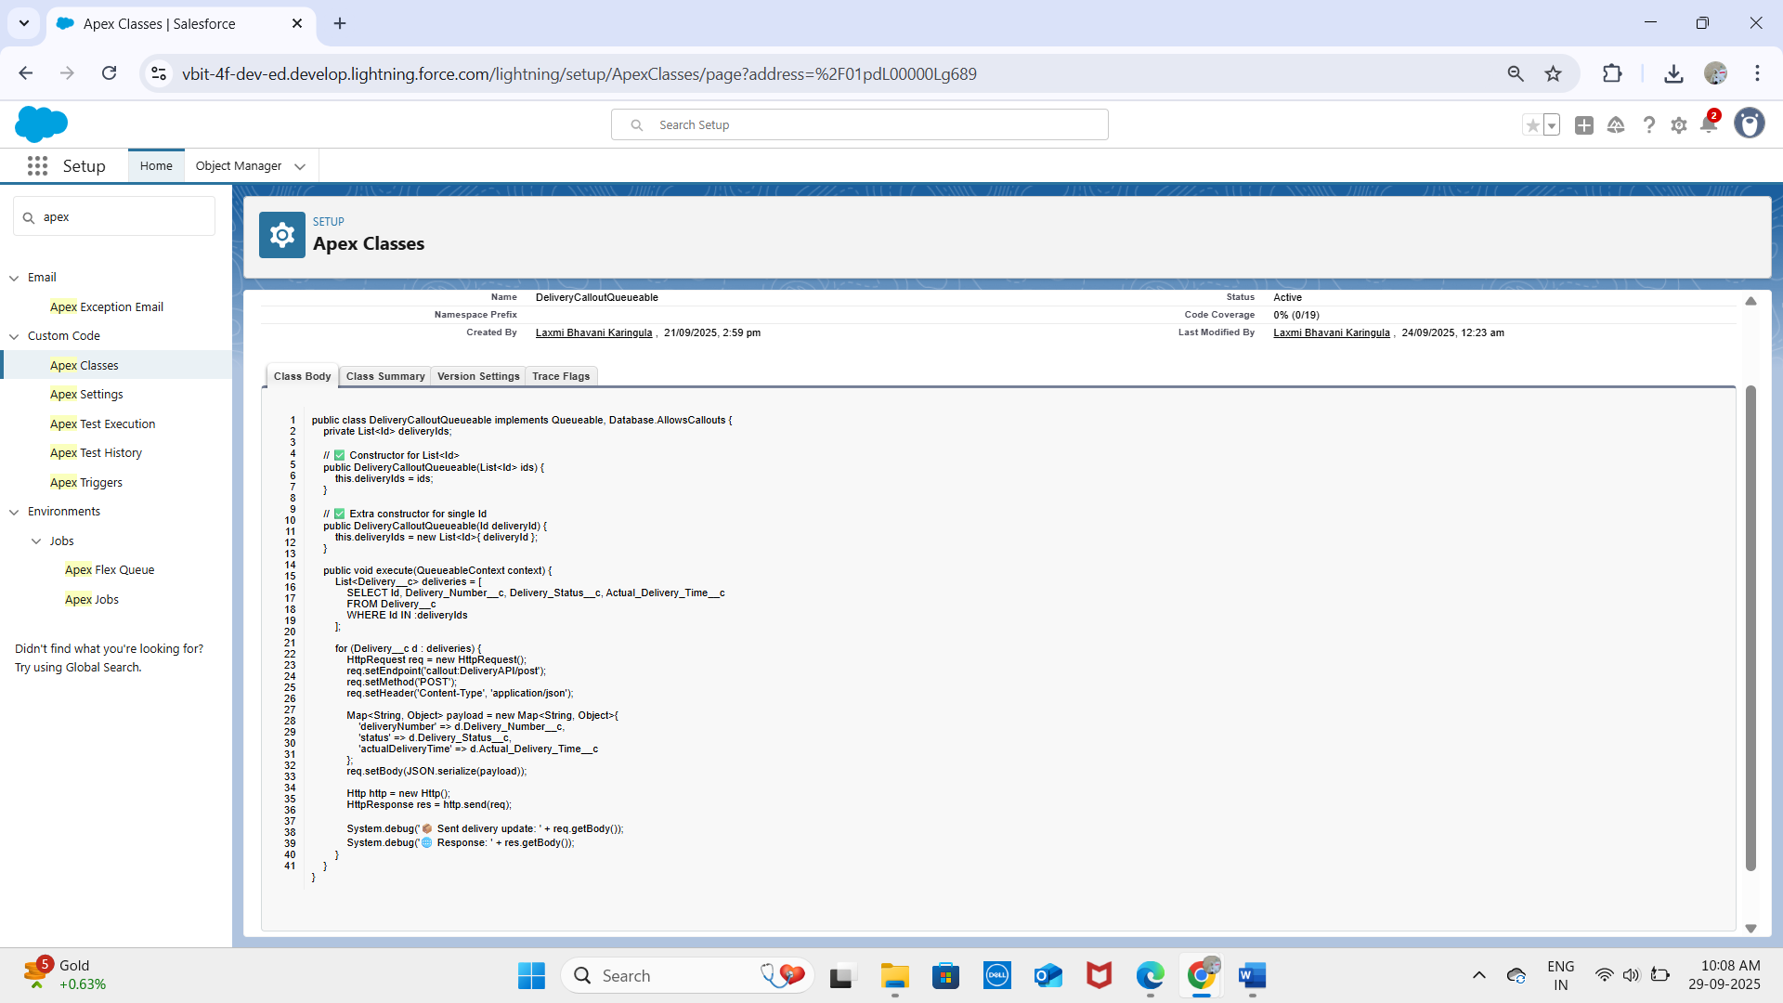**Top of Form**

**DeliveryHttpMock:**

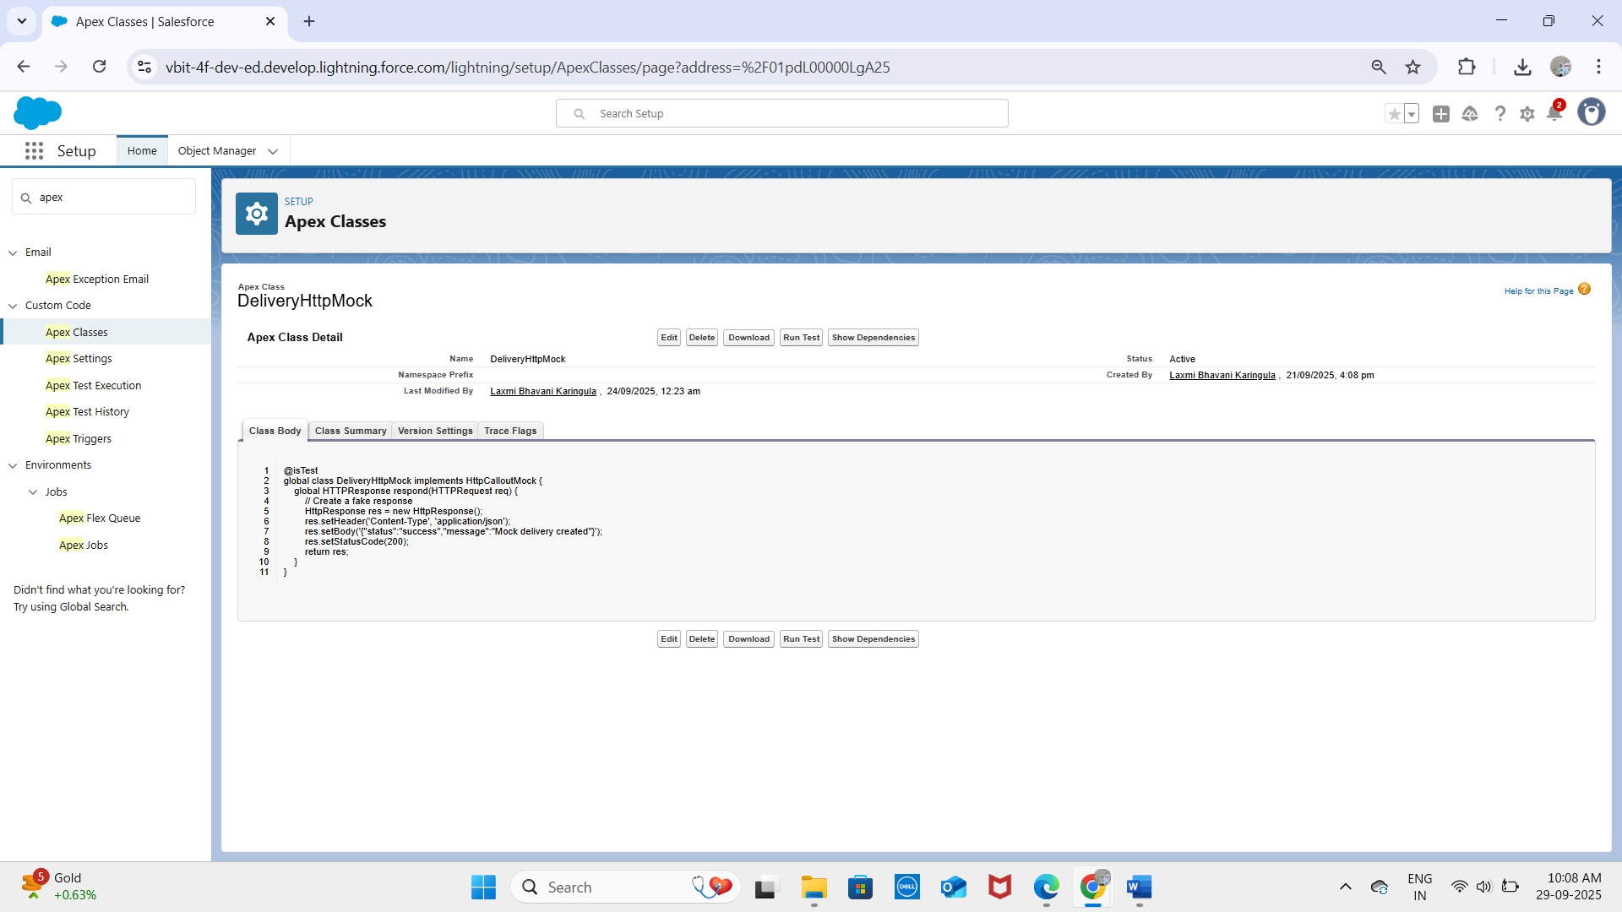

**MockHttpErrorGenerator:**

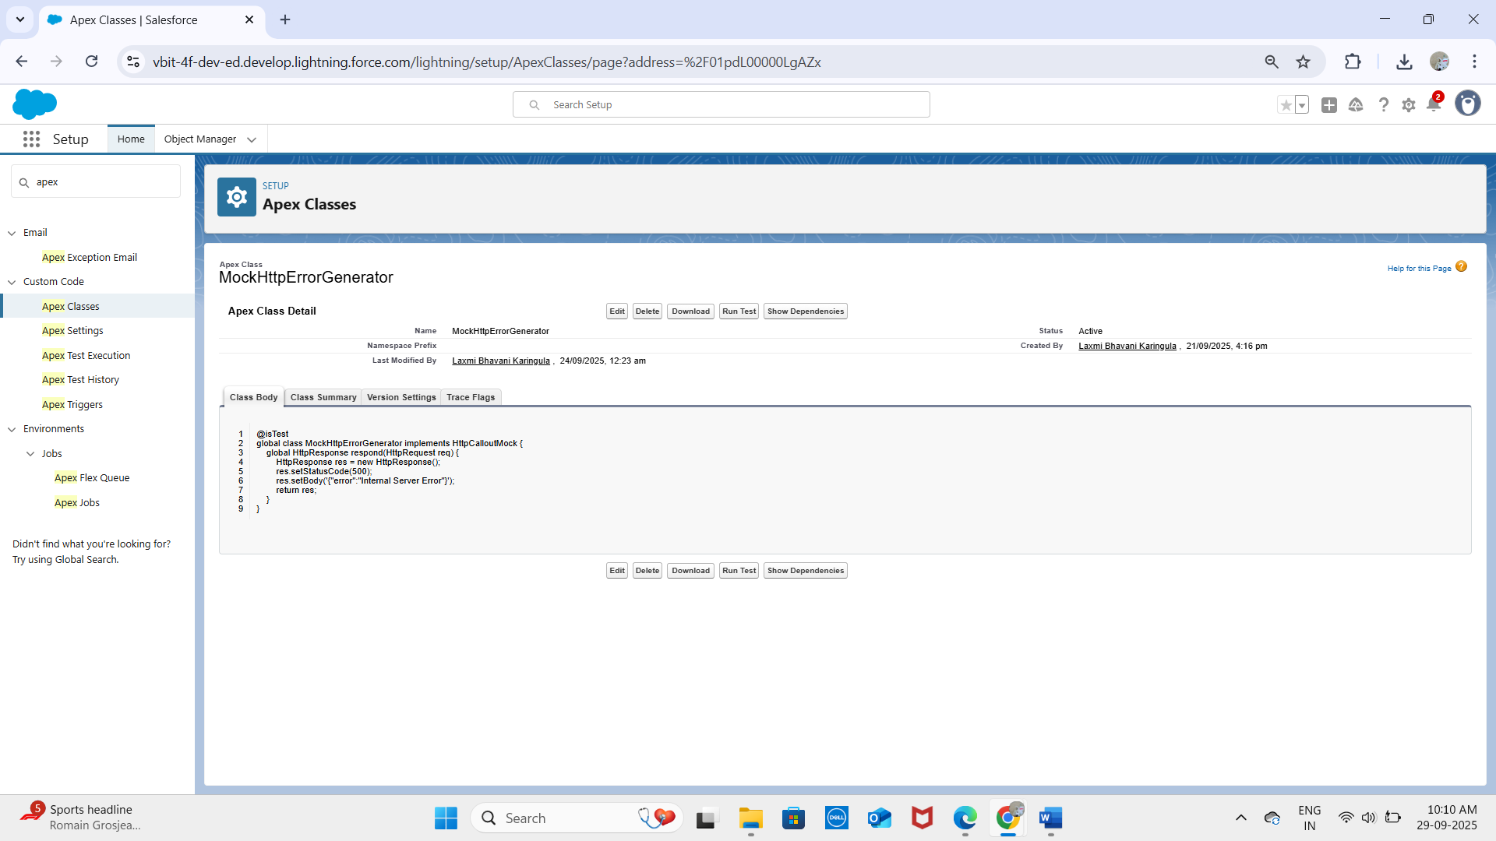

**MockHttpResponseGenerator:**

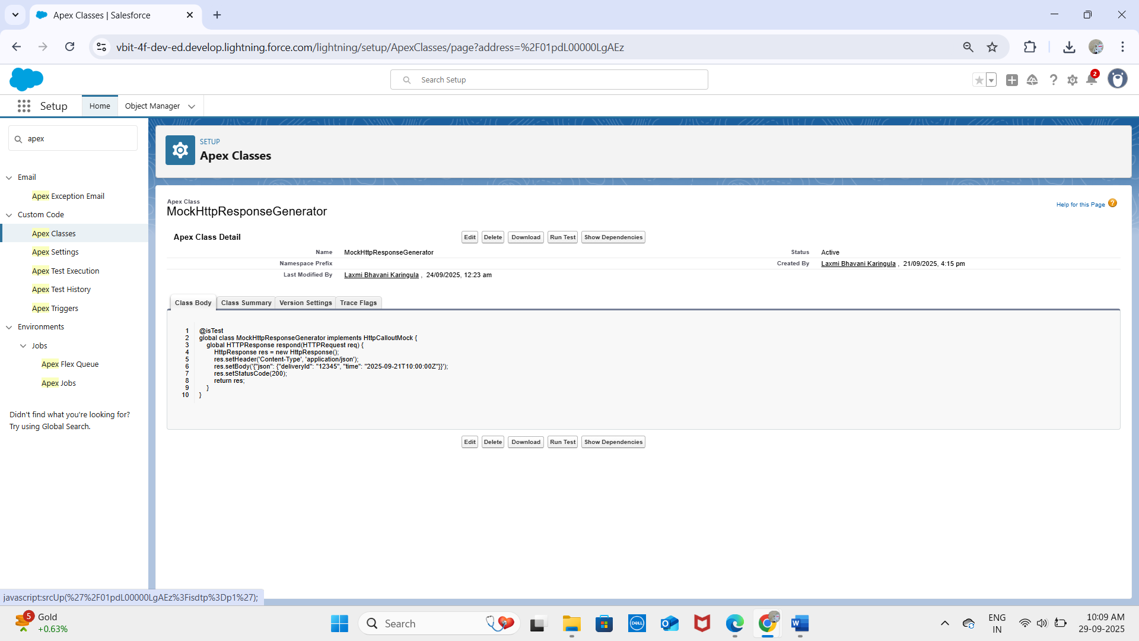

## 2. Apex Triggers

Triggers automate processes when records are inserted, updated, or deleted.  
Example – Prevent Duplicate Delivery Numbers

trigger DeliveryTrigger on Delivery__c (before insert, before update) {  
 for (Delivery__c d : Trigger.new) {  
 Boolean exists = [  
 SELECT Id FROM Delivery__c   
 WHERE Delivery_Number__c = :d.Delivery_Number__c   
 AND Id != :d.Id  
 LIMIT 1  
 ] != null;  
 if (exists) {  
 d.addError('This Delivery Number already exists.');  
 }  
 }  
}

## 3. Trigger Design Pattern

Best practice is to move logic into a handler class to keep triggers clean.

trigger DeliveryTrigger on Delivery__c (before insert, before update) {  
 DeliveryHandler.beforeSave(Trigger.new, Trigger.oldMap);  
}  
  
public class DeliveryHandler {  
 public static void beforeSave(List<Delivery__c> newList, Map<Id, Delivery__c> oldMap) {  
 // custom validation logic here  
 }  
}

## 4. SOQL & SOSL

SOQL – Query Deliveries by Status

List<Delivery__c> deliveries = [SELECT Id, Delivery_Status__c FROM Delivery__c WHERE Delivery_Status__c = 'Pending'];  
SOSL – Search Across Customers and OrdersList<List<SObject>> results =   
 [FIND 'Kavya*' IN ALL FIELDS   
 RETURNING Customer__c(Id, Name), Order__c(Id, Status__c)];

## 5. Collections (List, Set, Map)

List<String> orderIds = new List<String>();  
Set<Id> customerIds = new Set<Id>();  
Map<Id, Order__c> orderMap = new Map<Id, Order__c>([SELECT Id, Status__c FROM Order__c]);

## 6. Control Statements

for (Order__c o : [SELECT Id, Status__c FROM Order__c]) {  
 if (o.Status__c == 'Pending') {  
 o.Status__c = 'Completed';  
 }  
}

## 7. Batch Apex

For large data processing (e.g., updating multiple deliveries).

global class UpdateDeliveryBatch implements Database.Batchable<SObject> {  
 global Database.QueryLocator start(Database.BatchableContext bc) {  
 return Database.getQueryLocator('SELECT Id, Delivery_Status__c FROM Delivery__c');  
 }  
 global void execute(Database.BatchableContext bc, List<Delivery__c> scope) {  
 for (Delivery__c d : scope) {  
 d.Delivery_Status__c = 'Archived';  
 }  
 update scope;  
 }  
 global void finish(Database.BatchableContext bc) {}  
}

## 8. Queueable Apex

public class NotifyCustomerJob implements Queueable {  
 public void execute(QueueableContext context) {  
 // send email/notification about delivery update  
 }  
}

## 9. Scheduled Apex

global class DailyDeliveryReminder implements Schedulable {  
 global void execute(SchedulableContext sc) {  
 // send daily reminders for pending deliveries  
 }  
}

## 10. Future Methods

public class PaymentGateway {  
 @future(callout=true)  
 public static void processPayment(Id paymentId) {  
 // external API call for payment processing  
 }  
}

## 11. Exception Handling

try {  
 // risky logic  
} catch (Exception e) {  
 System.debug('Error: ' + e.getMessage());  
}

## 12. Test Classes

All Apex logic must be covered by test classes before deployment.

@isTest  
private class DeliveryTriggerTest {  
 @isTest static void testDuplicateDeliveryNumber() {  
 // insert deliveries and check addError  
 }  
}

## 13. Asynchronous Processing

Future → async callouts.  
  
Batch → large dataset processing (Deliveries, Orders).  
  
Queueable → notifications & chained jobs.  
  
Scheduled → reminders & daily updates.