**PHASE 7 – Integration & External Access**

In this phase, the focus is on integrating Salesforce with external systems and services for data exchange, automation, and real-time updates. Integration ensures that the Delivery, Orders, Customer, and Loyalty modules can communicate with other applications securely and efficiently.

**1. Named Credentials**

* Named Credentials provide a secure way to store authentication details for external systems.
* Avoids hardcoding usernames, passwords, or tokens in Apex.
* 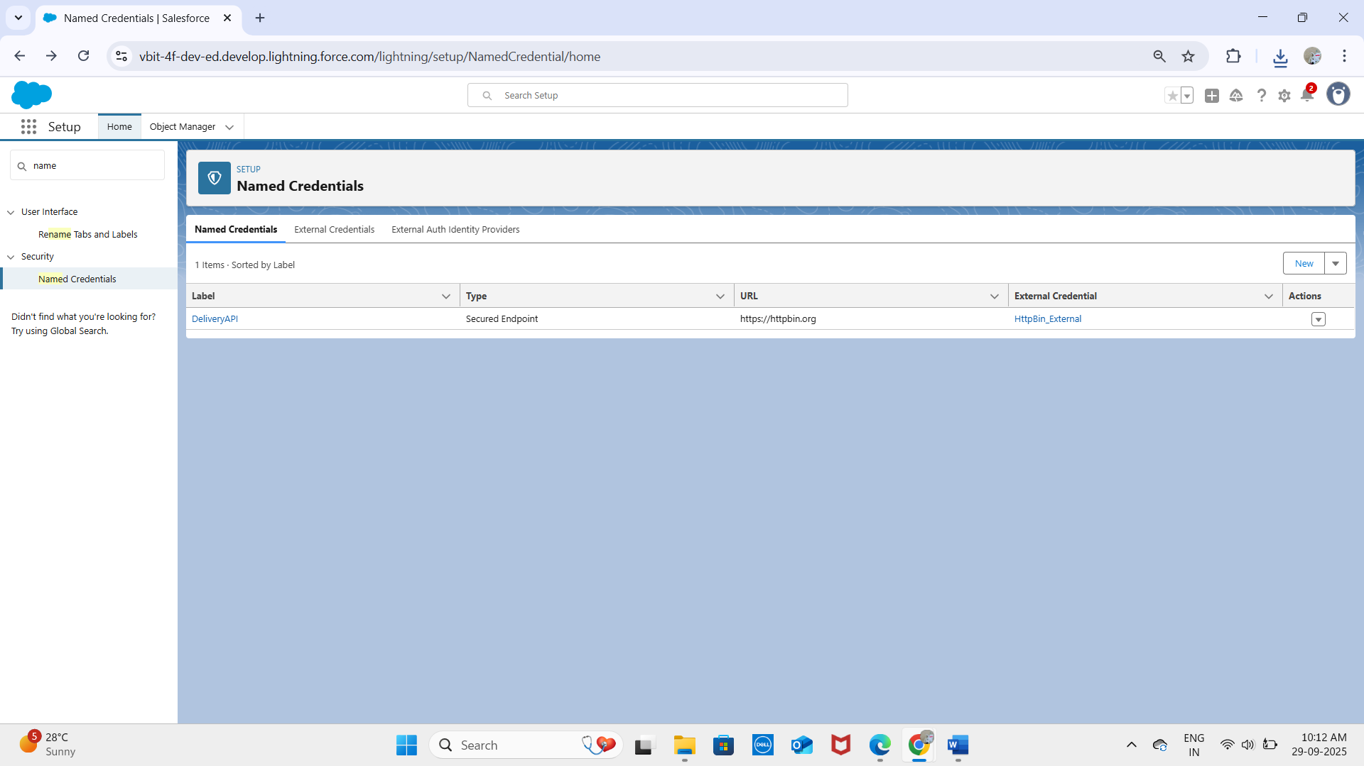
* 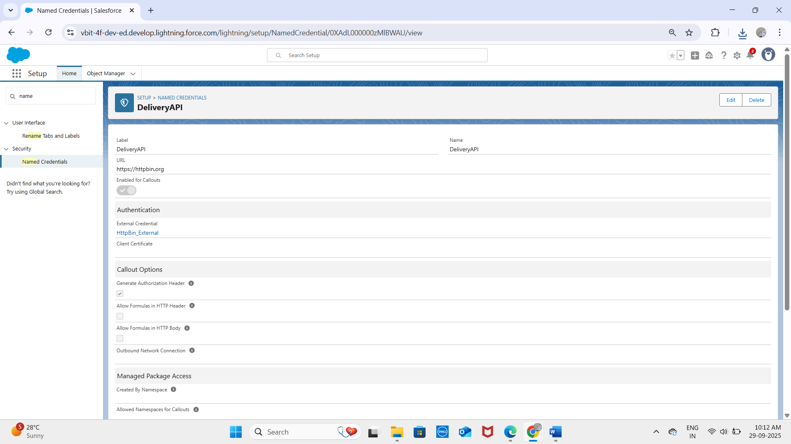

**2. External Services**

* Allows Salesforce to connect to APIs declaratively without heavy coding.
* Import API specifications (OpenAPI/Swagger) to automatically generate Apex actions.
* Example: Integrating a Delivery Tracking API to update delivery status in real-time.
* 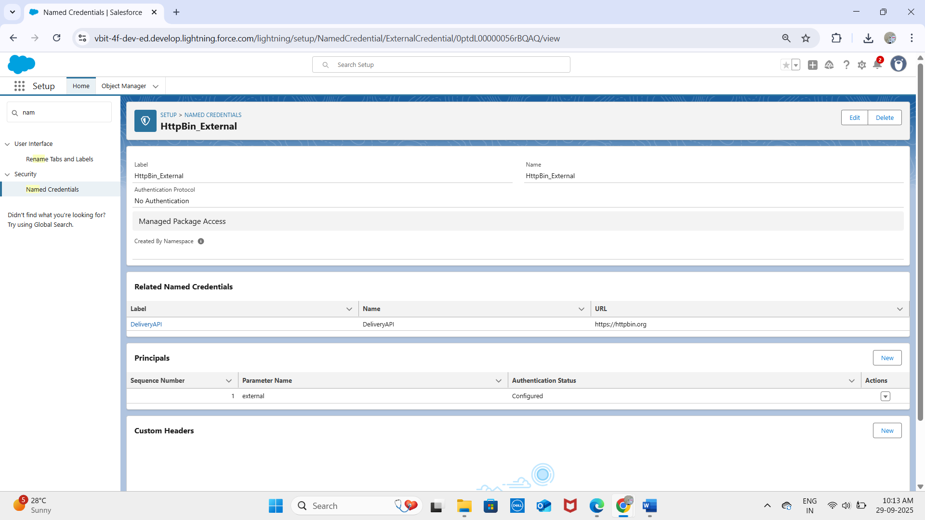

**3. Web Services (REST/SOAP)**

* REST API: JSON-based, used for modern, lightweight integrations.
* SOAP API: XML-based, suitable for enterprise or legacy system integrations.
* Enables external systems to read, update, or delete Salesforce records.
* Example: External ERP system updates Order__c records in Salesforce.

**4. Callouts**

* Outbound requests made from Salesforce to external systems via REST or SOAP.
* Requires Remote Site Settings or Named Credentials for security.
* Example: Sending Order details to an external delivery partner API for fulfillment.

**5. Platform Events**

* Supports event-driven communication within Salesforce or with external systems.
* Works using publish/subscribe model for real-time notifications.

Example: Publish a Delivery Completed Event when a delivery is done, triggering loyalty points updates in external systems.

**6. Change Data Capture (CDC)**

* Allows external systems to receive real-time notifications for record changes (create, update, delete, undelete).
* Useful for synchronizing Customer, Order, and Delivery data between Salesforce and external apps without frequent polling.

**7. Salesforce Connect**

* Enables Salesforce to access external data without importing it.
* Uses External Objects to display external records in real time.
* Example: Show Inventory Data from an external warehouse system in Salesforce Delivery records.

**8. API Limits**

* Salesforce enforces limits on API calls to ensure performance.
* Limits vary by edition and license type.
* Best practices: Use bulk APIs, caching, and event-driven integration for efficiency.

**9. OAuth & Authentication**

* OAuth is used for secure API authentication.
* Supports Single Sign-On (SSO) and secure external integrations.
* Example: A third-party logistics system accesses Salesforce data via OAuth tokens without exposing user passwords.

**10. Remote Site Settings**

**ApexdevNEt:**

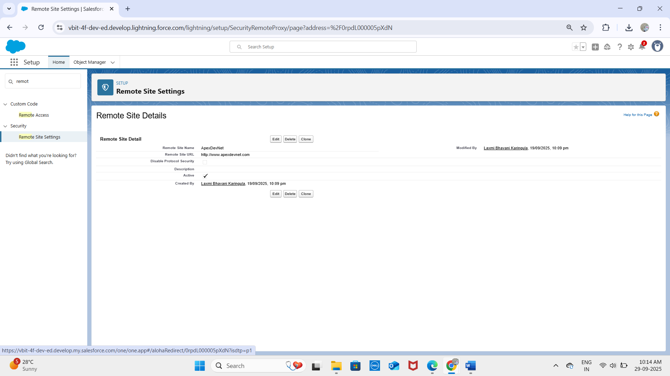

**HttpBin:**

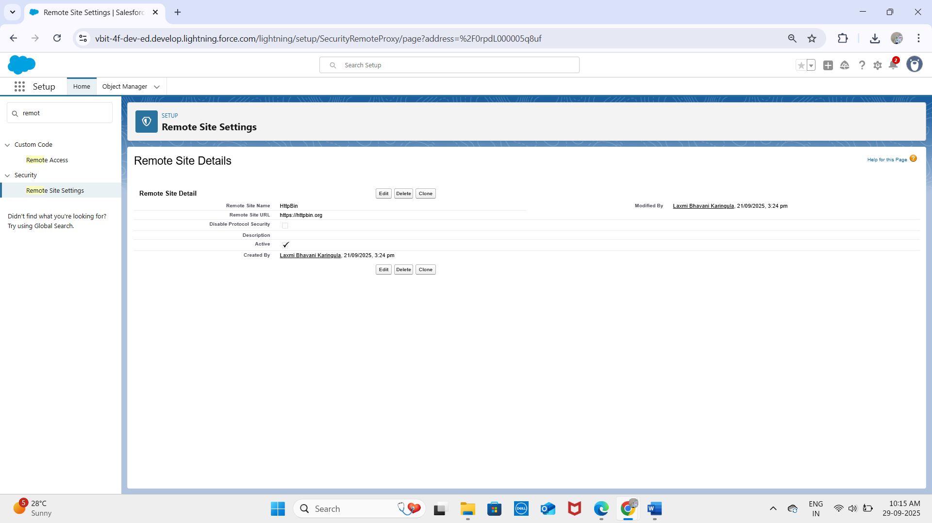

* Define which external endpoints Salesforce is allowed to access.
* Required for HTTP callouts from Apex unless Named Credentials are used.
* Enhances security by preventing unauthorized external connections.

**✅ Outcome:**  
With Phase 7 complete, the project now supports:

* Secure integration with payment gateways, delivery partners, and external systems.
* Real-time synchronization of Customer, Order, and Delivery data.
* Event-driven notifications for loyalty point updates.
* Scalable, secure, and maintainable external connections using Named Credentials, OAuth, and Remote Site Settings.