# Phase 2: Salesforce Org Setup & Configuration

## 1. Salesforce Edition

We selected a Developer Edition Org for this project. It provides standard CRM features along with Apex, Lightning, Flows, APIs, and AppExchange access. The Developer Org was chosen because it is free, permanent, and supports all features required for delivery orchestration (objects, automation, integrations).

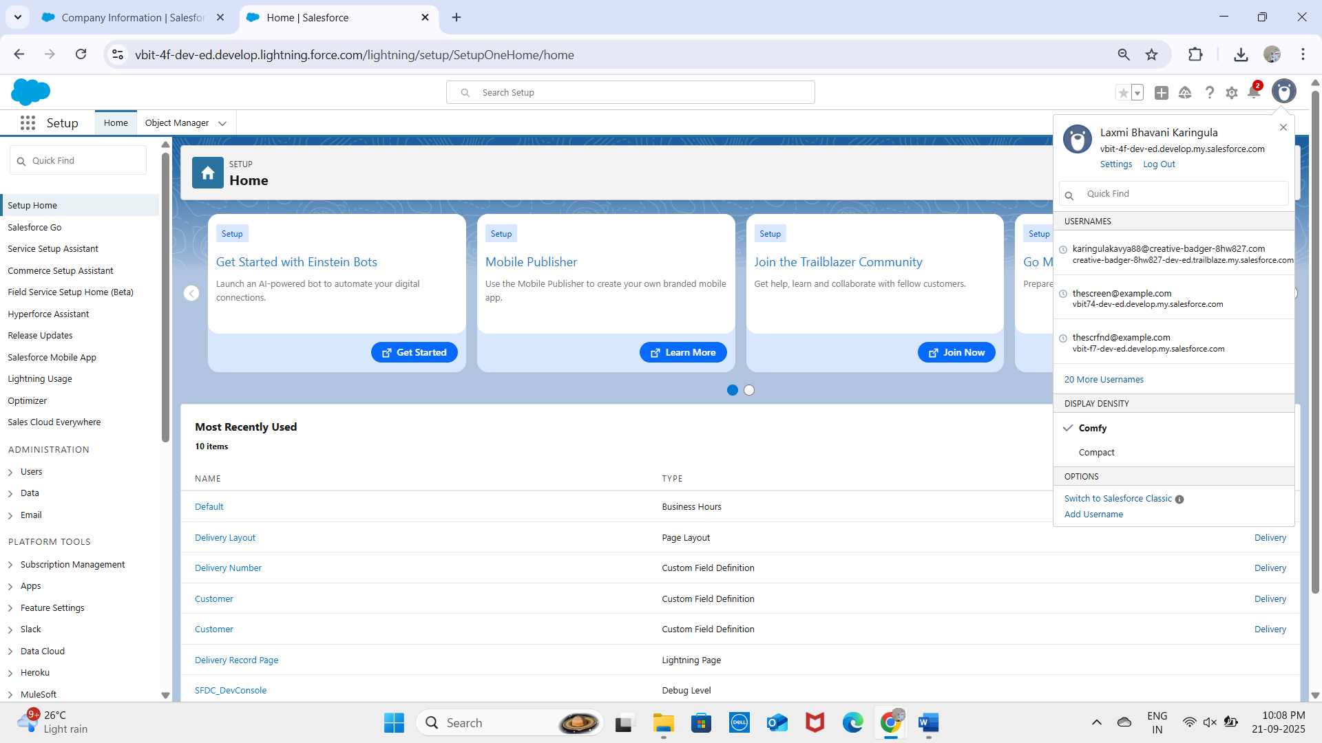

## 2. Company Profile Setup

Configured under Setup → Company Settings → Company Information.  
- Organization Name: vbit.  
- Time Zone: IST (India Standard Time).  
- Default Currency: INR.  
- Default Language: English.  
These settings ensure delivery schedules, SLA tracking, and reporting align with the region and business hours.

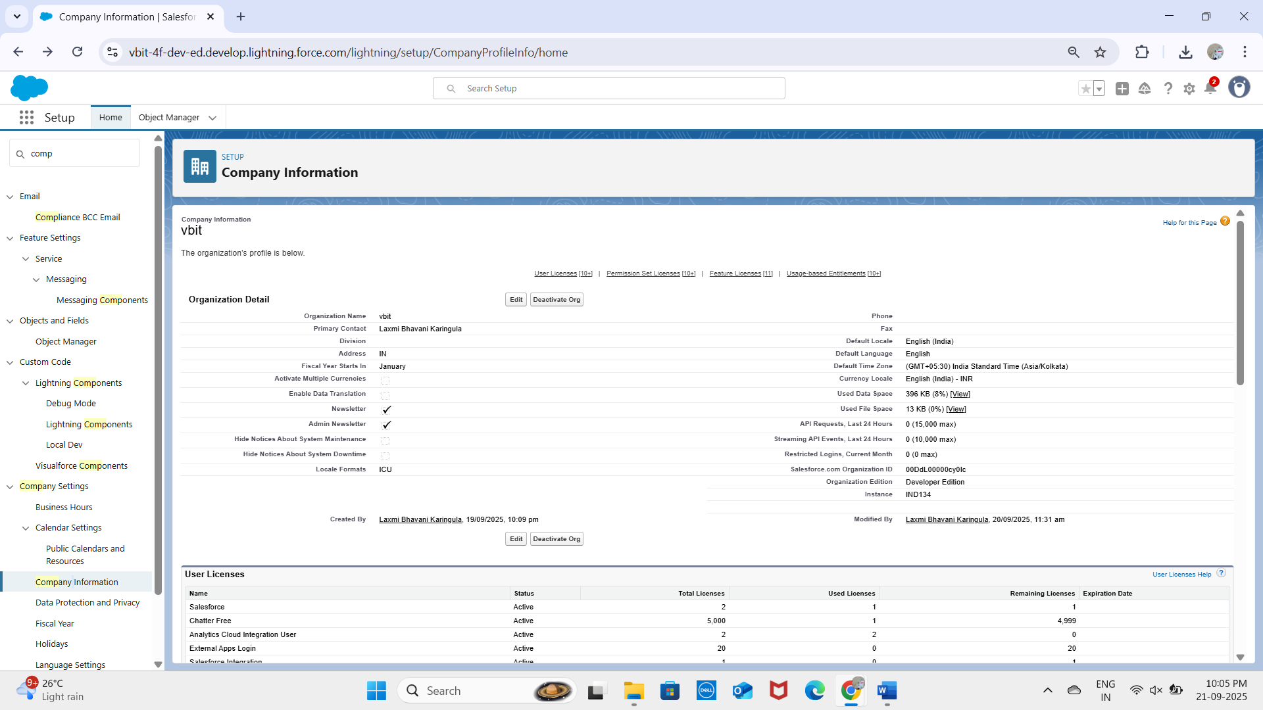

## 3. Business Hours & Holidays

Business hours defined as 9 AM – 9 PM, Monday to Saturday.  
Public holidays added to avoid scheduling deliveries on those dates.  
Ensures realistic planning for delivery agents and avoids assigning deliveries outside working hours.

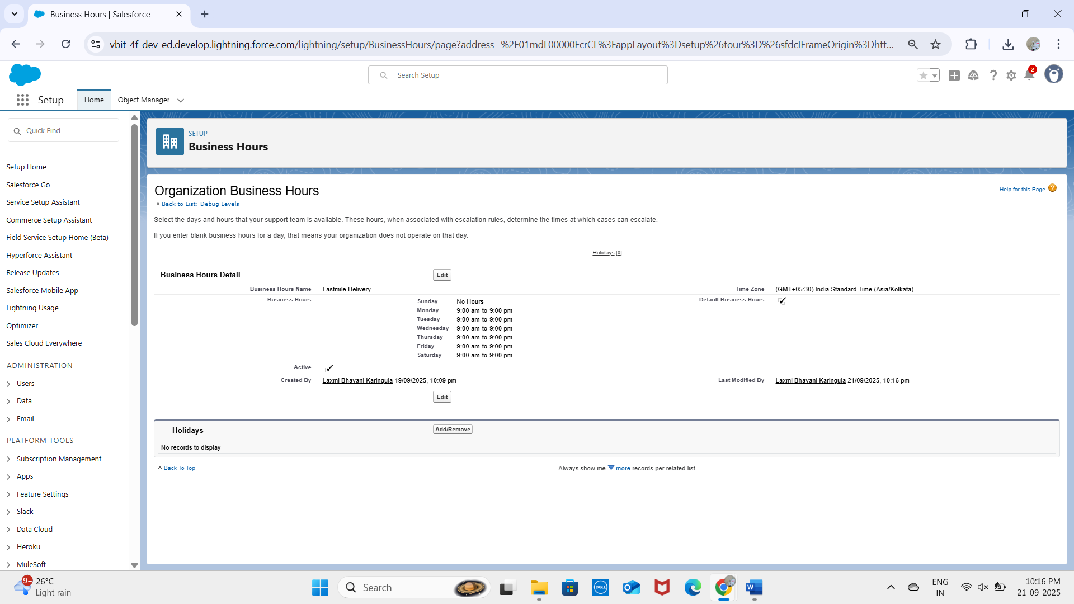

## 4. Fiscal Year Settings

## We enabled the Standard Fiscal Year (January–December). This allows consistent tracking of delivery SLAs, agent performance, and customer satisfaction metrics across quarterly and yearly reports. No custom fiscal year was required for logistics reporting.

## 5. User Setup & Licenses

## Admin User created with System Administrator license.

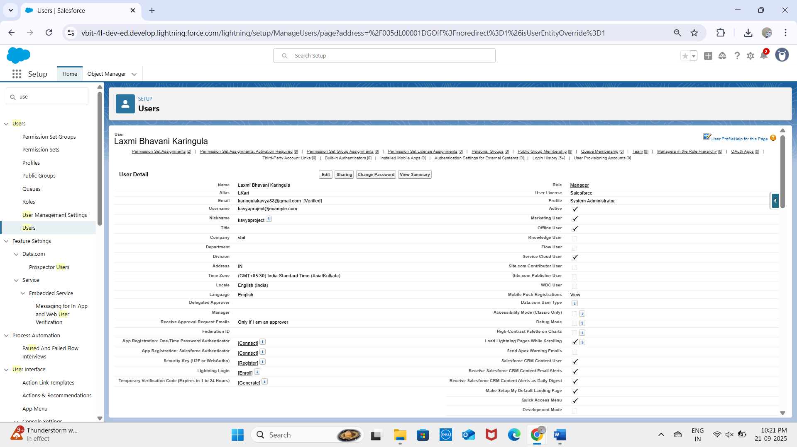

* **Integration User**

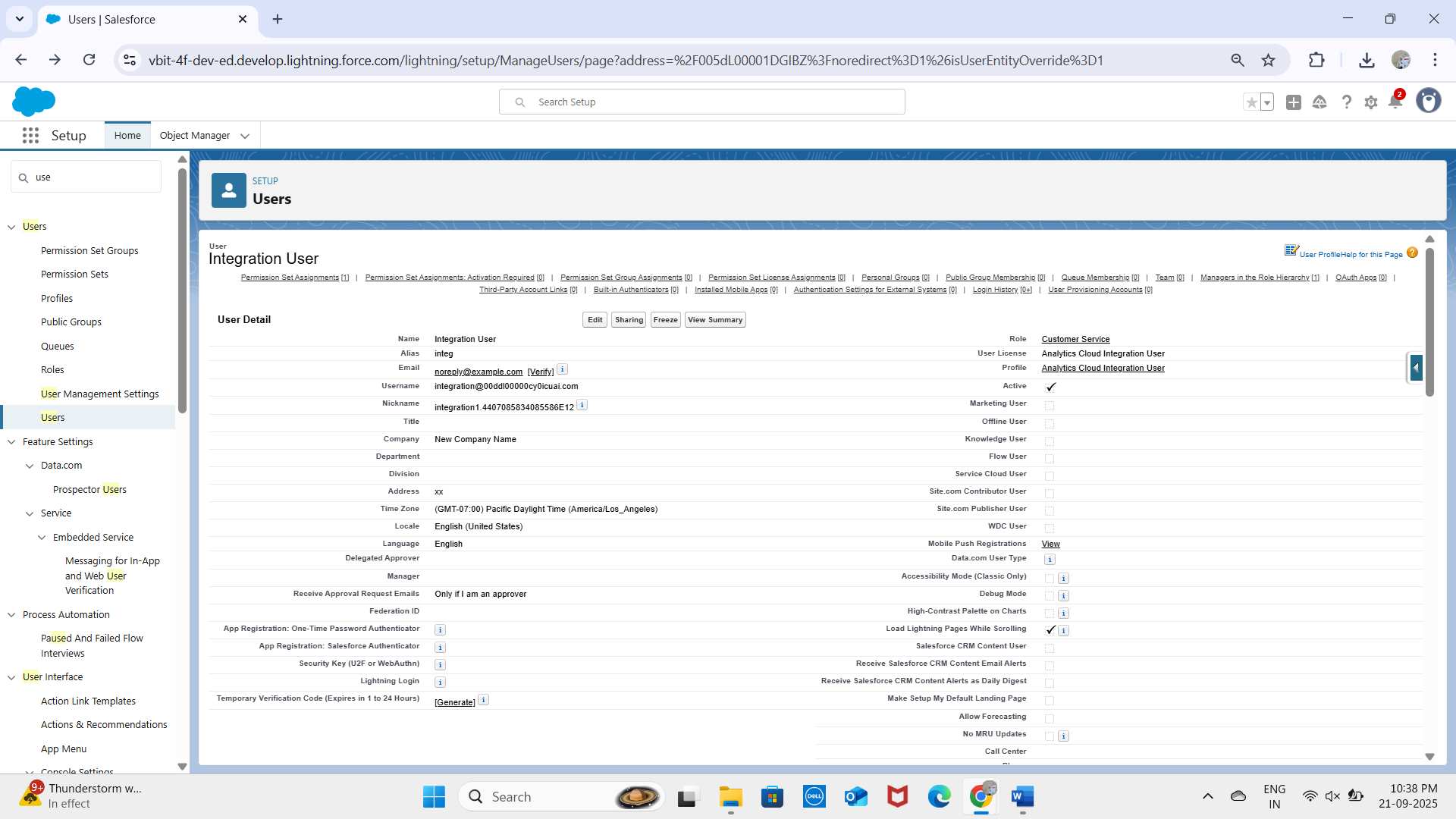

* **Security User**

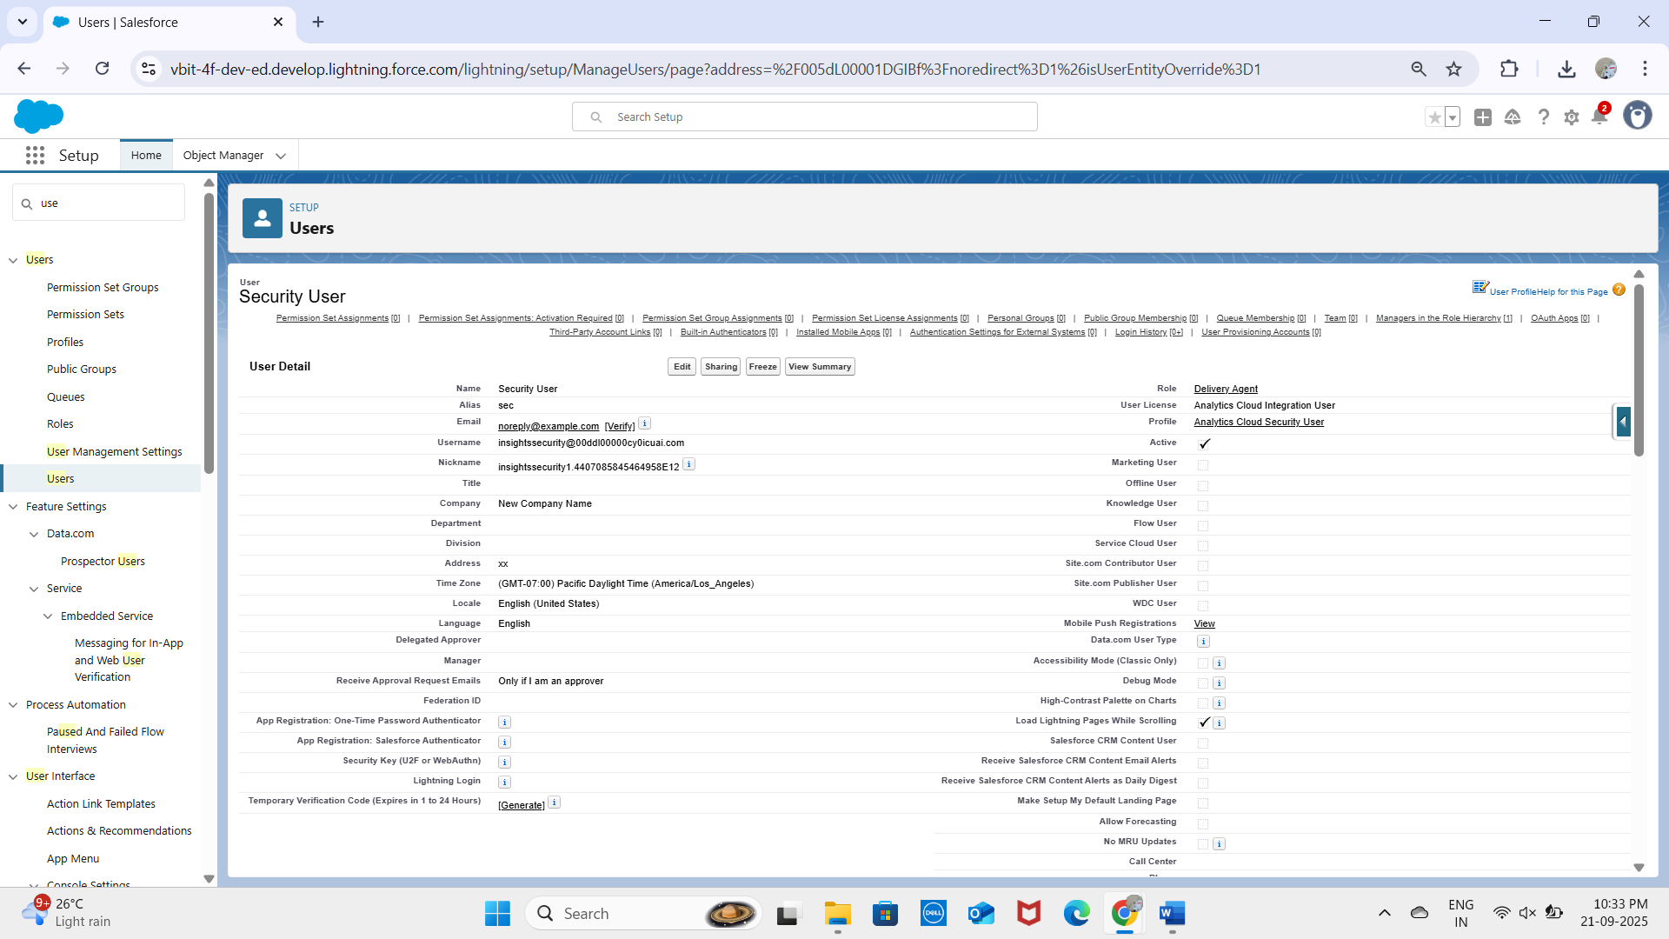  
  
- All users verified via email, login tested successfully.

## 6. Profiles

* **Admin Profile** – full access.
* **Manager Profile** – can oversee all deliveries, assign agents.
* **Customer Sales Profile** – can view and manage exceptions, notify customers.

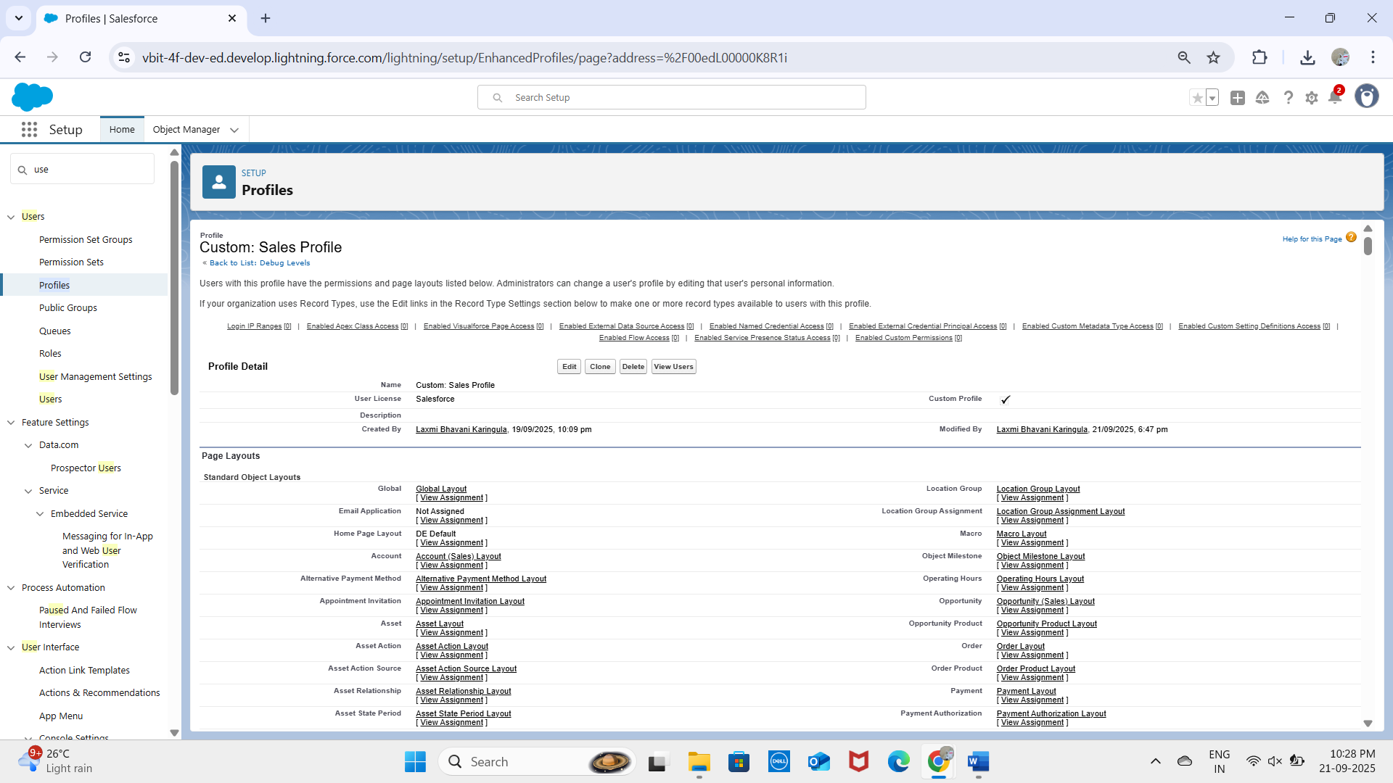

* **Delivery Agent Profile** – restricted to update only their assigned deliveries and mark status.
* **B2B Reordering Portal Buyer Profile**

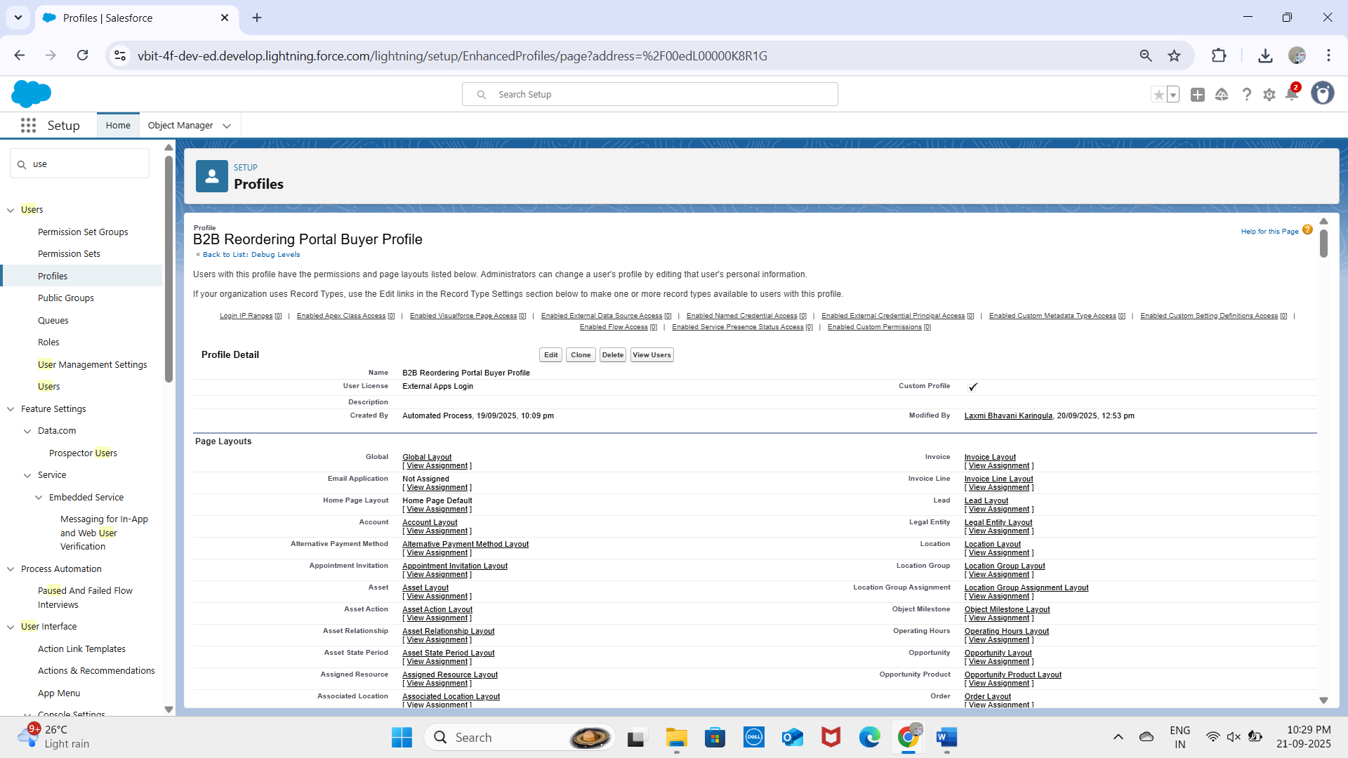

* **Marketing user**

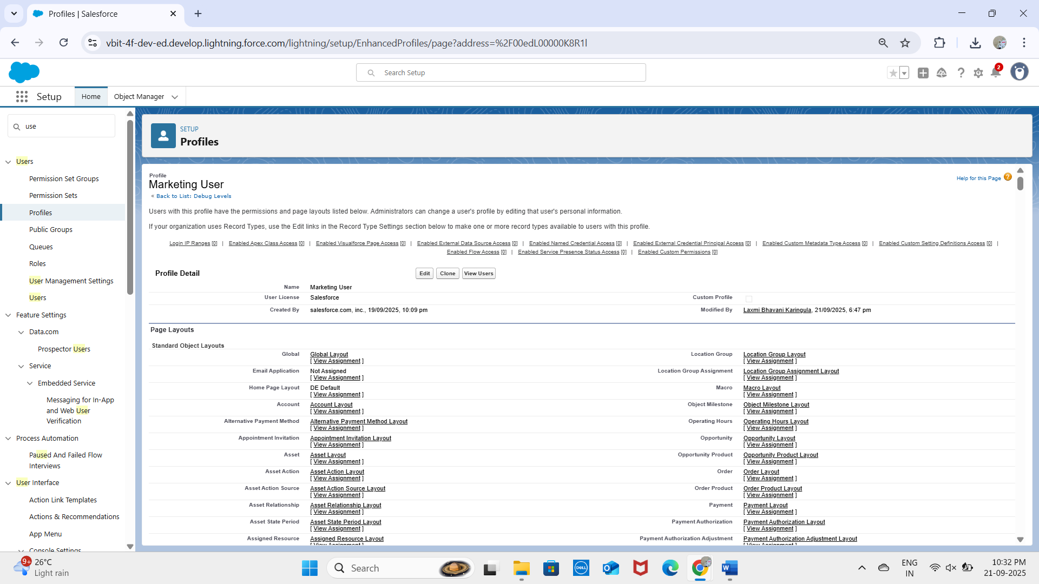

## 7. Roles

A role hierarchy was created:  
- Manager (top)  
 - Customer Service  
 - Delivery Agent  
This ensures visibility flows upwards: Managers see everything, CS can see relevant customer records, and Delivery Agents only see their own records.

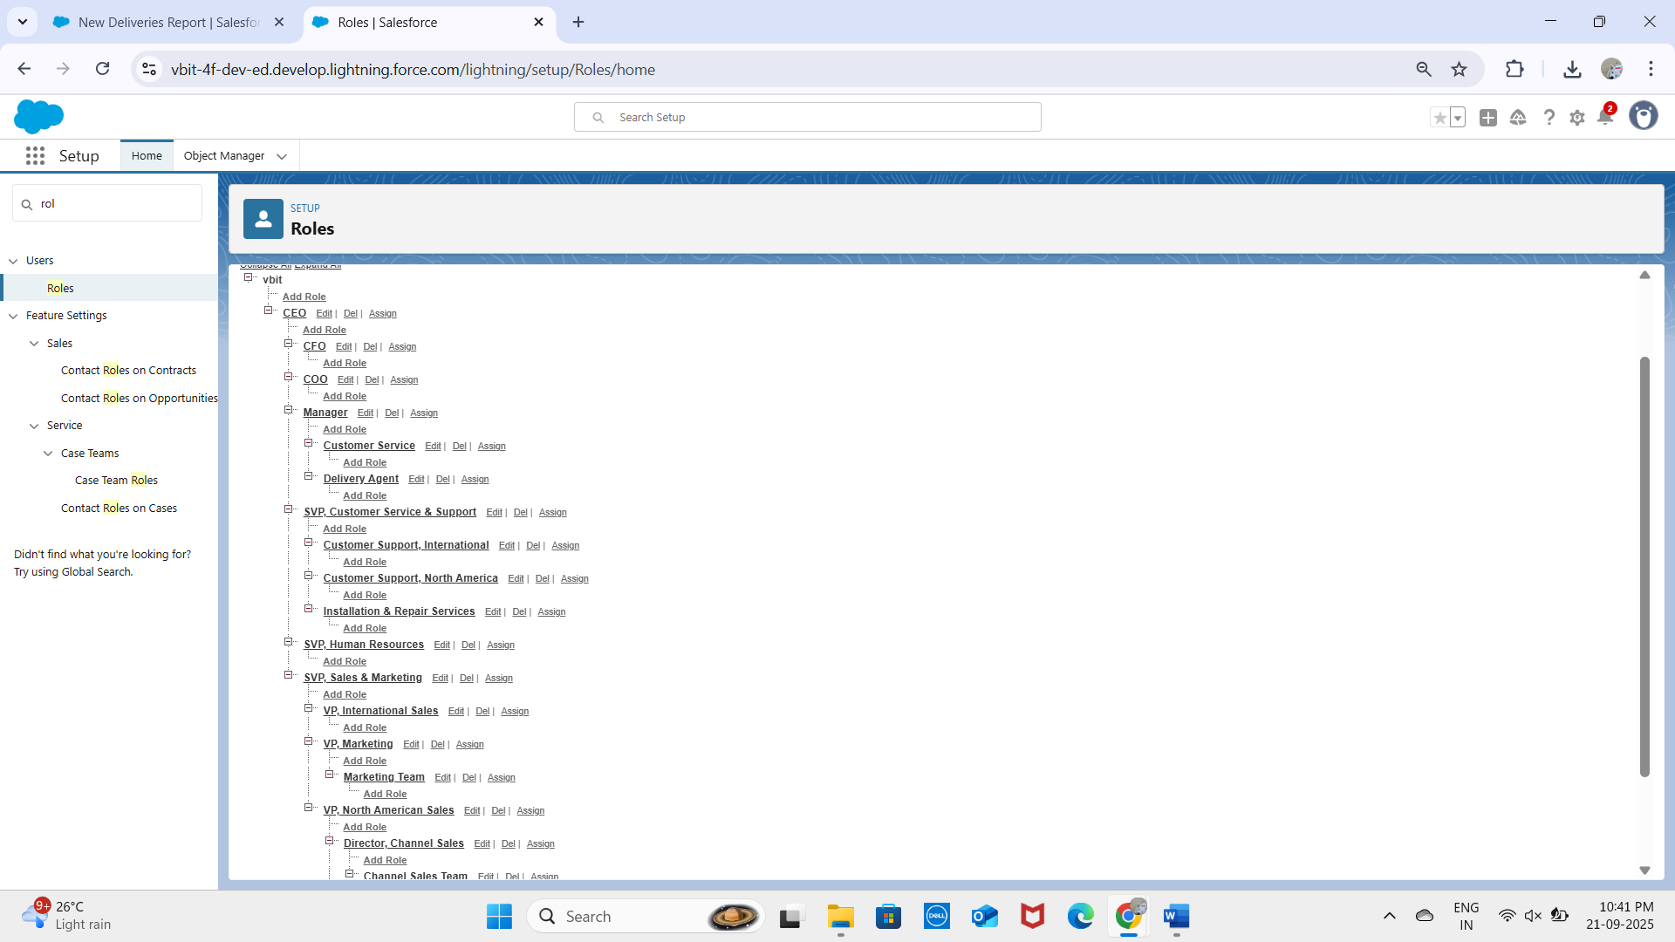

## 8. Permission Sets

Created a permission set 'DeliveryEstimationPermissionSet’to allow agents and CS staff to view dashboards without modifying profiles.  
Flexible extra access for testing integrations without changing role-based security.

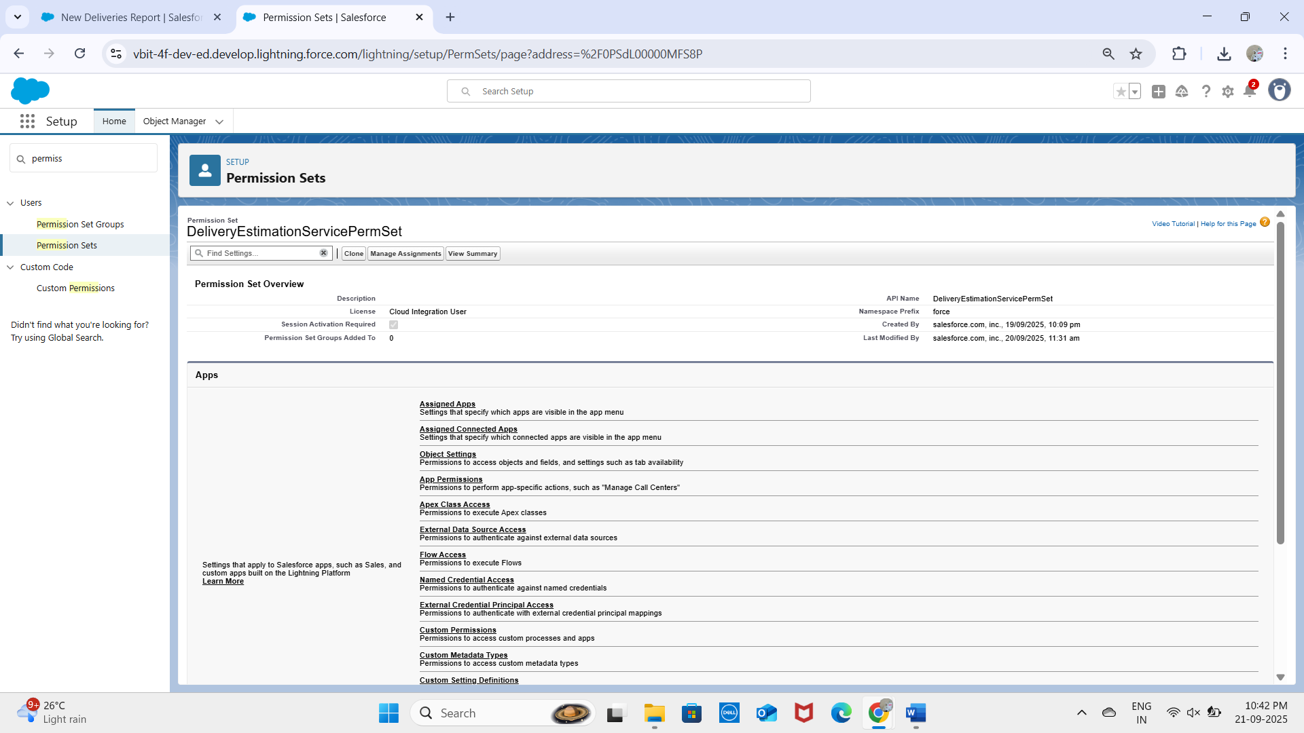

Created HttpBin_Access permission set

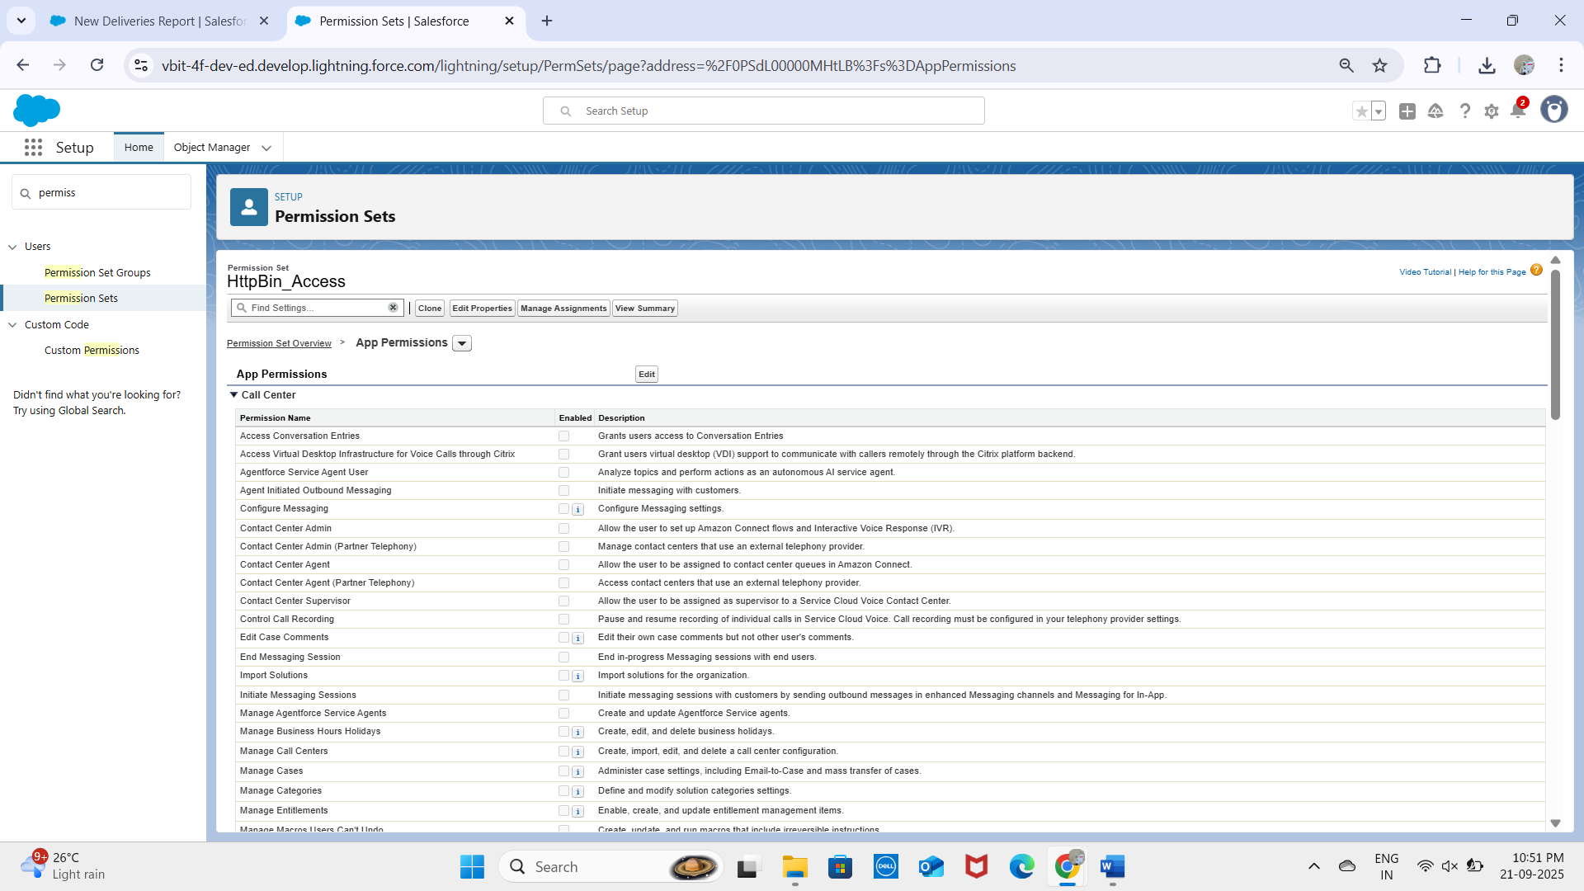

## 9. Organization-Wide Defaults (OWD)

- Delivery__c – Private (only assigned agent + manager can access).  
- Route__c – Public Read Only (visible for planning).  
- Delivery_Exception__c – Private (only agent and manager can view).  
- Notifications__c – Public Read/Write (since system-generated alerts may need to be visible org-wide).

## 10. Sharing Rules

Delivery__c records shared with Managers for oversight.  
Exceptions shared with Customer Service role for handling failed deliveries.  
This setup ensures operational transparency while maintaining data security.

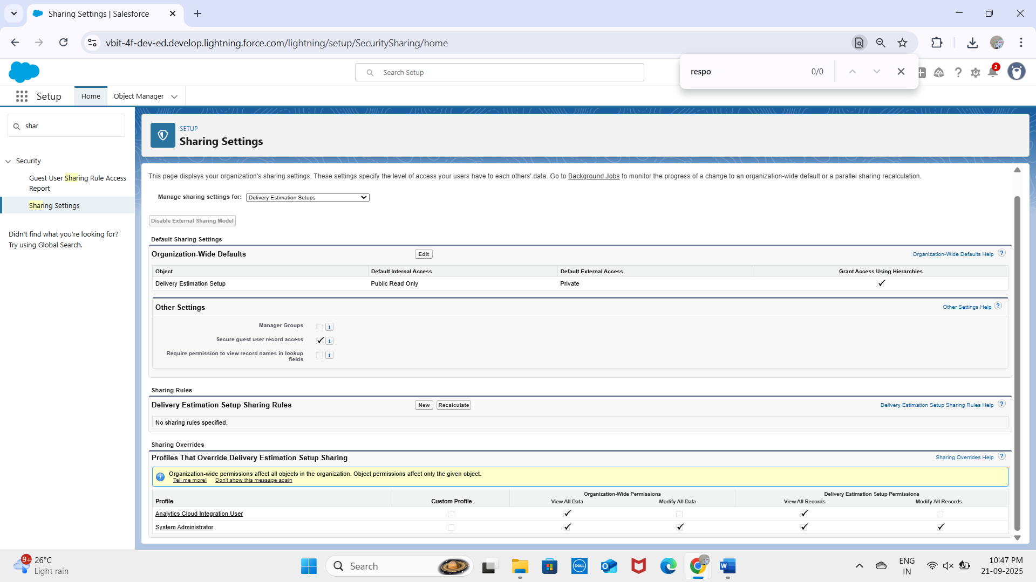

## 11. Login Access Policies

- Delivery Agents: login restricted to 8 AM – 10 PM.  
- Managers & CS: unrestricted login.  
- Two-Factor Authentication (2FA) enabled for all profiles.  
Ensures system security while allowing flexible access.

## 12. Deployment Basics

Custom objects created and deployed:  
- Delivery__c – core object for tracking packages.  
- Route__c – stores route and address details.  
- Delivery_Exception__c – logs exceptions (delays, failures).  
- Notifications__c – tracks customer notifications.

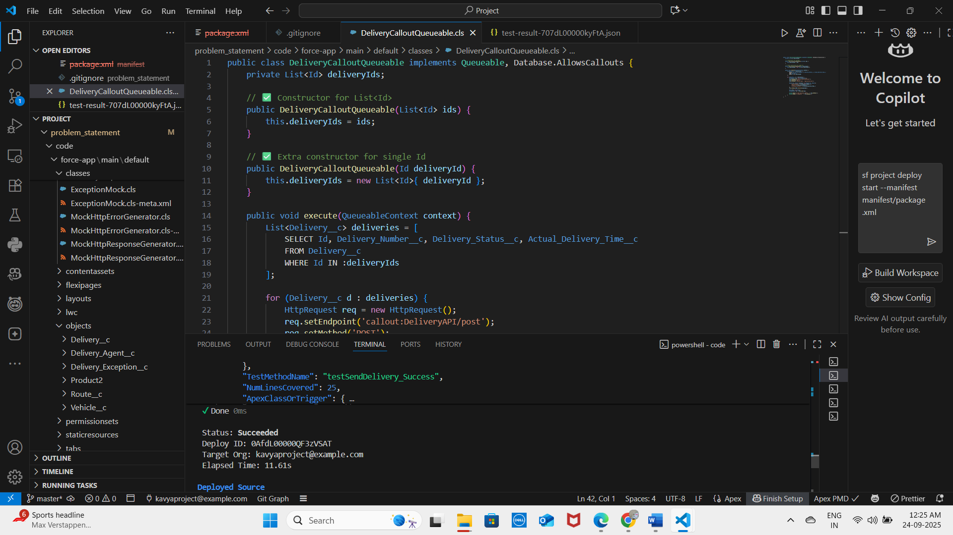  
Deployment options prepared using Change Sets and SFDX (VS Code).  
Both were tested to confirm successful migration of metadata.

✅ This completed the Salesforce Org Setup & Configuration for the Last-Mile Delivery Orchestration system.