**PHASE 9 – Reporting, Dashboards & Security Review**

Phase 9 focuses on designing reports and dashboards for insights, and ensuring security measures are properly implemented for the Delivery, Orders, Customer, and Loyalty modules.

**1. Reports (Tabular, Summary, Matrix, Joined)**

* Tabular Reports → Simple list of records (like an Excel sheet). Best for tasks like mailing lists.
* Summary Reports → Grouped by rows with subtotals (e.g., sales by region).
* Matrix Reports → Grouped by rows and columns; best for comparing data in two dimensions (e.g., sales by product vs. region).
* Joined Reports → Combine multiple report blocks with different objects into a single view. Useful for comparing related datasets.

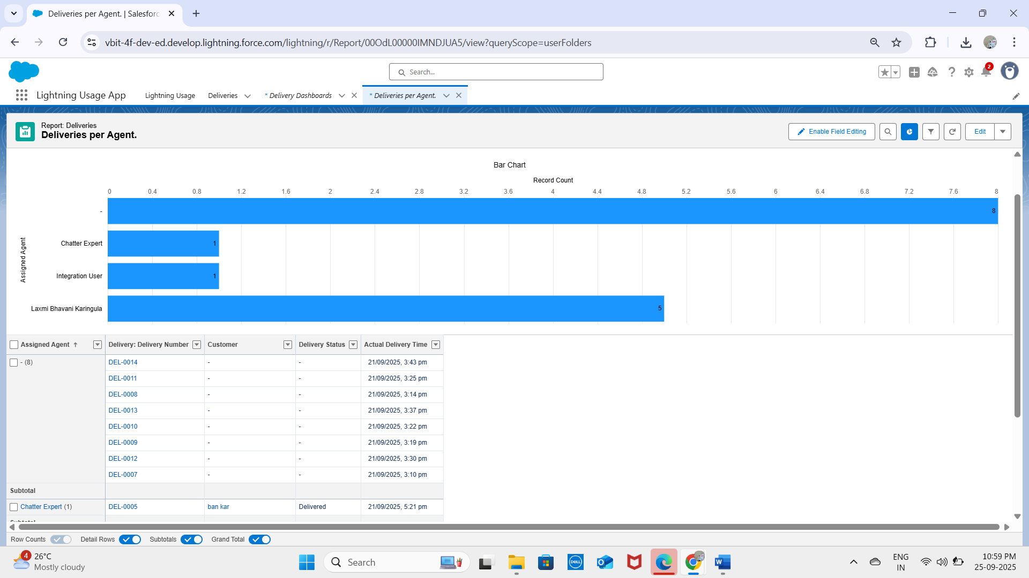

**2. Report Types**

* Standard Report Types → Auto-created by Salesforce for common relationships (e.g., Accounts with Contacts).
* Custom Report Types → Created by admins for specific reporting needs, including custom objects and complex relationships.

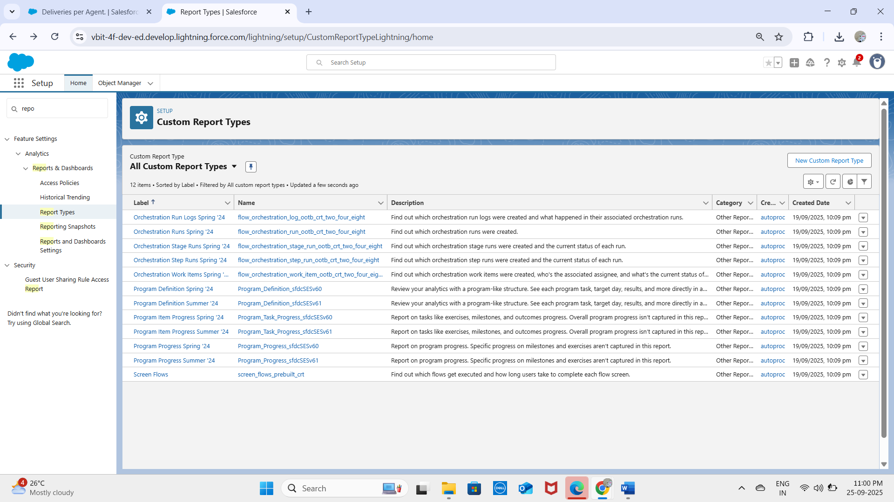

**3. Dashboards**

* Dashboards are visual representations of report data.
* Components include charts, tables, gauges, or metrics.
* Example: Dashboard displaying total Deliveries, Orders, and Loyalty Points.

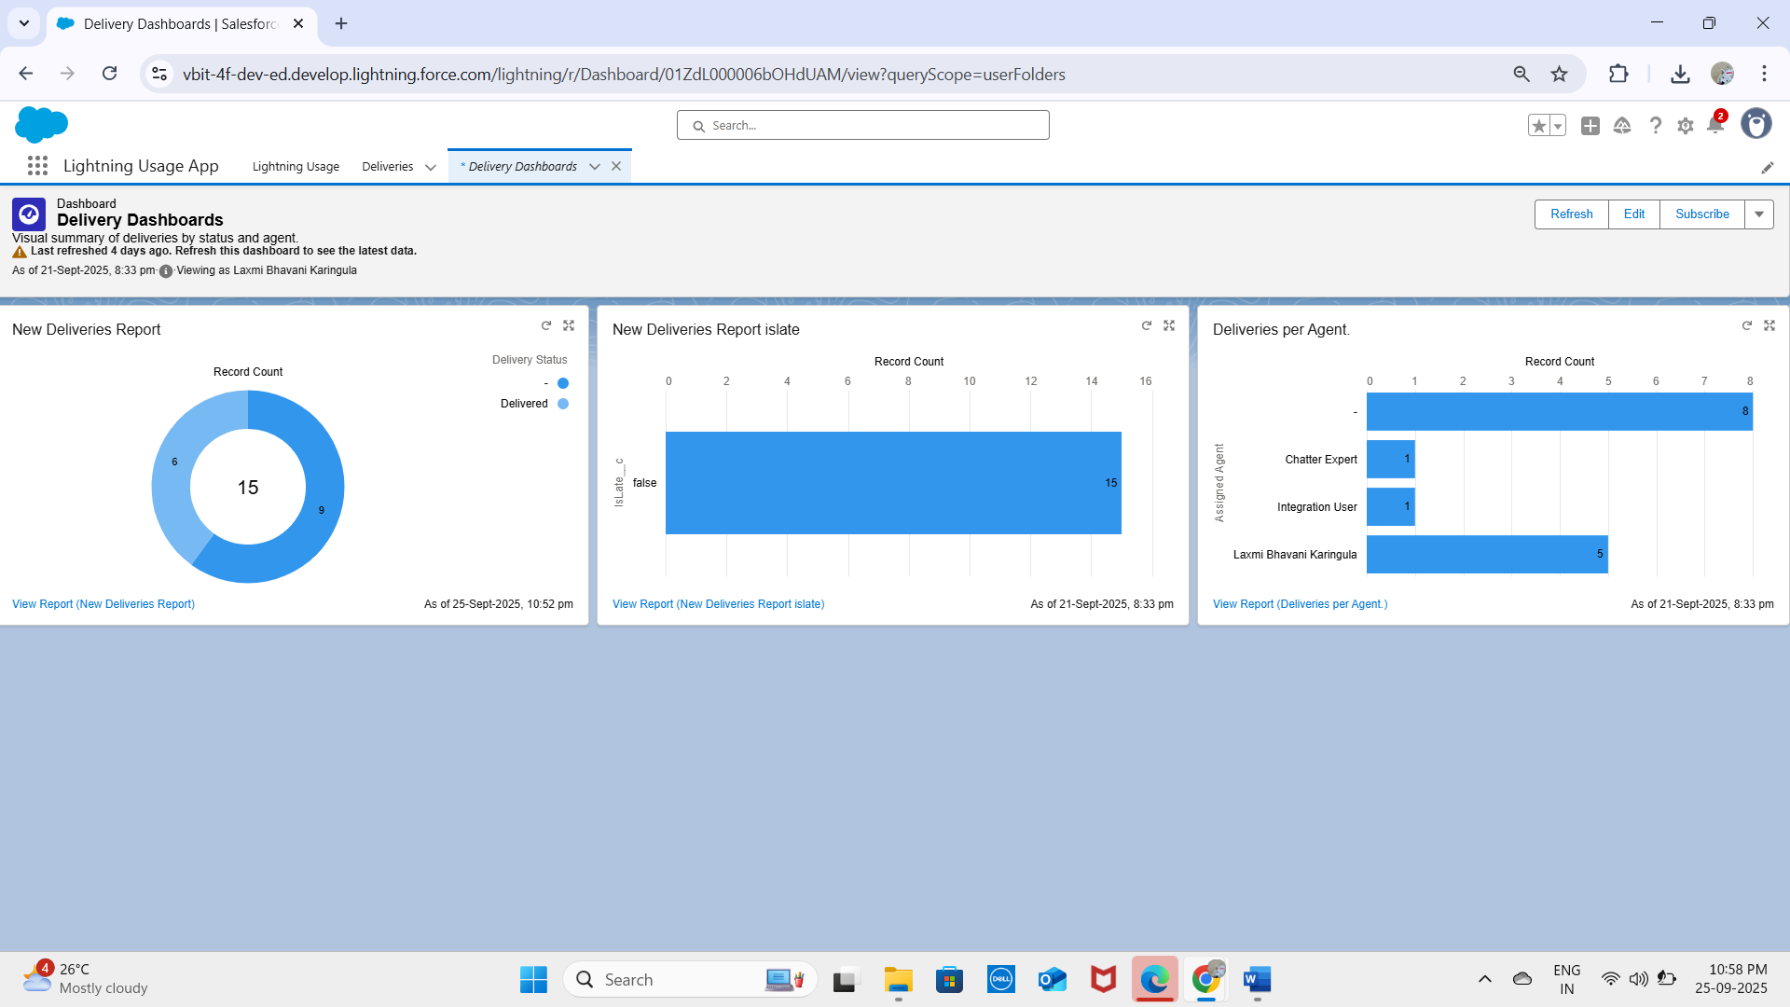

**4. Dynamic Dashboards**

* Allow users to see data based on their own security settings rather than the dashboard creator’s.
* Example: A manager sees only their team’s deliveries, while an operator sees only assigned stations.

**5. Sharing Settings**

* Define default access (Organization-Wide Defaults) and record-level visibility.
* Admins can configure sharing rules for roles, groups, or territories.
* Ensures sensitive data is accessible only to authorized users.

**6. Field Level Security (FLS)**

* Controls access to individual fields on objects.
* Fields can be read-only, hidden, or editable based on profiles/permission sets.
* Protects sensitive information like payment details or customer PII.

**7. Session Settings**

* Define user session duration, multi-factor authentication requirements, and timeout warnings.
* Enhances security while maintaining usability.

**8. Login IP Ranges**

* Restrict logins to specific IP ranges to enhance security.
* Example: Internal users may only log in from corporate office IP addresses.
* Prevents unauthorized access from unknown networks.

**9. Audit Trail**

* Tracks configuration changes in Salesforce.
* Logs who made changes, what was changed, and when.
* Helps in compliance, troubleshooting, and monitoring unauthorized modifications.

**✅ Outcome:**  
With Phase 9 complete, the project ensures:

* Comprehensive reporting for Deliveries, Orders, Customers, and Loyalty Points.
* Dynamic dashboards for role-based data visibility.
* Strong security and monitoring via FLS, session settings, login restrictions, and audit trails.