# PHASE 8 – Data Management & Deployment

Phase 8 focuses on managing Salesforce data efficiently and deploying customizations across environments while maintaining data quality, security, and integrity.

## 1. Data Import Wizard

- Salesforce’s guided tool for importing small to medium datasets (up to 50,000 records).  
- Supports standard objects (Accounts, Contacts, Leads) and custom objects (Delivery__c, Order__c, Loyalty_Program__c).  
- Field mapping ensures proper data alignment.  
- Example: Importing a bulk set of new Customer records or existing loyalty points.

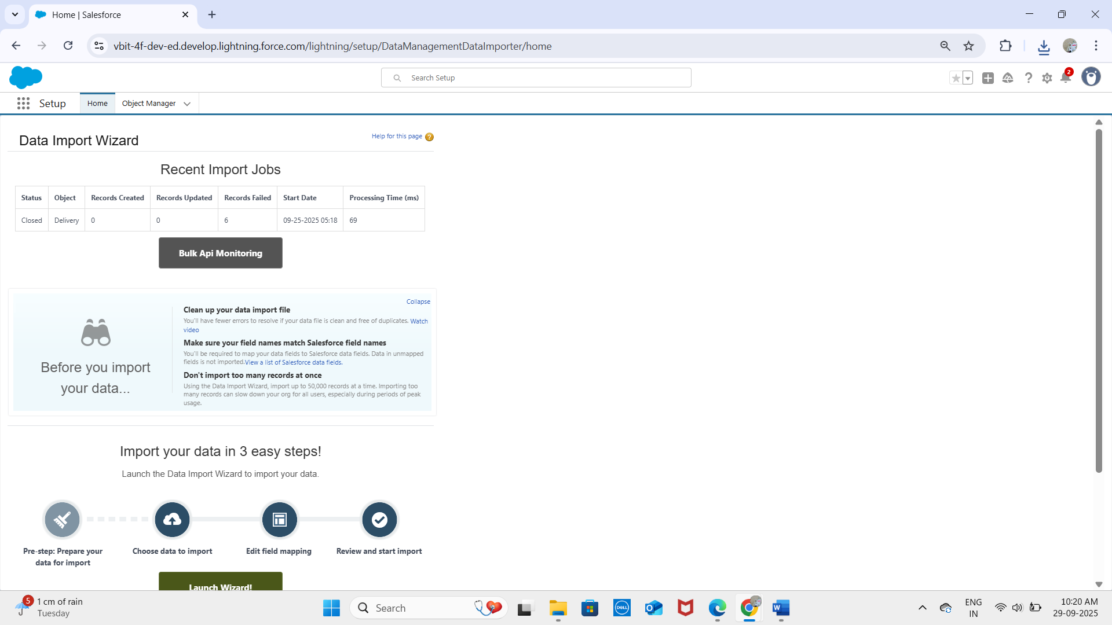

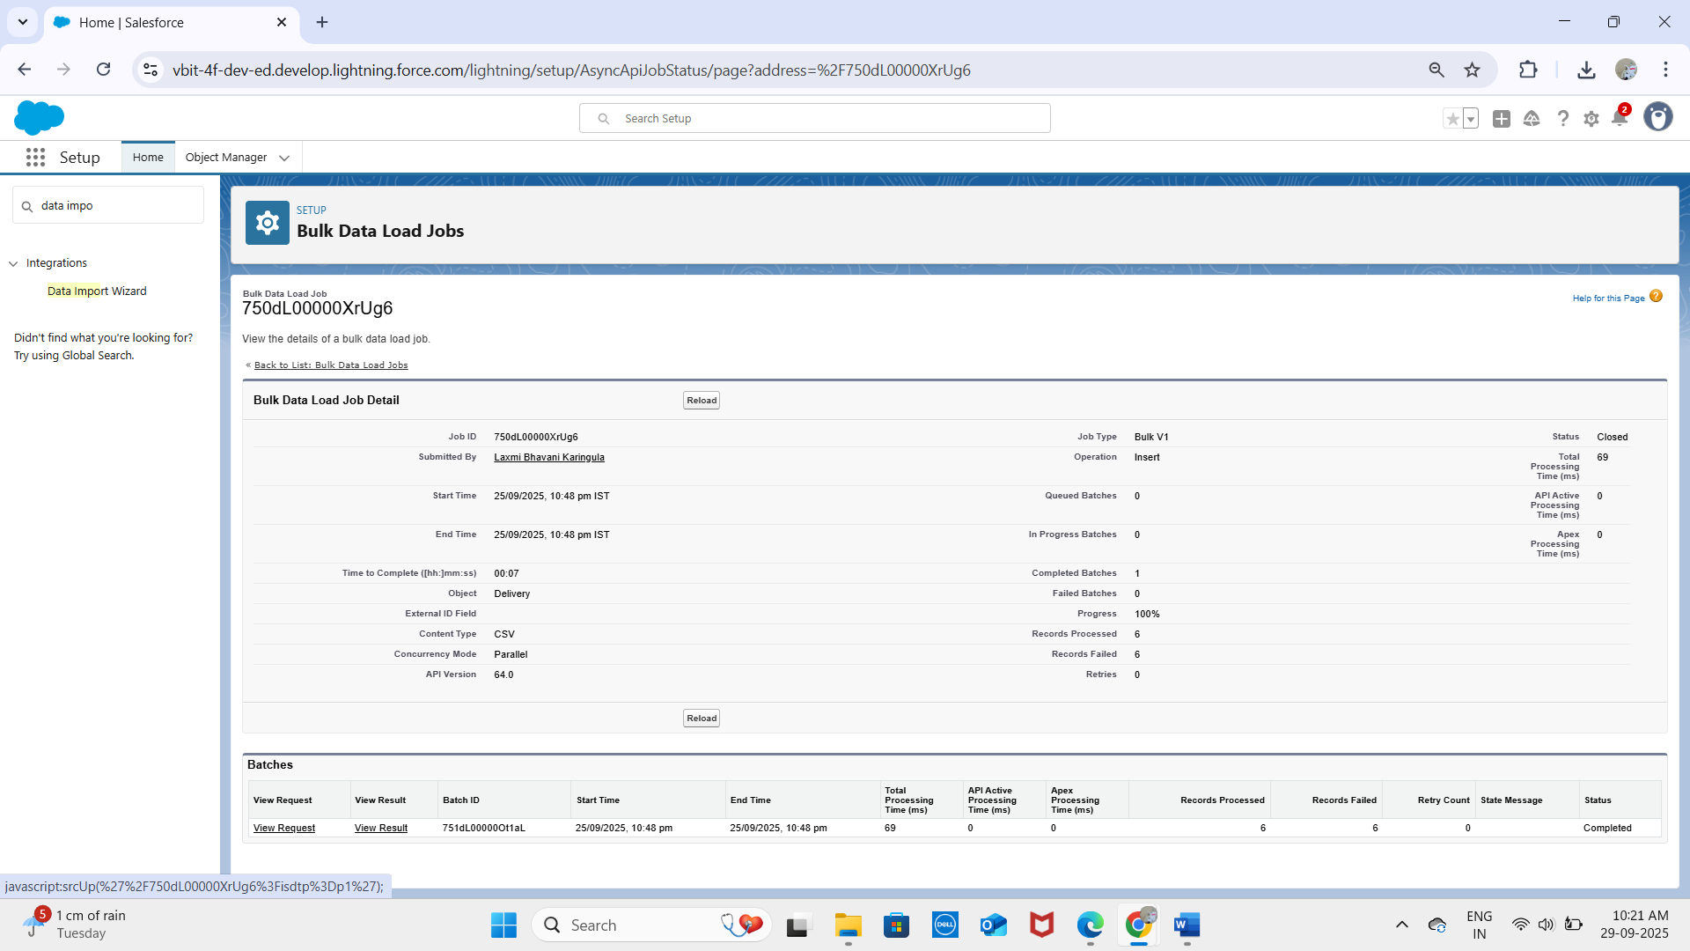

## 2. Data Loader

- Client application for bulk operations (up to 5 million records).  
- Supports import, update, delete, and export.  
- Example: Updating Delivery Status for all deliveries after system migration.  
- More powerful than the Import Wizard and suitable for developers/advanced admins.

## 3. Duplicate Rules

- Maintain data quality by preventing or alerting duplicate records.  
- Uses matching rules on fields like Customer Email, Order Number, or Loyalty ID.  
- Options: block duplicates or allow with warnings.

**Standard Account Duplicate Rule:**

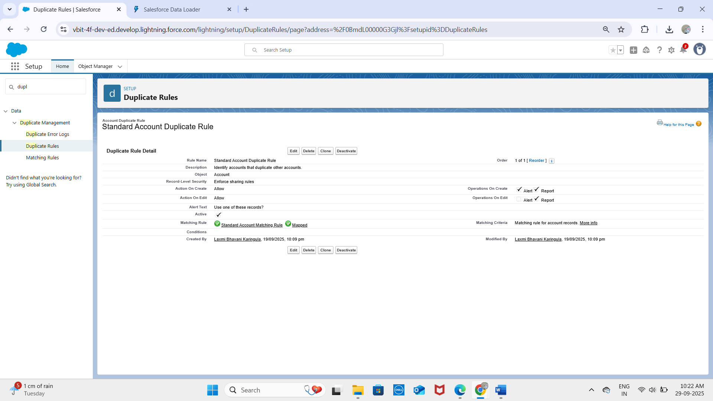

**Standard Contact Duplicate Rule:**

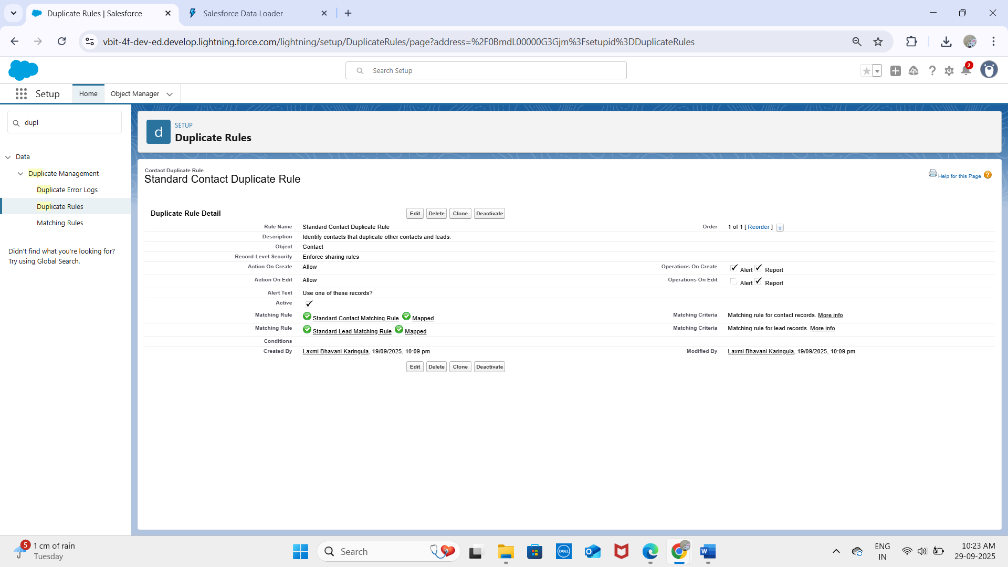

**Standard Lead Duplicate Rule:**

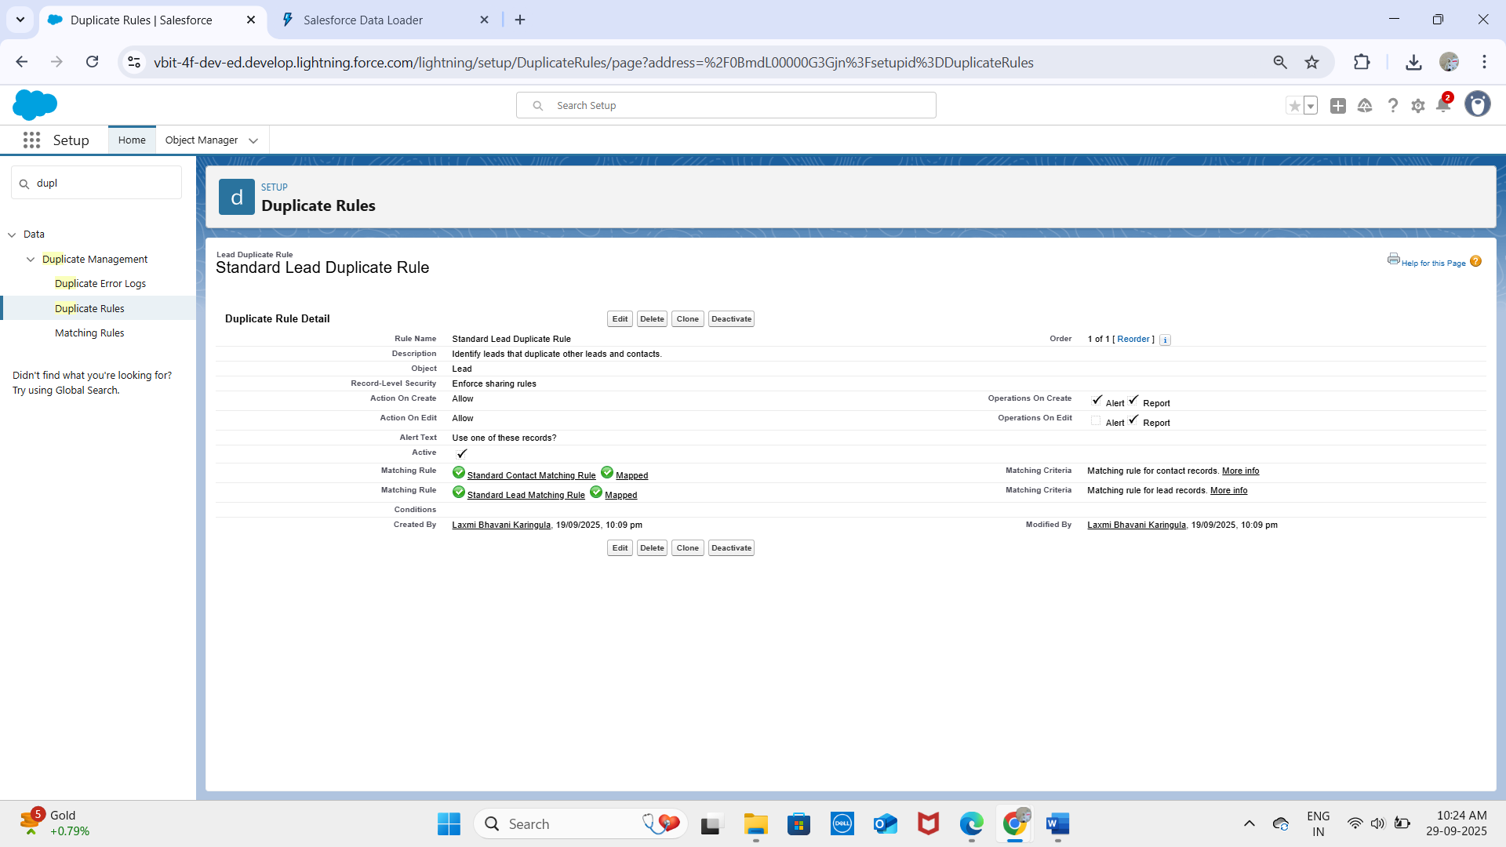

## 4. Data Export & Backup

- Salesforce Data Export Service enables manual or scheduled backups in CSV format.  
- Essential for disaster recovery and compliance.  
- Example: Export all Orders, Deliveries, and Customer data weekly.  
- Third-party backup solutions can provide real-time data protection.

## 5. Change Sets

- Used to migrate metadata (custom objects, fields, flows, validation rules) between Salesforce environments.  
- Example: Deploy Delivery__c object and its flows from Sandbox to Production.  
- Limitations: only works between connected orgs, supports only deployable metadata.

## 6. Unmanaged vs Managed Packages

- Unmanaged Packages: One-time metadata distribution, editable by recipients.  
 - Example: Sharing a custom Delivery Tracking solution for learning or internal use.  
- Managed Packages: Versioned, upgradeable, protects intellectual property.  
 - Example: ISV apps on AppExchange for loyalty program management.

## 7. ANT Migration Tool

- Command-line tool using Salesforce Metadata API.  
- Supports retrieving and deploying metadata programmatically.  
- Ideal for CI/CD automation.  
- Example: Automating deployment of Order and Delivery custom objects and flows.

## 8. VS Code & Salesforce DX (SFDX)

- Visual Studio Code: IDE for Salesforce development with extensions for Apex, LWC, and metadata.  
- SFDX CLI: Supports source-driven development, scratch orgs, version control, CI/CD pipelines.  
- Together, they enable advanced deployment, testing, and automation workflows.  
- Example: Using SFDX to deploy Phase 5 Apex classes, Phase 6 LWC components, and Phase 7 integration metadata.

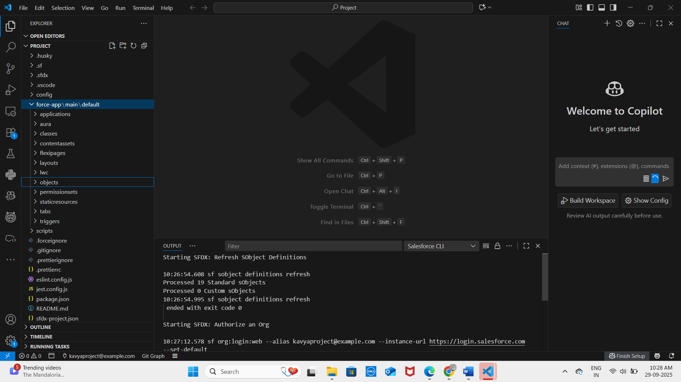

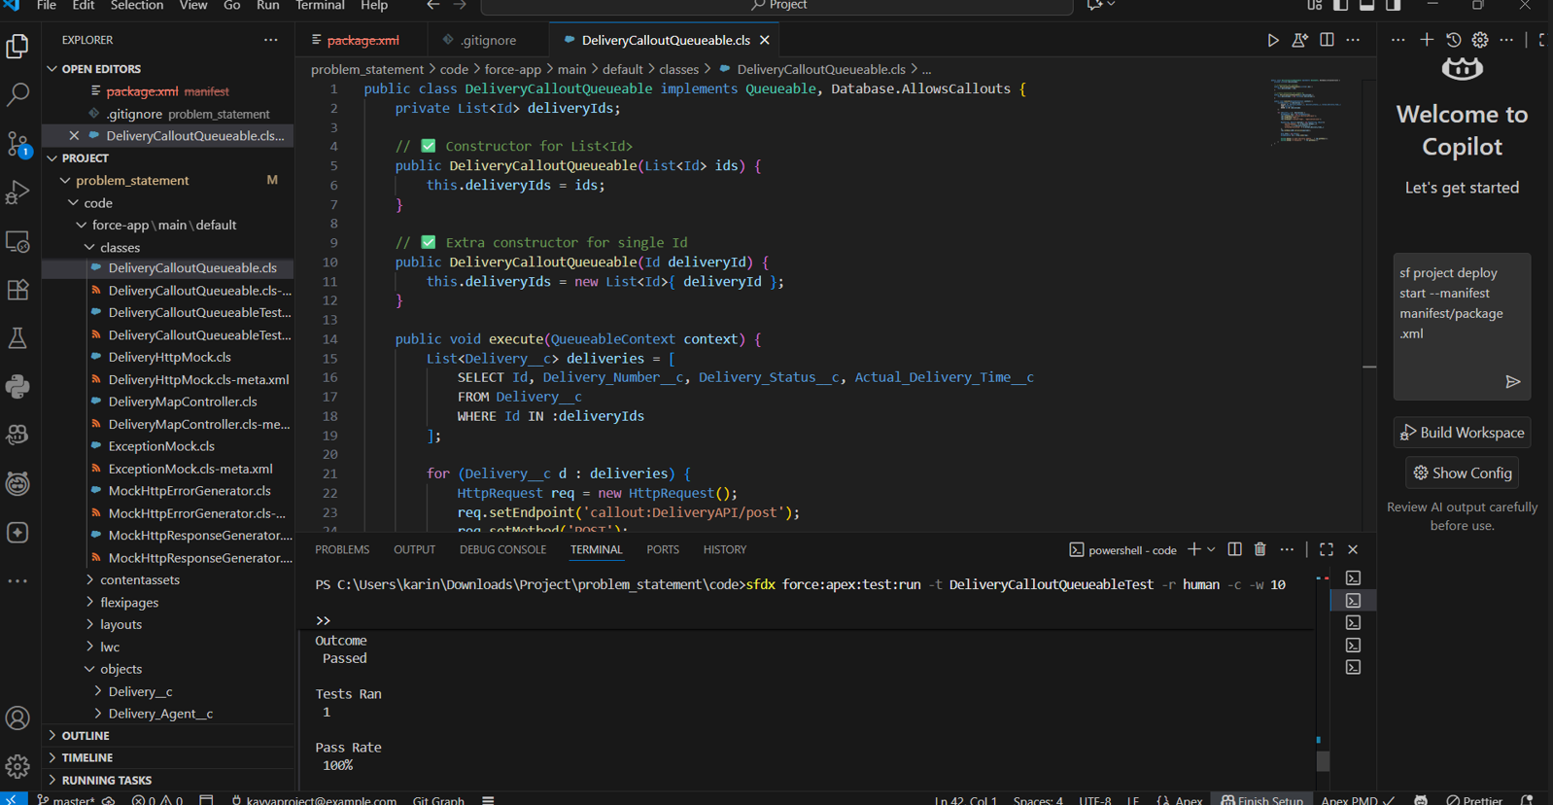

## Outcome

With Phase 8 complete, the project now has:  
- Efficient data import/export and backup processes.  
- High data quality with duplicate prevention.  
- Smooth deployment workflow across Salesforce environments.  
- Support for CI/CD and source-driven development, ensuring maintainability and scalability.