**15B17CI371 – Data Structures Lab**

**ODD 2024**

**Week 1-LAB A**

**Practice Lab**

**1.**

#include<iostream>

using namespace std;

struct node{

int data ;

struct node * next;

};

struct node* insert(struct node* head,int data){

if(head==NULL){

struct node* ptr=new struct node;

ptr->data=data;

ptr->next=NULL;

head=ptr;

return head;

}

else{

struct node* ptr=new struct node;

ptr->data=data;

ptr->next=head;

head=ptr;

return head;

}

}

struct node* insertatend(struct node* head, int data){

struct node*p=new struct node;

if(head==NULL)

{

p->data=data;

p->next=NULL;

return p;

}

struct node*ptr=head;

while(ptr->next!=NULL)

{

ptr=ptr->next;

}

ptr->next=p;

p->data=data;

p->next=NULL;

return head;

}

void print(struct node* head){

while(head!=NULL){

cout<<head->data<<" ";

head=head->next;

}

}

int countnodes(struct node*head){

int count=0,sum=0;

struct node*ptr= head;

while(ptr!=NULL){

sum+=ptr->data;

count++;

ptr=ptr->next;

}

return count;

}

float average(struct node*head){

int count=0,sum=0;

struct node*ptr= head;

while(ptr!=NULL){

sum+=ptr->data;

count++;

ptr=ptr->next;

}

return ((float)sum/count);

}

void printfirst_m(struct node*head,int m){

struct node*p=head;

while(m!=0){

cout<<p->data<<" ";

p=p->next;

m--;

}

cout<<endl;

}

int printelement(struct node*head, int a){

struct node*ptr=head;

while((a-1)!=0){

ptr=ptr->next;

a--;

}

return ptr->data;

}

void middle(struct node*head){

struct node*ptr=head;

int a=countnodes(head);

if (a%2!=0){

int b=(a+1)/2;

int x=printelement(head,b);

if(x%2==0){

cout<<"Middle element : " <<x<<" is even. "<<endl;

}

else{

cout<<"Middle element : " <<x<<" is odd. "<<endl;

}

}

else{

int c=a/2;

int d= c+1;

int p=printelement(head,c);

int q=printelement(head,d);

if(p%2==0){

cout<<"Middle elements are:\n "<<p<<" (even) & ";

}

else{

cout<<"Middle elements are: "<<p<<" (odd) & ";

}

if(q%2==0){

cout<<q<<" (even).\n ";

}

else{

cout<<q<<" (odd).\n ";

}

}

}

void elementfromend(struct node* head, int a){

struct node*ptr=head;

int n= countnodes(head);

int y=n-a;

while(y!=0){

ptr=ptr->next;

y--;

}

do{

cout<<ptr->data<<" ";

ptr=ptr->next;

}while(ptr!=NULL);

cout<<endl;

}

struct node* deleteelement(struct node * head, int value){

struct node *p = head;

struct node *q = head->next;

if(p->data==value){

head=p->next;

free(p);

return head;

}

while(q->data!=value && q->next!= NULL)

{

p = p->next;

q = q->next;

}

if(q->data == value){

p->next = q->next;

free(q);

}

return head;

}

struct node* searchdelete(struct node*head, int f){

struct node*ptr=head;

while(ptr!=NULL){

if(ptr->data==f){

cout<<f<<" exists in the given linked list."<<endl;

head = deleteelement(head,f);

cout<<"Updated LL:\n";

print(head);

return head;

}

else{

ptr=ptr->next;

}

}

cout<<f<<" doesn't exist in the given LL.\n";

return head;

}

int checkpair(struct node* head, int a, int b){

struct node*p=head;

struct node*q=head->next;

while(q->data!=b&&q->next!=NULL){

p=p->next;

q=q->next;

}

if(q->data==b&&p->data==a){

return 1;}

return 0;

}

struct node* interchangepair(struct node*head,int a, int b, int c, int d)

{

struct node*p=head;

struct node*q=head->next;

struct node*r=head;

struct node*s=head->next;

while(p->data!=a){

p=p->next;

q=q->next;

}

while(r->data!=c){

r=r->next;

s=s->next;

}

int temp1,temp2;

temp1=p->data;

p->data=r->data;

r->data=temp1;

temp2=q->data;

q->data=s->data;

s->data=temp2;

return head;

}

int checksublist( struct node*h1, struct node*h2){

int a=printelement(h2,1);

int i=countnodes(h1);

int j=countnodes(h2);

struct node*p=h1;

struct node*q=h2;

for(int b=0;b<i;b++){

if(p->data!=a){

p=p->next;

continue;

}

else{

struct node*r=p;

for(int c=0;c<j;c++){

if(r->data==q->data)

{

r=r->next;

q=q->next;

continue;

}

else{

q=h2;

goto pin;

}

}

cout<<"The given sub lists exists in the liinked list at position "<<b+1<<endl;

return b+1;

}

pin:

p=p->next;

}

cout<<"The given sub lists doesnt exists in the linked list . "<<endl;

return 0;

}

struct node* reverse(struct node*h){

int arr[countnodes(h)];

int i=0;

struct node*p= h;

while(p!=NULL){

arr[i]=p->data;

p=p->next;

i++;

}

p=h;

int j= countnodes(h)-1;

while(p!=NULL){

p->data=arr[j];

p=p->next;

j--;

}

return h;

}

struct node* updatereversedsublist(struct node*h1, struct node*h2, int g){

int l=countnodes(h2);

struct node*p=h1;

struct node*q=h2;

while((g-1)!=0)

{

p=p->next;

g--;

}

while(l!=0){

p->data=q->data;

p=p->next;

q=q->next;

l--;

}

return h1;

}

int main()

{

struct node*head;

head=NULL;

cout<<"Enter no. of elements to be inserted:\n";

int a;

cin>>a;

int s=a;

cout<<"Enter elements:\n";

while(a!=0){

int k=0;

cin>>k;

head=insert(head,k);

a--;

}

print(head);

cout<<endl;

cout<<"The number of nodes:"<<countnodes(head)<<endl;

cout<<"Average of nodes:"<<average(head)<<endl;

cout<<endl;

cout<<"Enter m for first m elements to be printed:\n";

int m;

cin>>m;

if(m>s){

cout<<"incorrect value of m\n";

}

else{

printfirst_m(head,m);

}

middle(head);

cout<<"Enter n for last n elements to be printed:\n";

int c;

cin>>c;

elementfromend(head,c);

cout<<endl<<"Enter a number to search and delete:\n";

int f;

cin>>f;

head=searchdelete(head,f);

a=s=m=c=0;

cout<<endl<<"Enter 1st pair:\n";

cin>>a>>s;

if(checkpair(head,a,s)){

cout<<"Enter 2nd pair:\n";

cin>>m>>c;

if(checkpair(head,m,c)){

head=interchangepair(head,a,s,m,c);

print(head);

}

else{

cout<<"Pair doesnt exist.\n";

}

}

else{

cout<<"Pair doesnt exist.\n";

}

cout<<"\nEnter No. of elements in sublist:\n";

cin>>a;

if(a>countnodes(head)){

cout<<endl<<"The size of given sublist is more than parent list.\n";

}

else{

struct node*h2= NULL;

cout<<"Enter elements:\n";

for(int i=0;i<a;i++)

{

cin>>s;

h2=insertatend(h2,s);

}

int g=checksublist(head,h2);

h2=reverse(h2);

head=updatereversedsublist(head,h2,g);

print(head);

}

return 0;

}

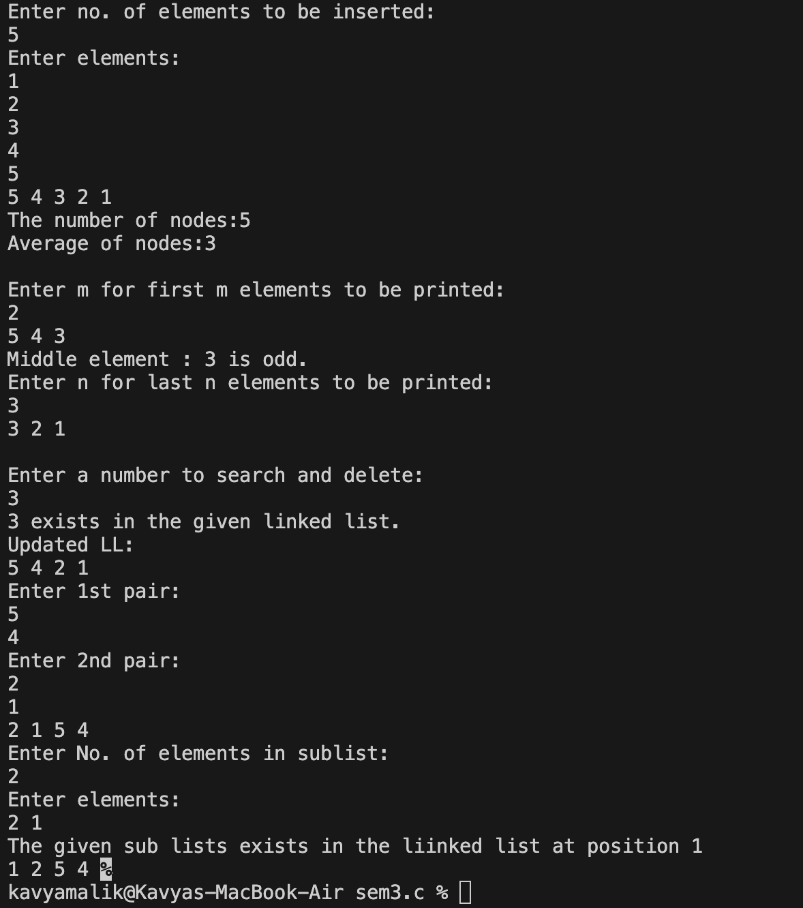

**2.**

#include<iostream>

#include<string.h>

using namespace std;

struct node

{

string data;

struct node *next;

};

void traversal(struct node *ptr)

{

while(ptr!=NULL)

{

cout<<ptr->data<<" ";

ptr = ptr->next;

}

}

struct node* insert(struct node* head,string data){

if(head==NULL){

struct node* ptr=new struct node;

ptr->data=data;

ptr->next=NULL;

head=ptr;

return head;

}

else{

struct node* ptr=new struct node;

ptr->data=data;

ptr->next=head;

head=ptr;

return head;

}

}

void alphabet(struct node *ptr, char data)

{

while(ptr!=NULL)

{

if(ptr->data[0]==data)

{

cout<<ptr->data<<" ";

}

ptr = ptr->next;

}

}

int exist(struct node *ptr, string data)

{

while(ptr!=NULL)

{

if(ptr->data==data)

{

return 1;

}

ptr = ptr->next;

}

return 0;

}

void max(struct node *ptr)

{ int max;

string data=ptr->data;

max=ptr->data.length();

while(ptr!=NULL)

{

if(ptr->data.length()>max)

{

max=ptr->data.length();

data=ptr->data;

}

ptr=ptr->next;

}

cout<<"The max length element is "<<data;

}

int main()

{

struct node* head;

head=NULL;

cout<<"Enter no. of elements to be inserted:\n";

int a;

cin>>a;

int k=a;

cout<<"Enter elements:\n";

while(a!=0){

string s;

cin>>s;

head=insert(head,s);

a--;

}

traversal(head);

char s;

cout<<endl<<"enter alphabet ";

cin>>s;

alphabet(head,s);

string m;

cout<<endl;

cout<<"Enter string you want to find: ";

cin>>m;

if(exist(head,m))

{

cout<<"It exists"<<endl;

}

else{

cout<<"It doesnot exist"<<endl;

}

max(head);

}

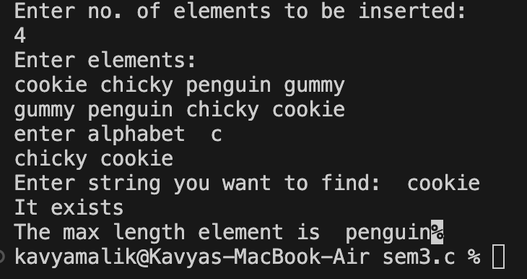

**3.**

#include <iostream>

#include <cmath>

using namespace std;

struct Node {

int value;

Node* next;

Node(int val) : value(val), next(nullptr) {}

};

void insert(Node*& head, int value);

void printElements(Node* head);

int countElements(Node* head);

bool hasNegative(Node* head);

int countGreaterThan15(Node* head);

void deleteValue(Node*& head, int value);

void updateValue(Node* head, int oldValue, int newValue);

void insertAtPosition(Node*& head, int value, int position);

void deletePrimes(Node*& head);

void deleteFibonacci(Node*& head);

bool isPrime(int n);

bool isFibonacci(int num);

bool isPerfectSquare(int x);

void deleteNode(Node*& head, Node* target, Node* prev);

int main() {

Node* head = nullptr;

int n;

cout << "Enter the number of elements to insert: ";

cin >> n;

for (int i = 0; i < n; i++) {

int value;

cout << "Enter element " << i + 1 << ": ";

cin >> value;

insert(head, value);

}

cout << "Elements in list: ";

printElements(head);

cout << "Number of elements: " << countElements(head) << endl;

cout << "List has negative value: " << (hasNegative(head) ? "Yes" : "No") << endl;

cout << "Number of elements greater than 15: " << countGreaterThan15(head) << endl;

int oldValue, newValue;

cout << "Enter value to update: ";

cin >> oldValue;

cout << "Enter new value: ";

cin >> newValue;

updateValue(head, oldValue, newValue);

cout << "List after updating " << oldValue << " to " << newValue << ": ";

printElements(head);

int position, insertValue;

cout << "Enter position to insert new value: ";

cin >> position;

cout << "Enter value to insert: ";

cin >> insertValue;

insertAtPosition(head, insertValue, position);

cout << "List after inserting " << insertValue << " at position " << position << ": ";

printElements(head);

int deleteValueInput;

cout << "Enter value to delete: ";

cin >> deleteValueInput;

deleteValue(head, deleteValueInput);

cout << "List after deleting " << deleteValueInput << ": ";

printElements(head);

deletePrimes(head);

cout << "List after deleting prime numbers: ";

printElements(head);

deleteFibonacci(head);

cout << "List after deleting Fibonacci numbers: ";

printElements(head);

return 0;

}

void insert(Node*& head, int value) {

Node* newNode = new Node(value);

if (!head) {

head = newNode;

head->next = head;

} else {

Node* temp = head;

while (temp->next != head) {

temp = temp->next;

}

temp->next = newNode;

newNode->next = head;

}

}

void printElements(Node* head) {

if (!head) {

cout << "List is empty" << endl;

return;

}

Node* temp = head;

do {

cout << temp->value << " ";

temp = temp->next;

} while (temp != head);

cout << endl;

}

int countElements(Node* head) {

if (!head) return 0;

int count = 0;

Node* temp = head;

do {

count++;

temp = temp->next;

} while (temp != head);

return count;

}

bool hasNegative(Node* head) {

if (!head) return false;

Node* temp = head;

do {

if (temp->value < 0) return true;

temp = temp->next;

} while (temp != head);

return false;

}

int countGreaterThan15(Node* head) {

if (!head) return 0;

int count = 0;

Node* temp = head;

do {

if (temp->value > 15) count++;

temp = temp->next;

} while (temp != head);

return count;

}

void deleteValue(Node*& head, int value) {

if (!head) return;

Node* temp = head;

Node* prev = nullptr;

do {

if (temp->value == value) {

deleteNode(head, temp, prev);

return;

}

prev = temp;

temp = temp->next;

} while (temp != head);

}

void updateValue(Node* head, int oldValue, int newValue) {

if (!head) return;

Node* temp = head;

do {

if (temp->value == oldValue) {

temp->value = newValue;

return;

}

temp = temp->next;

} while (temp != head);

}

void insertAtPosition(Node*& head, int value, int position) {

if (position < 0) return;

Node* newNode = new Node(value);

if (!head) {

if (position == 0) {

head = newNode;

head->next = head;

}

return;

}

if (position == 0) {

newNode->next = head;

Node* temp = head;

while (temp->next != head) {

temp = temp->next;

}

temp->next = newNode;

head = newNode;

return;

}

Node* temp = head;

int index = 0;

while (temp->next != head && index < position - 1) {

temp = temp->next;

index++;

}

newNode->next = temp->next;

temp->next = newNode;

}

void deletePrimes(Node*& head) {

if (!head) return;

Node* temp = head;

Node* prev = nullptr;

do {

if (isPrime(temp->value)) {

deleteNode(head, temp, prev);

temp = prev ? prev->next : head;

} else {

prev = temp;

temp = temp->next;

}

} while (temp != head);

}

void deleteFibonacci(Node*& head) {

if (!head) return;

Node* temp = head;

Node* prev = nullptr;

do {

if (isFibonacci(temp->value)) {

deleteNode(head, temp, prev);

temp = prev ? prev->next : head;

} else {

prev = temp;

temp = temp->next;

}

} while (temp != head);

}

bool isPrime(int n) {

if (n <= 1) return false;

if (n <= 3) return true;

if (n % 2 == 0 || n % 3 == 0) return false;

for (int i = 5; i * i <= n; i += 6) {

if (n % i == 0 || n % (i + 2) == 0) return false;

}

return true;

}

bool isFibonacci(int num) {

if (num < 0) return false;

int x = 5 * num * num;

return isPerfectSquare(x + 4) || isPerfectSquare(x - 4);

}

bool isPerfectSquare(int x) {

int s = static_cast<int>(sqrt(x));

return s * s == x;

}

void deleteNode(Node*& head, Node* target, Node* prev) {

if (prev) {

prev->next = target->next;

} else {

if (target->next == head) {

head = nullptr;

} else {

Node* last = head;

while (last->next != head) {

last = last->next;

}

last->next = target->next;

head = target->next;

}

}

delete target;

}

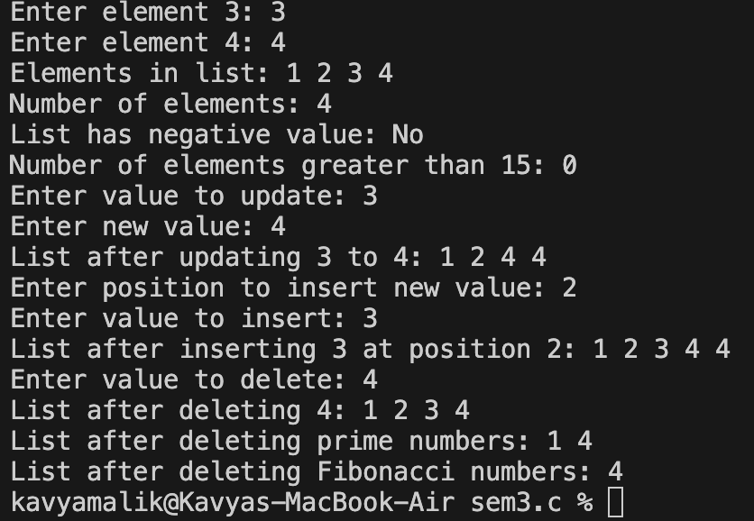

**4.**

#include <iostream>

using namespace std;

struct Node {

int value;

Node* next;

Node* prev;

Node(int val) : value(val), next(nullptr), prev(nullptr) {}

};

void insert(Node*& head, int value);

void printList(Node* head);

void traverseAndCheckDivisibility(Node* head, int m);

void deleteNodesGreaterThan(Node*& head, int x);

int countElementsBetweenDuplicates(Node* head, int value);

int main() {

Node* head = nullptr;

int n;

cout << "Enter the number of elements to insert: ";

cin >> n;

for (int i = 0; i < n; i++) {

int value;

cout << "Enter element " << i + 1 << ": ";

cin >> value;

insert(head, value);

}

cout << "Doubly Linked List: ";

printList(head);

int m;

cout << "Enter the number to check divisibility: ";

cin >> m;

cout << "Nodes divisible by " << m << ": ";

traverseAndCheckDivisibility(head, m);

int x;

cout << "Enter the value to delete nodes greater than: ";

cin >> x;

deleteNodesGreaterThan(head, x);

cout << "List after deleting nodes greater than " << x << ": ";

printList(head);

int duplicateValue;

cout << "Enter the duplicate value to find elements between: ";

cin >> duplicateValue;

int count = countElementsBetweenDuplicates(head, duplicateValue);

cout << "Number of elements between first pair of '" << duplicateValue << "' = " << count << endl;

return 0;

}

void insert(Node*& head, int value) {

Node* newNode = new Node(value);

if (!head) {

head = newNode;

return;

}

Node* temp = head;

while (temp->next) {

temp = temp->next;

}

temp->next = newNode;

newNode->prev = temp;

}

void printList(Node* head) {

if (!head) {

cout << "List is empty" << endl;

return;

}

Node* temp = head;

while (temp) {

cout << temp->value << " ";

temp = temp->next;

}

cout << endl;

}

void traverseAndCheckDivisibility(Node* head, int m) {

if (!head) return;

Node* temp = head;

while (temp) {

if (temp->value % m == 0) {

cout << temp->value << " ";

}

temp = temp->next;

}

cout << endl;

}

void deleteNodesGreaterThan(Node*& head, int x) {

Node* temp = head;

while (temp) {

Node* nextNode = temp->next;

if (temp->value > x) {

if (temp->prev) {

temp->prev->next = temp->next;

} else {

head = temp->next;

}

if (temp->next) {

temp->next->prev = temp->prev;

}

delete temp;

}

temp = nextNode;

}

}

int countElementsBetweenDuplicates(Node* head, int value) {

if (!head) return 0;

Node* first = nullptr;

Node* second = nullptr;

Node* temp = head;

while (temp) {

if (temp->value == value) {

if (!first) {

first = temp;

} else if (!second) {

second = temp;

break;

}

}

temp = temp->next;

}

if (!first || !second) return 0;

int count = 0;

temp = first->next;

while (temp && temp != second) {

count++;

temp = temp->next;

}

return count;

}

