**15B17CI371 – Data Structures Lab**

**ODD 2024**

**Week 2-LAB A**

**Practice Lab**

1.

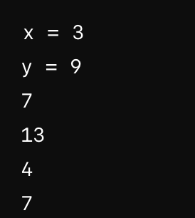

### **Dry Run**

#### **1. Initial State**

* stack is empty.
* x = 4
* y = 0

#### **2. Operations**

1. stack.push(7);
   * Stack: [7]
2. stack.push(x); (x is 4)
   * Stack: [7, 4]
3. stack.push(x + 5); (x + 5 is 4 + 5 = 9)
   * Stack: [7, 4, 9]
4. y = stack.top();
   * y is assigned the top value of the stack, which is 9.
   * Stack: [7, 4, 9]
   * y = 9
5. stack.pop();
   * Removes the top value (9).
   * Stack: [7, 4]
6. stack.push(x + y); (x + y is 4 + 9 = 13)
   * Stack: [7, 4, 13]
7. stack.push(y - 2); (y - 2 is 9 - 2 = 7)
   * Stack: [7, 4, 13, 7]
8. stack.push(3);
   * Stack: [7, 4, 13, 7, 3]
9. x = stack.top();
   * x is assigned the top value of the stack, which is 3.
   * Stack: [7, 4, 13, 7, 3]
   * x = 3
10. stack.pop();
    * Removes the top value (3).
    * Stack: [7, 4, 13, 7]

2.

#include <iostream>

using namespace std;

const int MAX_SIZE = 100;

struct Stack {

int data[MAX_SIZE];

int top;

Stack() : top(-1) {}

void push(int value) {

if (top < MAX_SIZE - 1) {

data[++top] = value;

} else {

cout << "Stack overflow" << endl;

}

}

void pop() {

if (top >= 0) {

--top;

} else {

cout << "Stack underflow" << endl;

}

}

int peek() const {

if (top >= 0) {

return data[top];

}

return -1; // Sentinel value indicating empty stack

}

bool isEmpty() const {

return top == -1;

}

};

void printPrimeFactors(int n) {

Stack stack;

while (n % 2 == 0) {

stack.push(2);

n /= 2;

}

for (int i = 3; i * i <= n; i += 2) {

while (n % i == 0) {

stack.push(i);

n /= i;

}

}

if (n > 2) {

stack.push(n);

}

while (!stack.isEmpty()) {

cout << stack.peek() << " ";

stack.pop();

}

cout << endl;

}

int main() {

int number;

cout << "Enter a positive integer: ";

cin >> number;

if (number <= 0) {

cout << "Please enter a positive integer." << endl;

return 1;

}

cout << "Prime factors in descending order: ";

printPrimeFactors(number);

return 0;

}

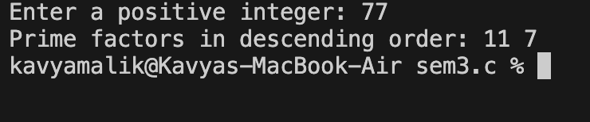

3.

#include <iostream>

using namespace std;

const int MAX_SIZE = 100;

struct Stack {

int data[MAX_SIZE];

int top;

Stack() : top(-1) {}

void push(int value) {

if (top < MAX_SIZE - 1) {

data[++top] = value;

} else {

cout << "Stack overflow" << endl;

}

}

void pop() {

if (top >= 0) {

--top;

} else {

cout << "Stack underflow" << endl;

}

}

int peek() const {

if (top >= 0) {

return data[top];

}

return -1;

}

bool isEmpty() const {

return top == -1;

}

int size() const {

return top + 1;

}

};

void splitStack(const Stack& original, Stack& bottomHalf, Stack& topHalf) {

int totalSize = original.size();

int halfSize = totalSize / 2;

int count = 0;

Stack tempStack;

Stack reversedStack = original;

while (!reversedStack.isEmpty()) {

tempStack.push(reversedStack.peek());

reversedStack.pop();

}

while (!tempStack.isEmpty()) {

if (count < halfSize) {

bottomHalf.push(tempStack.peek());

} else {

topHalf.push(tempStack.peek());

}

tempStack.pop();

count++;

}

}

void combineStacks(Stack& stack1, Stack& stack2) {

Stack tempStack;

while (!stack1.isEmpty()) {

tempStack.push(stack1.peek());

stack1.pop();

}

while (!stack2.isEmpty()) {

stack1.push(stack2.peek());

stack2.pop();

}

while (!tempStack.isEmpty()) {

stack1.push(tempStack.peek());

tempStack.pop();

}

}

void printStack(const Stack& stack) {

Stack tempStack = stack;

while (!tempStack.isEmpty()) {

cout << tempStack.peek() << " ";

tempStack.pop();

}

cout << endl;

}

int main() {

Stack originalStack;

for (int i = 1; i <= 10; ++i) {

originalStack.push(i);

}

Stack bottomHalf, topHalf;

splitStack(originalStack, bottomHalf, topHalf);

cout << "Bottom half: ";

printStack(bottomHalf);

cout << "Top half: ";

printStack(topHalf);

Stack stack1, stack2;

for (int i = 11; i <= 15; ++i) {

stack1.push(i);

}

for (int i = 16; i <= 20; ++i) {

stack2.push(i);

}

cout << "Stack 1 before combine: ";

printStack(stack1);

cout << "Stack 2 before combine: ";

printStack(stack2);

combineStacks(stack1, stack2);

cout << "Stack 1 after combine: ";

printStack(stack1);

return 0;

}

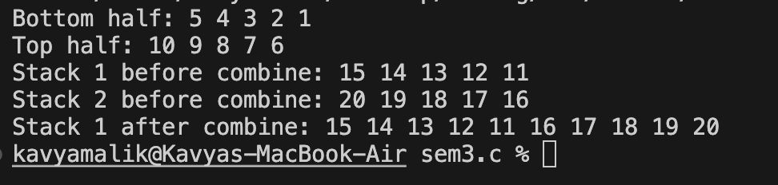

4.

#include <iostream>

using namespace std;

const int MAX_SIZE = 100;

struct Stack {

int data[MAX_SIZE];

int top;

Stack() : top(-1) {}

void push(int value) {

if (top < MAX_SIZE - 1) {

data[++top] = value;

} else {

cout << "Stack overflow" << endl;

}

}

void pop() {

if (top >= 0) {

--top;

} else {

cout << "Stack underflow" << endl;

}

}

int peek() const {

if (top >= 0) {

return data[top];

}

return -1; // Sentinel value indicating empty stack

}

bool isEmpty() const {

return top == -1;

}

};

void convertToBase(int number, int base) {

if (base < 2 || base > 9) {

cout << "Base must be between 2 and 9." << endl;

return;

}

Stack stack;

// Special case for zero

if (number == 0) {

cout << "0" << endl;

return;

}

// Convert number to the specified base

while (number > 0) {

stack.push(number % base);

number /= base;

}

// Print the result

while (!stack.isEmpty()) {

cout << stack.peek();

stack.pop();

}

cout << endl;

}

int main() {

int number, base;

cout << "Enter a positive integer: ";

cin >> number;

cout << "Enter the base (2 to 9): ";

cin >> base;

if (number < 0) {

cout << "Please enter a positive integer." << endl;

return 1;

}

convertToBase(number, base);

return 0;

}

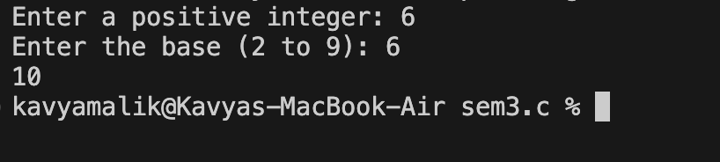

5.

#include <iostream>

#include <cstring>

#include <cctype>

using namespace std;

const int MAX_SIZE = 100;

struct Stack {

char data[MAX_SIZE];

int top;

Stack() : top(-1) {}

void push(char value) {

if (top < MAX_SIZE - 1) {

data[++top] = value;

} else {

cout << "Stack overflow" << endl;

}

}

char pop() {

if (top >= 0) {

return data[top--];

}

cout << "Stack underflow" << endl;

return '\0'; // Return null character to indicate error

}

char peek() const {

if (top >= 0) {

return data[top];

}

return '\0'; // Return null character if stack is empty

}

bool isEmpty() const {

return top == -1;

}

};

int precedence(char op) {

switch (op) {

case '+':

case '-':

return 1;

case '*':

case '/':

return 2;

case '^':

return 3;

default:

return 0;

}

}

bool isOperator(char c) {

return (c == '+' || c == '-' || c == '*' || c == '/' || c == '^');

}

void infixToPostfix(const char* infix, char* postfix) {

Stack operators;

int index = 0;

for (int i = 0; infix[i] != '\0'; ++i) {

char c = infix[i];

if (isdigit(c)) {

postfix[index++] = c;

} else if (c == '(') {

operators.push(c);

} else if (c == ')') {

while (!operators.isEmpty() && operators.peek() != '(') {

postfix[index++] = operators.pop();

}

operators.pop(); // Remove '(' from the stack

} else if (isOperator(c)) {

while (!operators.isEmpty() && precedence(operators.peek()) >= precedence(c)) {

postfix[index++] = operators.pop();

}

operators.push(c);

}

}

while (!operators.isEmpty()) {

postfix[index++] = operators.pop();

}

postfix[index] = '\0'; // Null-terminate the postfix expression

}

void reverseString(char* str) {

int length = strlen(str);

for (int i = 0; i < length / 2; ++i) {

char temp = str[i];

str[i] = str[length - i - 1];

str[length - i - 1] = temp;

}

}

void postfixToPrefix(const char* postfix, char* prefix) {

Stack st;

int length = strlen(postfix);

for (int i = 0; i < length; ++i) {

char c = postfix[i];

if (isdigit(c)) {

st.push(c);

} else if (isOperator(c)) {

char op1 = st.pop();

char op2 = st.pop();

prefix[0] = c;

prefix[1] = op2;

prefix[2] = op1;

prefix[3] = '\0'; // Null-terminate the prefix expression

for (int j = 0; prefix[j] != '\0'; ++j) {

st.push(prefix[j]);

}

}

}

int prefixIndex = 0;

while (!st.isEmpty()) {

prefix[prefixIndex++] = st.pop();

}

prefix[prefixIndex] = '\0';

reverseString(prefix); // Reverse the prefix to get correct order

}

void prefixToPostfix(const char* prefix, char* postfix) {

Stack st;

int length = strlen(prefix);

for (int i = length - 1; i >= 0; --i) {

char c = prefix[i];

if (isdigit(c)) {

st.push(c);

} else if (isOperator(c)) {

char op1 = st.pop();

char op2 = st.pop();

postfix[0] = op1;

postfix[1] = op2;

postfix[2] = c;

postfix[3] = '\0'; // Null-terminate the postfix expression

for (int j = 0; postfix[j] != '\0'; ++j) {

st.push(postfix[j]);

}

}

}

int postfixIndex = 0;

while (!st.isEmpty()) {

postfix[postfixIndex++] = st.pop();

}

postfix[postfixIndex] = '\0';

}

int evaluatePostfix(const char* postfix) {

Stack st;

int length = strlen(postfix);

for (int i = 0; i < length; ++i) {

char c = postfix[i];

if (isdigit(c)) {

st.push(c - '0');

} else if (isOperator(c)) {

int val2 = st.pop();

int val1 = st.pop();

switch (c) {

case '+': st.push(val1 + val2); break;

case '-': st.push(val1 - val2); break;

case '*': st.push(val1 * val2); break;

case '/': st.push(val1 / val2); break;

}

}

}

return st.pop();

}

int main() {

char infix[] = "(4+9*6)-((8-6)/2*4)*9/3";

char postfix[MAX_SIZE];

char prefix[MAX_SIZE];

infixToPostfix(infix, postfix);

cout << "Postfix: " << postfix << endl;

postfixToPrefix(postfix, prefix);

cout << "Prefix: " << prefix << endl;

char postfixFromPrefix[MAX_SIZE];

prefixToPostfix(prefix, postfixFromPrefix);

cout << "Postfix from Prefix: " << postfixFromPrefix << endl;

int result = evaluatePostfix(postfix);

cout << "Evaluation of Postfix: " << result << endl;

return 0;

}

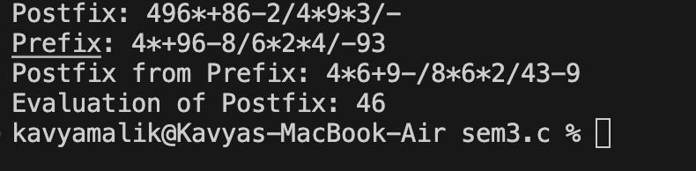

6.

#include <iostream>

#include <cstring>

using namespace std;

const int MAX_SIZE = 100;

struct Stack {

char data[MAX_SIZE];

int top;

Stack() : top(-1) {}

void push(char value) {

if (top < MAX_SIZE - 1) {

data[++top] = value;

} else {

cout << "Stack overflow" << endl;

}

}

char pop() {

if (top >= 0) {

return data[top--];

}

cout << "Stack underflow" << endl;

return '\0'; // Return null character to indicate error

}

char peek() const {

if (top >= 0) {

return data[top];

}

return '\0'; // Return null character if stack is empty

}

bool isEmpty() const {

return top == -1;

}

};

bool isOpeningSymbol(char c) {

return (c == '(' || c == '[' || c == '{');

}

bool isClosingSymbol(char c) {

return (c == ')' || c == ']' || c == '}');

}

bool isMatchingPair(char opening, char closing) {

return (opening == '(' && closing == ')') ||

(opening == '[' && closing == ']') ||

(opening == '{' && closing == '}');

}

bool areSymbolsBalanced(const char* expression) {

Stack stack;

for (int i = 0; expression[i] != '\0'; ++i) {

char c = expression[i];

if (isOpeningSymbol(c)) {

stack.push(c);

} else if (isClosingSymbol(c)) {

if (stack.isEmpty() || !isMatchingPair(stack.pop(), c)) {

return false; // Mismatch or unbalanced closing symbol

}

}

}

return stack.isEmpty(); // If stack is empty, symbols are balanced

}

int main() {

const int MAX_LENGTH = 100;

char expression[MAX_LENGTH];

cout << "Enter an expression with symbols (parentheses, brackets, braces): ";

cin.getline(expression, MAX_LENGTH);

if (areSymbolsBalanced(expression)) {

cout << "The symbols are balanced." << endl;

} else {

cout << "The symbols are not balanced." << endl;

}

return 0;

}

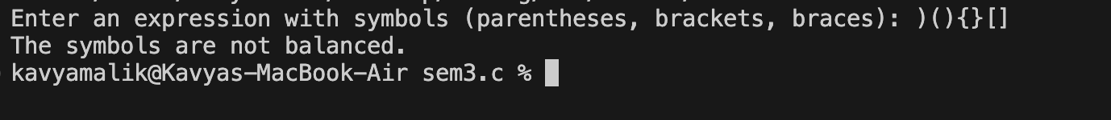

7.

#include <iostream>

#include <cstring>

using namespace std;

const int MAX_SIZE = 100;

struct Queue {

char data[MAX_SIZE];

int front, rear, size;

Queue() : front(0), rear(0), size(0) {}

void enqueue(char value) {

if (size < MAX_SIZE) {

data[rear] = value;

rear = (rear + 1) % MAX_SIZE;

size++;

} else {

cout << "Queue overflow" << endl;

}

}

char dequeue() {

if (size > 0) {

char value = data[front];

front = (front + 1) % MAX_SIZE;

size--;

return value;

}

cout << "Queue underflow" << endl;

return '\0';

}

bool isEmpty() const {

return size == 0;

}

char peek() const {

if (size > 0) {

return data[front];

}

return '\0';

}

};

void compressText(const char* input, char* output) {

Queue queue;

int index = 0;

for (int i = 0; input[i] != '\0'; ++i) {

if (input[i] != ' ') {

queue.enqueue(input[i]);

}

}

while (!queue.isEmpty()) {

char currentChar = queue.dequeue();

int count = 1;

while (!queue.isEmpty() && queue.peek() == currentChar) {

queue.dequeue();

count++;

}

output[index++] = currentChar;

if (count > 1) {

output[index++] = count + '0';

}

}

output[index] = '\0';

}

int main() {

const int MAX_LENGTH = 100;

char input[MAX_LENGTH];

char output[MAX_LENGTH];

cout << "Enter the text to compress: ";

cin.getline(input, MAX_LENGTH);

compressText(input, output);

cout << "Compressed text: " << output << endl;

return 0;

}



8.

#include <iostream>

#include <queue>

using namespace std;

void moveNthFront(queue<int>& q, int n) {

if (q.size() < n || n <= 0) {

cout << "Invalid value of n." << endl;

return;

}

queue<int> tempQueue;

for (int i = 1; i < n; ++i) {

tempQueue.push(q.front());

q.pop();

}

int nthElement = q.front();

q.pop();

while (!q.empty()) {

tempQueue.push(q.front());

q.pop();

}

q.push(nthElement);

while (!tempQueue.empty()) {

q.push(tempQueue.front());

tempQueue.pop();

}

}

int main() {

queue<int> q;

q.push(5);

q.push(11);

q.push(34);

q.push(67);

q.push(43);

q.push(55);

int n = 3;

cout << "Original queue: ";

queue<int> temp = q;

while (!temp.empty()) {

cout << temp.front() << " ";

temp.pop();

}

cout << endl;

moveNthFront(q, n);

cout << "Queue after moving the " << n << "th element to the front: ";

while (!q.empty()) {

cout << q.front() << " ";

q.pop();

}

cout << endl;

return 0;

}



9.

#include <iostream>

#include <queue>

#include <stack>

#include <cctype>

using namespace std;

bool isPalindrome(queue<char>& q, stack<char>& s) {

while (!q.empty() && !s.empty()) {

if (q.front() != s.top()) {

return false;

}

q.pop();

s.pop();

}

return q.empty() && s.empty();

}

int main() {

queue<char> q;

stack<char> s;

cout << "Enter a line of text (end with a period '.'): " << endl;

char c;

while (cin.get(c)) {

if (c == '.') {

break; // End input when a period is encountered

}

if (isalpha(c)) {

char lowerChar = tolower(c);

q.push(lowerChar);

s.push(lowerChar);

}

}

if (isPalindrome(q, s)) {

cout << "The text is a palindrome." << endl;

} else {

cout << "The text is not a palindrome." << endl;

}

return 0;

}

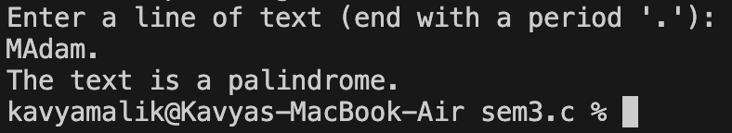

10.

#include <iostream>

#include <string>

#include <algorithm>

std::string reverse_between_substrings(const std::string& s) {

size_t start_S1 = s.find('x');

if (start_S1 == std::string::npos) return "Invalid Input";

size_t end_S1 = s.find('y', start_S1);

if (end_S1 == std::string::npos) return "Invalid Input";

size_t start_S2 = s.find('y', end_S1 + 1);

if (start_S2 == std::string::npos) return "Invalid Input";

size_t end_S2 = s.find('x', start_S2 + 1);

if (end_S2 == std::string::npos) return "Invalid Input";

if (end_S1 >= start_S2) return "Invalid Input";

std::string content_between = s.substr(end_S1 + 1, start_S2 - end_S1 - 1);

std::reverse(content_between.begin(), content_between.end());

std::string result = s.substr(0, end_S1 + 1) + content_between + s.substr(start_S2);

return result;

}

int main() {

std::string input_string;

std::cout << "Enter the string: ";

std::getline(std::cin, input_string);

std::string output_string = reverse_between_substrings(input_string);

std::cout << "Output: " << output_string << std::endl;

return 0;

}

