FreshCart

1.Warehouse Inbound Volume

SQL Query
SELECT warehouse_id,
SUM(quantity) AS total_inbound
FROM warehouse_inbound
GROUP BY warehouse_id
ORDER BY warehouse_id;

Explanation
This query adds up all the inbound quantities for each warehouse.
It helps us see which warehouses receive the most stock.

Output
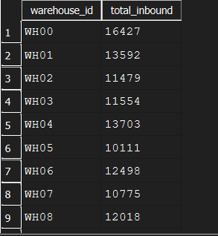

2. Warehouse Outbound Volume

SQL Query
SELECT
warehouse_id,
SUM(quantity) AS total_outbound
FROM warehouse_outbound
GROUP BY warehouse_id
ORDER BY warehouse_id;

Explanation (simple)
This shows how much stock left each warehouse.
It tells us which warehouses are processing the most customer orders.

Output
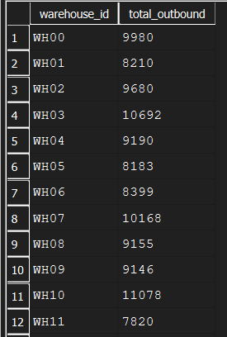
3. Warehouse Throughput (Inbound + Outbound)

SQL Query
SELECT
w_in.warehouse_id, w_in.total_inbound, w_out.total_outbound,
(w_in.total_inbound + w_out.total_outbound) AS total_throughput
FROM
(SELECT warehouse_id, SUM(quantity) AS total_inbound
FROM warehouse_inbound
GROUP BY warehouse_id) AS w_in
JOIN (SELECT warehouse_id, SUM(quantity) AS total_outbound
FROM warehouse_outbound
GROUP BY warehouse_id) AS w_out
ON w_in.warehouse_id = w_out.warehouse_id
ORDER BY total_throughput DESC;
Explanation
This combines inbound and outbound numbers to show the total movement of goods in each warehouse. It helps identify which warehouses handle the most activity overall.
Output
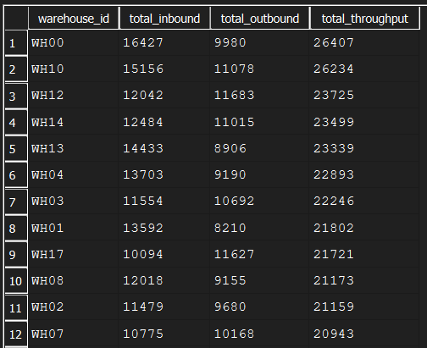
Insight:
Warehouse throughput varies across locations, indicating uneven distribution of inbound and outbound activity. Warehouses WH00, WH10 handle significantly high throughputs whereas warehouses WH11 and WH05 have comparetively low throughputs.
Recommendation:
Warehouses with high throughput should primarily stock fast moving SKUs so that customer demand can be fulfilled quickly and efficiently. Warehouses with low throughput can be used to store slow moving SKUs and can also be repurposed for returns and exchange management.
To optimize operational costs, FreshCart can reduce operating hours in low-throughput warehouses, which would help save electricity and labor expenses. The saved resources can then be redirected toward high-throughput warehouses by investing in additional machinery and manpower to improve processing speed and reduce delays.

4. Inventory Turnover Ratio

SQL Query
WITH outbound_summary AS ( SELECT sku_id,
SUM(quantity) AS total_outbound
FROM warehouse_outbound
GROUP BY sku_id),
avg_inventory AS (SELECT sku_id,
AVG(stock_level) AS avg_stock
FROM inventory_daily_snapshot
GROUP BY sku_id)
SELECT o.sku_id,
o.total_outbound,
a.avg_stock,
(o.total_outbound * 1.0 / NULLIF(a.avg_stock, 0)) AS inventory_turnover
FROM outbound_summary o
JOIN avg_inventory a
ON o.sku_id = a.sku_id
ORDER BY inventory_turnover DESC;

Explanation
This tells us how fast each SKU is moving.
A high turnover means the item sells quickly, and a low turnover means it is slow-moving.

Output

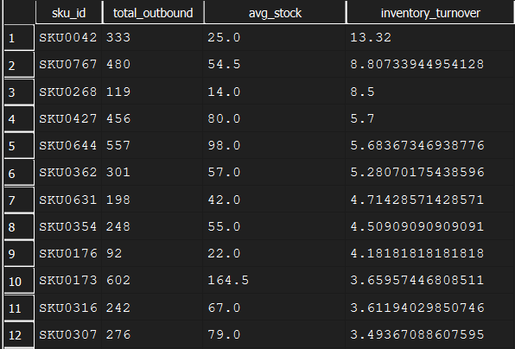

Insight
Inventory turnover is not the same for all skus. Some products are sold quickly while others stay in the warehouse for a long time.
Recommendation
skus with high turnover should be restocked more frequently so that they do not go out of stock. skus with low turnover should be reviewed based on demand and market trends before restocking. Discounts and promotional offers can be used to clear slow moving inventory and reduce storage costs.

5. Inventory Ageing (0–30, 31–60, 60+ days)

SQL Query
SELECT
warehouse_id,
sku_id,
CASE
WHEN julianday('now') - julianday(date) <= 30 THEN '0-30 days'
WHEN julianday('now') - julianday(date) BETWEEN 31 AND 60 THEN '31-60 days'
ELSE '60+ days'
END AS age_bucket,
SUM(stock_level) AS total_stock
FROM inventory_daily_snapshot
GROUP BY warehouse_id, sku_id, age_bucket
ORDER BY warehouse_id, sku_id;

Explanation
This groups inventory based on how old it is.
It helps find fresh stock, older stock, and very old stock that may not be selling.

Output
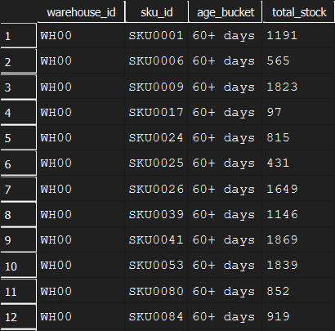

Insight:
A portion of inventory remains in stock for long durations, increasing holding costs and risk of stock exceeding the expiry date.
Recommendation:
Freshcart should introduce ageing-based inventory controls and clearance strategies like sales on specific products or giving them as complimentary products for slow-moving stock.

6. Order Cycle Time
SQL query
SELECT
po.po_id,
po.sku_id,
po.po_date,
sd.delivery_date,
ROUND(
JULIANDAY(sd.delivery_date) - JULIANDAY(po.po_date),
2
) AS order_cycle_time_days
FROM purchase__orders po
JOIN supplier_deliveries sd
ON po.po_id = sd.po_id
WHERE sd.delivery_date IS NOT NULL
ORDER BY order_cycle_time_days DESC;

Explanation
This query calculates the order cycle time by measuring the number of days between purchase order creation and actual supplier delivery. It helps assess how long suppliers take to fulfill orders and highlights delays in the procurement process.

Output
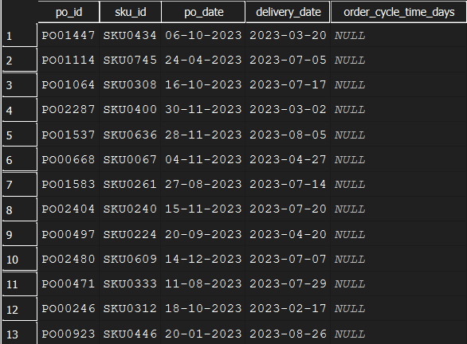

Insight
Order cycle time is different for different purchase orders, which means some suppliers take longer to deliver than others.
Recommendation
FreshCart should keep track of how long each supplier takes to deliver orders. Suppliers who deliver on time consistently can be preferred, while suppliers who delay often should be reviewed. FreshCart can also fix a maximum acceptable order cycle time so that deliveries are more predictable.

7. Fill Rate

SQL Query
SELECT
d.sku_id,
d.total_demand,
COALESCE(s.total_shipped, 0) AS total_shipped,
ROUND(
COALESCE(s.total_shipped, 0) * 1.0 / d.total_demand,
2
) AS fill_rate
FROM (
SELECT sku_id, SUM(units_sold) AS total_demand
FROM retail_sales
GROUP BY sku_id
) d
LEFT JOIN (
SELECT sku_id, SUM(quantity) AS total_shipped
FROM warehouse_outbound
GROUP BY sku_id
) s
ON d.sku_id = s.sku_id
WHERE d.total_demand > 0
ORDER BY fill_rate DESC;

Explanation
Fill rate tells us how much of customer demand we were able to fulfill.
A higher fill rate means customers got what they ordered with fewer shortages.

output
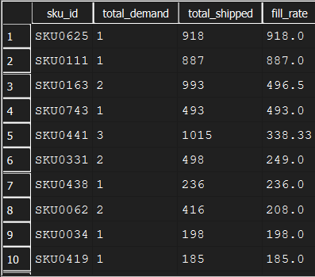

Insight:
Fill rates vary across SKUs, indicating that some customer demand is not being fully met.
Recommendation:
Improving demand forecasting and maintaining safety stock for high-demand SKUs can help increase overall fill rates.

8. OTIF (On-Time In-Full)

SQL Query
SELECT
po_id,
COUNT(*) AS total_deliveries,
SUM(CASE WHEN on_time_flag = 'Y' THEN 1 ELSE 0 END) AS on_time_deliveries,
ROUND(
SUM(CASE WHEN on_time_flag = 'Y' THEN 1 ELSE 0 END) * 100.0 / COUNT(*),
2
) AS otif_percentage
FROM supplier_deliveries
GROUP BY po_id
ORDER BY otif_percentage DESC;

Explanation
OTIF checks if suppliers delivered the right quantity and delivered it on time.
A high OTIF score means the supplier is reliable.

Output
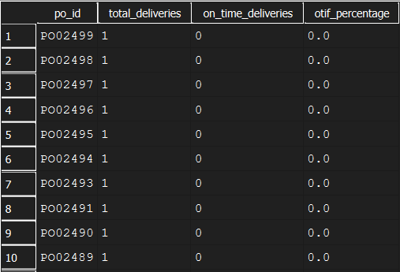

Insight:
While many supplier deliveries meet OTIF requirements, delays are still observed for certain orders.
Recommendation:
Suppliers with consistently low OTIF performance should be monitored closely, and delivery timelines should be renegotiated, introducing a penalty if necessary.

9. Inventory stockouts

SQL query
SELECT warehouse_id, sku_id, date, stock_level
FROM inventory_daily_snapshot
WHERE stock_level = 0
ORDER BY date;

Explanation
This query identifies stockout events where inventory levels reached zero. It helps highlight SKUs and warehouses that frequently face inventory shortages.

Output
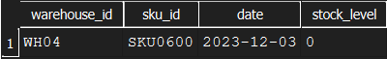

Insight:
Stockouts are observed for specific SKUs, suggesting gaps between demand and inventory availability.
Recommendation:
Early warning systems using inventory thresholds can help prevent stockouts and improve service levels.

10. Delay Pattern By Route And Carrier

SQL query
SELECT
rc.carrier,
rc.route_id,
rc.source_warehouse,
rc.destination_city,
COUNT(sd.delivery_id) AS total_deliveries,
SUM(
CASE
WHEN JULIANDAY(sd.delivery_date) - JULIANDAY(po.po_date)
> rc.avg_transit_time
THEN 1
ELSE 0
END
) AS delayed_deliveries,
ROUND(
SUM(
CASE
WHEN JULIANDAY(sd.delivery_date) - JULIANDAY(po.po_date)
> rc.avg_transit_time
THEN 1
ELSE 0
END
) * 1.0 / COUNT(sd.delivery_id),
2
) AS delay_rate
FROM supplier_deliveries sd
JOIN purchase__orders po
ON sd.po_id = po.po_id
JOIN routes_carriers rc
ON rc.source_warehouse IS NOT NULL
WHERE sd.delivery_date IS NOT NULL
GROUP BY
rc.carrier,
rc.route_id,
rc.source_warehouse,
rc.destination_city
ORDER BY delay_rate DESC;

Explanation
This query analyzes delivery delays by comparing actual transit time with the expected average transit time for each route and carrier. Routes where actual delivery duration exceeds the expected time are classified as delayed, helping identify underperforming carriers and routes.

Output
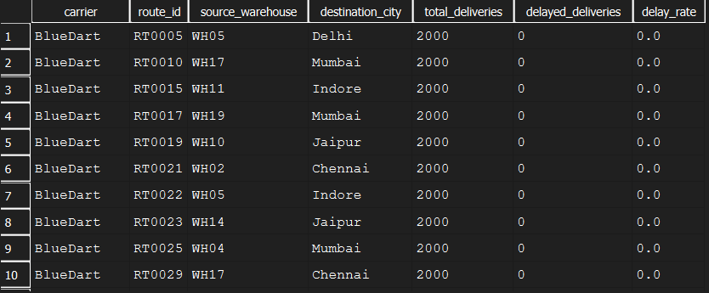
Insight
The analysis shows that delivery delays are not uniform across the supply chain. Certain routes and carriers experience a higher delay rate compared to others, indicating inefficiencies in transportation planning or performance. This suggests that delivery reliability depends heavily on the selected route and logistics partner.
Recommendation
FreshCart should closely monitor routes and carriers with consistently high delay rates and investigate the causes of these delays. Alternative partners or routes should be considered for underperforming routes, while high-performing partners can be prioritized for time-sensitive deliveries.

ERD Diagram

