**TASK 1: E COMMERCE WEBSITE**

**Github Link:** [**Exercise 1**](https://github.com/kavya-prabahar/Full-Stack-Development/tree/main/Exercise%201)

**Folder Structure:**

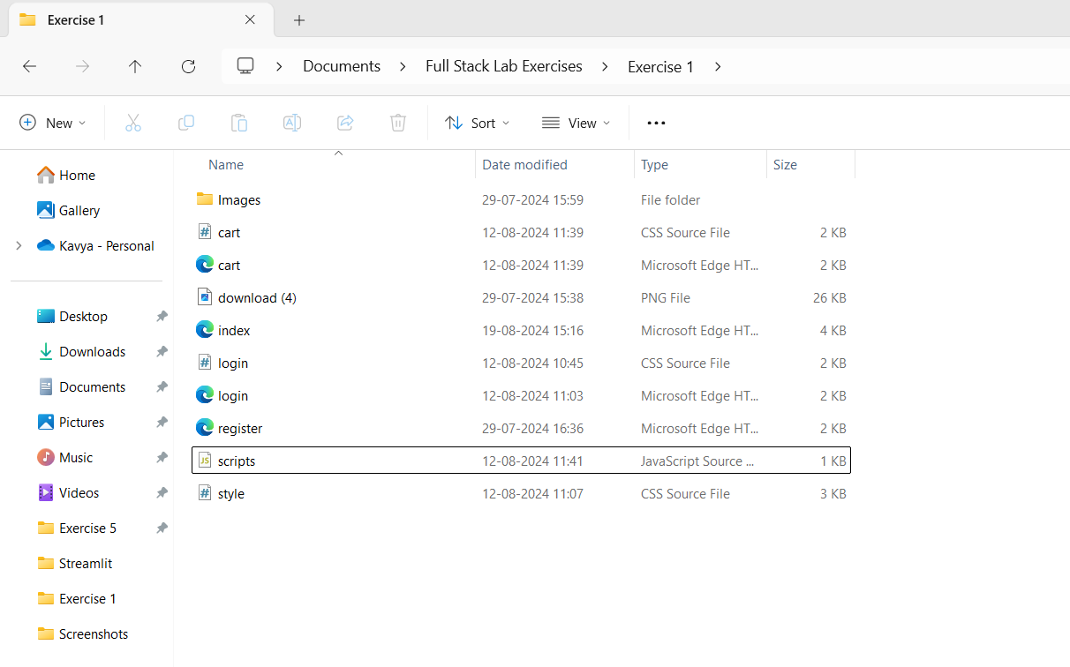

**Home Page:**

**Login Page:**

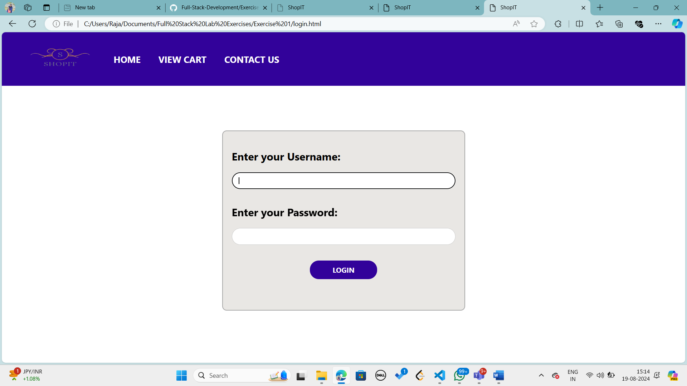

**Sign Up Page:**

**Adding Items to the Cart:**

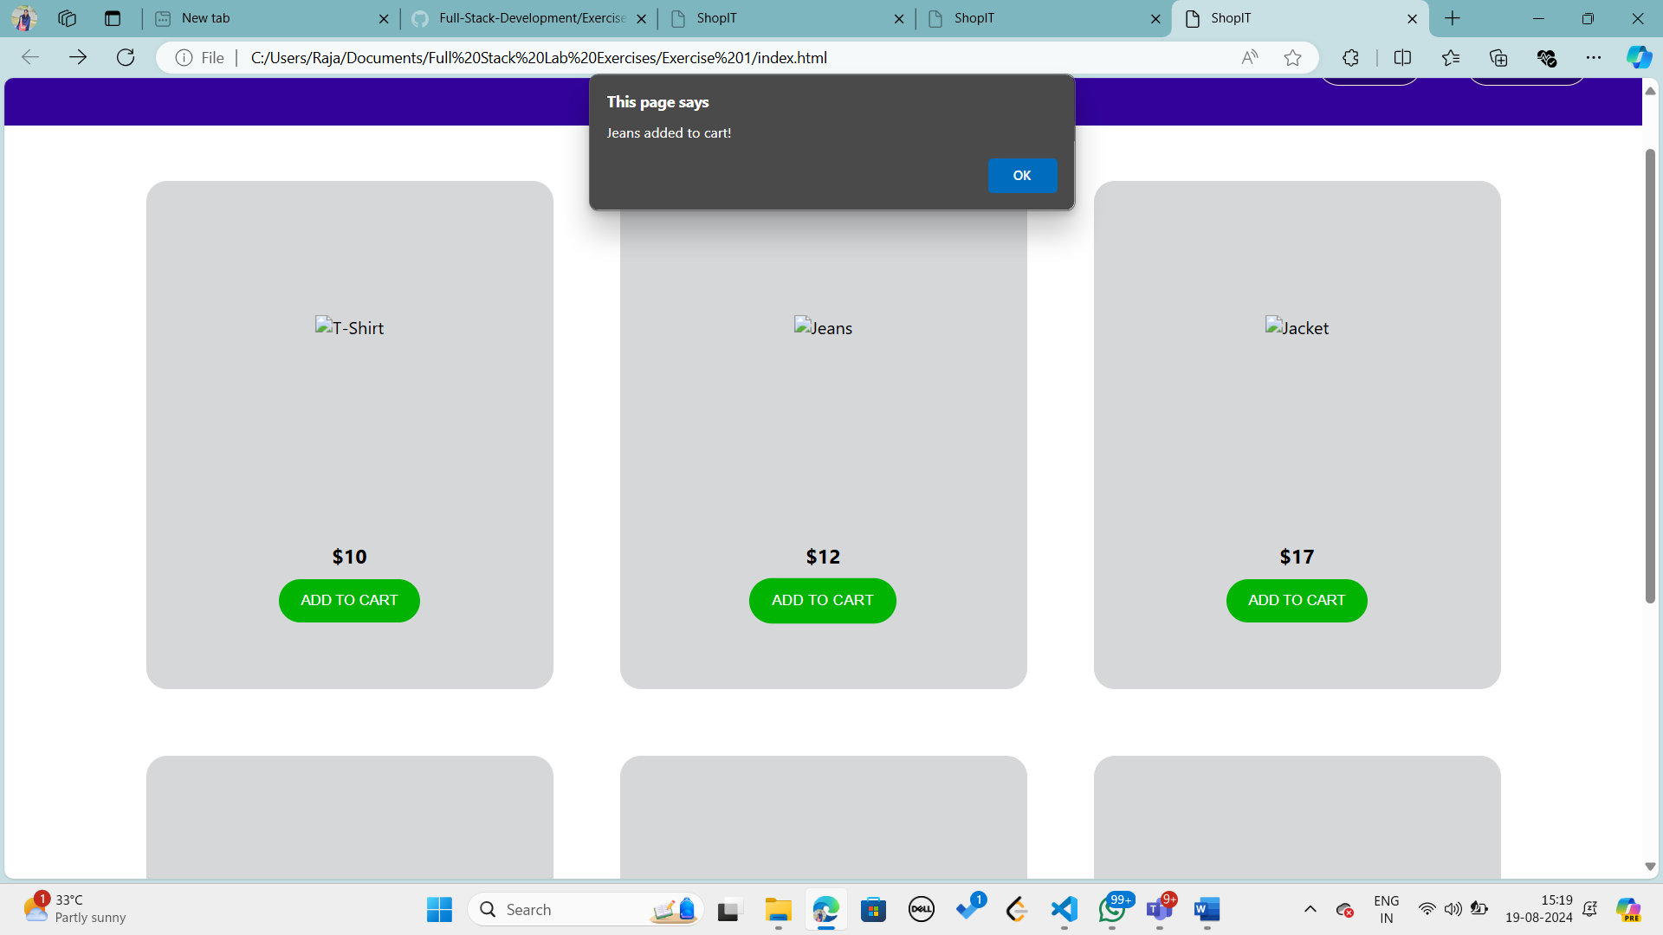

**View Cart Page:**

