**Class and Quiz Snapshots:**

**C programming( 9 to 11)**

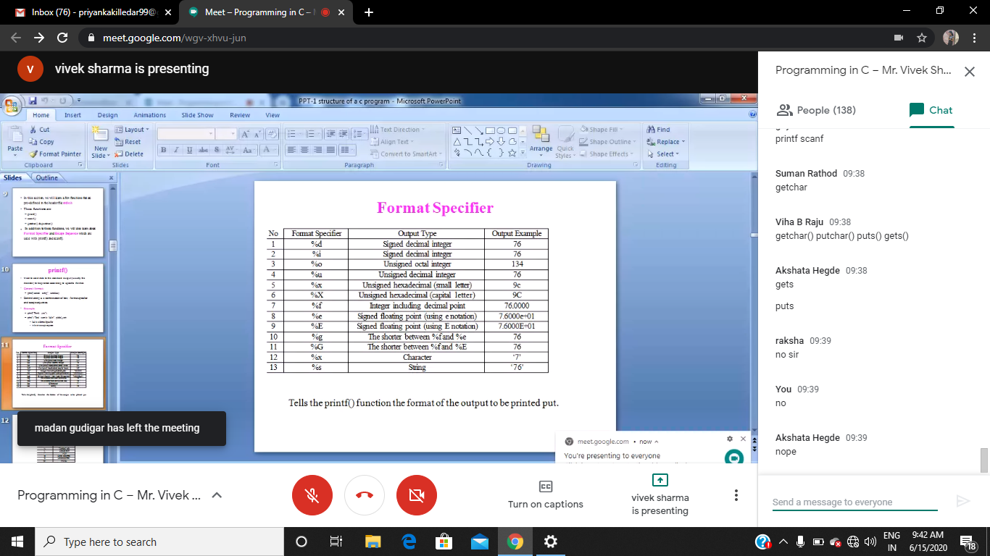

**Python workshop :**



