DAILY ONLINE ACTIVITIES SUMMARY

|  |  |  |  |  |  |  |  |
| --- | --- | --- | --- | --- | --- | --- | --- |
| **Date:** | **22/05/2020** | | | | **Name:** | **Kavya.R.Shetty** | |
| **Sem & Sec** | **VI , A sec** | | | | **USN:** | **4AL17CS042** | |
| Online Test Summary | | | | | | | |
| **Subject** | | **OR IA.1 Test** | | | | | |
| **Max. Marks** | | **30** | | **Score** | | **30** | |
| Certification Course Summary | | | | | | | |
| **Course** | **PYTHON FOR MACHINE LEARNING** | | | | | | |
| **Certificate Provider** | | | **Great Learning Academy** | **Duration** | | | **5hours** |
| Coding Challenges | | | | | | | |
| **Problem Statement:**   1. Write a C Program to implement various operations of Singly Linked List Stack. 2. Write a Java Program to separate the Individual Characters from a String 3. Write a Java Program to find the largest and smallest word in a string. | | | | | | | |
| **Status: Completed** | | | | | | | |
| **Uploaded the report in Github** | | | | **Yes** | | | |
| **If yes Repository name** | | | | <https://github.com/kavya-shetty765/DAILY-> [STATUS](https://github.com/nandithashetty/DAILY-STATUS) | | | |
| **Uploaded the report in slack** | | | | **Yes** | | | |

# Online Test Details:

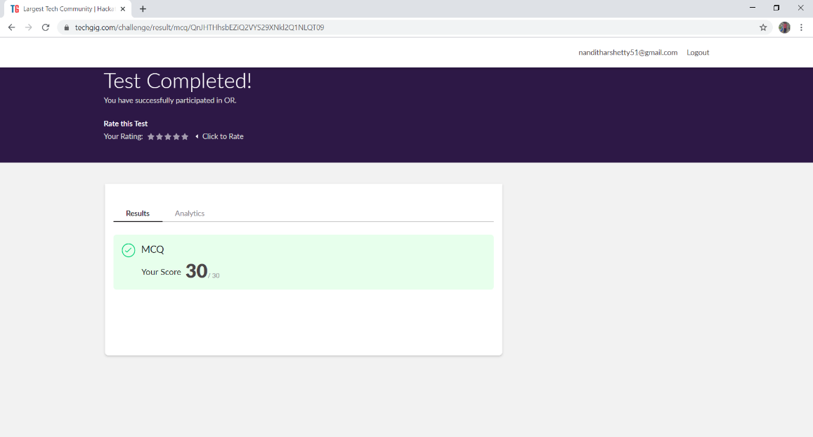

**Certification course Details:**

**Python for machine learning**

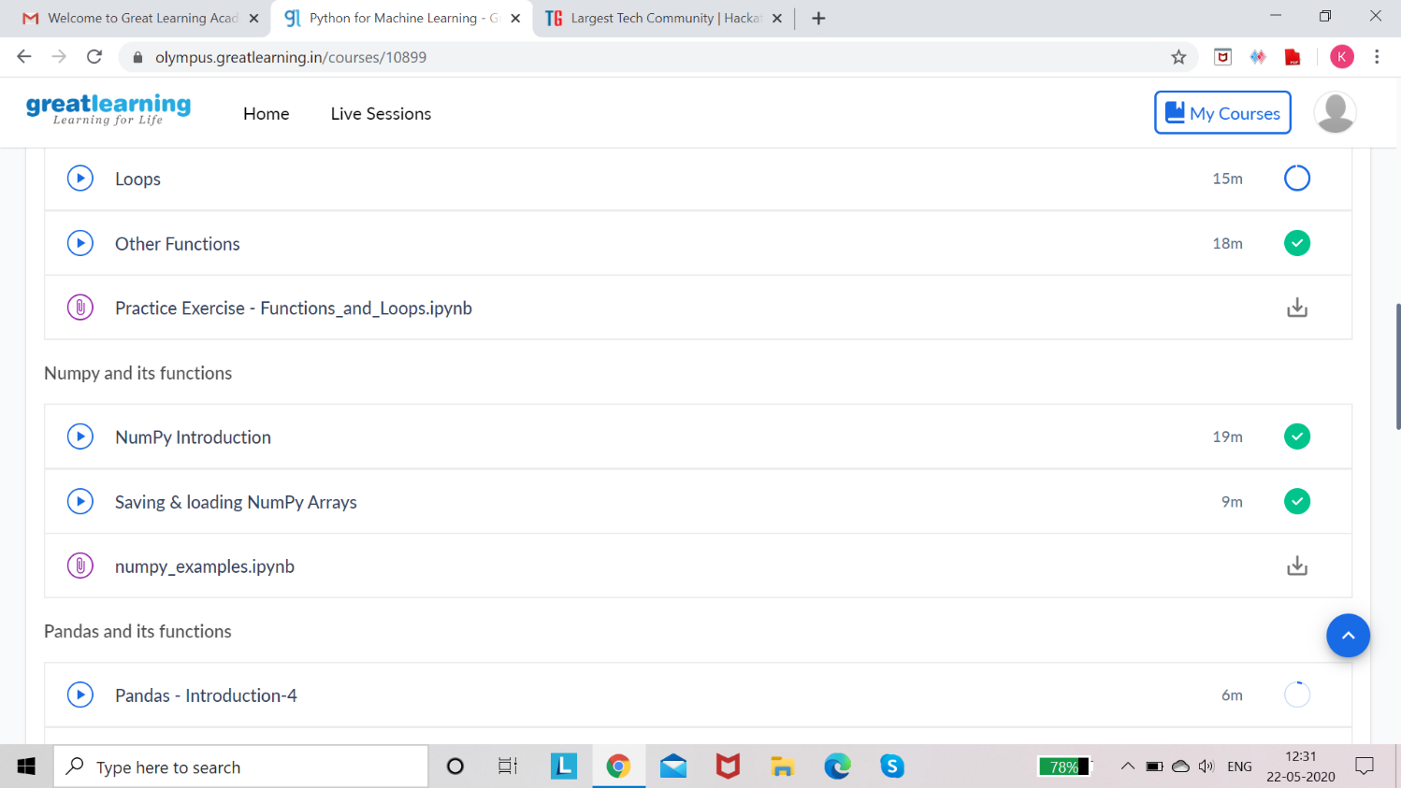

# Coding Challenge Details:

Refer the GitHub for Detailed Information:

<https://github.com/kavya-shetty765/DAILY-STATUS/tree/master/22-05-> [2020/ONLINE%20CODING](https://github.com/nandithashetty/DAILY-STATUS/tree/master/22-05-2020/ONLINE%20CODING)

The same report is also available in : <https://github.com/kavya-shetty765/DAILY-STATUS/tree/master/22-05-2020>