DAILY ONLINE ACTIVITIES SUMMARY

|  |  |  |  |  |  |  |  |
| --- | --- | --- | --- | --- | --- | --- | --- |
| **Date:** | **28/05/2020** | | | | **Name:** | **Kavya.R.Shetty** | |
| **Sem & Sec** | **VI , A sec** | | | | **USN:** | **4AL17CS042** | |
| Online Test Summary | | | | | | | |
| **Subject** | | **OS IA.2 Test** | | | | | |
| **Max. Marks** | | **30** | | **Score** | | **24** | |
| Certification Course Summary | | | | | | | |
| **Course** | **Introduction to Information Security** | | | | | | |
| **Certificate Provider** | | | **Great Learning Academy** | **Duration** | | | **5.5 hrs** |
| Coding Challenges | | | | | | | |
| **Problem Statement:**   1. Python program to find digital root of a number. 2. Write a function that accepts a string consisting entering of brackets ({}) and returns whether it is balanced. 3. write jsp code to display today’s date and time using expression tag 4. write jsp script to determine how many times the visitor has loaded the page 5. Given an array arr[] of size N and an integer K. The task is to find the last remaining element in the array after reducing the array. | | | | | | | |
| **Status: Completed** | | | | | | | |
| **Uploaded the report in Github** | | | | **Yes** | | | |
| **If yes Repository name** | | | | https://github.com/kavyashetty-765/DAILY-STATUS | | | |
| **Uploaded the report in slack** | | | | **Yes** | | | |

# Online Test Details:

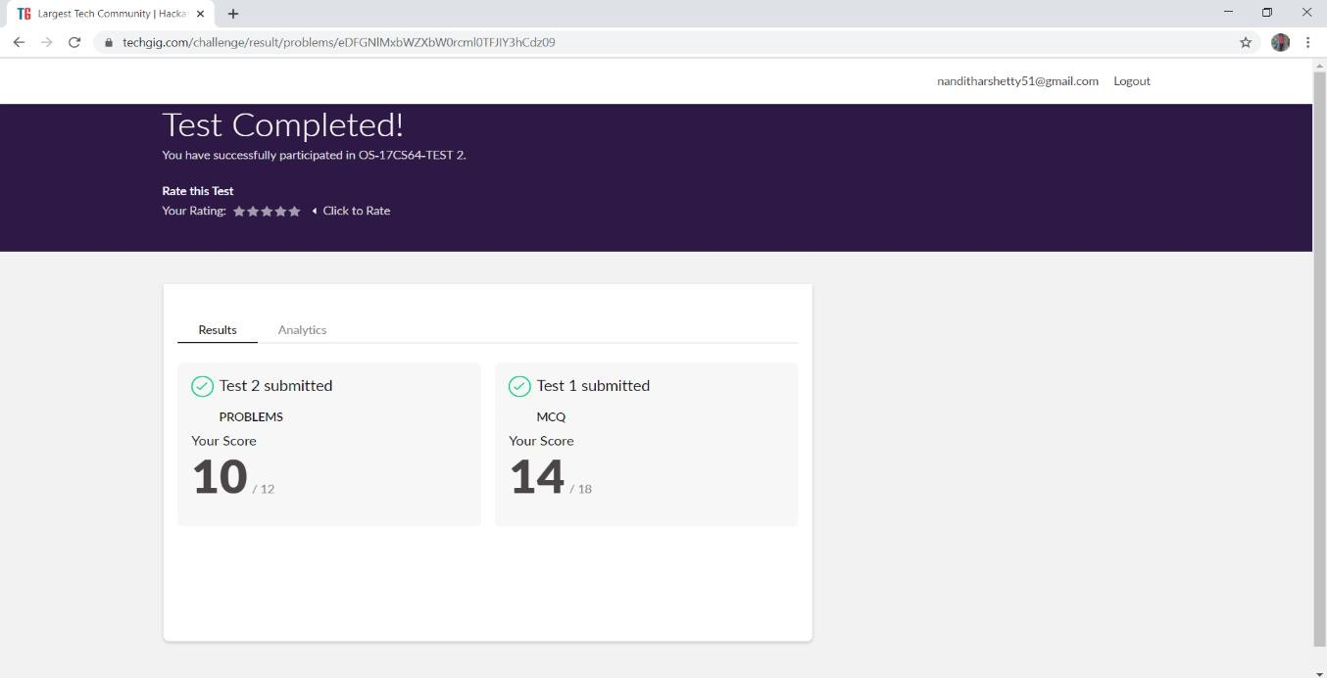

**Certification course Details:**

**Introduction to Information Security:**

Today I learnt detailed information about intro to Stanford and computer Security Field,Computer Security-its application and its future,Innovation in Cybersecurity-Quantum Computing

Refer GitHub account for Detailed information:

<https://github.com/kavya-shetty765/DAILY-STATUS/tree/master/28.05.2020>

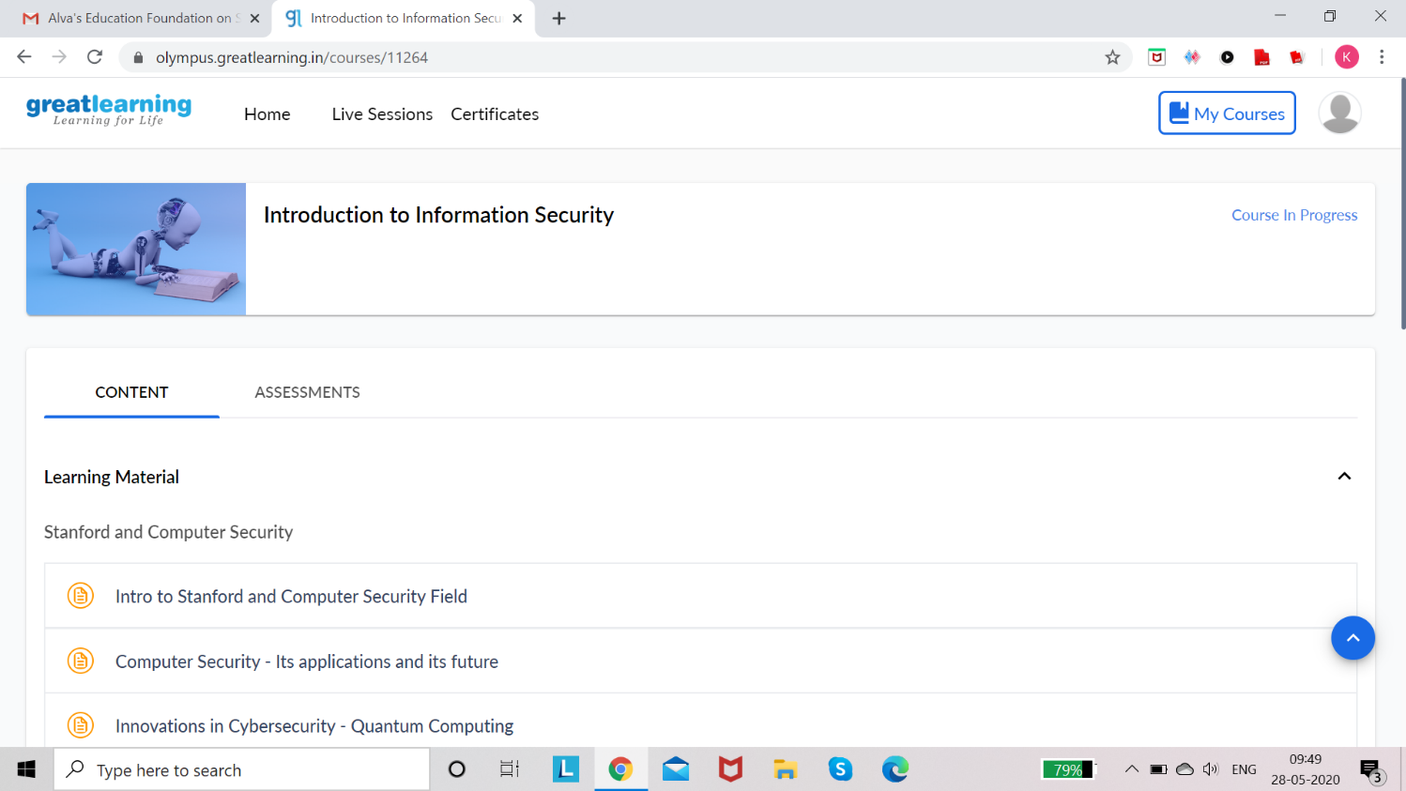

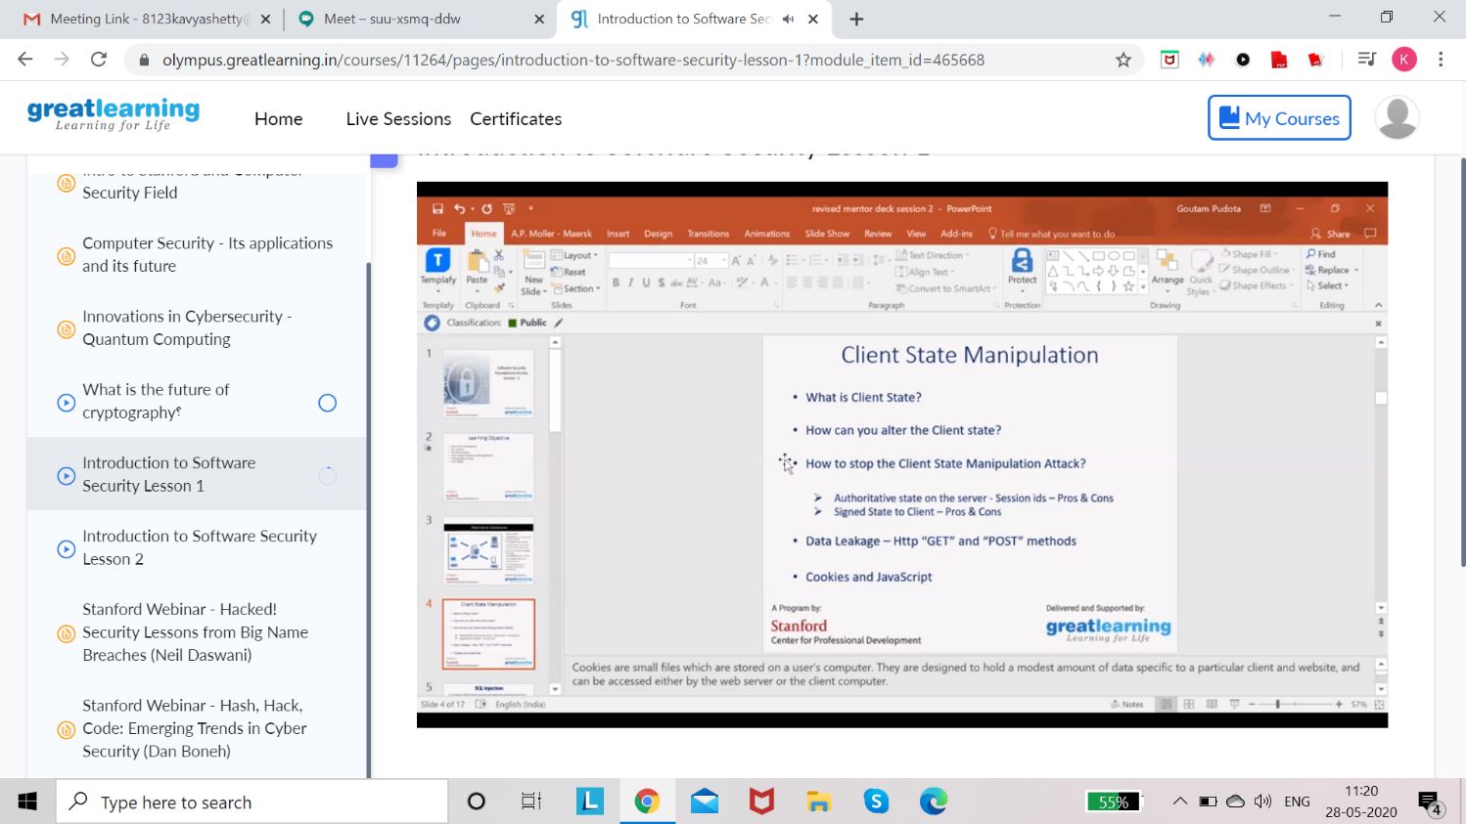

# Coding Challenge Details:

Refer the GitHub for Detailed Information:

<https://github.com/kavya-shetty765/DAILY-STATUS/tree/master/28.05.2020/ONLINE%20CODING>

The same report is also available in :

<https://github.com/kavya-shetty765/DAILY-STATUS/tree/master/28.05.2020>