DAILY ONLINE ACTIVITIES SUMMARY

|  |  |  |  |  |  |  |  |
| --- | --- | --- | --- | --- | --- | --- | --- |
| **Date:** | **7/06/2020** | | | | **Name:** | **Kavya.R.Shetty** | |
| **Sem & Sec** | **VI , A sec** | | | | **USN:** | **4AL17CS042** | |
| Online Test Summary | | | | | | | |
| **Subject** | | **SSCD IA 3** | | | | | |
| **Max. Marks** | | **30** | | **Score** | | **22** | |
| Certification Course Summary | | | | | | | |
| **Course** | **Introduction to Cloud Computing** | | | | | | |
| **Certificate Provider** | | | **COGNITIVE CLASS IBM** | **Duration** | | | **10 hrs** |
| Coding Challenges | | | | | | | |
| **Problem Statement:**   1. write a java Program to print smallest and biggest possible palindrome word in a given string 2. Python program to Print a list of first and last 5 elements where the values are square of numbers between 1 and 30 (both included) | | | | | | | |
| **Status: Completed** | | | | | | | |
| **Uploaded the report in Github** | | | | **Yes** | | | |
| **If yes Repository name** | | | | <https://github.com/kavya-shetty765/DAILY-STATUS> | | | |
| **Uploaded the report in slack** | | | | **Yes** | | | |

# Online Test Details:

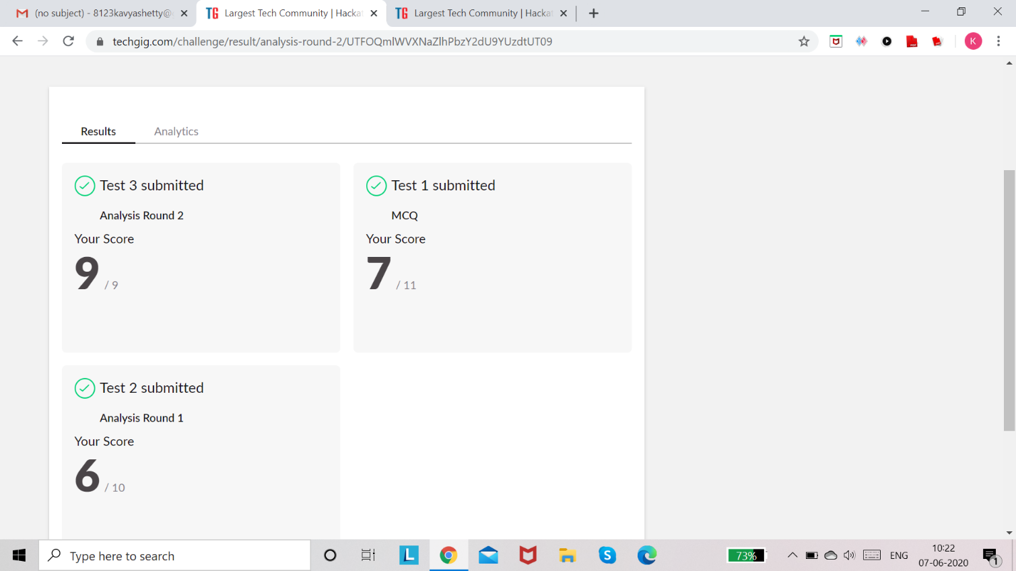

**Certification course Details:**

**Introduction to Cloud Computing:**

## Today I learnt Module 7 - “Cloud Security, Case Studies and Jobs in Cloud Computing”

In that I learnt about these topics,

* Cloud Security
* Case Studies in different Industry Verticals
* Carrer Opportunities and Job roles in Cloud computing Completed **Final Test** and Obtained **Certificate** and **Badge** for the same

## Certificate:

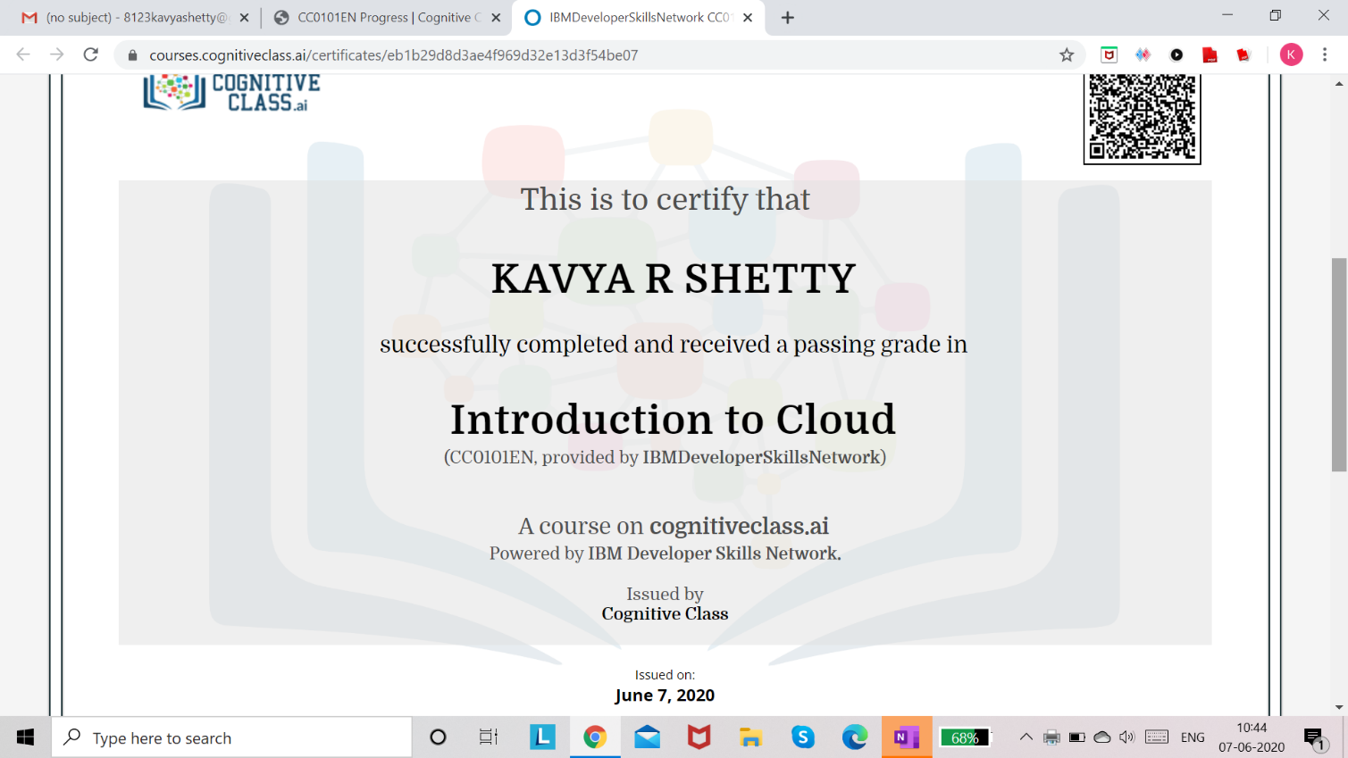

**Badge:**

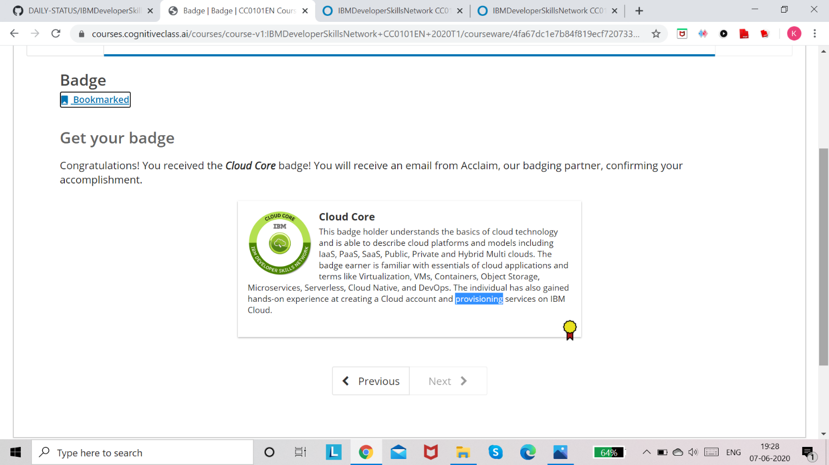

Refer GitHub account for Detailed information:

<https://github.com/kavya-shetty765/DAILY-STATUS/tree/master/7-06-> [2020/CERTIFICATION%20COURSE](https://github.com/nandithashetty/DAILY-STATUS/tree/master/7-06-2020/CERTIFICATION%20COURSE)

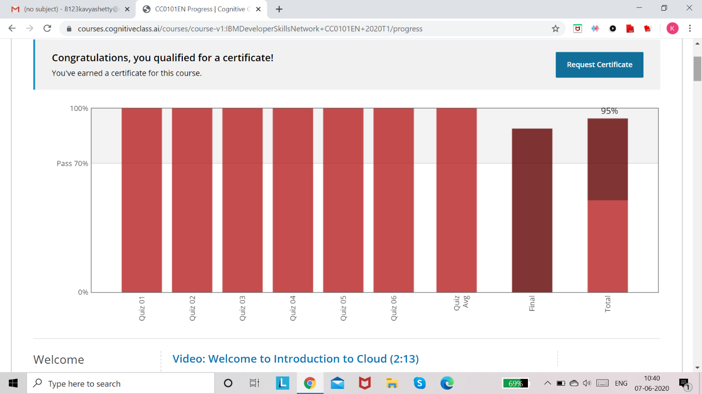

# Coding Challenge Details:

Refer the GitHub for Detailed Information:

<https://github.com/kavya-shetty765/DAILY-STATUS/tree/master/7-06-> [2020/ONLINE%20CODING](https://github.com/nandithashetty/DAILY-STATUS/tree/master/7-06-2020/ONLINE%20CODING)

The same report is also available in : <https://github.com/kavya-shetty765/DAILY-STATUS/tree/master/7-06-2020>