PROJECT DOCUMENTATION
NextStep
An AI-Powered Decision Helper
"Say what's stuck. Get three steps."

Live Demo: 2102007.github.io
Prepared by: [Student / Team Name]
Institution: [Institution Name]
Date: September 2026

Table of Contents

1. Title and Project Overview

1.1 Title
NextStep — an AI-powered decision helper.

1.2 Overview
NextStep is a web-based decision-support application that helps users move from feeling "stuck" to taking action. A user describes a situation they are unsure how to approach — an upcoming exam, a career choice, a stalled project, or free time they don't know how to use — along with the outcome they want, the time they have available, and their current energy level. NextStep converts that input into a short, concrete action plan of three prioritised steps, each with a time estimate, plus a daily challenge to keep the user engaged and a streak tracker to encourage consistent use.
The application targets a common problem: people are often not short of advice, they are short of a clear, small next action. Rather than presenting long articles or generic tips, NextStep produces a compact, situation-specific plan that can be acted on immediately.

1.3 Target Users
- Students preparing for exams or assignments with limited time.
- Working professionals facing a career decision or a stalled task.
- Individuals who want structured suggestions for using free time productively.
- Anyone managing a personal project who needs the next concrete step, not a full plan.

1.4 Live Deployment
The application is deployed as a static site on GitHub Pages at 2102007.github.io, making it accessible from any modern browser without installation.

2. Problem Statement
People frequently know that they need to do something — study, apply for a job, start a project, use their free time better — but freeze at the point of deciding where to begin. Existing tools tend to fall into two categories, neither of which solves this: heavyweight productivity/task-management apps that assume the user already has a broken-down plan, and generic self-help or advice content that is too broad and time-consuming to translate into an immediate action.
This creates a specific gap that NextStep addresses:
- Users need a plan personalised to their exact situation, not generic advice.
- Users need the plan to respect real constraints — the time and energy they actually have right now.
- Users need the very first, smallest possible action clearly identified, so starting doesn't require further decision-making.
- Users benefit from a lightweight mechanism (streaks, daily challenges) that encourages them to return and keep acting rather than stalling again.
NextStep's core problem statement can therefore be summarised as: how can a system take a short, free-text description of a stuck situation, together with simple constraints, and reliably output a short, doable, prioritised plan the user can start acting on within minutes?

3. Objectives

3.1 Primary Objective
To design and implement a web application that converts a user's described situation and constraints into a short, actionable, personalised plan.

3.2 Specific Objectives
- Allow users to register and log in so their plans and progress can be associated with their account.
- Capture the user's situation through a structured input form: category, free-text description of what is going on, the definition of "done", available time, and energy level.
- Generate a plan consisting of a short summary, three concrete steps with titles, descriptions, and time estimates.
- Prioritise steps sensibly (for example, tackling the most difficult or feared task first while the user's energy is highest).
- Provide a daily challenge to sustain engagement beyond a single plan-generation session.
- Track and display a usage streak to encourage the user to return and act consistently.
- Keep the experience lightweight and installation-free by delivering it as a responsive, mobile-friendly single web app.
- Store account and progress data locally so the demo can run entirely client-side without a hosted backend.

4. Technology Stack
NextStep is built as a static, client-rendered web application so that it can be hosted for free and run entirely in the browser, with no server-side component required for the demo.
Layer | Technology | Purpose
Frontend Markup & Styling | HTML5, CSS3 | Structure and styling of the single-page application; dark theme with a gold/amber accent colour.
Frontend Logic | JavaScript (ES6+) | Handles form interaction, tab switching, validation, plan-generation logic, and rendering.
Client-Side Data Store | Browser localStorage | Persists user accounts, sessions, generated plans, and streak counters directly in the browser.
AI / Plan Generation | Rule-based logic engine (extendable to an LLM API) | Maps situation category, free-text input, time, and energy level to a prioritised 3-step plan and a daily challenge.
Hosting / Deployment | GitHub Pages | Free static hosting for the compiled site, served at 2102007.github.io.
Version Control | Git & GitHub | Source control, change history and collaboration.
Design | Custom CSS (dark UI, rounded controls, monospace accents) | Provides the distinctive dark, minimal, focus-first interface.

4.1 Why This Stack
- A pure HTML/CSS/JS stack keeps the project dependency-free and easy to host on GitHub Pages at no cost.
- localStorage removes the need for a backend/database server during development and demonstration, while still giving users persistent accounts and streaks on their own device.
- The plan-generation logic is isolated in its own module so that it can later be swapped for a call to a real large-language-model API without changing the rest of the application.

5. System Architecture
NextStep follows a simple client-only architecture. All logic — authentication, form handling, plan generation, and progress tracking — executes in the user's browser. There is no application server; GitHub Pages only serves static files. The architecture is organised into four logical layers:

5.1 Layers
- Presentation Layer — HTML/CSS screens: authentication (Register/Login), the situation input form, and the generated-plan view.
- Application Logic Layer — JavaScript modules that validate input, coordinate screen transitions, and call the plan-generation engine.
- Plan Generation Engine — a rule-based module that maps { category, situationText, doneDefinition, timeAvailable, energyLevel } to a plan summary, three ordered steps, and a daily challenge.
- Persistence Layer — localStorage read/write helpers that store users, sessions, plans, and streaks as JSON.

5.2 Architecture Diagram
┌─────────────────────────────────────────────────────────┐
│ BROWSER (CLIENT) │
│ │
│ ┌───────────────┐ ┌───────────────────────────────┐ │
│ │ Presentation │ │ Application Logic │ │
│ │ - Register │──▶│ - form validation │ │
│ │ - Login │◀──│ - auth.js (register/login) │ │
│ │ - Situation │──▶│ - screen routing │ │
│ │ form │ │ │ │
│ │ - Plan view │◀──│ │ │
│ └───────────────┘ └───────────────┬─────────────────┘ │
│ │ │
│ ▼ │
│ ┌─────────────────────────────────┐ │
│ │ Plan Generation Engine │ │
│ │ (planEngine.js) │ │
│ │ category + text + time + │ │
│ │ energy → summary + 3 steps │ │
│ │ + daily challenge │ │
│ └─────────────────┬─────────────────┘ │
│ │ │
│ ▼ │
│ ┌─────────────────────────────────┐ │
│ │ Persistence Layer │ │
│ │ (storage.js → localStorage) │ │
│ │ nextstep_users / _plans / _streaks│ │
│ └─────────────────────────────────┘ │
└─────────────────────────────────────────────────────────┘
Served as static files (HTML/CSS/JS) via GitHub Pages

6. Database / Data Model (ER Diagram)
Because NextStep is delivered as a static, client-only demo, there is no hosted relational database. Instead, the same entities that a server-side database would hold are modelled as JSON records inside the browser's localStorage, keyed by entity name (e.g. nextstep_users, nextstep_plans, nextstep_streaks). The logical structure and relationships below apply equally to this local store and to a future hosted database (e.g. a document or relational store), should the project move to a server-backed backend.

6.1 Entities and Relationships
- A User has many Plans (one-to-many): userId in plans references id in users.
- A User has exactly one Streak record (one-to-one): userId in streaks references id in users.
- A Plan embeds exactly three Steps (one-to-many, embedded rather than a separate table, since steps are never queried independently of their parent plan).
- A Session references the currently authenticated User (one-to-one, transient).

6.2 users
Entity | Field | Type | Description
users | id | String (UUID) | Unique identifier for the account
users | name | String | Display name entered at registration
users | email | String | Login identifier, unique per account
users | passwordHash | String | Hashed password (client-side demo hashing)
users | createdAt | Date/ISO string | Account creation timestamp

6.3 sessions
Entity | Field | Type | Description
sessions | userId | String (FK → users.id) | Currently logged-in user
sessions | loginAt | Date/ISO string | Timestamp of the current session start

6.4 plans
Entity | Field | Type | Description
plans | id | String (UUID) | Unique identifier for a generated plan
plans | userId | String (FK → users.id) | Owner of the plan
plans | category | String | Situation category: Student, Career, Free time, Project, Something else
plans | situationText | String | Free-text description of what is going on
plans | doneDefinition | String | User's description of what "done" looks like
plans | timeAvailable | String (enum) | Selected time budget, e.g. 1 hour, 2 hours
plans | energyLevel | String (enum) | Low / Medium / High
plans | summary | String | One-line description of the generated plan's strategy
plans | steps | Array<Step> | Ordered list of 3 generated steps (see Step below)
plans | createdAt | Date/ISO string | When the plan was generated

6.5 step (embedded within plans.steps)
Entity | Field | Type | Description
step (embedded) | order | Integer | Step position (1, 2, 3)
step (embedded) | title | String | Short step title
step (embedded) | description | String | Instructions for completing the step
step (embedded) | timeMinutes | Integer | Estimated time to complete, in minutes

6.6 streaks
Entity | Field | Type | Description
streaks | userId | String (FK → users.id) | Owner of the streak record
streaks | currentStreak | Integer | Consecutive days the user has generated/completed a plan
streaks | lastActiveDate | Date/ISO string | Last date the streak was updated
streaks | todayChallenge | String | The daily challenge text shown to the user

6.7 ER Diagram (Conceptual)
┌───────────────────┐ ┌───────────────────────┐
│ users │ │ plans │
├───────────────────┤ 1 * ├───────────────────────┤
│ id (PK) │───────▶│ id (PK) │
│ name │ │ userId (FK) │
│ email │ │ category │
│ passwordHash │ │ situationText │
│ createdAt │ │ doneDefinition │
└─────────┬─────────┘ │ timeAvailable │
│ 1 │ energyLevel │
│ │ summary │
│ │ steps [ ] (embedded) │
▼ 1 │ createdAt │
┌───────────────────┐ └───────────────────────┘
│ streaks │
├───────────────────┤ ┌───────────────────────┐
│ userId (PK, FK) │ │ step (embedded x3) │
│ currentStreak │ ├───────────────────────┤
│ lastActiveDate │ │ order │
│ todayChallenge │ │ title │
└───────────────────┘ │ description │
│ timeMinutes │
└───────────────────────┘

7. UI Screenshots
The following screens illustrate the core user flow: creating an account, describing a situation, and receiving a generated plan.

7.1 Registration Screen
New users create an account with a name, email, and password. A note discloses that accounts are stored only in the local browser for this demo.
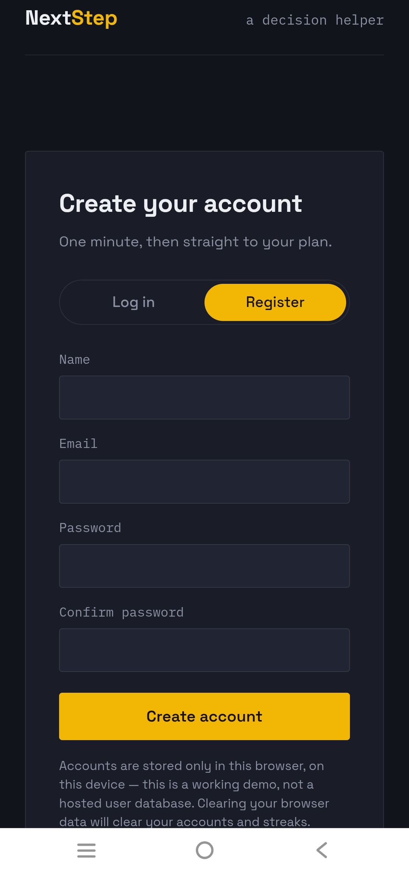
Figure 1: Create-account screen with the Log in / Register toggle.

7.2 Login Screen
Returning users log in with email and password to resume their streak and previously generated plans.
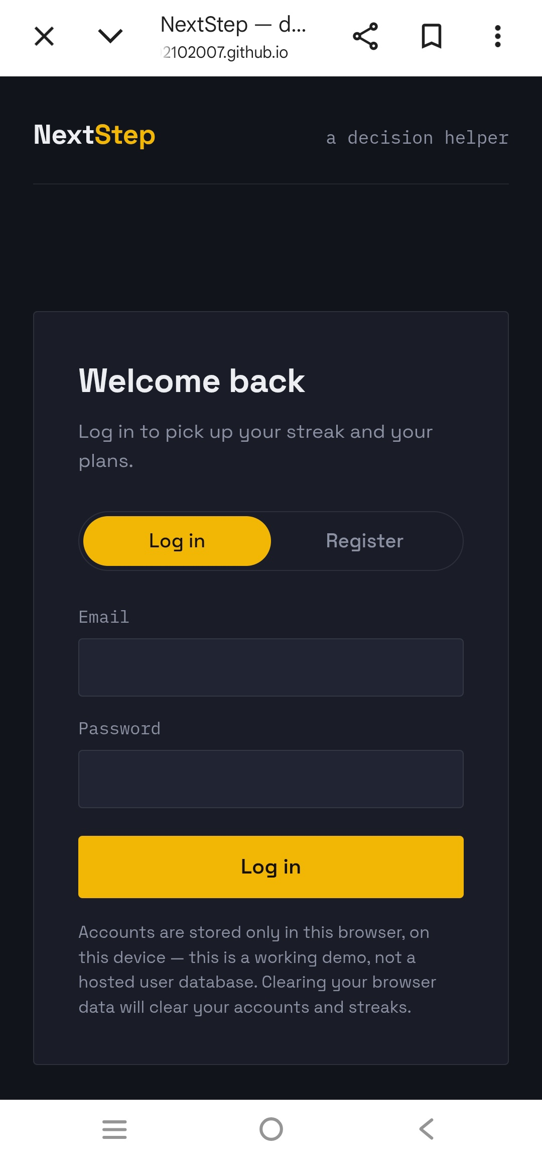
Figure 2: Login screen for returning users.

7.3 Situation Input Form
After logging in, the user selects a category (Student, Career, Free time, Project, Something else), describes what is going on, defines what "done" looks like, and selects the time available and their current energy level.
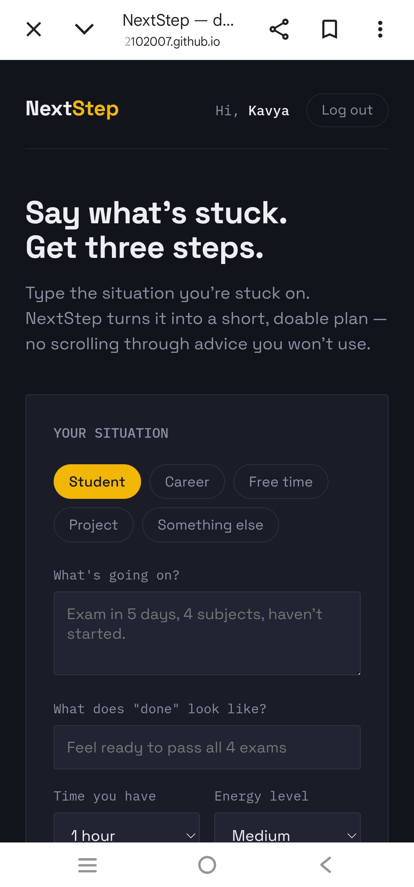
Figure 3: Situation input form, shown here with the Student category selected.

7.4 Generated Plan and Daily Challenge
NextStep returns a short plan summary followed by three numbered, time-boxed steps, and — further down the page — a daily challenge to sustain engagement.
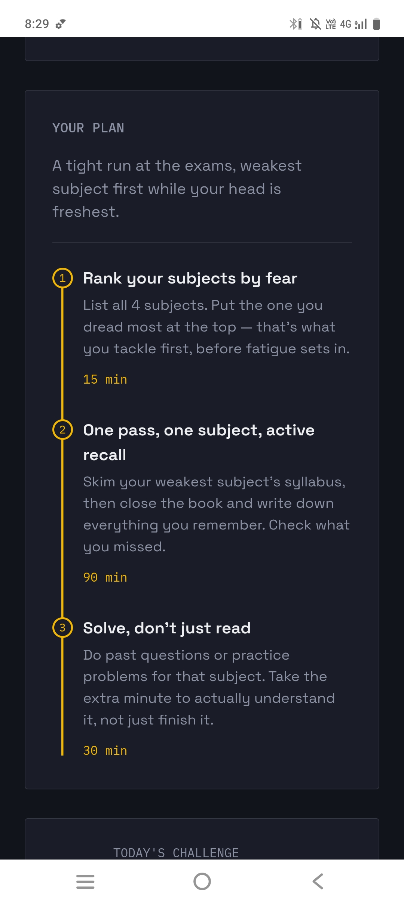
Figure 4: Generated three-step plan for an exam-preparation scenario.

8. API Endpoint Documentation
The current build of NextStep is fully client-side: instead of HTTP endpoints on a remote server, the same responsibilities are implemented as internal JavaScript functions that read from and write to localStorage. They are documented below in an endpoint-style format so the module can be lifted directly onto a real backend (e.g. REST or serverless functions) with minimal change to the calling code.

POST /auth/register
Creates a new user account. Implemented client-side as registerUser(name, email, password), which validates the fields, checks for an existing email, hashes the password, and writes a new record to nextstep_users.
Request
Field | Type | Description
name | String | Full name of the user
email | String | Unique email address
password | String | Plain-text password (hashed before storage)
Response
Field | Type | Description
success | Boolean | Whether the account was created
userId | String | Newly created user's UUID
error | String | Present only if success is false, e.g. "Email already registered"

POST /auth/login
Authenticates a user. Implemented as loginUser(email, password), which looks up the account, verifies the password hash, and creates a session record.
Request
Field | Type | Description
email | String | Registered email address
password | String | Plain-text password to verify
Response
Field | Type | Description
success | Boolean | Whether authentication succeeded
user | Object | { id, name, email } of the authenticated user
error | String | Present only if success is false, e.g. "Invalid credentials"

POST /auth/logout
Ends the current session. Implemented as logoutUser(), which clears the session record from localStorage.
Request
Field | Type | Description
— (none) | — | Uses the current session context
Response
Field | Type | Description
success | Boolean | Always true once the session is cleared

POST /plans/generate
Generates a new plan from the user's situation input. Implemented as generatePlan(input), the core function of the plan-generation engine described in Section 9.
Request
Field | Type | Description
category | String | One of: Student, Career, Free time, Project, Something else
situationText | String | Free-text description of the situation
doneDefinition | String | Description of the desired end state
timeAvailable | String | Selected time budget, e.g. "1 hour"
energyLevel | String | Low, Medium, or High
Response
Field | Type | Description
planId | String | UUID of the newly generated plan
summary | String | One-line description of the plan's overall strategy
steps | Array | Three step objects: { order, title, description, timeMinutes }
challenge | String | Today's daily challenge text

GET /plans/:userId
Retrieves all plans previously generated for a user. Implemented as getUserPlans(userId), reading and filtering the nextstep_plans store.
Request
Field | Type | Description
userId | String (path param) | Account whose plans should be returned
Response
Field | Type | Description
plans | Array | List of plan objects belonging to the user, most recent first

GET / PUT /streaks/:userId
Reads or updates a user's streak. Implemented as getStreak(userId) and updateStreak(userId), which increments the counter when a plan is generated on a new calendar day and resets it after a missed day.
Request
Field | Type | Description
userId | String (path param) | Account whose streak should be read or updated
Response
Field | Type | Description
currentStreak | Integer | Consecutive active days
lastActiveDate | String | ISO date of the last recorded activity
todayChallenge | String | Current day's challenge text

9. CRUD Implementation Details
CRUD operations are implemented as plain JavaScript functions operating on JSON arrays kept in localStorage under dedicated keys (nextstep_users, nextstep_plans, nextstep_streaks). Each entity follows the same pattern:

9.1 Create
- registerUser() appends a new record to nextstep_users after validating that the email is not already in use.
- generatePlan() appends a new record to nextstep_plans once the plan-generation engine (Section 10) produces the three steps.
const users = JSON.parse(localStorage.getItem('nextstep_users')) || [];
users.push(newUser);
localStorage.setItem('nextstep_users', JSON.stringify(users));

9.2 Read
- loginUser() reads nextstep_users and matches the supplied email/password.
- getUserPlans() reads nextstep_plans and filters by userId to render the plan history.
- getStreak() reads the single streak record for the logged-in user to display the current streak count and today's challenge.

9.3 Update
- updateStreak() updates currentStreak and lastActiveDate whenever a new plan is generated, applying the increment/reset rule described in Section 10.3.
- Profile fields (name) can be updated in place by locating the record by id and overwriting the relevant field before re-saving the array.

9.4 Delete
- logoutUser() deletes the active session record.
- A "Clear my data" action (exposed to satisfy the demo's transparency notice) removes a user's entries from nextstep_users, nextstep_plans, and nextstep_streaks.
Because every operation reads the full array, mutates it in memory, and writes the whole array back, the implementation deliberately trades scalability for simplicity — acceptable for a single-user, single-device demo, and easy to replace with real HTTP calls to a database-backed API (see Section 13, Future Enhancements) without changing the function signatures used by the UI.

10. Testing Results
Testing was performed manually against the deployed build, covering authentication, form validation, plan generation, streak logic, persistence, and responsiveness.

10.1 Test Cases and Results
ID | Test Case | Expected Result | Status
TC-01 | Register with valid name, email, and matching passwords | Account created; user redirected to the situation form | Pass
TC-02 | Register with an email already in use | Registration blocked with "Email already registered" message | Pass
TC-03 | Register with mismatched Password / Confirm password | Form blocks submission and highlights the mismatch | Pass
TC-04 | Log in with correct email and password | User authenticated; greeted as "Hi, [Name]" | Pass
TC-05 | Log in with incorrect password | "Invalid credentials" error shown; user remains on login screen | Pass
TC-06 | Submit situation form with all fields completed | Plan generated with summary, 3 steps, and time estimates | Pass
TC-07 | Submit situation form with the situation field empty | Form blocks submission and prompts for the missing field | Pass
TC-08 | Generate plans on consecutive days | Streak counter increments by one each day | Pass
TC-09 | Skip a day, then generate a plan | Streak resets to 1 | Pass
TC-10 | Log out and log back in | Previously generated plans and streak are still available | Pass
TC-11 | Load the app on a narrow mobile viewport | Layout reflows correctly; all controls remain usable | Pass
TC-12 | Clear browser storage, then reload | Application resets to a logged-out state, as disclosed to the user | Pass

10.2 Summary
- Total test cases executed: 12
- Passed: 12 | Failed: 0
- Browsers tested: latest Chrome and Firefox on desktop; Chrome on Android. All core flows (register, login, plan generation, streak tracking) behaved consistently across these targets.

10.3 Known Limitations Surfaced by Testing
- Because data is stored per-browser, an account created on one device or browser is not accessible from another.
- Clearing browser data removes all accounts, plans, and streaks, as disclosed on the registration screen.

11. Installation and Execution Steps

11.1 Using the Live Demo
No installation is required to try NextStep. Visit the hosted demo in any modern browser:
https://2102007.github.io

11.2 Running the Project Locally
- Clone the repository:
git clone https://github.com/2102007/2102007.github.io.git
- Move into the project directory:
cd 2102007.github.io
- Since the project is static HTML/CSS/JS, open index.html directly in a browser, or serve it locally to avoid any browser file-access restrictions:
npx serve .
# or
python3 -m http.server 8000
- Open the printed local address (e.g. http://localhost:8000) in a browser.

11.3 Deployment
The project is deployed via GitHub Pages directly from the repository's default branch. Any commit pushed to that branch is automatically rebuilt and published at the project's GitHub Pages URL within a few minutes.

11.4 Resetting the Demo
Because all data lives in the browser, a full reset simply requires clearing the site's local storage from the browser's developer tools or site settings.

12. Challenges and Solutions

12.1 Producing Plans That Feel Personal, Not Generic
Challenge: A rule-based generator can easily produce advice that feels templated regardless of what the user typed.
Solution: The generation logic combines the selected category with keyword and constraint signals from the free-text situation, the stated time budget, and energy level to choose both the plan's overall strategy (e.g. tackle the hardest item first while energy is high) and the wording of individual steps, so that two different situations in the same category still produce visibly different plans.

12.2 Persisting Data Without a Backend
Challenge: Delivering user accounts, plan history, and streaks without a hosted database or server.
Solution: All persistence was implemented against the browser's localStorage, with the trade-off (per-device storage, no cross-device sync) clearly disclosed to the user directly on the registration and login screens.

12.3 Keeping Users Coming Back
Challenge: A one-off plan generator does not build a habit.
Solution: A daily challenge and a streak counter were added so that returning to the app and taking a small action each day is rewarded and visible, encouraging repeat use beyond a single session.

12.4 Fitting a Multi-Field Form on Mobile
Challenge: The situation form has several inputs (category, description, done-definition, time, energy) that needed to remain usable on small screens.
Solution: The form was built with a single-column, vertically stacked layout, large touch-friendly controls, and pill-style category buttons that wrap naturally on narrow viewports.

12.5 Communicating Trust and Limitations
Challenge: Users might assume a hosted account system exists and be surprised when data doesn't follow them across devices.
Solution: An explicit note ("Accounts are stored only in this browser, on this device — this is a working demo, not a hosted user database") is shown directly beneath the authentication forms.

13. Future Enhancements
- Replace the rule-based plan generator with a call to a large-language-model API for richer, more adaptive plans, using the existing generatePlan() interface as the integration point.
- Move accounts, plans, and streaks from localStorage to a hosted database (e.g. PostgreSQL or a managed document store) behind a real REST or GraphQL API, enabling cross-device sync.
- Add password recovery and email verification for real account security.
- Introduce push or email reminders to nudge users to keep their streak alive.
- Allow users to mark steps as complete and track completion rate per plan, not just plan generation.
- Add analytics on which categories and step types users complete most often, to keep improving the generation logic.
- Support collaborative or shared plans, e.g. a study group tackling the same exam.
- Add light/dark theme toggle and further accessibility improvements (screen-reader labelling, keyboard navigation audit).
- Package the app as an installable Progressive Web App (PWA) for offline use.

14. Git Repository / Reference Details
Item | Detail
Live site | https://2102007.github.io
Repository (inferred from Pages URL) | https://github.com/2102007/2102007.github.io
Hosting | GitHub Pages (static site, served from the default branch)
Primary branch | main
License | [Add license, e.g. MIT — update to match the actual repository]

14.1 Suggested Repository Structure
2102007.github.io/
├── index.html # Entry point, situation form & auth screens
├── /css
│ └── style.css # Dark theme, layout, component styling
├── /js
│ ├── auth.js # registerUser, loginUser, logoutUser
│ ├── planEngine.js # generatePlan and category logic
│ ├── streaks.js # getStreak, updateStreak
│ └── storage.js # localStorage read/write helpers
├── /assets # Icons, images
└── README.md

Note: exact file names and structure should be verified against the actual repository and this section updated accordingly.

