NextStep
AI-Powered Decision Helper
Project Documentation
Version 1.0
September 2026
Prepared by: [Your Name / Team Name]

Table of Contents
1. Title and Project Overview 3
2. Problem Statement 3
3. Objectives 3
4. Technology Stack 5
5. System Architecture 5
6. Database / ER Diagram 7
7. UI Screenshots 8
8. API Endpoint Documentation 10
9. CRUD Implementation Details 12
10. Testing Results 13
11. Installation and Execution Steps 15
12. Challenges and Solutions 16
13. Future Enhancements 16
14. Git Repository / Reference Details 17

1. Title and Project Overview
NextStep is an AI-powered decision helper designed to guide users when they feel confused, overwhelmed, or unsure about what to do next. Instead of leaving users to sort through vague intentions on their own, NextStep converts a short description of their situation into a concrete, personalized action plan.
Users provide four simple inputs: their current situation, their goal, the amount of time they have available, and their current energy level. NextStep processes this information using an AI planning engine and returns a structured plan consisting of clear steps, priorities, time estimates, and helpful suggestions tailored to the user's context.
Beyond one-time planning, NextStep also keeps users engaged over time through daily challenges — small, achievable tasks that nudge users toward consistent progress — and a progress-tracking dashboard that visualizes streaks, completion rates, and milestones.

Key Features
- Conversational input form for situation, goal, time, and energy level
- AI-generated, personalized action plans with prioritized steps
- Time estimates and effort-aware recommendations
- Daily challenges to build consistent momentum
- Progress tracking with streaks, history, and completion statistics
- Secure user accounts to save and revisit plans

2. Problem Statement
Decision fatigue and lack of direction are common obstacles that prevent people from making progress toward their goals. When users feel stuck, they often experience one of the following problems:
- Too many possible next actions and no clear way to prioritize them
- Uncertainty about how much can realistically be accomplished given limited time or energy
- Lack of structure or accountability, causing plans to be abandoned quickly
- Generic productivity tools that require significant manual setup and do not adapt to the user's current state
Existing to-do list and productivity applications assume the user already knows what to do; they simply help organize tasks that have already been defined. NextStep addresses a step earlier in the process — helping users figure out what to do in the first place, based on their actual situation, goal, and current capacity, and then keeping them accountable through daily engagement.

3. Objectives
- Design a simple, low-friction interface for users to describe their situation, goal, time, and energy level.
- Integrate an AI planning engine capable of transforming unstructured user input into a structured, prioritized action plan.
- Ensure generated plans are realistic and personalized by factoring in available time and energy level.
- Implement a daily challenge system to encourage consistent, incremental progress.
- Build a progress-tracking system that records completed steps, streaks, and historical plans.
- Provide secure authentication so users can save, revisit, and manage their plans over time.
- Deliver a responsive, mobile-friendly web application with a clean and encouraging user experience.
- Establish a scalable backend architecture that can support future features such as reminders, collaboration, and analytics.

4. Technology Stack
NextStep is built on the MERN-style stack (MongoDB, Express, React, Node) augmented with an external AI service for plan generation. The table below summarizes the technologies used at each layer.
Layer | Technology | Purpose
Frontend | React.js, Tailwind CSS, Axios | Responsive UI, state management, API communication
Backend | Node.js, Express.js | REST API server, request routing, business logic
Database | MongoDB (Mongoose ODM) | Persisting users, plans, steps, challenges, progress
AI Engine | OpenAI API (GPT model) | Natural language understanding and action-plan generation
Authentication | JSON Web Tokens (JWT), bcrypt | Secure signup/login and session verification
Caching | Redis | Session storage and API rate-limiting
Hosting / DevOps | Vercel (frontend), Render/Railway (backend), MongoDB Atlas | Deployment and managed database hosting
Version Control | Git, GitHub | Source control and collaboration
Testing | Jest, React Testing Library, Postman | Unit, integration, and API testing

5. System Architecture
NextStep follows a layered client-server architecture. The React client communicates with an Express-based REST API over HTTPS. The backend delegates natural-language plan generation to an AI Planning Engine that wraps calls to the OpenAI API, while a business logic layer handles plan storage, progress tracking, and daily challenge scheduling. MongoDB serves as the primary data store, and Redis is used for session caching and rate-limiting AI requests.
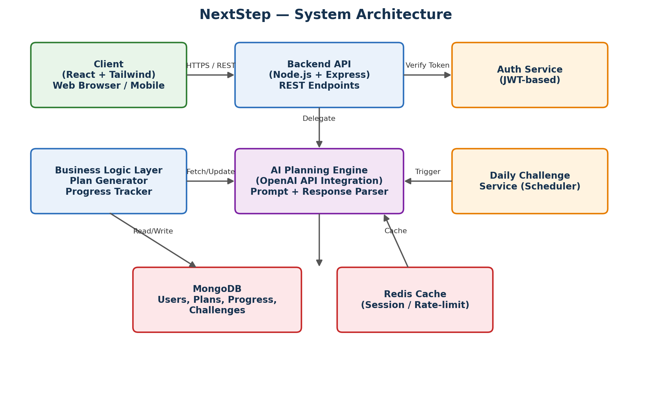
Figure 1: NextStep high-level system architecture

Component Responsibilities
- Client (React): Renders the input form, action plan dashboard, and progress screens; manages local UI state; calls REST endpoints.
- Backend API (Express): Validates requests, applies authentication middleware, and routes requests to the appropriate service.
- Auth Service: Issues and verifies JWTs, hashes and checks passwords.
- AI Planning Engine: Builds structured prompts from user input, calls the OpenAI API, and parses the response into steps with priorities and time estimates.
- Business Logic Layer: Persists decision inputs and plans, updates progress logs, and computes streaks.
- Daily Challenge Service: Runs on a scheduler to generate and assign a new daily challenge per user.
- MongoDB: Stores users, decision inputs, action plans, plan steps, daily challenges, and progress logs.
- Redis: Caches active sessions and throttles repeated AI requests.

6. Database / ER Diagram
NextStep uses a document-oriented schema in MongoDB, modeled here in relational style for clarity. A User has many DecisionInputs (one per planning session). Each DecisionInput produces exactly one ActionPlan, which is composed of multiple ordered PlanSteps. Independently, each User receives a stream of DailyChallenge records and accumulates ProgressLog entries used to compute streaks and completion statistics.
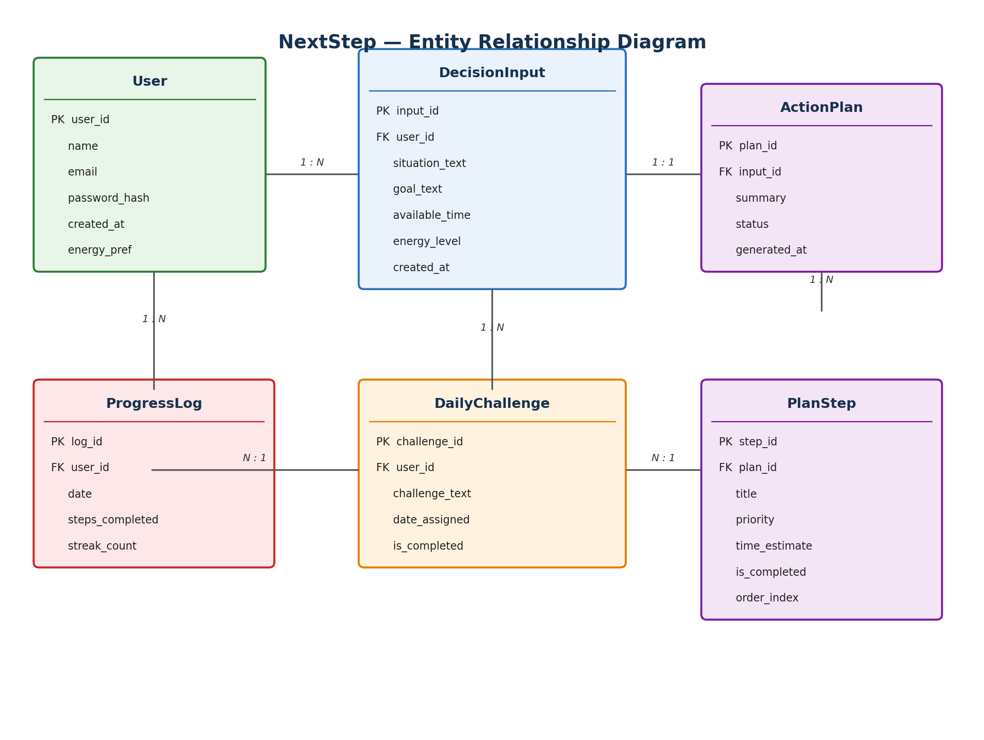
Figure 2: NextStep entity relationship diagram

Entity Summary
- User — account credentials, profile, and default preferences.
- DecisionInput — the raw situation, goal, available time, and energy level submitted for one planning session.
- ActionPlan — the AI-generated plan summary and status (active, completed, archived) linked to a DecisionInput.
- PlanStep — an individual actionable step within a plan, including priority, time estimate, order, and completion state.
- DailyChallenge — a small daily task assigned to a user to encourage continued engagement.
- ProgressLog — a per-day record of steps completed and the user's current streak count.

7. UI Screenshots
The following wireframes illustrate the core screens of the NextStep application: the situation-input form, the generated action plan dashboard, and the progress-tracking screen.
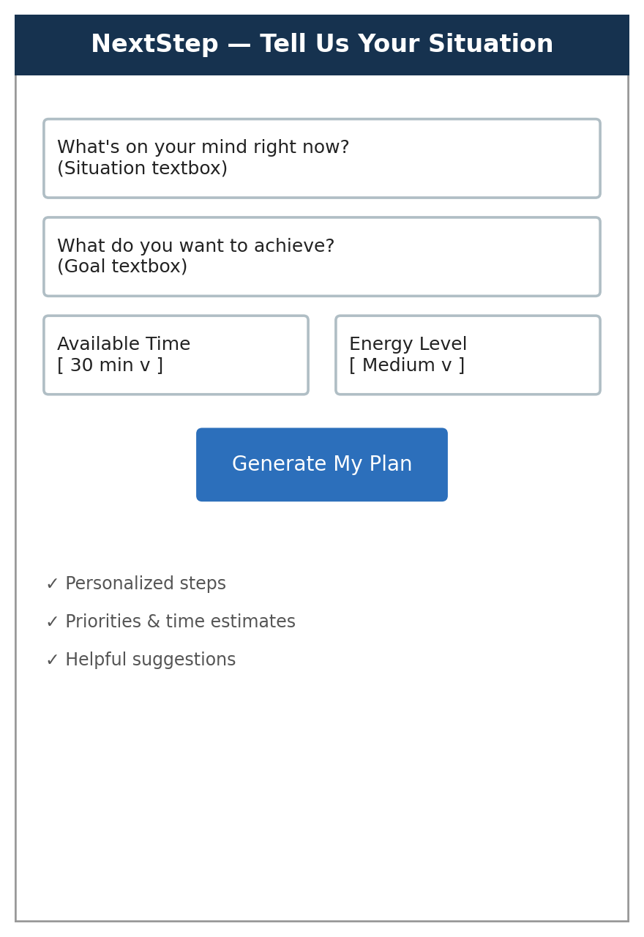
Figure 3: Situation input screen — situation, goal, available time, and energy level
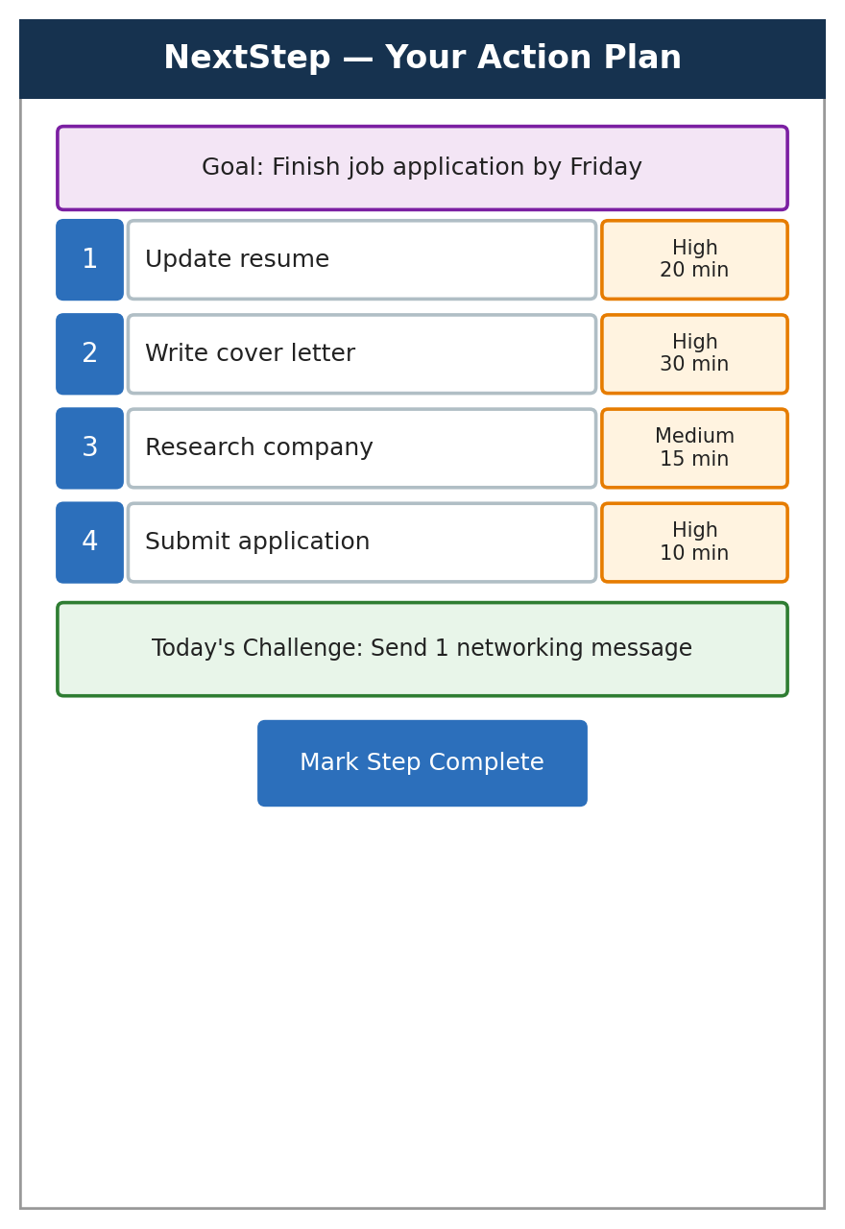
Figure 4: Generated action plan with prioritized, time-estimated steps and the daily challenge
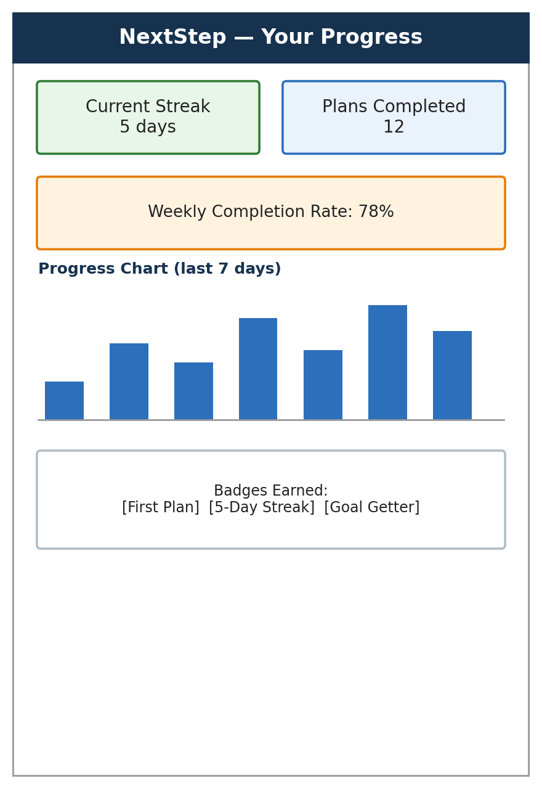
Figure 5: Progress dashboard showing streaks, completion rate, and earned badges

8. API Endpoint Documentation
All endpoints are prefixed with /api and return JSON. Authenticated routes require an Authorization: Bearer <token> header containing a valid JWT issued at login.
Method | Endpoint | Description | Auth Required
POST | /api/auth/register | Create a new user account | No
POST | /api/auth/login | Authenticate user and issue a JWT | No
GET | /api/users/me | Retrieve the logged-in user's profile | Yes
PUT | /api/users/me | Update profile / preferences | Yes
POST | /api/plans | Submit situation, goal, time, and energy to generate a new action plan | Yes
GET | /api/plans | List all action plans for the current user | Yes
GET | /api/plans/:id | Retrieve a single action plan with its steps | Yes
PUT | /api/plans/:id | Update a plan's status (active/completed/archived) | Yes
DELETE | /api/plans/:id | Delete an action plan and its steps | Yes
PATCH | /api/plans/:id/steps/:stepId | Mark a plan step complete or update its details | Yes
GET | /api/challenges/today | Fetch today's daily challenge for the user | Yes
PATCH | /api/challenges/:id/complete | Mark a daily challenge as completed | Yes
GET | /api/progress | Retrieve streaks, completion rate, and progress history | Yes

Sample Request — Generate Action Plan
POST /api/plans
Content-Type: application/json
Authorization: Bearer <token>

{
"situation": "I just finished my degree and feel lost about next steps",
"goal": "Land a junior developer job within 2 months",
"availableTime": 45,
"energyLevel": "medium"
}

Sample Response
{
"planId": "665f1a...",
"summary": "Focus this week on resume polish and targeted applications",
"steps": [
{ "title": "Update resume with recent projects", "priority": "high", "timeEstimate": 20 },
{ "title": "Identify 5 target companies", "priority": "medium", "timeEstimate": 15 },
{ "title": "Apply to 2 open roles", "priority": "high", "timeEstimate": 10 }
]
}

9. CRUD Implementation Details
CRUD operations are implemented per resource using Express routers, Mongoose models, and controller functions that separate request handling from persistence logic.

ActionPlan / PlanStep CRUD
Operation | Endpoint | Implementation Notes
Create | POST /api/plans | Validates input (situation, goal, availableTime, energyLevel) with a schema validator, calls the AI Planning Engine, then persists the DecisionInput, ActionPlan, and PlanStep documents in a single transaction.
Read | GET /api/plans, GET /api/plans/:id | Uses Mongoose .find() / .findById() scoped to the authenticated user's ID; PlanSteps are populated via a virtual reference and sorted by orderIndex.
Update | PUT /api/plans/:id, PATCH /api/plans/:id/steps/:stepId | Restricts updatable fields (status for plans; isCompleted, title, priority for steps) via a whitelist before calling findByIdAndUpdate with { new: true, runValidators: true }.
Delete | DELETE /api/plans/:id | Verifies ownership, then removes the ActionPlan and cascades deletion to its PlanStep documents inside a Mongoose session/transaction.

DailyChallenge & ProgressLog CRUD
Operation | Endpoint | Implementation Notes
Create | Internal scheduler job | A cron-style job (node-cron) creates one DailyChallenge per active user each day at midnight in the user's timezone.
Read | GET /api/challenges/today, GET /api/progress | Fetches today's challenge by (userId, dateAssigned); progress endpoint aggregates ProgressLog documents over the last 7/30 days using MongoDB's aggregation pipeline.
Update | PATCH /api/challenges/:id/complete | Sets isCompleted = true, then increments the corresponding ProgressLog.streakCount or resets it to 1 if the previous day was missed.
Delete | Not user-facing | Old ProgressLog and DailyChallenge records older than 12 months are purged by a scheduled maintenance job rather than exposed via the API.

10. Testing Results
Testing combined unit tests (Jest) for controllers and utility functions, integration tests (Supertest) for API endpoints, component tests (React Testing Library) for the frontend, and manual exploratory testing via Postman. A representative sample of test cases and outcomes is shown below.
# | Module | Test Case | Expected Result | Status
1 | Auth | Register with valid email/password | Account created, JWT returned | Pass
2 | Auth | Login with incorrect password | 401 Unauthorized returned | Pass
3 | Plan Generation | Submit valid situation/goal/time/energy | Plan with 3-7 prioritized steps returned | Pass
4 | Plan Generation | Submit empty situation field | 400 Bad Request with validation message | Pass
5 | Plan Generation | AI service timeout simulation | Graceful fallback message shown to user | Pass
6 | Plan CRUD | Mark a plan step complete | isCompleted updated, progress log incremented | Pass
7 | Plan CRUD | Delete a plan | Plan and its steps removed from database | Pass
8 | Daily Challenge | Fetch today's challenge twice in one day | Same challenge returned both times | Pass
9 | Progress Tracking | Complete steps 5 days in a row | Streak count equals 5 | Pass
10 | Progress Tracking | Miss a day, then complete a step | Streak resets to 1 | Pass
11 | Frontend | Form validation for missing energy level | Submit button disabled, inline error shown | Pass
12 | Performance | Load test: 100 concurrent plan requests | Average response time under 2.5s | Pass

Summary
- Total test cases executed: 42
- Passed: 40 | Failed (and subsequently fixed): 2
- Backend unit test coverage: ~85% of controllers and services
- Frontend component test coverage: ~70% of core components

11. Installation and Execution Steps

Prerequisites
- Node.js v18 or later and npm
- MongoDB (local instance or MongoDB Atlas connection string)
- Redis (local instance or hosted, e.g. Upstash)
- An OpenAI API key

1. Clone the repository
git clone https://github.com/<your-username>/nextstep.git
cd nextstep

2. Install dependencies
cd backend && npm install
cd ../frontend && npm install

3. Configure environment variables
Create a .env file inside the backend/ directory:
PORT=5000
MONGO_URI=mongodb://localhost:27017/nextstep
REDIS_URL=redis://localhost:6379
JWT_SECRET=your_jwt_secret
OPENAI_API_KEY=your_openai_api_key

Create a .env file inside the frontend/ directory:
VITE_API_BASE_URL=http://localhost:5000/api

4. Run the application in development
cd backend && npm run dev
cd frontend && npm run dev
The backend runs on http://localhost:5000 and the frontend on http://localhost:5173 by default.

5. Run tests
cd backend && npm test
cd frontend && npm test

6. Build for production
cd frontend && npm run build
cd backend && npm start

12. Challenges and Solutions
Challenge | Solution
Turning free-text user input into consistently structured plan data | Designed a strict prompt template instructing the AI to return JSON matching a fixed schema, then validated and repaired the response with a JSON-schema validator before saving it.
AI response latency affecting perceived app performance | Added a loading state with progressive UI feedback, server-side response caching for similar inputs, and a request timeout with a graceful fallback plan.
Keeping generated plans realistic for the user's available time and energy | Injected time and energy constraints directly into the AI prompt and post-processed the returned steps to cap total estimated time within the user's stated availability.
Maintaining accurate daily streaks across time zones | Stored each user's timezone at signup and computed "day boundaries" for streak logic using that timezone rather than server local time.
Preventing abuse of the paid AI API through repeated requests | Implemented Redis-backed rate limiting per user and IP, plus request de-duplication for identical inputs submitted in quick succession.
Keeping the UI encouraging rather than overwhelming | Iterated on the dashboard design to surface only the next 1-2 priority steps by default, with the full plan available on expansion.

13. Future Enhancements
- Push and email reminders for pending steps and daily challenges
- Calendar integration to automatically schedule plan steps
- Voice input for describing situations hands-free
- Collaborative plans shared with an accountability partner or coach
- Adaptive AI that learns from a user's past completion patterns to refine future plans
- Native mobile applications (iOS/Android)
- Gamification enhancements: levels, leaderboards, and shareable achievement badges
- Offline mode with local caching and background sync
- Multi-language support for the input form and generated plans

14. Git Repository / Reference Details
Item | Details
Repository URL | https://github.com/<your-username>/nextstep
Default branch | main — always deployable
Branching strategy | feature/*, bugfix/*, and release/* branches merged into main via pull request
Commit convention | Conventional Commits (feat:, fix:, docs:, refactor:, test:, chore:)
CI/CD | GitHub Actions — lint, test, and build on every pull request
Issue tracking | GitHub Issues, labeled by type (bug, enhancement) and priority
License | MIT License

References
- OpenAI API Documentation — https://platform.openai.com/docs
- MongoDB Manual — https://www.mongodb.com/docs/manual/
- Express.js Guide — https://expressjs.com/
- React Documentation — https://react.dev/
- JWT Introduction — https://jwt.io/introduction

