
INDUSTRY INTERNSHIP REPORT
On

“JAVA FULL STACK”

By
GOLLA KAVYA (219X1A0527)

Submitted in accordance with the requirement for the degree of B-Tech in

Department of Computer Science and Engineering

G. PULLA REDDY ENGINEERING COLLEGE (Autonomous): KURNOOL

(Affiliated to JNTUA, ANANTHAPURAMU) KURNOOL - 518007
2024 – 2025


Department of Computer Science and Engineering

G. PULLA REDDY ENGINEERING COLLEGE (Autonomous): KURNOOL

(Affiliated to JNTUA, ANANTHAPURAMU)

CERTIFICATE

This is to certify that the internship titled ‘Java Full Stack’ is a Bonafide record of work carried out by GOLLA KAVYA (219X1A0527), and the Internship report is submitted in partial fulfillment of requirements for the award of degree of Bachelor of Technology in Computer Science and Engineering.

……………………………..  Sri. P. Praveen Yadav Assistant Professor Department of C.S.E.,  G. Pulla Reddy Engineering College, Kurnool. | ……………………………..  Dr. N. Kasiviswanath  Professor & Head of the Department Department of C.S.E.,  G. Pulla Reddy Engineering College, Kurnool.

INTERNSHIP DETAILS

Name of the College :G. Pulla Reddy Engineering College
Department :Computer Science and Engineering
Name of the Student :Golla Kavya
Register Number : 219X1A0527
Name of the Faculty Guide : Sri. P. Praveen Yadav
Duration of the Internship : From 23-12-2024 To 23-04-2025 Name and address of the Organization: Dhee Coding Lab,Yelhanka, Bangalore Internship Domain : Java Full Stack
Internship Title : Java Full Stack
Internship Stipend : No Stipend
Date of Internship Report Submission : 30-04-2025

Internship Coordinator
Dr. B. Geetha Vani Professor
CSE Department GPREC

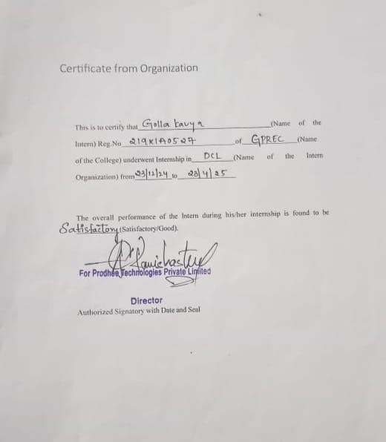

CERTIFICATE FROM ORGANIZATION

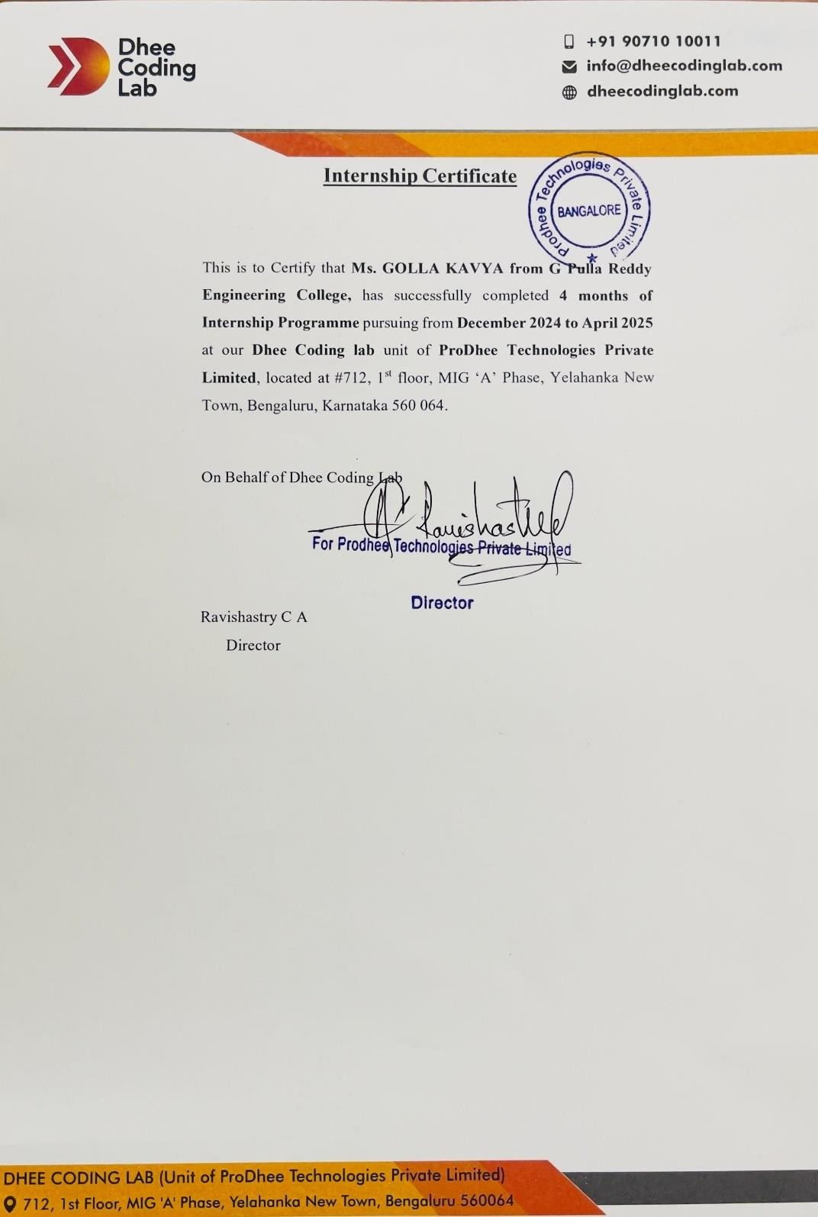
Internship Completion Certificate

DECLARATION

I Golla Kavya, a student bearing the Roll No. 219X1A0527, of the Department of Computer Science and Engineering, G. Pulla Reddy Engineering College, do hereby declare that the I have completed the mandatory internship titled Java Full Stack from 23-12-2024 to 23-04-2025 in Dhee Coding Lab, Bangalore under the Faculty Guide ship of Ravi Shastry.

(Student Signature and Date)

ACKNOWLEDGEMENT

I wish to express my deep sense of gratitude to my internal supervisor Sri. P. Praveen Yadav, Assistant Professor of Computer Science and Engineering Department, G. Pulla Reddy Engineering College.
My sincere thanks to our Internship Coordinator Dr.B.GeethaVani for her immaculate guidance, constant encouragement and cooperation which have made possible to bring out this internship work.
My sincere thanks to Mr. Ravi Shastry, of Organization , for helping me and giving me the required information needed for my internship work.
I am thankful to our Head of the Department Dr.N.Kasiviswanath, for his whole hearted support and encouragement during the internship.
I am grateful to our Internship Dean Dr.Y.V.Siva Reddy and to our respected Principal Dr.B.Sreenivasa Reddy for providing requisite facilities and helping us in providing such a good environment.
I wish to convey my acknowledgements to all the staff members of the Computer Science and Engineering Department for giving the required information needed for my internship work.
Finally, I wish to thank all our friends and well wishers who have helped me directly or indirectly during the course of this internship work.

Table of Contents

Chapter 1: INTRODUCTION 1
  - About the Internship Company/Organization 2
  - Virtual/Offline Internship details 4

Chapter 2: WORK DONE DURING INTERNSHIP 6
  - About Course/Domain 7
  - Technologies learnt during internship 12
  - Assessments/Tasks assigned details 13

Chapter 3: PROJECTS/MODULES COMPLETED 17
  - About Project 1/ Module 1 18
  - About Project 2 / Module 2. 24
  - About Project 3 / Module 3. 27
  - About Project 4 / Module 4. 29

Chapter 4: ACTIVITY LOG 38

Chapter 5: CONCLUSION 42

Chapter 6: REFERENCES 46

LIST OF FIGURES

FIGURE NO.  1.1.1  1.1.2  1.1.3  3.1.1  3.1.2  3.2.1  3.2.2  3.3.1  3.3.2  3.4.1  3.4.2  3.4.3  3.4.4  3.4.5  3.4.6  3.4.7 | FIGURE NAME  DCL LOGO  Phases of Full Stack Java Development Benefits of Full Stack Java Development Shopping Cart Application  Vending Application  Eat Fit Blog Website Interface Eat Fit Blog Interface  DCL Interface DCL website  Visual Chart Diagrams Registering for the Course Login and View Courses Viewing Course Details Student Details  Viewing handled Course  Course Details | PAGE NO.  2  9  11  23  23  26  26  28  28  33  34  34  35  35  36  37

INTRODUCTION

CHAPTER 1: INTRODUCTION

About the Internship Organization
Dhee Coding Lab (DCL)is a Bengaluru-based organization dedicated to transforming individuals into industry-ready software developers through its comprehensive training programs.

Fig 1.1.1 DCL
Dhee Coding Lab is a skill development and training organization that focuses on providing high-quality technical education to students and aspiring professionals. With a strong emphasis on practical learning, DCL specializes in training individuals in the fields of software development, web technologies, and programming languages. The organization is known for its hands-on approach, interactive teaching methods, and mentorship programs aimed at bridging the gap between academic learning and industry requirements.

About Dhee Coding Lab
Dhee Coding Lab is a premier Bengaluru-based educational organization committed to nurturing and transforming aspiring individuals into industry-ready software developers. Through its comprehensive and immersive training programs, Dhee Coding Lab aims to bridge the gap between theoretical knowledge acquired in traditional education systems and the practical skills required in today’s fast-paced tech industry.

Why Choose Dhee Coding Lab?
Dhee Coding Lab stands out for its focused and impactful approach to developer education, delivering a unique learning experience through the following key feature

Intensive Bootcamp Program
Dhee Coding Lab offers a meticulously designed intensive bootcamp, tailored to provide students with a deep and hands-on understanding of software development. The program is structured to simulate real-world scenarios, helping learners build not just coding proficiency but also problem-solving skills, teamwork, and product thinking.

Guaranteed Interview Opportunities
As part of its strong industry integration, Dhee Coding Lab guarantees a minimum of 30 interview opportunities for each enrolled student. This reflects their confidence in the training process and their unwavering commitment to student success and employment.

Real-World Project Exposure

Students are immersed in the end-to-end software development lifecycle, including internships that replicate a hybrid onsite-offshore development model. This gives learners a feel of professional environments, deadlines, and teamwork, preparing them thoroughly for their careers ahead.

Simplified and Inclusive Learning Approach
The program is designed to be accessible to learners from all backgrounds. With its simplified teaching methodology, even students who have completed just 12th grade can enroll and become capable, confident software developers. This inclusive model supports a wide range of learners, regardless of prior technical experience.

Impressive Track Record
Dhee Coding Lab’s success speaks through its numbers:
- 216,000+ hours of collective hands-on software development experience.
- 350,000+ students trained through various programs, workshops, and bootcamps.
- A mission to contribute to a “Skilled India”, empowering youth to meet global technological demands.

Campus Engagement & Collaborations
Dhee Coding Lab collaborates closely with educational institutions across India to extend its training programs, internships, and placement support. A recent example includes their internship interview drive on November 27, 2024, at G. Pulla Reddy Engineering College, Andhra Pradesh, which welcomed participation from students across all departments. These campus partnerships help align academic learning with real industry expectations and opportunities.

Contact Information
- Phone: +91 90710 10011
- Email: info@dheecodinglab.com
- Website: dheecodinglab.com

Offline Internship Details
The Offline Internship Program at Dhee Coding Lab is a comprehensive, 12-week, full-time internship designed to transform students into confident, industry-ready developers. This in-person training experience offers immersive learning through real-world projects, expert mentorship, and daily performance tracking.

Duration & Timings
        - Total Duration: 12 Weeks
        - Timings: Monday to Saturday, from 9:00 AM to 5:00 PM
        - Location: Dhee Coding Lab Campus, Bengaluru

Program Structure
This offline internship is crafted to mirror the dynamic environment of software development companies. The daily schedule is structured to build technical expertise, encourage communication, and promote self-driven learning.

Daily Learning + Practice
Interns engage in hands-on training sessions where they code, debug, and develop real-world applications under the guidance of experienced mentors.

Daily Presentations (2 Hours)
A dedicated 2-hour session each day is reserved for interns to present their learnings and progress. This encourages:
          - Consistent revision and knowledge retention
          - Improved communication and presentation skills
          - Confidence in articulating technical concepts

Mentorship & Guidance
The faculty at Dhee Coding Lab consists of highly experienced mentors, many from prestigious institutions (IITs, IISc) and top tech companies (Google, Microsoft, Meta).

Tech Stack & Tools
Interns work on modern technologies and industry tools including:
- Programming: Python, Java, JavaScript
- Frontend: HTML, CSS, React.js
- Backend: Node.js, Express.js
- Databases: SQL, MongoDB
- Tools: Git, GitHub

Learning Outcomes
By the end of the 1 weeks, interns will:
  - Gain solid experience in building full-stack applications
  - Understand the end-to-end software development lifecycle
  - Improve collaboration through team-based projects
  - Be capable of explaining and documenting their work professionally
  - Receive constructive feedback on their presentations and code

Certificate & Recognition
Upon successful completion, interns receive a certificate of internship, which validates their practical experience and can be added to their resume, portfolio, or LinkedIn profile.

This offline internship at Dhee Coding Lab is not just about learning how to code, it's about developing the confidence, discipline, and communication skills needed to thrive in the software industry.

WORKDONE DURING INTERNSHIP

2.WORKDONE DURING INTERNSHIP

ABOUT COURSE/DOMAIN
Introduction:
Full Stack Java Development is a comprehensive approach to building modern web applications using Java technologies for both frontend (client-side) and backend (server-side) development. It encompasses various components, each critical for ensuring the functionality, performance, and scalability of software throughout its development lifecycle.
    - Frontend Development: This element of Full Stack Java Development focuses on creating the user interface and experience of the application. It includes technologies that define how user interact with the system. It consists of web technologies such as HTML, CSS, and JavaScript, which are used to structure, style, and add interactivity to web pages. Frontend development also involves the use of frameworks like React, Angular, or Vue.js, which help developers build dynamic and responsive single-page applications (SPAs).
    - Backend Development: Backend development involves the server-side logic, application functionality, and database communication. It serves as the core engine that processes user requests, performs business logic, and manages data transactions. This is primarily handled using Java, along with the Spring Framework (including Spring Boot, Spring MVC, and Spring Security) to create robust, scalable, and secure APIs and services. These frameworks offer features such as dependency injection, RESTful service support, and easy configuration for rapid development.
    - Database Management: This component is responsible for data storage, retrieval, and manipulation, which are essential for any dynamic web application. Developers use Relational Databases (e.g., MySQL, PostgreSQL) and NoSQL Databases (e.g., MongoDB) based on the project requirements. Technologies such as JDBC, JPA, and Hibernate are used to connect and map Java objects to database tables, enabling efficient data persistence and management.
    - API and Web Services: APIs facilitate communication between the frontend and backend, allowing seamless data exchange and service invocation. RESTful APIs, developed using Spring Boot or JAX-RS, are widely used for this purpose. These APIs adhere to HTTP methods and standards, ensuring lightweight and efficient interaction. Tools like Swagger are often used for documenting and testing APIs to enhance developer collaboration and productivity.

    - Tools and Development Environments: A variety of tools support the development, build, and deployment processes in Full Stack Java projects. Popular IDEs like IntelliJ IDEA, Eclipse, and NetBeans provide integrated environments for coding, debugging, and testing. Build automation tools like Maven and Gradle manage project dependencies and streamline the compilation and deployment processes.
    - Version Control and Collaboration: Version control is essential for managing code changes and collaboration across development teams. Git is the most widely used version control system, supported by platforms such as GitHub, GitLab, and Bitbucket, which also facilitate team collaboration, code reviews, and continuous integration.
    - Testing: Testing ensures the reliability and correctness of the application before deployment. Developers use tools such as JUnit for unit testing, Mockito for mocking objects in tests, and Selenium for automated browser testing. For behavior-driven development, Cucumber is often used to write human-readable test scenarios that verify business logic.
    - Security: Security is a critical aspect of application development, ensuring the protection of data and user privacy. Spring Security is a key module used to handle authentication, authorization, and secure data transmission. Additionally, technologies like JWT (JSON Web Token) are used for managing session tokens and access control in REST APIs.
    - Soft Skills and Collaboration: Effective Full Stack Java Development also depends on strong communication, collaboration, and problem-solving skills. Cross-functional team collaboration is facilitated through tools like JIRA, Confluence, Slack, and Trello, which help manage project tasks, documentation, and team discussions effectively.

In summary, Full Stack Java Development integrates frontend and backend technologies, tools, and methodologies to build powerful and responsive web applications. By utilizing modern frameworks like Spring Boot and React, adopting best practices, and collaborating effectively, developers can deliver high-quality software that meets user expectations and business goals efficiently.

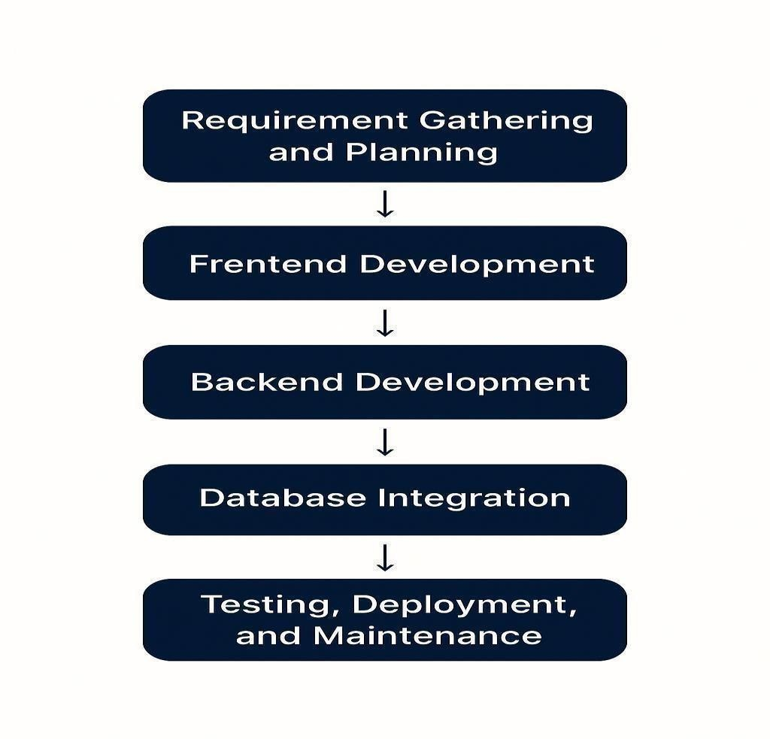
Five Phases of Full Stack Java Development:

Fig 1.1.2: Phases of Full Stack Java Development

The phases of Full Stack Java Development follow a systematic approach to building robust web applications. It begins with requirement gathering and planning, where the scope and objectives of the project are defined. This is followed by frontend development, where the user interface is created using technologies like HTML, CSS, and JavaScript. Next, backend development involves building server-side logic and APIs, often using Java frameworks like Spring Boot. Database integration ensures data is stored and retrieved efficiently using systems such as MySQL or MongoDB. Finally, testing, deployment, and maintenance are carried out to ensure the application is bug-free, properly hosted, and updated regularly for optimal performance.

Development:
Frontend Development: This involves building the user interface (UI) and user experience (UX) using:
    - Languages & Tools: HTML, CSS, JavaScript
    - Frameworks: React, Angular, or Vue.js
    - Focus areas include responsive design, form validation, routing, and state management.
Backend Development: The backend layer handles business logic, API creation, and data manipulation using:
    - Core Language: Java
    - Frameworks: Spring Boot, Spring MVC
    - Tasks: Authentication, authorization, API design, session handling, business rules, and application logic
Database Integration
    - Relational: MySQL, PostgreSQL
    - NoSQL: MongoDB
    - Integrated with the backend using JPA (Java Persistence API) or hibernate for object- relational mapping (ORM).
Prototype Development: Wireframes and working prototypes are created using tools like Figma or Balsamiq for frontend mockups and Postman for testing APIs. Early demos help validate technical choices and design flows.
Refinement Based on Feedback: Stakeholders and users test early builds. Based on usability, performance, and feedback, iterative improvements are made to frontend designs, backend logic, and system architecture.

Deployment and Maintenance:
    - Application is packaged using tools like Maven or Gradle
    - Security & Performance Testing: Using tools like JUnit, Selenium, SonarQube
    - Deployment: On-premise, cloud (AWS, Azure, GCP), or using Docker and Kubernetes for containerized environments. Deployment pipelines are configured using CI/CD tools like Jenkins, GitHub Actions, or GitLab CI. Applications are then launched through platforms such as web portals, app stores, or internal deployment networks.

Service and Support:
Technical Support and Monitoring: Logging and monitoring are handled using tools such as ELK Stack (Elasticsearch, Logstash, Kibana) or Prometheus and Grafana to ensure stability, detect issues, and handle customer complaints.
Updates and Bug Fixes: Regular updates are rolled out with performance improvements, new features, and security patches. Agile or Scrum methodologies guide these incremental releases.
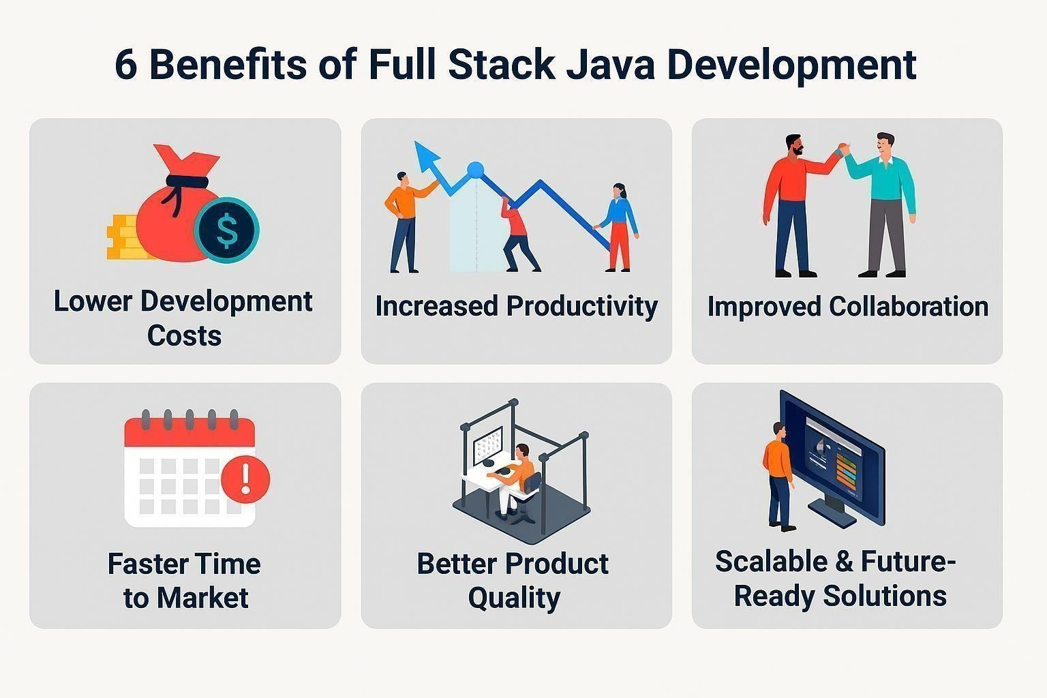

Fig 1.1.3: Benefits of Full Stack Java Development

Full stack Java development offers numerous benefits that make it an attractive choice for businesses. By leveraging a single language across both front-end and back-end, it significantly lowers development costs and boosts productivity. This unified approach fosters improved collaboration among team members, leading to faster time to market for new features and products. Additionally, the robust nature of Java ensures better product quality, while its scalability and future-ready solutions provide a solid foundation for long-term growth and adaptability.

2.2 TECHNOLOGIES LEARNT DURING INTERNSHIP
Used Technologies:
- Core Java
- HTML
- CSS
- Java Script
- Advanced Java

Core Java:
  - Core Java is the foundation of Java programming.
  - It includes basic concepts such as object-oriented programming (OOP), data types, operators, control statements, and exception handling.
  - Supports multithreading and memory management through built-in libraries.
  - Widely used for building desktop applications and the back-end logic of web applications.
  - Provides strong community support and a vast collection of APIs.
  - Essential for understanding frameworks like Spring and Hibernate.
  - Java's platform independence is enabled through the Java Virtual Machine (JVM).

HTML (Hyper Text Markup Language):
  - Standard markup language for creating web pages.
  - Structures the content on the web using elements like headings, paragraphs, images, and links.
  - Works in conjunction with CSS and JavaScript for full front-end development.
  - Easy to learn and widely supported by all browsers.
  - Forms the skeleton of any website.

CSS (Cascading Style Sheets):
  - Used for styling HTML content and improving visual presentation.
  - Controls layout, colors, fonts, spacing, and responsiveness.
  - Supports external, internal, and inline styling methods.
  - Enables animations, transitions, and media queries for responsive design.
  - Works closely with frameworks like Bootstrap for faster styling.

JavaScript:
  - A client-side scripting language used for adding interactivity to web pages.
  - Enables dynamic content updates, form validations, and event handling.

  - Popular frameworks and libraries include React, Angular, and Vue.
  - Runs in browsers without any additional plugins.
  - Essential for modern web application development.

Advanced Java:
  - Extends Core Java by focusing on web and enterprise applications.
  - Includes technologies like Servlets, JSP (JavaServer Pages), JDBC, and EJB.
  - Supports web-based solutions through Java EE and frameworks like Spring and Hibernate.
  - Used for building server-side applications and connecting to databases.
  - Facilitates MVC architecture and RESTful web services.
  - Oftenused in combination with front-end technologies for full-stack development.

2.3 TASKS ASSIGNED DETAILS

Project 1: Console Applications
- Shopping Cart System
Problem Statement: Develop a simple console-based Shopping Cart system where users can add products, remove products, and view their cart before proceeding to checkout.
Goal: Implement the system logic using Java or Python (or any preferred language) and create a user-friendly command-line interface for managing the cart.
Setup and Environment:
- IDE: Eclipse, IntelliJ IDEA (Java) or any Python IDE
- Languages Used: Java, Python

Learning Concepts:
- Basic OOP concepts such as classes and objects (Product, Cart).
- User input handling using Scanner (Java) or input() (Python).
- Loops and arrays/lists for cart management.
- Conditional statements to handle various user actions.

Task Implementation:
- Define classes for Product (name, price, quantity) and ShoppingCart (add product, remove product, view cart).
- Implement logic to add products to the cart and allow users to remove them.
- Allow the user to view the cart contents and display total price.

Test Automation:
- Not necessarily automated, but you can test the cart manually

Vending Machine System
Problem Statement: Design a Vending Machine that simulates the selection of items, payment processing, and item dispensing.
Goal: Create the logic for a Vending Machine using Java or Python, with a simple command- line interface.
Setup and Environment:
- IDE: Eclipse, IntelliJ IDEA (Java) or any Python IDE
- Languages Used: Java, Python Learning Concepts:
- Classes and Objects to represent items, coins, and vending machine logic.
- Conditionals and loops for item selection and error handling.
- Basic math operations to handle payments and change. Task Implementation:
- Create a class for Item (name, price) and a VendingMachine class to manage the inventory and processing.
- Allow users to select an item, input payment, and calculate change.
- Handle scenarios like insufficient funds or out-of-stock items. Test Automation:
- Implement simple tests using a test framework (JUnit for Java or unittest for Python) to verify the selection, payment, and change process.

Project 2: EatFit Blog Website Project Overview:
Develop a responsive and visually appealing EatFit Blog that focuses on health, nutrition, and wellness.
Objective: To create a user-friendly and informative blog about healthy living, promoting topics such as diet, nutrition, fitness, and overall well-being.

Technology Stack:
- Frontend: HTML5, CSS3, JavaScript
- Tools/Editors: Visual Studio Code, Chrome Developer Tools Learning Concepts:
- HTML/CSS for website structure and styling.
- Responsive design using media queries to ensure the blog looks great on all devices.

Task Implementation:
- Homepage: Featuring a banner with the title "EatFit Blog," followed by sections on health, nutrition, and meal plans.
- Navigation Bar: Includes links to sections such as "Home," "About Us," and "Contact."
- Blog Categories: The blog should have clearly defined categories for posts such as "Diet," "Exercise," "Meal Plans," and more.
- Footer: Include contact info, social media links, and other necessary information.
- Social Media Links: Connect users to external platforms like Facebook, Twitter, and Instagram for further engagement.
Test Automation:
- Perform manual testing of the blog on multiple screen sizes to ensure responsive design works.
- Use basic JavaScript testing for dynamic elements like the search bar.

Project 3: Cloning a DCL (Data Communication and Link) Website Project Overview:
Create a clone of a Data Communication and Link (DCL) website, which demonstrates basic networking protocols and concepts.
Objective: Replicate the features of a typical DCL website that presents data communication protocols, network designs, and similar topics.

Technology Stack:
- Frontend: HTML5, CSS3, JavaScript
- Backend (optional): Node.js, Python (Flask) Learning Concepts:
- HTML/CSS for basic layout and design.
- JavaScript for interactive and dynamic content.
- Backend: If needed, use server-side languages like Node.js or Python to simulate data handling and communication.

Task Implementation:
- Homepage: A well-structured homepage that includes a brief about networking, protocols, and links to other pages for detailed discussions.
- Content Pages: Include sections like "TCP/IP," "OSI Model," and "Routing Algorithms."
- Interactive Features: Include examples like clickable protocol diagrams and quizzes for interactivity.

Project4: Course Registration Application using JDBC

Tasks Assigned:
- Problem Statement: Design and implement a course registration system where students can register for courses.
- Goal: Use JDBC to interact with a database to store course and student registration data.

Requirements:
  - JDBC for database interaction
  - Database (e.g., MySQL) for storing courses, students, and registrations
  - Command-line or GUI for interacting with users
- Setup and Environment: Set up a database server, JDBC driver, and Java development environment.
- Learning Concepts: JDBC, SQL queries, connection pooling, CRUD operations.
- Task Implementation: Implement functionality for adding courses, registering students, and viewin
- g registration statuses.
- Test Automation: Use JUnit to test the database interaction and CRUD operations.

3. PROJECTS/MODULES COMPLETED

3. PROJECTS/MODULES COMPLETED

3.1 ABOUT MODULE1:

Java Development (Core & Advanced)
Java is one of the most widely-used programming languages known for its platform independence, robustness, and scalability. The Java Development module combines both Core and Advanced Java concepts to provide a comprehensive learning experience, preparing developers to work on backend systems, web applications, and enterprise-level applications.
Introduction to Java Development:
- Object-Oriented Programming (OOP): Java is an object-oriented language, making it easy to model real-world entities and manage complex software projects.
- Platform Independence: Java applications are platform-independent, meaning they can run on any system that supports the Java Virtual Machine (JVM).
- Multithreading and Concurrency: Java supports multithreading, allowing developers to write highly responsive applications that perform multiple tasks simultaneously.

Topics Covered:
- Core Java Concepts:
- Data Types, Variables, and Operators:
  - Java supports various data types (int, float, char, boolean) to handle different types of data.
  - Variables are used to store values, and operators allow for arithmetic, relational, and logical operations.
- Control Flow Statements:
  - Conditional statements like if, else, and switch help execute different blocks of code based on conditions.
  - Loops (for, while, do-while) allow for repeating tasks efficiently.

- Classes and Objects:
  - Java’s foundation lies in classes and objects, encapsulating data and behavior into reusable components.
- Exception Handling:
  - Java provides a robust error-handling mechanism using try, catch, and finally blocks to ensure smooth program execution.

  - Polymorphism enables different behaviors of the same method, depending on the object.
  - Collections Framework:
  - Java’s collections (List, Set, Map) are used to store and manipulate groups of objects efficiently.

Advanced Java Concepts:
  - Servlets and JSP:
    - Java Servlets process client requests and generate dynamic web content, while JavaServer Pages (JSP) allow for dynamic web page generation, separating business logic from presentation.
    - JDBC (Java Database Connectivity):
    - JDBC enables Java applications to connect to databases, perform CRUD operations, and handle data retrieval and manipulation.
  - Spring Framework:
    - The Spring Framework provides tools for building robust enterprise-level applications, including Dependency Injection (DI), Aspect-Oriented Programming (AOP), and MVC architecture.
    - Spring Boot simplifies backend development, making it easier to build stand-alone, production-grade applications.
  - RESTful Web Services:
    - REST APIs follow standard HTTP methods (GET, POST, PUT, DELETE) to facilitate communication between frontend and backend systems.
    - JSON and XML are commonly used data formats for transmitting information over the network.
  - Multithreading and Concurrency:
    - Java’s multithreading capabilities allow developers to execute multiple tasks simultaneously, improving performance and responsiveness.
    - Security in Java:
    - Java provides tools like Spring Security to handle authentication, authorization, and secure communication within web applications.
- Databases and Data Access:
  - JDBC and Hibernate/JPA:
  - JDBC allows Java applications to interact with relational databases, executing queries and retrieving results.
  - Hibernate and JPA (Java Persistence API) offer an Object-Relational Mapping (ORM) solution to map Java objects to database tables, simplifying database access.

- Development Tools:
  - Git & GitHub: These version control systems are essential for managing code changes and collaborating in teams.
  - Maven: Used for project management and dependency handling in Java applications, ensuring all dependencies are correctly included.

Brief Summary:
This Java Development module equips students with both fundamental and advanced Java concepts, enabling them to create robust backend applications and web services. Core Java provides the foundational skills required for object-oriented programming, exception handling, and multithreading, while Advanced Java introduces enterprise-level technologies like Spring, Servlets, JDBC, and RESTful web services. By mastering both, developers gain the ability to build scalable, efficient, and secure Java applications across various domains, from web development to enterprise solutions. This comprehensive learning ensures a solid understanding of Java’s capabilities, preparing developers for real-world software development challenges.

3.1.1 About Project 1: Console Applications - Shopping Cart and Vending Machine

Project1 Title: Shopping Cart Application & Vending Machine Console Applications
Objective:
The objective of this project is to develop two console-based applications: a Shopping Cart and a Vending Machine. These applications aim to simulate real-world user interactions through text-based interfaces, providing users with a hands-on experience in creating and managing cart systems and vending machine operations. The projects are built using Core Java, which focuses on implementing basic object-oriented concepts like classes, objects, and methods, as well as control flow structures like loops and conditionals. Description:

Shopping Cart Console Application:
The Shopping Cart application is designed to simulate an e-commerce shopping cart system where users can:
        - View a list of products
        - Add items to their cart
        - Remove items from the cart
        - Calculate the total price of items in the cart
        - Proceed to checkout and display the final amount The main features of the application include:
- Product Catalog:
  - The user can view a list of available products, each with a name, price, and unique ID.
  - Products are displayed in a simple text-based format, using a loop to show the product list on the console.
- Add to Cart:
  - Users can select products by entering their product ID and specify the quantity to add them to their cart.
  - The cart is stored as a list, and the application updates the total cost as new items are added.
- Remove from Cart:
  - The user can remove products from the cart by specifying the product ID.
  - If the item is in the cart, it is removed, and the total price is updated accordingly.

- Checkout:
  - Upon completing the selection, the user is prompted to proceed to checkout.
  - The final total amount is displayed, including the tax (if applicable), and the application provides an option to simulate the payment process.

Vending Machine Console Application:
The Vending Machine application simulates the operation of a real-world vending machine. It allows users to:
- View available products
- Select a product
- Insert money into the machine
- Get the selected item if the correct amount is inserted, or receive a refund if insufficient funds are provided.
The main features of the application include:
- Product List:
  - The vending machine displays a list of available snacks, drinks, or items, each with a name, price, and unique ID.
  - The user selects an item by entering the product ID.
- Payment System:
  - The user can enter money into the vending machine, and the application checks if the amount inserted is sufficient to buy the selected product.
  - If the inserted amount is more than the price, the machine provides change.
- Dispensing Item:
  - Once the correct amount is inserted, the vending machine "dispenses" the selected item and updates the inventory.

Tech Stack for Both Projects:

Technology | Purpose
Java (Core) | Programming language used for developing logic and control flow
Arrays/ArrayLists | Data structures used for storing products and cart items
Methods | Functions used to implement actions like adding/removing items, selecting  products, etc.
Control Flow | Loops, conditionals used to manage user inputs and application flow
Scanner | User input management for product selection, payment, etc.

Concepts Demonstrated
Encapsulation: Each class encapsulates its data and exposes only relevant operations.
Abstraction: The interface hides internal implementation from the user.
Inheritance & Polymorphism: Interface-based coding allows flexibility in adding new types of users.
Exception Handling: Graceful error handling using try-catch blocks and custom exceptions.

OUTPUT:
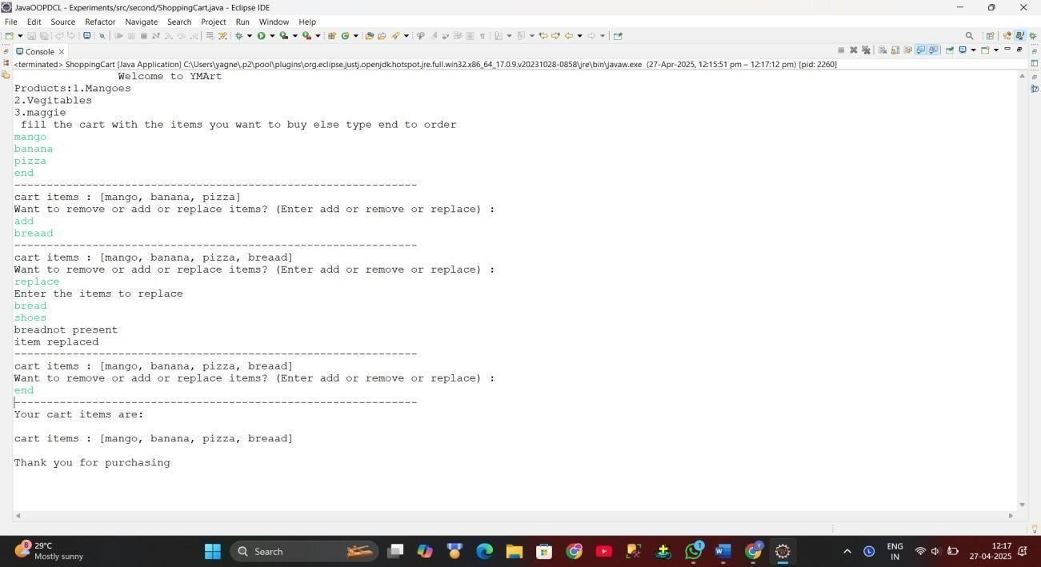
Fig 3.1.1 Shopping Cart Application

The Mart website provides a seamless shopping experience by allowing you to fill your cart with items you wish to purchase. Once you've added items to your cart, you have the flexibility to remove or replace them as needed. The user-friendly interface ensures that making changes is quick and easy. After finalizing your selections, the website displays a summary of the items in your cart. This streamlined process helps you manage your shopping efficiently and ensures you get exactly what you need.

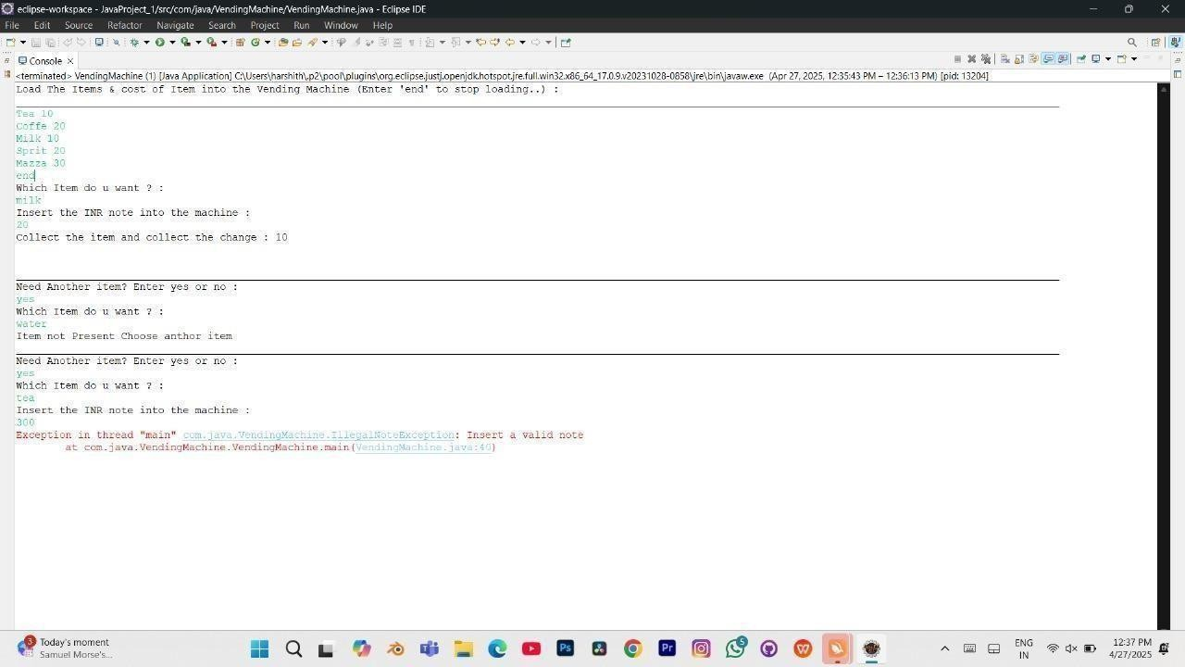
Fig 3.1.2: Vending Machine Console Application

The vending machine console application asks you which item you want, prompts you to insert the INR note into the machine, and then allows you to collect the item and the change. The vending machine console application asks if you need another item. If you enter "yes," it then asks which item you want and proceeds accordingly.

3.2. About Module2/Project2

HTML, CSS, and JavaScript: A Simple Guide to Building a Web Page
HTML, CSS, and JavaScript are the foundational technologies used to build modern websites and web applications. Each of these technologies serves a unique purpose, and when combined, they create interactive, visually appealing, and well-structured web pages. Below is an overview of these technologies and how they work together to create a cohesive web experience.

HTML (HyperText Markup Language)
HTML is the backbone of any web page. It provides the structure and content of the webpage, defining elements like headings, paragraphs, links, images, and more.
  - Purpose: To structure the content and layout of the webpage.
  - Key Components:
- Elements: Tags like <html>, <head>, <body>, <h1>, <p>, <a>, etc., define different parts of the page.
- Attributes: Provide additional information about HTML elements (e.g., src, href, alt).

CSS (Cascading Style Sheets)
CSS is used to control the look and feel of a webpage. It defines styles for HTML elements, such as colors, fonts, spacing, and positioning. CSS is what makes a web page visually attractive.
  - Purpose: To style and layout, the content structured by HTML.

Key Components:
- Selectors: Define which HTML elements are styled.
- Properties and Values: Define the styles to be applied, like color, font-size, margin, padding, etc.

JavaScript (JS)
JavaScript is used to make the webpage interactive. It allows you to manipulate the content dynamically, handle user events (such as clicks or form submissions), and update the webpage without reloading.
  - Purpose: To add interactivity and dynamic functionality to the webpage.

Key Components:
- Variables: Used to store data.
- Functions: Encapsulate reusable blocks of code.
- Events: Enable interaction, such as button clicks or form submissions.

3.2.2 Project Title: EatFit Blog – A Responsive Health & Lifestyle Blog Webpage

Objective:
The objective of Project 1 is to develop a visually appealing, user-friendly, and responsive blog- style webpage named EatFit Blog. This blog aims to promote healthy living through curated content related to diet, nutrition, meal planning, and wellness. The project is a front-end development task that utilizes standard web technologies such as HTML5, CSS3, and Font Awesome for design aesthetics and user interactivity.

Description:
The EatFit Blog interface is structured to replicate a modern blog platform. It includes a well-defined layout divided into several key sections, each serving a specific purpose to enhance the user experience:

Navigation Bar:
A prominent top navigation bar provides quick access to key sections of the site including:
  - Home
  - Why EatFit?
  - Visit EatFit
It also includes social media icons (Facebook, Twitter, YouTube) to allow users to connect with the EatFit community on external platforms. The layout uses Flexbox to evenly space the links and icons, providing a clean and balanced look.

Header Section:
Below the navigation, there's a visually engaging header that features:
  - An icon (<i class="fa-solid fa-hippo">) symbolizing the blog’s friendly and wellness- centered identity.
  - The blog title: Eatfit Blog, styled with a custom blue accent color to emphasize branding.

Category Menu:
This horizontal category strip includes clickable labels like:
  - Featured,Health & Diet
  - Meal Plans,Food & Drinks.

Footer Section:
The footer reinforces the branding by repeating the Eat fit Blog logo and title. It includes:
  - A “Follow Us” prompt,Social media icons to encourage user interaction beyond the
  - A visually distinct background (blue) to mark the end of the page.

Tech Stack

Technology | Purpose
HTML5 | Structuring the web pages

Technology | Purpose
CSS3 | Styling, layout design, responsiveness
JavaScript | Adding interactivity (dropdowns, hover effects,  smooth scroll)
VS Code | Code editing and debugging

OUTPUT:
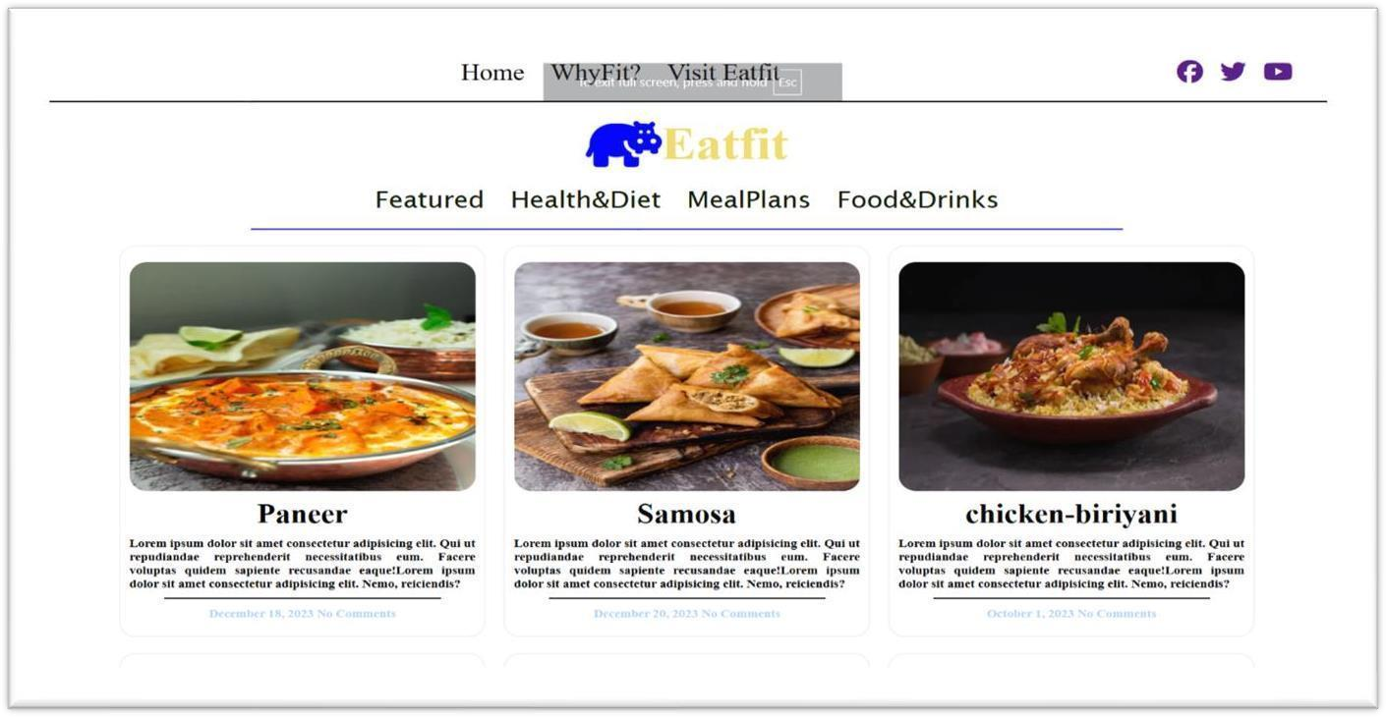

Fig 3.2.1: Eatfit Website interface

The header and main part of Eat fit blog contains home section and cards of different food items and the page looks as above.

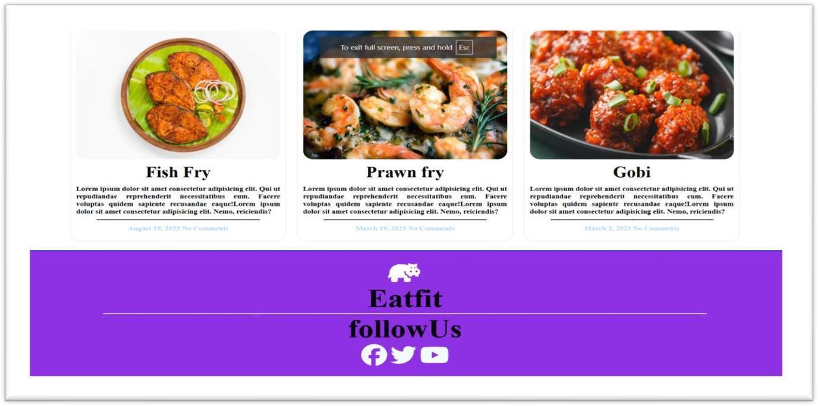
Fig:3.2.2: -Footer Section

The footer section of Eat fit blog consists of social media handles.
3.3 About Module3/Project 3 Project 3: DCL Website Clone Overview
The DCL Website Clone is a visually stunning and fully responsive web application built using

HTML, CSS, and JavaScript.
The goal of this project was to closely replicate the user interface of the official DCL website, helping to practice real-world web design principles and front-end development techniques.
This clone project sharpened skills in building structured web pages, styling complex layouts, implementing interactivity, and ensuring responsiveness across various devices. It also provided practical exposure to pixel-perfect design, mobile responsiveness, and dynamic UI behaviour.

Key Features
- Landing Page with Hero Section
  - Developed a professional-looking hero section with background images, overlays, and call-to-action buttons.
  - Incorporated navigation menus that remain consistent across pages.

Interactive Navigation and Links
  - Built a dynamic navigation bar with hover effects.
  - Smooth scrolling was added for better user experience.
  - Responsive drop-down menus recreated using JavaScript and CSS.

Fully Responsive Layout
  - Designed layouts that adapt seamlessly to desktop, tablet, and mobile screens.
  - Used media queries to optimize the website's look and usability across different screen sizes.

Recreation of UI Components
- Recreated major sections like Services, About Us, Testimonials, and Footer.
- Integrated dummy images and placeholder text where necessary while maintaining the structure of the original website.

Modern and Clean Styling
- Implemented clean fonts, consistent color themes, and smooth hover animations.
- Focused on enhancing visual appeal and usability through thoughtful UI/UX .

Learning Outcomes
- Improved understanding of semantic HTML and CSS positioning.
- Gained experience in responsive web design using media queries.
- Strengthened skills in vanilla JavaScript for DOM manipulation and user interactions.

OUTPUT:
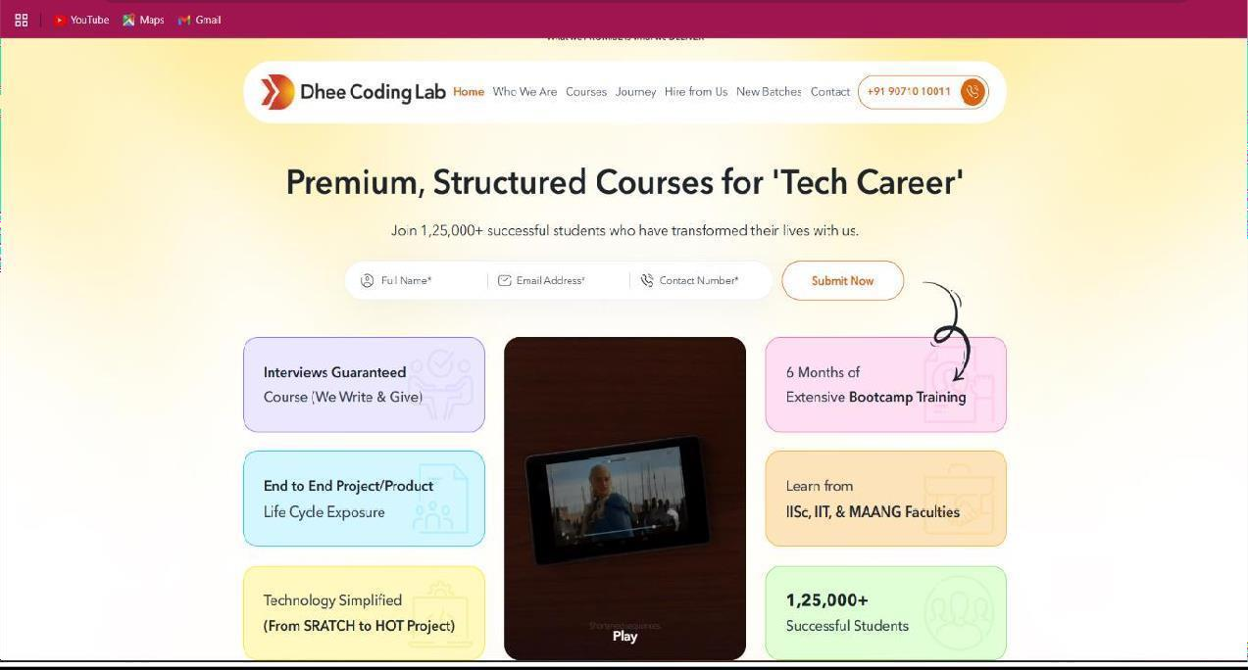
Fig 3.3.1: Clone Website

The cloned website consists of guaranteed interviews, end-to-end projects, streamlined technology, bootcamp training, and successful students.

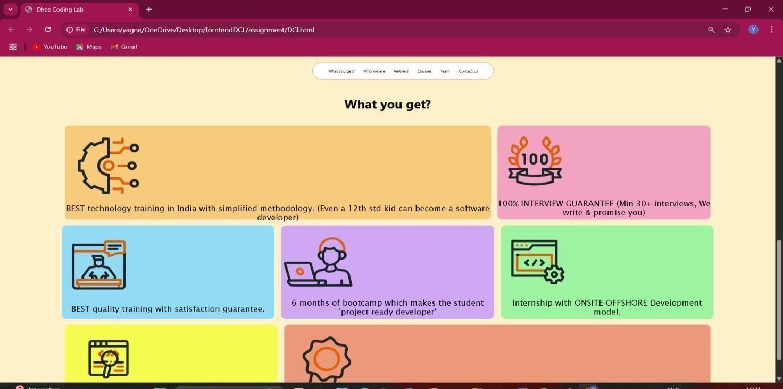
Fig:3.3.2 DCL interface

The DCL interface consists of the program descriptions like the technology they are using for the course, interview preparations and training period.

3.4 PROJECT4
Project: Course Registration Application using JDBC

Technologies Used: Java, JDBC, MySQL (or PostgreSQL), SQL

Problem Statement: Manual course registration processes are prone to errors, lack real-time validation (e.g., prerequisite checks, seat availability), and require administrative overhead for record-keeping. A dynamic, database-backed system allows students and staff to perform registrations, view course rosters, and update offerings in a controlled, auditable environment.

Goal: Implement a command-line or simple GUI application in Java that connects to a relational database via JDBC to manage course records, student profiles, and registration transactions. The system should support CRUD operations on courses and registrations, ensure data integrity, and allow users to query their enrollment status.

Key Requirements & Design Highlights:
- Database Schema:
  - students (sid, name, email, password, profession)
  - courses (cid, cname, duration, price)
  - enroll (sid,cid,cname,email)

JDBC Layer:
  - Establish and manage connections via a ConnectionPool or direct DriverManager.
  - Use PreparedStatement for secure parameterized queries.

Functional Modules:
  - Admin Functions: Add, update, delete courses; view enrollment counts.
  - Student Functions: Browse available courses, register/drop courses (with capacity check), view current schedule.

Error Handling & Transactions:
  - Wrap multi-step operations (e.g., check capacity then insert registration) in transactions to ensure atomicity.
  - Handle SQL exceptions gracefully and report meaningful messages to the user.

Testing:
  - Unit tests for DAO (Data Access Object) classes using an in-memory database.

DESCRIPTION

The Course Registration System is a full-fledged Java web application built using Servlets for the backend, JDBC for database operations, and HTML/CSS for the front-end interface. The system simulates a university-style portal where students can register, view, and manage course enrollments.

Core Functionality:

- User Authentication:

  - Users can register or log in to access their personalized dashboard.

  - Authentication is managed using HTTP sessions and cookies to maintain login status.

Course Dashboard:

  - Upon login, students can:

    - View a list of all available courses
    - Register for any course they’re eligible for
    - Deregister from previously selected courses
    - Check their currently registered courses

Admin Module (Optional):

  - The admin can:

- Add new courses

- Delete outdated or canceled courses

- Manage course details directly via the database

  - This module is protected by elevated permissions or a separate login system.

Backend Features:

  - All course and registration data is stored in a MySQL database.

  - Validation checks prevent duplicate registrations and invalid course selections.

  - Session timeout handling ensures secure logout after a period of inactivity.

Technical Stack & Concepts Used:

- Frontend Design (HTML/CSS):

  - HTML structures the pages for login, registration, course lists, and dashboard.

  - CSS provides styling for layout, buttons, tables, and overall user interface design.

  - Pages are simple, intuitive, and responsive for improved user experience.

Backend Processing (Servlets):

  - Servlets handle HTTP requests (GET for loading pages, POST for submitting forms).

  - Key servlets:

    - LoginServlet

    - RegisterServlet

    - CourseListServlet

    - EnrollServlet

    - DropCourseServlet

  - Logic is split cleanly across servlets for modularity and ease of maintenance.

Database Integration (JDBC + MySQL):

  - JDBC is used to connect and interact with a MySQL database.

  - Common operations include:

    - Inserting new users or enrollments

    - Fetching course data

    - Deleting course records

  - Tables include:

    - users – stores user credentials and roles

    - courses – stores course details like ID, name, and description

    - registrations – maps users to enrolled courses

Session Management:

  - HTTP sessions track user activity across multiple requests.

  - Cookies may be used to remember users or auto-fill login info (if implemented).

  - The application enforces session timeouts for enhanced security.

Security & Validation:

  - Input fields are validated to prevent:

    - SQL injection (using PreparedStatements)

    - Cross-site scripting

    - Blank submissions

  - Ensures data integrity in all operations.

The backend validates inputs, handles session timeouts, and maintains integrity between users and their registered courses. The database contains tables such as users, courses, and registrations.
Learning outcomes:

- Mastery of backend integration using JDBC

- Understanding of MVC architecture

- How to manage stateful web applications

- Handling user inputs securely

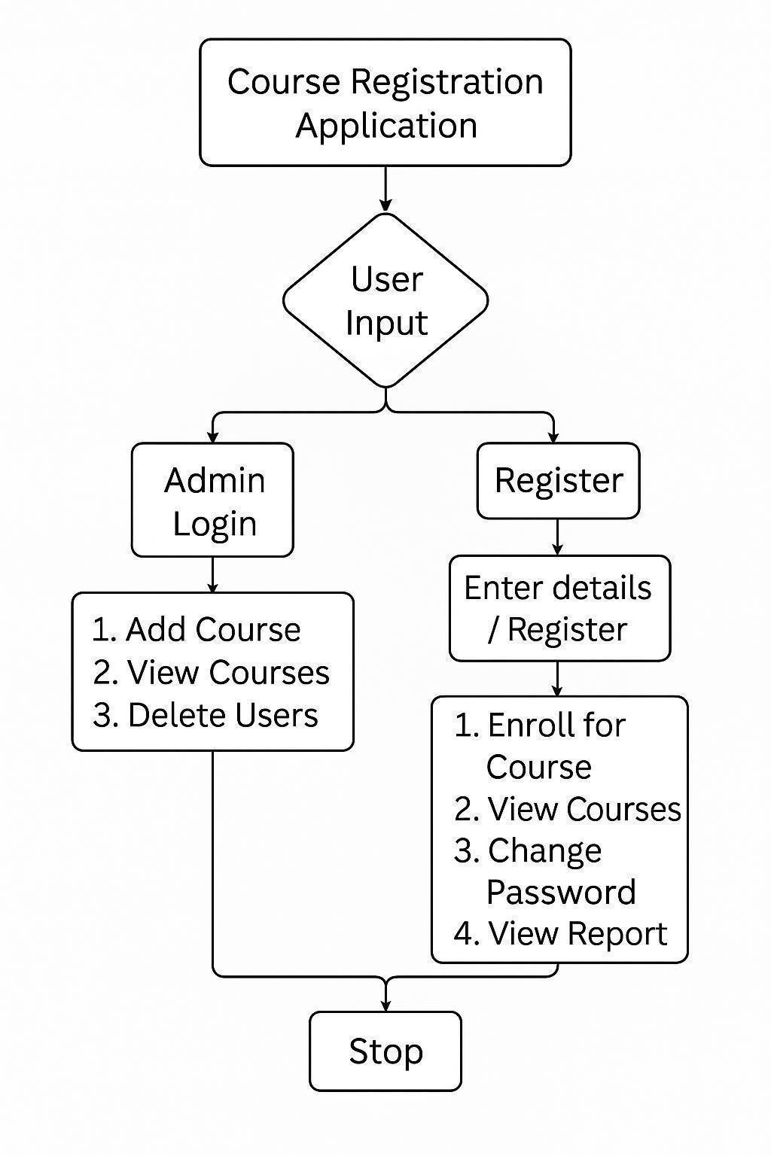
Fig: 3.4.1: Visual Chart Diagrams

This flowchart represents a Course Registration Application. It begins with user input, which leads to either Admin Login or User Registration. Admins can add courses, view available courses, and delete users. Registered users can enroll in courses, view courses, change their password, and view reports. The process concludes with a stop operation once the tasks are completed.

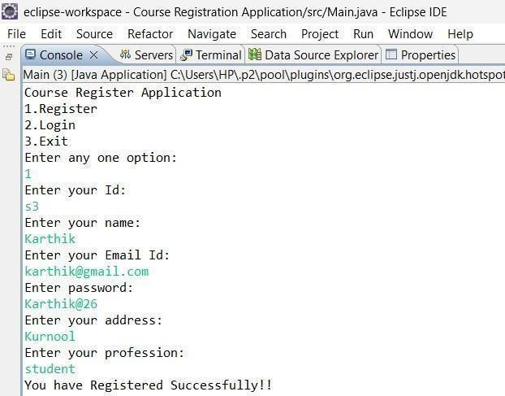
Fig 3.4.2 Registering for the courses

The registration process for the course consists of the following options: 1. Register, 2. Login, 3. Exit. When you select the "Register" option, it prompts you to enter your ID, name, email ID, password, address, and profession. After entering these details, it confirms that you have registered successfully.

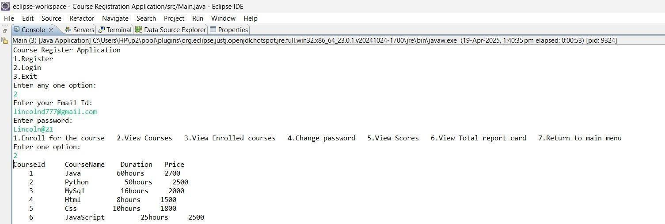
Fig 3.4.3 Login and view courses

The login and view courses process consists of logging in by entering your email ID and password. Once logged in, it shows the following options: 1. Enroll for the course, 2. View courses, 3. View enrolled courses, 4. Change password, 5. View scores, 6. View total report card, 7. Return to main menu. If you select "View courses," it displays all available courses as shown in the figure.
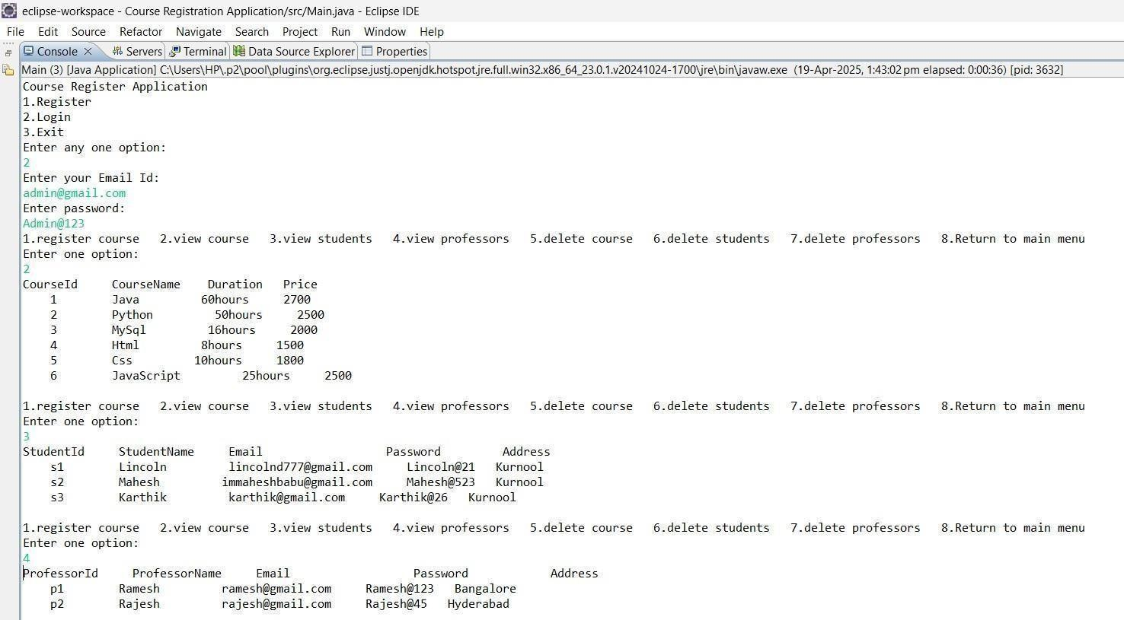

Fig 3.4.4 Viewing Course Details

The above figure shows viewing course details. It displays the course ID, course name, duration, and price. If you select "View students," it shows the students' details.
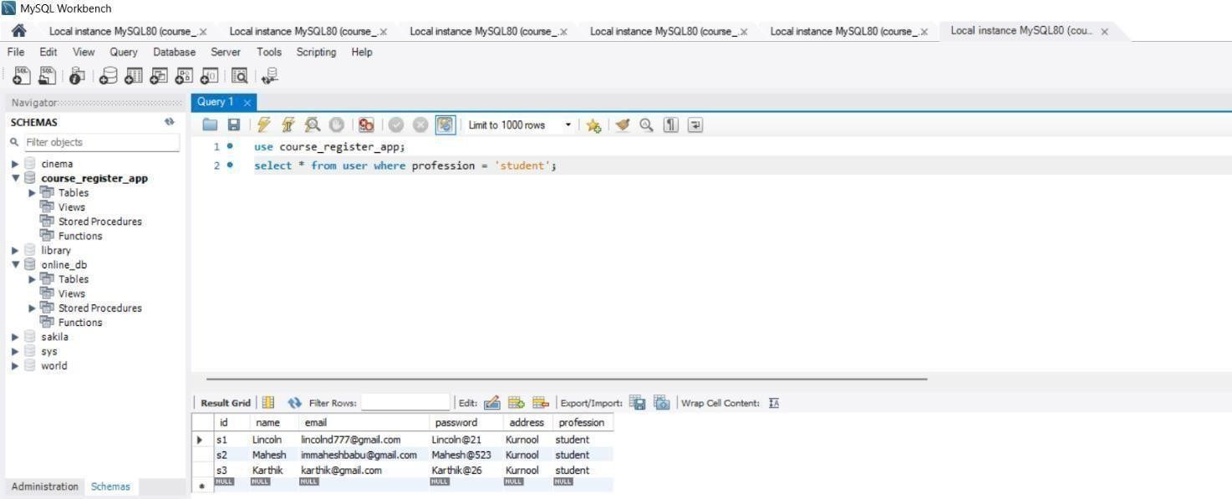
Fig 3.4.5 Student Details

The figure shows the student Details which are being displayed by using the query.
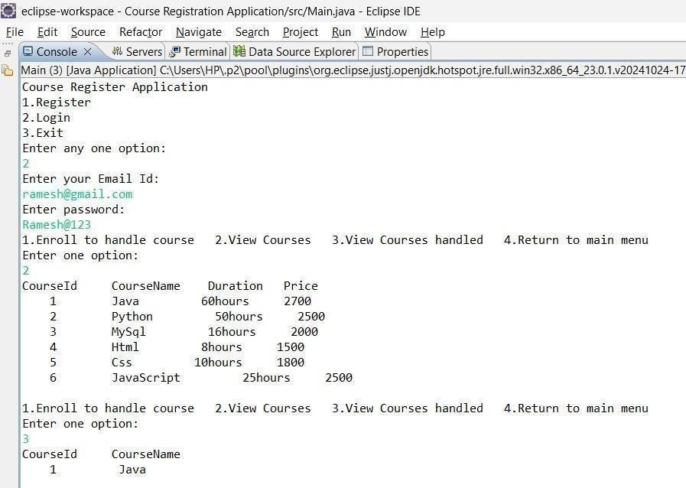
Fig 3.3.5 Viewing Handled Courses

The above figure shows the option to enroll in or handle a course. If you select it, it displays the handled courses with the course ID and course name.

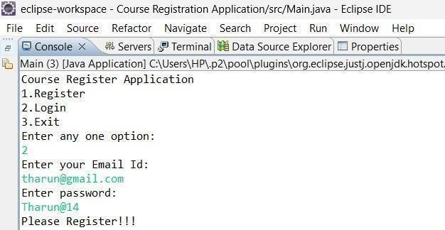

Fig 3.3.6 Handling the invalid user

If the user enters an incorrect email ID, it shows an "Invalid user" message. The above figure illustrates handling the invalid user

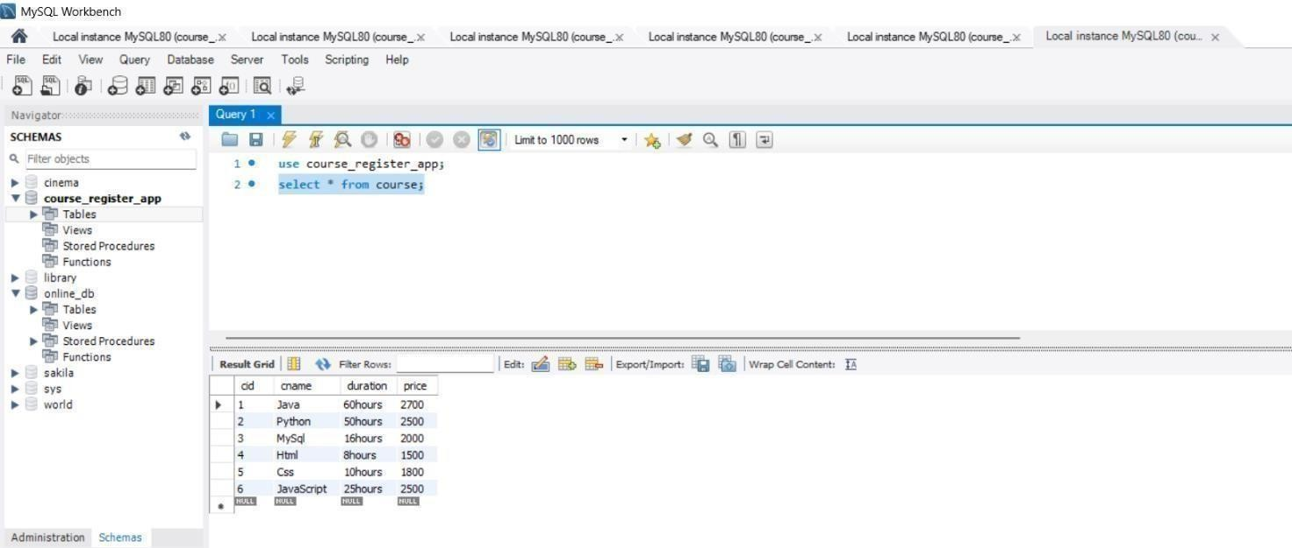
Fig 3.3.7 Course Details

In the tables section, if we execute a query to see table information, the entire table data is displayed as shown in the above figure.

4.ACTIVITY LOG

ACTIVITY LOG FOR THE WEEK
weeks | Description of the daily activity | Learning Outcome | Person In- Charge Signature
Week–1 | Introduced to web development using HTML and CSS. Practiced structuring pages with headings, paragraphs, forms, tables, and divs. Styled pages using colors, borders, box model, Flexbox, and Grid. Created a static personal portfolio website by the end of the week. | Built and styled responsive static web pages using HTML and CSS.
Week-2 | Set up Java environment and IDEs.  Learned about variables, data types, type casting, operators, and input/output operations. Practiced conditionals (if, else, switch), loops, arrays, and methods. Implemented small programs to solidify core concepts. | Gained foundational understanding of Java programming and logic building.
Week-3 | Delved into Object-Oriented  Programming concepts: classes, objects, inheritance, polymorphism, abstraction, and encapsulation. Implemented constructors, method overloading/overriding, and interfaces. Learned exception handling using try-catch, custom exceptions, and file I/O. | Understood OOP principles and applied exception handling in Java.
Week-4 | Covered foundational data structures: arrays, strings, sorting (bubble, selection), searching (linear, binary), recursion, and linked lists. Solved beginner-level DSA problems to | Learned basic data structure implementation and problem solving.

Week-5 | Explored advanced DSA conc stacks, queues, trees, graphs, hashing. Practiced dyn programming and greedy algorit Additionally, improved aptitude reasoning and arithmetic pro sets. | Strengthened DSA problem- solving and aptitude skills for placements.
Week-6 | Learned DBMS concepts like relational models and ER diagrams. Practiced SQL operations: DDL, DML, DCL, joins, subqueries, and views. Used Oracle SQL to create, query, and manipulate relational  databases. | Gained ability to design and query databases using SQL.
Week-7 | Covered JavaScript fundamentals – variables, functions, arrays, loops, and objects. Manipulated DOM, handled user events, and created dynamic content. Applied modern ES6 features and built a small JS  project. | Acquired skills to build dynamic web pages using JavaScript.
Week-8 | Set up React project using create- react-app. Created components, managed state with useState, handled side effects with useEffect, and performed routing with React Router. Built a small single-page application using React. | Built interactive frontend apps using React and Hooks.

Week-9 | Installed Spring framework and learned dependency injection, bean configuration, and annotations. Implemented MVC architecture with controllers, views, and models. Integrated form handling and validation in Spring MVC. | Understood Spring Core and MVC  architecture for backend development.
Week-10 | Built RESTful services using Spring Boot. Used annotations like @RestController, @RequestMapping, and @PathVariable.  Connected backend to React frontend via REST APIs and tested using Postman. | Developed REST APIs and integrated frontend with backend.
Week-11 | Learned Hibernate and JPA for ORM. Implemented entity relationships and CRUD using Spring Data JPA. Explored AWS basics: EC2, RDS, and deployed full stack apps on cloud.Connected backend APIs with cloud-hosted  databases. | Integrated backend apps with databases and deployed on AWS.
Week-12 | Finalized full stack project, added validations, and deployed online. Gave project presentations and mock interviews. Created professional resume and received internship  certificate. | Completed end- to-end project and became job- ready in full stack  development.

5.CONCLUSION

5.CONCLUSION

During my internship at DheeCoding Lab, I had the opportunity to work extensively in the Java Full Stack domain, which greatly enhanced my technical and professional skills. Throughout the program, I gained hands-on experience in developing dynamic web applications using technologies such as Core Java, Spring Boot, Hibernate, MySQL, HTML, CSS, JavaScript, and React.js. Frontend Skills: Created structured and styled webpages using HTML and CSS, with hands-on use of Flexbox, positioning, and responsive design principles.
- Java Programming: Gained deep understanding of Core Java, covering OOP concepts (inheritance, encapsulation, abstraction, polymorphism), constructors, method overloading/overriding, and exception handling.
- Advanced Java: Explored collections framework, file handling, type casting, arrays, and string manipulations, improving coding logic and efficiency.
- SQL Database Management: Practiced DDL, DML, joins, subqueries, group functions, views, transactions, and stored procedures using MySQL.
- Backend Integration: Implemented JDBC to connect Java applications with databases, enabling full CRUD operations.
- Hands-On Practice: Solved coding challenges on HackerRank, participated in regular mock tests, and team discussions to apply concepts in real-time scenarios.
- Project Work: Involved in building a mini project that demonstrated end-to-end integration of frontend, backend, and database.
  - Soft Skills: Daily presentations improved confidence and clarity in technical communication. The internship provided me with a deeper understanding of both frontend and backend development, RESTful API creation, database management, and security implementation using JWT. I also learned important software development practices like version control with Git and
teamwork through Agile methodologies.

Overall, this internship has strengthened my foundation in full-stack development, improved my problem-solving abilities, and prepared me to take on real-world projects confidently. I am grateful to DheeCoding Lab for providing me with this valuable learning experience and mentorship.

REFERENCES

https://dheecodinglab.com/
- https://docs.oracle.com/en/java/
- https://spring.io/projects/spring-boot

https://hibernate.org/orm/documentation/
- https://react.dev/
- https://dev.mysql.com/doc/
- https://www.w3schools.com/
- https://developer.mozilla.org/

https://www.tutorialspoint.com/java/index.htm
- https://www.geeksforgeeks.org/

