TRAVEL INSURANCE PREDICTION – PROJECT REPORT
CHAPTER 1 – INTRODUCTION
1.1 Introduction
Travel insurance provides financial protection to travellers against unexpected situations that may occur during a journey. With the increasing number of people travelling for personal and professional purposes, understanding which customers are more likely to purchase travel insurance can be useful for insurance companies.
This project focuses on analysing customer-related information and building a classification model to predict whether a customer is likely to purchase travel insurance. The dataset contains demographic, financial, health-related, employment, and travel-history attributes.
The project follows a complete data analytics and machine learning workflow, beginning with data inspection and preprocessing, followed by Exploratory Data Analysis (EDA), feature preparation, model building, hyperparameter tuning, and prediction evaluation.
The classification algorithm used in this project is Random Forest Classifier. Random Forest was selected because it can handle multiple input features and capture non-linear relationships between customer characteristics and insurance purchase decisions. GridSearchCV was additionally used to search for better Random Forest hyperparameters.
1.2 Problem Statement
Insurance companies need to identify customers who are more likely to purchase travel insurance. Manually analysing customer characteristics is difficult when the dataset contains a large number of records.
The objective of this project is to analyse historical customer data and develop a classification model that predicts the likelihood of a customer purchasing travel insurance based on attributes such as age, annual income, family size, chronic disease status, frequent flyer status, employment type, and overseas travel experience.
1.3 Objectives
The major objectives are:
- To understand the Travel Insurance dataset.
- To perform data cleaning and preprocessing.
- To identify important customer patterns through EDA.
- To analyse demographic, financial and travel-related characteristics.
- To prepare features for classification.
- To build a Random Forest Classification model.
- To improve the model using GridSearchCV.
- To evaluate the classification model using suitable performance metrics.
- To generate sample predictions for customer inputs.
- To identify challenges and possible improvements.
CHAPTER 2 – DATASET DESCRIPTION
2.1 Dataset Overview
- The dataset used in this project is TravelInsurancePrediction.csv.
- The notebook loads the dataset using Pandas and performs analysis on customer information related to travel insurance purchase.
- The dataset contains 1,987 records and initially includes 10 columns.
- The target variable is:
- TravelInsurance
- where the classification indicates whether the customer purchased travel insurance.
2.2 Important Dataset Attributes
Attribute | Description
Age | Age of the customer
Employment Type | Employment category
GraduateOrNot | Educational qualification status
AnnualIncome | Annual income of the customer
FamilyMembers | Number of family members
ChronicDiseases | Indicates presence of chronic disease
FrequentFlyer | Indicates whether the customer is a frequent flyer
EverTravelledAbroad | Indicates previous overseas travel
TravelInsurance | Target variable indicating insurance purchase

CHAPTER 3 – DATA PREPROCESSING
3.1 Data Loading
The dataset was loaded using the Pandas read_csv() function. Initial records were examined using head() to understand the structure and contents of the dataset.
3.2 Missing Value Analysis
The dataset was checked using isna().sum() to identify missing values.
Notebook output: all original columns show 0 missing values at this stage.
Therefore, there was no need for statistical imputation of the original dataset.
However, after the categorical encoding step, the notebook contains missing values in Employment Type because of the mapping used for the category values. This is an important preprocessing issue that should be acknowledged in the report rather than claiming that every final feature was completely free of missing values.
3.3 Removing Unnecessary Columns
The following columns were removed:
- Unnamed: 0
- GraduateOrNot
The Unnamed: 0 column represents an unnecessary index-like field. GraduateOrNot was also removed before model preparation.
3.4 Categorical Encoding
Categorical variables were converted into numerical form so that they could be used by the machine learning algorithm.
For example:
- FrequentFlyer: Yes → 1, No → 0
- EverTravelledAbroad: Yes → 1, No → 0
- Employment Type: categorical employment groups were converted into numerical values.
This transformation converts categorical information into a format suitable for Random Forest classification.

3.5 Feature and Target Separation
The dataset was divided into:
X – Independent Features
The TravelInsurance column was removed from the feature dataset.
y – Target Variable
TravelInsurance was selected as the target variable.
Thus, the model learns the relationship between customer characteristics and the travel insurance purchase decision.
3.6 Train-Test Split
The dataset was divided into training and testing sets using an 80:20 split.
The notebook output shows:
- Training records: 1,589
- Testing records: 398
A random_state of 42 was used to ensure reproducibility.
CHAPTER 4 – EXPLORATORY DATA ANALYSIS
4.1 Correlation Analysis
Figure 4.1 Correlation Matrix of Numerical Features
Observation
The correlation matrix was created to understand the relationships between numerical variables in the dataset. The heatmap provides a compact view of the strength and direction of relationships among customer attributes.
Insight
Correlation analysis helps identify variables that may have stronger associations with other numerical features and provides an initial understanding of the dataset before model building.

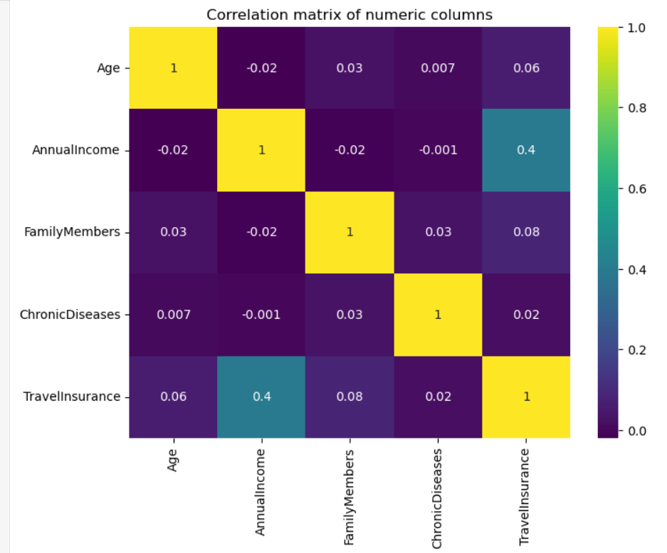
4.2 Age Distribution
Observation
The customers in the dataset are distributed between ages 25 and 35. The highest frequency is observed at age 28, while the number of customers varies across the other age groups.
Insight
The dataset is concentrated around young and middle-aged adult customers. Age can therefore provide useful information when analysing travel insurance purchase behaviour.
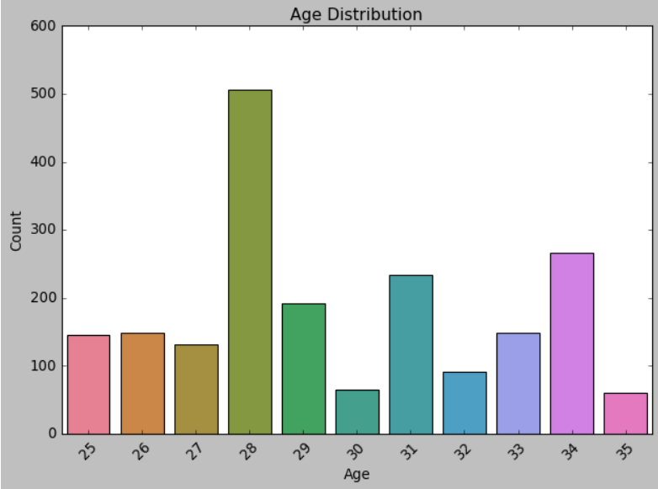

4.3 Family Members Distribution
Observation
The number of family members varies from 2 to 9 in the dataset. Customers with four and five family members form relatively large groups.
Insight
Family size can influence travel requirements because customers travelling with larger families may have different insurance needs compared with individual travellers.
4.4 Annual Income Distribution
Observation
The annual income distribution covers a broad range of customer income levels. The graph also displays the mean annual income, which is approximately ₹932,762.96.
The distribution is not perfectly symmetric, with customer frequencies varying considerably across different income ranges.
Insight
Income is an important customer characteristic because the ability and willingness to purchase travel-related financial protection can vary according to income level.
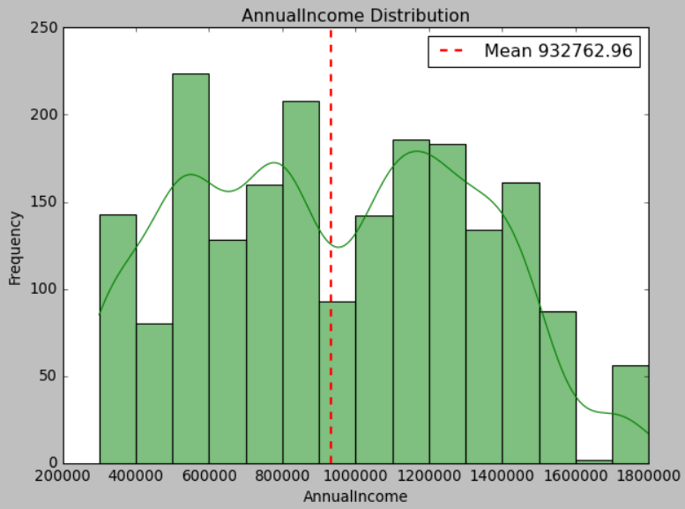
4.5 Chronic Disease Distribution
Observation
The visualization shows that approximately 72.2% of customers do not have chronic diseases, while approximately 27.8% have chronic diseases.
Insight
The dataset contains a considerably larger group of customers without chronic diseases. Health-related characteristics can still be useful for understanding customer profiles and their travel insurance requirements.
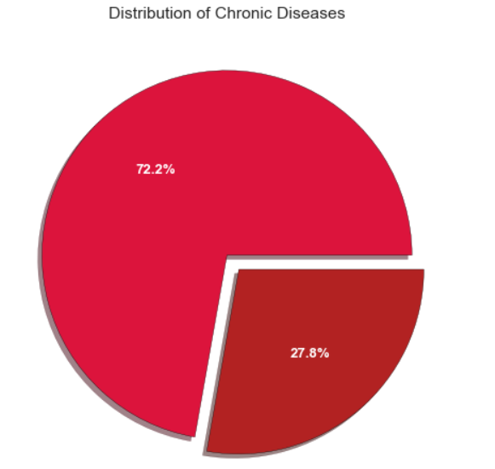
4.6 Frequent Flyer Status
Observation
The graph shows that 1,570 customers are not frequent flyers, while approximately 417 customers are frequent flyers.
Therefore, non-frequent flyers form the larger portion of the dataset.
Insight
Frequent-flyer status is an important travel behaviour variable. Customers who travel frequently may have different insurance requirements compared with customers who travel occasionally.
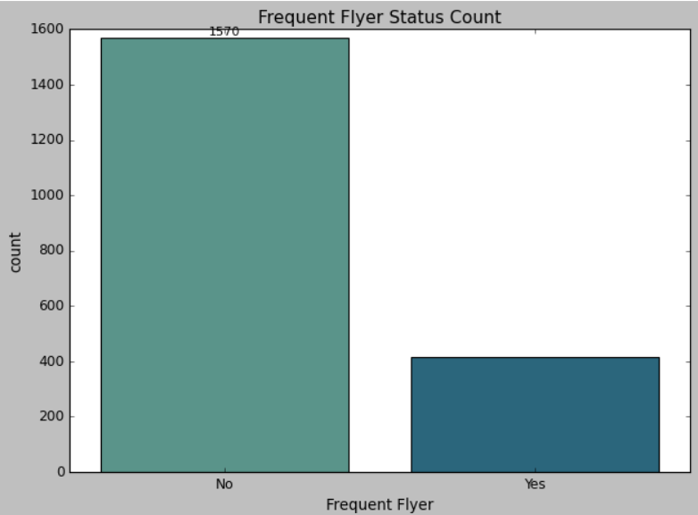
CHAPTER 5 – MACHINE LEARNING METHODOLOGY
5.1 Classification Approach
This project is a binary classification problem because the target variable, TravelInsurance, represents two possible outcomes:
- 0 – No Travel Insurance
- 1 – Travel Insurance
The objective of classification is to learn patterns from historical customer data and predict the insurance purchase outcome for new customers.
5.2 Random Forest Classifier
The machine learning algorithm implemented in the notebook is the Random Forest Classifier.
Random Forest is an ensemble classification algorithm that combines multiple decision trees to produce a final prediction. Each tree learns patterns from the training data, and the combined decision of the trees is used for classification.
Why Random Forest was selected
Random Forest was suitable for this project because:
- It can handle multiple customer-related features.
- It can capture non-linear relationships.
- It is less dependent on a single decision tree.
- It generally provides robust classification performance.
- It can work effectively with numerical and encoded categorical features.
- It is suitable for analysing relationships between customer characteristics and insurance decisions.
5.3 Initial Model Building
- A Random Forest Classifier was first created using the default parameters.
- The model was trained using the training dataset:
- rf.fit(x_train, y_train)
- The initial model was then evaluated on the test dataset.
- Initial Accuracy
- The notebook produced an accuracy of approximately:
- 81.16%
- This indicates that the initial Random Forest correctly classified approximately 81% of the test observations.
CHAPTER 6 – HYPERPARAMETER TUNING
6.1 GridSearchCV
After building the initial Random Forest model, GridSearchCV was used to search for better combinations of model parameters.
The parameter grid included:
- max_depth
- max_features
- min_samples_leaf
- min_samples_split
- criterion
- n_estimators
- bootstrap
The search evaluated:
720 parameter combinations

6.2 Purpose of Hyperparameter Tuning
Hyperparameter tuning was performed to identify a Random Forest configuration that could potentially provide better generalisation performance than the initial default model.
GridSearchCV systematically evaluates the specified parameter combinations instead of manually selecting a single configuration.
CHAPTER 7 – MODEL EVALUATION
7.1 Accuracy
The initial Random Forest achieved:
Accuracy = 81.16%
Accuracy represents the proportion of correctly classified observations among all test observations.
7.2 Precision
Precision measures how many of the customers predicted as likely to purchase travel insurance actually belong to the positive class.
High precision means that the model produces fewer false positive predictions.
7.3 Recall
Recall measures how many of the actual travel-insurance purchasers were correctly identified by the model.
This is particularly important in insurance targeting because missing potential customers can reduce the effectiveness of marketing campaigns.
7.4 F1-Score
F1-score combines precision and recall into a single measure.
It is useful when both false positives and false negatives need to be considered.
CHAPTER 8 – SAMPLE PREDICTIONS
8.1 Prediction Process
Once the Random Forest model has been trained, new customer information can be supplied to the model to determine whether the customer is likely to purchase travel insurance.
The input features correspond to the variables used during model training, including:
- Age
- Employment Type
- Annual Income
- Family Members
- Chronic Diseases
- Frequent Flyer
- Ever Travelled Abroad
The trained model generates a binary prediction:
0 → Customer is predicted not to purchase travel insurance
1 → Customer is predicted to purchase travel insurance
8.2 Sample Prediction Table
You can present your actual prediction outputs in this format:
Sample Customer | Age | Annual Income | Family Members | Chronic Disease | Frequent Flyer | Travelled Abroad | Prediction
Customer 1 | 31 | 400000 | 6 | 1 | 0 | 0 | Model Output
Customer 2 | 34 | 500000 | 4 | 1 | 0 | 0 | Model Output
Customer 3 | 28 | 700000 | 3 | 1 | 0 | 0 | Model Output

CHAPTER 9 – CHALLENGES FACED
Several challenges were encountered during the development of the project.
9.1 Data Preparation
The raw dataset contained categorical attributes that needed to be converted into numerical form before model training.
9.2 Feature Selection
Unnecessary columns had to be removed to ensure that only relevant features were provided to the model.
9.3 Categorical Encoding
Converting categorical values into numerical representations required careful mapping.
9.4 Hyperparameter Search
GridSearchCV evaluated 720 combinations across three folds, resulting in 2,160 model fits. This made the tuning process computationally intensive.
9.5 Model Evaluation
A complete evaluation requires multiple metrics rather than relying only on accuracy. Precision, recall, F1-score and ROC-AUC provide additional information about classification performance.
CHAPTER 10 – POTENTIAL IMPROVEMENTS
The model can be improved in several ways:
- Correctly handle any missing values introduced during categorical encoding.
- Verify the consistency of all categorical mappings.
- Use stratified train-test splitting to maintain class proportions.
- Compare Random Forest with other classification algorithms such as Logistic Regression, Decision Tree, Gradient Boosting and XGBoost.
- Perform feature importance analysis.
- Use ROC-AUC and confusion matrix for deeper evaluation.
- Apply appropriate outlier detection and treatment to numerical variables.
- Perform additional feature engineering from income, family size and travel behaviour.
- Optimise the Random Forest hyperparameters using a carefully selected search space.
CHAPTER 11 – CONCLUSION
The Travel Insurance Prediction project successfully combines Exploratory Data Analysis and machine learning classification to study customer characteristics and predict travel insurance purchase behaviour. Random Forest was used as the classification model, followed by GridSearchCV for hyperparameter tuning. The analysis also identified important patterns in age, income, family size, health status and travel behaviour. The project demonstrates how customer data can be transformed through preprocessing, EDA and classification techniques to support insurance-related decision making.

