Game Design Document

Fill up the following document

1. Write the title of your project.

THE DRAGON OF THE KINGDOM

1. What is the goal of the game?

TO PROTECT THE CASTLE

1. Write a brief story of your game.

***IT’S A MAGICAL WORD BUT WITH LOTS OF PROBLEMS, THE KING OF THE GREATEST CASTLE NAMED GERONIMO HORD HAD AN ARGUMENT WITH THE OTHER GREAT KING NAMED FRACTUAL TICK BECAUSE THE GREONIMO KING HAD THE BEST DRAGON NAMES MEDUSA WHICH IS VERY RARE SPECIE AND HAVE THE ONLY ONE DRAGON OF THAT SPECIE THE BOTH HAD FIGHT THE KING GERONIMO DECIDED TO FIGHT WITH MEDUSA BECAUSE HE WAS RARE AND POWERFUL SO THE OTHER KING ATTACKED THE GERONIMO TOWER SO WE HAVE TO PROTECT THE GREONIMO TOWER WITH MEDUSA THIS DRAGON HAS TWO POWERS 1 TO ATTACT WITH FIREBALLS 2 TO SNEEZE ON THE OPPONENTS WITH 1 POWER THE OPPONENT WILL BURN FOR 0.5SEC THEN WILL DESAPEAR WITH SECOND THE OPPONENT WILL BE STATUE FOR 1 SEC***

1. Which are the playing characters of this game?

* Playing characters are the ones who respond to the user based on the input from the user.
* Cars, monkeys, dinos, wizards, etc., are the playing characters in the game.

|  |  |  |
| --- | --- | --- |
| Number | Character Name | What can this character do? |
| 1 | MEDUSA | CAN SHOOT FIRE BALLS AND SNEEZE |
| 2 |  |  |
| 3 |  |  |
| 4 |  |  |
| 5 |  |  |
| 6 |  |  |
| 7 |  |  |
| 8 |  |  |

1. Which are the Non-Playing Characters of this game?

* Non-Playing characters are the ones that don't have an action or behavior when the user interacts with the game.
* Hurdles, stones, bananas, coins, etc., are non-playing characters in the game.

|  |  |  |
| --- | --- | --- |
| Number | Character Name | What can this character do? |
| 1 | CASTLE | NOTHING |
| 2 |  |  |
| 3 |  |  |
| 4 |  |  |
| 5 |  |  |
| 6 |  |  |
| 7 |  |  |
| 8 |  |  |

Draw your imagination of this game. What does this game look like?

* Draw the game either on your computer or on paper.
* Add images of the game scenes to show each of the playing and non-playing characters at least once.

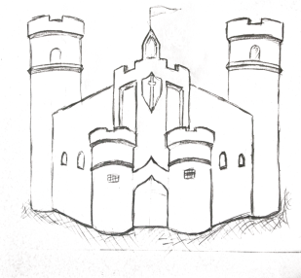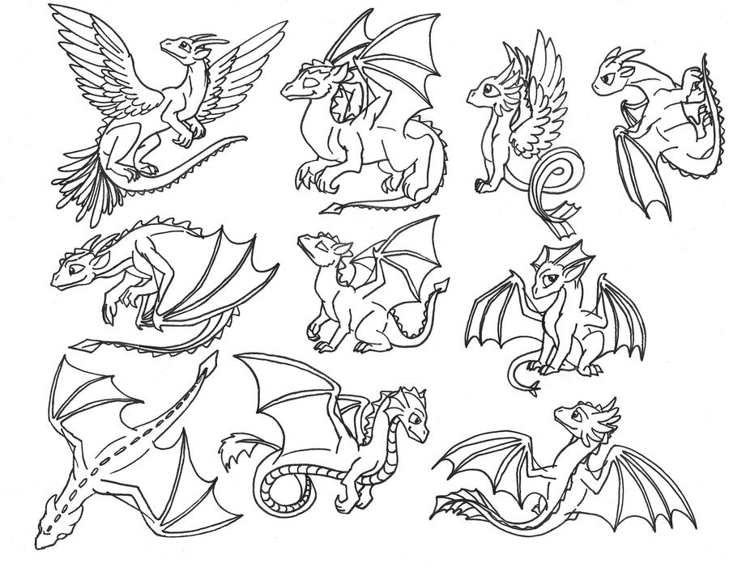TICKS ARMYC:\Users\USER\AppData\Local\Microsoft\Windows\INetCache\IE\DKY012BT\black_grass_gif_by_ryanv777-d5dznul[1].jpg

CASTLE MEAUSAC:\Users\USER\AppData\Local\Microsoft\Windows\INetCache\IE\DKY012BT\black_grass_gif_by_ryanv777-d5dznul[1].jpg

How do you plan to make your game engaging?

WITH THE HELP OF THE STORY AND THE FUNCTION OF THE GAME