**WEEK 3**

**Exercise 1: Configuring a Basic Spring Application**

*Pom.xml*

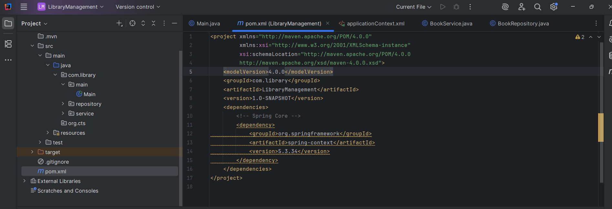

*BookRepository.class*

*BookService.class*

*Main.class*

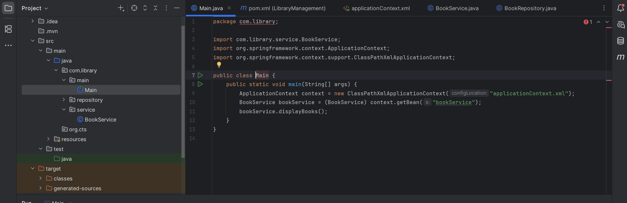

**Output:**

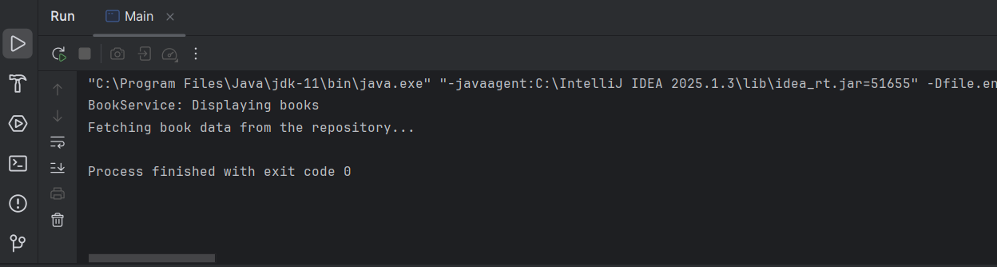

**______________________________________________________________________________________________**

**Exercise 2: Implementing Dependency Injection**

Pom.xml, Bookservice.class, BookRepository.java are same as Exercise1

*Main.class*



***Output:***

**Exercise 4: Creating and Configuring a Maven Project**

1. **Add Spring Dependencies in pom.xml:**
   * Include dependencies for Spring Context, Spring AOP, and Spring WebMVC.
2. **Configure Maven Plugins:**
   * Configure the Maven Compiler Plugin for Java version 1.8 in the pom.xml file.

Pom.xml

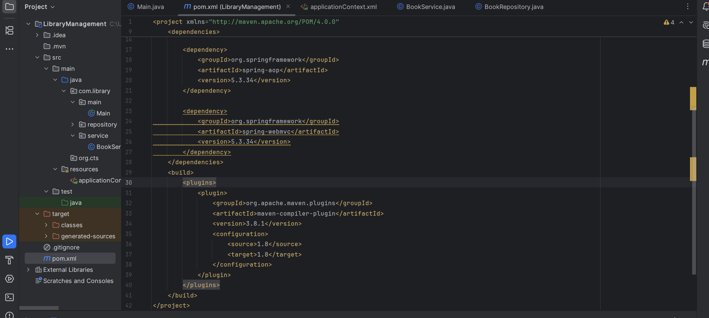

**Exercise 5: Configuring the Spring IoC Container**

In this exercise, the focus is on understanding how the Spring IoC (Inversion of Control) container manages the application's components. Although the code and output are the same as Exercise 1, this exercise highlights the internal working of Spring — how it creates, wires, and manages beans using the configuration defined in applicationContext.xml. By defining beans for BookService and BookRepository, and using setter-based dependency injection, Spring handles the object creation and linking. This demonstrates the power of the IoC container, where control over object creation is inverted from the developer to the framework.

BookService.class

BookRepository.class

Main.class



Output :

**Exercise 7: Implementing Constructor and Setter Injection**

NotificationService.java

BookService.java

Main.java

applicationContext.xml

Output:

