AUDIT REPORT

agentic-pipeline-builder: demo video audit report
A slide-by-slide record of every number, assumption and calculation in the demo video, with its source.
Item | Value
Repository | https://github.com/kavya2693/agentic-pipeline-builder
Numbers taken from commit | cbcb816890b0cb816098c9b2e8f9850dc959f944 (outputs last changed in cbcb816 (2026-10-13 22:10:14 +0400))
Video | docs/demo/demo.mp4 · 86.0 s · 1920x1080 · 30 fps · silent
Generated | 2026-10-14 14:13
Automated checks | 58 pass · 0 fail · 1 manual (of 59 figures)
Assumptions | 14 (A-01 to A-14)

How to use this report
Every number or claim on screen has an ID (F-01, F-02, ...) and every modelling assumption has an ID (A-01, ...). Cite the ID. Each figure lists its source file, the exact column, row or key, the formula for derived numbers, and an automated check result. The change-impact matrix (section 5) shows which slides and files change if an input or assumption changes.
Types: direct = read straight from a repo output; derived = computed from direct values (formula given); illustrative = drawing or example, not data; general knowledge = context not produced by the repo.

Regenerate
make e2e # data/raw + answer key, then discover, validate, build, dbt build, score -> outputs/metrics.json, report.md
make stress # outputs/stress.json, stress.md (10%-scale defect-rate sweep)
PYTHONPATH=src .venv/bin/python docs/demo/source/tools/export_contract_sheet.py docs/demo/source/assets/contract_sheet.json
python3 docs/demo/source/tools/inject_contract.py docs/demo/source/assets/contract_sheet.json docs/demo/source/compositions/value.html --rules orders__pk__unique,orders__customer_id__not_null,orders__customer_id__references_customers,orders__ordered_at__window,orders__order_total__type,orders__status__in_set
cd docs/demo/source && npx --yes hyperframes@0.8.156 check && npx --yes hyperframes@0.8.156 render -f 30 -q looks -o renders/agentic-pipeline-builder-master.mp4 && cd -
ffmpeg -y -i docs/demo/source/renders/agentic-pipeline-builder-master.mp4 -c:v libx264 -preset slow -crf 25 -pix_fmt yuv420p -movflags +faststart -an docs/demo/demo.mp4
python3 docs/demo/source/tools/build_audit_report.py docs/demo/source/audit/facts.yaml # stills, checks, MD/DOCX/PDF

1. Figures
ID | Shown | Slides | Source | Column / row / key | How computed | Type | Check
F-01 | 3 chips | 01 | author's framing | - | - | general knowledge | manual: Context statement, not a repo output.
F-02 | 4 problem cards | 01 | README 'The problem', 'Why it is hard' | README lines 16-34 | - | general knowledge | ✓ verified
F-03 | 7 files | 02, 05, 08 | examples/catalog.yml | tables | count of tables | direct | ✓ verified
F-04 | 1.86M rows | 02, 05, 06, 08 | outputs/metrics.json | quarantine[*].rows | 60,300 + 972,645 + 402,000 + 405,134 + 4,000 + 19,575 + 120 = 1,863,774 | derived | ✓ verified
F-05 | 45,677 planted defects | 02, 06, 08 | outputs/metrics.json | dq.agent.injected | - | direct | ✓ verified
F-06 | csv · json · jsonl · parquet | 02 | examples/catalog.yml | tables[*].file extensions | set of extensions | direct | ✓ verified
F-07 | two date formats in one column | 02 | examples/catalog.yml | customers.signup_date formats ['%m/%d/%Y', '%Y-%m-%d'] | - | direct | ✓ verified
F-08 | 9 defect types at known rows | 02 | outputs/metrics.json | dq.agent.by_defect | count of keys | direct | ✓ verified
F-09 | ONE STATE MACHINE / orchestrator.py band | 03, 05 | src/pipeline_builder/orchestrator.py:131-148 | STATES, TRANSITIONS | - | direct | ✓ verified
F-10 | too many bad rows? stop / quarantine > 5%? any table / HALTED | 03, 05 | src/pipeline_builder/orchestrator.py:35, :93-95, :143 | max_quarantine_rate = 0.05; too_many_rejects -> HALTED | - | direct | ✓ verified
F-11 | build, test, retry once / retried once | 03, 05 | src/pipeline_builder/orchestrator.py:153 | MAX_ATTEMPTS DBT_BUILD = 2 | 2 attempts = 1 retry | direct | ✓ verified
F-12 | every type right / bad rows caught / dbt build green | 03 | outputs/metrics.json | schema.types.agent, quarantine, dbt | agent types correct == total; quarantined rows > 0; dbt.ok and no failed tests | derived | ✓ verified
F-13 | 93.0% | 04, 09 | outputs/stress.json | sweep['0.005'].dq_recall | - | direct | ✓ verified
F-14 | 20.8% | 04, 09 | outputs/stress.json | sweep['0.02'].dq_recall | - | direct | ✓ verified
F-15 | 92.0% | 04 | outputs/stress.json | frozen_contract['0.005'].dq_recall | - | direct | ✓ verified
F-16 | 91.3% | 04 | outputs/stress.json | frozen_contract['0.02'].dq_recall | - | direct | ✓ verified
F-17 | red bar 0.9300 -> 0.2075, green bar 0.9197 -> 0.9126 of full width | 04 | demo:compositions/explainer.html; outputs/stress.json | scaleX targets | scaleX = recall (4 decimals, as stored) | derived | ✓ verified
F-18 | 39 s · 44 s · 0.14 s · 6 s · 11 s | 05 | outputs/metrics.json | state_log[*].seconds (DISCOVER..DBT_BUILD) | 38.67, 44.15, 0.14, 5.93, 10.99 rounded (BUILD kept to 2 decimals) | derived | ✓ verified
F-19 | 100 s (slides 05, 06 title, 08) / 99.9 s (slide 06 log) | 05, 06, 08 | outputs/metrics.json | seconds_raw_to_built = 99.9 | rounded to whole seconds | direct | ✓ verified
F-20 | 136 rules | 05, 06 | outputs/metrics.json; examples/rules.yml | rules | - | direct | ✓ verified
F-21 | 39 files / 39 dbt files | 05, 06 | outputs/metrics.json | generated.dbt_files | - | direct | ✓ verified
F-22 | DAG · nightly 03:00 | 05 | examples/raw_drop_pipeline.py:25 | schedule='0 3 * * *' | - | direct | ✓ verified
F-23 | 31 models | 05, 06, 08 | outputs/metrics.json | dbt.models.success | - | direct | ✓ verified
F-24 | 91 tests pass | 05, 06, 08 | outputs/metrics.json | dbt.tests.pass | - | direct | ✓ verified
F-25 | file tags on the boxes | 05 | src/pipeline_builder/*.py; README | orchestrator, discovery, validation, describe, builder, sql, runtime, dbt_run, evaluate | - | direct | ✓ verified
F-26 | --contract into Discover and Validate | 05 | src/pipeline_builder/orchestrator.py:69-90 | cfg.contract -> catalog.yml, rules.yml | - | direct | ✓ verified
F-27 | row-for-row check | 05, 06 | outputs/metrics.json | sql_vs_pandas[*].only_sql, only_pandas | all zero | direct | ✓ verified
F-28 | Local LLM · opt-in · wording only | 05 | src/pipeline_builder/describe.py:1-7, :24-27; cli.py:203 | ollama_client, --llm default None | - | direct | ✓ verified
F-29 | 54 columns · 7 keys · 7 joins | 06 | outputs/metrics.json | schema.types.agent.total, primary_keys.correct, foreign_keys.found | - | direct | ✓ verified
F-30 | 38.67 · 44.15 · 0.14 · 5.93 · 10.99 | 06 | outputs/metrics.json | state_log[*].seconds | - | direct | ✓ verified
F-31 | 88-line DAG | 06 | outputs/metrics.json | generated.dag_lines | - | direct | ✓ verified
F-32 | 5 warn | 06 | outputs/metrics.json | dbt.tests.warn | - | direct | ✓ verified
F-33 | DONE · 0 tests failed | 06 | outputs/metrics.json | final_state, dbt.failed | - | direct | ✓ verified
F-34 | orders 2.86% 11,507 · order_items 2.00% 19,452 · customers 1.99% 1,200 · payments 1.83% 7,409 · returns 0.50% 98 · products 0.00% 0 · stores 0.00% 0 | 06 | outputs/metrics.json | quarantine[*] | quarantine_rate x 100 to 2 decimals | direct | ✓ verified
F-35 | the same 39,666 rows | 06, 08 | outputs/metrics.json | sql_vs_pandas[*].both | 1,200 + 19,452 + 11,507 + 7,409 + 98 = 39,666 (sql = pandas = both) | derived | ✓ verified
F-36 | 9 bars | 06 | outputs/metrics.json | dq.agent.by_defect | - | direct | ✓ verified
F-37 | 88.6% | 06, 08 | outputs/metrics.json | dq.agent.recall = 0.8856 | - | direct | ✓ verified
F-38 | 100% for duplicate_row and null_required, 0% for the other seven | 06 | outputs/metrics.json | dq.naive_baseline.by_defect | - | direct | ✓ verified
F-39 | order_id unique 2,000 · customer_id not null 2,000 · customer_id in customers 2,000 · ordered_at date in window 2,000 · order_total is decimal 2,000 · status one of 7 values 1,515 | 07 | demo:assets/contract_sheet.json (tools/export_contract_sheet.py re-runs discovery + validation on data/raw); examples/rules.yml | rules[*].rows_flagged, evidence, severity | rows held per rule = unique rows the rule flags | derived | ✓ verified
F-40 | 11,507 of 402,000 rows held back (2.86%) | 07 | outputs/metrics.json | quarantine[table=orders] | 11,507 / 402,000 = 2.86% | direct | ✓ verified
F-41 | stg_orders 390,493 | 07 | outputs/metrics.json | orders rows - quarantined; marts.fct_orders | 402,000 - 11,507 = 390,493 (equals the fct_orders row count) | derived | ✓ verified
F-42 | + 17 more rules on orders (16 flag no rows) | 07 | examples/rules.yml; demo:assets/contract_sheet.json | orders rules = 23 | 23 - 6 shown = 17; 16 of them flag 0 rows (the order_total outlier warning flags 17) | derived | ✓ verified
F-43 | cancel, pending_x ringed in the status value set | 07 | examples/rules.yml orders__status__in_set; README 'Known limitations' | kwargs.value_set | - | direct | ✓ verified
F-44 | under the 5% gate | 06, 07 | outputs/metrics.json | max quarantine_rate = 0.02862 | max rate < 0.05 | derived | ✓ verified
F-45 | Days of detective work become a review. | 07 | README 'The problem' (days per source) and 'Known limitations' (first contract needs a person) | - | - | general knowledge | ✓ verified
F-47 | 100% (54/54) | 08, 03 | outputs/metrics.json | schema.types.agent.accuracy | - | direct | ✓ verified
F-48 | pandas 68.5% · DuckDB 81.5% | 08 | outputs/metrics.json | schema.types.pandas_default / duckdb_sniff accuracy | - | direct | ✓ verified
F-50 | hand-written pass: 29.5% | 08 | outputs/metrics.json | dq.naive_baseline.recall | - | direct | ✓ verified
F-51 | 98.4% | 08 | outputs/metrics.json | dq.agent.row_precision | - | direct | ✓ verified
F-52 | hand-written pass: 3.4% | 08 | outputs/metrics.json | dq.naive_baseline.row_precision | - | direct | ✓ verified
F-58 | 16.3% | 09 | outputs/stress.json | sweep['0.1'].dq_recall | - | direct | ✓ verified
F-59 | 91.5% | 09 | outputs/stress.json | frozen_contract['0.1'].dq_recall | - | direct | ✓ verified
F-60 | primary keys found: 4 of 7 | 09 | outputs/stress.json | sweep['0.02'].primary_keys | - | direct | ✓ verified
F-61 | every profiler tolerance sits near 1% | 09 | src/pipeline_builder/discovery.py:30-31; validation.py:25, :31 | KEY_MAX_NULL 0.01, KEY_MIN_DISTINCT 0.99, NOT_NULL_MAX 0.01, NON_NEGATIVE_SHARE 0.99 | - | direct | ✓ verified
F-62 | 10%-scale drops | 09 | outputs/stress.json | scale | - | direct | ✓ verified
F-63 | OPEN SOURCE · MIT | 10 | LICENSE | - | - | direct | ✓ verified
F-64 | dbt · DuckDB · Airflow DAG · pandas · Python | 10 | pyproject.toml; examples/raw_drop_pipeline.py | dependencies; airflow import | - | direct | ✓ verified
F-65 | $ make e2e # generate 1.86M rows, build, dbt build, score | 10 | Makefile | e2e: data run | - | direct | ✓ verified
F-66 | RUNS ON A LAPTOP | 10 | README 'The result' | 'green build in 100 s on a laptop' | - | direct | ✓ verified

2. Automated check run (2026-10-14 14:13)
ID | Expected on slide | Recomputed from repo | Result
F-01 | 3 chips | - | manual
F-02 | true | true | ✓ pass
F-03 | 7 | 7 | ✓ pass
F-04 | 1.86M | 1.86M | ✓ pass
F-05 | 45,677 | 45,677 | ✓ pass
F-06 | csv · json · jsonl · parquet | csv · json · jsonl · parquet | ✓ pass
F-07 | 2 | 2 | ✓ pass
F-08 | 9 | 9 | ✓ pass
F-09 | true | true | ✓ pass
F-10 | true | true | ✓ pass
F-11 | true | true | ✓ pass
F-12 | true | true | ✓ pass
F-13 | 93.0% | 93.0% | ✓ pass
F-14 | 20.8% | 20.8% | ✓ pass
F-15 | 92.0% | 92.0% | ✓ pass
F-16 | 91.3% | 91.3% | ✓ pass
F-17 | true | true | ✓ pass
F-18 | 39 s · 44 s · 0.14 s · 6 s · 11 s | 39 s · 44 s · 0.14 s · 6 s · 11 s | ✓ pass
F-19 | 100 s | 100 s | ✓ pass
F-20 | 136 | 136 | ✓ pass
F-21 | 39 | 39 | ✓ pass
F-22 | true | true | ✓ pass
F-23 | 31 | 31 | ✓ pass
F-24 | 91 | 91 | ✓ pass
F-25 | true | true | ✓ pass
F-26 | true | true | ✓ pass
F-27 | true | true | ✓ pass
F-28 | true | true | ✓ pass
F-29 | 54 columns · 7 keys · 7 joins | 54 columns · 7 keys · 7 joins | ✓ pass
F-30 | 38.67 · 44.15 · 0.14 · 5.93 · 10.99 | 38.67 · 44.15 · 0.14 · 5.93 · 10.99 | ✓ pass
F-31 | 88 | 88 | ✓ pass
F-32 | 5 | 5 | ✓ pass
F-33 | DONE · 0 failed | DONE · 0 failed | ✓ pass
F-34 | orders 2.86% 11,507 · order_items 2.00% 19,452 · customers 1.99% 1,200 · payments 1.83% 7,409 · returns 0.50% 98 · products 0.00% 0 · stores 0.00% 0 | orders 2.86% 11,507 · order_items 2.00% 19,452 · customers 1.99% 1,200 · payments 1.83% 7,409 · returns 0.50% 98 · products 0.00% 0 · stores 0.00% 0 | ✓ pass
F-35 | 39,666 | 39,666 | ✓ pass
F-36 | duplicate_row 4,316 100.0% · null_required 9,179 100.0% · orphan_fk 6,961 100.0% · type_corruption 6,863 100.0% · negative_value 6,879 100.0% · future_date 2,300 100.0% · malformed_email 300 100.0% · invalid_enum 4,016 63.4% · outlier_value 4,863 22.8% | duplicate_row 4,316 100.0% · null_required 9,179 100.0% · orphan_fk 6,961 100.0% · type_corruption 6,863 100.0% · negative_value 6,879 100.0% · future_date 2,300 100.0% · malformed_email 300 100.0% · invalid_enum 4,016 63.4% · outlier_value 4,863 22.8% | ✓ pass
F-37 | 88.6% | 88.6% | ✓ pass
F-38 | true | true | ✓ pass
F-39 | true | true | ✓ pass
F-40 | 11,507 of 402,000 (2.86%) | 11,507 of 402,000 (2.86%) | ✓ pass
F-41 | 390,493 | 390,493 | ✓ pass
F-42 | 17 more (16 flag no rows) | 17 more (16 flag no rows) | ✓ pass
F-43 | true | true | ✓ pass
F-44 | true | true | ✓ pass
F-45 | true | true | ✓ pass
F-47 | 100% | 100% | ✓ pass
F-48 | pandas 68.5% · DuckDB 81.5% | pandas 68.5% · DuckDB 81.5% | ✓ pass
F-50 | 29.5% | 29.5% | ✓ pass
F-51 | 98.4% | 98.4% | ✓ pass
F-52 | 3.4% | 3.4% | ✓ pass
F-58 | 16.3% | 16.3% | ✓ pass
F-59 | 91.5% | 91.5% | ✓ pass
F-60 | 4/7 | 4/7 | ✓ pass
F-61 | true | true | ✓ pass
F-62 | 0.1 | 0.1 | ✓ pass
F-63 | true | true | ✓ pass
F-64 | true | true | ✓ pass
F-65 | true | true | ✓ pass
F-66 | true | true | ✓ pass

3. Assumptions register
ID | Assumption | Source | Figures affected | Slides affected
A-01 | All data is synthetic: a seeded generator writes a regional retailer's nightly drop (60k customers, 400k orders, 973k order lines, 405k payments, 20k returns, 4,000 products, 120 stores). The generator and the inference rules were written by the same person, so 100% type accuracy is an upper bound, not evidence that the rules generalise. | scripts/generate_data.py:14-18 (scale 1.0, seed 7); src/pipeline_builder/datagen.py; README 'The data' | all figures | slides 01, 02, 03, 04, 05, 06, 07, 08, 09, 10
A-02 | Defects are planted at 0.5% of rows per defect type (nine types) at known rows; the answer key in data/ground_truth holds every type, key, relationship and defect. | scripts/generate_data.py:15 (--defect-rate 0.005); README 'The data' | F-05, F-08, F-36, F-37, F-38, F-50, F-51, F-52 | slides 02, 06, 08
A-03 | The drop is judged as of 2026-02-01: date-window rules reject dates after the run date. | Makefile:4 (AS_OF ?= 2026-02-01); validation.py (date window rule) | F-34, F-36, F-39, F-40 | slides 06, 07
A-04 | Quarantine gate: the run halts before building if any table would quarantine more than 5% of its rows. | src/pipeline_builder/orchestrator.py:35 (max_quarantine_rate = 0.05), :143 (too_many_rejects -> HALTED); cli.py:201 | F-10, F-34, F-44 | slides 03, 05, 06, 07
A-05 | Profiler tolerances sit near 1%: a type needs 98% of values to parse, a required column at most 1% nulls, a key 99% distinct and at most 1% nulls, a non-negative column 99% non-negative, a category at least 0.1% of rows; outliers are flagged above 10x the p99. | src/pipeline_builder/discovery.py:27, :30-31, :33; validation.py:25, :28, :31, :33 | F-03, F-20, F-29, F-36, F-47, F-13, F-14, F-58, F-61 | slides 02, 03, 04, 05, 06, 08, 09
A-06 | Retry policy: only DBT_BUILD and LAND are retried (2 attempts each); a rule that fails on the data fails the same way twice. | src/pipeline_builder/orchestrator.py:153 (MAX_ATTEMPTS) | F-11 | slides 03, 05
A-07 | Timings are wall-clock seconds from one run on the author's laptop and vary with the machine and its load. | outputs/metrics.json state_log, seconds_raw_to_built; README 'The result' | F-18, F-19, F-30 | slides 05, 06, 08
A-08 | Stress runs are at 10% scale (about 40,000 orders) with defect rates 0.5%, 2%, 5%, 10% per type (seed 7); the frozen contract is learned once on a separate 0.5% drop (seed 3) and enforced unchanged. | scripts/stress_defect_rate.py:93, :99-103; outputs/stress.md | F-13, F-14, F-15, F-16, F-17, F-58, F-59, F-60, F-62 | slides 04, 09
A-09 | Scoring: a defect is caught when a rule flags its row on its column (a duplicate row by any uniqueness rule). Row precision = flagged rows that carry any planted defect / all flagged rows. | src/pipeline_builder/evaluate.py:143-183 (score_flags) | F-36, F-37, F-38, F-50, F-51, F-52, F-13, F-14, F-15, F-16, F-58, F-59 | slides 04, 06, 08, 09
A-10 | The 'hand-written first pass' baseline is every column required plus the first column unique. | src/pipeline_builder/validation.py:276 (naive_rules) | F-38, F-50, F-52 | slides 06, 08
A-11 | The local LLM (Ollama) is off by default and only words column descriptions; types, keys, rules and SQL are deterministic code. The headline run did not use it (descriptions.model_leads = 0). | src/pipeline_builder/describe.py:1-7; cli.py:141, :203; outputs/metrics.json descriptions | F-28 | slides 05
A-12 | Video rounding: percentages to 1 decimal (the type-accuracy card to 0), seconds to whole numbers on slides 05 and 08 (BUILD 0.14 s kept) and 2 decimals in the slide 06 log; 1.86M = 1,863,774 rows. | this audit (display convention) | F-04, F-18, F-19, F-36, F-37, F-47, F-48, F-50, F-51, F-52 | slides 02, 03, 05, 06, 08
A-13 | Slide 01 (industry, everyday problems) is general data-engineering knowledge used as context, echoed by the README's problem statement. It is not a result of this repo and carries no numbers. | author's framing; README 'The problem', 'Why it is hard' | F-01, F-02 | slides 01
A-14 | Slide 07's scene is schematic: the row tokens are illustrative (every 11th goes to quarantine); the counters, the contract rows and the ringed values come from the export. 'cancel' and 'pending_x' are typos learned as allowed values (README 'Known limitations'). | compositions/value.html CONFIG; README 'Known limitations' | F-39, F-41, F-43 | slides 07

4. Slide by slide

Slide 01: The industry
0.0-7.2 s · composition compositions/s01-context.html
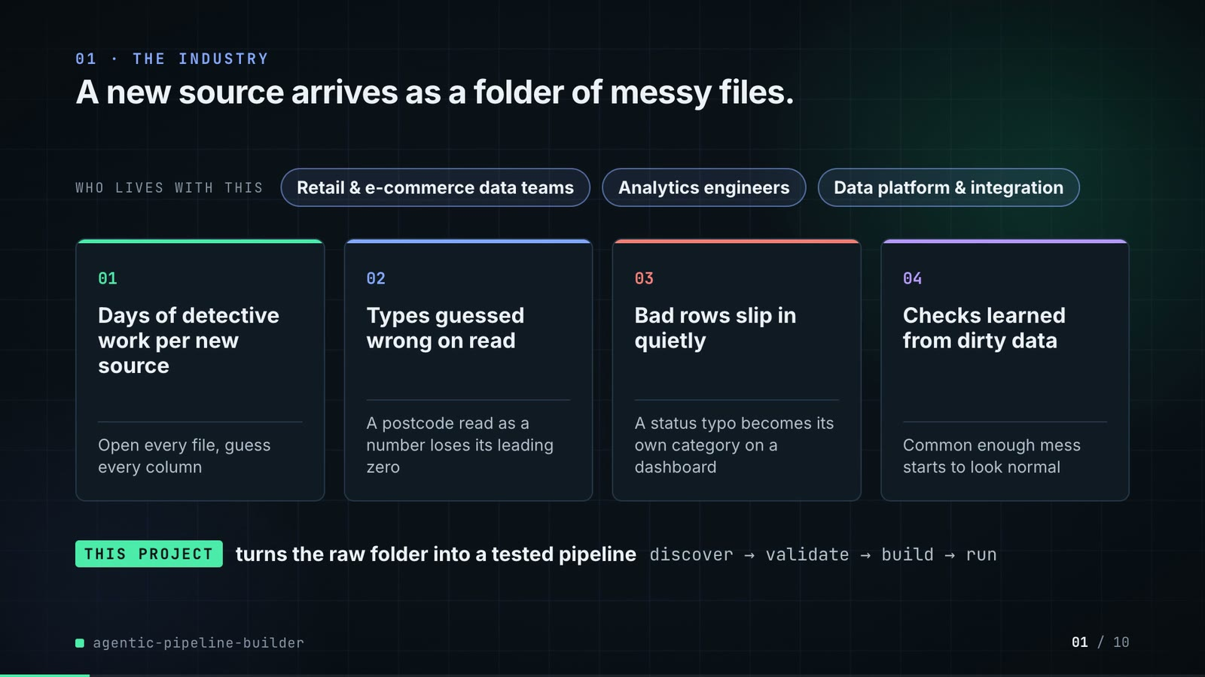
On-screen text (verbatim)
01 · THE INDUSTRY
A new source arrives as a folder of messy files.
WHO LIVES WITH THIS · Retail & e-commerce data teams · Analytics engineers · Data platform & integration
01 Days of detective work per new source — Open every file, guess every column
02 Types guessed wrong on read — A postcode read as a number loses its leading zero
03 Bad rows slip in quietly — A status typo becomes its own category on a dashboard
04 Checks learned from dirty data — Common enough mess starts to look normal
THIS PROJECT turns the raw folder into a tested pipeline · discover → validate → build → run
Figures on this slide
ID | Shown | Source · key | Calculation | Check
F-01 | 3 chips | author's framing · - | - | manual
F-02 | 4 problem cards | README 'The problem', 'Why it is hard' · README lines 16-34 | - | ✓

Assumptions: A-13
Illustrative, not data:
• The whole slide is context; no repo figures.
To change this slide: Edit the chips (#ctx-c1..3) and cards (#ctx-k1..4) in compositions/s01-context.html.

Slide 02: This project
6.8-11.6 s · composition compositions/s02-hook.html
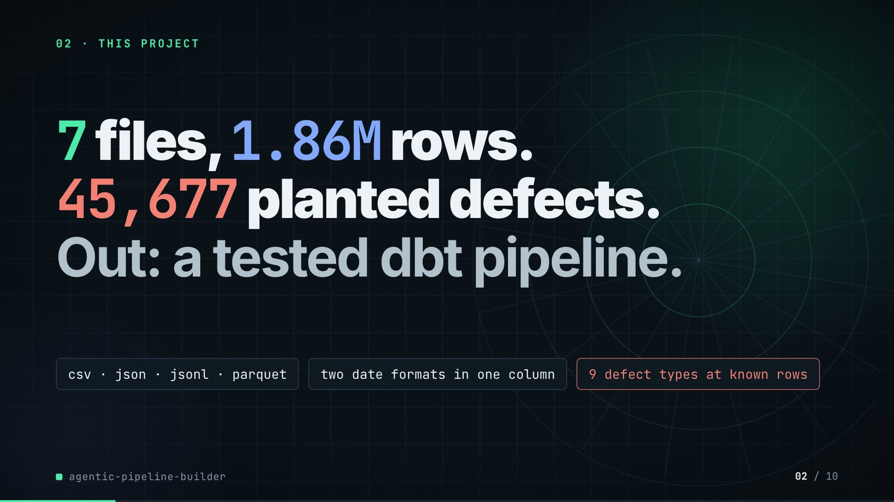
On-screen text (verbatim)
02 · THIS PROJECT
7 files, 1.86M rows. 45,677 planted defects. Out: a tested dbt pipeline.
csv · json · jsonl · parquet · two date formats in one column · 9 defect types at known rows
Figures on this slide
ID | Shown | Source · key | Calculation | Check
F-03 | 7 files | examples/catalog.yml · tables | count of tables | ✓
F-04 | 1.86M rows | outputs/metrics.json · quarantine[*].rows | 60,300 + 972,645 + 402,000 + 405,134 + 4,000 + 19,575 + 120 = 1,863,774 | ✓
F-05 | 45,677 planted defects | outputs/metrics.json · dq.agent.injected | - | ✓
F-06 | csv · json · jsonl · parquet | examples/catalog.yml · tables[*].file extensions | set of extensions | ✓
F-07 | two date formats in one column | examples/catalog.yml · customers.signup_date formats ['%m/%d/%Y', '%Y-%m-%d'] | - | ✓
F-08 | 9 defect types at known rows | outputs/metrics.json · dq.agent.by_defect | count of keys | ✓

Assumptions: A-01, A-02, A-12
Illustrative, not data:
• Rings in the background are decoration.
To change this slide: Headline spans #hook-l1..l3 and chips #hook-f1..f3 in compositions/s02-hook.html; sizes come from make e2e (outputs/metrics.json).

Slide 03: How it works (white chapter, slide A)
11.3-19.3 s · composition compositions/explainer.html (CONFIG.blocks, CONFIG.groups, CONFIG.loop)
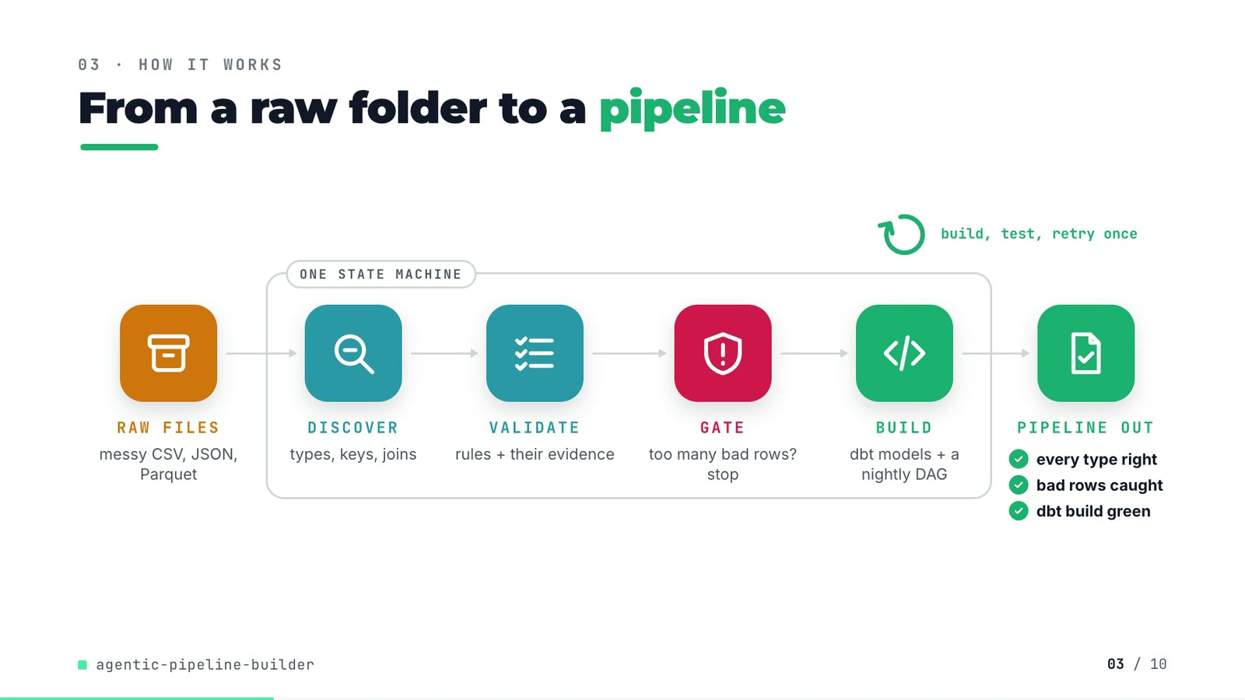
On-screen text (verbatim)
03 · HOW IT WORKS
From a raw folder to a pipeline
RAW FILES messy CSV, JSON, Parquet → [ONE STATE MACHINE: DISCOVER types, keys, joins → VALIDATE rules + their evidence → GATE too many bad rows? stop → BUILD dbt models + a nightly DAG] → PIPELINE OUT ✓ every type right ✓ bad rows caught ✓ dbt build green
build, test, retry once (loop over BUILD)
Figures on this slide
ID | Shown | Source · key | Calculation | Check
F-09 | ONE STATE MACHINE / orchestrator.py band | src/pipeline_builder/orchestrator.py:131-148 · STATES, TRANSITIONS | - | ✓
F-10 | too many bad rows? stop / quarantine > 5%? any table / HALTED | src/pipeline_builder/orchestrator.py:35, :93-95, :143 · max_quarantine_rate = 0.05; too_many_rejects -> HALTED | - | ✓
F-11 | build, test, retry once / retried once | src/pipeline_builder/orchestrator.py:153 · MAX_ATTEMPTS DBT_BUILD = 2 | 2 attempts = 1 retry | ✓
F-12 | every type right / bad rows caught / dbt build green | outputs/metrics.json · schema.types.agent, quarantine, dbt | agent types correct == total; quarantined rows > 0; dbt.ok and no failed tests | ✓
F-47 | 100% (54/54) | outputs/metrics.json · schema.types.agent.accuracy | - | ✓

Assumptions: A-04, A-06
Illustrative, not data:
• Icons and colours are a visual language, not data.
To change this slide: Edit CONFIG in compositions/explainer.html; badge truth is F-12.

Slide 04: The key idea (white chapter, slide B)
19.3-26.3 s · composition compositions/explainer.html (#ex-b ...)
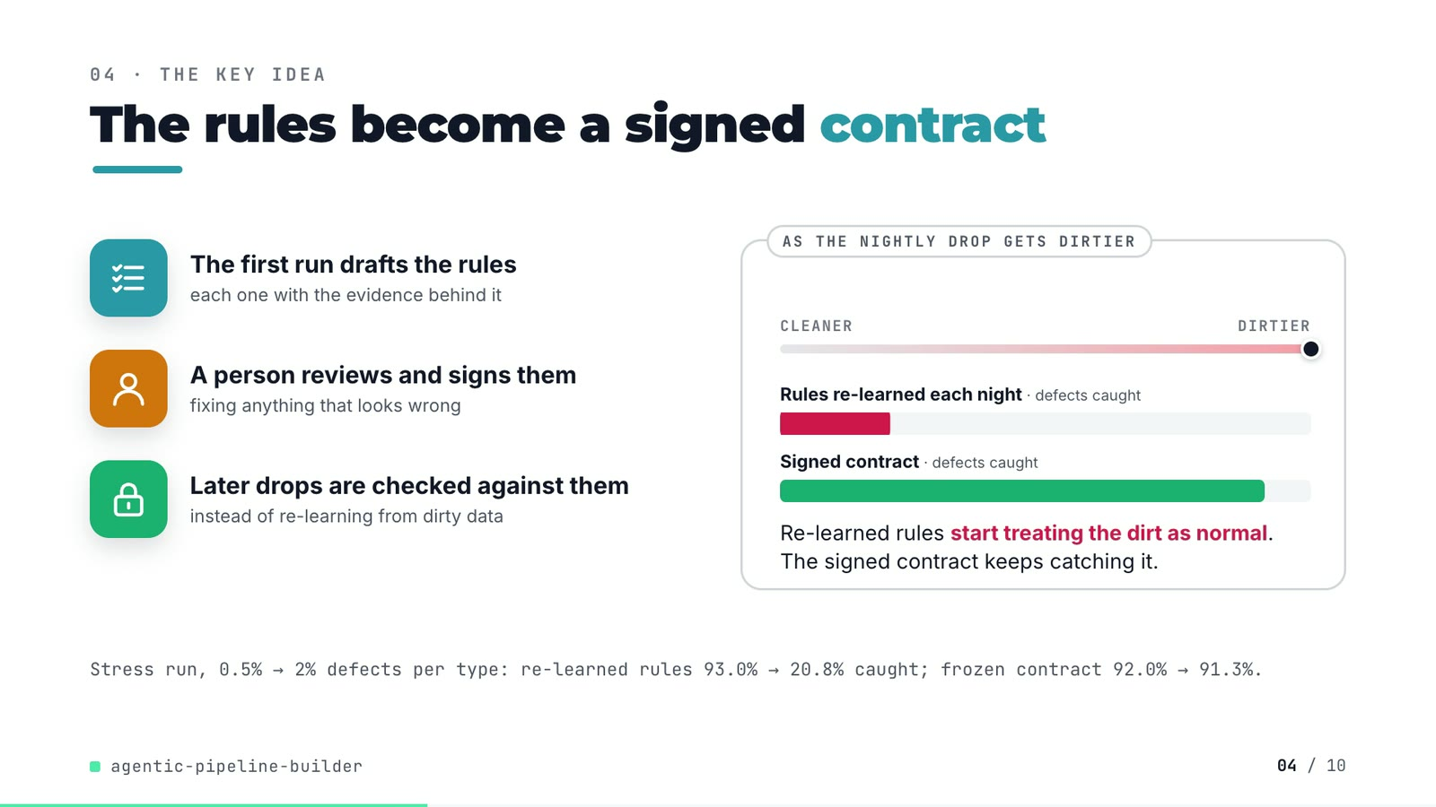
On-screen text (verbatim)
04 · THE KEY IDEA
The rules become a signed contract
The first run drafts the rules — each one with the evidence behind it
A person reviews and signs them — fixing anything that looks wrong
Later drops are checked against them — instead of re-learning from dirty data
AS THE NIGHTLY DROP GETS DIRTIER: CLEANER → DIRTIER; Rules re-learned each night · defects caught (red bar shrinks); Signed contract · defects caught (green bar holds). Re-learned rules start treating the dirt as normal. The signed contract keeps catching it.
Stress run, 0.5% → 2% defects per type: re-learned rules 93.0% → 20.8% caught; frozen contract 92.0% → 91.3%.
Figures on this slide
ID | Shown | Source · key | Calculation | Check
F-13 | 93.0% | outputs/stress.json · sweep['0.005'].dq_recall | - | ✓
F-14 | 20.8% | outputs/stress.json · sweep['0.02'].dq_recall | - | ✓
F-15 | 92.0% | outputs/stress.json · frozen_contract['0.005'].dq_recall | - | ✓
F-16 | 91.3% | outputs/stress.json · frozen_contract['0.02'].dq_recall | - | ✓
F-17 | red bar 0.9300 -> 0.2075, green bar 0.9197 -> 0.9126 of full width | demo:compositions/explainer.html; outputs/stress.json · scaleX targets | scaleX = recall (4 decimals, as stored) | ✓

Assumptions: A-05, A-08, A-09
Illustrative, not data:
• The slider is schematic (cleaner → dirtier = 0.5% → 2%); bar lengths are the stress recalls (F-17).
To change this slide: Markup under #ex-b in compositions/explainer.html; the footnote figures are F-13..F-16.

Slide 05: Architecture
26.0-40.6 s · composition compositions/s03-architecture.html
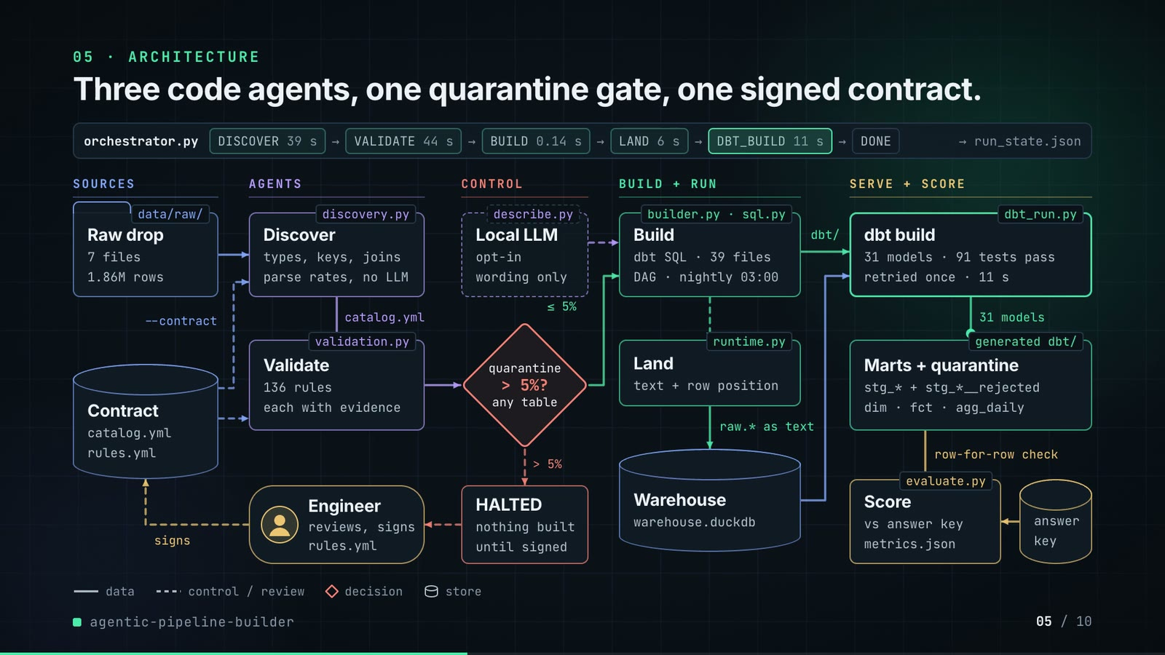
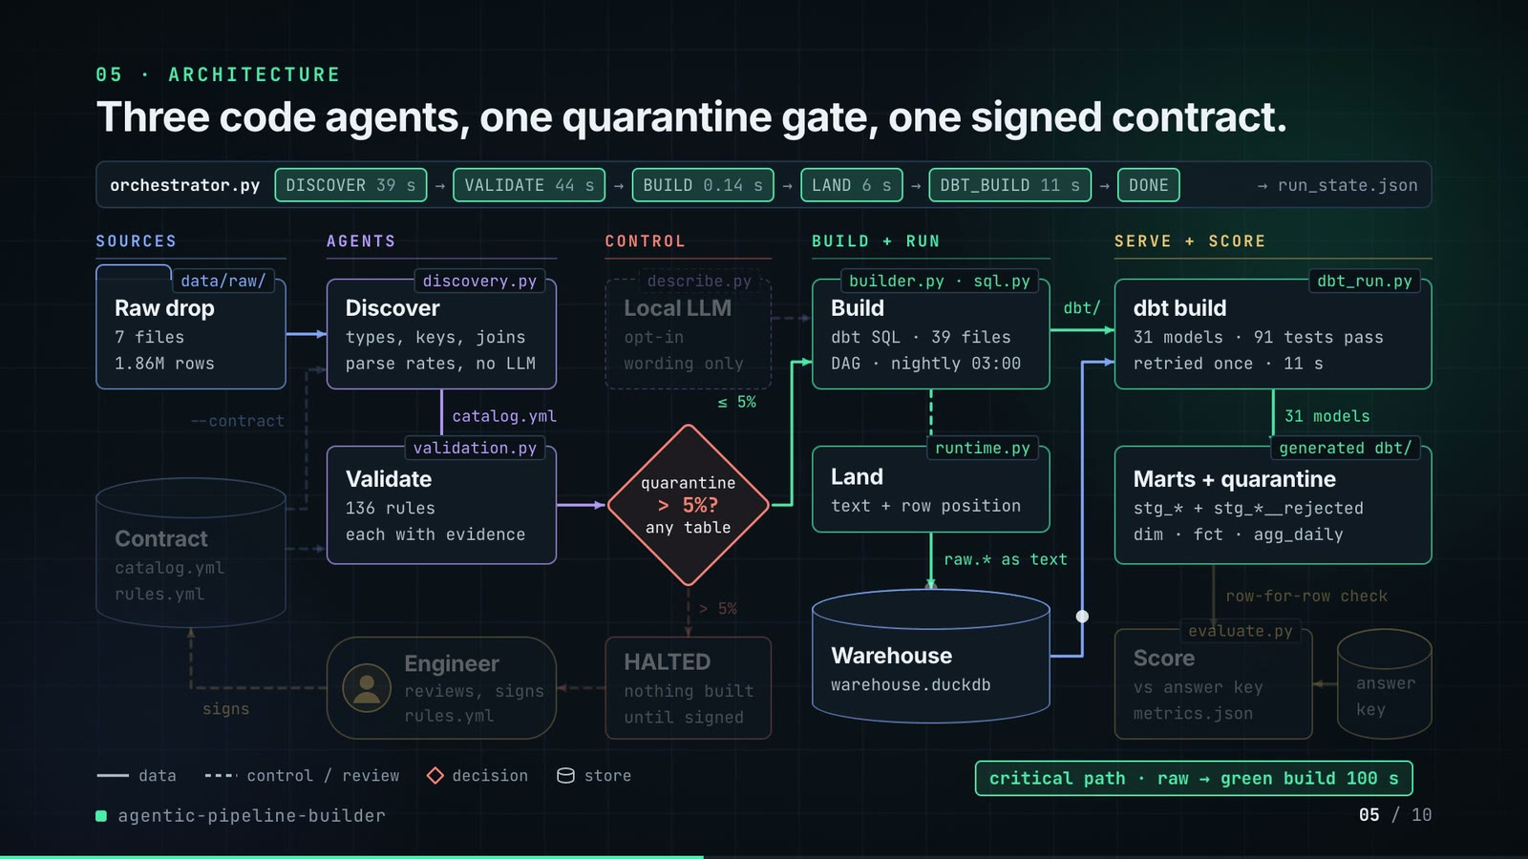
On-screen text (verbatim)
05 · ARCHITECTURE
Three code agents, one quarantine gate, one signed contract.
orchestrator.py: DISCOVER 39 s → VALIDATE 44 s → BUILD 0.14 s → LAND 6 s → DBT_BUILD 11 s → DONE → run_state.json
SOURCES: data/raw/ Raw drop (7 files, 1.86M rows) · Contract store (catalog.yml, rules.yml) --contract → Discover, Validate
AGENTS: discovery.py Discover (types, keys, joins; parse rates, no LLM) → catalog.yml → validation.py Validate (136 rules, each with evidence) · Engineer (reviews, signs rules.yml) → signs → Contract
CONTROL: describe.py Local LLM (opt-in, wording only; dashed = external) · quarantine > 5%? any table (≤ 5% → Build; > 5% → HALTED: nothing built until signed → Engineer)
BUILD + RUN: builder.py · sql.py Build (dbt SQL · 39 files, DAG · nightly 03:00) → runtime.py Land (text + row position) → raw.* as text → Warehouse (warehouse.duckdb)
SERVE + SCORE: dbt_run.py dbt build (31 models · 91 tests pass, retried once · 11 s) → 31 models → generated dbt/ Marts + quarantine (stg_* + stg_*__rejected; dim · fct · agg_daily) → row-for-row check → evaluate.py Score (vs answer key, metrics.json) ← answer key
Legend: data · control / review · decision · store. Critical path · raw → green build 100 s
Figures on this slide
ID | Shown | Source · key | Calculation | Check
F-03 | 7 files | examples/catalog.yml · tables | count of tables | ✓
F-04 | 1.86M rows | outputs/metrics.json · quarantine[*].rows | 60,300 + 972,645 + 402,000 + 405,134 + 4,000 + 19,575 + 120 = 1,863,774 | ✓
F-09 | ONE STATE MACHINE / orchestrator.py band | src/pipeline_builder/orchestrator.py:131-148 · STATES, TRANSITIONS | - | ✓
F-10 | too many bad rows? stop / quarantine > 5%? any table / HALTED | src/pipeline_builder/orchestrator.py:35, :93-95, :143 · max_quarantine_rate = 0.05; too_many_rejects -> HALTED | - | ✓
F-11 | build, test, retry once / retried once | src/pipeline_builder/orchestrator.py:153 · MAX_ATTEMPTS DBT_BUILD = 2 | 2 attempts = 1 retry | ✓
F-18 | 39 s · 44 s · 0.14 s · 6 s · 11 s | outputs/metrics.json · state_log[*].seconds (DISCOVER..DBT_BUILD) | 38.67, 44.15, 0.14, 5.93, 10.99 rounded (BUILD kept to 2 decimals) | ✓
F-19 | 100 s (slides 05, 06 title, 08) / 99.9 s (slide 06 log) | outputs/metrics.json · seconds_raw_to_built = 99.9 | rounded to whole seconds | ✓
F-20 | 136 rules | outputs/metrics.json; examples/rules.yml · rules | - | ✓
F-21 | 39 files / 39 dbt files | outputs/metrics.json · generated.dbt_files | - | ✓
F-22 | DAG · nightly 03:00 | examples/raw_drop_pipeline.py:25 · schedule='0 3 * * *' | - | ✓
F-23 | 31 models | outputs/metrics.json · dbt.models.success | - | ✓
F-24 | 91 tests pass | outputs/metrics.json · dbt.tests.pass | - | ✓
F-25 | file tags on the boxes | src/pipeline_builder/*.py; README · orchestrator, discovery, validation, describe, builder, sql, runtime, dbt_run, evaluate | - | ✓
F-26 | --contract into Discover and Validate | src/pipeline_builder/orchestrator.py:69-90 · cfg.contract -> catalog.yml, rules.yml | - | ✓
F-27 | row-for-row check | outputs/metrics.json · sql_vs_pandas[*].only_sql, only_pandas | all zero | ✓
F-28 | Local LLM · opt-in · wording only | src/pipeline_builder/describe.py:1-7, :24-27; cli.py:203 · ollama_client, --llm default None | - | ✓

Assumptions: A-04, A-05, A-06, A-07, A-11
Illustrative, not data:
• Packets moving along the wires and the state chips lighting up show execution order, not timing; the real durations are the labels in the band.
To change this slide: NODES and W (wires) in compositions/s03-architecture.html; the band chips are static text.

Slide 06: The system running
40.2-54.2 s · composition compositions/s04-routes.html
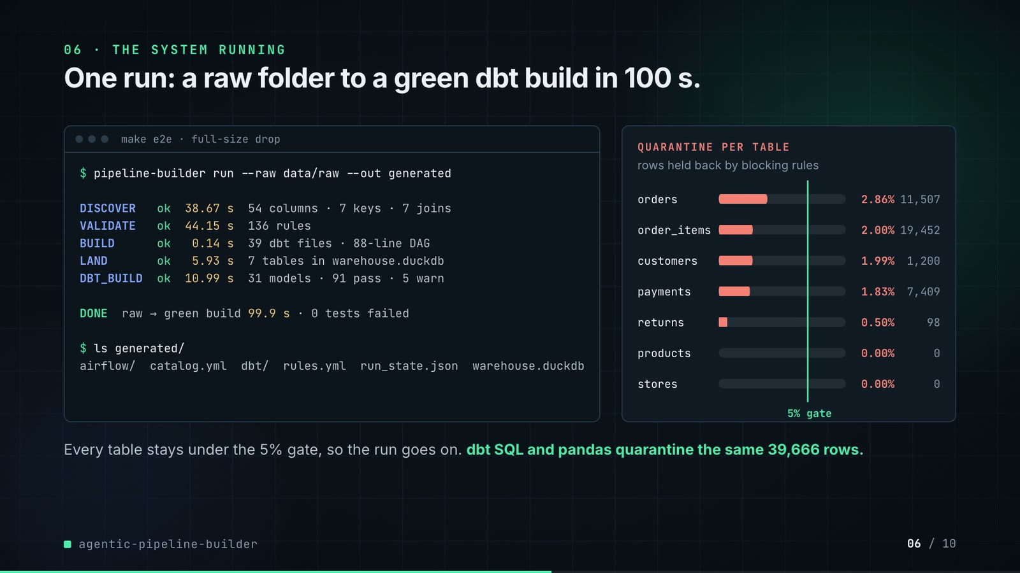
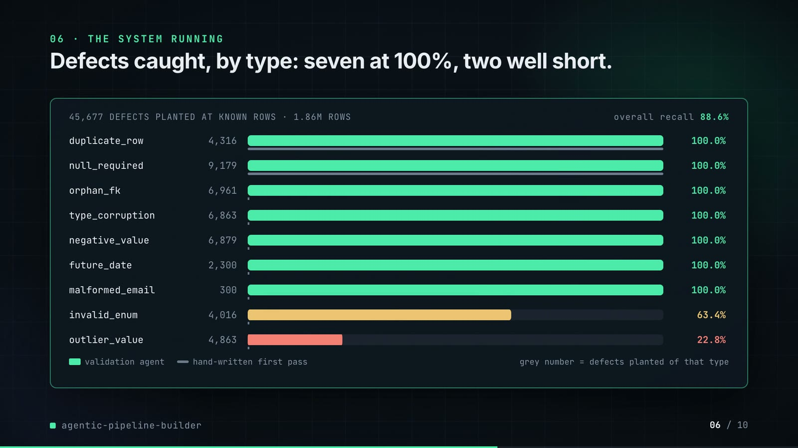
On-screen text (verbatim)
06 · THE SYSTEM RUNNING
One run: a raw folder to a green dbt build in 100 s.
$ pipeline-builder run --raw data/raw --out generated · DISCOVER ok 38.67 s 54 columns · 7 keys · 7 joins · VALIDATE ok 44.15 s 136 rules · BUILD ok 0.14 s 39 dbt files · 88-line DAG · LAND ok 5.93 s 7 tables in warehouse.duckdb · DBT_BUILD ok 10.99 s 31 models · 91 pass · 5 warn · DONE raw → green build 99.9 s · 0 tests failed
QUARANTINE PER TABLE (rows held back by blocking rules): orders 2.86% 11,507 · order_items 2.00% 19,452 · customers 1.99% 1,200 · payments 1.83% 7,409 · returns 0.50% 98 · products 0.00% 0 · stores 0.00% 0 · 5% gate
Every table stays under the 5% gate, so the run goes on. dbt SQL and pandas quarantine the same 39,666 rows.
Phase 2: Defects caught, by type: seven at 100%, two well short. 45,677 DEFECTS PLANTED AT KNOWN ROWS · 1.86M ROWS · overall recall 88.6% · per-type bars (F-36) with the hand-written first pass as thin grey bars (F-38)
Figures on this slide
ID | Shown | Source · key | Calculation | Check
F-04 | 1.86M rows | outputs/metrics.json · quarantine[*].rows | 60,300 + 972,645 + 402,000 + 405,134 + 4,000 + 19,575 + 120 = 1,863,774 | ✓
F-05 | 45,677 planted defects | outputs/metrics.json · dq.agent.injected | - | ✓
F-19 | 100 s (slides 05, 06 title, 08) / 99.9 s (slide 06 log) | outputs/metrics.json · seconds_raw_to_built = 99.9 | rounded to whole seconds | ✓
F-20 | 136 rules | outputs/metrics.json; examples/rules.yml · rules | - | ✓
F-21 | 39 files / 39 dbt files | outputs/metrics.json · generated.dbt_files | - | ✓
F-23 | 31 models | outputs/metrics.json · dbt.models.success | - | ✓
F-24 | 91 tests pass | outputs/metrics.json · dbt.tests.pass | - | ✓
F-27 | row-for-row check | outputs/metrics.json · sql_vs_pandas[*].only_sql, only_pandas | all zero | ✓
F-29 | 54 columns · 7 keys · 7 joins | outputs/metrics.json · schema.types.agent.total, primary_keys.correct, foreign_keys.found | - | ✓
F-30 | 38.67 · 44.15 · 0.14 · 5.93 · 10.99 | outputs/metrics.json · state_log[*].seconds | - | ✓
F-31 | 88-line DAG | outputs/metrics.json · generated.dag_lines | - | ✓
F-32 | 5 warn | outputs/metrics.json · dbt.tests.warn | - | ✓
F-33 | DONE · 0 tests failed | outputs/metrics.json · final_state, dbt.failed | - | ✓
F-34 | orders 2.86% 11,507 · order_items 2.00% 19,452 · customers 1.99% 1,200 · payments 1.83% 7,409 · returns 0.50% 98 · products 0.00% 0 · stores 0.00% 0 | outputs/metrics.json · quarantine[*] | quarantine_rate x 100 to 2 decimals | ✓
F-35 | the same 39,666 rows | outputs/metrics.json · sql_vs_pandas[*].both | 1,200 + 19,452 + 11,507 + 7,409 + 98 = 39,666 (sql = pandas = both) | ✓
F-36 | 9 bars | outputs/metrics.json · dq.agent.by_defect | - | ✓
F-37 | 88.6% | outputs/metrics.json · dq.agent.recall = 0.8856 | - | ✓
F-38 | 100% for duplicate_row and null_required, 0% for the other seven | outputs/metrics.json · dq.naive_baseline.by_defect | - | ✓
F-44 | under the 5% gate | outputs/metrics.json · max quarantine_rate = 0.02862 | max rate < 0.05 | ✓

Assumptions: A-02, A-03, A-04, A-07, A-09, A-10
Illustrative, not data:
• The terminal is a styled rendering of the state log in outputs/metrics.json, not a screen recording; the command line is the one make e2e runs (without its report flags).
To change this slide: LOG, Q and DQ arrays in compositions/s04-routes.html (copied from outputs/metrics.json).

Slide 07: End-user value (white)
53.9-66.9 s · composition compositions/value.html (SHEET injected by tools/inject_contract.py; CONFIG)
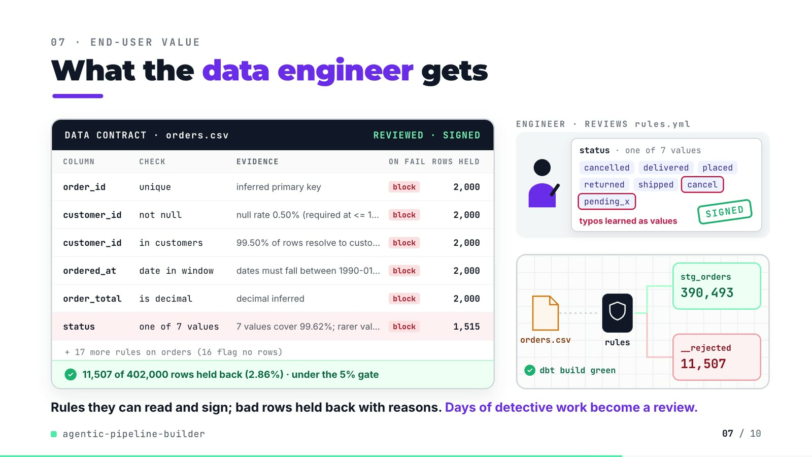
On-screen text (verbatim)
07 · END-USER VALUE
What the data engineer gets
DATA CONTRACT · orders.csv · DRAFT → REVIEWED · SIGNED
COLUMN / CHECK / EVIDENCE / ON FAIL / ROWS HELD: order_id unique (inferred primary key) block 2,000 · customer_id not null (null rate 0.50% (required at <= 1%)) block 2,000 · customer_id in customers (99.50% of rows resolve to customers.customer_id) block 2,000 · ordered_at date in window (dates must fall between 1990-01-01 and the run date 2026-02-01) block 2,000 · order_total is decimal (decimal inferred) block 2,000 · status one of 7 values (7 values cover 99.62%; rarer values excluded) block 1,515
+ 17 more rules on orders (16 flag no rows)
11,507 of 402,000 rows held back (2.86%) · under the 5% gate
Scene: ENGINEER · REVIEWS rules.yml — status · one of 7 values: cancelled, delivered, placed, returned, shipped, cancel (ringed), pending_x (ringed) · typos learned as values · SIGNED stamp
TONIGHT'S DROP: orders.csv → rules → stg_orders 390,493 / __rejected 11,507 · dbt build green
Rules they can read and sign; bad rows held back with reasons. Days of detective work become a review.
Figures on this slide
ID | Shown | Source · key | Calculation | Check
F-39 | order_id unique 2,000 · customer_id not null 2,000 · customer_id in customers 2,000 · ordered_at date in window 2,000 · order_total is decimal 2,000 · status one of 7 values 1,515 | demo:assets/contract_sheet.json (tools/export_contract_sheet.py re-runs discovery + validation on data/raw); examples/rules.yml · rules[*].rows_flagged, evidence, severity | rows held per rule = unique rows the rule flags | ✓
F-40 | 11,507 of 402,000 rows held back (2.86%) | outputs/metrics.json · quarantine[table=orders] | 11,507 / 402,000 = 2.86% | ✓
F-41 | stg_orders 390,493 | outputs/metrics.json · orders rows - quarantined; marts.fct_orders | 402,000 - 11,507 = 390,493 (equals the fct_orders row count) | ✓
F-42 | + 17 more rules on orders (16 flag no rows) | examples/rules.yml; demo:assets/contract_sheet.json · orders rules = 23 | 23 - 6 shown = 17; 16 of them flag 0 rows (the order_total outlier warning flags 17) | ✓
F-43 | cancel, pending_x ringed in the status value set | examples/rules.yml orders__status__in_set; README 'Known limitations' · kwargs.value_set | - | ✓
F-44 | under the 5% gate | outputs/metrics.json · max quarantine_rate = 0.02862 | max rate < 0.05 | ✓
F-45 | Days of detective work become a review. | README 'The problem' (days per source) and 'Known limitations' (first contract needs a person) · - | - | ✓

Assumptions: A-03, A-04, A-14
Illustrative, not data:
• Row tokens flowing to the bins are schematic (every 11th to quarantine); the counters are real.
• The review (ringing two values, the SIGNED stamp) shows the human step the README asks for; the counts shown are from the draft run, before any edit.
To change this slide: Re-run tools/export_contract_sheet.py, then tools/inject_contract.py with --rules; scene layout in CONFIG of compositions/value.html.

Slide 08: Results
66.6-75.4 s · composition compositions/s05-results.html
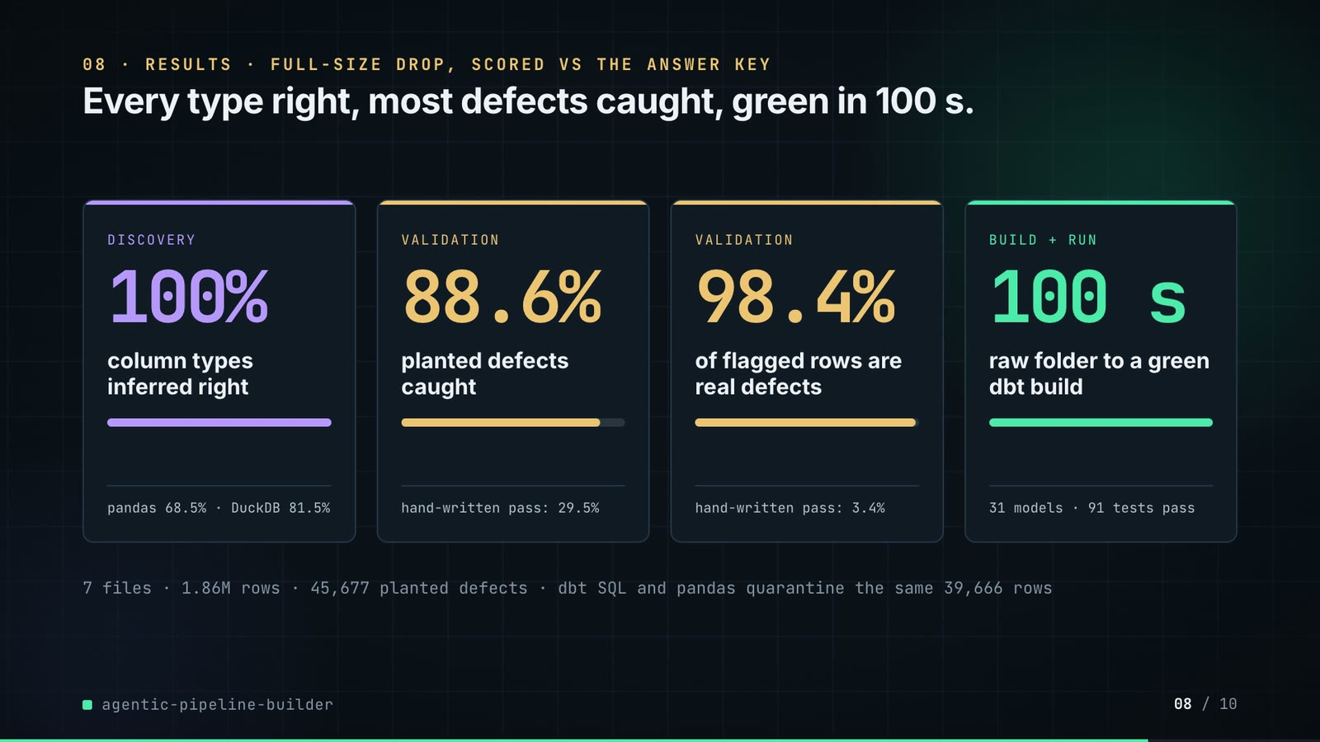
On-screen text (verbatim)
08 · RESULTS · FULL-SIZE DROP, SCORED VS THE ANSWER KEY
Every type right, most defects caught, green in 100 s.
DISCOVERY 100% column types inferred right · pandas 68.5% · DuckDB 81.5%
VALIDATION 88.6% planted defects caught · hand-written pass: 29.5%
VALIDATION 98.4% of flagged rows are real defects · hand-written pass: 3.4%
BUILD + RUN 100 s raw folder to a green dbt build · 31 models · 91 tests pass
7 files · 1.86M rows · 45,677 planted defects · dbt SQL and pandas quarantine the same 39,666 rows
Figures on this slide
ID | Shown | Source · key | Calculation | Check
F-03 | 7 files | examples/catalog.yml · tables | count of tables | ✓
F-04 | 1.86M rows | outputs/metrics.json · quarantine[*].rows | 60,300 + 972,645 + 402,000 + 405,134 + 4,000 + 19,575 + 120 = 1,863,774 | ✓
F-05 | 45,677 planted defects | outputs/metrics.json · dq.agent.injected | - | ✓
F-19 | 100 s (slides 05, 06 title, 08) / 99.9 s (slide 06 log) | outputs/metrics.json · seconds_raw_to_built = 99.9 | rounded to whole seconds | ✓
F-23 | 31 models | outputs/metrics.json · dbt.models.success | - | ✓
F-24 | 91 tests pass | outputs/metrics.json · dbt.tests.pass | - | ✓
F-35 | the same 39,666 rows | outputs/metrics.json · sql_vs_pandas[*].both | 1,200 + 19,452 + 11,507 + 7,409 + 98 = 39,666 (sql = pandas = both) | ✓
F-37 | 88.6% | outputs/metrics.json · dq.agent.recall = 0.8856 | - | ✓
F-47 | 100% (54/54) | outputs/metrics.json · schema.types.agent.accuracy | - | ✓
F-48 | pandas 68.5% · DuckDB 81.5% | outputs/metrics.json · schema.types.pandas_default / duckdb_sniff accuracy | - | ✓
F-50 | hand-written pass: 29.5% | outputs/metrics.json · dq.naive_baseline.recall | - | ✓
F-51 | 98.4% | outputs/metrics.json · dq.agent.row_precision | - | ✓
F-52 | hand-written pass: 3.4% | outputs/metrics.json · dq.naive_baseline.row_precision | - | ✓

Assumptions: A-01, A-07, A-09, A-10, A-12
Illustrative, not data:
• The mini bars under each number are the number as a share of 100%; the 100 s card's bar is full by design.
To change this slide: The stats array and card text in compositions/s05-results.html.

Slide 09: What didn't win
75.0-82.0 s · composition compositions/s06-twist.html
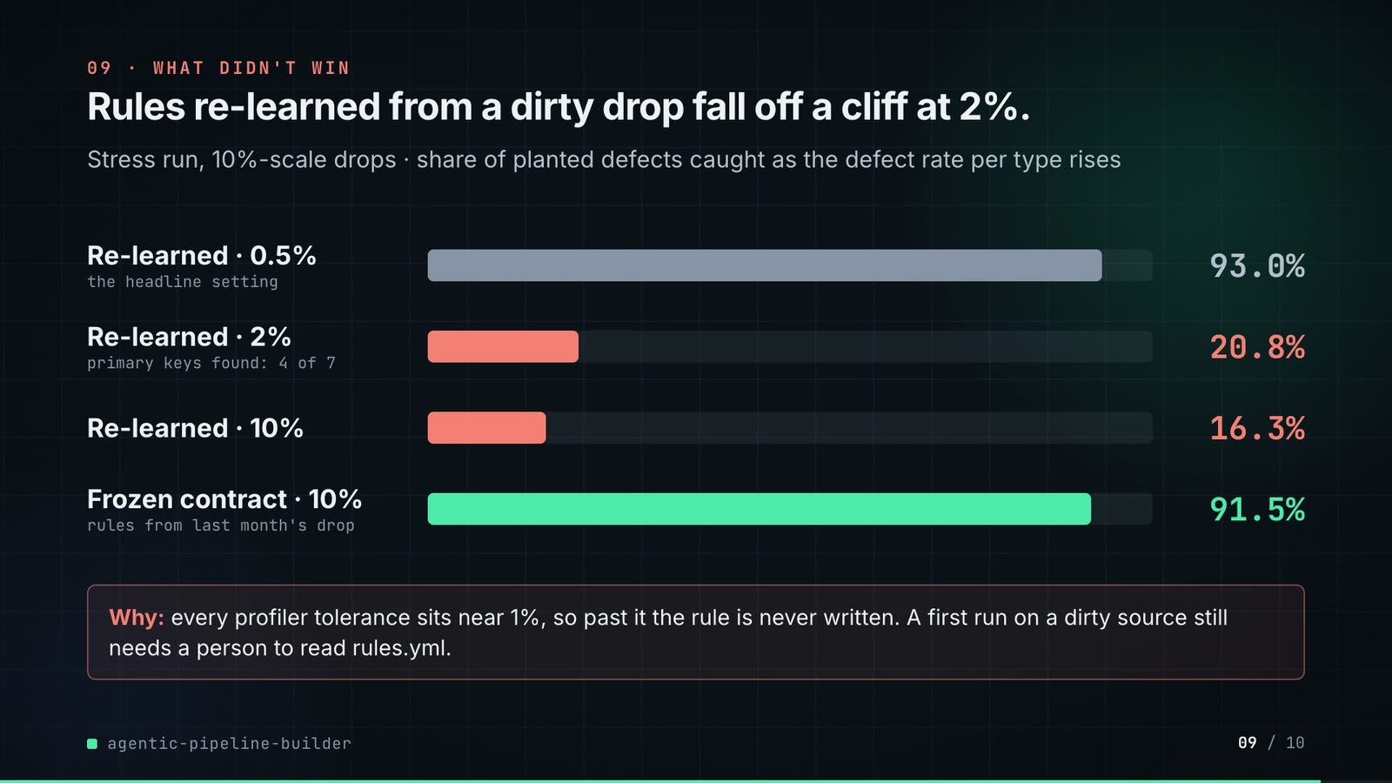
On-screen text (verbatim)
09 · WHAT DIDN'T WIN
Rules re-learned from a dirty drop fall off a cliff at 2%.
Stress run, 10%-scale drops · share of planted defects caught as the defect rate per type rises
Re-learned · 0.5% (the headline setting) 93.0% · Re-learned · 2% (primary keys found: 4 of 7) 20.8% · Re-learned · 10% 16.3% · Frozen contract · 10% (rules from last month's drop) 91.5%
Why: every profiler tolerance sits near 1%, so past it the rule is never written. A first run on a dirty source still needs a person to read rules.yml.
Figures on this slide
ID | Shown | Source · key | Calculation | Check
F-13 | 93.0% | outputs/stress.json · sweep['0.005'].dq_recall | - | ✓
F-14 | 20.8% | outputs/stress.json · sweep['0.02'].dq_recall | - | ✓
F-58 | 16.3% | outputs/stress.json · sweep['0.1'].dq_recall | - | ✓
F-59 | 91.5% | outputs/stress.json · frozen_contract['0.1'].dq_recall | - | ✓
F-60 | primary keys found: 4 of 7 | outputs/stress.json · sweep['0.02'].primary_keys | - | ✓
F-61 | every profiler tolerance sits near 1% | src/pipeline_builder/discovery.py:30-31; validation.py:25, :31 · KEY_MAX_NULL 0.01, KEY_MIN_DISTINCT 0.99, NOT_NULL_MAX 0.01, NON_NEGATIVE_SHARE 0.99 | - | ✓
F-62 | 10%-scale drops | outputs/stress.json · scale | - | ✓

Assumptions: A-05, A-08, A-09
Illustrative, not data:
• Bar widths are recall x 1000 px.
To change this slide: Rows #twist-r1..r4 in compositions/s06-twist.html (values from outputs/stress.json).

Slide 10: End card
81.6-86.0 s · composition compositions/s07-end.html

On-screen text (verbatim)
10 · OPEN SOURCE · MIT · RUNS ON A LAPTOP
agentic-pipeline-builder
github.com/kavya2693/agentic-pipeline-builder
dbt · DuckDB · Airflow DAG · pandas · Python
$ make e2e # generate 1.86M rows, build, dbt build, score
Figures on this slide
ID | Shown | Source · key | Calculation | Check
F-63 | OPEN SOURCE · MIT | LICENSE · - | - | ✓
F-64 | dbt · DuckDB · Airflow DAG · pandas · Python | pyproject.toml; examples/raw_drop_pipeline.py · dependencies; airflow import | - | ✓
F-65 | $ make e2e # generate 1.86M rows, build, dbt build, score | Makefile · e2e: data run | - | ✓
F-66 | RUNS ON A LAPTOP | README 'The result' · 'green build in 100 s on a laptop' | - | ✓

Assumptions: A-12
Illustrative, not data:
• The faint five-node loop on the right is decoration (a state-machine motif).
To change this slide: Text in compositions/s07-end.html.

5. Change-impact matrix
Input / assumption | Affected figures | Slides | Files to edit | Re-run
A-01: All data is synthetic: a seeded generator writes a regional retailer's nightly drop (60k customers, 400k orders, 973k order lines, 405k payments, 20k returns, 4,000 products, 120 stores) | all figures | 01, 02, 03, 04, 05, 06, 07, 08, 09, 10 | src/pipeline_builder/datagen.py; scripts/generate_data.py | make e2e; make stress
A-02: Defects are planted at 0 | F-05, F-08, F-36, F-37, F-38, F-50, F-51, F-52 | 02, 06, 08 | scripts/generate_data.py:15 | make e2e
A-03: The drop is judged as of 2026-02-01: date-window rules reject dates after the run date | F-34, F-36, F-39, F-40 | 06, 07 | Makefile:4 | make e2e; export_contract_sheet.py + inject_contract.py
A-04: Quarantine gate: the run halts before building if any table would quarantine more than 5% of its rows | F-10, F-34, F-44 | 03, 05, 06, 07 | src/pipeline_builder/orchestrator.py:35 or --max-quarantine-rate | make e2e
A-05: Profiler tolerances sit near 1%: a type needs 98% of values to parse, a required column at most 1% nulls, a key 99% distinct and at most 1% nulls, a non-negative column 99% non-negative, a category at least 0 | F-03, F-20, F-29, F-36, F-47, F-13, F-14, F-58, F-61 | 02, 03, 04, 05, 06, 08, 09 | src/pipeline_builder/discovery.py:27-35; src/pipeline_builder/validation.py:25-36 | make e2e; make stress
A-06: Retry policy: only DBT_BUILD and LAND are retried (2 attempts each); a rule that fails on the data fails the same way twice | F-11 | 03, 05 | src/pipeline_builder/orchestrator.py:153 | make e2e
A-07: Timings are wall-clock seconds from one run on the author's laptop and vary with the machine and its load | F-18, F-19, F-30 | 05, 06, 08 | - | make e2e
A-08: Stress runs are at 10% scale (about 40,000 orders) with defect rates 0 | F-13, F-14, F-15, F-16, F-17, F-58, F-59, F-60, F-62 | 04, 09 | scripts/stress_defect_rate.py:93-103 | make stress
A-09: Scoring: a defect is caught when a rule flags its row on its column (a duplicate row by any uniqueness rule) | F-36, F-37, F-38, F-50, F-51, F-52, F-13, F-14, F-15, F-16, F-58, F-59 | 04, 06, 08, 09 | src/pipeline_builder/evaluate.py:143 | make e2e; make stress
A-10: The 'hand-written first pass' baseline is every column required plus the first column unique | F-38, F-50, F-52 | 06, 08 | src/pipeline_builder/validation.py:276 | make e2e
A-11: The local LLM (Ollama) is off by default and only words column descriptions; types, keys, rules and SQL are deterministic code | F-28 | 05 | --llm flag | uv run pipeline-builder run ... --llm llama3.2
A-12: Video rounding: percentages to 1 decimal (the type-accuracy card to 0), seconds to whole numbers on slides 05 and 08 (BUILD 0 | F-04, F-18, F-19, F-36, F-37, F-47, F-48, F-50, F-51, F-52 | 02, 03, 05, 06, 08 | the composition file named on each slide | hyperframes render
A-13: Slide 01 (industry, everyday problems) is general data-engineering knowledge used as context, echoed by the README's problem statement | F-01, F-02 | 01 | compositions/s01-context.html | hyperframes render
A-14: Slide 07's scene is schematic: the row tokens are illustrative (every 11th goes to quarantine); the counters, the contract rows and the ringed values come from the export | F-39, F-41, F-43 | 07 | compositions/value.html (CONFIG) | hyperframes render

6. Known differences and caveats
• All data is synthetic and the generator and inference rules share an author: 100% type accuracy is an upper bound (A-01). The format-shift stress arm (outputs/stress.md) is the honest measure and drops type accuracy to 94.4% without a warning; it is not on screen.
• Slide 04's footnote and slide 09 use the 10%-scale stress runs; slides 02, 06 and 08 use the full-size drop. The two 0.5% recalls differ (93.0% at 10% scale vs 88.6% full size).
• Timings (39/44/0.14/6/11 s, 100 s) are one run on the author's laptop (A-07).
• The Airflow DAG is generated and checked against stub modules, not run on a live Airflow (README 'Known limitations'); the end card's 'Airflow DAG' chip means the generated file.
• Inflated prices are mostly missed (22.8%) and 322 orders with the rare real status 'disputed' are quarantined as typos (README); slide 07's status row (1,515 rows held) includes those 322.
• Slide 07's review step is shown, not measured: the counts on the sheet are from the draft rules, before any edit.
• Slide 01 statements are general data-engineering knowledge (A-13).

Appendix: environment
Item | Value
Commit | cbcb816890b0cb816098c9b2e8f9850dc959f944
Python | 3.11.7
pandas | 3.0.6
numpy | 2.4.6
duckdb | 1.5.6
yaml | 6.0.3
pyarrow | 26.0.0
Profile / seeds | data_seed=7, stress_baseline_seed=3, defect_rate=0.005, as_of=2026-02-01
Run time | metrics.json seconds_raw_to_built = 99.9 s for the pipeline run (data generation not included); the contract-sheet export re-runs discovery + validation in about 40 s

