AUDIT REPORT

fleet-routing-cvrp: demo video audit report
A slide-by-slide record of every number, assumption and calculation in the demo video, with its source.
Item | Value
Repository | https://github.com/kavya2693/fleet-routing-cvrp
Numbers taken from commit | c9b3c09d094cd863c61c2af426513b6d9b33ba68 (outputs last changed in c9b3c09 (2026-10-13 21:56:42 +0400))
Video | docs/demo/demo.mp4 · 84.0 s · 1920x1080 · 30 fps · silent
Generated | 2026-10-14 13:44
Automated checks | 52 pass · 0 fail · 4 manual (of 56 figures)
Assumptions | 16 (A-01 to A-16)

How to use this report
Every number or claim on screen has an ID (F-01, F-02, ...) and every modelling assumption has an ID (A-01, ...). Cite the ID. Each figure lists its source file, the exact column, row or key, the formula for derived numbers, and an automated check result. The change-impact matrix (section 5) shows which slides and files change if an input or assumption changes.
Types: direct = read straight from a repo output; derived = computed from direct values (formula given); illustrative = drawing or example, not data; general knowledge = context not produced by the repo.

Regenerate
make run # outputs/full/*.csv, results.json, route_map.png (~18 min)
python3 docs/demo/source/tools/darkmap.py outputs/full/route_map.png docs/demo/source/assets
PYTHONPATH=src .venv/bin/python docs/demo/source/tools/export_dispatch_sheet.py docs/demo/source/assets/dispatch_sheet.json
python3 docs/demo/source/tools/inject_sheet.py docs/demo/source/assets/dispatch_sheet.json docs/demo/source/compositions/value.html --rows 12,24,30,34,38,53 --animate 24,30,34,53
cd docs/demo/source && npx --yes hyperframes@0.8.156 check && npx --yes hyperframes@0.8.156 render -f 30 -q looks -o renders/fleet-routing-cvrp-master.mp4 && cd -
ffmpeg -y -i docs/demo/source/renders/fleet-routing-cvrp-master.mp4 -c:v libx264 -preset slow -crf 25 -pix_fmt yuv420p -movflags +faststart -an docs/demo/demo.mp4
python3 docs/demo/source/tools/build_audit_report.py docs/demo/source/audit/facts.yaml # stills, checks, MD/DOCX/PDF

1. Figures
ID | Shown | Slides | Source | Column / row / key | How computed | Type | Check
F-01 | 3 industry chips | 01 | author's framing | - | - | general knowledge | manual: Context statement, not a repo output.
F-02 | 4 problem cards | 01 | README 'The problem' (problems 2-4) | README lines 16-27 | - | general knowledge | ✓ verified
F-03 | 300 trucks | 02, 05, 08 | outputs/full/results.json | trucks | - | direct | ✓ verified
F-04 | 4 depots | 02, 08 | outputs/full/results.json | depots | - | direct | ✓ verified
F-05 | Up to 2,800 orders a day | 02 | data/full/dispatch_orders.csv | orders per date (max = 2,785 on 2025-12-08) | max daily order count = 2,785, rounded up to the nearest hundred = 2,800 | derived | ✓ verified
F-06 | every stop has a delivery window | 02 | data/full/dispatch_orders.csv | tw_start, tw_end (no missing values) | count of missing windows = 0 | direct | ✓ verified
F-07 | trailer capacity + shift limits | 02 | src/fleet_routing/routing.py:202, :205 | capacity + time dimensions | - | direct | ✓ verified
F-08 | >5% of peak shipments misrouted | 02 | outputs/full/risk_scores.csv; README line 26-27 | model=xgboost, period=peak, base_rate (0.0531) | base_rate x 100 = 5.3% > 5% | direct | ✓ verified
F-09 | OR-Tools, 6 s per depot / solve budget 6.0 s | 03, 05 | outputs/full/results.json | solver_seconds_per_depot_day | - | direct | ✓ verified
F-10 | EVERY MONDAY | 03 | README line 43 | README | - | direct | ✓ verified
F-11 | windows kept / fewer km / fewer trucks | 03 | outputs/full/routing_summary.csv | arm in {sweep, ortools_risk}, window=peak: on_time_pct, total_km, vehicle_days | on_time_pct = 100; total_km(ortools_risk) < total_km(sweep); vehicle_days(ortools_risk) < vehicle_days(sweep) | derived | ✓ verified
F-12 | build, score, improve | 03 | src/fleet_routing/routing.py:229-230 | PATH_CHEAPEST_ARC + GUIDED_LOCAL_SEARCH | - | direct | ✓ verified
F-13 | Later stops are riskier | 04 | src/fleet_routing/data.py:238-241; outputs/full/results.json position_effect_logodds_per_stop | 0.09 generated, 0.094 estimated | estimated slope > 0 | direct | ✓ verified
F-14 | -4.2% misroutes | 04 | outputs/full/routing_summary.csv | window=peak, misroute_pct: ortools_risk 4.3871, ortools 4.5810 | (4.3871 - 4.5810) / 4.5810 x 100 = -4.23% | derived | ✓ verified
F-15 | +4.0% km | 04 | outputs/full/routing_summary.csv | window=peak, total_km: ortools_risk 113,937.7, ortools 109,607.3 | (113,937.7 - 109,607.3) / 109,607.3 x 100 = +3.95% | derived | ✓ verified
F-16 | 2 yrs x 40 zones | 05, 08 | data/full/zone_demand.csv; outputs/full/results.json zones | 731 daily rows 2024-01-01..2025-12-31; zones = 40 | - | direct | ✓ verified
F-17 | 200k history | 05 | data/full/shipments_history.csv | row count | - | direct | ✓ verified
F-18 | 24k | 05 | outputs/full/results.json | dispatch_orders = 24,394 | 24,394 rounded to thousands | direct | ✓ verified
F-19 | +0.094 log-odds / stop | 05 | outputs/full/results.json | position_effect_logodds_per_stop | - | direct | ✓ verified
F-20 | forecast.py, risk.py, simulate.py, routing.py, replay(), data.py | 05 | src/fleet_routing/ | files + def replay | - | direct | ✓ verified
F-21 | call top 5% before loading | 05, 09 | src/fleet_routing/config.py:93 | ADDRESS_CHECK_SHARE = 0.05 | - | direct | ✓ verified
F-22 | Depot 3 · dispatch 2025-12-09 | 06 | data/full/depots.csv (busiest depot); src/fleet_routing/cli.py:121-125; config peak window | depot with most vehicles = 3; first peak dispatch = 2025-12-08 + 1 day | - | direct | ✓ verified
F-23 | 104 trucks | 06 | outputs/full/route_map.png (left panel title) | plot title | - | direct | manual: Read from the PNG title; the repo does not save per-depot-day routes. Cross-check: depot 3 fleet = 104 (depots.csv).
F-24 | 11,368 km | 06 | outputs/full/route_map.png (left panel title) | plot title | - | direct | manual: Read from the PNG title; not persisted in any CSV.
F-25 | 93 trucks | 06 | outputs/full/route_map.png (right panel title); re-run in demo assets/dispatch_sheet.json | trucks_used | - | direct | ✓ verified
F-26 | 8,574 km | 06 | outputs/full/route_map.png (right panel title) | plot title | - | direct | manual: Read from the PNG title. The single-day re-run (assets/dispatch_sheet.json) gives 8,412.7 km because the solver stops on wall-clock time (A-04).
F-27 | -24.6% km | 06 | F-24, F-26 (plot titles) | 8,574 vs 11,368 | (8,574 - 11,368) / 11,368 x 100 = -24.58% | derived | ✓ verified
F-28 | 13,554 orders | 06 | outputs/full/routing_summary.csv | arm=sweep, window=peak, orders | - | direct | ✓ verified
F-29 | 140,683 km | 06, 08 | outputs/full/routing_summary.csv | arm=sweep, window=peak, total_km | - | direct | ✓ verified
F-30 | 109,607 km | 06, 08 | outputs/full/routing_summary.csv | arm=ortools, window=peak, total_km | - | direct | ✓ verified
F-31 | -22.1% | 06, 08 | outputs/full/routing_summary.csv | F-30 vs F-29 | (109,607.3 - 140,683.4) / 140,683.4 x 100 = -22.09% | derived | ✓ verified
F-32 | 93 trucks | 07 | demo assets/dispatch_sheet.json (re-run of the repo's routing for Depot 3, 2025-12-09) | trucks_used (rostered 104) | - | direct | ✓ verified
F-33 | 910 orders | 07 | demo assets/dispatch_sheet.json; data/full/dispatch_orders.csv | orders on 2025-12-08 for depot 3 | - | direct | ✓ verified
F-34 | all inside their delivery windows | 07 | demo assets/dispatch_sheet.json | on_time = delivered = orders | 910 / 910 | direct | ✓ verified
F-35 | 8,413 km | 07 | demo assets/dispatch_sheet.json | total_km = 8,412.7 | rounded | direct | ✓ verified
F-36 | T-013, T-025, T-031, T-035, T-039, T-054 | 07 | demo assets/dispatch_sheet.json, injected into compositions/value.html | vehicles 12, 24, 30, 34, 38, 53 | truck id = vehicle index + 1; depart = SHIFT_START | direct | ✓ verified
F-37 | + 87 more trucks | 07 | F-32 | 93 - 6 rows | 93 - 6 = 87 | derived | ✓ verified
F-38 | -8.1% | 08 | outputs/full/routing_summary.csv | vehicle_days: ortools 1,339 vs sweep 1,457 | (1,339 - 1,457) / 1,457 x 100 = -8.10% | derived | ✓ verified
F-39 | 1,457 | 08 | outputs/full/routing_summary.csv | arm=sweep, window=peak, vehicle_days | - | direct | ✓ verified
F-40 | 1,339 | 08 | outputs/full/routing_summary.csv | arm=ortools, window=peak, vehicle_days | - | direct | ✓ verified
F-41 | 0.208 | 08 | outputs/full/forecast_scores.csv | model=xgboost, period=all, wape | - | direct | ✓ verified
F-42 | ETS 0.260 | 08 | outputs/full/forecast_scores.csv | model=ets, period=all, wape | - | direct | ✓ verified
F-43 | naive 0.344 | 08 | outputs/full/forecast_scores.csv | model=seasonal_naive, period=all, wape | - | direct | ✓ verified
F-44 | 8.7% | 08 | outputs/full/roster_scores.csv | model=xgboost, period=peak, short_depot_days_pct | - | direct | ✓ verified
F-45 | ETS forecast: 53.8% | 08 | outputs/full/roster_scores.csv | model=ets, period=peak, short_depot_days_pct | - | direct | ✓ verified
F-46 | 16.6% | 09 | outputs/full/address_checks.csv | ranked_by=rule, window=peak, reduction_pct | - | direct | ✓ verified
F-47 | 16.4% | 09 | outputs/full/address_checks.csv | ranked_by=xgboost, window=peak, reduction_pct | - | direct | ✓ verified
F-48 | 15.8% | 09 | outputs/full/address_checks.csv | ranked_by=logistic, window=peak, reduction_pct | - | direct | ✓ verified
F-49 | 1.1% | 09 | outputs/full/address_checks.csv | ranked_by=random, window=peak, reduction_pct | - | direct | ✓ verified
F-50 | ROC-AUC 0.645 | 09 | outputs/full/risk_scores.csv | model=xgboost, period=all, roc_auc | - | direct | ✓ verified
F-51 | ROC-AUC 0.647 | 09 | outputs/full/risk_scores.csv | model=logistic, period=all, roc_auc | - | direct | ✓ verified
F-52 | ceiling AUC 0.647 | 09 | outputs/full/risk_scores.csv | model=ceiling, period=all, roc_auc | - | direct | ✓ verified
F-53 | MIT | 10 | LICENSE line 1 | - | - | direct | ✓ verified
F-54 | ~18 min | 10 | outputs/full/results.json | runtime_seconds = 1063 | 1063 / 60 = 17.7 min | derived | ✓ verified
F-55 | OR-Tools · XGBoost · statsmodels · Python | 10 | pyproject.toml dependencies | ortools, xgboost, statsmodels | - | direct | ✓ verified
F-56 | $ make run | 10 | Makefile | run target | - | direct | ✓ verified

2. Automated check run (2026-10-14 13:44)
ID | Expected on slide | Recomputed from repo | Result
F-01 | 3 industry chips | - | manual
F-02 | true | true | ✓ pass
F-03 | 300 | 300 | ✓ pass
F-04 | 4 | 4 | ✓ pass
F-05 | true | true | ✓ pass
F-06 | true | true | ✓ pass
F-07 | true | true | ✓ pass
F-08 | true | true | ✓ pass
F-09 | 6.0 | 6.0 | ✓ pass
F-10 | true | true | ✓ pass
F-11 | true | true | ✓ pass
F-12 | true | true | ✓ pass
F-13 | true | true | ✓ pass
F-14 | -4.2% | -4.2% | ✓ pass
F-15 | +4.0% | +4.0% | ✓ pass
F-16 | true | true | ✓ pass
F-17 | 200,000 | 200,000 | ✓ pass
F-18 | 24k | 24k | ✓ pass
F-19 | 0.094 | 0.094 | ✓ pass
F-20 | true | true | ✓ pass
F-21 | true | true | ✓ pass
F-22 | true | true | ✓ pass
F-23 | 104 trucks | - | manual
F-24 | 11,368 km | - | manual
F-25 | 93 | 93 | ✓ pass
F-26 | 8,574 km | - | manual
F-27 | -24.6% | -24.6% | ✓ pass
F-28 | 13,554 | 13,554 | ✓ pass
F-29 | 140,683 | 140,683 | ✓ pass
F-30 | 109,607 | 109,607 | ✓ pass
F-31 | -22.1% | -22.1% | ✓ pass
F-32 | 93 | 93 | ✓ pass
F-33 | true | true | ✓ pass
F-34 | true | true | ✓ pass
F-35 | 8,413 | 8,413 | ✓ pass
F-36 | true | true | ✓ pass
F-37 | 87 | 87 | ✓ pass
F-38 | -8.1% | -8.1% | ✓ pass
F-39 | 1,457 | 1,457 | ✓ pass
F-40 | 1,339 | 1,339 | ✓ pass
F-41 | 0.208 | 0.208 | ✓ pass
F-42 | 0.260 | 0.260 | ✓ pass
F-43 | 0.344 | 0.344 | ✓ pass
F-44 | 8.7% | 8.7% | ✓ pass
F-45 | 53.8% | 53.8% | ✓ pass
F-46 | 16.6% | 16.6% | ✓ pass
F-47 | 16.4% | 16.4% | ✓ pass
F-48 | 15.8% | 15.8% | ✓ pass
F-49 | 1.1% | 1.1% | ✓ pass
F-50 | 0.645 | 0.645 | ✓ pass
F-51 | 0.647 | 0.647 | ✓ pass
F-52 | 0.647 | 0.647 | ✓ pass
F-53 | true | true | ✓ pass
F-54 | ~18 min | ~18 min | ✓ pass
F-55 | true | true | ✓ pass
F-56 | true | true | ✓ pass

3. Assumptions register
ID | Assumption | Source | Figures affected | Slides affected
A-01 | All data is synthetic, produced by a seeded generator sized to the production problem (300 trucks, 4 depots, 40 zones, 2 years of demand, 200,000 historical shipments). The production data is proprietary. | src/fleet_routing/config.py:32-46 (FULL profile, seed=7); scripts/generate_data.py; README 'The data' | all figures | slides 01, 02, 03, 04, 05, 06, 07, 08, 09, 10
A-02 | Misroute risk rises with route position: the generator adds 0.09 log-odds per stop past the first, capped at 15 stops. The pipeline re-estimates it from history (0.094). | src/fleet_routing/data.py:238-241 (position_logit); README 'Known limitations' (biggest gap) | F-13, F-14, F-15, F-19, F-46, F-47, F-48, F-49 | slides 04, 05, 09
A-03 | A misroute is priced at 150 km inside the risk-priced router (cost per stop = 150 km x 0.094 x p(1-p) per position past the first). | src/fleet_routing/config.py:90 (MISROUTE_COST_KM = 150.0); README 'The approach' | F-14, F-15, F-23, F-24, F-25, F-26, F-27, F-32, F-33, F-34, F-35, F-36 | slides 04, 06, 07
A-04 | Each OR-Tools solve is capped at 6 s wall-clock per depot-day (1.5 s on the small profile). Results vary slightly run to run and with machine load. | src/fleet_routing/config.py:45 (solver_seconds=6.0); routing.py:231; README 'Known limitations' | F-09, F-25, F-26, F-30, F-31, F-35, F-38, F-40 | slides 03, 05, 06, 07, 08
A-05 | Distances are straight lines x 1.3 (circuity) at a flat 50 km/h. No road network, traffic or driver breaks. | src/fleet_routing/config.py:74 (SPEED_KMH = 50.0), :76 (CIRCUITY = 1.3); README 'Known limitations' | F-24, F-26, F-27, F-29, F-30, F-31, F-35, F-36 | slides 06, 07, 08
A-06 | Drivers leave the depot from 06:00 and must be back by 18:00. | src/fleet_routing/config.py:72-73 (SHIFT_START, SHIFT_END); routing.py:205 | F-07, F-36 | slides 02, 07
A-07 | Delivery windows are hard constraints in OR-Tools (it drops a stop rather than arrive late) and are ignored by the sweep baseline, so the on-time comparison is lopsided by design. | src/fleet_routing/routing.py:205-225; README 'Known limitations' | F-11, F-34 | slides 03, 07
A-08 | A pre-dispatch call fixes the postcode, address and handwritten-label faults completely; it cannot fix a between-depots zone or a cross-dock relabel. | src/fleet_routing/risk.py:134-142 (address_check); README 'Known limitations' | F-46, F-47, F-48, F-49 | slides 09
A-09 | The dispatch office calls the top 5% of each day's consignees. | src/fleet_routing/config.py:93 (ADDRESS_CHECK_SHARE = 0.05) | F-21, F-46, F-47, F-48, F-49 | slides 05, 09
A-10 | Trucks booked per depot-day = ceil(forecast orders x 2.1 pallets/stop x 1.10 headroom / (mean capacity x 0.85 fill)), capped at the depot fleet. | src/fleet_routing/simulate.py:36-45 (roster_size); config.py:82-84 | F-44, F-45, F-32 | slides 07, 08
A-11 | Fleet mix: 70% tractors with 26 pallets, 30% rigids with 14 pallets; depot fleets 63 / 86 / 47 / 104. | src/fleet_routing/config.py:67-69; data/full/depots.csv | F-03, F-23, F-25, F-32, F-36 | slides 02, 05, 06, 07, 08
A-12 | Evaluation windows: quiet week 2025-10-13..17 and peak week 2025-12-08..12 (orders Mon-Fri, dispatched the next day, leftovers carried, up to 3 clear-out days). | src/fleet_routing/config.py:43, :95 (CLEAR_OUT_DAYS = 3) | F-28, F-28, F-29, F-30, F-31, F-38, F-39, F-40 | slides 06, 08
A-13 | Forecasts are backtested from 12 weekly (Monday) origins over the last 12 weeks of 2025; every feature is at least a week old. | src/fleet_routing/config.py:40, :44; forecast.py:166-183 | F-10, F-41, F-42, F-43, F-44, F-45 | slides 03, 08
A-14 | Router cost terms: a dropped stop costs 1,000 km x (1 + days waited); each truck used costs 40 km. | src/fleet_routing/routing.py:32 (DROP_PENALTY_KM), :34 (VEHICLE_FIXED_KM) | F-25, F-26, F-30, F-35, F-40 | slides 06, 07, 08
A-15 | Video rounding: percentages to 1 decimal, km and counts to whole numbers with thousands separators, WAPE and AUC to 3 decimals; '24k', '200k', '~18 min' are rounded labels. | this audit (display convention) | F-14, F-15, F-18, F-27, F-31, F-38, F-41, F-42, F-43, F-44, F-45, F-46, F-47, F-48, F-49, F-50, F-51, F-52, F-54 | slides 04, 05, 06, 08, 09, 10
A-16 | Slide 01 (industry, everyday problems) is general logistics knowledge used as context. It is not a result of this repo and carries no numbers. | author's framing; README 'The problem' supports problems 2-4 | F-01, F-02 | slides 01

4. Slide by slide

Slide 01: The industry
0.0-7.2 s · composition compositions/s01-context.html
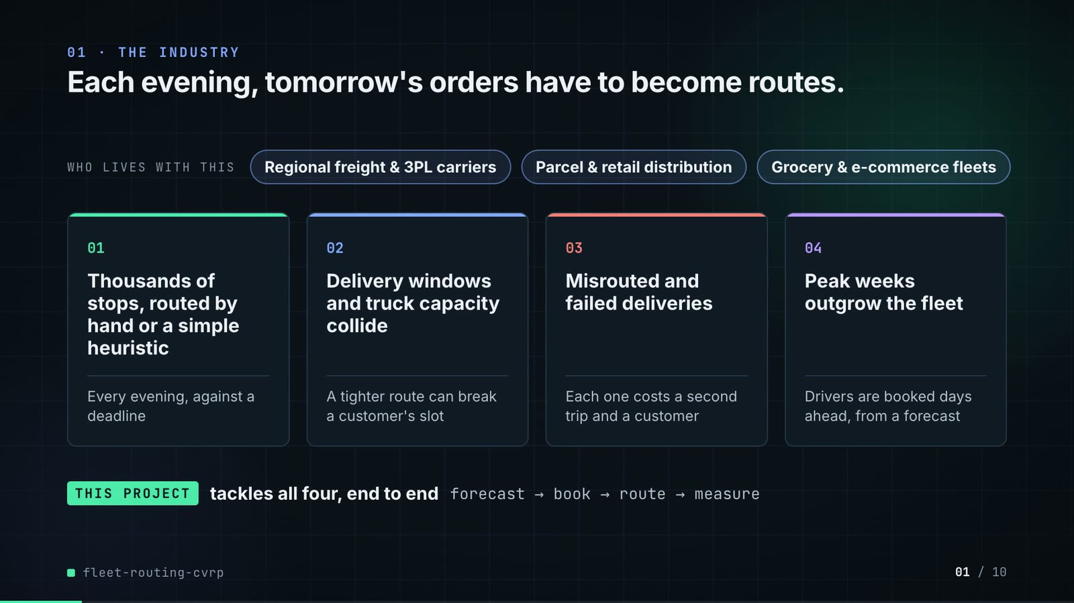
On-screen text (verbatim)
01 · THE INDUSTRY
Each evening, tomorrow's orders have to become routes.
WHO LIVES WITH THIS · Regional freight & 3PL carriers · Parcel & retail distribution · Grocery & e-commerce fleets
01 Thousands of stops, routed by hand or a simple heuristic — Every evening, against a deadline
02 Delivery windows and truck capacity collide — A tighter route can break a customer's slot
03 Misrouted and failed deliveries — Each one costs a second trip and a customer
04 Peak weeks outgrow the fleet — Drivers are booked days ahead, from a forecast
THIS PROJECT tackles all four, end to end · forecast → book → route → measure
Figures on this slide
ID | Shown | Source · key | Calculation | Check
F-01 | 3 industry chips | author's framing · - | - | manual
F-02 | 4 problem cards | README 'The problem' (problems 2-4) · README lines 16-27 | - | ✓

Assumptions: A-16
Illustrative, not data:
• The whole slide is context; no repo figures.
To change this slide: Edit the chips (#ctx-c1..3) and cards (#ctx-k1..4) in compositions/s01-context.html.

Slide 02: This project
6.8-11.6 s · composition compositions/s02-hook.html
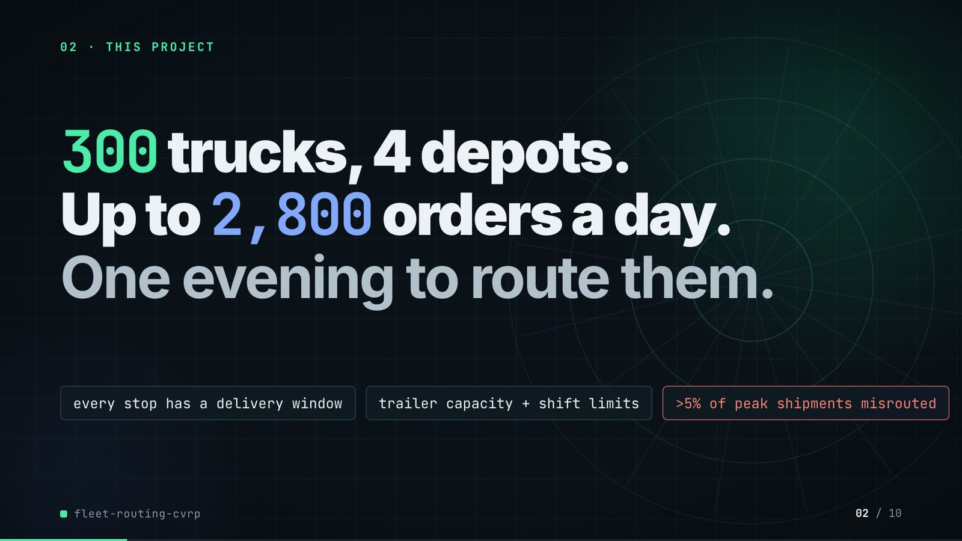
On-screen text (verbatim)
02 · THIS PROJECT
300 trucks, 4 depots. Up to 2,800 orders a day. One evening to route them.
every stop has a delivery window · trailer capacity + shift limits · >5% of peak shipments misrouted
Figures on this slide
ID | Shown | Source · key | Calculation | Check
F-03 | 300 trucks | outputs/full/results.json · trucks | - | ✓
F-04 | 4 depots | outputs/full/results.json · depots | - | ✓
F-05 | Up to 2,800 orders a day | data/full/dispatch_orders.csv · orders per date (max = 2,785 on 2025-12-08) | max daily order count = 2,785, rounded up to the nearest hundred = 2,800 | ✓
F-06 | every stop has a delivery window | data/full/dispatch_orders.csv · tw_start, tw_end (no missing values) | count of missing windows = 0 | ✓
F-07 | trailer capacity + shift limits | src/fleet_routing/routing.py:202, :205 · capacity + time dimensions | - | ✓
F-08 | >5% of peak shipments misrouted | outputs/full/risk_scores.csv; README line 26-27 · model=xgboost, period=peak, base_rate (0.0531) | base_rate x 100 = 5.3% > 5% | ✓

F-05 note: Peak-week days have 2,622-2,785 orders. The README describes the peak as 'closer to 2,700' a day (an average); the slide states the upper bound.
Assumptions: A-01, A-06, A-11
Illustrative, not data:
• Depot rings in the background are decoration.
To change this slide: Headline spans #hook-l1..l3 and chips #hook-f1..f3 in compositions/s02-hook.html; fleet/depots come from config.py FULL profile.

Slide 03: How it works (white chapter, slide A)
11.3-19.3 s · composition compositions/explainer.html (CONFIG.blocks, CONFIG.groups, CONFIG.loop)
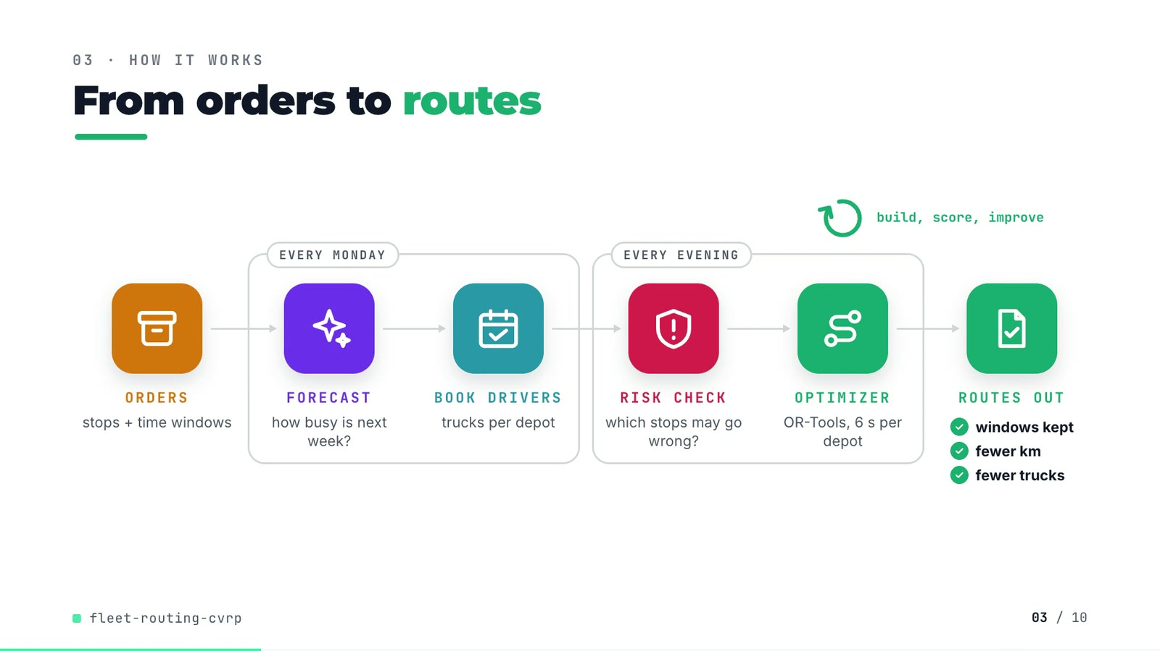
On-screen text (verbatim)
03 · HOW IT WORKS
From orders to routes
ORDERS stops + time windows → [EVERY MONDAY: FORECAST how busy is next week? → BOOK DRIVERS trucks per depot] → [EVERY EVENING: RISK CHECK which stops may go wrong? → OPTIMIZER OR-Tools, 6 s per depot] → ROUTES OUT ✓ windows kept ✓ fewer km ✓ fewer trucks
build, score, improve (loop over the optimizer)
Figures on this slide
ID | Shown | Source · key | Calculation | Check
F-09 | OR-Tools, 6 s per depot / solve budget 6.0 s | outputs/full/results.json · solver_seconds_per_depot_day | - | ✓
F-10 | EVERY MONDAY | README line 43 · README | - | ✓
F-11 | windows kept / fewer km / fewer trucks | outputs/full/routing_summary.csv · arm in {sweep, ortools_risk}, window=peak: on_time_pct, total_km, vehicle_days | on_time_pct = 100; total_km(ortools_risk) < total_km(sweep); vehicle_days(ortools_risk) < vehicle_days(sweep) | ✓
F-12 | build, score, improve | src/fleet_routing/routing.py:229-230 · PATH_CHEAPEST_ARC + GUIDED_LOCAL_SEARCH | - | ✓

Assumptions: A-04, A-07, A-13
Illustrative, not data:
• Icons and colours are a visual language, not data.
• 'every evening' = each order day is dispatched the next day (A-12).
To change this slide: Edit CONFIG in compositions/explainer.html; badge truth comes from routing_summary.csv (F-11).

Slide 04: The key idea (white chapter, slide B)
19.3-26.3 s · composition compositions/explainer.html (#ex-b ...)
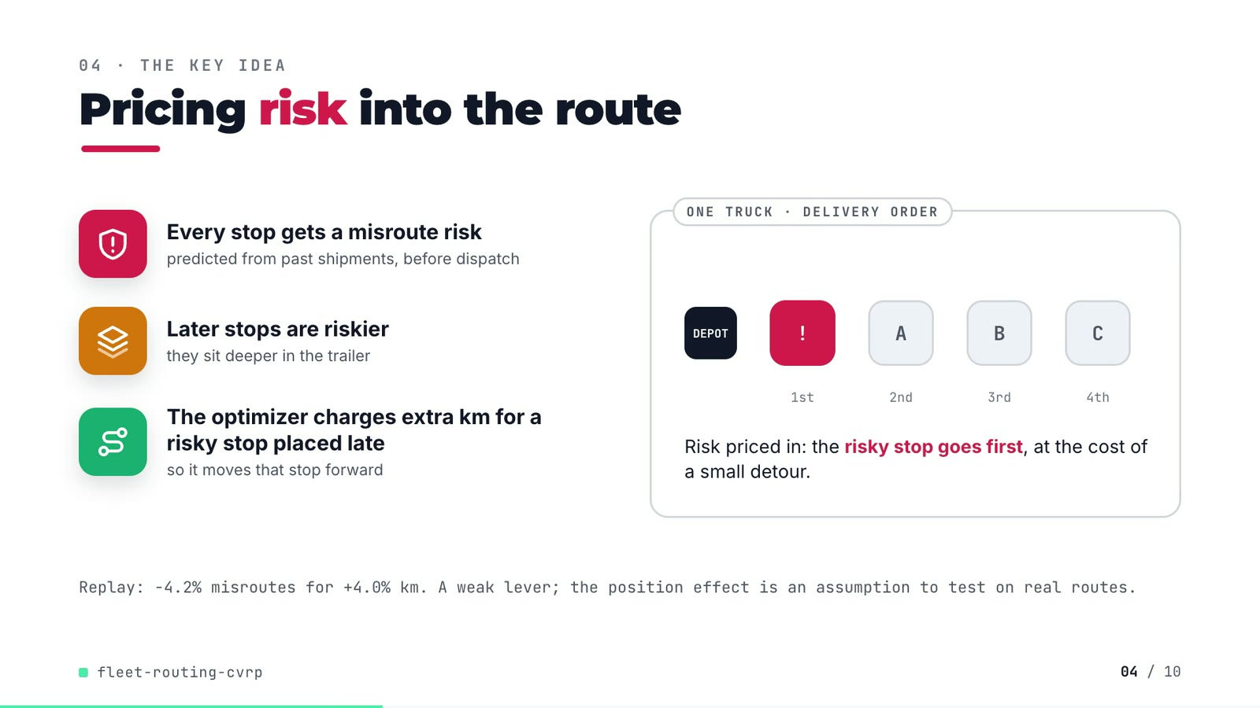
On-screen text (verbatim)
04 · THE KEY IDEA
Pricing risk into the route
Every stop gets a misroute risk — predicted from past shipments, before dispatch
Later stops are riskier — they sit deeper in the trailer
The optimizer charges extra km for a risky stop placed late — so it moves that stop forward
ONE TRUCK · DELIVERY ORDER: DEPOT, !, A, B, C (1st..4th). Risk priced in: the risky stop goes first, at the cost of a small detour.
Replay: −4.2% misroutes for +4.0% km. A weak lever; the position effect is an assumption to test on real routes.
Figures on this slide
ID | Shown | Source · key | Calculation | Check
F-13 | Later stops are riskier | src/fleet_routing/data.py:238-241; outputs/full/results.json position_effect_logodds_per_stop · 0.09 generated, 0.094 estimated | estimated slope > 0 | ✓
F-14 | -4.2% misroutes | outputs/full/routing_summary.csv · window=peak, misroute_pct: ortools_risk 4.3871, ortools 4.5810 | (4.3871 - 4.5810) / 4.5810 x 100 = -4.23% | ✓
F-15 | +4.0% km | outputs/full/routing_summary.csv · window=peak, total_km: ortools_risk 113,937.7, ortools 109,607.3 | (113,937.7 - 109,607.3) / 109,607.3 x 100 = +3.95% | ✓

Assumptions: A-02, A-03, A-15
Illustrative, not data:
• The A/B/C/! demo is schematic; it mirrors tests/test_risk_pricing_moves_a_risky_stop_to_the_front, not a real route.
To change this slide: Markup under #ex-b in compositions/explainer.html; the footnote figures are F-14 and F-15.

Slide 05: Architecture
26.0-38.8 s · composition compositions/s03-architecture.html
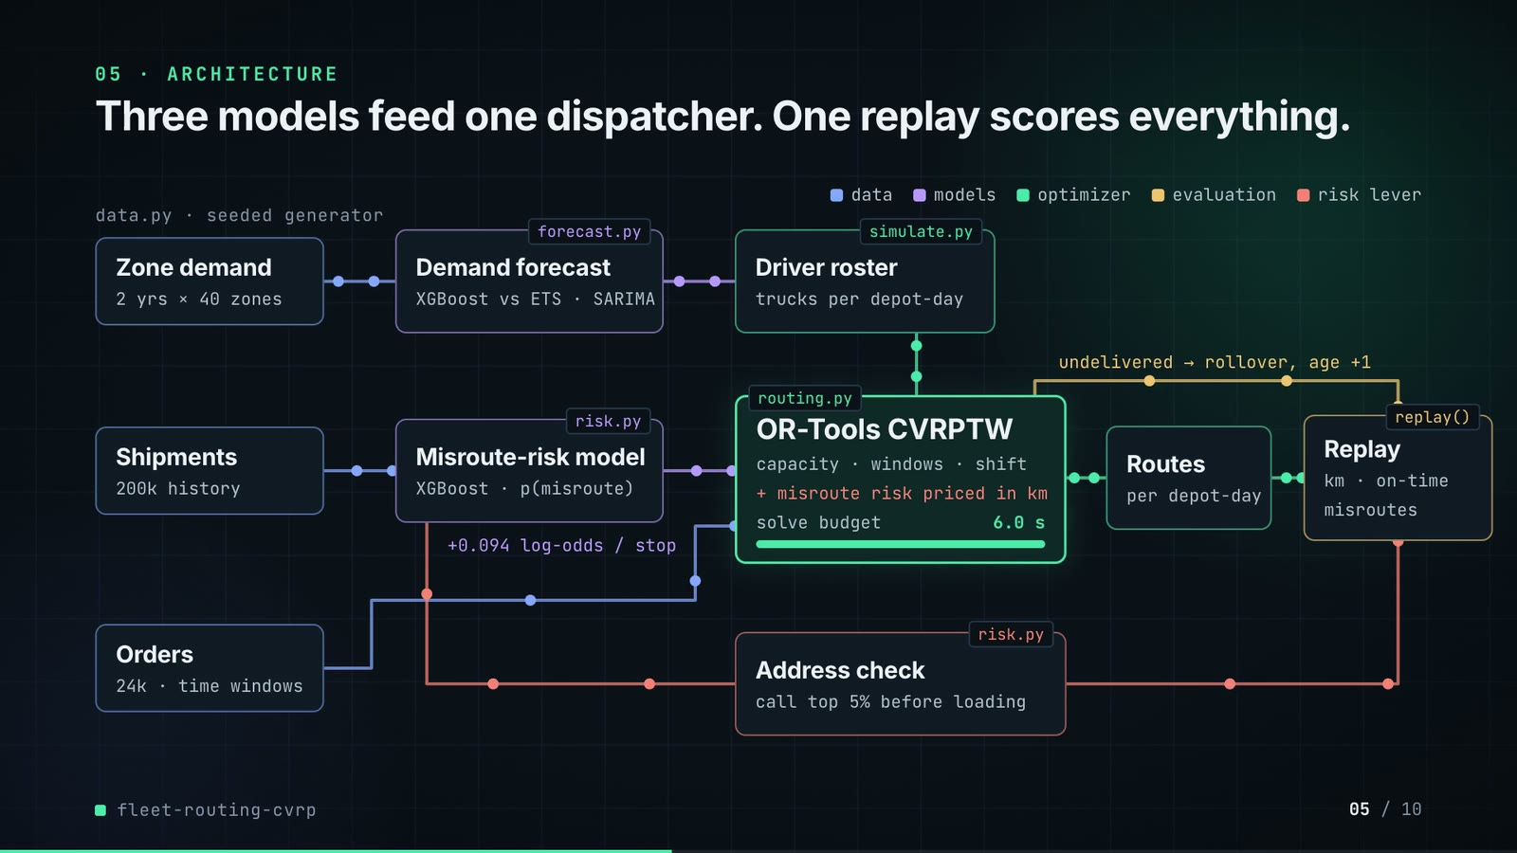
On-screen text (verbatim)
05 · ARCHITECTURE
Three models feed one dispatcher. One replay scores everything.
data.py · seeded generator: Zone demand (2 yrs × 40 zones), Shipments (200k history), Orders (24k · time windows)
forecast.py Demand forecast (XGBoost vs ETS · SARIMA) → simulate.py Driver roster (trucks per depot-day)
risk.py Misroute-risk model (XGBoost · p(misroute)) · +0.094 log-odds / stop
routing.py OR-Tools CVRPTW (capacity · windows · shift · + misroute risk priced in km · solve budget 6.0 s) → Routes (per depot-day) → replay() Replay (km · on-time · misroutes)
undelivered → rollover, age +1 · risk.py Address check (call top 5% before loading)
Legend: data · models · optimizer · evaluation · risk lever
Figures on this slide
ID | Shown | Source · key | Calculation | Check
F-03 | 300 trucks | outputs/full/results.json · trucks | - | ✓
F-09 | OR-Tools, 6 s per depot / solve budget 6.0 s | outputs/full/results.json · solver_seconds_per_depot_day | - | ✓
F-16 | 2 yrs x 40 zones | data/full/zone_demand.csv; outputs/full/results.json zones · 731 daily rows 2024-01-01..2025-12-31; zones = 40 | - | ✓
F-17 | 200k history | data/full/shipments_history.csv · row count | - | ✓
F-18 | 24k | outputs/full/results.json · dispatch_orders = 24,394 | 24,394 rounded to thousands | ✓
F-19 | +0.094 log-odds / stop | outputs/full/results.json · position_effect_logodds_per_stop | - | ✓
F-20 | forecast.py, risk.py, simulate.py, routing.py, replay(), data.py | src/fleet_routing/ · files + def replay | - | ✓
F-21 | call top 5% before loading | src/fleet_routing/config.py:93 · ADDRESS_CHECK_SHARE = 0.05 | - | ✓

Assumptions: A-01, A-02, A-04, A-09, A-12
Illustrative, not data:
• Packets moving along the wires are decoration; the solve-budget bar fills in real seconds.
To change this slide: Node boxes (#n-*) and the wires array in compositions/s03-architecture.html.

Slide 06: The system running
38.4-53.0 s · composition compositions/s04-routes.html; assets/map-sweep.png, assets/map-ortools.png (from outputs/full/route_map.png via tools/darkmap.py)
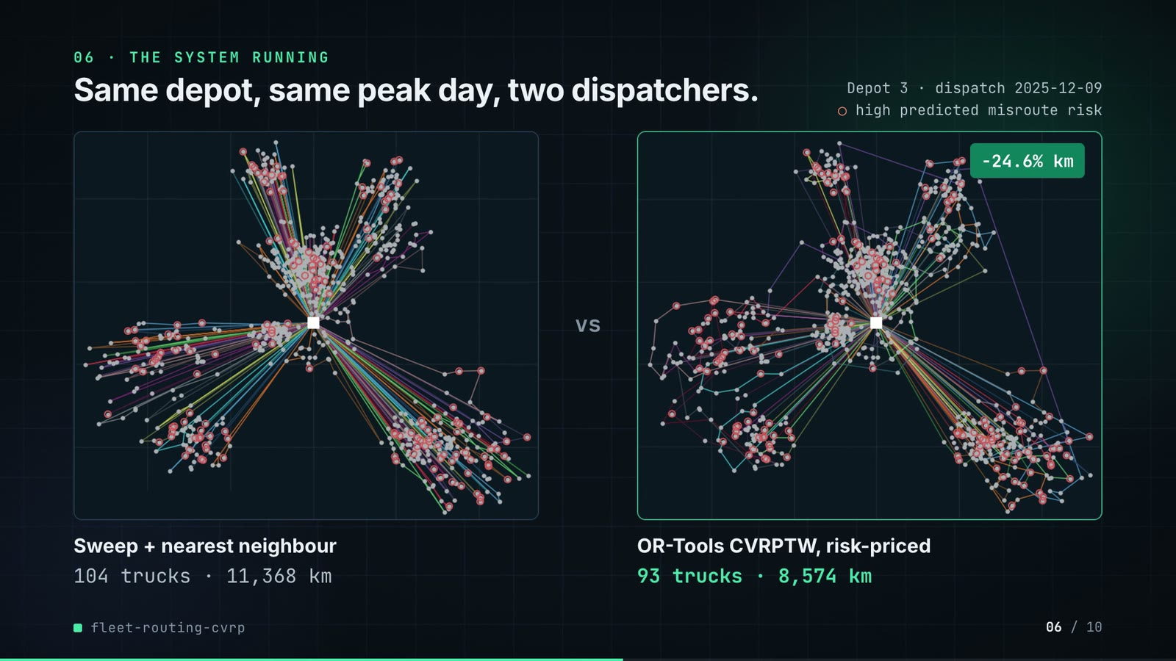
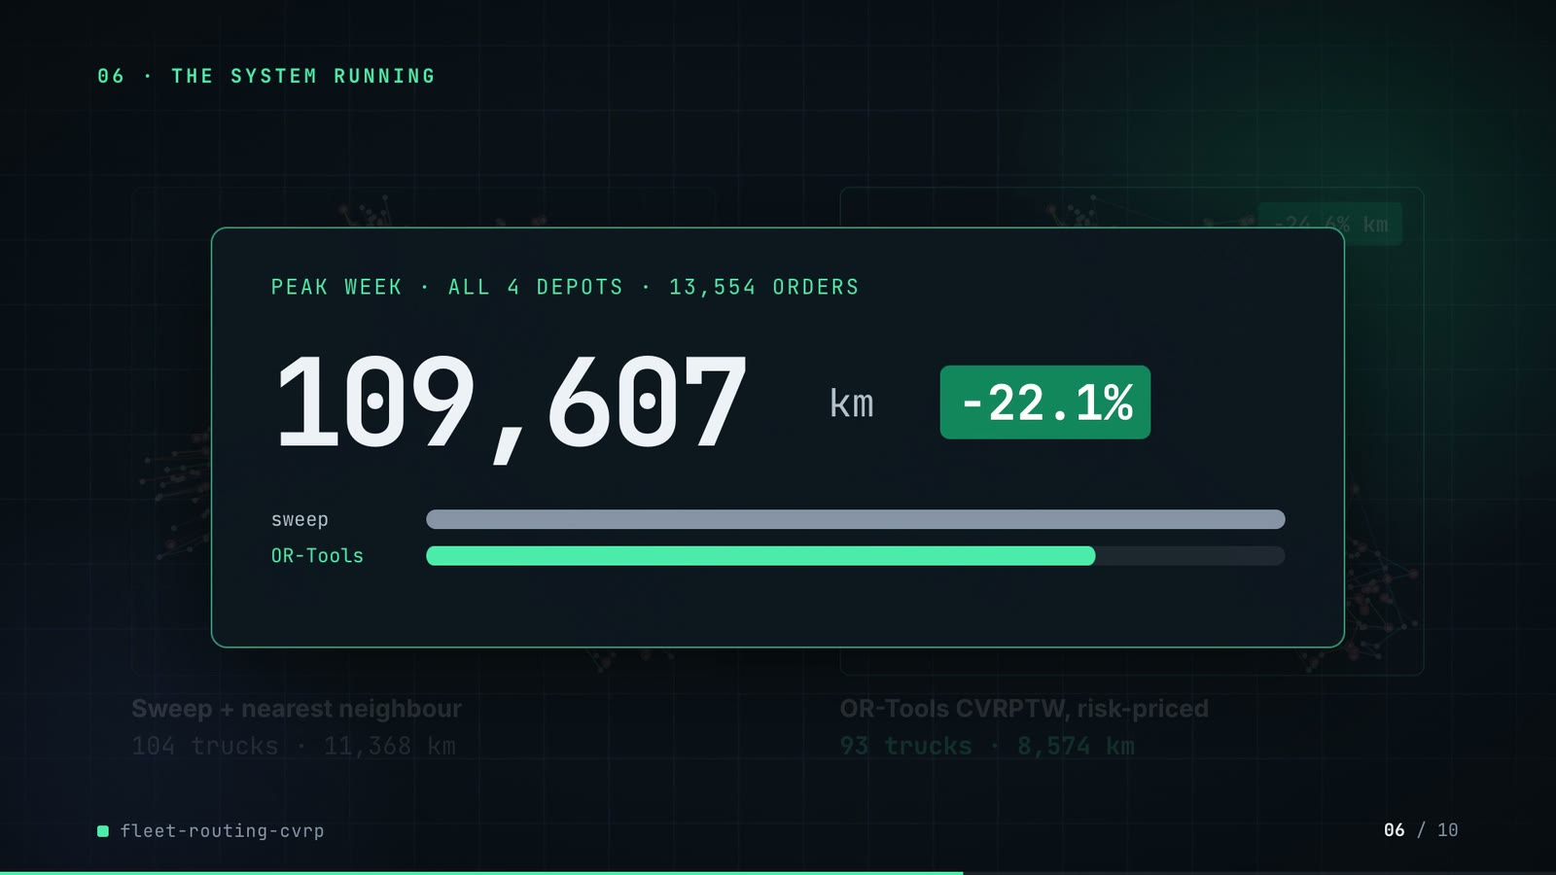
On-screen text (verbatim)
06 · THE SYSTEM RUNNING
Same depot, same peak day, two dispatchers.
Depot 3 · dispatch 2025-12-09 · ○ high predicted misroute risk
Sweep + nearest neighbour: 104 trucks · 11,368 km | OR-Tools CVRPTW, risk-priced: 93 trucks · 8,574 km | −24.6% km
PEAK WEEK · ALL 4 DEPOTS · 13,554 ORDERS — 140,683 → 109,607 km, −22.1% (sweep vs OR-Tools bars)
Figures on this slide
ID | Shown | Source · key | Calculation | Check
F-22 | Depot 3 · dispatch 2025-12-09 | data/full/depots.csv (busiest depot); src/fleet_routing/cli.py:121-125; config peak window · depot with most vehicles = 3; first peak dispatch = 2025-12-08 + 1 day | - | ✓
F-23 | 104 trucks | outputs/full/route_map.png (left panel title) · plot title | - | manual
F-24 | 11,368 km | outputs/full/route_map.png (left panel title) · plot title | - | manual
F-25 | 93 trucks | outputs/full/route_map.png (right panel title); re-run in demo assets/dispatch_sheet.json · trucks_used | - | ✓
F-26 | 8,574 km | outputs/full/route_map.png (right panel title) · plot title | - | manual
F-27 | -24.6% km | F-24, F-26 (plot titles) · 8,574 vs 11,368 | (8,574 - 11,368) / 11,368 x 100 = -24.58% | ✓
F-28 | 13,554 orders | outputs/full/routing_summary.csv · arm=sweep, window=peak, orders | - | ✓
F-29 | 140,683 km | outputs/full/routing_summary.csv · arm=sweep, window=peak, total_km | - | ✓
F-30 | 109,607 km | outputs/full/routing_summary.csv · arm=ortools, window=peak, total_km | - | ✓
F-31 | -22.1% | outputs/full/routing_summary.csv · F-30 vs F-29 | (109,607.3 - 140,683.4) / 140,683.4 x 100 = -22.09% | ✓

F-27 note: Arithmetic is checked; the two inputs are manual (F-24, F-26).
Assumptions: A-03, A-04, A-05, A-12, A-14
Illustrative, not data:
• Maps are the repo's real route_map.png, colour-inverted to dark; the legend is redrawn because the original legend was removed from the image.
• The map compares sweep with risk-priced OR-Tools; the peak-week counter compares sweep with plain OR-Tools.
To change this slide: Map captions (#routes-cap-l/r, #routes-chip) and counter (#routes-wk-num, #routes-bar) in compositions/s04-routes.html; maps come from make run → outputs/full/route_map.png.

Slide 07: End-user value (white)
52.7-65.7 s · composition compositions/value.html (SHEET block injected by tools/inject_sheet.py)
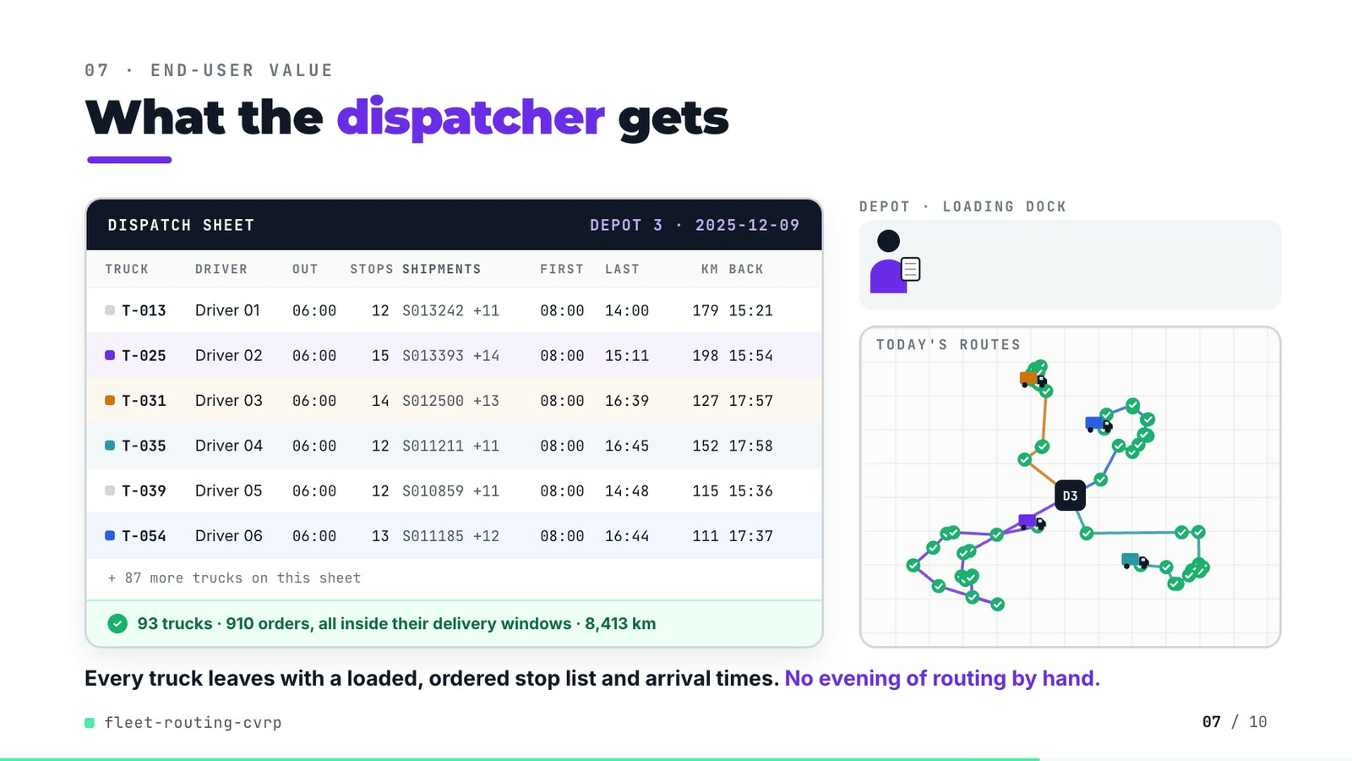
On-screen text (verbatim)
07 · END-USER VALUE
What the dispatcher gets
DISPATCH SHEET · DEPOT 3 · 2025-12-09 — columns TRUCK, DRIVER, OUT, STOPS, SHIPMENTS, FIRST, LAST, KM, BACK
T-013 Driver 01 06:00 12 S013242 +11 08:00 14:00 179 15:21
T-025 Driver 02 06:00 15 S013393 +14 08:00 15:11 198 15:54
T-031 Driver 03 06:00 14 S012500 +13 08:00 16:39 127 17:57
T-035 Driver 04 06:00 12 S011211 +11 08:00 16:45 152 17:58
T-039 Driver 05 06:00 12 S010859 +11 08:00 14:48 115 15:36
T-054 Driver 06 06:00 13 S011185 +12 08:00 16:44 111 17:37
+ 87 more trucks on this sheet · ✓ 93 trucks · 910 orders, all inside their delivery windows · 8,413 km
DEPOT · LOADING DOCK · TODAY'S ROUTES
Every truck leaves with a loaded, ordered stop list and arrival times. No evening of routing by hand.
Figures on this slide
ID | Shown | Source · key | Calculation | Check
F-32 | 93 trucks | demo assets/dispatch_sheet.json (re-run of the repo's routing for Depot 3, 2025-12-09) · trucks_used (rostered 104) | - | ✓
F-33 | 910 orders | demo assets/dispatch_sheet.json; data/full/dispatch_orders.csv · orders on 2025-12-08 for depot 3 | - | ✓
F-34 | all inside their delivery windows | demo assets/dispatch_sheet.json · on_time = delivered = orders | 910 / 910 | ✓
F-35 | 8,413 km | demo assets/dispatch_sheet.json · total_km = 8,412.7 | rounded | ✓
F-36 | T-013, T-025, T-031, T-035, T-039, T-054 | demo assets/dispatch_sheet.json, injected into compositions/value.html · vehicles 12, 24, 30, 34, 38, 53 | truck id = vehicle index + 1; depart = SHIFT_START | ✓
F-37 | + 87 more trucks | F-32 · 93 - 6 rows | 93 - 6 = 87 | ✓

Assumptions: A-03, A-04, A-05, A-06, A-10, A-11
Illustrative, not data:
• Driver 01-06 are placeholders (no real people).
• Dispatcher figure, loading dock, truck drawings, 3 boxes per truck (stands in for 12-15 shipments) and driving speed are illustrative.
• The 4 animated trucks (T-025, T-031, T-035, T-054) were chosen because their routes spread in different directions; their stop positions and order are real, scaled to fit the panel.
• 'No evening of routing by hand' is framing from the README problem statement, not a measured result.
To change this slide: Re-run tools/export_dispatch_sheet.py, then tools/inject_sheet.py (--rows / --animate pick the trucks); layout in compositions/value.html.

Slide 08: Results
65.4-74.2 s · composition compositions/s05-results.html (stats array)
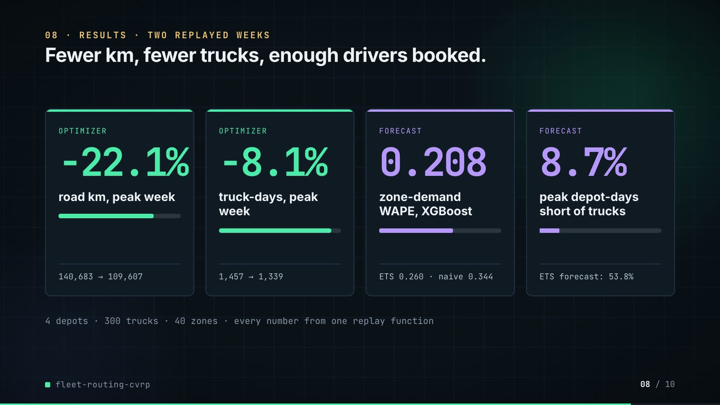
On-screen text (verbatim)
08 · RESULTS · TWO REPLAYED WEEKS
Fewer km, fewer trucks, enough drivers booked.
OPTIMIZER −22.1% road km, peak week · 140,683 → 109,607
OPTIMIZER −8.1% truck-days, peak week · 1,457 → 1,339
FORECAST 0.208 zone-demand WAPE, XGBoost · ETS 0.260 · naive 0.344
FORECAST 8.7% peak depot-days short of trucks · ETS forecast: 53.8%
4 depots · 300 trucks · 40 zones · every number from one replay function
Figures on this slide
ID | Shown | Source · key | Calculation | Check
F-03 | 300 trucks | outputs/full/results.json · trucks | - | ✓
F-04 | 4 depots | outputs/full/results.json · depots | - | ✓
F-16 | 2 yrs x 40 zones | data/full/zone_demand.csv; outputs/full/results.json zones · 731 daily rows 2024-01-01..2025-12-31; zones = 40 | - | ✓
F-29 | 140,683 km | outputs/full/routing_summary.csv · arm=sweep, window=peak, total_km | - | ✓
F-30 | 109,607 km | outputs/full/routing_summary.csv · arm=ortools, window=peak, total_km | - | ✓
F-31 | -22.1% | outputs/full/routing_summary.csv · F-30 vs F-29 | (109,607.3 - 140,683.4) / 140,683.4 x 100 = -22.09% | ✓
F-38 | -8.1% | outputs/full/routing_summary.csv · vehicle_days: ortools 1,339 vs sweep 1,457 | (1,339 - 1,457) / 1,457 x 100 = -8.10% | ✓
F-39 | 1,457 | outputs/full/routing_summary.csv · arm=sweep, window=peak, vehicle_days | - | ✓
F-40 | 1,339 | outputs/full/routing_summary.csv · arm=ortools, window=peak, vehicle_days | - | ✓
F-41 | 0.208 | outputs/full/forecast_scores.csv · model=xgboost, period=all, wape | - | ✓
F-42 | ETS 0.260 | outputs/full/forecast_scores.csv · model=ets, period=all, wape | - | ✓
F-43 | naive 0.344 | outputs/full/forecast_scores.csv · model=seasonal_naive, period=all, wape | - | ✓
F-44 | 8.7% | outputs/full/roster_scores.csv · model=xgboost, period=peak, short_depot_days_pct | - | ✓
F-45 | ETS forecast: 53.8% | outputs/full/roster_scores.csv · model=ets, period=peak, short_depot_days_pct | - | ✓

Assumptions: A-04, A-05, A-10, A-12, A-13, A-15
Illustrative, not data:
• Mini bars under each number are drawn to the same ratio (after / before).
To change this slide: The stats array and card text in compositions/s05-results.html.

Slide 09: What didn't win
73.8-80.0 s · composition compositions/s06-twist.html
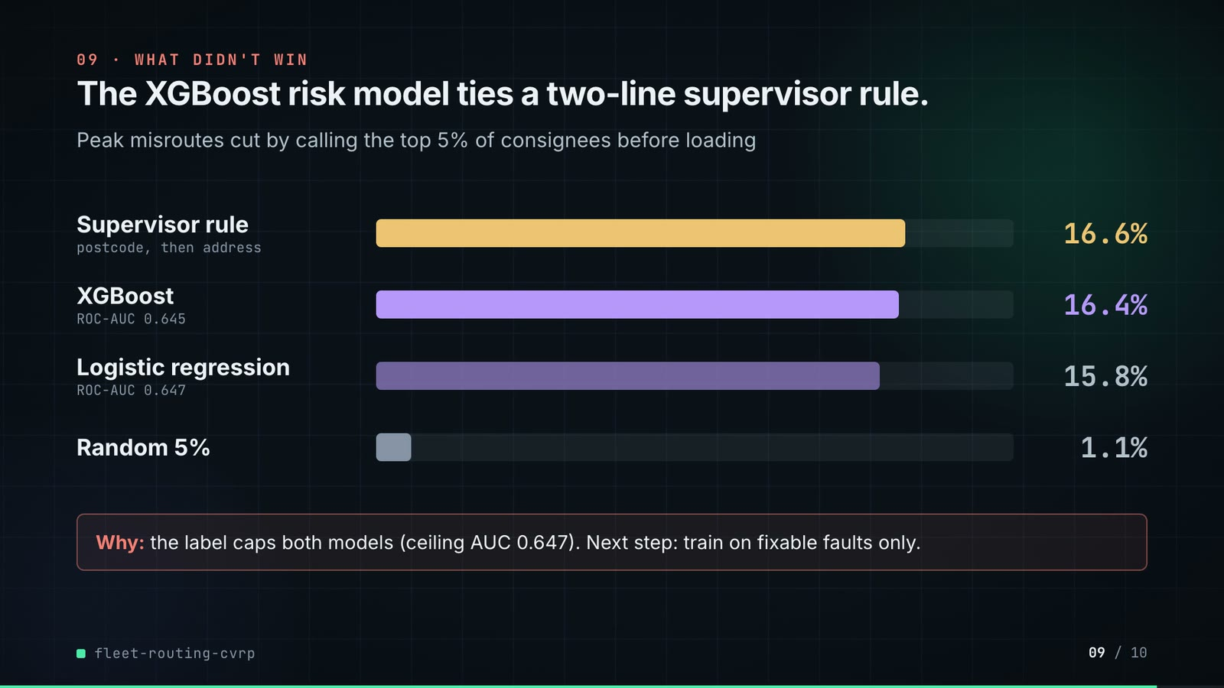
On-screen text (verbatim)
09 · WHAT DIDN'T WIN
The XGBoost risk model ties a two-line supervisor rule.
Peak misroutes cut by calling the top 5% of consignees before loading
Supervisor rule (postcode, then address) 16.6% · XGBoost (ROC-AUC 0.645) 16.4% · Logistic regression (ROC-AUC 0.647) 15.8% · Random 5% 1.1%
Why: the label caps both models (ceiling AUC 0.647). Next step: train on fixable faults only.
Figures on this slide
ID | Shown | Source · key | Calculation | Check
F-21 | call top 5% before loading | src/fleet_routing/config.py:93 · ADDRESS_CHECK_SHARE = 0.05 | - | ✓
F-46 | 16.6% | outputs/full/address_checks.csv · ranked_by=rule, window=peak, reduction_pct | - | ✓
F-47 | 16.4% | outputs/full/address_checks.csv · ranked_by=xgboost, window=peak, reduction_pct | - | ✓
F-48 | 15.8% | outputs/full/address_checks.csv · ranked_by=logistic, window=peak, reduction_pct | - | ✓
F-49 | 1.1% | outputs/full/address_checks.csv · ranked_by=random, window=peak, reduction_pct | - | ✓
F-50 | ROC-AUC 0.645 | outputs/full/risk_scores.csv · model=xgboost, period=all, roc_auc | - | ✓
F-51 | ROC-AUC 0.647 | outputs/full/risk_scores.csv · model=logistic, period=all, roc_auc | - | ✓
F-52 | ceiling AUC 0.647 | outputs/full/risk_scores.csv · model=ceiling, period=all, roc_auc | - | ✓

Assumptions: A-02, A-08, A-09, A-15
Illustrative, not data:
• Bar lengths: 1,000 px track = 20% reduction.
To change this slide: Rows #twist-r1..r4 (bar widths are inline styles) in compositions/s06-twist.html.

Slide 10: End card
79.6-84.0 s · composition compositions/s07-end.html

On-screen text (verbatim)
10 · OPEN SOURCE · MIT · RUNS ON A LAPTOP
fleet-routing-cvrp
github.com/kavya2693/fleet-routing-cvrp
OR-Tools · XGBoost · statsmodels · Python
$ make run # 300 trucks, 4 depots, ~18 min
Figures on this slide
ID | Shown | Source · key | Calculation | Check
F-53 | MIT | LICENSE line 1 · - | - | ✓
F-54 | ~18 min | outputs/full/results.json · runtime_seconds = 1063 | 1063 / 60 = 17.7 min | ✓
F-55 | OR-Tools · XGBoost · statsmodels · Python | pyproject.toml dependencies · ortools, xgboost, statsmodels | - | ✓
F-56 | $ make run | Makefile · run target | - | ✓

Assumptions: A-15
Illustrative, not data:
• Faded route map in the background is the OR-Tools panel of route_map.png.
To change this slide: Text in compositions/s07-end.html.

5. Change-impact matrix
Input / assumption | Affected figures | Slides | Files to edit | Re-run
A-01: All data is synthetic, produced by a seeded generator sized to the production problem (300 trucks, 4 depots, 40 zones, 2 years of demand, 200,000 historical shipments) | all figures | 01, 02, 03, 04, 05, 06, 07, 08, 09, 10 | src/fleet_routing/config.py (FULL profile); src/fleet_routing/data.py | make data; make run
A-02: Misroute risk rises with route position: the generator adds 0 | F-13, F-14, F-15, F-19, F-46, F-47, F-48, F-49 | 04, 05, 09 | src/fleet_routing/data.py:241 | make data; make run
A-03: A misroute is priced at 150 km inside the risk-priced router (cost per stop = 150 km x 0 | F-14, F-15, F-23, F-24, F-25, F-26, F-27, F-32, F-33, F-34, F-35, F-36 | 04, 06, 07 | src/fleet_routing/config.py:90 | make run; export_dispatch_sheet.py + inject_sheet.py
A-04: Each OR-Tools solve is capped at 6 s wall-clock per depot-day (1 | F-09, F-25, F-26, F-30, F-31, F-35, F-38, F-40 | 03, 05, 06, 07, 08 | src/fleet_routing/config.py:45 | make run; export_dispatch_sheet.py + inject_sheet.py
A-05: Distances are straight lines x 1 | F-24, F-26, F-27, F-29, F-30, F-31, F-35, F-36 | 06, 07, 08 | src/fleet_routing/config.py:74-76 | make run; export_dispatch_sheet.py + inject_sheet.py
A-06: Drivers leave the depot from 06:00 and must be back by 18:00 | F-07, F-36 | 02, 07 | src/fleet_routing/config.py:72-73 | make run; export_dispatch_sheet.py + inject_sheet.py
A-07: Delivery windows are hard constraints in OR-Tools (it drops a stop rather than arrive late) and are ignored by the sweep baseline, so the on-time comparison is lopsided by design | F-11, F-34 | 03, 07 | src/fleet_routing/routing.py | make run
A-08: A pre-dispatch call fixes the postcode, address and handwritten-label faults completely; it cannot fix a between-depots zone or a cross-dock relabel | F-46, F-47, F-48, F-49 | 09 | src/fleet_routing/risk.py:134-142 | make run
A-09: The dispatch office calls the top 5% of each day's consignees | F-21, F-46, F-47, F-48, F-49 | 05, 09 | src/fleet_routing/config.py:93 | make run
A-10: Trucks booked per depot-day = ceil(forecast orders x 2 | F-44, F-45, F-32 | 07, 08 | src/fleet_routing/config.py:82-84 | make run
A-11: Fleet mix: 70% tractors with 26 pallets, 30% rigids with 14 pallets; depot fleets 63 / 86 / 47 / 104 | F-03, F-23, F-25, F-32, F-36 | 02, 05, 06, 07, 08 | src/fleet_routing/config.py:67-69 | make data; make run
A-12: Evaluation windows: quiet week 2025-10-13 | F-28, F-28, F-29, F-30, F-31, F-38, F-39, F-40 | 06, 08 | src/fleet_routing/config.py:43 | make run
A-13: Forecasts are backtested from 12 weekly (Monday) origins over the last 12 weeks of 2025; every feature is at least a week old | F-10, F-41, F-42, F-43, F-44, F-45 | 03, 08 | src/fleet_routing/config.py:44 | make run
A-14: Router cost terms: a dropped stop costs 1,000 km x (1 + days waited); each truck used costs 40 km | F-25, F-26, F-30, F-35, F-40 | 06, 07, 08 | src/fleet_routing/routing.py:32-34 | make run
A-15: Video rounding: percentages to 1 decimal, km and counts to whole numbers with thousands separators, WAPE and AUC to 3 decimals; '24k', '200k', '~18 min' are rounded labels | F-14, F-15, F-18, F-27, F-31, F-38, F-41, F-42, F-43, F-44, F-45, F-46, F-47, F-48, F-49, F-50, F-51, F-52, F-54 | 04, 05, 06, 08, 09, 10 | the composition file named on each slide | hyperframes render
A-16: Slide 01 (industry, everyday problems) is general logistics knowledge used as context | F-01, F-02 | 01 | compositions/s01-context.html | hyperframes render

6. Known differences and caveats
• Map-day km: the slide shows 8,574 km (route_map.png title, from make run). The single-day re-run used for slide 07 gives 8,412.7 km. OR-Tools stops on wall-clock time, so repeated runs differ slightly (README 'Known limitations': 87,715 vs 88,698 km on the quiet week).
• −24.6% (slide 06) is derived from the two plot titles; the repo does not store per-depot-day routes for make run.
• The map (slide 06) compares sweep with risk-priced OR-Tools; the peak-week counter (slides 06, 08) compares sweep with plain OR-Tools.
• 'Up to 2,800 orders a day' (slide 02) is the busiest day in the data (2,785 orders, rounded up); the README's 'closer to 2,700' describes a typical peak day.
• On-time 100% / 'windows kept' is true by construction: OR-Tools treats windows as hard and rolls stops over instead (A-07).
• Slide 01 statements are general industry knowledge (A-16).
• Route-position misroute risk is a mechanism written into the generator (A-02); its real size must be measured on real route histories before the routing-side misroute numbers mean anything (README 'Known limitations').
• Driver names on slide 07 are placeholders.

Appendix: environment
Item | Value
Commit | c9b3c09d094cd863c61c2af426513b6d9b33ba68
Python | 3.11.7
ortools | 9.15.6755
xgboost | 3.2.0
pandas | 3.0.6
numpy | 2.4.6
statsmodels | 0.15.0
sklearn | 1.9.1
Profile / seeds | profile=full, seed=7, risk_model_seed=7
Run time | results.json runtime_seconds = 1063 s (about 17.7 min) for make run on the author's laptop

