AUDIT REPORT

hcp-graph-targeting: demo video audit report
A slide-by-slide record of every number, assumption and calculation in the demo video, with its source.
Item | Value
Repository | https://github.com/kavya2693/hcp-graph-targeting
Numbers taken from commit | 719ffbfc4cf1d5bf57f19f9c80be25168ad972f6 (outputs last changed in 719ffbf (2026-10-13 21:46:05 +0400))
Video | docs/demo/demo.mp4 · 88.0 s · 1920x1080 · 30 fps · silent
Generated | 2026-10-14 14:15
Automated checks | 57 pass · 0 fail · 2 manual (of 59 figures)
Assumptions | 12 (A-01 to A-12)

How to use this report
Every number or claim on screen has an ID (F-01, F-02, ...) and every modelling assumption has an ID (A-01, ...). Cite the ID. Each figure lists its source file, the exact column, row or key, the formula for derived numbers, and an automated check result. The change-impact matrix (section 5) shows which slides and files change if an input or assumption changes.
Types: direct = read straight from a repo output; derived = computed from direct values (formula given); illustrative = drawing or example, not data; general knowledge = context not produced by the repo.

Regenerate
make run # data/ + outputs/ablation.csv, deltas.csv, feature_importance.csv, summary.json
uv run python scripts/seed_sweep.py # outputs/seed_sweep.csv/.txt (seeds 11, 23)
.venv/bin/python docs/demo/source/tools/export_call_plan.py docs/demo/source/assets/call_plan.json # ~30 s; asserts AUC + captured match ablation.csv
python3 docs/demo/source/tools/inject_sheet.py docs/demo/source/assets/call_plan.json docs/demo/source/compositions --rows 1,2,3,4,5,6
cd docs/demo/source && npx --yes hyperframes@0.8.156 check && npx --yes hyperframes@0.8.156 render -f 30 -q looks -o renders/hcp-graph-targeting-master.mp4 && cd -
ffmpeg -y -i docs/demo/source/renders/hcp-graph-targeting-master.mp4 -c:v libx264 -preset slow -crf 25 -pix_fmt yuv420p -movflags +faststart -an docs/demo/demo.mp4
python3 docs/demo/source/tools/build_audit_report.py docs/demo/source/audit/facts.yaml # stills, checks, MD/DOCX/PDF

1. Figures
ID | Shown | Slides | Source | Column / row / key | How computed | Type | Check
F-01 | 3 industry chips | 01 | author's framing | - | - | general knowledge | manual: Context statement, not a repo output.
F-02 | 4 problem cards | 01 | README 'The problem' | README lines 11-26 | - | general knowledge | ✓ verified
F-03 | 20,000 doctors / 20,000 HCPs | 02, 05, 07, 10 | outputs/summary.json | n_hcps | - | direct | ✓ verified
F-04 | 75,155 ties | 02, 05 | outputs/summary.json; data/edges.csv | n_edges | - | direct | ✓ verified
F-05 | Calls for just 1 in 20 | 02 | outputs/summary.json | budgets.captured_5pct = 1,000; n_hcps = 20,000 | 20,000 / 1,000 = 20 | derived | ✓ verified
F-06 | 8 specialties · 12 regions | 02 | data/hcps.csv | specialty, region (distinct values) | - | direct | ✓ verified
F-07 | 24 months of class prescriptions | 02, 05 | data/monthly_class_rx.csv | month columns (2024-07..2026-06) | columns - hcp_id | direct | ✓ verified
F-08 | only 8.1% convert to the new drug / all 20,000 HCPs: 8.1% | 02, 06 | outputs/summary.json | conversion_rate = 0.08085 (1,617 of 20,000) | rounded to 1 decimal | direct | ✓ verified
F-09 | PRACTICES · groups of about 50 | 03 | outputs/summary.json; README line 161 | communities_per_level[1] = 408 | 20,000 / 408 = 49 | derived | ✓ verified
F-10 | EVERY FOLD, 5 TIMES / Stratified 5-fold | 03, 05 | outputs/summary.json | folds | - | direct | ✓ verified
F-11 | more converters · shuffle-tested · leak-tested | 03 | outputs/ablation.csv; tests/test_leakage.py | captured_5pct graph features > decile list; control rows present; leakage tests exist | 189 > 126 | derived | ✓ verified
F-12 | held-out AUC fell to 0.589 | 04 | docs/adr/0001-graph-features-built-fold-safe-embeddings-label-free.md:17 | ADR text | - | direct | ✓ verified
F-13 | 0.668 | 04, 08 | outputs/ablation.csv | arm='+ community and neighbour conversion rates', auc | - | direct | ✓ verified
F-14 | and a test pins it | 04 | tests/test_leakage.py | own-label flip test | - | direct | ✓ verified
F-15 | PRACTICE RATE 2 / 5 | 04 | schematic | - | - | illustrative | manual: Illustrative drawing of features.py label_graph_features; not real HCPs.
F-16 | generate(), profile_features(), louvain_communities(), structural_features(), label_graph_features(), node2vec, GraphSAGE, make_folds(), run_arm(), captured_at_budget(), summarise(), bootstrap_delta(), cli.py shuffled control | 05 | src/hcp_targeting/ | def names | - | direct | ✓ verified
F-17 | 35 regions · 408 communities | 05 | outputs/summary.json | communities_per_level | - | direct | ✓ verified
F-18 | betweenness k=256 | 05 | src/hcp_targeting/cli.py:198 | --betweenness-k default | - | direct | ✓ verified
F-19 | 400 trees · depth 4 | 05 | src/hcp_targeting/evaluate.py:88-90 | n_estimators, max_depth | - | direct | ✓ verified
F-20 | nine model arms · 7 arms + 2 controls · 45 fits | 05 | src/hcp_targeting/evaluate.py (ARMS); cli.py:98 (ARMS[2], ARMS[5]); outputs/ablation.csv | 7 Arm(...) + 2 control rows | (7 + 2) x 5 folds = 45 | derived | ✓ verified
F-21 | 32-d walks · 2 × SAGEConv | 05 | src/hcp_targeting/cli.py:197; embeddings.py:131-133 | --dim 32; conv1, conv2 = SAGEConv | - | direct | ✓ verified
F-22 | k = 1,000 · 4,000 | 05 | outputs/summary.json | budgets | - | direct | ✓ verified
F-23 | 200 resamples · 95% CI | 05, 08 | src/hcp_targeting/cli.py:201; evaluate.py:52 | --n-boot default 200; percentiles 2.5/97.5 | - | direct | ✓ verified
F-24 | full run ≈ 403 s · 10-core laptop | 05 | README line 178 | README text | - | direct | ✓ verified
F-25 | CPU only, no GPU or API key / RUNS ON A LAPTOP CPU | 05, 10 | README 'Running it' | README text | - | direct | ✓ verified
F-26 | fallback: decile, then annual Rx (today's list) | 05 | src/hcp_targeting/cli.py:83-84 | rule = decile * 1e6 + annual_class_rx | - | direct | ✓ verified
F-27 | practice + peers · no own label · train labels only | 05 | src/hcp_targeting/features.py:153-184; tests/test_leakage.py | inner_folds = 5 | - | direct | ✓ verified
F-28 | generate() · seed 7 | 05 | outputs/summary.json | seed | - | direct | ✓ verified
F-29 | 590 of 1,834 HCPs in one regional block · 1,304 ties | 06 | demo assets/call_plan.json (network_sample), exported by tools/export_call_plan.py from Louvain on data/edges.csv | len(nodes), l0_size, len(edges) | 8 largest level-1 communities of the 5th-largest level-0 block | direct | ✓ verified
F-30 | 9 of 59 15.3% · 7 of 68 10.3% · 6 of 60 10.0% · 4 of 64 6.2% · 4 of 87 4.6% · 4 of 97 4.1% · 2 of 78 2.6% · 2 of 79 2.5% | 06 | demo assets/call_plan.json (network_sample.communities); labels from data/hcps.csv converted | converted, size, rate | rate = converted / size | direct | ✓ verified
F-31 | ● converted · ● not yet | 06 | data/hcps.csv; demo assets/call_plan.json | converted per hcp_id | - | direct | ✓ verified
F-32 | 126 · 0.623 | 06 | outputs/ablation.csv | arm='decile list (no model)': captured_5pct, auc | - | direct | ✓ verified
F-33 | 166 · 0.641 | 06 | outputs/ablation.csv | captured_5pct, auc | - | direct | ✓ verified
F-34 | 188 · 0.658 | 06 | outputs/ablation.csv | captured_5pct, auc | - | direct | ✓ verified
F-35 | 189 · 0.668 | 06 | outputs/ablation.csv | captured_5pct, auc | - | direct | ✓ verified
F-36 | 202 · 0.676 | 06 | outputs/ablation.csv | captured_5pct, auc | - | direct | ✓ verified
F-37 | 212 · 0.674 | 06, 08 | outputs/ablation.csv | captured_5pct, auc | - | direct | ✓ verified
F-38 | 146 · 0.633 | 06, 08 | outputs/ablation.csv | arm='control, HCPs shuffled across the graph: + community and neighbour conversion rates' | - | direct | ✓ verified
F-39 | 322 · 0.761 | 06, 08 | outputs/ablation.csv | arm='ceiling: true propensity (answer key)' | - | direct | ✓ verified
F-40 | #1 HCP 16728 … #6 HCP 04338 | 07 | demo assets/call_plan.json, injected into compositions/value.html | plan ranks 1-6 | score = out-of-fold p(convert); practice rate = fold-built community_conv_rate_l1 as the HCP saw it when held out; PEERS ✓ = nbr_converted | direct | ✓ verified
F-41 | + 994 more on this plan | 07 | demo assets/call_plan.json | calls - 6 rows | 1,000 - 6 = 994 | derived | ✓ verified
F-42 | 848 of the 1,000 are not in the decile list's top 1,000 | 07 | demo assets/call_plan.json | plan[].decile_rank > 1,000 | count | derived | ✓ verified
F-43 | 1,000 calls · 189 converters reached · decile list: 126 | 07 | demo assets/call_plan.json; outputs/ablation.csv | captured, captured_decile_list (equal to ablation.csv captured_5pct) | - | direct | ✓ verified
F-44 | 29 of 100 HCPs here are planned · called: 29 · switched: 6 | 07 | demo assets/call_plan.json (scene) | size, planned, planned_converted | - | direct | ✓ verified
F-45 | TOP 1,000 OF 20,000 HCPS | 07 | demo assets/call_plan.json | calls, n_hcps | - | direct | ✓ verified
F-46 | +50% · decile list 126 → 189 | 08 | outputs/ablation.csv | captured_5pct: graph features 189, decile list 126 | 189 / 126 - 1 = +50.0% | derived | ✓ verified
F-47 | 0.641 → 0.668 · +0.027 [+0.018, +0.037] | 08 | outputs/deltas.csv | arm='+ community and neighbour conversion rates', vs='profile + decile', metric=auc | - | direct | ✓ verified
F-48 | 0.633 · below profile-only 0.641 | 08 | outputs/ablation.csv | both control rows auc; profile + decile auc | - | direct | ✓ verified
F-49 | 44% · 126 → 212 of 322 | 08 | outputs/ablation.csv | captured_5pct: decile 126, best (n2v + SAGE) 212, ceiling 322 | (212 - 126) / (322 - 126) = 43.9% | derived | ✓ verified
F-50 | +0.025 to +0.039 AUC | 08 | outputs/seed_sweep.csv | auc: 'graph features' minus 'profile' per seed (7, 11, 23) | min/max of 0.0269, 0.0247, 0.0388 | derived | ✓ verified
F-51 | +0.027 | 09 | outputs/deltas.csv | arm='+ community and neighbour conversion rates', vs='profile + decile', auc | - | direct | ✓ verified
F-52 | +0.008 | 09 | outputs/deltas.csv | arm='graph features + node2vec', vs='graph features', auc | - | direct | ✓ verified
F-53 | -0.002 | 09 | outputs/deltas.csv | arm='graph features + GraphSAGE', vs='graph features', auc | - | direct | ✓ verified
F-54 | +0.005 | 09 | outputs/deltas.csv | arm='graph features + node2vec + GraphSAGE', vs='graph features', auc | - | direct | ✓ verified
F-55 | -0.010 | 09 | outputs/deltas.csv | arm='profile + embeddings only (no hand-built graph features)', vs='graph features', auc | - | direct | ✓ verified
F-56 | 61% · node2vec 40% · SAGE 21% | 09 | outputs/summary.json | gain_share_by_block_full_model: node2vec 0.3975, graphsage 0.2091 | 0.3975 + 0.2091 = 0.6067 | derived | ✓ verified
F-57 | MIT | 10 | LICENSE line 1 | - | - | direct | ✓ verified
F-58 | XGBoost · NetworkX · PyTorch Geometric · Python | 10 | pyproject.toml dependencies | xgboost, networkx, torch-geometric | - | direct | ✓ verified
F-59 | $ make run # 20,000 HCPs, 9 arms, 5 folds | 10 | Makefile; cli.py defaults | run target; --n-hcps 20000; 7 arms + 2 controls; --folds 5 | - | direct | ✓ verified

2. Automated check run (2026-10-14 14:15)
ID | Expected on slide | Recomputed from repo | Result
F-01 | 3 industry chips | - | manual
F-02 | true | true | ✓ pass
F-03 | 20,000 | 20,000 | ✓ pass
F-04 | 75,155 | 75,155 | ✓ pass
F-05 | 1 in 20 | 1 in 20 | ✓ pass
F-06 | true | true | ✓ pass
F-07 | 24 | 24 | ✓ pass
F-08 | 8.1% | 8.1% | ✓ pass
F-09 | 49 | 49 | ✓ pass
F-10 | 5 | 5 | ✓ pass
F-11 | true | true | ✓ pass
F-12 | true | true | ✓ pass
F-13 | 0.668 | 0.668 | ✓ pass
F-14 | true | true | ✓ pass
F-15 | PRACTICE RATE 2 / 5 | - | manual
F-16 | true | true | ✓ pass
F-17 | 35 · 408 | 35 · 408 | ✓ pass
F-18 | true | true | ✓ pass
F-19 | true | true | ✓ pass
F-20 | 45 | 45 | ✓ pass
F-21 | true | true | ✓ pass
F-22 | 1,000 · 4,000 | 1,000 · 4,000 | ✓ pass
F-23 | true | true | ✓ pass
F-24 | true | true | ✓ pass
F-25 | true | true | ✓ pass
F-26 | true | true | ✓ pass
F-27 | true | true | ✓ pass
F-28 | 7 | 7 | ✓ pass
F-29 | 590 of 1,834 · 1,304 | 590 of 1,834 · 1,304 | ✓ pass
F-30 | 9 of 59 15.3% · 7 of 68 10.3% · 6 of 60 10.0% · 4 of 64 6.2% · 4 of 87 4.6% · 4 of 97 4.1% · 2 of 78 2.6% · 2 of 79 2.5% | 9 of 59 15.3% · 7 of 68 10.3% · 6 of 60 10.0% · 4 of 64 6.2% · 4 of 87 4.6% · 4 of 97 4.1% · 2 of 78 2.6% · 2 of 79 2.5% | ✓ pass
F-31 | true | true | ✓ pass
F-32 | 126 · 0.623 | 126 · 0.623 | ✓ pass
F-33 | 166 · 0.641 | 166 · 0.641 | ✓ pass
F-34 | 188 · 0.658 | 188 · 0.658 | ✓ pass
F-35 | 189 · 0.668 | 189 · 0.668 | ✓ pass
F-36 | 202 · 0.676 | 202 · 0.676 | ✓ pass
F-37 | 212 · 0.674 | 212 · 0.674 | ✓ pass
F-38 | 146 · 0.633 | 146 · 0.633 | ✓ pass
F-39 | 322 · 0.761 | 322 · 0.761 | ✓ pass
F-40 | true | true | ✓ pass
F-41 | 994 | 994 | ✓ pass
F-42 | 848 | 848 | ✓ pass
F-43 | 189 · 126 | 189 · 126 | ✓ pass
F-44 | 29 of 100 · 6 | 29 of 100 · 6 | ✓ pass
F-45 | 1,000 of 20,000 | 1,000 of 20,000 | ✓ pass
F-46 | +50% | +50% | ✓ pass
F-47 | +0.027 [+0.018, +0.037] | +0.027 [+0.018, +0.037] | ✓ pass
F-48 | 0.633 · 0.633 · 0.641 | 0.633 · 0.633 · 0.641 | ✓ pass
F-49 | 44% | 44% | ✓ pass
F-50 | +0.025 to +0.039 | +0.025 to +0.039 | ✓ pass
F-51 | +0.027 [+0.018, +0.037] | +0.027 [+0.018, +0.037] | ✓ pass
F-52 | +0.008 [-0.000, +0.014] | +0.008 [-0.000, +0.014] | ✓ pass
F-53 | -0.002 [-0.008, +0.003] | -0.002 [-0.008, +0.003] | ✓ pass
F-54 | +0.005 [-0.002, +0.012] | +0.005 [-0.002, +0.012] | ✓ pass
F-55 | -0.010 [-0.020, -0.001] | -0.010 [-0.020, -0.001] | ✓ pass
F-56 | 61% · 40% · 21% | 61% · 40% · 21% | ✓ pass
F-57 | true | true | ✓ pass
F-58 | true | true | ✓ pass
F-59 | true | true | ✓ pass

3. Assumptions register
ID | Assumption | Source | Figures affected | Slides affected
A-01 | All data is synthetic, produced by a seeded generator (20,000 HCPs, 8 specialties, 12 regions, about 440 practice groups, 24 months of class prescriptions, 75,155 ties). Real HCP prescribing and claims data is proprietary and not used. | src/hcp_targeting/data.py:78-206 (generate, seed 7); scripts/generate_data.py; README 'The data' | all figures | slides 01, 02, 03, 04, 05, 06, 07, 08, 09, 10
A-02 | The generator decides how much the network matters: conversion depends on hidden practice-group culture (sd 0.75 log-odds) and exposure to advocate key opinion leaders (+1.3 log-odds at full exposure). The size of the graph lift is a property of the generator, not evidence about a real market. | src/hcp_targeting/data.py:96-98, :181-191; README 'Known limitations' (biggest gap) | F-13, F-29, F-30, F-32, F-33, F-34, F-35, F-36, F-37, F-38, F-39, F-43, F-46, F-47, F-48, F-49, F-50 | slides 04, 06, 07, 08
A-03 | A call budget is 5% (1,000 calls) or 20% (4,000 calls) of the 20,000 HCPs; 'converters reached' assumes the call is what converts the HCP (the model ranks propensity, not uplift from calling). | src/hcp_targeting/cli.py:199-200 (--budget-small 0.05, --budget-large 0.20); evaluate.py:23-26 (captured_at_budget); README 'Known limitations' | F-05, F-22, F-32, F-33, F-34, F-35, F-36, F-37, F-38, F-39, F-41, F-42, F-43, F-44, F-45, F-46, F-49 | slides 02, 05, 06, 07, 08
A-04 | Label-derived features (community and neighbour conversion rates) are rebuilt inside every outer fold from training labels only, with an inner 5-fold split and a prior weight of 20; embeddings are trained without labels. | src/hcp_targeting/features.py:153-184 (label_graph_features); evaluate.py:126-130; docs/adr/0001 | F-10, F-11, F-12, F-13, F-27, F-35, F-40 | slides 03, 04, 05, 06, 07, 08
A-05 | Louvain runs at resolution 1 (regional blocks) and 16 (practice-size communities); 16 was chosen to match practice size, not tuned on conversion. | src/hcp_targeting/features.py:60-76; README line 161 | F-09, F-17, F-29, F-30, F-44 | slides 03, 05, 06, 07
A-06 | Betweenness is estimated from 256 sampled sources (64 in the seed sweep). | src/hcp_targeting/cli.py:198; features.py:89-91; scripts/seed_sweep.py:47 | F-18, F-50 | slides 05, 08
A-07 | Every arm uses one XGBoost setting (400 trees, depth 4, learning rate 0.03, seed 7) on the same 5 stratified folds; 7 arms plus 2 shuffled-graph controls = 45 fits. | src/hcp_targeting/evaluate.py:65-99, :143-144; cli.py:82-104 | F-13, F-19, F-20, F-32, F-33, F-34, F-35, F-36, F-37, F-38, F-39, F-46, F-47, F-48 | slides 04, 05, 06, 08
A-08 | The shuffled-graph control moves every HCP to a random node of the same graph (seed 8 permutation): structure is unchanged, the person-position link is broken. | src/hcp_targeting/cli.py:93-104 | F-11, F-38, F-48 | slides 03, 06, 08
A-09 | The ceiling row scores HCPs by the generator's true propensity (answer key), which no feature reads. | src/hcp_targeting/cli.py:106-107; data.py:42-43, :221-226 | F-39, F-49 | slides 06, 08
A-10 | The call plan on slide 07 ranks the arm '+ community and neighbour conversion rates' (hand-built graph features, no embeddings) by its out-of-fold scores; the demo's export re-runs that arm and asserts AUC 0.668 and 189 / 126 converters captured match outputs/ablation.csv. | docs/demo/source/tools/export_call_plan.py | F-40, F-41, F-42, F-43, F-44, F-45 | slides 07
A-11 | Video rounding: AUC to 3 decimals, AUC deltas to 3 decimals with sign, percentages to 1 decimal (community rates, 8.1%) or whole numbers (+50%, 44%, 61%, 40%, 21%, practice rate on slide 07), counts with thousands separators; '1 in 20' = 5% budget; '≈403 s' quotes the README. | this audit (display convention) | F-05, F-08, F-30, F-46, F-49, F-50, F-51, F-52, F-53, F-54, F-55, F-56 | slides 02, 06, 08, 09
A-12 | Slide 01 (industry, everyday problems) is general pharma-commercial knowledge used as context, consistent with README 'The problem'. It carries no numbers and is not a repo result. | author's framing; README 'The problem' | F-01, F-02 | slides 01

4. Slide by slide

Slide 01: The industry
0.0-7.2 s · composition compositions/s01-context.html

On-screen text (verbatim)
01 · THE INDUSTRY
Every launch, a sales team has to choose which doctors to call.
WHO LIVES WITH THIS · Pharma launch teams · Field sales & commercial ops · Specialty & device makers
01 A few calls per rep, thousands of doctors — Every call spent is one not spent elsewhere
02 Call lists ranked by prescription volume — Deciles show who writes most, not who will switch
03 The heaviest writers are often the most loyal — Calls go to confirming the incumbent's fans
04 Doctors adopt when their peers adopt — Shared patients and referrals never reach the list
THIS PROJECT tests what the referral network adds · network → features → score → call list
Figures on this slide
ID | Shown | Source · key | Calculation | Check
F-01 | 3 industry chips | author's framing · - | - | manual
F-02 | 4 problem cards | README 'The problem' · README lines 11-26 | - | ✓

Assumptions: A-12
Illustrative, not data:
• The whole slide is context; no repo figures.
To change this slide: Edit the chips (#ctx-c1..3) and cards (#ctx-k1..4) in compositions/s01-context.html.

Slide 02: This project
6.8-11.6 s · composition compositions/s02-hook.html
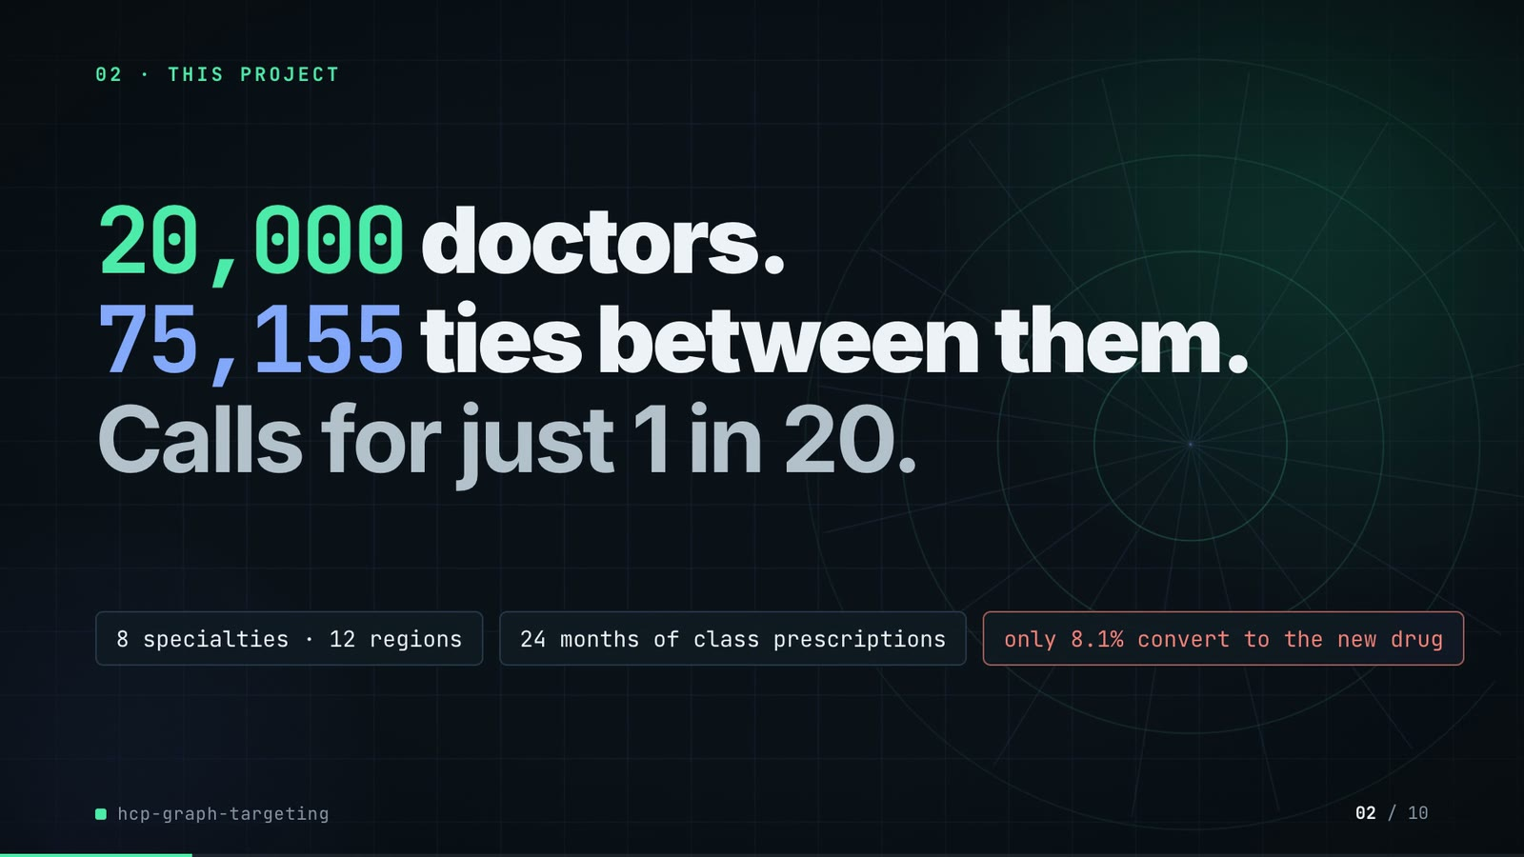
On-screen text (verbatim)
02 · THIS PROJECT
20,000 doctors. 75,155 ties between them. Calls for just 1 in 20.
8 specialties · 12 regions · 24 months of class prescriptions · only 8.1% convert to the new drug
Figures on this slide
ID | Shown | Source · key | Calculation | Check
F-03 | 20,000 doctors / 20,000 HCPs | outputs/summary.json · n_hcps | - | ✓
F-04 | 75,155 ties | outputs/summary.json; data/edges.csv · n_edges | - | ✓
F-05 | Calls for just 1 in 20 | outputs/summary.json · budgets.captured_5pct = 1,000; n_hcps = 20,000 | 20,000 / 1,000 = 20 | ✓
F-06 | 8 specialties · 12 regions | data/hcps.csv · specialty, region (distinct values) | - | ✓
F-07 | 24 months of class prescriptions | data/monthly_class_rx.csv · month columns (2024-07..2026-06) | columns - hcp_id | ✓
F-08 | only 8.1% convert to the new drug / all 20,000 HCPs: 8.1% | outputs/summary.json · conversion_rate = 0.08085 (1,617 of 20,000) | rounded to 1 decimal | ✓

Assumptions: A-01, A-03
Illustrative, not data:
• Rings in the background are decoration.
To change this slide: Headline spans #hook-l1..l3 and chips #hook-f1..f3 in compositions/s02-hook.html.

Slide 03: How it works (white chapter, slide A)
11.3-19.3 s · composition compositions/explainer.html (CONFIG.blocks, CONFIG.groups, CONFIG.loop)
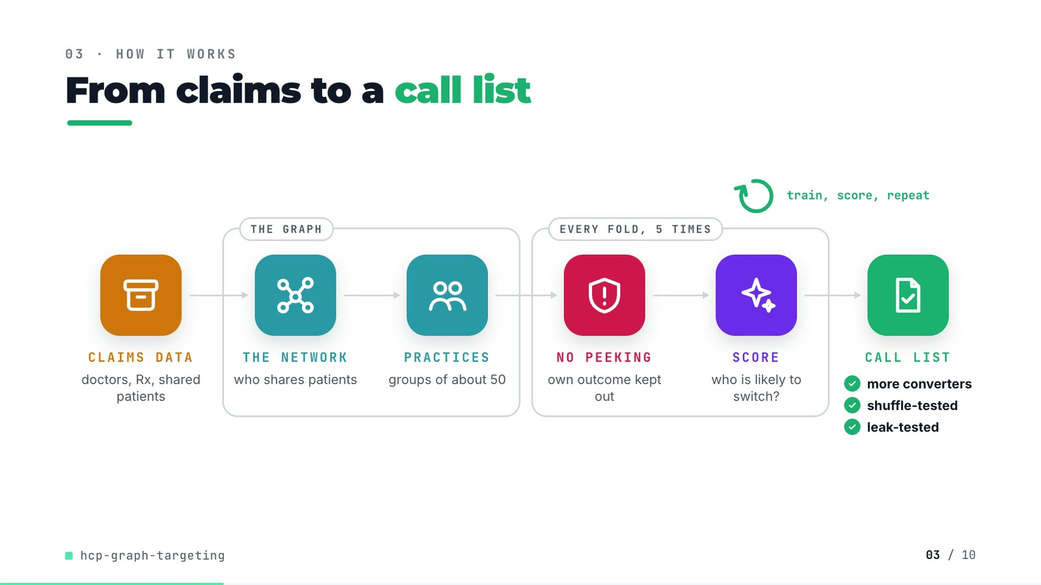
On-screen text (verbatim)
03 · HOW IT WORKS
From claims to a call list
CLAIMS DATA doctors, Rx, shared patients → [THE GRAPH: THE NETWORK who shares patients → PRACTICES groups of about 50] → [EVERY FOLD, 5 TIMES: NO PEEKING own outcome kept out → SCORE who is likely to switch?] → CALL LIST ✓ more converters ✓ shuffle-tested ✓ leak-tested
train, score, repeat (loop over the scoring step)
Figures on this slide
ID | Shown | Source · key | Calculation | Check
F-09 | PRACTICES · groups of about 50 | outputs/summary.json; README line 161 · communities_per_level[1] = 408 | 20,000 / 408 = 49 | ✓
F-10 | EVERY FOLD, 5 TIMES / Stratified 5-fold | outputs/summary.json · folds | - | ✓
F-11 | more converters · shuffle-tested · leak-tested | outputs/ablation.csv; tests/test_leakage.py · captured_5pct graph features > decile list; control rows present; leakage tests exist | 189 > 126 | ✓

Assumptions: A-04, A-05, A-08
Illustrative, not data:
• Icons and colours are a visual language, not data.
• 'Claims data' describes where shared-patient ties come from in practice; the repo's data is generated (A-01).
To change this slide: Edit CONFIG in compositions/explainer.html; badge truth is F-11.

Slide 04: The key idea (white chapter, slide B)
19.3-26.3 s · composition compositions/explainer.html (#ex-b ...)
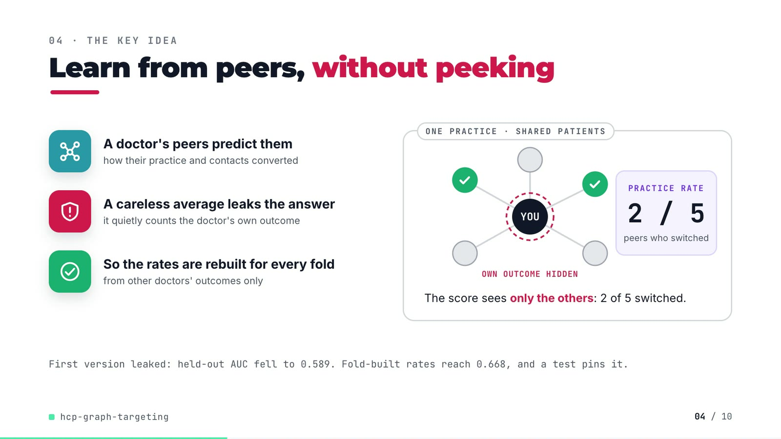
On-screen text (verbatim)
04 · THE KEY IDEA
Learn from peers, without peeking
A doctor's peers predict them — how their practice and contacts converted
A careless average leaks the answer — it quietly counts the doctor's own outcome
So the rates are rebuilt for every fold — from other doctors' outcomes only
ONE PRACTICE · SHARED PATIENTS: YOU + 5 peers, OWN OUTCOME HIDDEN, PRACTICE RATE 2 / 5 peers who switched. The score sees only the others: 2 of 5 switched.
First version leaked: held-out AUC fell to 0.589. Fold-built rates reach 0.668, and a test pins it.
Figures on this slide
ID | Shown | Source · key | Calculation | Check
F-12 | held-out AUC fell to 0.589 | docs/adr/0001-graph-features-built-fold-safe-embeddings-label-free.md:17 · ADR text | - | ✓
F-13 | 0.668 | outputs/ablation.csv · arm='+ community and neighbour conversion rates', auc | - | ✓
F-14 | and a test pins it | tests/test_leakage.py · own-label flip test | - | ✓
F-15 | PRACTICE RATE 2 / 5 | schematic · - | - | manual

Assumptions: A-04, A-07
Illustrative, not data:
• The YOU + 5 peers demo is schematic (F-15); it mirrors label_graph_features, not real HCPs.
To change this slide: Markup under #ex-b and the practice demo block in compositions/explainer.html; the footnote figures are F-12, F-13, F-14.

Slide 05: Architecture
26.0-42.0 s · composition compositions/s03-architecture.html
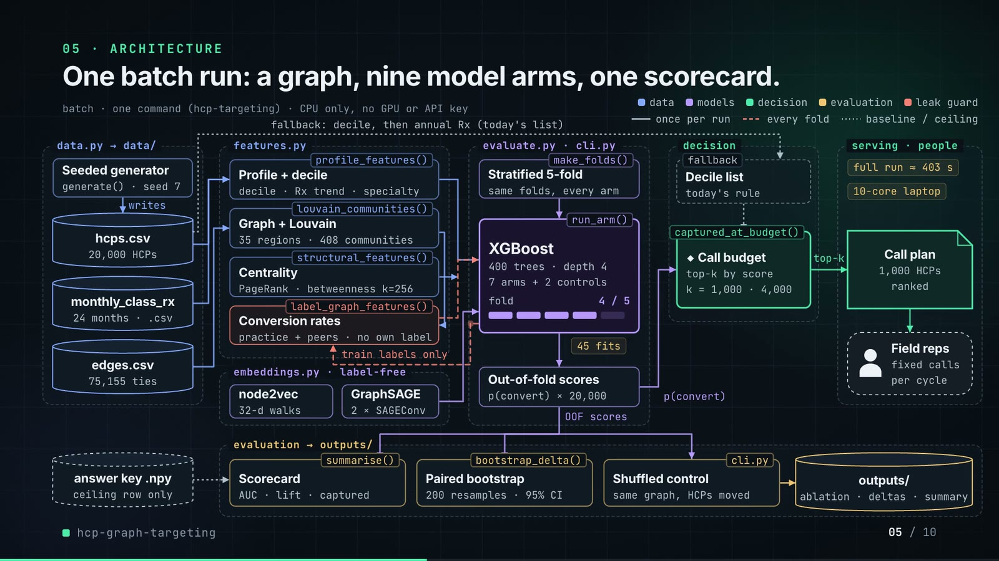
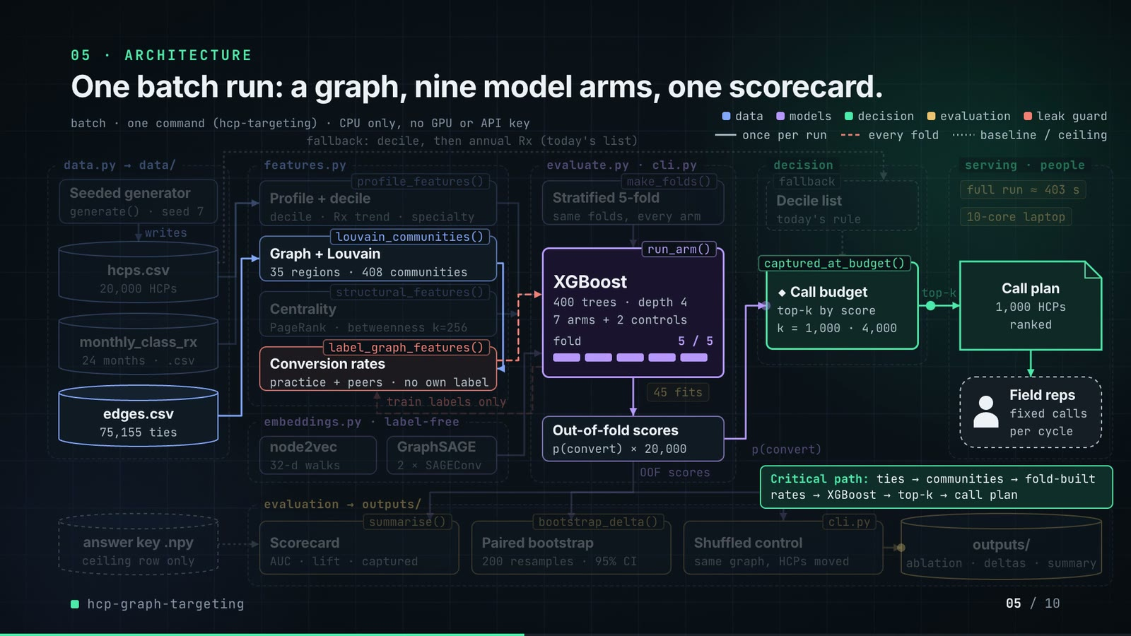
On-screen text (verbatim)
05 · ARCHITECTURE
One batch run: a graph, nine model arms, one scorecard.
batch · one command (hcp-targeting) · CPU only, no GPU or API key
Legend: data · models · decision · evaluation · leak guard; once per run · every fold · baseline / ceiling
data.py → data/: Seeded generator (generate() · seed 7) writes hcps.csv (20,000 HCPs), monthly_class_rx (24 months · .csv), edges.csv (75,155 ties); answer key .npy (ceiling row only)
features.py: profile_features() Profile + decile (decile · Rx trend · specialty); louvain_communities() Graph + Louvain (35 regions · 408 communities); structural_features() Centrality (PageRank · betweenness k=256); label_graph_features() Conversion rates (practice + peers · no own label)
embeddings.py · label-free: node2vec (32-d walks), GraphSAGE (2 × SAGEConv)
evaluate.py · cli.py: make_folds() Stratified 5-fold (same folds, every arm) → run_arm() XGBoost (400 trees · depth 4 · 7 arms + 2 controls · fold n / 5) → Out-of-fold scores (p(convert) × 20,000); 45 fits; feedback loop 'train labels only' back to Conversion rates
decision: fallback Decile list (today's rule) → captured_at_budget() ◆ Call budget (top-k by score · k = 1,000 · 4,000)
serving · people: Call plan (1,000 HCPs ranked) → Field reps (fixed calls per cycle); notes: full run ≈ 403 s · 10-core laptop
evaluation → outputs/: summarise() Scorecard (AUC · lift · captured), bootstrap_delta() Paired bootstrap (200 resamples · 95% CI), cli.py Shuffled control (same graph, HCPs moved) → outputs/ (ablation · deltas · summary)
Edge labels: writes · train labels only · fallback: decile, then annual Rx (today's list) · p(convert) · top-k · OOF scores
Critical path: ties → communities → fold-built rates → XGBoost → top-k → call plan
Figures on this slide
ID | Shown | Source · key | Calculation | Check
F-03 | 20,000 doctors / 20,000 HCPs | outputs/summary.json · n_hcps | - | ✓
F-04 | 75,155 ties | outputs/summary.json; data/edges.csv · n_edges | - | ✓
F-07 | 24 months of class prescriptions | data/monthly_class_rx.csv · month columns (2024-07..2026-06) | columns - hcp_id | ✓
F-10 | EVERY FOLD, 5 TIMES / Stratified 5-fold | outputs/summary.json · folds | - | ✓
F-16 | generate(), profile_features(), louvain_communities(), structural_features(), label_graph_features(), node2vec, GraphSAGE, make_folds(), run_arm(), captured_at_budget(), summarise(), bootstrap_delta(), cli.py shuffled control | src/hcp_targeting/ · def names | - | ✓
F-17 | 35 regions · 408 communities | outputs/summary.json · communities_per_level | - | ✓
F-18 | betweenness k=256 | src/hcp_targeting/cli.py:198 · --betweenness-k default | - | ✓
F-19 | 400 trees · depth 4 | src/hcp_targeting/evaluate.py:88-90 · n_estimators, max_depth | - | ✓
F-20 | nine model arms · 7 arms + 2 controls · 45 fits | src/hcp_targeting/evaluate.py (ARMS); cli.py:98 (ARMS[2], ARMS[5]); outputs/ablation.csv · 7 Arm(...) + 2 control rows | (7 + 2) x 5 folds = 45 | ✓
F-21 | 32-d walks · 2 × SAGEConv | src/hcp_targeting/cli.py:197; embeddings.py:131-133 · --dim 32; conv1, conv2 = SAGEConv | - | ✓
F-22 | k = 1,000 · 4,000 | outputs/summary.json · budgets | - | ✓
F-23 | 200 resamples · 95% CI | src/hcp_targeting/cli.py:201; evaluate.py:52 · --n-boot default 200; percentiles 2.5/97.5 | - | ✓
F-24 | full run ≈ 403 s · 10-core laptop | README line 178 · README text | - | ✓
F-25 | CPU only, no GPU or API key / RUNS ON A LAPTOP CPU | README 'Running it' · README text | - | ✓
F-26 | fallback: decile, then annual Rx (today's list) | src/hcp_targeting/cli.py:83-84 · rule = decile * 1e6 + annual_class_rx | - | ✓
F-27 | practice + peers · no own label · train labels only | src/hcp_targeting/features.py:153-184; tests/test_leakage.py · inner_folds = 5 | - | ✓
F-28 | generate() · seed 7 | outputs/summary.json · seed | - | ✓

F-20 note: 7 arms: T().count(' Arm(') counts the seven entries of ARMS (the dataclass definition line is 'class Arm:').
F-24 note: README states this for an earlier session; the captured run in outputs/ took 12,279 s (3.4 h) on a shared machine (summary.json runtime_seconds).
Assumptions: A-01, A-03, A-04, A-05, A-06, A-07, A-08, A-09
Illustrative, not data:
• Packets moving along the edges follow execution order but their speed is decorative; the fold counter shows the 5 folds, not wall-clock time.
• 'Field reps · fixed calls per cycle' is the human-in-the-loop consumer from the README problem statement; the repo has no rep or scheduling code.
• 'Call plan' is the top-k of the out-of-fold scores (what captured_at_budget counts); the repo does not write a plan file — the demo's export script does (slide 07).
To change this slide: FRAMES, N (components) and W (edges) objects in compositions/s03-architecture.html.

Slide 06: The system running
41.6-56.2 s · composition compositions/s04-routes.html (NET block injected by tools/inject_sheet.py; LADDER array)
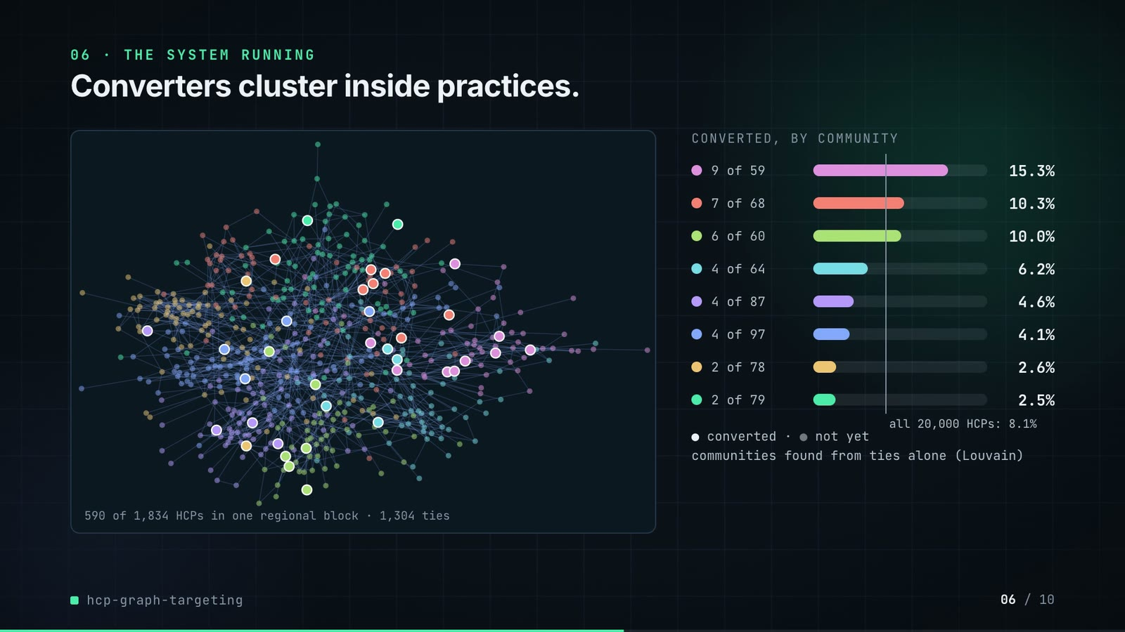
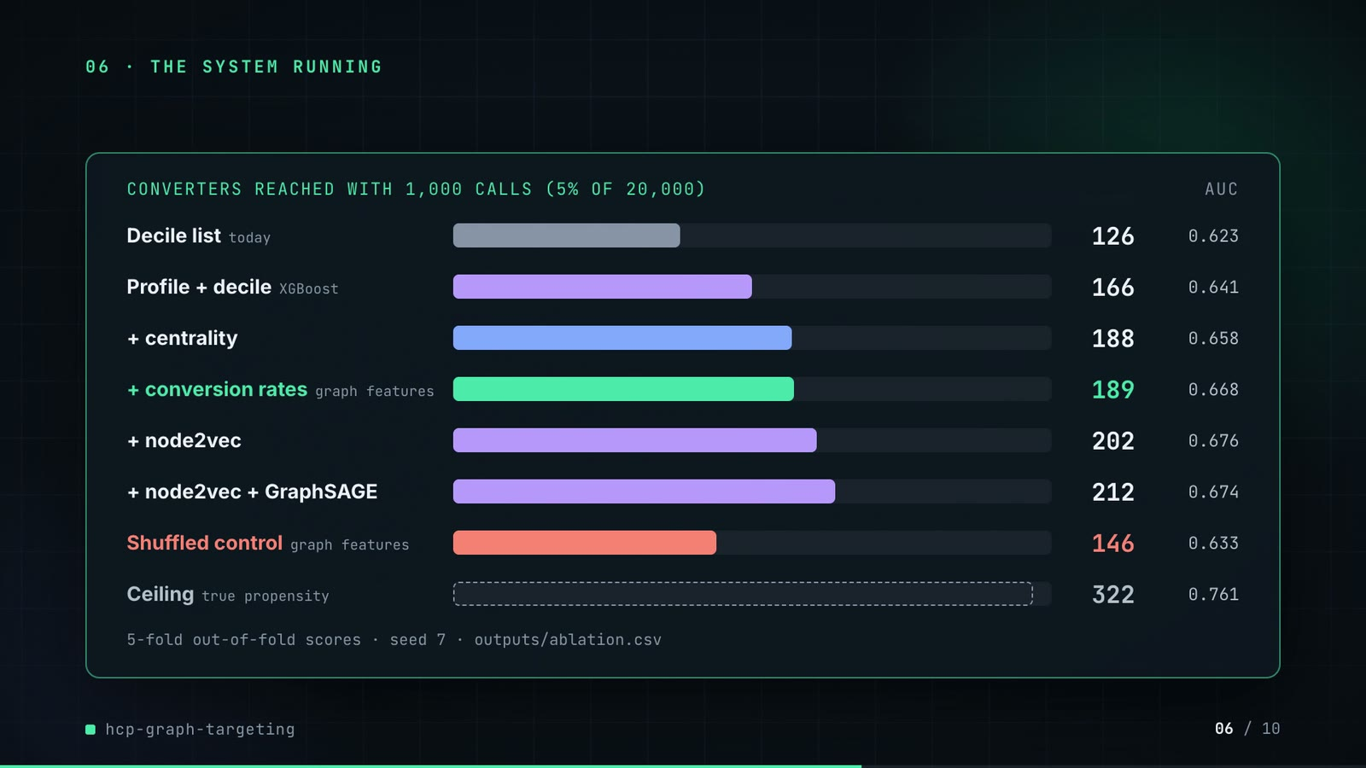
On-screen text (verbatim)
06 · THE SYSTEM RUNNING
Converters cluster inside practices.
Network panel: 590 of 1,834 HCPs in one regional block · 1,304 ties
CONVERTED, BY COMMUNITY: 9 of 59 15.3% · 7 of 68 10.3% · 6 of 60 10.0% · 4 of 64 6.2% · 4 of 87 4.6% · 4 of 97 4.1% · 2 of 78 2.6% · 2 of 79 2.5% · all 20,000 HCPs: 8.1%
● converted · ● not yet · communities found from ties alone (Louvain)
CONVERTERS REACHED WITH 1,000 CALLS (5% OF 20,000) · AUC: Decile list today 126 0.623 · Profile + decile XGBoost 166 0.641 · + centrality 188 0.658 · + conversion rates (graph features) 189 0.668 · + node2vec 202 0.676 · + node2vec + GraphSAGE 212 0.674 · Shuffled control (graph features) 146 0.633 · Ceiling (true propensity) 322 0.761
5-fold out-of-fold scores · seed 7 · outputs/ablation.csv
Figures on this slide
ID | Shown | Source · key | Calculation | Check
F-08 | only 8.1% convert to the new drug / all 20,000 HCPs: 8.1% | outputs/summary.json · conversion_rate = 0.08085 (1,617 of 20,000) | rounded to 1 decimal | ✓
F-29 | 590 of 1,834 HCPs in one regional block · 1,304 ties | demo assets/call_plan.json (network_sample), exported by tools/export_call_plan.py from Louvain on data/edges.csv · len(nodes), l0_size, len(edges) | 8 largest level-1 communities of the 5th-largest level-0 block | ✓
F-30 | 9 of 59 15.3% · 7 of 68 10.3% · 6 of 60 10.0% · 4 of 64 6.2% · 4 of 87 4.6% · 4 of 97 4.1% · 2 of 78 2.6% · 2 of 79 2.5% | demo assets/call_plan.json (network_sample.communities); labels from data/hcps.csv converted · converted, size, rate | rate = converted / size | ✓
F-31 | ● converted · ● not yet | data/hcps.csv; demo assets/call_plan.json · converted per hcp_id | - | ✓
F-32 | 126 · 0.623 | outputs/ablation.csv · arm='decile list (no model)': captured_5pct, auc | - | ✓
F-33 | 166 · 0.641 | outputs/ablation.csv · captured_5pct, auc | - | ✓
F-34 | 188 · 0.658 | outputs/ablation.csv · captured_5pct, auc | - | ✓
F-35 | 189 · 0.668 | outputs/ablation.csv · captured_5pct, auc | - | ✓
F-36 | 202 · 0.676 | outputs/ablation.csv · captured_5pct, auc | - | ✓
F-37 | 212 · 0.674 | outputs/ablation.csv · captured_5pct, auc | - | ✓
F-38 | 146 · 0.633 | outputs/ablation.csv · arm='control, HCPs shuffled across the graph: + community and neighbour conversion rates' | - | ✓
F-39 | 322 · 0.761 | outputs/ablation.csv · arm='ceiling: true propensity (answer key)' | - | ✓

F-30 note: Counts are over the whole level-1 community. One community (6 of 60) has 2 members outside the sampled regional block, so the panel draws 58 of its 60 HCPs; all 6 converters are inside. Node labels are re-checked against data/hcps.csv by sample_labels_match() (F-31).
Assumptions: A-02, A-03, A-05, A-07, A-08, A-09
Illustrative, not data:
• The network layout is a seeded spring layout (networkx, seed 7) of the real sampled subgraph; position has no meaning beyond tie structure.
• Community colours are arbitrary.
• Bar lengths: 860 px track = 340 converters.
To change this slide: Re-run tools/export_call_plan.py + tools/inject_sheet.py for the network panel; LADDER array in compositions/s04-routes.html for the ladder.

Slide 07: End-user value (white)
55.9-68.9 s · composition compositions/value.html (SHEET block injected by tools/inject_sheet.py)
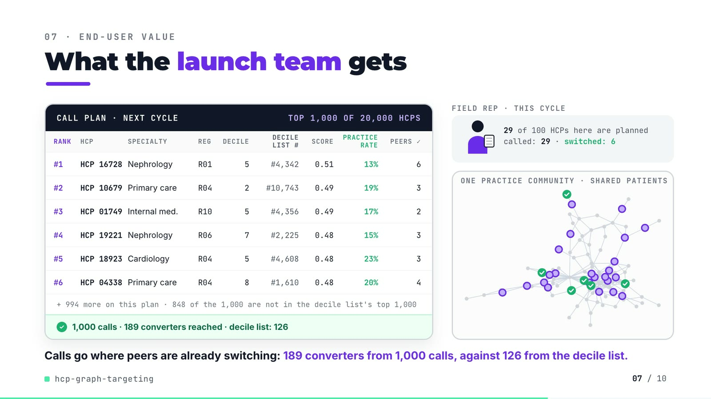
On-screen text (verbatim)
07 · END-USER VALUE
What the launch team gets
CALL PLAN · NEXT CYCLE · TOP 1,000 OF 20,000 HCPS — columns RANK, HCP, SPECIALTY, REG, DECILE, DECILE LIST #, SCORE, PRACTICE RATE, PEERS ✓
#1 HCP 16728 Nephrology R01 5 #4,342 0.51 13% 6
#2 HCP 10679 Primary care R04 2 #10,743 0.49 19% 3
#3 HCP 01749 Internal med. R10 5 #4,356 0.49 17% 2
#4 HCP 19221 Nephrology R06 7 #2,225 0.48 15% 3
#5 HCP 18923 Cardiology R04 5 #4,608 0.48 23% 3
#6 HCP 04338 Primary care R04 8 #1,610 0.48 20% 4
+ 994 more on this plan · 848 of the 1,000 are not in the decile list's top 1,000
✓ 1,000 calls · 189 converters reached · decile list: 126
FIELD REP · THIS CYCLE: 29 of 100 HCPs here are planned · called: 29 · switched: 6
ONE PRACTICE COMMUNITY · SHARED PATIENTS
Calls go where peers are already switching: 189 converters from 1,000 calls, against 126 from the decile list.
Figures on this slide
ID | Shown | Source · key | Calculation | Check
F-03 | 20,000 doctors / 20,000 HCPs | outputs/summary.json · n_hcps | - | ✓
F-40 | #1 HCP 16728 … #6 HCP 04338 | demo assets/call_plan.json, injected into compositions/value.html · plan ranks 1-6 | score = out-of-fold p(convert); practice rate = fold-built community_conv_rate_l1 as the HCP saw it when held out; PEERS ✓ = nbr_converted | ✓
F-41 | + 994 more on this plan | demo assets/call_plan.json · calls - 6 rows | 1,000 - 6 = 994 | ✓
F-42 | 848 of the 1,000 are not in the decile list's top 1,000 | demo assets/call_plan.json · plan[].decile_rank > 1,000 | count | ✓
F-43 | 1,000 calls · 189 converters reached · decile list: 126 | demo assets/call_plan.json; outputs/ablation.csv · captured, captured_decile_list (equal to ablation.csv captured_5pct) | - | ✓
F-44 | 29 of 100 HCPs here are planned · called: 29 · switched: 6 | demo assets/call_plan.json (scene) · size, planned, planned_converted | - | ✓
F-45 | TOP 1,000 OF 20,000 HCPS | demo assets/call_plan.json · calls, n_hcps | - | ✓

Assumptions: A-02, A-03, A-04, A-10
Illustrative, not data:
• HCP numbers are the generator's synthetic hcp_id values (no real people).
• 'NEXT CYCLE' frames the out-of-fold ranking as a plan; in the repo the scores and outcomes come from the same campaign window (README 'Known limitations': static snapshot).
• The rep figure, call cards and their timing are illustrative; the community (level-1 community 8), its ties, which members are on the plan and which converted are real, laid out with a seeded spring layout.
• Practice rate is the smoothed fold-built community conversion rate (prior weight 20), so it is not a raw share.
To change this slide: Re-run tools/export_call_plan.py, then tools/inject_sheet.py (--rows picks the plan ranks); layout in compositions/value.html.

Slide 08: Results
68.6-77.4 s · composition compositions/s05-results.html (stats array)
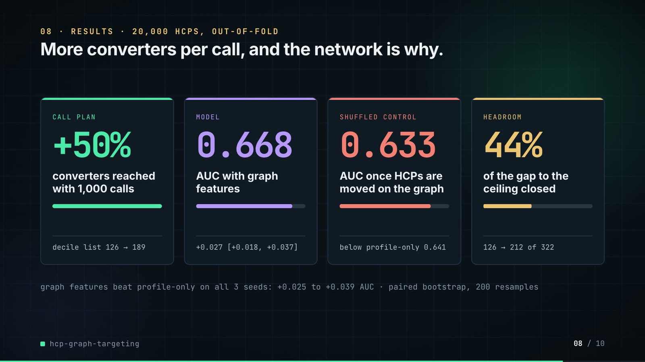
On-screen text (verbatim)
08 · RESULTS · 20,000 HCPS, OUT-OF-FOLD
More converters per call, and the network is why.
CALL PLAN +50% converters reached with 1,000 calls · decile list 126 → 189
MODEL 0.668 AUC with graph features · +0.027 [+0.018, +0.037]
SHUFFLED CONTROL 0.633 AUC once HCPs are moved on the graph · below profile-only 0.641
HEADROOM 44% of the gap to the ceiling closed · 126 → 212 of 322
graph features beat profile-only on all 3 seeds: +0.025 to +0.039 AUC · paired bootstrap, 200 resamples
Figures on this slide
ID | Shown | Source · key | Calculation | Check
F-13 | 0.668 | outputs/ablation.csv · arm='+ community and neighbour conversion rates', auc | - | ✓
F-23 | 200 resamples · 95% CI | src/hcp_targeting/cli.py:201; evaluate.py:52 · --n-boot default 200; percentiles 2.5/97.5 | - | ✓
F-37 | 212 · 0.674 | outputs/ablation.csv · captured_5pct, auc | - | ✓
F-38 | 146 · 0.633 | outputs/ablation.csv · arm='control, HCPs shuffled across the graph: + community and neighbour conversion rates' | - | ✓
F-39 | 322 · 0.761 | outputs/ablation.csv · arm='ceiling: true propensity (answer key)' | - | ✓
F-46 | +50% · decile list 126 → 189 | outputs/ablation.csv · captured_5pct: graph features 189, decile list 126 | 189 / 126 - 1 = +50.0% | ✓
F-47 | 0.641 → 0.668 · +0.027 [+0.018, +0.037] | outputs/deltas.csv · arm='+ community and neighbour conversion rates', vs='profile + decile', metric=auc | - | ✓
F-48 | 0.633 · below profile-only 0.641 | outputs/ablation.csv · both control rows auc; profile + decile auc | - | ✓
F-49 | 44% · 126 → 212 of 322 | outputs/ablation.csv · captured_5pct: decile 126, best (n2v + SAGE) 212, ceiling 322 | (212 - 126) / (322 - 126) = 43.9% | ✓
F-50 | +0.025 to +0.039 AUC | outputs/seed_sweep.csv · auc: 'graph features' minus 'profile' per seed (7, 11, 23) | min/max of 0.0269, 0.0247, 0.0388 | ✓

Assumptions: A-02, A-03, A-07, A-08, A-09, A-11
Illustrative, not data:
• Mini bars: card 1 and 4 are drawn to the ratio shown; cards 2-3 are AUC / 0.761 (ceiling).
To change this slide: The stats array and card text in compositions/s05-results.html.

Slide 09: What didn't win
77.0-84.0 s · composition compositions/s06-twist.html (ROWS array)
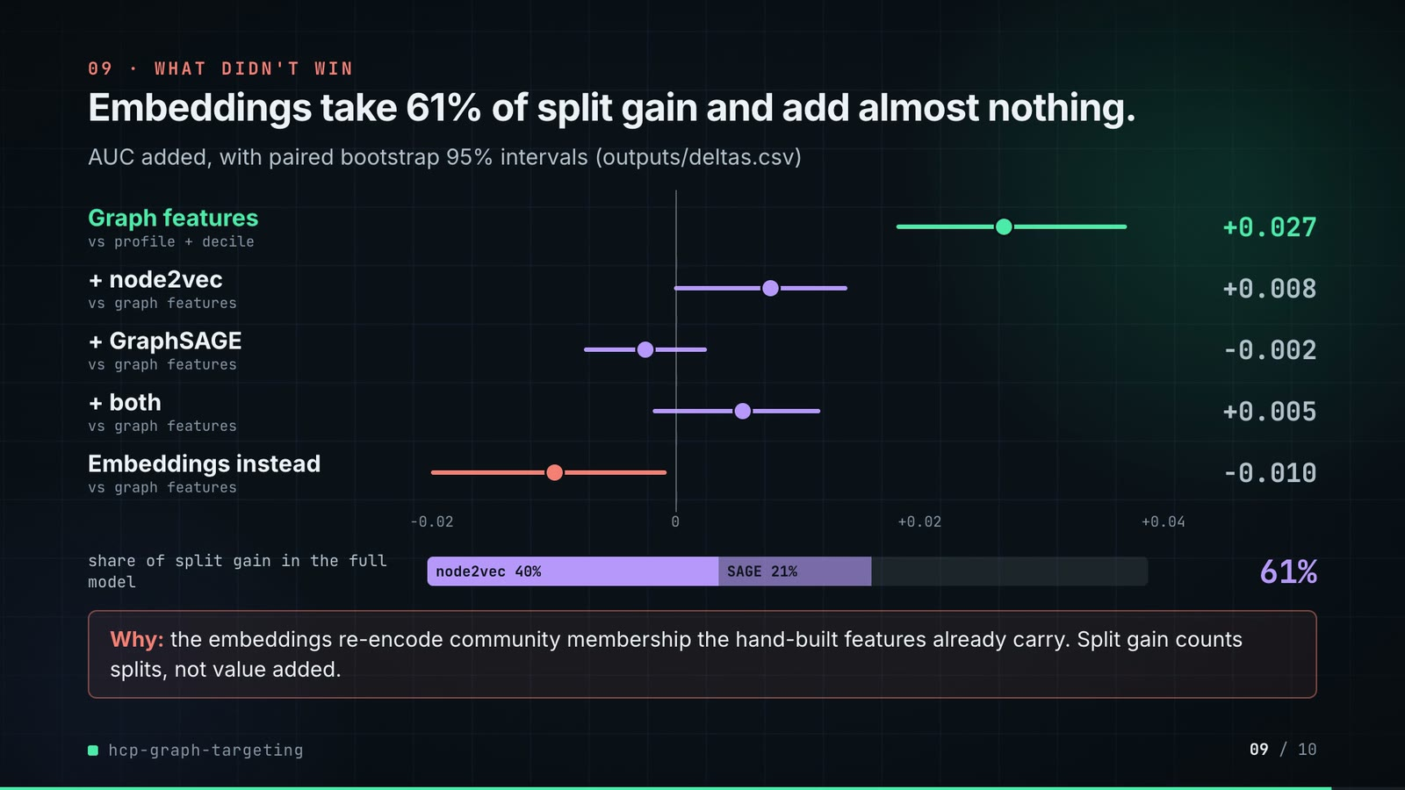
On-screen text (verbatim)
09 · WHAT DIDN'T WIN
Embeddings take 61% of split gain and add almost nothing.
AUC added, with paired bootstrap 95% intervals (outputs/deltas.csv)
Graph features vs profile + decile +0.027 · + node2vec vs graph features +0.008 · + GraphSAGE vs graph features -0.002 · + both vs graph features +0.005 · Embeddings instead vs graph features -0.010
share of split gain in the full model: node2vec 40% · SAGE 21% · 61%
Why: the embeddings re-encode community membership the hand-built features already carry. Split gain counts splits, not value added.
Figures on this slide
ID | Shown | Source · key | Calculation | Check
F-51 | +0.027 | outputs/deltas.csv · arm='+ community and neighbour conversion rates', vs='profile + decile', auc | - | ✓
F-52 | +0.008 | outputs/deltas.csv · arm='graph features + node2vec', vs='graph features', auc | - | ✓
F-53 | -0.002 | outputs/deltas.csv · arm='graph features + GraphSAGE', vs='graph features', auc | - | ✓
F-54 | +0.005 | outputs/deltas.csv · arm='graph features + node2vec + GraphSAGE', vs='graph features', auc | - | ✓
F-55 | -0.010 | outputs/deltas.csv · arm='profile + embeddings only (no hand-built graph features)', vs='graph features', auc | - | ✓
F-56 | 61% · node2vec 40% · SAGE 21% | outputs/summary.json · gain_share_by_block_full_model: node2vec 0.3975, graphsage 0.2091 | 0.3975 + 0.2091 = 0.6067 | ✓

F-53 note: delta = -0.00249; the README rounds it to -0.003, the video shows -0.002 (3-decimal rounding of the CSV value).
F-54 note: delta = 0.00549; the README writes +0.006.
Assumptions: A-02, A-07, A-11
Illustrative, not data:
• Axis -0.02 … +0.04 AUC; dots are point estimates, lines are the 95% intervals.
To change this slide: ROWS array (deltas) and the gain bar in compositions/s06-twist.html.

Slide 10: End card
83.6-88.0 s · composition compositions/s07-end.html
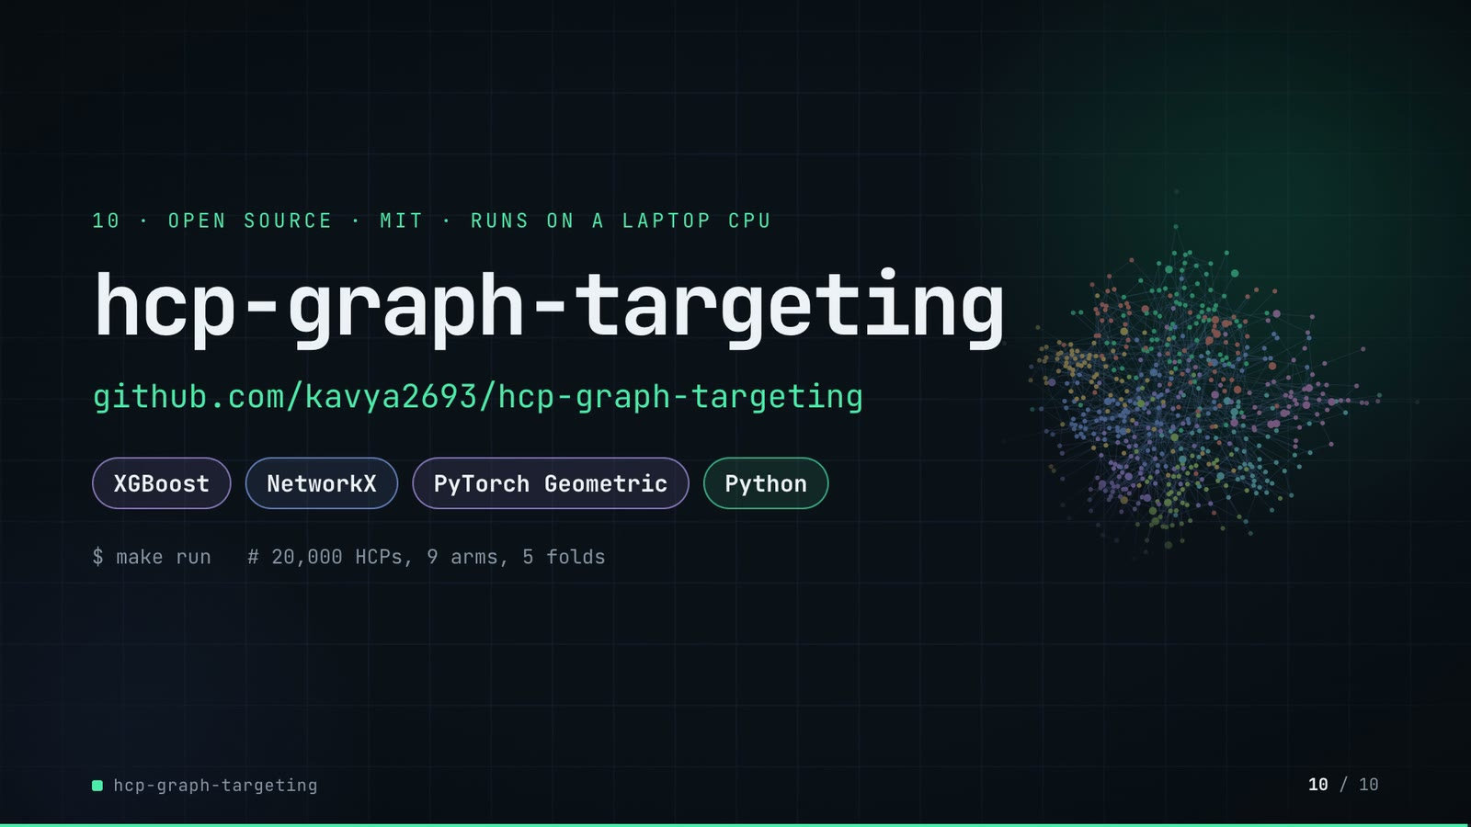
On-screen text (verbatim)
10 · OPEN SOURCE · MIT · RUNS ON A LAPTOP CPU
hcp-graph-targeting
github.com/kavya2693/hcp-graph-targeting
XGBoost · NetworkX · PyTorch Geometric · Python
$ make run # 20,000 HCPs, 9 arms, 5 folds
Figures on this slide
ID | Shown | Source · key | Calculation | Check
F-03 | 20,000 doctors / 20,000 HCPs | outputs/summary.json · n_hcps | - | ✓
F-25 | CPU only, no GPU or API key / RUNS ON A LAPTOP CPU | README 'Running it' · README text | - | ✓
F-57 | MIT | LICENSE line 1 · - | - | ✓
F-58 | XGBoost · NetworkX · PyTorch Geometric · Python | pyproject.toml dependencies · xgboost, networkx, torch-geometric | - | ✓
F-59 | $ make run # 20,000 HCPs, 9 arms, 5 folds | Makefile; cli.py defaults · run target; --n-hcps 20000; 7 arms + 2 controls; --folds 5 | - | ✓

Assumptions: A-11
Illustrative, not data:
• Faded network in the background is the slide 06 sample.
To change this slide: Text in compositions/s07-end.html.

5. Change-impact matrix
Input / assumption | Affected figures | Slides | Files to edit | Re-run
A-01: All data is synthetic, produced by a seeded generator (20,000 HCPs, 8 specialties, 12 regions, about 440 practice groups, 24 months of class prescriptions, 75,155 ties) | all figures | 01, 02, 03, 04, 05, 06, 07, 08, 09, 10 | src/hcp_targeting/data.py; scripts/generate_data.py | make data; make run; export_call_plan.py + inject_sheet.py
A-02: The generator decides how much the network matters: conversion depends on hidden practice-group culture (sd 0 | F-13, F-29, F-30, F-32, F-33, F-34, F-35, F-36, F-37, F-38, F-39, F-43, F-46, F-47, F-48, F-49, F-50 | 04, 06, 07, 08 | src/hcp_targeting/data.py:98, :188-189 | make run; export_call_plan.py + inject_sheet.py
A-03: A call budget is 5% (1,000 calls) or 20% (4,000 calls) of the 20,000 HCPs; 'converters reached' assumes the call is what converts the HCP (the model ranks propensity, not uplift from calling) | F-05, F-22, F-32, F-33, F-34, F-35, F-36, F-37, F-38, F-39, F-41, F-42, F-43, F-44, F-45, F-46, F-49 | 02, 05, 06, 07, 08 | src/hcp_targeting/cli.py:199-200 | make run; export_call_plan.py + inject_sheet.py
A-04: Label-derived features (community and neighbour conversion rates) are rebuilt inside every outer fold from training labels only, with an inner 5-fold split and a prior weight of 20; embeddings are trained without labels | F-10, F-11, F-12, F-13, F-27, F-35, F-40 | 03, 04, 05, 06, 07, 08 | src/hcp_targeting/features.py:153-184; src/hcp_targeting/evaluate.py:129 (prior_weight) | make run; export_call_plan.py + inject_sheet.py
A-05: Louvain runs at resolution 1 (regional blocks) and 16 (practice-size communities); 16 was chosen to match practice size, not tuned on conversion | F-09, F-17, F-29, F-30, F-44 | 03, 05, 06, 07 | src/hcp_targeting/features.py:60 | make run; export_call_plan.py + inject_sheet.py
A-06: Betweenness is estimated from 256 sampled sources (64 in the seed sweep) | F-18, F-50 | 05, 08 | src/hcp_targeting/cli.py:198 | make run
A-07: Every arm uses one XGBoost setting (400 trees, depth 4, learning rate 0 | F-13, F-19, F-20, F-32, F-33, F-34, F-35, F-36, F-37, F-38, F-39, F-46, F-47, F-48 | 04, 05, 06, 08 | src/hcp_targeting/evaluate.py:85-98 | make run; export_call_plan.py + inject_sheet.py
A-08: The shuffled-graph control moves every HCP to a random node of the same graph (seed 8 permutation): structure is unchanged, the person-position link is broken | F-11, F-38, F-48 | 03, 06, 08 | src/hcp_targeting/cli.py:93-104 | make run
A-09: The ceiling row scores HCPs by the generator's true propensity (answer key), which no feature reads | F-39, F-49 | 06, 08 | src/hcp_targeting/data.py | make run
A-10: The call plan on slide 07 ranks the arm '+ community and neighbour conversion rates' (hand-built graph features, no embeddings) by its out-of-fold scores; the demo's export re-runs that arm and asserts AUC 0 | F-40, F-41, F-42, F-43, F-44, F-45 | 07 | docs/demo/source/tools/export_call_plan.py (arm, CALLS) | export_call_plan.py + inject_sheet.py; hyperframes render
A-11: Video rounding: AUC to 3 decimals, AUC deltas to 3 decimals with sign, percentages to 1 decimal (community rates, 8 | F-05, F-08, F-30, F-46, F-49, F-50, F-51, F-52, F-53, F-54, F-55, F-56 | 02, 06, 08, 09 | the composition file named on each slide | hyperframes render
A-12: Slide 01 (industry, everyday problems) is general pharma-commercial knowledge used as context, consistent with README 'The problem' | F-01, F-02 | 01 | compositions/s01-context.html | hyperframes render

6. Known differences and caveats
• All results come from one generated market (seed 7, plus two sweep seeds). The generator wires practice culture and opinion-leader exposure into conversion, so the size of the graph lift is set by the generator, not measured on a real market (README 'Known limitations', A-02).
• 'Converters reached' ranks propensity, not uplift from calling: there is no call response model (A-03).
• Slide 07 presents out-of-fold scores as a 'next cycle' plan. In the repo the snapshot is static: the same campaign window provides labels for the fold-built features and the outcomes being scored (README 'Known limitations').
• The slide 07 plan comes from the demo's export script, which re-runs one arm of make run (same data, seed, folds and settings) and asserts AUC 0.668 and 189 / 126 captured against outputs/ablation.csv. The repo itself does not write a plan file.
• 'Full run ≈ 403 s' quotes the README for an earlier session; the captured run in outputs/ took 12,279 s on a shared machine.
• Slide 09 shows the GraphSAGE delta as -0.002 and the both-embeddings delta as +0.005 (3-decimal rounding of outputs/deltas.csv); the README text writes -0.003 and +0.006.
• The 44% headroom figure uses the best arm (node2vec + GraphSAGE, 212); the +50% figure uses the hand-built graph-features arm (189).
• Slide 01 statements are general industry knowledge (A-12).

Appendix: environment
Item | Value
Commit | 719ffbfc4cf1d5bf57f19f9c80be25168ad972f6
Python | 3.11.7
xgboost | 3.2.0
networkx | 3.6.1
torch | 2.10.0
torch_geometric | 2.8.1
sklearn | 1.9.1
pandas | 3.0.6
numpy | 2.4.6
Profile / seeds | data_seed=7, cv_folds=5, louvain_seed=7, xgboost_seed=7, bootstrap_resamples=200
Run time | summary.json runtime_seconds = 12,278.9 s (3.4 h) for the captured make run on a shared machine; README reports 403 s for a full run on an idle 10-core laptop. The demo's export re-run of one arm took about 30 s.

