AUDIT REPORT

last-mile-dispatch: demo video audit report
A slide-by-slide record of every number, assumption and calculation in the demo video, with its source.
Item | Value
Repository | https://github.com/kavya2693/last-mile-dispatch
Numbers taken from commit | c7de8a6ad78ef3961f773e55ae9af197085c3f9c (outputs last changed in c7de8a6 (2026-10-13 17:55:02 +0400))
Video | docs/demo/demo.mp4 · 84.6 s · 1920x1080 · 30 fps · silent
Generated | 2026-10-14 14:19
Automated checks | 60 pass · 0 fail · 1 manual (of 61 figures)
Assumptions | 13 (A-01 to A-13)

How to use this report
Every number or claim on screen has an ID (F-01, F-02, ...) and every modelling assumption has an ID (A-01, ...). Cite the ID. Each figure lists its source file, the exact column, row or key, the formula for derived numbers, and an automated check result. The change-impact matrix (section 5) shows which slides and files change if an input or assumption changes.
Types: direct = read straight from a repo output; derived = computed from direct values (formula given); illustrative = drawing or example, not data; general knowledge = context not produced by the repo.

Regenerate
make run # data/ (seed 7) and outputs/*.csv, summary.json, run_log.txt (~3 min)
python3 docs/demo/source/tools/export_series.py docs/demo/source/assets/run_series.json
PYTHONPATH=src .venv/bin/python docs/demo/source/tools/export_rider_board.py docs/demo/source/assets/rider_board.json
python3 docs/demo/source/tools/inject_sheet.py docs/demo/source/assets/rider_board.json docs/demo/source/compositions/value.html --name SHEET
for f in s02-hook s04-routes s07-end; do python3 docs/demo/source/tools/inject_sheet.py docs/demo/source/assets/run_series.json docs/demo/source/compositions/$f.html --name SERIES; done
cd docs/demo/source && npx --yes hyperframes@0.8.156 check && npx --yes hyperframes@0.8.156 render -f 30 -q looks -o renders/last-mile-dispatch-master.mp4 && cd -
ffmpeg -y -i docs/demo/source/renders/last-mile-dispatch-master.mp4 -c:v libx264 -preset slow -crf 25 -pix_fmt yuv420p -movflags +faststart -an docs/demo/demo.mp4
python3 docs/demo/source/tools/build_audit_report.py docs/demo/source/audit/facts.yaml # stills, checks, MD/DOCX/PDF

1. Figures
ID | Shown | Slides | Source | Column / row / key | How computed | Type | Check
F-01 | 3 industry chips | 01 | author's framing | - | - | general knowledge | manual: Context statement, not a repo output.
F-02 | 4 problem cards | 01 | README 'The problem', 'Insights and learning' | README text | - | general knowledge | ✓ verified
F-03 | 26 hubs | 02, 05, 07 | outputs/summary.json; data/hubs.csv | hubs; row count | - | direct | ✓ verified
F-04 | 473 riders | 02, 05 | data/riders.csv | row count | - | direct | ✓ verified
F-05 | 477,868 orders | 02, 05 | data/orders.csv.gz | row count | - | direct | ✓ verified
F-06 | 6 weeks / 42 days | 02, 05 | data/days.csv | row count = 42 | 42 / 7 = 6 weeks | derived | ✓ verified
F-07 | 30 minutes to each door / 30-minute promise | 02, 07 | src/last_mile_dispatch/config.py:27 | SLA_MIN = 30 | - | direct | ✓ verified
F-08 | a wave every 2 min / EVERY 2 MINUTES / dispatch wave 2 min | 02, 03, 05 | src/last_mile_dispatch/config.py:23 | WAVE_MIN = 2 | - | direct | ✓ verified
F-09 | Ramadan · weekends · rain | 02 | data/days.csv | ramadan, weekend, rain columns | any ramadan, any weekend, exactly one rain day | direct | ✓ verified
F-10 | 36 riders sometimes skip doors | 02 | data/riders.csv | remote_marker == True | count | direct | ✓ verified
F-11 | hub dots + circles | 02, 10 | data/hubs.csv; config.py:12 (SERVICE_RADIUS_KM = 4.0) | lat/lon -> km from the centroid (demo assets/run_series.json) | - | direct | ✓ verified
F-12 | ORDERS → BAG → MATCH → DOOR CHECK → A/B TEST → VERDICT | 03 | src/last_mile_dispatch/ | functions | - | direct | ✓ verified
F-13 | 4 WEEKS | 03 | outputs/summary.json | experiment_days = 28 | 28 / 7 = 4 | derived | ✓ verified
F-14 | cheaper orders / fewer cancels / fewer fake marks | 03 | outputs/ab_readout.csv | welch_hi for cost_per_delivered, cancel_rate, fake_accepted_per_1k | welch_hi < 0 for all three | derived | ✓ verified
F-15 | 3 steps / ≤ 3 stops · 1 km | 04, 05 | src/last_mile_dispatch/bagging.py:3-5, :51-87; config.py:37, :65-67 | BAG_CAPACITY = 3, BAG_MAX_DROP_GAP_KM = 1.0, BAG_MAX_CREATED_GAP_MIN = 12.0, BAG_MAX_EXTRA_MIN = 9.0 | - | direct | ✓ verified
F-16 | 9.71 | 04 | outputs/ablation.csv | policy=baseline, cost_per_delivered | - | direct | ✓ verified
F-17 | 8.95 AED | 04 | outputs/ablation.csv | policy=bagging, cost_per_delivered | - | direct | ✓ verified
F-18 | generate_data.py, runner.py run_all(), simulate.py simulate_hub_day(), bagging.py, assignment.py (min_cost, fifo), geo.py, geofence.py, experiment.py, report.py | 05 | src/last_mile_dispatch/, scripts/ | defs | - | direct | ✓ verified
F-19 | power.csv, ab_readout.csv, geofence_eval.csv, ablation.csv, rerandomisation.csv, hub_day_metrics.csv | 05 | outputs/ | files | - | direct | ✓ verified
F-20 | 3,640 rows | 05 | outputs/hub_day_metrics.csv | row count | 26 x 28 x 5 | direct | ✓ verified
F-21 | 11,566 marks | 05 | outputs/geofence_eval.csv | slice=all, events | - | direct | ✓ verified
F-22 | hub-day runs 4,004 | 05 | outputs/run_log.txt line 2 | 'simulated 4,004 hub-day-policy runs' | 26 x 14 + 26 x 28 x 5 = 4,004 | direct | ✓ verified
F-23 | full run, laptop 180 s | 05 | outputs/summary.json | runtime_s = 179.8 | rounded to whole seconds | derived | ✓ verified
F-24 | cancel if not out 45 min | 05 | src/last_mile_dispatch/config.py:28 | CANCEL_AFTER_MIN = 45 | - | direct | ✓ verified
F-25 | 150 m geofence | 05 | src/last_mile_dispatch/config.py:79 | GEOFENCE_RADIUS_M = 150.0 | - | direct | ✓ verified
F-26 | 500 re-draws | 05 | outputs/rerandomisation.csv | draws | - | direct | ✓ verified
F-27 | 13 vs 13 hubs | 05, 08, 09 | outputs/summary.json | arms.treatment, arms.control | len of each list | direct | ✓ verified
F-28 | 4 parallel workers · 5 policies, 1 seed | 05 | src/last_mile_dispatch/cli.py:29; runner.py:36-41; config.py:62 | --workers default 4; same seed for every policy; ALL_POLICIES | - | direct | ✓ verified
F-29 | CI slice 8 hubs × 7 d | 05 | src/last_mile_dispatch/cli.py:38, :40; .github/workflows/ci.yml | hubs.head(8), experiment days head(7) | - | direct | ✓ verified
F-30 | generate_data.py · seed 7 | 05 | scripts/generate_data.py:168 | --seed default 7 | - | direct | ✓ verified
F-31 | two lines, Feb 2 - Mar 1 | 06 | outputs/hub_day_metrics.csv | sum(cancelled) / sum(orders) by date and policy | injected SERIES block must equal the recomputation | derived | ✓ verified
F-32 | RAIN DAY · 42.5% → 14.0% | 06 | outputs/stress_split.csv | day_type=rain day, cancel_rate | x 100 | direct | ✓ verified
F-33 | 37,530 → 11,063 | 06 | outputs/hub_day_metrics.csv | sum(cancelled) by policy | - | direct | ✓ verified
F-34 | −70.5% | 06 | outputs/hub_day_metrics.csv | F-33 | (11,063 / 37,530 - 1) x 100 = -70.52% | derived | ✓ verified
F-35 | 125,715 orders · 9.71 → 9.36 · −3.7% | 06 | outputs/stress_split.csv | day_type=ordinary weekday | cost_treat / cost_base - 1 | derived | ✓ verified
F-36 | 184,449 orders · 9.65 → 8.30 · −14.0% | 06 | outputs/stress_split.csv | day_type=weekend or Ramadan | cost_treat / cost_base - 1 | derived | ✓ verified
F-37 | 16,817 orders · 10.42 → 6.84 · −34.4% | 06 | outputs/stress_split.csv | day_type=rain day | cost_treat / cost_base - 1 | derived | ✓ verified
F-38 | RAMADAN band from Feb 18 | 06 | data/days.csv | first date with ramadan = True | - | direct | ✓ verified
F-39 | Rider 01-05 rows | 07 | demo assets/rider_board.json (re-run of the repo's simulator), injected into compositions/value.html | rows | km = sum of road legs; waited = wave time - oldest order's creation; due = earliest creation + 30 min | direct | ✓ verified
F-40 | 795 of 821 delivered, 7 cancelled · FIFO would cancel 59 | 07 | outputs/hub_day_metrics.csv | hub_id=18, date=2026-02-14, policy in {bagging+matching+geofence, baseline} | - | direct | ✓ verified
F-41 | + 3 bags held for the next wave · 5 free riders, 8 bags waiting | 07 | demo assets/rider_board.json | bags_held, free_riders, bags_waiting_before | held = bags waiting - riders matched | direct | ✓ verified
F-42 | All 9 inside the 30-minute promise. | 07 | demo assets/rider_board.json | orders_dispatched; stops[].on_time | every stop ETA - creation <= 30 min | direct | ✓ verified
F-43 | HUB 18 | 07 | outputs/summary.json | arms.treatment | - | direct | ✓ verified
F-44 | −10.6% | 08 | outputs/ab_readout.csv | metric=cost_per_delivered, rel_diff | x 100 | direct | ✓ verified
F-45 | AED 9.79 → 8.75 | 08 | outputs/ab_readout.csv | metric=cost_per_delivered, control, treatment | - | direct | ✓ verified
F-46 | +28.3 | 08 | outputs/ab_readout.csv | metric=on_time_share_of_orders, diff | x 100 | direct | ✓ verified
F-47 | 58.0% → 86.2% | 08 | outputs/ab_readout.csv | metric=on_time_share_of_orders, control, treatment | x 100 | direct | ✓ verified
F-48 | 3.7% · control 11.6% | 08 | outputs/ab_readout.csv | metric=cancel_rate, treatment, control | x 100 | direct | ✓ verified
F-49 | −72.4% | 08 | outputs/ab_readout.csv | metric=fake_accepted_per_1k, rel_diff | x 100 | direct | ✓ verified
F-50 | 11.7 → 3.2 per 1,000 | 08 | outputs/ab_readout.csv | metric=fake_accepted_per_1k, control, treatment | - | direct | ✓ verified
F-51 | 326,981 orders | 08 | outputs/summary.json | orders_in_experiment | - | direct | ✓ verified
F-52 | Welch 95% CIs exclude zero on all four | 08 | outputs/ab_readout.csv | welch_lo, welch_hi | lo > 0 or hi < 0 for cost, on-time, cancel, fake | derived | ✓ verified
F-53 | 0.667 / 0.650 | 09 | outputs/ab_readout.csv | metric=utilization, control, treatment | - | direct | ✓ verified
F-54 | −0.040 to +0.007 | 09 | outputs/ab_readout.csv | metric=utilization, welch_lo, welch_hi | - | direct | ✓ verified
F-55 | p = 0.16 | 09 | outputs/ab_readout.csv | metric=utilization, welch_p | - | direct | ✓ verified
F-56 | 27 hubs per arm | 09 | outputs/power.csv | metric=utilization, hubs_per_arm_needed | - | direct | ✓ verified
F-57 | axis −0.05..+0.05 = 1,000 px; bar 95 → 571 px, estimate at 333 px | 09 | compositions/s06-twist.html; outputs/ab_readout.csv | welch_lo, welch_hi, diff | px = (v + 0.05) x 10,000 | derived | ✓ verified
F-58 | MIT | 10 | LICENSE line 1 | - | - | direct | ✓ verified
F-59 | ~3 min | 10 | outputs/summary.json | runtime_s = 179.8 | 179.8 / 60 = 3.0 min | derived | ✓ verified
F-60 | SciPy · pandas · NumPy · Python | 10 | pyproject.toml dependencies | numpy, pandas, scipy | - | direct | ✓ verified
F-61 | $ make run # 26 hubs, 4 weeks, ~3 min | 10 | Makefile; outputs/summary.json | run target; hubs; experiment_days | - | direct | ✓ verified

2. Automated check run (2026-10-14 14:19)
ID | Expected on slide | Recomputed from repo | Result
F-01 | 3 industry chips | - | manual
F-02 | true | true | ✓ pass
F-03 | 26 | 26 | ✓ pass
F-04 | 473 | 473 | ✓ pass
F-05 | 477,868 | 477,868 | ✓ pass
F-06 | 42 days | 42 days | ✓ pass
F-07 | true | true | ✓ pass
F-08 | true | true | ✓ pass
F-09 | true | true | ✓ pass
F-10 | 36 | 36 | ✓ pass
F-11 | true | true | ✓ pass
F-12 | true | true | ✓ pass
F-13 | 4 weeks | 4 weeks | ✓ pass
F-14 | true | true | ✓ pass
F-15 | true | true | ✓ pass
F-16 | 9.71 | 9.71 | ✓ pass
F-17 | 8.95 | 8.95 | ✓ pass
F-18 | true | true | ✓ pass
F-19 | true | true | ✓ pass
F-20 | 3,640 | 3,640 | ✓ pass
F-21 | 11,566 | 11,566 | ✓ pass
F-22 | true | true | ✓ pass
F-23 | 180 s | 180 s | ✓ pass
F-24 | true | true | ✓ pass
F-25 | true | true | ✓ pass
F-26 | 500 | 500 | ✓ pass
F-27 | 13 vs 13 | 13 vs 13 | ✓ pass
F-28 | true | true | ✓ pass
F-29 | true | true | ✓ pass
F-30 | true | true | ✓ pass
F-31 | true | true | ✓ pass
F-32 | 42.5% → 14.0% | 42.5% → 14.0% | ✓ pass
F-33 | 37,530 → 11,063 | 37,530 → 11,063 | ✓ pass
F-34 | -70.5% | -70.5% | ✓ pass
F-35 | 125,715 · 9.71 → 9.36 · -3.7% | 125,715 · 9.71 → 9.36 · -3.7% | ✓ pass
F-36 | 184,449 · 9.65 → 8.30 · -14.0% | 184,449 · 9.65 → 8.30 · -14.0% | ✓ pass
F-37 | 16,817 · 10.42 → 6.84 · -34.4% | 16,817 · 10.42 → 6.84 · -34.4% | ✓ pass
F-38 | 2026-02-18 | 2026-02-18 | ✓ pass
F-39 | true | true | ✓ pass
F-40 | 795 of 821 delivered, 7 cancelled · FIFO 59 | 795 of 821 delivered, 7 cancelled · FIFO 59 | ✓ pass
F-41 | 3 held · 5 riders, 8 bags | 3 held · 5 riders, 8 bags | ✓ pass
F-42 | true | true | ✓ pass
F-43 | true | true | ✓ pass
F-44 | -10.6% | -10.6% | ✓ pass
F-45 | 9.79 → 8.75 | 9.79 → 8.75 | ✓ pass
F-46 | +28.3 | +28.3 | ✓ pass
F-47 | 58.0% → 86.2% | 58.0% → 86.2% | ✓ pass
F-48 | 3.7% · control 11.6% | 3.7% · control 11.6% | ✓ pass
F-49 | -72.4% | -72.4% | ✓ pass
F-50 | 11.7 → 3.2 | 11.7 → 3.2 | ✓ pass
F-51 | 326,981 | 326,981 | ✓ pass
F-52 | true | true | ✓ pass
F-53 | 0.667 / 0.650 | 0.667 / 0.650 | ✓ pass
F-54 | -0.040 to +0.007 | -0.040 to +0.007 | ✓ pass
F-55 | 0.16 | 0.16 | ✓ pass
F-56 | 27 | 27 | ✓ pass
F-57 | true | true | ✓ pass
F-58 | true | true | ✓ pass
F-59 | ~3 min | ~3 min | ✓ pass
F-60 | true | true | ✓ pass
F-61 | true | true | ✓ pass

3. Assumptions register
ID | Assumption | Source | Figures affected | Slides affected
A-01 | All data is synthetic, produced by a seeded generator sized to the production problem (26 hubs, 473 riders, 42 days, 477,868 orders). Production dispatch data is proprietary. | scripts/generate_data.py:9, :168 (seed 7); src/last_mile_dispatch/config.py:11-18; README 'The data' | all figures | slides 01, 02, 03, 04, 05, 06, 07, 08, 09, 10
A-02 | The rider roster is fixed and sized for an ordinary weekday evening; every policy pays for the same riders. Cost savings therefore come mostly from cancelled orders turned into deliveries, and utilisation falls. | scripts/generate_data.py:84-85 (make_riders); README 'Known limitations' (the biggest gap) | F-04, F-33, F-34, F-35, F-36, F-37, F-44, F-45, F-53, F-54, F-55, F-56 | slides 02, 05, 06, 08, 09
A-03 | Travel is straight-line distance x 1.35 at an hour-dependent speed (bike 24 km/h, car 22 km/h; peaks x0.68-0.88, rain x0.6), not a road graph; riders return to the hub between trips. | src/last_mile_dispatch/config.py:13, :36; geo.py:29-46; simulate.py:247-249; README 'Known limitations' | F-32, F-33, F-34, F-35, F-36, F-37, F-39, F-44, F-45, F-46, F-47 | slides 06, 07, 08
A-04 | Matching prices each rider-bag pair in AED: km cost of the vehicle, 1.0 per minute late, minus 1.4 per minute already waited, minus a 9.0 credit per order. The matcher is myopic (one 2-minute wave at a time). | src/last_mile_dispatch/config.py:74-76; assignment.py:46-58; README 'Known limitations' | F-14, F-33, F-34, F-39, F-44, F-45, F-46, F-47, F-48 | slides 03, 06, 07, 08
A-05 | Bagging limits: drops within 1 km and created within 12 minutes of the seed order, at most 3 stops, and the first customer may wait at most 9 extra minutes. | src/last_mile_dispatch/config.py:37, :65-67; bagging.py:51-87 | F-15, F-16, F-17, F-39, F-41 | slides 04, 05, 07
A-06 | Geofence rule: a 'customer unavailable' mark is flagged when fewer than 2 of the rider's last 6 GPS pings are within 150 m of the customer; flagged riders are sent back to the door (treatment) or the flag is only logged (baseline). | src/last_mile_dispatch/config.py:43, :79-80; geofence.py:31-39; simulate.py:218-230 | F-21, F-25, F-49, F-50 | slides 05, 08
A-07 | Fake marks: about 8% of riders (36 of 473 in the data) mark 'customer unavailable' without reaching the door on 22% of their stops; fakes are known by construction and riders do not change habit when flagged. | src/last_mile_dispatch/config.py:40-41; scripts/generate_data.py:94; README 'Known limitations' | F-10, F-21, F-49, F-50 | slides 02, 05, 08
A-08 | Service promise 30 minutes from order creation; a customer cancels if nothing has left the hub after 45 minutes; the dispatcher wakes every 2 minutes; 2 minutes handover per stop. | src/last_mile_dispatch/config.py:23, :27-29 | F-07, F-08, F-24, F-32, F-33, F-34, F-42, F-46, F-47, F-48 | slides 02, 03, 05, 06, 07, 08
A-09 | Experiment design: hubs sorted by pre-period orders per day, paired, one coin flip per pair (seed 2026); one number per hub over four weeks; Welch t and hub-bootstrap 95% intervals; power from the pre-period between-hub spread. | src/last_mile_dispatch/cli.py:22, :58-98; experiment.py:20-124 | F-27, F-44, F-45, F-46, F-47, F-48, F-49, F-50, F-52, F-53, F-54, F-55, F-56, F-57 | slides 05, 08, 09
A-10 | Calendar: two pre-period weeks from 2026-01-19, then four experiment weeks 2026-02-02 to 2026-03-01; weekends are Saturday-Sunday; Ramadan from 2026-02-18; one rain day 2026-02-07 (35% more orders, 40% slower traffic). | src/last_mile_dispatch/config.py:16-18; scripts/generate_data.py:35-36; README 'The data' | F-06, F-09, F-13, F-31, F-32, F-35, F-36, F-37, F-38, F-40 | slides 02, 03, 05, 06, 07
A-11 | The rider board (slide 07) re-runs the repo's own simulator for hub 18 on 2026-02-14 under the treatment and records the 21:46 wave; drop ETAs replay the simulator's clock with geo.travel_min for riders who are honest and customers who are home. | docs/demo/source/tools/export_rider_board.py; simulate.py:189-253 | F-39, F-40, F-41, F-42 | slides 07
A-12 | Video rounding: percentages to 1 decimal, AED to 2 decimals, utilisation and CI bounds to 3 decimals, counts with thousands separators; '~3 min' and '180 s' are rounded run times. | this audit (display convention) | F-16, F-17, F-23, F-32, F-34, F-35, F-36, F-37, F-44, F-45, F-46, F-47, F-48, F-49, F-50, F-53, F-54, F-55, F-59 | slides 04, 05, 06, 08, 09, 10
A-13 | Slide 01 (industries, everyday problems) is general delivery-operations knowledge used as context. It is not a result of this repo and carries no numbers. | author's framing; README 'The problem' supports problems 1-4 | F-01, F-02 | slides 01

4. Slide by slide

Slide 01: The industry
0.0-7.2 s · composition compositions/s01-context.html
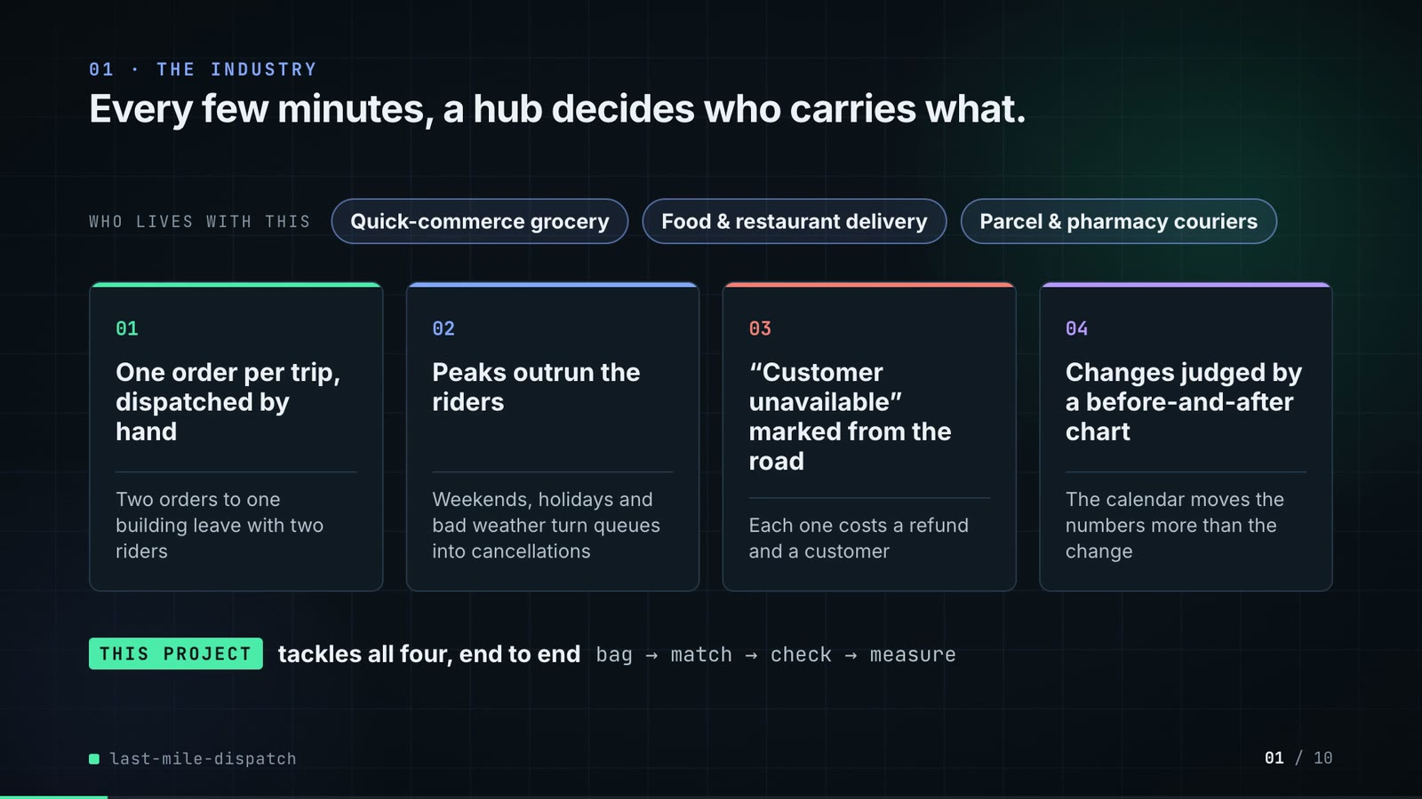
On-screen text (verbatim)
01 · THE INDUSTRY
Every few minutes, a hub decides who carries what.
WHO LIVES WITH THIS · Quick-commerce grocery · Food & restaurant delivery · Parcel & pharmacy couriers
01 One order per trip, dispatched by hand — Two orders to one building leave with two riders
02 Peaks outrun the riders — Weekends, holidays and bad weather turn queues into cancellations
03 “Customer unavailable” marked from the road — Each one costs a refund and a customer
04 Changes judged by a before-and-after chart — The calendar moves the numbers more than the change
THIS PROJECT tackles all four, end to end · bag → match → check → measure
Figures on this slide
ID | Shown | Source · key | Calculation | Check
F-01 | 3 industry chips | author's framing · - | - | manual
F-02 | 4 problem cards | README 'The problem', 'Insights and learning' · README text | - | ✓

Assumptions: A-13
Illustrative, not data:
• The whole slide is context; no repo figures.
To change this slide: Edit the chips (#ctx-c1..3) and cards (#ctx-k1..4) in compositions/s01-context.html.

Slide 02: This project
6.8-11.6 s · composition compositions/s02-hook.html (SERIES block injected by tools/inject_sheet.py)
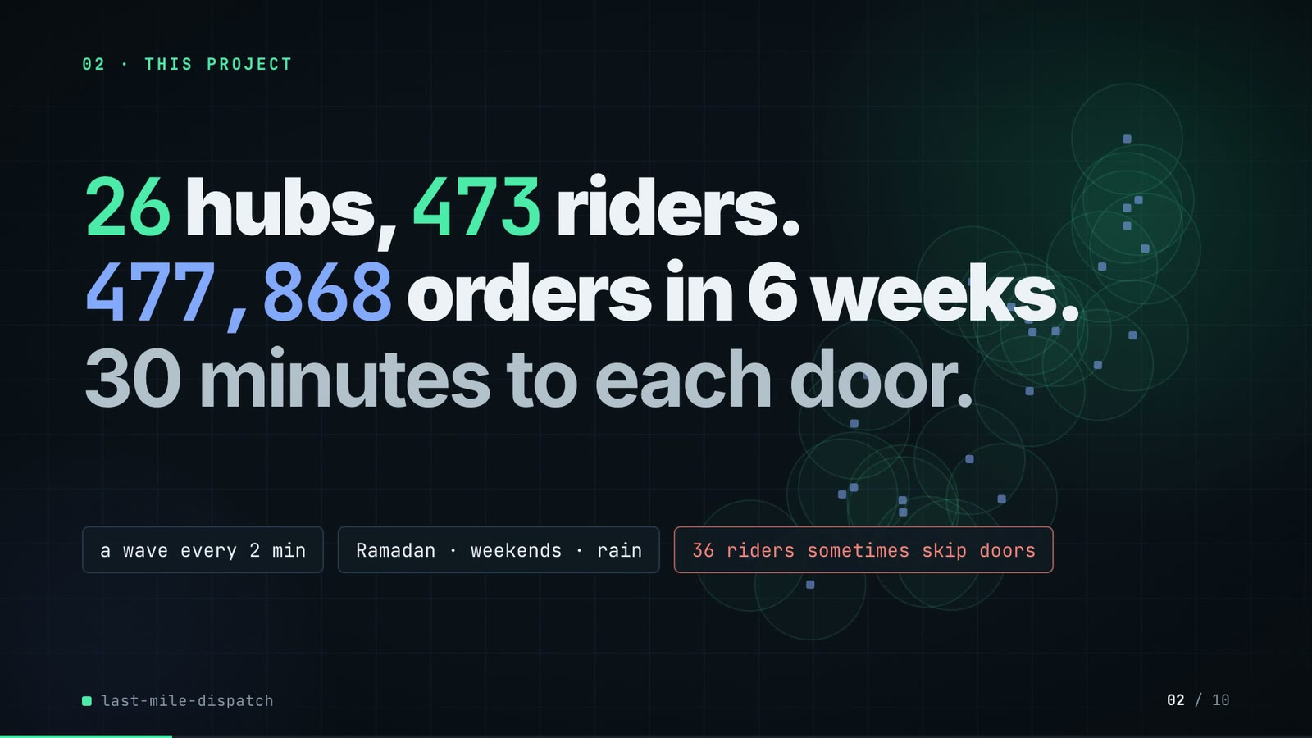
On-screen text (verbatim)
02 · THIS PROJECT
26 hubs, 473 riders. 477,868 orders in 6 weeks. 30 minutes to each door.
a wave every 2 min · Ramadan · weekends · rain · 36 riders sometimes skip doors
Figures on this slide
ID | Shown | Source · key | Calculation | Check
F-03 | 26 hubs | outputs/summary.json; data/hubs.csv · hubs; row count | - | ✓
F-04 | 473 riders | data/riders.csv · row count | - | ✓
F-05 | 477,868 orders | data/orders.csv.gz · row count | - | ✓
F-06 | 6 weeks / 42 days | data/days.csv · row count = 42 | 42 / 7 = 6 weeks | ✓
F-07 | 30 minutes to each door / 30-minute promise | src/last_mile_dispatch/config.py:27 · SLA_MIN = 30 | - | ✓
F-08 | a wave every 2 min / EVERY 2 MINUTES / dispatch wave 2 min | src/last_mile_dispatch/config.py:23 · WAVE_MIN = 2 | - | ✓
F-09 | Ramadan · weekends · rain | data/days.csv · ramadan, weekend, rain columns | any ramadan, any weekend, exactly one rain day | ✓
F-10 | 36 riders sometimes skip doors | data/riders.csv · remote_marker == True | count | ✓
F-11 | hub dots + circles | data/hubs.csv; config.py:12 (SERVICE_RADIUS_KM = 4.0) · lat/lon -> km from the centroid (demo assets/run_series.json) | - | ✓

Assumptions: A-01, A-07, A-08, A-10
Illustrative, not data:
• The background is the 26 real hub positions with a 4 km service circle each (decoration, low opacity).
To change this slide: Headline spans #hook-l1..l3 and chips #hook-f1..f3 in compositions/s02-hook.html; counts come from data/*.csv.

Slide 03: How it works (white chapter, slide A)
11.3-19.3 s · composition compositions/explainer.html (CONFIG.blocks, CONFIG.groups, CONFIG.loop)
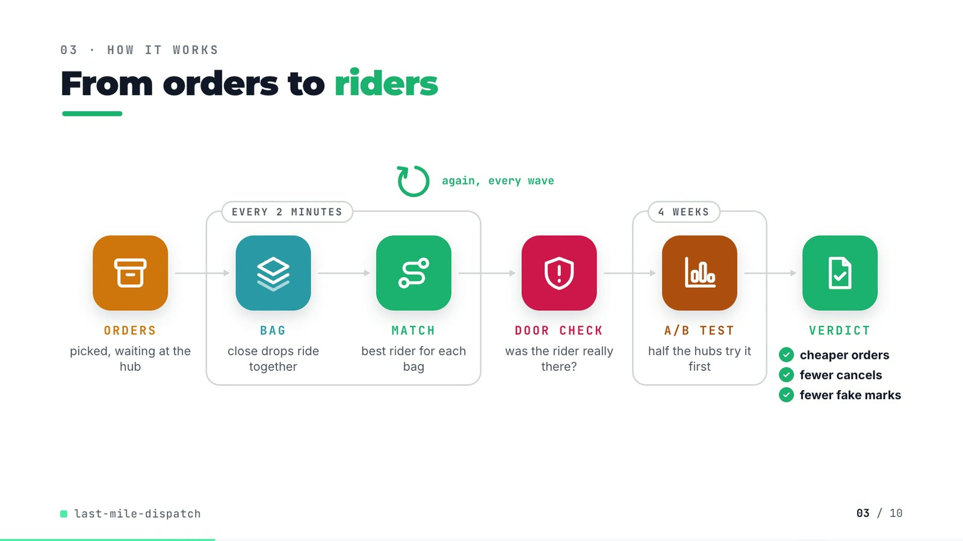
On-screen text (verbatim)
03 · HOW IT WORKS
From orders to riders
ORDERS picked, waiting at the hub → [EVERY 2 MINUTES: BAG close drops ride together → MATCH best rider for each bag] → DOOR CHECK was the rider really there? → [4 WEEKS: A/B TEST half the hubs try it first] → VERDICT ✓ cheaper orders ✓ fewer cancels ✓ fewer fake marks
again, every wave (loop over MATCH)
Figures on this slide
ID | Shown | Source · key | Calculation | Check
F-08 | a wave every 2 min / EVERY 2 MINUTES / dispatch wave 2 min | src/last_mile_dispatch/config.py:23 · WAVE_MIN = 2 | - | ✓
F-12 | ORDERS → BAG → MATCH → DOOR CHECK → A/B TEST → VERDICT | src/last_mile_dispatch/ · functions | - | ✓
F-13 | 4 WEEKS | outputs/summary.json · experiment_days = 28 | 28 / 7 = 4 | ✓
F-14 | cheaper orders / fewer cancels / fewer fake marks | outputs/ab_readout.csv · welch_hi for cost_per_delivered, cancel_rate, fake_accepted_per_1k | welch_hi < 0 for all three | ✓

Assumptions: A-05, A-06, A-08, A-09
Illustrative, not data:
• Icons and colours are a visual language, not data.
To change this slide: Edit CONFIG in compositions/explainer.html; badge truth comes from ab_readout.csv (F-14).

Slide 04: The key idea (white chapter, slide B)
19.3-26.3 s · composition compositions/explainer.html (#ex-b ...)
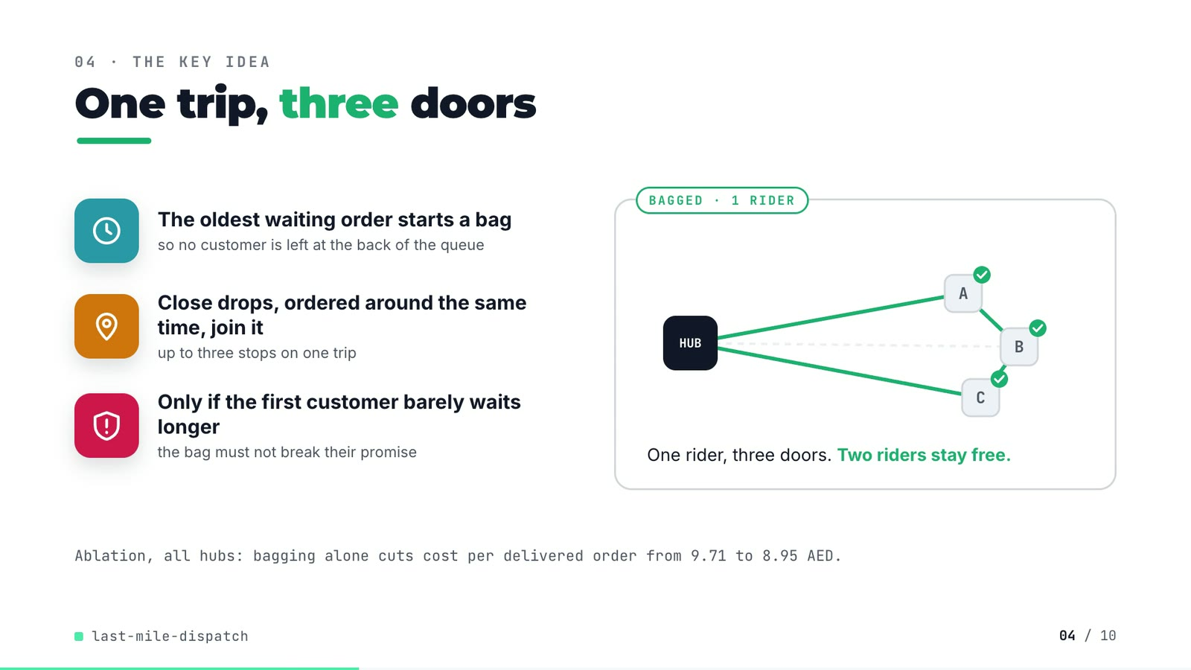
On-screen text (verbatim)
04 · THE KEY IDEA
One trip, three doors
The oldest waiting order starts a bag — so no customer is left at the back of the queue
Close drops, ordered around the same time, join it — up to three stops on one trip
Only if the first customer barely waits longer — the bag must not break their promise
ONE ORDER PER TRIP · 3 RIDERS → BAGGED · 1 RIDER (HUB, A, B, C). One rider, three doors. Two riders stay free.
Ablation, all hubs: bagging alone cuts cost per delivered order from 9.71 to 8.95 AED.
Figures on this slide
ID | Shown | Source · key | Calculation | Check
F-15 | 3 steps / ≤ 3 stops · 1 km | src/last_mile_dispatch/bagging.py:3-5, :51-87; config.py:37, :65-67 · BAG_CAPACITY = 3, BAG_MAX_DROP_GAP_KM = 1.0, BAG_MAX_CREATED_GAP_MIN = 12.0, BAG_MAX_EXTRA_MIN = 9.0 | - | ✓
F-16 | 9.71 | outputs/ablation.csv · policy=baseline, cost_per_delivered | - | ✓
F-17 | 8.95 AED | outputs/ablation.csv · policy=bagging, cost_per_delivered | - | ✓

Assumptions: A-02, A-05, A-12
Illustrative, not data:
• The HUB/A/B/C demo is schematic: it shows the rule in bagging.make_bags, not a real bag.
To change this slide: Markup under #ex-b in compositions/explainer.html; the footnote figures are F-16 and F-17.

Slide 05: Architecture
26.0-41.0 s · composition compositions/s03-architecture.html
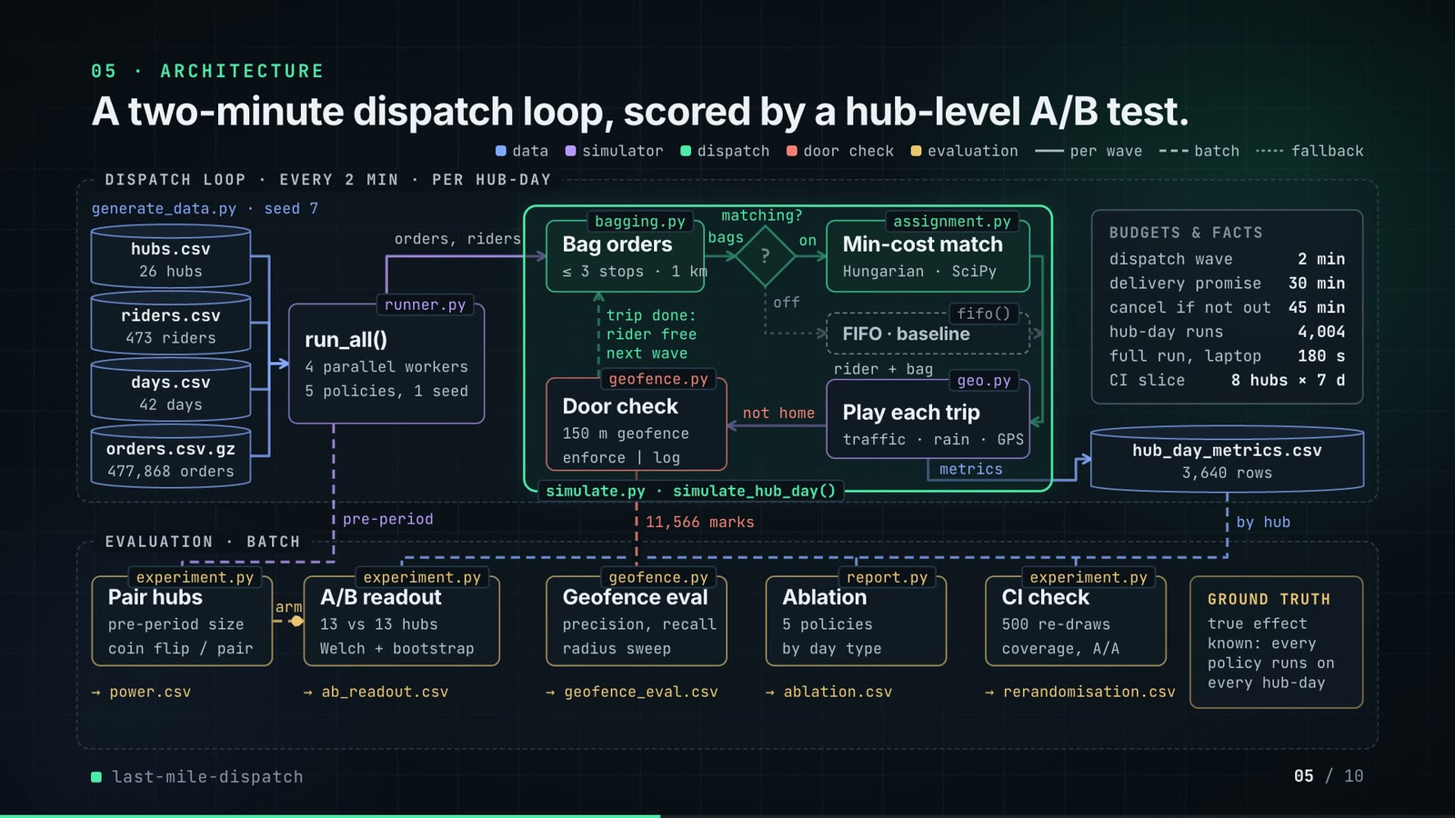
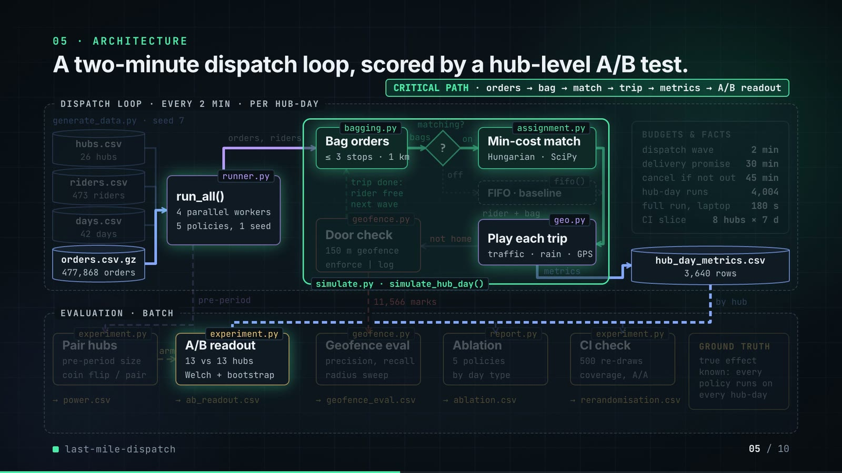
On-screen text (verbatim)
05 · ARCHITECTURE
A two-minute dispatch loop, scored by a hub-level A/B test.
Legend: data · simulator · dispatch · door check · evaluation · per wave (solid) · batch (dashed) · fallback (dotted)
DISPATCH LOOP · EVERY 2 MIN · PER HUB-DAY — generate_data.py · seed 7: hubs.csv 26 hubs, riders.csv 473 riders, days.csv 42 days, orders.csv.gz 477,868 orders
runner.py run_all(): 4 parallel workers, 5 policies, 1 seed → orders, riders →
simulate.py · simulate_hub_day(): bagging.py Bag orders (≤ 3 stops · 1 km) → bags → matching? → on → assignment.py Min-cost match (Hungarian · SciPy); off → fifo() FIFO · baseline → rider + bag → geo.py Play each trip (traffic · rain · GPS) → not home → geofence.py Door check (150 m geofence · enforce | log) → trip done: rider free, next wave
metrics → hub_day_metrics.csv 3,640 rows · BUDGETS & FACTS: dispatch wave 2 min, delivery promise 30 min, cancel if not out 45 min, hub-day runs 4,004, full run, laptop 180 s, CI slice 8 hubs × 7 d
EVALUATION · BATCH: experiment.py Pair hubs (pre-period size, coin flip / pair) → arm → experiment.py A/B readout (13 vs 13 hubs, Welch + bootstrap) → ab_readout.csv; geofence.py Geofence eval (precision, recall, radius sweep) ← 11,566 marks → geofence_eval.csv; report.py Ablation (5 policies, by day type) → ablation.csv; experiment.py CI check (500 re-draws, coverage, A/A) → rerandomisation.csv; → power.csv; GROUND TRUTH: true effect known: every policy runs on every hub-day
CRITICAL PATH · orders → bag → match → trip → metrics → A/B readout
Figures on this slide
ID | Shown | Source · key | Calculation | Check
F-03 | 26 hubs | outputs/summary.json; data/hubs.csv · hubs; row count | - | ✓
F-04 | 473 riders | data/riders.csv · row count | - | ✓
F-05 | 477,868 orders | data/orders.csv.gz · row count | - | ✓
F-06 | 6 weeks / 42 days | data/days.csv · row count = 42 | 42 / 7 = 6 weeks | ✓
F-08 | a wave every 2 min / EVERY 2 MINUTES / dispatch wave 2 min | src/last_mile_dispatch/config.py:23 · WAVE_MIN = 2 | - | ✓
F-15 | 3 steps / ≤ 3 stops · 1 km | src/last_mile_dispatch/bagging.py:3-5, :51-87; config.py:37, :65-67 · BAG_CAPACITY = 3, BAG_MAX_DROP_GAP_KM = 1.0, BAG_MAX_CREATED_GAP_MIN = 12.0, BAG_MAX_EXTRA_MIN = 9.0 | - | ✓
F-18 | generate_data.py, runner.py run_all(), simulate.py simulate_hub_day(), bagging.py, assignment.py (min_cost, fifo), geo.py, geofence.py, experiment.py, report.py | src/last_mile_dispatch/, scripts/ · defs | - | ✓
F-19 | power.csv, ab_readout.csv, geofence_eval.csv, ablation.csv, rerandomisation.csv, hub_day_metrics.csv | outputs/ · files | - | ✓
F-20 | 3,640 rows | outputs/hub_day_metrics.csv · row count | 26 x 28 x 5 | ✓
F-21 | 11,566 marks | outputs/geofence_eval.csv · slice=all, events | - | ✓
F-22 | hub-day runs 4,004 | outputs/run_log.txt line 2 · 'simulated 4,004 hub-day-policy runs' | 26 x 14 + 26 x 28 x 5 = 4,004 | ✓
F-23 | full run, laptop 180 s | outputs/summary.json · runtime_s = 179.8 | rounded to whole seconds | ✓
F-24 | cancel if not out 45 min | src/last_mile_dispatch/config.py:28 · CANCEL_AFTER_MIN = 45 | - | ✓
F-25 | 150 m geofence | src/last_mile_dispatch/config.py:79 · GEOFENCE_RADIUS_M = 150.0 | - | ✓
F-26 | 500 re-draws | outputs/rerandomisation.csv · draws | - | ✓
F-27 | 13 vs 13 hubs | outputs/summary.json · arms.treatment, arms.control | len of each list | ✓
F-28 | 4 parallel workers · 5 policies, 1 seed | src/last_mile_dispatch/cli.py:29; runner.py:36-41; config.py:62 · --workers default 4; same seed for every policy; ALL_POLICIES | - | ✓
F-29 | CI slice 8 hubs × 7 d | src/last_mile_dispatch/cli.py:38, :40; .github/workflows/ci.yml · hubs.head(8), experiment days head(7) | - | ✓
F-30 | generate_data.py · seed 7 | scripts/generate_data.py:168 · --seed default 7 | - | ✓

Assumptions: A-01, A-03, A-04, A-05, A-06, A-08, A-09
Illustrative, not data:
• Packets moving along the wires are decoration in execution order (the dispatch loop turns twice).
• 'per wave' (solid) vs 'batch' (dashed) marks what runs inside each 2-minute wave and what runs after all hub-days.
• The '?' diamond is the decision point Policy.matching (config.py); the dotted path is the FIFO fallback used by the baseline.
• The critical-path highlight is the chain that produces the headline A/B numbers.
To change this slide: Node boxes (#n-*), cylinders (CYL) and the W wires object in compositions/s03-architecture.html.

Slide 06: The system running
40.6-53.2 s · composition compositions/s04-routes.html (SERIES block injected by tools/inject_sheet.py from tools/export_series.py)
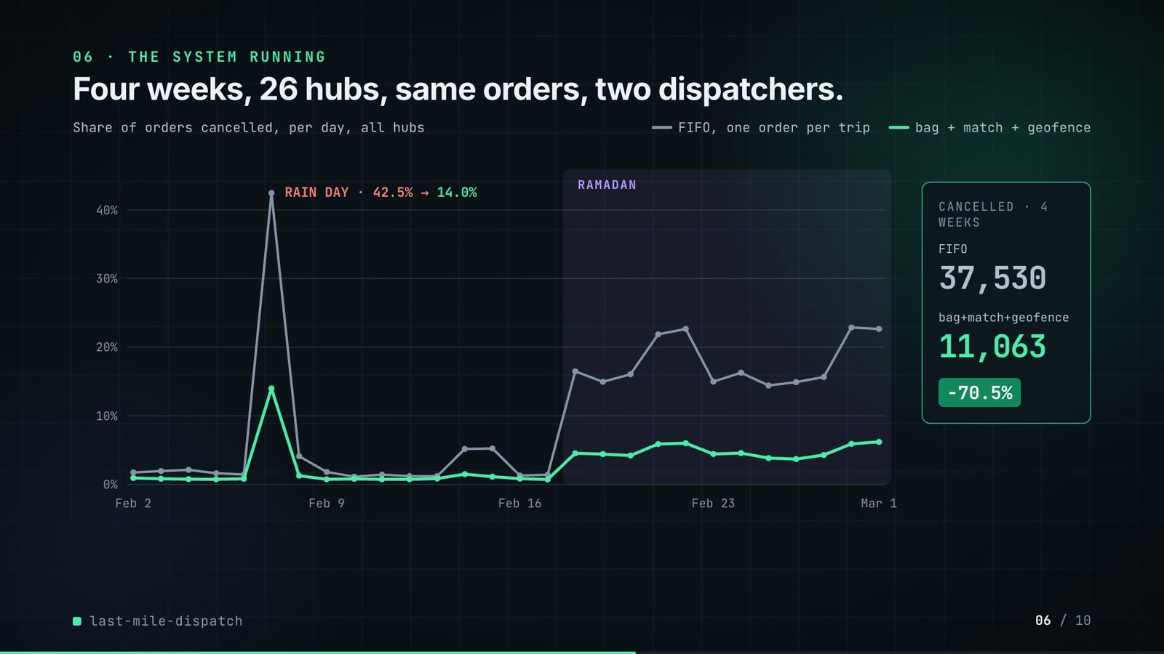
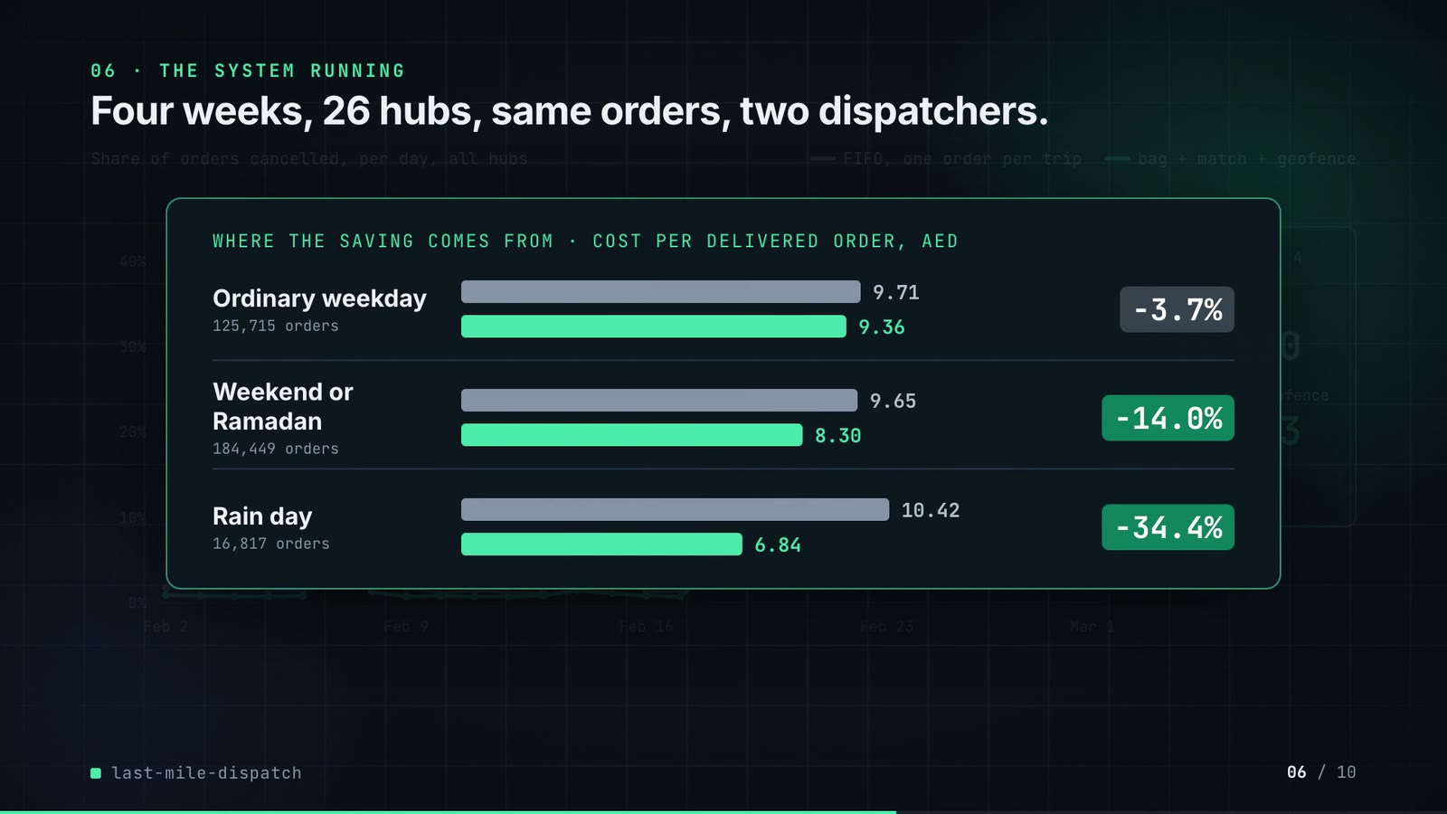
On-screen text (verbatim)
06 · THE SYSTEM RUNNING
Four weeks, 26 hubs, same orders, two dispatchers.
Share of orders cancelled, per day, all hubs · FIFO, one order per trip vs bag + match + geofence · RAMADAN band · RAIN DAY · 42.5% → 14.0%
CANCELLED · 4 WEEKS: FIFO 37,530 · bag+match+geofence 11,063 · −70.5%
WHERE THE SAVING COMES FROM · COST PER DELIVERED ORDER, AED: Ordinary weekday (125,715 orders) 9.71 → 9.36 −3.7% · Weekend or Ramadan (184,449 orders) 9.65 → 8.30 −14.0% · Rain day (16,817 orders) 10.42 → 6.84 −34.4%
Figures on this slide
ID | Shown | Source · key | Calculation | Check
F-31 | two lines, Feb 2 - Mar 1 | outputs/hub_day_metrics.csv · sum(cancelled) / sum(orders) by date and policy | injected SERIES block must equal the recomputation | ✓
F-32 | RAIN DAY · 42.5% → 14.0% | outputs/stress_split.csv · day_type=rain day, cancel_rate | x 100 | ✓
F-33 | 37,530 → 11,063 | outputs/hub_day_metrics.csv · sum(cancelled) by policy | - | ✓
F-34 | −70.5% | outputs/hub_day_metrics.csv · F-33 | (11,063 / 37,530 - 1) x 100 = -70.52% | ✓
F-35 | 125,715 orders · 9.71 → 9.36 · −3.7% | outputs/stress_split.csv · day_type=ordinary weekday | cost_treat / cost_base - 1 | ✓
F-36 | 184,449 orders · 9.65 → 8.30 · −14.0% | outputs/stress_split.csv · day_type=weekend or Ramadan | cost_treat / cost_base - 1 | ✓
F-37 | 16,817 orders · 10.42 → 6.84 · −34.4% | outputs/stress_split.csv · day_type=rain day | cost_treat / cost_base - 1 | ✓
F-38 | RAMADAN band from Feb 18 | data/days.csv · first date with ramadan = True | - | ✓

Assumptions: A-02, A-03, A-08, A-10
Illustrative, not data:
• Chart and bars are drawn from the injected numbers (no hand-typed data points); bars are to scale from zero.
To change this slide: Re-run tools/export_series.py and inject it (--name SERIES); layout in compositions/s04-routes.html.

Slide 07: End-user value (white)
52.9-65.9 s · composition compositions/value.html (SHEET block injected by tools/inject_sheet.py from tools/export_rider_board.py)
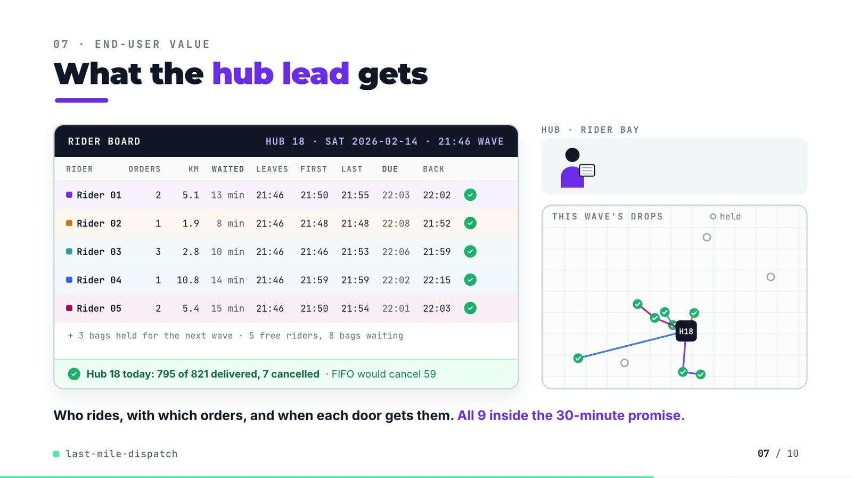
On-screen text (verbatim)
07 · END-USER VALUE
What the hub lead gets
RIDER BOARD · HUB 18 · SAT 2026-02-14 · 21:46 WAVE — columns RIDER, ORDERS, KM, WAITED, LEAVES, FIRST, LAST, DUE, BACK
Rider 01 2 5.1 13 min 21:46 21:50 21:55 22:03 22:02 ✓
Rider 02 1 1.9 8 min 21:46 21:48 21:48 22:08 21:52 ✓
Rider 03 3 2.8 10 min 21:46 21:46 21:53 22:06 21:59 ✓
Rider 04 1 10.8 14 min 21:46 21:59 21:59 22:02 22:15 ✓
Rider 05 2 5.4 15 min 21:46 21:50 21:54 22:01 22:03 ✓
+ 3 bags held for the next wave · 5 free riders, 8 bags waiting
✓ Hub 18 today: 795 of 821 delivered, 7 cancelled · FIFO would cancel 59
HUB · RIDER BAY · THIS WAVE'S DROPS · held
Who rides, with which orders, and when each door gets them. All 9 inside the 30-minute promise.
Figures on this slide
ID | Shown | Source · key | Calculation | Check
F-03 | 26 hubs | outputs/summary.json; data/hubs.csv · hubs; row count | - | ✓
F-07 | 30 minutes to each door / 30-minute promise | src/last_mile_dispatch/config.py:27 · SLA_MIN = 30 | - | ✓
F-39 | Rider 01-05 rows | demo assets/rider_board.json (re-run of the repo's simulator), injected into compositions/value.html · rows | km = sum of road legs; waited = wave time - oldest order's creation; due = earliest creation + 30 min | ✓
F-40 | 795 of 821 delivered, 7 cancelled · FIFO would cancel 59 | outputs/hub_day_metrics.csv · hub_id=18, date=2026-02-14, policy in {bagging+matching+geofence, baseline} | - | ✓
F-41 | + 3 bags held for the next wave · 5 free riders, 8 bags waiting | demo assets/rider_board.json · bags_held, free_riders, bags_waiting_before | held = bags waiting - riders matched | ✓
F-42 | All 9 inside the 30-minute promise. | demo assets/rider_board.json · orders_dispatched; stops[].on_time | every stop ETA - creation <= 30 min | ✓
F-43 | HUB 18 | outputs/summary.json · arms.treatment | - | ✓

Assumptions: A-03, A-04, A-05, A-08, A-11
Illustrative, not data:
• Rider 01-05 are placeholders (no real people); all five are on bikes.
• The hub-lead figure, rider bay, scooter drawings and driving speed are illustrative; drop positions and stop order are real, scaled to fit the panel (uniform scale).
• Grey circles are the drops of the 3 bags held for the next wave.
To change this slide: Re-run tools/export_rider_board.py (hub, date, wave arguments), then tools/inject_sheet.py --name SHEET; layout in compositions/value.html.

Slide 08: Results
65.6-74.4 s · composition compositions/s05-results.html (stats array)
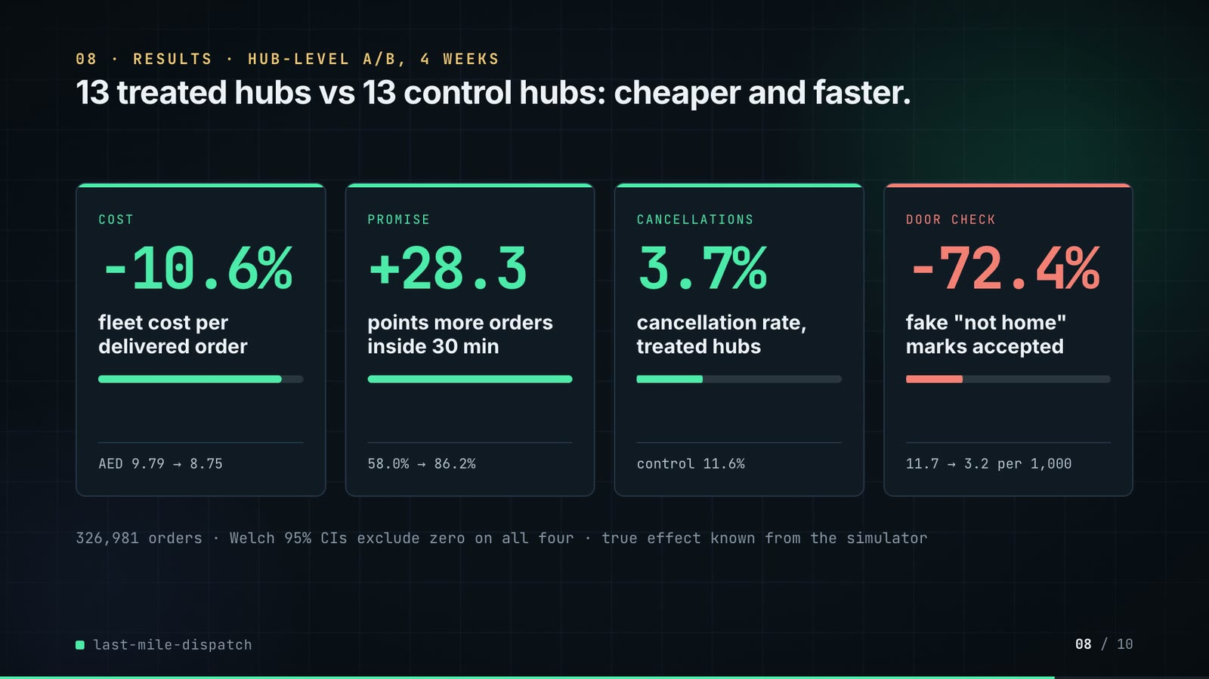
On-screen text (verbatim)
08 · RESULTS · HUB-LEVEL A/B, 4 WEEKS
13 treated hubs vs 13 control hubs: cheaper and faster.
COST −10.6% fleet cost per delivered order · AED 9.79 → 8.75
PROMISE +28.3 points more orders inside 30 min · 58.0% → 86.2%
CANCELLATIONS 3.7% cancellation rate, treated hubs · control 11.6%
DOOR CHECK −72.4% fake "not home" marks accepted · 11.7 → 3.2 per 1,000
326,981 orders · Welch 95% CIs exclude zero on all four · true effect known from the simulator
Figures on this slide
ID | Shown | Source · key | Calculation | Check
F-27 | 13 vs 13 hubs | outputs/summary.json · arms.treatment, arms.control | len of each list | ✓
F-44 | −10.6% | outputs/ab_readout.csv · metric=cost_per_delivered, rel_diff | x 100 | ✓
F-45 | AED 9.79 → 8.75 | outputs/ab_readout.csv · metric=cost_per_delivered, control, treatment | - | ✓
F-46 | +28.3 | outputs/ab_readout.csv · metric=on_time_share_of_orders, diff | x 100 | ✓
F-47 | 58.0% → 86.2% | outputs/ab_readout.csv · metric=on_time_share_of_orders, control, treatment | x 100 | ✓
F-48 | 3.7% · control 11.6% | outputs/ab_readout.csv · metric=cancel_rate, treatment, control | x 100 | ✓
F-49 | −72.4% | outputs/ab_readout.csv · metric=fake_accepted_per_1k, rel_diff | x 100 | ✓
F-50 | 11.7 → 3.2 per 1,000 | outputs/ab_readout.csv · metric=fake_accepted_per_1k, control, treatment | - | ✓
F-51 | 326,981 orders | outputs/summary.json · orders_in_experiment | - | ✓
F-52 | Welch 95% CIs exclude zero on all four | outputs/ab_readout.csv · welch_lo, welch_hi | lo > 0 or hi < 0 for cost, on-time, cancel, fake | ✓

Assumptions: A-02, A-03, A-04, A-06, A-09, A-12
Illustrative, not data:
• Mini bars under each number are drawn to the same ratio (treatment / control).
To change this slide: The stats array and card text in compositions/s05-results.html.

Slide 09: What didn't win
74.0-80.6 s · composition compositions/s06-twist.html
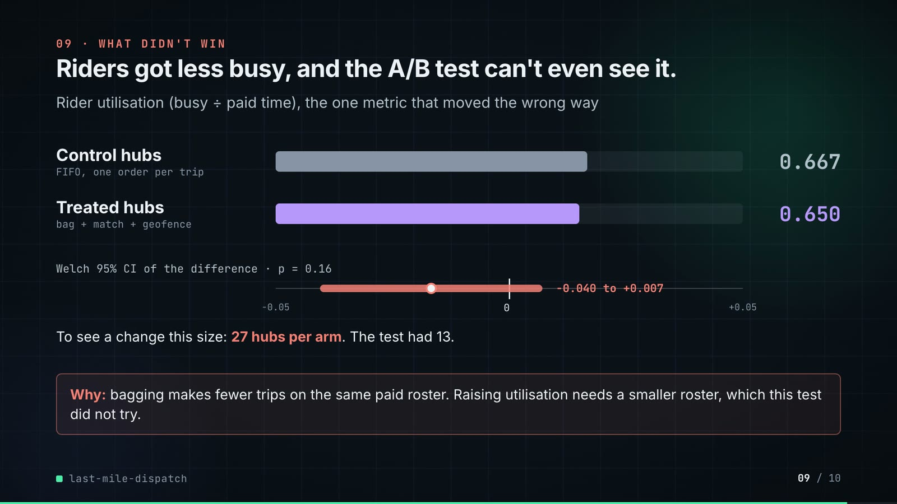
On-screen text (verbatim)
09 · WHAT DIDN'T WIN
Riders got less busy, and the A/B test can't even see it.
Rider utilisation (busy ÷ paid time), the one metric that moved the wrong way
Control hubs (FIFO, one order per trip) 0.667 · Treated hubs (bag + match + geofence) 0.650
Welch 95% CI of the difference · p = 0.16 · −0.040 to +0.007 (axis −0.05 … 0 … +0.05)
To see a change this size: 27 hubs per arm. The test had 13.
Why: bagging makes fewer trips on the same paid roster. Raising utilisation needs a smaller roster, which this test did not try.
Figures on this slide
ID | Shown | Source · key | Calculation | Check
F-27 | 13 vs 13 hubs | outputs/summary.json · arms.treatment, arms.control | len of each list | ✓
F-53 | 0.667 / 0.650 | outputs/ab_readout.csv · metric=utilization, control, treatment | - | ✓
F-54 | −0.040 to +0.007 | outputs/ab_readout.csv · metric=utilization, welch_lo, welch_hi | - | ✓
F-55 | p = 0.16 | outputs/ab_readout.csv · metric=utilization, welch_p | - | ✓
F-56 | 27 hubs per arm | outputs/power.csv · metric=utilization, hubs_per_arm_needed | - | ✓
F-57 | axis −0.05..+0.05 = 1,000 px; bar 95 → 571 px, estimate at 333 px | compositions/s06-twist.html; outputs/ab_readout.csv · welch_lo, welch_hi, diff | px = (v + 0.05) x 10,000 | ✓

Assumptions: A-02, A-09, A-12
Illustrative, not data:
• Utilisation bars: 1,000 px track = 1.0 (from zero).
To change this slide: Rows #twist-r1..r2 and the CI strip (#twist-ci) in compositions/s06-twist.html.

Slide 10: End card
80.2-84.6 s · composition compositions/s07-end.html

On-screen text (verbatim)
10 · OPEN SOURCE · MIT · RUNS ON A LAPTOP
last-mile-dispatch
github.com/kavya2693/last-mile-dispatch
SciPy · pandas · NumPy · Python
$ make run # 26 hubs, 4 weeks, ~3 min
Figures on this slide
ID | Shown | Source · key | Calculation | Check
F-11 | hub dots + circles | data/hubs.csv; config.py:12 (SERVICE_RADIUS_KM = 4.0) · lat/lon -> km from the centroid (demo assets/run_series.json) | - | ✓
F-58 | MIT | LICENSE line 1 · - | - | ✓
F-59 | ~3 min | outputs/summary.json · runtime_s = 179.8 | 179.8 / 60 = 3.0 min | ✓
F-60 | SciPy · pandas · NumPy · Python | pyproject.toml dependencies · numpy, pandas, scipy | - | ✓
F-61 | $ make run # 26 hubs, 4 weeks, ~3 min | Makefile; outputs/summary.json · run target; hubs; experiment_days | - | ✓

Assumptions: A-12
Illustrative, not data:
• Faded background: the 26 real hub positions with 4 km circles.
To change this slide: Text in compositions/s07-end.html.

5. Change-impact matrix
Input / assumption | Affected figures | Slides | Files to edit | Re-run
A-01: All data is synthetic, produced by a seeded generator sized to the production problem (26 hubs, 473 riders, 42 days, 477,868 orders) | all figures | 01, 02, 03, 04, 05, 06, 07, 08, 09, 10 | scripts/generate_data.py; src/last_mile_dispatch/config.py | make data; make run
A-02: The rider roster is fixed and sized for an ordinary weekday evening; every policy pays for the same riders | F-04, F-33, F-34, F-35, F-36, F-37, F-44, F-45, F-53, F-54, F-55, F-56 | 02, 05, 06, 08, 09 | scripts/generate_data.py:84-85 | make data; make run
A-03: Travel is straight-line distance x 1 | F-32, F-33, F-34, F-35, F-36, F-37, F-39, F-44, F-45, F-46, F-47 | 06, 07, 08 | src/last_mile_dispatch/config.py:13, :36; src/last_mile_dispatch/geo.py:29-41 | make run; export_rider_board.py + inject_sheet.py
A-04: Matching prices each rider-bag pair in AED: km cost of the vehicle, 1 | F-14, F-33, F-34, F-39, F-44, F-45, F-46, F-47, F-48 | 03, 06, 07, 08 | src/last_mile_dispatch/config.py:74-76 | make run; export_rider_board.py + inject_sheet.py
A-05: Bagging limits: drops within 1 km and created within 12 minutes of the seed order, at most 3 stops, and the first customer may wait at most 9 extra minutes | F-15, F-16, F-17, F-39, F-41 | 04, 05, 07 | src/last_mile_dispatch/config.py:37, :65-67 | make run; export_rider_board.py + inject_sheet.py
A-06: Geofence rule: a 'customer unavailable' mark is flagged when fewer than 2 of the rider's last 6 GPS pings are within 150 m of the customer; flagged riders are sent back to the door (treatment) or the flag is only logged (baseline) | F-21, F-25, F-49, F-50 | 05, 08 | src/last_mile_dispatch/config.py:79-80 | make run
A-07: Fake marks: about 8% of riders (36 of 473 in the data) mark 'customer unavailable' without reaching the door on 22% of their stops; fakes are known by construction and riders do not change habit when flagged | F-10, F-21, F-49, F-50 | 02, 05, 08 | src/last_mile_dispatch/config.py:40-41 | make data; make run
A-08: Service promise 30 minutes from order creation; a customer cancels if nothing has left the hub after 45 minutes; the dispatcher wakes every 2 minutes; 2 minutes handover per stop | F-07, F-08, F-24, F-32, F-33, F-34, F-42, F-46, F-47, F-48 | 02, 03, 05, 06, 07, 08 | src/last_mile_dispatch/config.py:23-29 | make run; export_rider_board.py + inject_sheet.py
A-09: Experiment design: hubs sorted by pre-period orders per day, paired, one coin flip per pair (seed 2026); one number per hub over four weeks; Welch t and hub-bootstrap 95% intervals; power from the pre-period between-hub spread | F-27, F-44, F-45, F-46, F-47, F-48, F-49, F-50, F-52, F-53, F-54, F-55, F-56, F-57 | 05, 08, 09 | src/last_mile_dispatch/cli.py:22; src/last_mile_dispatch/experiment.py | make run
A-10: Calendar: two pre-period weeks from 2026-01-19, then four experiment weeks 2026-02-02 to 2026-03-01; weekends are Saturday-Sunday; Ramadan from 2026-02-18; one rain day 2026-02-07 (35% more orders, 40% slower traffic) | F-06, F-09, F-13, F-31, F-32, F-35, F-36, F-37, F-38, F-40 | 02, 03, 05, 06, 07 | src/last_mile_dispatch/config.py:16-18; scripts/generate_data.py:35-36 | make data; make run
A-11: The rider board (slide 07) re-runs the repo's own simulator for hub 18 on 2026-02-14 under the treatment and records the 21:46 wave; drop ETAs replay the simulator's clock with geo | F-39, F-40, F-41, F-42 | 07 | docs/demo/source/tools/export_rider_board.py (hub, date, wave arguments) | export_rider_board.py + inject_sheet.py; hyperframes render
A-12: Video rounding: percentages to 1 decimal, AED to 2 decimals, utilisation and CI bounds to 3 decimals, counts with thousands separators; '~3 min' and '180 s' are rounded run times | F-16, F-17, F-23, F-32, F-34, F-35, F-36, F-37, F-44, F-45, F-46, F-47, F-48, F-49, F-50, F-53, F-54, F-55, F-59 | 04, 05, 06, 08, 09, 10 | the composition file named on each slide | hyperframes render
A-13: Slide 01 (industries, everyday problems) is general delivery-operations knowledge used as context | F-01, F-02 | 01 | compositions/s01-context.html | hyperframes render

6. Known differences and caveats
• Everything is simulated (A-01). The A/B readout is what an experimenter would see; the 'true effect' is known only because every policy ran on every hub-day with the same random draws.
• The cost saving is mostly cancellations turned into deliveries on a fixed, paid roster (A-02); slide 06 shows it is under 4% on an ordinary weekday and 34% on the rain day.
• Slide 07's ETAs are reconstructed with the repo's travel function for one wave; they equal the simulator's delivery times because the five riders are honest and all nine customers are home (asserted in export_rider_board.py).
• Slide 08 uses hub-level means (13 vs 13); the ablation numbers on slide 04 pool every hub and every day, so they differ slightly from the A/B means.
• '36 riders sometimes skip doors' is a generator setting (8% of riders, 22% of their stops), not an observed behaviour (A-07).
• Slide 01 statements are general industry knowledge (A-13).
• Rider names on slide 07 are placeholders.

Appendix: environment
Item | Value
Commit | c7de8a6ad78ef3961f773e55ae9af197085c3f9c
Python | 3.11.7
numpy | 2.4.6
pandas | 3.0.6
scipy | 1.17.1
Profile / seeds | data=7, hub_assignment=2026, rerandomisation=2027, simulator=hub_id * 10000 + day index (same for every policy)
Run time | summary.json runtime_s = 179.8 s (about 3 min) for make run with 4 workers on the author's laptop

