AUDIT REPORT

llm-cost-router: demo video audit report
A slide-by-slide record of every number, assumption and calculation in the demo video, with its source.
Item | Value
Repository | https://github.com/kavya2693/llm-cost-router
Numbers taken from commit | 2ec9b2fce927432c4f8445ad43a97a3a20d56942 (outputs last changed in 2ec9b2f (2026-10-14 12:38:13 +0400))
Video | docs/demo/demo.mp4 · 84.0 s · 1920x1080 · 30 fps · silent
Generated | 2026-10-14 14:15
Automated checks | 47 pass · 0 fail · 1 manual (of 48 figures)
Assumptions | 11 (A-01 to A-11)

How to use this report
Every number or claim on screen has an ID (F-01, F-02, ...) and every modelling assumption has an ID (A-01, ...). Cite the ID. Each figure lists its source file, the exact column, row or key, the formula for derived numbers, and an automated check result. The change-impact matrix (section 5) shows which slides and files change if an input or assumption changes.
Types: direct = read straight from a repo output; derived = computed from direct values (formula given); illustrative = drawing or example, not data; general knowledge = context not produced by the repo.

Regenerate
make run # data/*, outputs/results.json|md, per_case.csv (replays the response cache, under a second)
.venv/bin/python docs/demo/source/tools/export_routing_log.py docs/demo/source/assets/routing_log.json
python3 docs/demo/source/tools/inject_sheet.py docs/demo/source/assets/routing_log.json outputs/results.json docs/demo/source/compositions --rows ext-023,cla-021,sum-026,rea-040,rea-021,cla-035
cd docs/demo/source && npx --yes hyperframes@0.8.156 check && npx --yes hyperframes@0.8.156 render -f 30 -q looks -o renders/llm-cost-router-master.mp4 && cd -
ffmpeg -y -i docs/demo/source/renders/llm-cost-router-master.mp4 -c:v libx264 -preset slow -crf 25 -pix_fmt yuv420p -movflags +faststart -an docs/demo/demo.mp4
python3 docs/demo/source/tools/build_audit_report.py docs/demo/source/audit/facts.yaml # stills, checks, MD/DOCX/PDF

1. Figures
ID | Shown | Slides | Source | Column / row / key | How computed | Type | Check
F-01 | 3 industry chips | 01 | author's framing | - | - | general knowledge | manual: Context statement, not a repo output.
F-02 | 4 problem cards | 01 | README 'The problem', 'Why it is hard' | README lines 12-35 | - | general knowledge | ✓ verified
F-03 | 16.4M LLM requests a year / 16.4M / yr / 16.4M req | 02, 05, 08 | outputs/results.json | annual_requests (sum over 4 tasks = 16,394,979) | sum / 1e6, 1 decimal | derived | ✓ verified
F-04 | 4 tasks | 02, 05 | outputs/results.json | policy (one entry per task type) | count | direct | ✓ verified
F-05 | 3 self-hosted models / 3 models | 02, 05, 10 | outputs/results.json | model_seconds (one entry per model) | count | direct | ✓ verified
F-06 | 200 cases, known answers | 02, 05, 10 | data/eval_suite.jsonl | line count; every case has an 'answer' | count | direct | ✓ verified
F-07 | 3B $0.06 · 7B $0.20 per M tokens | 02, 05, 08 | src/llm_cost_router/config.py:35-37 | MODELS usd_per_m_* | - | direct | ✓ verified
F-08 | wrong small answers ship silently | 02 | outputs/results.json | splits.test['router, structural check only'].wrong_accepted_small = 27 | > 0 | derived | ✓ verified
F-09 | lower bill / mostly small / answers checked | 03 | outputs/results.json; src/llm_cost_router/router.py:61 | cost_per_1k_usd router < all-large; share_answered_small > 0.5; verify() runs on every small answer | - | derived | ✓ verified
F-10 | ≤ 2 calls / request; FALLBACK | 03, 05 | src/llm_cost_router/router.py:54-66; README 'Stop condition' | route(): one optional small call, one large call | - | direct | ✓ verified
F-11 | PO-51719 · Summit Auto Parts · LED-3580 · 20 · Sharjah · 2026-05-14; keep the 3B answer | 04, 07 | demo:assets/routing_log.json (export of the repo's Router) | id = ext-023: first_model, check_passed, escalated, output, input | - | direct | ✓ verified
F-12 | 6 confident wrong answers got through / 6 wrong answers passed above 0.9999 | 04, 09 | outputs/per_case.csv; demo:assets/routing_log.json | arm = router, tuned on dev; task = reasoning; escalated = False; correct = False | count = 6; every confidence > 0.9999 | derived | ✓ verified
F-13 | Worked for orders, tickets and summaries | 04, 09 | outputs/results.json | splits.test[arm].by_task[task].completion | router ≥ all-large for 3 tasks | derived | ✓ verified
F-14 | dev 80 · test 120 | 05 | data/eval_suite.jsonl | split | count per split | direct | ✓ verified
F-15 | 3 models × 200 | 05, 10 | outputs/responses/*.jsonl | line counts | 200 lines in each of 3 files | direct | ✓ verified
F-16 | ≈ 46 min CPU | 05 | outputs/results.json | model_seconds (796.1 + 706.2 + 1240.3 s) | sum / 60 = 45.8 min, rounded | derived | ✓ verified
F-17 | 365 days | 05 | data/traffic_daily.csv | row count | - | direct | ✓ verified
F-18 | data.py, eval_suite.jsonl, evaluate.py calibrate(), outputs/responses/, data/, prompts.py, router.py Router.route(), Ollama (client.py), verifiers.py verify(), grading.py, summarise(), paired_bootstrap(), outputs/results.json, per_case.csv | 05 | src/llm_cost_router/*.py; data/; outputs/ | file / def | - | direct | ✓ verified
F-19 | policy table in Router.route() | 05 | outputs/results.json | policy[task].first, policy[task].threshold | - | direct | ✓ verified
F-20 | schema / grounded in input / confidence ≥ τ | 05 | src/llm_cost_router/verifiers.py:59-149; router.py:62 | verify_* functions; verdict.confidence >= policy.threshold | - | direct | ✓ verified
F-21 | 3B kept 91% / 91% of requests / 91% | 05, 06, 08 | outputs/results.json | splits.test['router, tuned on dev'].share_answered_small = 0.9083 | x 100, whole number | direct | ✓ verified
F-22 | p50 3.6 s · p95 20.4 s | 05 | outputs/results.json | splits.test['router, tuned on dev'].p50_latency_s, p95_latency_s | 1 decimal | direct | ✓ verified
F-23 | vs 5.8 s for all-7B | 05 | outputs/results.json | splits.test['all-large qwen2.5-coder:7b'].p50_latency_s | 1 decimal | direct | ✓ verified
F-24 | 6 arms · 120 | 05 | outputs/results.json | splits.test arms with a completion | count | direct | ✓ verified
F-25 | make run < 1 s / replays … in under a second | 05, 10 | outputs/run_log.txt:85 | 'make run ... 0.469 total' | total < 1 s | direct | ✓ verified
F-26 | 95% CI · 4,000 | 05 | src/llm_cost_router/evaluate.py:136 | reps: int = 4000 | - | direct | ✓ verified
F-27 | per task, the cheapest ≥ 7B | 05 | src/llm_cost_router/evaluate.py:105-122 | options below large completion are skipped; key = (cost, -completion, threshold) | - | direct | ✓ verified
F-28 | 120 held-out requests | 06, 07 | outputs/results.json | splits.test['router, tuned on dev'].n | - | direct | ✓ verified
F-29 | 109 / 109 answered by 3B / 109 of 120 requests | 06, 07, 08 | outputs/per_case.csv | arm = router, tuned on dev; escalated = False | count | direct | ✓ verified
F-30 | 11 / 11 escalated | 06, 07 | outputs/per_case.csv | arm = router, tuned on dev; escalated = True | count | direct | ✓ verified
F-31 | $0.0176 | 06, 07, 08 | outputs/results.json | splits.test['router, tuned on dev'].cost_per_1k_usd = 0.0175998 | 4 decimals | direct | ✓ verified
F-32 | $0.0452 | 06, 07, 08 | outputs/results.json | splits.test['all-large qwen2.5-coder:7b'].cost_per_1k_usd = 0.045235 | 4 decimals | direct | ✓ verified
F-33 | 82.5% | 06, 08 | outputs/results.json | splits.test['router, tuned on dev'].completion = 0.825 | x 100, 1 decimal | direct | ✓ verified
F-34 | 85.0% | 06, 08 | outputs/results.json | splits.test['all-large qwen2.5-coder:7b'].completion = 0.85 | x 100, 1 decimal | direct | ✓ verified
F-35 | 120-cell grid | 06 | outputs/per_case.csv; demo:compositions/s04-routes.html (GRID block) | arm = router, tuned on dev: task, escalated, correct | cell-by-cell equality | direct | ✓ verified
F-36 | failed the confidence bar | 06 | demo:assets/routing_log.json (export of the repo's Router) | escalated rows: check_passed, confidence < threshold | - | derived | ✓ verified
F-37 | all qwen 3B 75.8% · all llama3.2 80.0% · all 7B 85.0% · $0.0452 · router, checks only 77.5% · router, tuned 82.5% · $0.0176 · perfect verifier 91.7% · $0.0178 | 06 | outputs/results.json; demo:compositions/s04-routes.html (GRID.arms) | splits.test[arm].completion, cost_per_1k_usd | 1 decimal %, 4 decimals $ | direct | ✓ verified
F-38 | 61% cheaper / About 61% cheaper / −61% | 06, 07, 08 | outputs/results.json | cost_per_1k_usd: router 0.0175998, all-large 0.045235 | (router / all-large − 1) x 100 = −61.1% | derived | ✓ verified
F-39 | 2.5 points less complete | 06, 08 | outputs/results.json | completion: router 0.825, all-large 0.85 | (0.85 − 0.825) x 100 = 2.5 | derived | ✓ verified
F-40 | 6 ledger rows | 07 | demo:assets/routing_log.json; outputs/per_case.csv; demo:compositions/value.html (SHEET block) | per case: first_model, check_passed, confidence, escalated, output, cost_usd | $ per 1k = cost_usd x 1000, 3 decimals | direct | ✓ verified
F-41 | + 114 more requests in the ledger | 07 | outputs/results.json | n = 120 minus the 6 rows shown | 120 − 6 | derived | ✓ verified
F-42 | CI [−7.5, +2.5] pts | 08 | outputs/results.json | splits.test.router_minus_large_ci95 = [-0.075, 0.025] | x 100, 1 decimal | direct | ✓ verified
F-43 | $247 / all-7B $779 | 08 | outputs/results.json | splits.test[arm].projected_annual_cost_usd: 246.65, 778.78 | whole dollars | direct | ✓ verified
F-44 | 93 / 93 · 87 / 87 · 87 / 83 · 63 / 77 | 09 | outputs/results.json | splits.test[arm].by_task[task].completion | x 100, whole numbers | direct | ✓ verified
F-45 | 38 × 168 = 6264 (true 6384) | 09 | outputs/responses/qwen2.5-coder_3b.jsonl; demo:assets/routing_log.json | case rea-028 | 38 x 168 = 6384; 6384 + 45 = 6429 | direct | ✓ verified
F-46 | confidence is read at the ANSWER line | 09 | src/llm_cost_router/verifiers.py:115-127 (answer_confidence) | lowest token probability among the digits after the final ANSWER marker | - | direct | ✓ verified
F-47 | OPEN SOURCE · MIT · NO GPU, NO API KEY | 10 | LICENSE; README 'Running it', 'Inference time' | MIT License; 'need no model server or key'; CPU inference | - | direct | ✓ verified
F-48 | Ollama · Qwen2.5-Coder · Llama 3.2 · Python | 10 | src/llm_cost_router/client.py; config.py; pyproject.toml | Ollama client; model ids; python | - | direct | ✓ verified

2. Automated check run (2026-10-14 14:15)
ID | Expected on slide | Recomputed from repo | Result
F-01 | 3 industry chips | - | manual
F-02 | true | true | ✓ pass
F-03 | 16.4M | 16.4M | ✓ pass
F-04 | 4 | 4 | ✓ pass
F-05 | 3 | 3 | ✓ pass
F-06 | 200 | 200 | ✓ pass
F-07 | true | true | ✓ pass
F-08 | true | true | ✓ pass
F-09 | true | true | ✓ pass
F-10 | true | true | ✓ pass
F-11 | true | true | ✓ pass
F-12 | 6 | 6 | ✓ pass
F-13 | true | true | ✓ pass
F-14 | dev 80 · test 120 | dev 80 · test 120 | ✓ pass
F-15 | true | true | ✓ pass
F-16 | 46 | 46 | ✓ pass
F-17 | 365 | 365 | ✓ pass
F-18 | true | true | ✓ pass
F-19 | true | true | ✓ pass
F-20 | true | true | ✓ pass
F-21 | 91% | 91% | ✓ pass
F-22 | p50 3.6 s · p95 20.4 s | p50 3.6 s · p95 20.4 s | ✓ pass
F-23 | 5.8 s | 5.8 s | ✓ pass
F-24 | 6 | 6 | ✓ pass
F-25 | true | true | ✓ pass
F-26 | true | true | ✓ pass
F-27 | true | true | ✓ pass
F-28 | 120 | 120 | ✓ pass
F-29 | 109 | 109 | ✓ pass
F-30 | 11 | 11 | ✓ pass
F-31 | $0.0176 | $0.0176 | ✓ pass
F-32 | $0.0452 | $0.0452 | ✓ pass
F-33 | 82.5% | 82.5% | ✓ pass
F-34 | 85.0% | 85.0% | ✓ pass
F-35 | true | true | ✓ pass
F-36 | true | true | ✓ pass
F-37 | true | true | ✓ pass
F-38 | -61% | -61% | ✓ pass
F-39 | 2.5 | 2.5 | ✓ pass
F-40 | true | true | ✓ pass
F-41 | 114 | 114 | ✓ pass
F-42 | [-7.5, +2.5] | [-7.5, +2.5] | ✓ pass
F-43 | $247 / $779 | $247 / $779 | ✓ pass
F-44 | 93 / 93 · 87 / 87 · 87 / 83 · 63 / 77 | 93 / 93 · 87 / 87 · 87 / 83 · 63 / 77 | ✓ pass
F-45 | true | true | ✓ pass
F-46 | true | true | ✓ pass
F-47 | true | true | ✓ pass
F-48 | true | true | ✓ pass

3. Assumptions register
ID | Assumption | Source | Figures affected | Slides affected
A-01 | All data is synthetic, produced by a seeded generator sized to the production problem: 200 evaluation cases (50 per task type, half easy, half hard) and 365 days of request volume per task type. The production data is proprietary. | src/llm_cost_router/config.py:15 (SEED = 20261013); src/llm_cost_router/data.py:390-470; README 'The data' | all figures | slides 01, 02, 03, 04, 05, 06, 07, 08, 09, 10
A-02 | Prices are an assumption, not a quote: $0.06 per million tokens for the 3B models and $0.20 for the 7B model. The saving is driven by the 3.3x ratio between tiers. | src/llm_cost_router/config.py:34-37 (MODELS); README 'Known limitations' | F-07, F-09, F-31, F-32, F-37, F-38, F-40, F-43 | slides 02, 03, 05, 06, 07, 08
A-03 | Latency is the measured CPU inference time per request on an M1 Pro laptop shared with other jobs (model load time excluded); an escalated request waits for the small call and then the large one. | src/llm_cost_router/client.py:79; src/llm_cost_router/router.py:43-46; README lines 53-54 and 'Known limitations' | F-16, F-22, F-23 | slides 05
A-04 | The routing policy is tuned on the dev split only (20 cases per task type): per task, the cheapest {first small model, confidence threshold} whose dev completion is at least the 7B model's. Every headline number is on the 120 held-out cases. | src/llm_cost_router/evaluate.py:102-134 (calibrate); src/llm_cost_router/data.py:402 (split) | F-12, F-13, F-14, F-19, F-21, F-27, F-28, F-29, F-30, F-31, F-33, F-35, F-36, F-37, F-38, F-39, F-40, F-42, F-44 | slides 04, 05, 06, 07, 08, 09
A-05 | Ground truth comes from the generator (answers fixed before the text is written); grading.py is the answer key the router never sees. A summary must stay under 40 words and use only numbers from the report. | src/llm_cost_router/grading.py:1-13; src/llm_cost_router/verifiers.py:99-112 | F-08, F-12, F-13, F-33, F-34, F-35, F-37, F-39, F-42, F-44, F-45 | slides 02, 04, 06, 08, 09
A-06 | Models run at temperature 0 with seed 7, but multi-threaded CPU inference is not bit-for-bit deterministic; the committed response cache (outputs/responses/*.jsonl) is what makes every number reproducible. | src/llm_cost_router/client.py:50; README 'Known limitations' | all figures | slides 01, 02, 03, 04, 05, 06, 07, 08, 09, 10
A-07 | Annual volume is the sum of the 365-day traffic log, with logging gaps filled by the mean of the same weekday within 28 days; the projected bill multiplies each task's cost per 1k requests by its volume. | src/llm_cost_router/evaluate.py:146-166 (annual_volume, projected_annual_cost); data.py:428 (base_daily = 38,000) | F-03, F-17, F-43 | slides 02, 05, 08
A-08 | The completion interval is a paired bootstrap over the same 120 cases, 4,000 resamples, seed 0. | src/llm_cost_router/evaluate.py:136-142 | F-26, F-42 | slides 05, 08
A-09 | Output caps per task (160, 8, 90, 220 tokens) keep a full collection run under an hour on CPU; a truncated reasoning answer fails its check. | src/llm_cost_router/config.py:44 (MAX_TOKENS); verifiers.py:134-137 | F-16 | slides 05
A-10 | Video rounding: percentages to whole numbers or 1 decimal, dollars per 1k to 4 decimals, per-request costs as $ per 1k to 3 decimals, the yearly bill to whole dollars, 16.4M to 1 decimal, 45.8 min shown as '≈ 46 min'. | this audit (display convention) | F-03, F-16, F-21, F-22, F-23, F-31, F-32, F-33, F-34, F-37, F-38, F-39, F-40, F-43, F-44 | slides 02, 05, 06, 07, 08, 09
A-11 | Slide 01 (industry, everyday problems) is general knowledge about running LLMs in operations, used as context. It is not a result of this repo and carries no numbers. | author's framing; README 'The problem' and 'Why it is hard' support all four problems | F-01, F-02 | slides 01

4. Slide by slide

Slide 01: The industry
0.0-7.2 s · composition compositions/s01-context.html
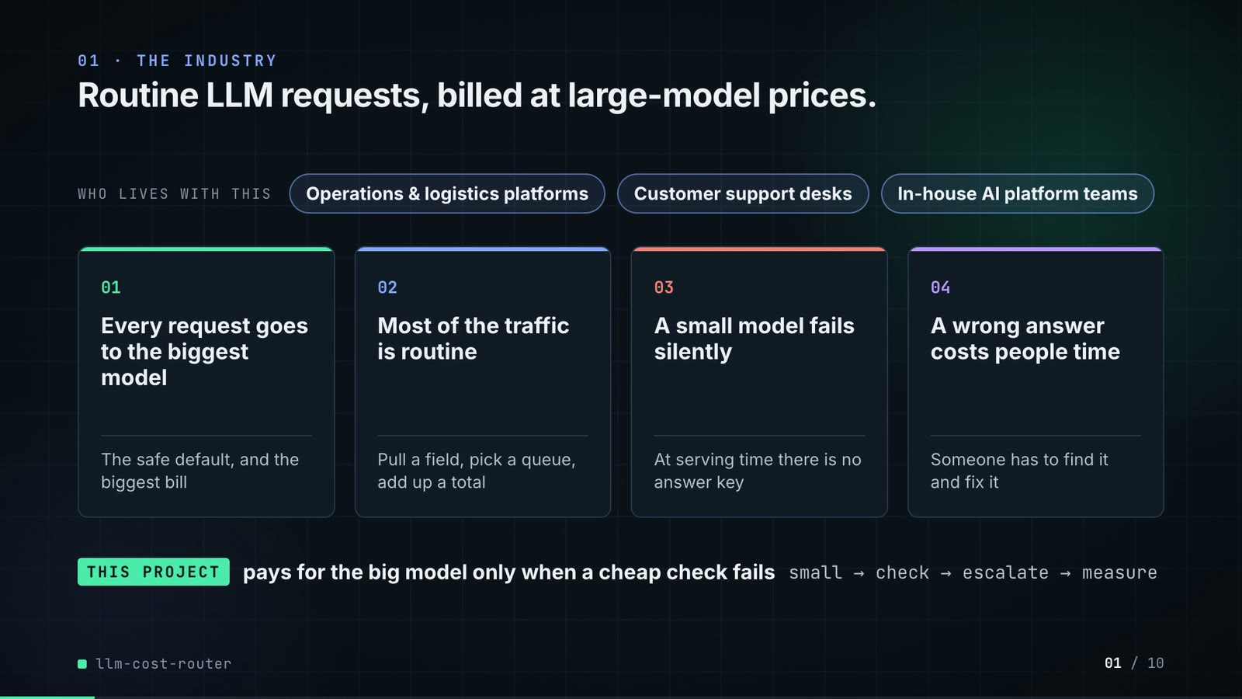
On-screen text (verbatim)
01 · THE INDUSTRY
Routine LLM requests, billed at large-model prices.
WHO LIVES WITH THIS · Operations & logistics platforms · Customer support desks · In-house AI platform teams
01 Every request goes to the biggest model — The safe default, and the biggest bill
02 Most of the traffic is routine — Pull a field, pick a queue, add up a total
03 A small model fails silently — At serving time there is no answer key
04 A wrong answer costs people time — Someone has to find it and fix it
THIS PROJECT pays for the big model only when a cheap check fails · small → check → escalate → measure
Figures on this slide
ID | Shown | Source · key | Calculation | Check
F-01 | 3 industry chips | author's framing · - | - | manual
F-02 | 4 problem cards | README 'The problem', 'Why it is hard' · README lines 12-35 | - | ✓

Assumptions: A-11
Illustrative, not data:
• The whole slide is context; no repo figures.
To change this slide: Edit the chips (#ctx-c1..3) and cards (#ctx-k1..4) in compositions/s01-context.html.

Slide 02: This project
6.8-11.6 s · composition compositions/s02-hook.html
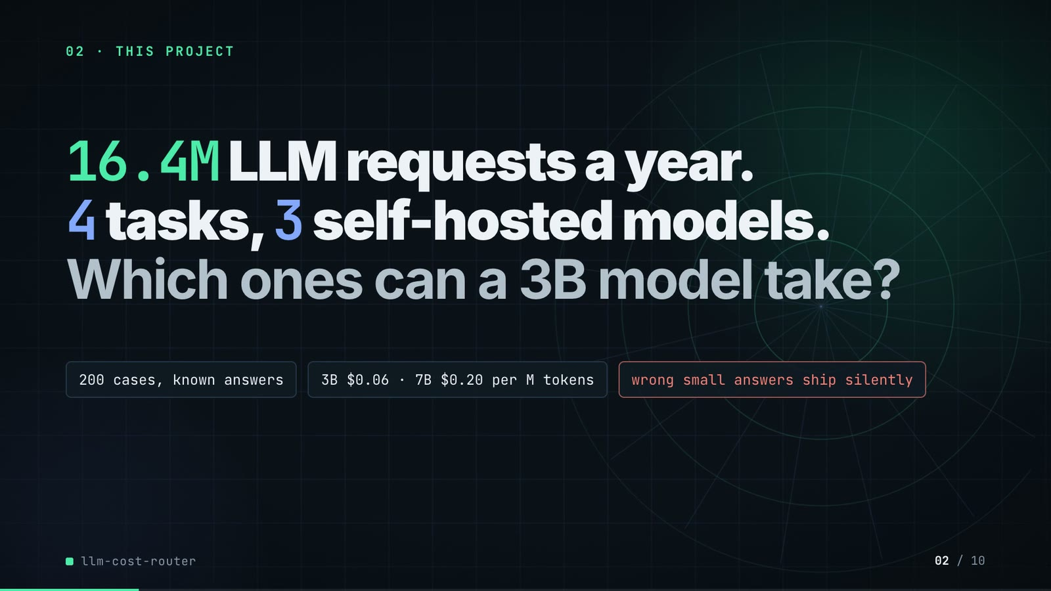
On-screen text (verbatim)
02 · THIS PROJECT
16.4M LLM requests a year. 4 tasks, 3 self-hosted models. Which ones can a 3B model take?
200 cases, known answers · 3B $0.06 · 7B $0.20 per M tokens · wrong small answers ship silently
Figures on this slide
ID | Shown | Source · key | Calculation | Check
F-03 | 16.4M LLM requests a year / 16.4M / yr / 16.4M req | outputs/results.json · annual_requests (sum over 4 tasks = 16,394,979) | sum / 1e6, 1 decimal | ✓
F-04 | 4 tasks | outputs/results.json · policy (one entry per task type) | count | ✓
F-05 | 3 self-hosted models / 3 models | outputs/results.json · model_seconds (one entry per model) | count | ✓
F-06 | 200 cases, known answers | data/eval_suite.jsonl · line count; every case has an 'answer' | count | ✓
F-07 | 3B $0.06 · 7B $0.20 per M tokens | src/llm_cost_router/config.py:35-37 · MODELS usd_per_m_* | - | ✓
F-08 | wrong small answers ship silently | outputs/results.json · splits.test['router, structural check only'].wrong_accepted_small = 27 | > 0 | ✓

Assumptions: A-01, A-02, A-07
Illustrative, not data:
• Rings in the background are decoration.
To change this slide: Headline spans #hook-l1..l3 and chips #hook-f1..f3 in compositions/s02-hook.html.

Slide 03: How it works (white chapter, slide A)
11.3-19.3 s · composition compositions/explainer.html (CONFIG.blocks, CONFIG.groups)
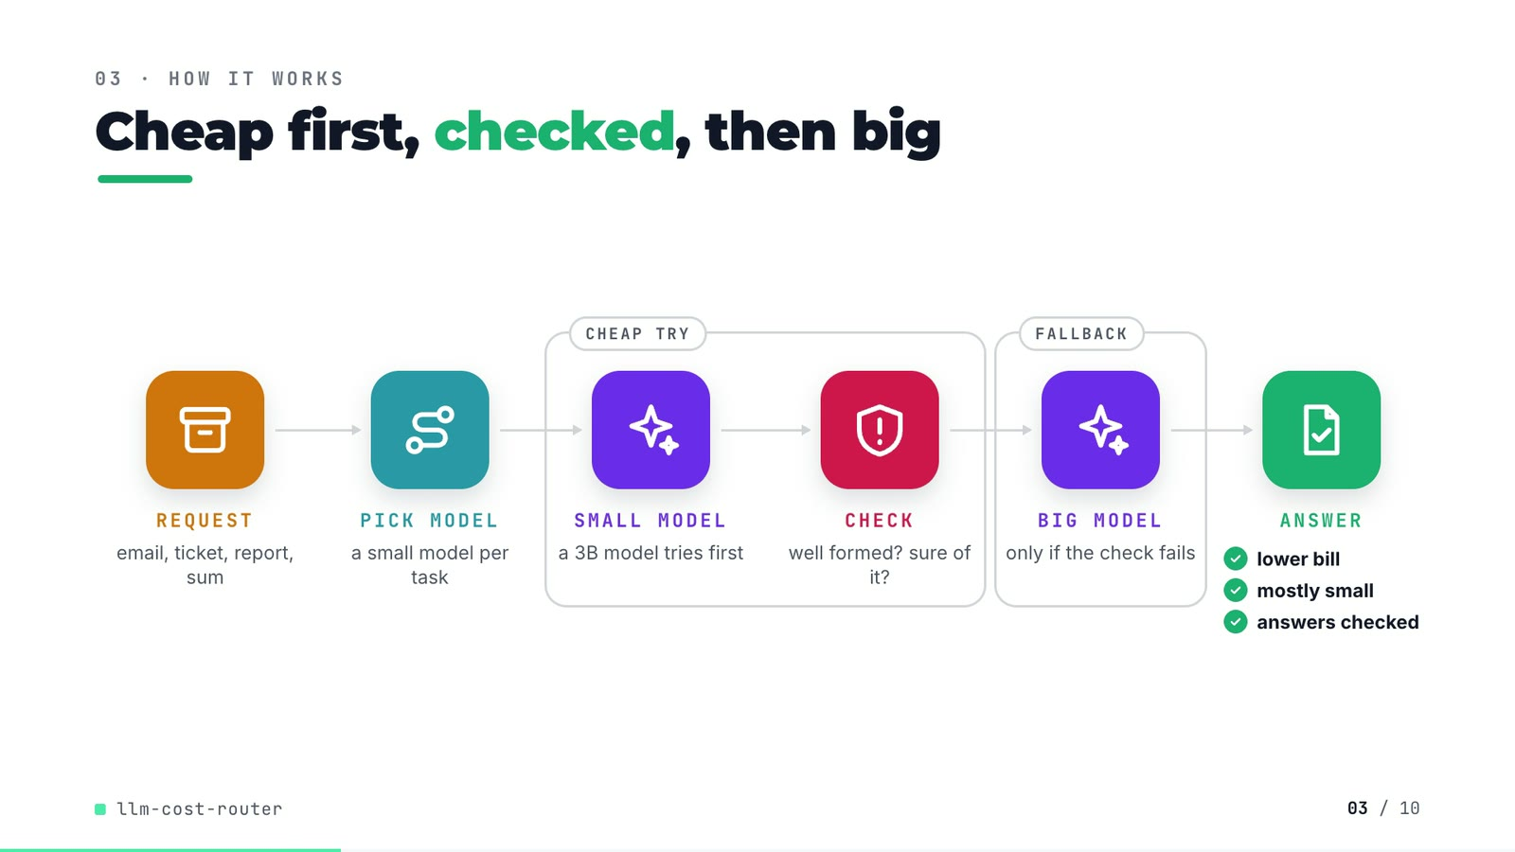
On-screen text (verbatim)
03 · HOW IT WORKS
Cheap first, checked, then big
REQUEST email, ticket, report, sum → PICK MODEL a small model per task → [CHEAP TRY: SMALL MODEL a 3B model tries first → CHECK well formed? sure of it?] → [FALLBACK: BIG MODEL only if the check fails] → ANSWER ✓ lower bill ✓ mostly small ✓ answers checked
Figures on this slide
ID | Shown | Source · key | Calculation | Check
F-09 | lower bill / mostly small / answers checked | outputs/results.json; src/llm_cost_router/router.py:61 · cost_per_1k_usd router < all-large; share_answered_small > 0.5; verify() runs on every small answer | - | ✓
F-10 | ≤ 2 calls / request; FALLBACK | src/llm_cost_router/router.py:54-66; README 'Stop condition' · route(): one optional small call, one large call | - | ✓

Assumptions: A-02, A-04
Illustrative, not data:
• Icons and colours are a visual language, not data.
To change this slide: Edit CONFIG in compositions/explainer.html; badge truth is F-09.

Slide 04: The key idea (white chapter, slide B)
19.3-26.3 s · composition compositions/explainer.html (#ex-b)
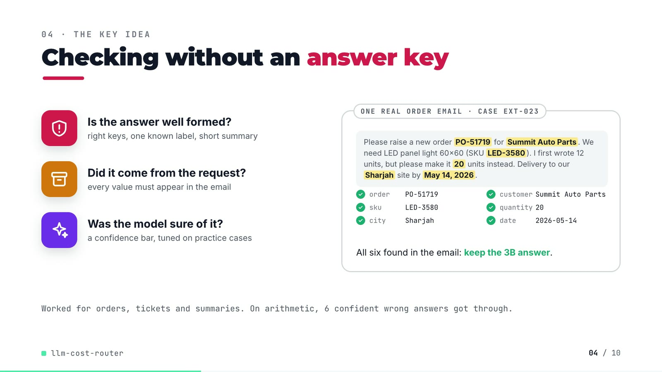
On-screen text (verbatim)
04 · THE KEY IDEA
Checking without an answer key
Is the answer well formed? — right keys, one known label, short summary
Did it come from the request? — every value must appear in the email
Was the model sure of it? — a confidence bar, tuned on practice cases
ONE REAL ORDER EMAIL · CASE EXT-023: 'Please raise a new order PO-51719 for Summit Auto Parts. We need LED panel light 60x60 (SKU LED-3580). I first wrote 12 units, but please make it 20 units instead. Delivery to our Sharjah site by May 14, 2026.' → order PO-51719 ✓ customer Summit Auto Parts ✓ sku LED-3580 ✓ quantity 20 ✓ city Sharjah ✓ date 2026-05-14 ✓ · All six found in the email: keep the 3B answer.
Worked for orders, tickets and summaries. On arithmetic, 6 confident wrong answers got through.
Figures on this slide
ID | Shown | Source · key | Calculation | Check
F-11 | PO-51719 · Summit Auto Parts · LED-3580 · 20 · Sharjah · 2026-05-14; keep the 3B answer | demo:assets/routing_log.json (export of the repo's Router) · id = ext-023: first_model, check_passed, escalated, output, input | - | ✓
F-12 | 6 confident wrong answers got through / 6 wrong answers passed above 0.9999 | outputs/per_case.csv; demo:assets/routing_log.json · arm = router, tuned on dev; task = reasoning; escalated = False; correct = False | count = 6; every confidence > 0.9999 | ✓
F-13 | Worked for orders, tickets and summaries | outputs/results.json · splits.test[arm].by_task[task].completion | router ≥ all-large for 3 tasks | ✓

Assumptions: A-04, A-05
Illustrative, not data:
• The email is an excerpt of case ext-023 (greeting, previous-order line, phone number and sign-off omitted); the six ticks show verify_extraction's grounding rule, which checks every value.
To change this slide: Markup under #ex-b in compositions/explainer.html; the footnote figures are F-12 and F-13.

Slide 05: Architecture
26.0-41.0 s · composition compositions/s03-architecture.html
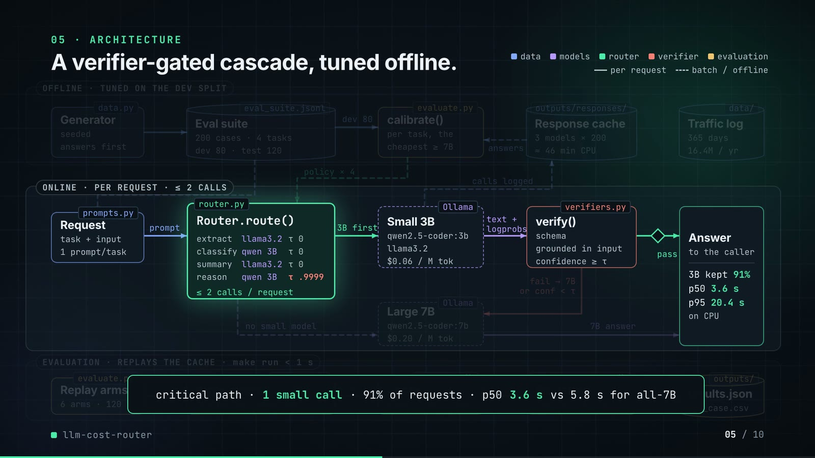
On-screen text (verbatim)
05 · ARCHITECTURE
A verifier-gated cascade, tuned offline.
OFFLINE · TUNED ON THE DEV SPLIT: data.py Generator (seeded, answers first) → eval_suite.jsonl Eval suite (200 cases · 4 tasks, dev 80 · test 120) → dev 80 → evaluate.py calibrate() (per task, the cheapest ≥ 7B) ← answers ← outputs/responses/ Response cache (3 models × 200, ≈ 46 min CPU) · data/ Traffic log (365 days, 16.4M / yr)
ONLINE · PER REQUEST · ≤ 2 CALLS: prompts.py Request (task + input, 1 prompt/task) → prompt → router.py Router.route() [extract llama3.2 τ 0 · classify qwen 3B τ 0 · summary llama3.2 τ 0 · reason qwen 3B τ .9999 · ≤ 2 calls / request] → 3B first → Ollama Small 3B (qwen2.5-coder:3b, llama3.2, $0.06 / M tok) → text + logprobs → verifiers.py verify() (schema, grounded in input, confidence ≥ τ) → pass → Answer (to the caller · 3B kept 91% · p50 3.6 s · p95 20.4 s · on CPU)
fail → 7B or conf < τ → Ollama Large 7B (qwen2.5-coder:7b, $0.20 / M tok) → 7B answer → Answer · no small model → Large 7B · policy × 4 (calibrate → Router) · calls logged (Small 3B → Response cache)
EVALUATION · REPLAYS THE CACHE · make run < 1 s: evaluate.py Replay arms (6 arms · 120) → grading.py Answer key (the router never sees it) → right? → summarise() Score (completion · cost) → paired_bootstrap() Bootstrap (95% CI · 4,000) → outputs/ results.json, per_case.csv
critical path · 1 small call · 91% of requests · p50 3.6 s vs 5.8 s for all-7B
Legend: data · models · router · verifier · evaluation · per request (solid) · batch / offline (dashed)
Figures on this slide
ID | Shown | Source · key | Calculation | Check
F-03 | 16.4M LLM requests a year / 16.4M / yr / 16.4M req | outputs/results.json · annual_requests (sum over 4 tasks = 16,394,979) | sum / 1e6, 1 decimal | ✓
F-04 | 4 tasks | outputs/results.json · policy (one entry per task type) | count | ✓
F-05 | 3 self-hosted models / 3 models | outputs/results.json · model_seconds (one entry per model) | count | ✓
F-06 | 200 cases, known answers | data/eval_suite.jsonl · line count; every case has an 'answer' | count | ✓
F-07 | 3B $0.06 · 7B $0.20 per M tokens | src/llm_cost_router/config.py:35-37 · MODELS usd_per_m_* | - | ✓
F-10 | ≤ 2 calls / request; FALLBACK | src/llm_cost_router/router.py:54-66; README 'Stop condition' · route(): one optional small call, one large call | - | ✓
F-14 | dev 80 · test 120 | data/eval_suite.jsonl · split | count per split | ✓
F-15 | 3 models × 200 | outputs/responses/*.jsonl · line counts | 200 lines in each of 3 files | ✓
F-16 | ≈ 46 min CPU | outputs/results.json · model_seconds (796.1 + 706.2 + 1240.3 s) | sum / 60 = 45.8 min, rounded | ✓
F-17 | 365 days | data/traffic_daily.csv · row count | - | ✓
F-18 | data.py, eval_suite.jsonl, evaluate.py calibrate(), outputs/responses/, data/, prompts.py, router.py Router.route(), Ollama (client.py), verifiers.py verify(), grading.py, summarise(), paired_bootstrap(), outputs/results.json, per_case.csv | src/llm_cost_router/*.py; data/; outputs/ · file / def | - | ✓
F-19 | policy table in Router.route() | outputs/results.json · policy[task].first, policy[task].threshold | - | ✓
F-20 | schema / grounded in input / confidence ≥ τ | src/llm_cost_router/verifiers.py:59-149; router.py:62 · verify_* functions; verdict.confidence >= policy.threshold | - | ✓
F-21 | 3B kept 91% / 91% of requests / 91% | outputs/results.json · splits.test['router, tuned on dev'].share_answered_small = 0.9083 | x 100, whole number | ✓
F-22 | p50 3.6 s · p95 20.4 s | outputs/results.json · splits.test['router, tuned on dev'].p50_latency_s, p95_latency_s | 1 decimal | ✓
F-23 | vs 5.8 s for all-7B | outputs/results.json · splits.test['all-large qwen2.5-coder:7b'].p50_latency_s | 1 decimal | ✓
F-24 | 6 arms · 120 | outputs/results.json · splits.test arms with a completion | count | ✓
F-25 | make run < 1 s / replays … in under a second | outputs/run_log.txt:85 · 'make run ... 0.469 total' | total < 1 s | ✓
F-26 | 95% CI · 4,000 | src/llm_cost_router/evaluate.py:136 · reps: int = 4000 | - | ✓
F-27 | per task, the cheapest ≥ 7B | src/llm_cost_router/evaluate.py:105-122 · options below large completion are skipped; key = (cost, -completion, threshold) | - | ✓

Assumptions: A-01, A-02, A-03, A-04, A-06, A-08, A-09
Illustrative, not data:
• Packets moving along the wires are a schematic of execution order; 1 escalation in 11 packets approximates the 11 / 120 escalation share, not real traffic.
• 'Ollama' marks the model calls made by client.py; the evaluation replays the same calls from the cache.
• The 'no small model' path exists in router.py (TaskPolicy first=None) but the tuned policy does not use it for any task.
• The critical-path p50 (3.6 s) is the router's median over all held-out requests, including escalated ones.
To change this slide: Node boxes (#n-*) and the edge table E in compositions/s03-architecture.html.

Slide 06: The system running
40.6-53.0 s · composition compositions/s04-routes.html (GRID block injected by tools/inject_sheet.py)
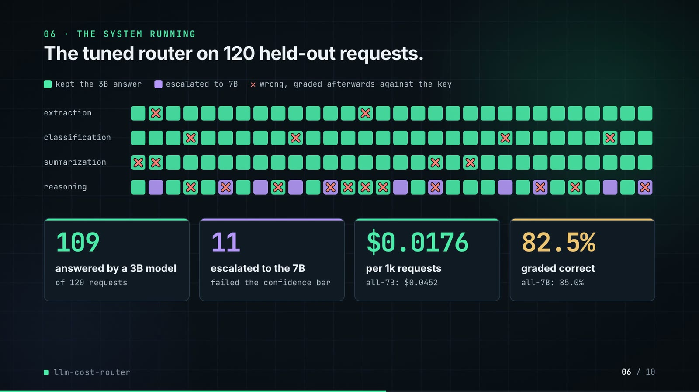
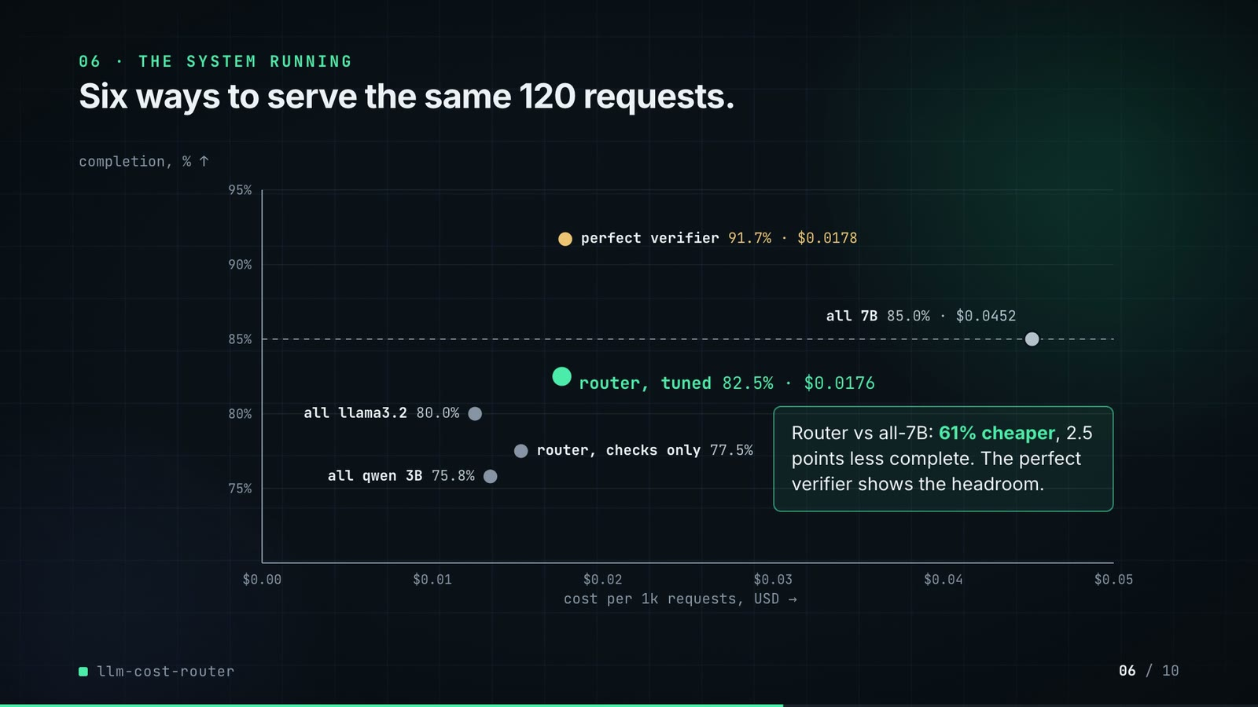
On-screen text (verbatim)
06 · THE SYSTEM RUNNING
Phase 1: The tuned router on 120 held-out requests. · kept the 3B answer · escalated to 7B · ✕ wrong, graded afterwards against the key · rows extraction / classification / summarization / reasoning (30 cells each)
109 answered by a 3B model (of 120 requests) · 11 escalated to the 7B (failed the confidence bar) · $0.0176 per 1k requests (all-7B: $0.0452) · 82.5% graded correct (all-7B: 85.0%)
Phase 2: Six ways to serve the same 120 requests. Completion % vs cost per 1k requests: all qwen 3B 75.8% · all llama3.2 80.0% · router, checks only 77.5% · router, tuned 82.5% · $0.0176 · perfect verifier 91.7% · $0.0178 · all 7B 85.0% · $0.0452; dashed line at the all-7B completion.
Router vs all-7B: 61% cheaper, 2.5 points less complete. The perfect verifier shows the headroom.
Figures on this slide
ID | Shown | Source · key | Calculation | Check
F-21 | 3B kept 91% / 91% of requests / 91% | outputs/results.json · splits.test['router, tuned on dev'].share_answered_small = 0.9083 | x 100, whole number | ✓
F-28 | 120 held-out requests | outputs/results.json · splits.test['router, tuned on dev'].n | - | ✓
F-29 | 109 / 109 answered by 3B / 109 of 120 requests | outputs/per_case.csv · arm = router, tuned on dev; escalated = False | count | ✓
F-30 | 11 / 11 escalated | outputs/per_case.csv · arm = router, tuned on dev; escalated = True | count | ✓
F-31 | $0.0176 | outputs/results.json · splits.test['router, tuned on dev'].cost_per_1k_usd = 0.0175998 | 4 decimals | ✓
F-32 | $0.0452 | outputs/results.json · splits.test['all-large qwen2.5-coder:7b'].cost_per_1k_usd = 0.045235 | 4 decimals | ✓
F-33 | 82.5% | outputs/results.json · splits.test['router, tuned on dev'].completion = 0.825 | x 100, 1 decimal | ✓
F-34 | 85.0% | outputs/results.json · splits.test['all-large qwen2.5-coder:7b'].completion = 0.85 | x 100, 1 decimal | ✓
F-35 | 120-cell grid | outputs/per_case.csv; demo:compositions/s04-routes.html (GRID block) · arm = router, tuned on dev: task, escalated, correct | cell-by-cell equality | ✓
F-36 | failed the confidence bar | demo:assets/routing_log.json (export of the repo's Router) · escalated rows: check_passed, confidence < threshold | - | ✓
F-37 | all qwen 3B 75.8% · all llama3.2 80.0% · all 7B 85.0% · $0.0452 · router, checks only 77.5% · router, tuned 82.5% · $0.0176 · perfect verifier 91.7% · $0.0178 | outputs/results.json; demo:compositions/s04-routes.html (GRID.arms) · splits.test[arm].completion, cost_per_1k_usd | 1 decimal %, 4 decimals $ | ✓
F-38 | 61% cheaper / About 61% cheaper / −61% | outputs/results.json · cost_per_1k_usd: router 0.0175998, all-large 0.045235 | (router / all-large − 1) x 100 = −61.1% | ✓
F-39 | 2.5 points less complete | outputs/results.json · completion: router 0.825, all-large 0.85 | (0.85 − 0.825) x 100 = 2.5 | ✓

Assumptions: A-02, A-04, A-05, A-10
To change this slide: Re-run export_routing_log.py and inject_sheet.py; layout constants in compositions/s04-routes.html.

Slide 07: End-user value
52.7-65.7 s · composition compositions/value.html (SHEET block injected by tools/inject_sheet.py)
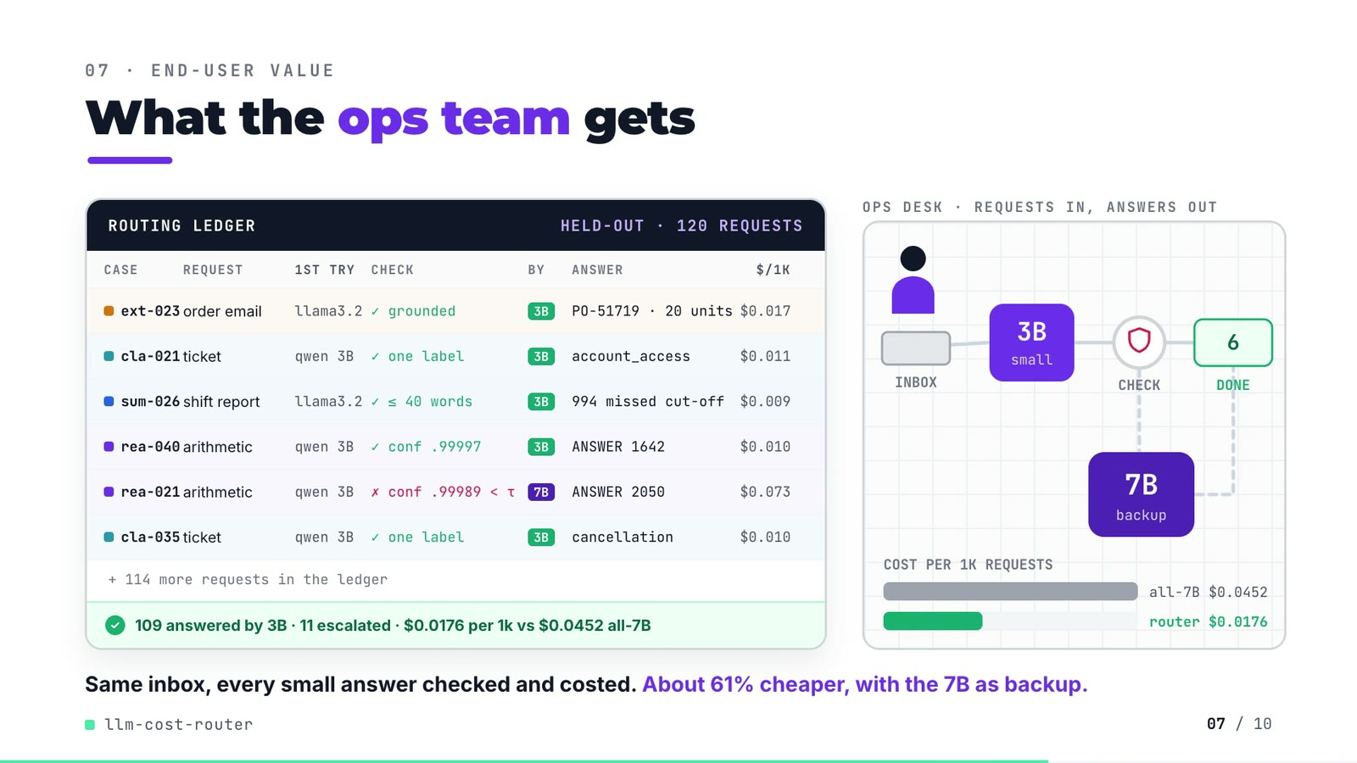
On-screen text (verbatim)
07 · END-USER VALUE
What the ops team gets
ROUTING LEDGER · HELD-OUT · 120 REQUESTS · CASE / REQUEST / 1ST TRY / CHECK / BY / ANSWER / $/1K
ext-023 order email llama3.2 ✓ grounded 3B PO-51719 · 20 units $0.017
cla-021 ticket qwen 3B ✓ one label 3B account_access $0.011
sum-026 shift report llama3.2 ✓ ≤ 40 words 3B 994 missed cut-off $0.009
rea-040 arithmetic qwen 3B ✓ conf .99997 3B ANSWER 1642 $0.010
rea-021 arithmetic qwen 3B ✗ conf .99989 < τ 7B ANSWER 2050 $0.073
cla-035 ticket qwen 3B ✓ one label 3B cancellation $0.010
+ 114 more requests in the ledger · ✓ 109 answered by 3B · 11 escalated · $0.0176 per 1k vs $0.0452 all-7B
Scene: OPS DESK · REQUESTS IN, ANSWERS OUT — INBOX → 3B small → CHECK → DONE (count 0..6); rea-021 detours through 7B backup · COST PER 1K REQUESTS all-7B $0.0452 / router $0.0176
Same inbox, every small answer checked and costed. About 61% cheaper, with the 7B as backup.
Figures on this slide
ID | Shown | Source · key | Calculation | Check
F-11 | PO-51719 · Summit Auto Parts · LED-3580 · 20 · Sharjah · 2026-05-14; keep the 3B answer | demo:assets/routing_log.json (export of the repo's Router) · id = ext-023: first_model, check_passed, escalated, output, input | - | ✓
F-28 | 120 held-out requests | outputs/results.json · splits.test['router, tuned on dev'].n | - | ✓
F-29 | 109 / 109 answered by 3B / 109 of 120 requests | outputs/per_case.csv · arm = router, tuned on dev; escalated = False | count | ✓
F-30 | 11 / 11 escalated | outputs/per_case.csv · arm = router, tuned on dev; escalated = True | count | ✓
F-31 | $0.0176 | outputs/results.json · splits.test['router, tuned on dev'].cost_per_1k_usd = 0.0175998 | 4 decimals | ✓
F-32 | $0.0452 | outputs/results.json · splits.test['all-large qwen2.5-coder:7b'].cost_per_1k_usd = 0.045235 | 4 decimals | ✓
F-38 | 61% cheaper / About 61% cheaper / −61% | outputs/results.json · cost_per_1k_usd: router 0.0175998, all-large 0.045235 | (router / all-large − 1) x 100 = −61.1% | ✓
F-40 | 6 ledger rows | demo:assets/routing_log.json; outputs/per_case.csv; demo:compositions/value.html (SHEET block) · per case: first_model, check_passed, confidence, escalated, output, cost_usd | $ per 1k = cost_usd x 1000, 3 decimals | ✓
F-41 | + 114 more requests in the ledger | outputs/results.json · n = 120 minus the 6 rows shown | 120 − 6 | ✓

Assumptions: A-02, A-04, A-05, A-10
Illustrative, not data:
• The ledger is a presentation of the router's real per-request log; the repo writes outputs/per_case.csv, not a ledger file.
• The six rows were picked to show each task and one escalation; they are not a random sample (16 of the 109 kept answers were wrong, see slide 09).
• '994 missed cut-off' condenses the summary's reported count; the full summary text is in the routing log.
• The person, inbox, trays and envelopes are a schematic of the routing flow.
To change this slide: Pick rows with inject_sheet.py --rows; scene geometry in CONFIG in compositions/value.html.

Slide 08: Results
65.4-74.2 s · composition compositions/s05-results.html
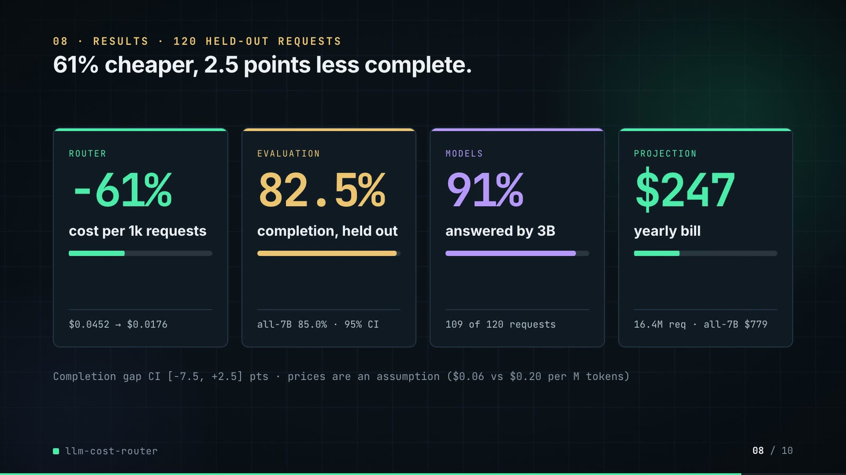
On-screen text (verbatim)
08 · RESULTS · 120 HELD-OUT REQUESTS
61% cheaper, 2.5 points less complete.
router −61% cost per 1k requests ($0.0452 → $0.0176)
evaluation 82.5% completion, held out (all-7B 85.0% · 95% CI)
models 91% answered by 3B (109 of 120 requests)
projection $247 yearly bill (16.4M req · all-7B $779)
Completion gap CI [−7.5, +2.5] pts · prices are an assumption ($0.06 vs $0.20 per M tokens)
Figures on this slide
ID | Shown | Source · key | Calculation | Check
F-03 | 16.4M LLM requests a year / 16.4M / yr / 16.4M req | outputs/results.json · annual_requests (sum over 4 tasks = 16,394,979) | sum / 1e6, 1 decimal | ✓
F-07 | 3B $0.06 · 7B $0.20 per M tokens | src/llm_cost_router/config.py:35-37 · MODELS usd_per_m_* | - | ✓
F-21 | 3B kept 91% / 91% of requests / 91% | outputs/results.json · splits.test['router, tuned on dev'].share_answered_small = 0.9083 | x 100, whole number | ✓
F-29 | 109 / 109 answered by 3B / 109 of 120 requests | outputs/per_case.csv · arm = router, tuned on dev; escalated = False | count | ✓
F-31 | $0.0176 | outputs/results.json · splits.test['router, tuned on dev'].cost_per_1k_usd = 0.0175998 | 4 decimals | ✓
F-32 | $0.0452 | outputs/results.json · splits.test['all-large qwen2.5-coder:7b'].cost_per_1k_usd = 0.045235 | 4 decimals | ✓
F-33 | 82.5% | outputs/results.json · splits.test['router, tuned on dev'].completion = 0.825 | x 100, 1 decimal | ✓
F-34 | 85.0% | outputs/results.json · splits.test['all-large qwen2.5-coder:7b'].completion = 0.85 | x 100, 1 decimal | ✓
F-38 | 61% cheaper / About 61% cheaper / −61% | outputs/results.json · cost_per_1k_usd: router 0.0175998, all-large 0.045235 | (router / all-large − 1) x 100 = −61.1% | ✓
F-39 | 2.5 points less complete | outputs/results.json · completion: router 0.825, all-large 0.85 | (0.85 − 0.825) x 100 = 2.5 | ✓
F-42 | CI [−7.5, +2.5] pts | outputs/results.json · splits.test.router_minus_large_ci95 = [-0.075, 0.025] | x 100, 1 decimal | ✓
F-43 | $247 / all-7B $779 | outputs/results.json · splits.test[arm].projected_annual_cost_usd: 246.65, 778.78 | whole dollars | ✓

Assumptions: A-02, A-04, A-07, A-08, A-10
Illustrative, not data:
• Mini bars are ratios to the all-7B baseline (or to 120 requests for the 91% card).
To change this slide: The stats array and card text in compositions/s05-results.html.

Slide 09: What didn't win
73.8-80.0 s · composition compositions/s06-twist.html
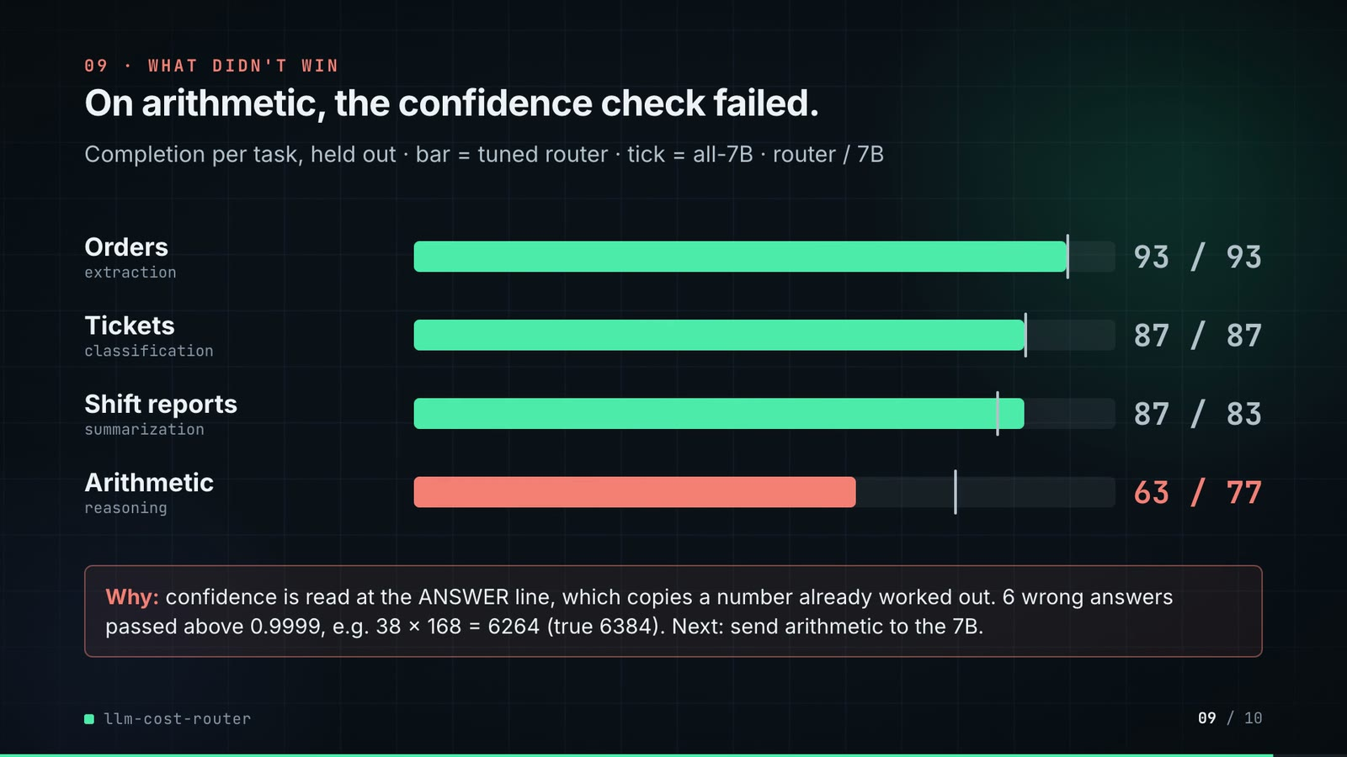
On-screen text (verbatim)
09 · WHAT DIDN'T WIN
On arithmetic, the confidence check failed.
Completion per task, held out · bar = tuned router · tick = all-7B · router / 7B
Orders (extraction) 93 / 93 · Tickets (classification) 87 / 87 · Shift reports (summarization) 87 / 83 · Arithmetic (reasoning) 63 / 77
Why: confidence is read at the ANSWER line, which copies a number already worked out. 6 wrong answers passed above 0.9999, e.g. 38 × 168 = 6264 (true 6384). Next: send arithmetic to the 7B.
Figures on this slide
ID | Shown | Source · key | Calculation | Check
F-12 | 6 confident wrong answers got through / 6 wrong answers passed above 0.9999 | outputs/per_case.csv; demo:assets/routing_log.json · arm = router, tuned on dev; task = reasoning; escalated = False; correct = False | count = 6; every confidence > 0.9999 | ✓
F-13 | Worked for orders, tickets and summaries | outputs/results.json · splits.test[arm].by_task[task].completion | router ≥ all-large for 3 tasks | ✓
F-44 | 93 / 93 · 87 / 87 · 87 / 83 · 63 / 77 | outputs/results.json · splits.test[arm].by_task[task].completion | x 100, whole numbers | ✓
F-45 | 38 × 168 = 6264 (true 6384) | outputs/responses/qwen2.5-coder_3b.jsonl; demo:assets/routing_log.json · case rea-028 | 38 x 168 = 6384; 6384 + 45 = 6429 | ✓
F-46 | confidence is read at the ANSWER line | src/llm_cost_router/verifiers.py:115-127 (answer_confidence) · lowest token probability among the digits after the final ANSWER marker | - | ✓

Assumptions: A-04, A-05
To change this slide: Bar widths, ticks and values in compositions/s06-twist.html (1000 px = 100%).

Slide 10: End card
79.6-84.0 s · composition compositions/s07-end.html
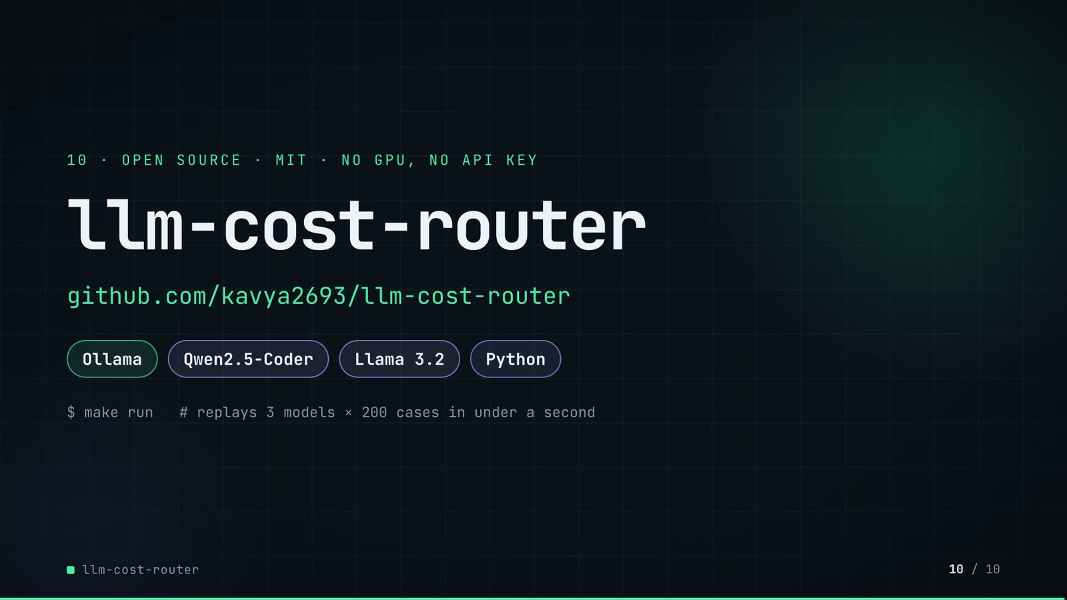
On-screen text (verbatim)
10 · OPEN SOURCE · MIT · NO GPU, NO API KEY
llm-cost-router
github.com/kavya2693/llm-cost-router
Ollama · Qwen2.5-Coder · Llama 3.2 · Python
$ make run # replays 3 models × 200 cases in under a second
Figures on this slide
ID | Shown | Source · key | Calculation | Check
F-05 | 3 self-hosted models / 3 models | outputs/results.json · model_seconds (one entry per model) | count | ✓
F-06 | 200 cases, known answers | data/eval_suite.jsonl · line count; every case has an 'answer' | count | ✓
F-15 | 3 models × 200 | outputs/responses/*.jsonl · line counts | 200 lines in each of 3 files | ✓
F-25 | make run < 1 s / replays … in under a second | outputs/run_log.txt:85 · 'make run ... 0.469 total' | total < 1 s | ✓
F-47 | OPEN SOURCE · MIT · NO GPU, NO API KEY | LICENSE; README 'Running it', 'Inference time' · MIT License; 'need no model server or key'; CPU inference | - | ✓
F-48 | Ollama · Qwen2.5-Coder · Llama 3.2 · Python | src/llm_cost_router/client.py; config.py; pyproject.toml · Ollama client; model ids; python | - | ✓

Assumptions: A-06
To change this slide: Text in compositions/s07-end.html.

5. Change-impact matrix
Input / assumption | Affected figures | Slides | Files to edit | Re-run
A-01: All data is synthetic, produced by a seeded generator sized to the production problem: 200 evaluation cases (50 per task type, half easy, half hard) and 365 days of request volume per task type | all figures | 01, 02, 03, 04, 05, 06, 07, 08, 09, 10 | src/llm_cost_router/data.py; src/llm_cost_router/config.py:15 | make data; make models (~46 min CPU) if prompts or cases change; make run
A-02: Prices are an assumption, not a quote: $0 | F-07, F-09, F-31, F-32, F-37, F-38, F-40, F-43 | 02, 03, 05, 06, 07, 08 | src/llm_cost_router/config.py:34-37 | make run; export_routing_log.py + inject_sheet.py
A-03: Latency is the measured CPU inference time per request on an M1 Pro laptop shared with other jobs (model load time excluded); an escalated request waits for the small call and then the large one | F-16, F-22, F-23 | 05 | re-collect with make models on the target machine | make models; make run
A-04: The routing policy is tuned on the dev split only (20 cases per task type): per task, the cheapest {first small model, confidence threshold} whose dev completion is at least the 7B model's | F-12, F-13, F-14, F-19, F-21, F-27, F-28, F-29, F-30, F-31, F-33, F-35, F-36, F-37, F-38, F-39, F-40, F-42, F-44 | 04, 05, 06, 07, 08, 09 | src/llm_cost_router/evaluate.py:102-134; DEV_PER_TYPE in src/llm_cost_router/data.py | make run; export_routing_log.py + inject_sheet.py
A-05: Ground truth comes from the generator (answers fixed before the text is written); grading | F-08, F-12, F-13, F-33, F-34, F-35, F-37, F-39, F-42, F-44, F-45 | 02, 04, 06, 08, 09 | src/llm_cost_router/grading.py | make run
A-06: Models run at temperature 0 with seed 7, but multi-threaded CPU inference is not bit-for-bit deterministic; the committed response cache (outputs/responses/* | all figures | 01, 02, 03, 04, 05, 06, 07, 08, 09, 10 | outputs/responses/*.jsonl (via make models) | make models; make run
A-07: Annual volume is the sum of the 365-day traffic log, with logging gaps filled by the mean of the same weekday within 28 days; the projected bill multiplies each task's cost per 1k requests by its volume | F-03, F-17, F-43 | 02, 05, 08 | src/llm_cost_router/data.py:428-446 | make data; make run
A-08: The completion interval is a paired bootstrap over the same 120 cases, 4,000 resamples, seed 0 | F-26, F-42 | 05, 08 | src/llm_cost_router/evaluate.py:136 | make run
A-09: Output caps per task (160, 8, 90, 220 tokens) keep a full collection run under an hour on CPU; a truncated reasoning answer fails its check | F-16 | 05 | src/llm_cost_router/config.py:44 | make models; make run
A-10: Video rounding: percentages to whole numbers or 1 decimal, dollars per 1k to 4 decimals, per-request costs as $ per 1k to 3 decimals, the yearly bill to whole dollars, 16 | F-03, F-16, F-21, F-22, F-23, F-31, F-32, F-33, F-34, F-37, F-38, F-39, F-40, F-43, F-44 | 02, 05, 06, 07, 08, 09 | the composition file named on each slide | hyperframes render
A-11: Slide 01 (industry, everyday problems) is general knowledge about running LLMs in operations, used as context | F-01, F-02 | 01 | compositions/s01-context.html | hyperframes render

6. Known differences and caveats
• The repo's results are on a synthetic suite (A-01); the 16.4M requests a year is the generator's traffic log, not a measured production volume.
• Prices are an assumption (A-02). Every cost figure (61%, $0.0176, $0.0452, $247, $779, the per-row $/1k) scales with the price table.
• The router is 2.5 points less complete than all-7B on the held-out split, with a 95% interval of [−7.5, +2.5]; the slides state the deficit, they do not claim parity.
• 16 of the 109 kept 3B answers were wrong (outputs/results.md 'Wrong answers let through'); the ledger on slide 07 shows six chosen rows, all graded correct.
• Latency is CPU time on a shared laptop (A-03); the router's p95 (20.4 s) is worse than all-7B's (12.6 s) because an escalation pays for two calls. The video shows p95 on slide 05 only.
• routing_log.json is produced by the demo's export script calling the repo's own calibrate() and Router on the committed cache; F-35 and F-40 cross-check it against outputs/per_case.csv.
• Slide 01 statements are general knowledge (A-11).

Appendix: environment
Item | Value
Commit | 2ec9b2fce927432c4f8445ad43a97a3a20d56942
Python | 3.11.7
llm_cost_router | 0.1.0
Profile / seeds | suite_and_traffic=20261013, ollama_seed=7, temperature=0, bootstrap_seed=0
Run time | make run replays the committed response cache in 0.47 s (outputs/run_log.txt); refreshing the cache with make models took 45.8 min of CPU inference (13.3 + 11.8 + 20.7 min)

