AUDIT REPORT

peak-capacity-planner: demo video audit report
A slide-by-slide record of every number, assumption and calculation in the demo video, with its source.
Item | Value
Repository | https://github.com/kavya2693/peak-capacity-planner
Numbers taken from commit | e7248d751fba80345b2c28598d66cd4727f348b3 (outputs last changed in e7248d7 (2026-10-14 11:28:26 +0400))
Video | docs/demo/demo.mp4 · 89.8 s · 1920x1080 · 30 fps · silent
Generated | 2026-10-14 18:57
Automated checks | 73 pass · 0 fail · 4 manual (of 77 figures)
Assumptions | 13 (A-01 to A-13)

How to use this report
Every number or claim on screen has an ID (F-01, F-02, ...) and every modelling assumption has an ID (A-01, ...). Cite the ID. Each figure lists its source file, the exact column, row or key, the formula for derived numbers, and an automated check result. The change-impact matrix (section 5) shows which slides and files change if an input or assumption changes.
Types: direct = read straight from a repo output; derived = computed from direct values (formula given); illustrative = drawing or example, not data; general knowledge = context not produced by the repo.

Regenerate
make run # data/ (seed 11) and results/*.csv, summary.json, run_log.txt (~3 min)
.venv/bin/python docs/demo/source/tools/export_series.py docs/demo/source/assets/run_series.json
.venv/bin/python docs/demo/source/tools/export_roster.py docs/demo/source/assets/sale_day_roster.json
python3 docs/demo/source/tools/inject_sheet.py docs/demo/source/assets/run_series.json docs/demo/source/compositions/s04-routes.html --marker SERIES
python3 docs/demo/source/tools/inject_sheet.py docs/demo/source/assets/sale_day_roster.json docs/demo/source/compositions/value.html --marker SHEET --rows A1,A2,A4,B1,B2,C1 --animate A1,B2,C1
python3 docs/demo/source/tools/inject_sheet.py docs/demo/source/assets/sale_day_roster.json docs/demo/source/compositions/s07-end.html --marker SALE
cd docs/demo/source && npx --yes hyperframes@0.8.156 check && npx --yes hyperframes@0.8.156 render -f 30 -q looks -o renders/peak-capacity-planner-master.mp4 && cd -
ffmpeg -y -i docs/demo/source/renders/peak-capacity-planner-master.mp4 -c:v libx264 -preset slow -crf 25 -pix_fmt yuv420p -movflags +faststart -an docs/demo/demo.mp4
python3 docs/demo/source/tools/build_audit_report.py docs/demo/source/audit/facts.yaml # stills, checks, MD/DOCX/PDF

1. Figures
ID | Shown | Slides | Source | Column / row / key | How computed | Type | Check
F-01 | 3 industry chips | 01 | author's framing | - | - | general knowledge | manual: Context statement, not a repo output.
F-02 | 4 problem cards | 01 | README 'The problem', 'Why it is hard' | README lines 22-31 | - | general knowledge | ✓ verified
F-03 | 12 hubs | 02, 05, 06, 08 | data/hubs.csv | row count | - | direct | ✓ verified
F-04 | 3 cities / 3 own-rider pools | 02, 05 | data/cities.csv | row count | - | direct | ✓ verified
F-05 | Sale day: 4.2× the orders | 02 | data/hourly_orders.csv.gz | orders on 2025-11-28 / mean Mon-Fri daily orders 2025-09-01..11-14 | 49,134 / 11,696 = 4.20 | derived | ✓ verified
F-06 | On time = delivered within 60 minutes of the order / promise 60 min | 02, 05 | src/peak_capacity/config.py:17 | PROMISE_MINUTES | - | direct | ✓ verified
F-07 | busiest hour 3.9× a normal peak | 02 | data/hourly_orders.csv.gz | max hourly orders 2025-11-28 / max over hours of the mean ordinary-weekday hourly orders | 3.87, rounded | derived | ✓ verified
F-08 | Ramadan moves ~11 days a year | 02 | src/peak_capacity/config.py:81-86 (RAMADAN) | first-day dates 2023-2026 | mean shift between consecutive years = (12 + 10 + 11) / 3 = 11 days | derived | ✓ verified
F-81 | 51 peak days planned | 02 | results/hub_day.csv | distinct date | - | direct | ✓ verified
F-82 | Peak = Ramadan, Eid and a November mega-sale | 02 | src/peak_capacity/config.py (WINDOWS); README 'The result' | two windows | - | direct | ✓ verified
F-09 | ✓ more on time ✓ lower rider cost ✓ lower total cost | 03 | results/summary.json | replay_otd, rider_cost, total_cost | mip_t99_d85 better than rule_of_thumb on all three | derived | ✓ verified
F-10 | 3 years, hour by hour | 03 | data/hourly_orders.csv.gz | date years, op_hour | distinct years = 2023, 2024, 2025 | direct | ✓ verified
F-11 | 85% / 0.85 margin / margin 0.85 / 85% margin / riders at 85% | 04, 05, 06, 07 | src/peak_capacity/experiment.py:64 | Config('mip_t99_d85', ..., 0.85) | - | direct | ✓ verified
F-12 | 95.0% | 04 | results/plan_summary.csv | config=mip_t99_d100_oracle, replay_otd | x 100, 1 dp | direct | ✓ verified
F-13 | 99.6% | 04 | results/plan_summary.csv | config=mip_t99_d85_oracle, replay_otd | x 100, 1 dp | direct | ✓ verified
F-14 | WITH A 15% MARGIN | 04 | src/peak_capacity/experiment.py:64 | derate 0.85 | 1 - 0.85 = 15% | derived | manual: Arithmetic on F-11 (checked there).
F-15 | 11.2M orders | 05 | data/hourly_orders.csv.gz | sum(orders) | 11,198,428 / 1e6, 1 dp | direct | ✓ verified
F-16 | generate.py seed 11 | 05 | scripts/generate_data.py:14 | --seed default | - | direct | ✓ verified
F-17 | 1,340 gaps filled | 05 | results/cleaning.csv | gaps_filled | - | direct | ✓ verified
F-18 | 309 spikes fixed | 05 | results/cleaning.csv | spikes_replaced | - | direct | ✓ verified
F-19 | gradient boosting | 05 | src/peak_capacity/forecast.py:71-72 | HistGradientBoostingRegressor(loss='poisson') | - | direct | ✓ verified
F-20 | 13 configs / configurations 13 | 05 | results/plan_summary.csv | row count | - | direct | ✓ verified
F-21 | 1,989 | 05, 10 | results/run_log.txt | 'solving 1989 city-day plans' | - | direct | ✓ verified
F-22 | solver gap 0.5% | 05 | src/peak_capacity/plan.py:129 | gapRel=0.005 | - | direct | ✓ verified
F-23 | 200 / 200 nodes | 05 | src/peak_capacity/plan.py:82 | max_nodes: int = 200 | - | direct | ✓ verified
F-24 | time backstop 20 s | 05 | src/peak_capacity/plan.py:83 | time_limit: int = 20 | - | direct | ✓ verified
F-25 | full run 179 s / ~3 min | 05, 10 | results/run_log.txt | '[ 179.3s] done' | 179.3 s, rounded; ~3 min on slide 10 | direct | ✓ verified
F-26 | hubs open 07–03 | 05 | src/peak_capacity/config.py:14-15 | OPEN_CLOCK_HOUR = 7, N_HOURS = 20 | 07:00 + 20 h = 03:00 | derived | ✓ verified
F-27 | 7,956 hub-days | 05 | results/hub_day.csv | row count | 13 configs x 612 hub-days | direct | ✓ verified
F-28 | ✓ checked vs queue maths | 05 | tests/test_replay.py:20 | test_dispatch_matches_erlang_c_waiting_probabilities | - | direct | ✓ verified
F-29 | Pick the margin · from the replay, not assumed · margin 0.85 | 05 | docs/adr/0001-plan-with-a-fluid-mip-judge-with-an-order-replay.md | Decision bullet 4 | - | direct | ✓ verified
F-30 | 8h shifts · 4h agency blocks | 05 | src/peak_capacity/config.py:53, :55 | OWN_SHIFT_HOURS, GIG_BLOCK_HOURS | - | direct | ✓ verified
F-31 | transforms.py, calendar.py, forecast.py, seasonal_naive(), rule_of_thumb(), plan.py · plan_city_day(), service.py, experiment.py, replay.py, generate.py | 05 | src/peak_capacity/ | def names | - | direct | ✓ verified
F-34 | 51 peak days | 06 | results/hub_day.csv | distinct date | 39 Ramadan-window days + 12 sale-window days | direct | ✓ verified
F-35 | three daily on-time lines | 06 | results/hub_day.csv -> demo:assets/run_series.json -> s04-routes.html | sum(on_time)/sum(accepted) per date and config | - | derived | ✓ verified
F-36 | 76.9% | 06, 08 | results/plan_summary.csv | config=rule_of_thumb, replay_otd | x 100 | direct | ✓ verified
F-37 | 96.4% | 06 | results/plan_summary.csv | config=mip_t99_d100, replay_otd | x 100 | direct | ✓ verified
F-38 | 98.9% | 06, 08 | results/plan_summary.csv | config=mip_t99_d85, replay_otd | x 100 | direct | ✓ verified
F-39 | sale day: rule of thumb 2.2% | 06 | results/hub_day.csv | config=rule_of_thumb, segment=sale_day | sum(on_time)/sum(accepted) | derived | ✓ verified
F-40 | target 99% | 06 | src/peak_capacity/experiment.py:64 | target 0.99 | - | direct | manual: Same Config line as F-11 (checked there).
F-41 | 98.9% | 06 | results/plan_summary.csv | mip_t99_d85 replay_otd | x 100 | direct | ✓ verified
F-42 | 94.1% | 06, 09 | results/plan_summary.csv | mip_t99_d85 served_on_time_share | x 100 | direct | ✓ verified
F-43 | 4.8% | 06, 09 | results/plan_summary.csv | mip_t99_d85 lost_share | x 100 | direct | ✓ verified
F-44 | 99.9% | 06 | results/plan_summary.csv | mip_t99_d85_derated_caps replay_otd | x 100 | direct | ✓ verified
F-45 | 90.6% | 06 | results/plan_summary.csv | mip_t99_d85_derated_caps served_on_time_share | x 100 | direct | ✓ verified
F-46 | 9.4% | 06 | results/plan_summary.csv | mip_t99_d85_derated_caps lost_share | x 100 | direct | ✓ verified
F-47 | +1.03M AED | 06 | results/plan_summary.csv | total_cost | 10,133,900 - 9,107,180 = 1,026,720 AED (all lost margin) | derived | ✓ verified
F-48 | twice the customers | 06 | results/plan_summary.csv | lost_share | 9.36% / 4.82% = 1.94, rounded to 'twice' (README: 'twice as many') | derived | ✓ verified
F-49 | rows A1, A2, A4, B1, B2, C1 | 07 | demo:assets/sale_day_roster.json -> value.html SHEET block | own_riders, gig_total, peak_riders, max_on_duty, busiest_hour, busiest_forecast, busiest_slots, otd | - | derived | ✓ verified
F-50 | the whole sheet | 07 | tools/export_roster.py vs results/hub_day.csv (config mip_t99_d85, 2025-11-28) | per hub | - | derived | ✓ verified
F-51 | 787 own shifts | 07 | results/hub_day.csv | sum(own_riders), mip_t99_d85, sale_day | - | direct | ✓ verified
F-52 | 3,348 agency blocks | 07 | results/hub_day.csv | sum(gig_blocks) | - | direct | ✓ verified
F-53 | AED 561,160 | 07 | results/hub_day.csv | sum(rider_cost) | - | direct | ✓ verified
F-54 | 96.0% on time | 07 | results/hub_day.csv | sum(on_time)/sum(accepted) | 43,782 / 45,628 = 95.954% -> 96.0% | derived | ✓ verified
F-55 | FRI 28 NOV 2025 | 07 | results/hub_day.csv | segment=sale_day date | last Friday of November (config.mega_sale_day) | direct | ✓ verified
F-56 | at the busiest hour, slots sold < orders due | 07 | demo:assets/sale_day_roster.json | busiest_slots < busiest_forecast for all 12 hubs | - | derived | ✓ verified
F-57 | 77.7% | 07 | results/hub_day.csv | config=mip_t99_d85, date=2025-11-28, hub=B2 | on_time / accepted | direct | ✓ verified
F-58 | −17.6% | 08 | results/plan_summary.csv | rider_cost | 8,015,150 / 9,731,060 - 1 | derived | ✓ verified
F-59 | 9.73M → 8.02M AED | 08 | results/plan_summary.csv | rider_cost | /1e6, 2 dp | direct | ✓ verified
F-60 | 98.9% · rule of thumb 76.9% | 08 | results/plan_summary.csv | replay_otd | see F-36, F-38 | direct | manual: Same values as F-36 and F-38 (checked there).
F-61 | −6.4% | 08 | results/plan_summary.csv | total_cost | 9,107,180 / 9,731,060 - 1 | derived | ✓ verified
F-62 | 14.57 → 12.74 AED/order | 08 | results/plan_summary.csv | cost_per_delivered | 2 dp | direct | ✓ verified
F-63 | 8.5% | 08, 09 | results/forecast_accuracy.csv | segment=eid, forecaster=model, daily_wape | x 100 | direct | ✓ verified
F-64 | naive forecast 43.9% / 43.9% on Eid | 08, 09 | results/forecast_accuracy.csv | segment=eid, forecaster=naive, daily_wape | x 100 | direct | ✓ verified
F-65 | 612 hub-days | 08 | results/plan_summary.csv | hub_days | 12 hubs x 51 days | direct | ✓ verified
F-66 | 754,577 customers | 08 | results/hub_day.csv | sum(demand) per config | - | direct | ✓ verified
F-67 | 8.6% (TRAP) | 09 | results/forecast_accuracy.csv | segment=sale_day, forecaster=naive | x 100 | direct | ✓ verified
F-69 | 11.6% | 09 | results/forecast_accuracy.csv | segment=sale_day, forecaster=model | x 100 | direct | ✓ verified
F-70 | still 11.6% under | 09 | results/forecast_accuracy.csv | segment=sale_day, forecaster=model, bias | x 100 (negative = under) | direct | ✓ verified
F-75 | Judge forecasts by the plan they make · same planner and replay | 09 | src/peak_capacity/experiment.py:71 | Config('mip_t99_d85_naive', 'naive', 'mip', 0.99, 0.85) | - | direct | ✓ verified
F-76 | 9.7% | 09 | results/plan_summary.csv | mip_t99_d85_naive lost_share | x 100 | direct | ✓ verified
F-77 | 3.9% (the floor, not available) | 09 | results/plan_summary.csv | mip_t99_d85_oracle lost_share | x 100 | direct | ✓ verified
F-78 | 9.11M vs 10.04M AED | 09 | results/plan_summary.csv | total_cost | /1e6, 2 dp | direct | ✓ verified
F-79 | 88.0% | 09 | results/plan_summary.csv | mip_t99_d85_naive served_on_time_share | x 100 | direct | ✓ verified
F-80 | NEXT · plan it over several sale sizes | 09 | README 'Known limitations' and 'Insights and learning' | scenario-based plan over sale intensity | - | direct | ✓ verified
F-73 | PuLP + CBC · scikit-learn · DuckDB · Python · MIT | 10 | pyproject.toml | dependencies, license | - | direct | ✓ verified
F-74 | faded bars | 10 | demo:assets/sale_day_roster.json -> s07-end.html SALE block | sum of hub forecasts per hour | - | derived | ✓ verified

2. Automated check run (2026-10-14 18:57)
ID | Expected on slide | Recomputed from repo | Result
F-01 | 3 industry chips | - | manual
F-02 | true | true | ✓ pass
F-03 | 12 | 12 | ✓ pass
F-04 | 3 | 3 | ✓ pass
F-05 | 4.2 | 4.2 | ✓ pass
F-06 | true | true | ✓ pass
F-07 | 3.9 | 3.9 | ✓ pass
F-08 | 11 | 11 | ✓ pass
F-81 | 51 | 51 | ✓ pass
F-82 | true | true | ✓ pass
F-09 | true | true | ✓ pass
F-10 | 3 | 3 | ✓ pass
F-11 | true | true | ✓ pass
F-12 | 95.0 | 95.0 | ✓ pass
F-13 | 99.6 | 99.6 | ✓ pass
F-14 | WITH A 15% MARGIN | - | manual
F-15 | 11.2 | 11.2 | ✓ pass
F-16 | true | true | ✓ pass
F-17 | 1,340 | 1,340 | ✓ pass
F-18 | 309 | 309 | ✓ pass
F-19 | true | true | ✓ pass
F-20 | 13 | 13 | ✓ pass
F-21 | true | true | ✓ pass
F-22 | true | true | ✓ pass
F-23 | true | true | ✓ pass
F-24 | true | true | ✓ pass
F-25 | 179 | 179 | ✓ pass
F-26 | true | true | ✓ pass
F-27 | 7,956 | 7,956 | ✓ pass
F-28 | true | true | ✓ pass
F-29 | true | true | ✓ pass
F-30 | true | true | ✓ pass
F-31 | true | true | ✓ pass
F-34 | 51 | 51 | ✓ pass
F-35 | true | true | ✓ pass
F-36 | 76.9 | 76.9 | ✓ pass
F-37 | 96.4 | 96.4 | ✓ pass
F-38 | 98.9 | 98.9 | ✓ pass
F-39 | 2.2 | 2.2 | ✓ pass
F-40 | target 99% | - | manual
F-41 | 98.9 | 98.9 | ✓ pass
F-42 | 94.1 | 94.1 | ✓ pass
F-43 | 4.8 | 4.8 | ✓ pass
F-44 | 99.9 | 99.9 | ✓ pass
F-45 | 90.6 | 90.6 | ✓ pass
F-46 | 9.4 | 9.4 | ✓ pass
F-47 | 1.03 | 1.03 | ✓ pass
F-48 | true | true | ✓ pass
F-49 | true | true | ✓ pass
F-50 | true | true | ✓ pass
F-51 | 787 | 787 | ✓ pass
F-52 | 3,348 | 3,348 | ✓ pass
F-53 | 561,160 | 561,160 | ✓ pass
F-54 | 96.0 | 96.0 | ✓ pass
F-55 | true | true | ✓ pass
F-56 | true | true | ✓ pass
F-57 | 77.7 | 77.7 | ✓ pass
F-58 | -17.6 | -17.6 | ✓ pass
F-59 | 9.73 8.02 | 9.73 8.02 | ✓ pass
F-60 | 98.9% · rule of thumb 76.9% | - | manual
F-61 | -6.4 | -6.4 | ✓ pass
F-62 | 14.57 12.74 | 14.57 12.74 | ✓ pass
F-63 | 8.5 | 8.5 | ✓ pass
F-64 | 43.9 | 43.9 | ✓ pass
F-65 | 612 | 612 | ✓ pass
F-66 | 754,577 | 754,577 | ✓ pass
F-67 | 8.6 | 8.6 | ✓ pass
F-69 | 11.6 | 11.6 | ✓ pass
F-70 | -11.6 | -11.6 | ✓ pass
F-75 | true | true | ✓ pass
F-76 | 9.7 | 9.7 | ✓ pass
F-77 | 3.9 | 3.9 | ✓ pass
F-78 | 9.11 10.04 | 9.11 10.04 | ✓ pass
F-79 | 88.0 | 88.0 | ✓ pass
F-80 | true | true | ✓ pass
F-73 | true | true | ✓ pass
F-74 | true | true | ✓ pass

3. Assumptions register
ID | Assumption | Source | Figures affected | Slides affected
A-01 | All data is synthetic, produced by a seeded generator sized to the production problem (12 hubs, 3 cities, 2023-2025 hourly orders, about 11.2M orders). Production order data is proprietary. Sensitivity: every figure; a new seed moves every number. | scripts/generate_data.py:14 (seed 11); src/peak_capacity/generate.py:91; README 'The data' | all figures | slides 01, 02, 03, 04, 05, 06, 07, 08, 09, 10
A-02 | Rider throughput is derated to 85% of the fluid rate (60 / trip minutes per rider-hour) for the chosen plan. Sensitivity: high; at derate 1.0 replayed on-time falls from 98.9% to 96.4% and rider cost from 8.02M to 7.19M AED. | src/peak_capacity/experiment.py:64-74 (Config derate 0.85); src/peak_capacity/service.py:19-21 (fluid_rate); plan.py:113 (derate x rate x riders) | F-11, F-12, F-13, F-14, F-29, F-36, F-37, F-38, F-41, F-42, F-43, F-44, F-45, F-46, F-47, F-48, F-50, F-51, F-52, F-53, F-54, F-58, F-59, F-61, F-62 | slides 04, 05, 06, 07, 08, 09
A-03 | Delivered on time = within 60 minutes of the order being placed; an order is ready 6 minutes after it is placed. Sensitivity: high; every on-time share depends on it. | src/peak_capacity/config.py:17-18 (PROMISE_MINUTES, PICK_MINUTES) | F-06, F-12, F-13, F-36, F-37, F-38, F-39, F-41, F-42, F-44, F-45, F-50, F-54, F-58, F-60 | slides 02, 04, 05, 06, 07, 08, 09
A-04 | Rider economics in AED: own rider 160 per 8-hour shift, agency rider 130 per 4-hour block, a turned-away order costs 30 in lost margin. Sensitivity: high for every cost figure; none of the on-time shares move unless the plan changes. | src/peak_capacity/config.py:53-57 (OWN_SHIFT_COST, GIG_BLOCK_COST, LOST_ORDER_COST) | F-47, F-53, F-58, F-59, F-61, F-62 | slides 06, 07, 08
A-05 | Replay randomness: trips are lognormal around each hub's mean with CV 0.35, 25% slower 16:00-19:00 in Ramadan, own riders no-show 3% and agency riders 8%, and 70% of turned-away customers retry the next hour. Sensitivity: medium; changes replayed on-time and turned-away shares. | src/peak_capacity/config.py:47-48 (TRIP_CV, IFTAR_TRAFFIC), :63-64 (no-shows), :68 (SLOT_RETRY) | F-12, F-13, F-36, F-37, F-38, F-39, F-41, F-42, F-43, F-44, F-45, F-46, F-48, F-50, F-54, F-58, F-60 | slides 04, 06, 07, 08, 09
A-06 | Hub space caps riders on duty at 3x the riders an ordinary weekday's busiest hour needs; own riders work 6 days in 7, drawn from a city pool. Sensitivity: high on the sale day, where the cap binds (peak on duty = space for every hub on slide 07). | src/peak_capacity/config.py:71 (OWN_AVAILABILITY), :75 (SPACE_MULTIPLE); generate.py:142-160 (max_on_duty, own_pool) | F-03, F-04, F-50, F-51, F-52, F-56 | slides 02, 05, 06, 07, 08
A-07 | CBC stops at a 0.5% optimality gap or 200 branch-and-bound nodes per city-day, with 20 CPU seconds as a backstop. Sensitivity: low; README reports two full runs differing by under 0.01% of cost in three configurations. | src/peak_capacity/plan.py:82-83, :127-135; README 'How it works' (stop conditions) | F-22, F-23, F-24, F-50, F-58, F-59, F-61 | slides 05, 07, 08
A-08 | Forecasts are made as of a cutoff (31 Jan 2025 for Ramadan, 31 Oct 2025 for the sale) with no data after it; the event model is gradient-boosted (Poisson) on the ratio to each hub's 28-day ordinary level. Sensitivity: medium; forecast quality shows up mainly as turned-away customers. | src/peak_capacity/config.py:112-115 (WINDOWS); src/peak_capacity/forecast.py:36-37, :71-72 | F-19, F-63, F-64, F-67, F-69, F-70, F-75, F-76, F-77, F-78, F-79 | slides 05, 08, 09
A-09 | The rule of thumb sizes own riders to the day's forecast at 70% utilisation over three fixed shift starts, adds evening agency blocks, and never closes a slot. Sensitivity: high for every 'vs rule of thumb' figure. | src/peak_capacity/plan.py:163-204 (rule_of_thumb, utilisation=0.7) | F-09, F-36, F-39, F-58, F-59, F-60, F-61, F-62 | slides 03, 06, 08
A-10 | Slots are sold up to the roster's flat-out rider throughput (cap rule 'fluid'); the derated-cap rule is kept as an ablation. Sensitivity: high for on time vs turned away (slide 06 phase 2). | src/peak_capacity/plan.py:146-147; experiment.py:41, :74 | F-41, F-42, F-43, F-44, F-45, F-46, F-47, F-48, F-56, F-75, F-76, F-77 | slides 06, 07, 09
A-11 | 'Ordinary weekday' for the slide 02 multiples = Monday-Friday in the 10 weeks before the sale ramp (2025-09-01..2025-11-14), all 12 hubs pooled. Sensitivity: low; Oct 1 - Nov 14 gives 4.16x / 3.85x, the same after rounding. | this audit (definition); data/hourly_orders.csv.gz; README 'The problem' (4.2x, 3.9x) | F-05, F-07 | slides 02
A-12 | Video rounding: percentages to 1 decimal, AED millions to 2 decimals, counts with thousands separators; '~11 days', '~3 min' and '11.2M' are rounded labels. Sensitivity: display only. | this audit (display convention) | F-05, F-07, F-08, F-15, F-25, F-47, F-48, F-54, F-59, F-62, F-73 | slides 02, 05, 06, 07, 08, 10
A-13 | Slide 01 (industries, everyday problems) is general delivery-operations knowledge used as context, not a result of this repo, and carries no numbers. Sensitivity: none. | author's framing; README 'The problem' and 'Why it is hard' support problems 1, 3 and 4 | F-01, F-02 | slides 01

4. Slide by slide

Slide 01: The industry
0.0-7.2 s · composition compositions/s01-context.html
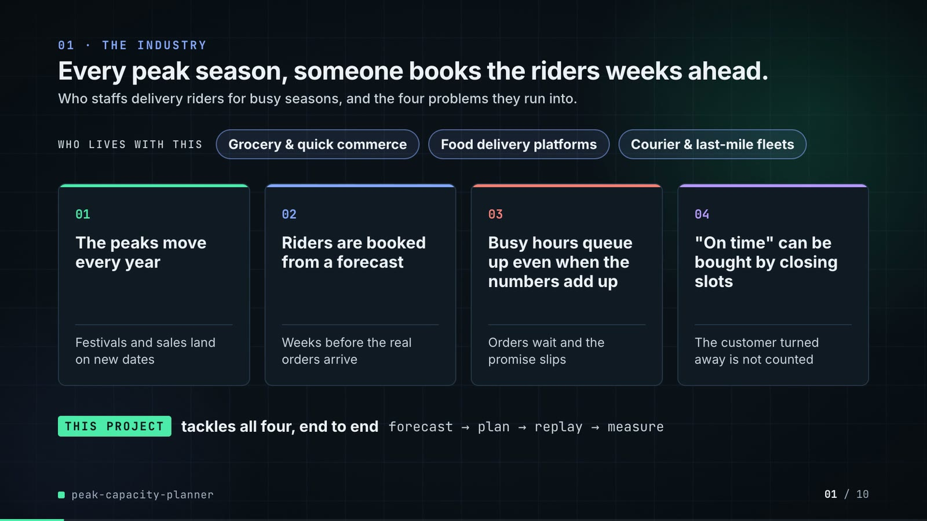
On-screen text (verbatim)
01 · THE INDUSTRY
Every peak season, someone books the riders weeks ahead.
Who staffs delivery riders for busy seasons, and the four problems they run into.
WHO LIVES WITH THIS · Grocery & quick commerce · Food delivery platforms · Courier & last-mile fleets
01 The peaks move every year — Festivals and sales land on new dates
02 Riders are booked from a forecast — Weeks before the real orders arrive
03 Busy hours queue up even when the numbers add up — Orders wait and the promise slips
04 "On time" can be bought by closing slots — The customer turned away is not counted
THIS PROJECT tackles all four, end to end · forecast → plan → replay → measure
Figures on this slide
ID | Shown | Source · key | Calculation | Check
F-01 | 3 industry chips | author's framing · - | - | manual
F-02 | 4 problem cards | README 'The problem', 'Why it is hard' · README lines 22-31 | - | ✓

Assumptions: A-13
Illustrative, not data:
• The whole slide is context; no repo figures.
To change this slide: Edit the chips (#ctx-c1..3) and cards (#ctx-k1..4) in compositions/s01-context.html.

Slide 02: This project
6.8-12.0 s · composition compositions/s02-hook.html

On-screen text (verbatim)
02 · THIS PROJECT
The project in one line: grocery hubs that must book delivery riders before the peak arrives.
12 hubs, 3 cities. Sale day: 4.2× the orders. Riders booked weeks before.
51 peak days planned · busiest hour 3.9× a normal peak · Ramadan moves ~11 days a year
Peak = Ramadan, Eid and a November mega-sale. On time = delivered within 60 minutes of the order.
Figures on this slide
ID | Shown | Source · key | Calculation | Check
F-03 | 12 hubs | data/hubs.csv · row count | - | ✓
F-04 | 3 cities / 3 own-rider pools | data/cities.csv · row count | - | ✓
F-05 | Sale day: 4.2× the orders | data/hourly_orders.csv.gz · orders on 2025-11-28 / mean Mon-Fri daily orders 2025-09-01..11-14 | 49,134 / 11,696 = 4.20 | ✓
F-06 | On time = delivered within 60 minutes of the order / promise 60 min | src/peak_capacity/config.py:17 · PROMISE_MINUTES | - | ✓
F-07 | busiest hour 3.9× a normal peak | data/hourly_orders.csv.gz · max hourly orders 2025-11-28 / max over hours of the mean ordinary-weekday hourly orders | 3.87, rounded | ✓
F-08 | Ramadan moves ~11 days a year | src/peak_capacity/config.py:81-86 (RAMADAN) · first-day dates 2023-2026 | mean shift between consecutive years = (12 + 10 + 11) / 3 = 11 days | ✓
F-81 | 51 peak days planned | results/hub_day.csv · distinct date | - | ✓
F-82 | Peak = Ramadan, Eid and a November mega-sale | src/peak_capacity/config.py (WINDOWS); README 'The result' · two windows | - | ✓

F-05 note: Matches README 'The problem' (4.2 times). Ordinary-weekday window defined in A-11.
F-07 note: Matches README 'The problem' (3.9 times a normal peak).
Assumptions: A-01, A-03, A-11, A-12
Illustrative, not data:
• Rings in the background are decoration.
To change this slide: Headline spans #hook-l1..l3 and chips #hook-f1..f3 in compositions/s02-hook.html; multiples are recomputed by the sale_multiple helper.

Slide 03: How it works (white chapter, slide A)
11.7-19.7 s · composition compositions/explainer.html (CONFIG.blocks, CONFIG.groups, CONFIG.loop)
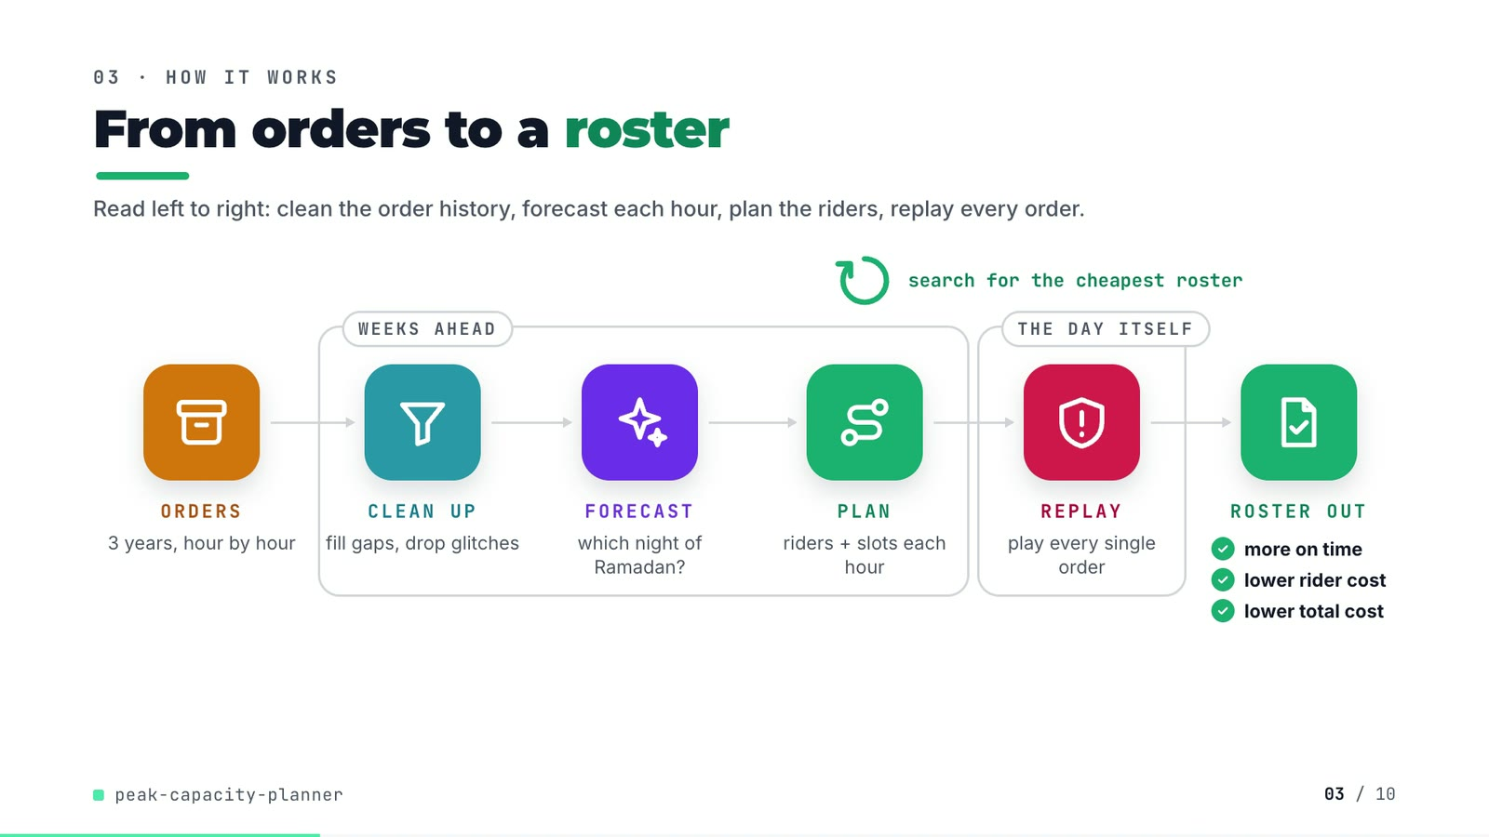
On-screen text (verbatim)
03 · HOW IT WORKS
From orders to a roster
Read left to right: clean the order history, forecast each hour, plan the riders, replay every order.
ORDERS 3 years, hour by hour → [WEEKS AHEAD: CLEAN UP fill gaps, drop glitches → FORECAST which night of Ramadan? → PLAN riders + slots each hour] → [THE DAY ITSELF: REPLAY play every single order] → ROSTER OUT ✓ more on time ✓ lower rider cost ✓ lower total cost
search for the cheapest roster (loop over PLAN)
Figures on this slide
ID | Shown | Source · key | Calculation | Check
F-09 | ✓ more on time ✓ lower rider cost ✓ lower total cost | results/summary.json · replay_otd, rider_cost, total_cost | mip_t99_d85 better than rule_of_thumb on all three | ✓
F-10 | 3 years, hour by hour | data/hourly_orders.csv.gz · date years, op_hour | distinct years = 2023, 2024, 2025 | ✓

Assumptions: A-02, A-09
Illustrative, not data:
• Icons and colours are a visual language, not data.
• 'THE DAY ITSELF' = the replay plays each planned day against the true orders, after the fact.
To change this slide: Edit CONFIG in compositions/explainer.html; badge truth is F-09.

Slide 04: The key idea (white chapter, slide B)
19.7-26.7 s · composition compositions/explainer.html (#ex-b ...)
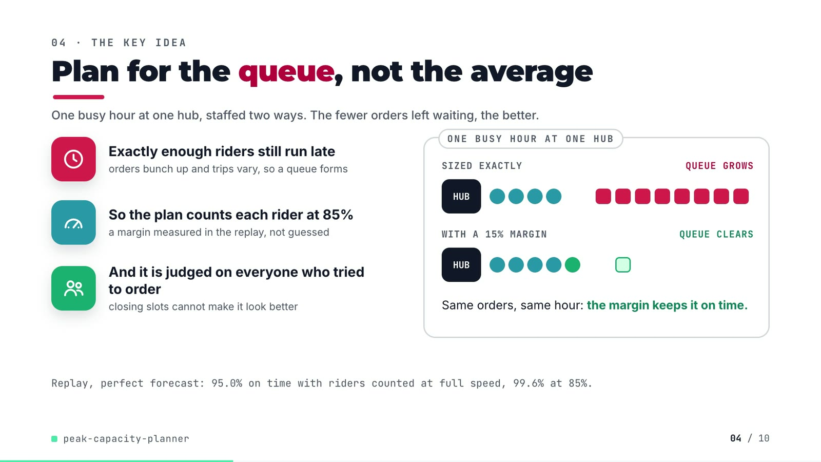
On-screen text (verbatim)
04 · THE KEY IDEA
Plan for the queue, not the average
One busy hour at one hub, staffed two ways. The fewer orders left waiting, the better.
Exactly enough riders still run late — orders bunch up and trips vary, so a queue forms
So the plan counts each rider at 85% — a margin measured in the replay, not guessed
And it is judged on everyone who tried to order — closing slots cannot make it look better
ONE BUSY HOUR AT ONE HUB: SIZED EXACTLY (4 riders) → QUEUE GROWS; WITH A 15% MARGIN (5 riders) → QUEUE CLEARS. Same orders, same hour: the margin keeps it on time.
Replay, perfect forecast: 95.0% on time with riders counted at full speed, 99.6% at 85%.
Figures on this slide
ID | Shown | Source · key | Calculation | Check
F-11 | 85% / 0.85 margin / margin 0.85 / 85% margin / riders at 85% | src/peak_capacity/experiment.py:64 · Config('mip_t99_d85', ..., 0.85) | - | ✓
F-12 | 95.0% | results/plan_summary.csv · config=mip_t99_d100_oracle, replay_otd | x 100, 1 dp | ✓
F-13 | 99.6% | results/plan_summary.csv · config=mip_t99_d85_oracle, replay_otd | x 100, 1 dp | ✓
F-14 | WITH A 15% MARGIN | src/peak_capacity/experiment.py:64 · derate 0.85 | 1 - 0.85 = 15% | manual

Assumptions: A-02, A-03, A-05
Illustrative, not data:
• The queue demo (4 vs 5 riders, 8 orders) is schematic; it mirrors README 'Where the plan-to-replay gap comes from', not a specific hub-hour.
To change this slide: Markup under #ex-b in compositions/explainer.html; the footnote figures are F-12 and F-13.

Slide 05: Architecture
26.4-41.4 s · composition compositions/s03-architecture.html
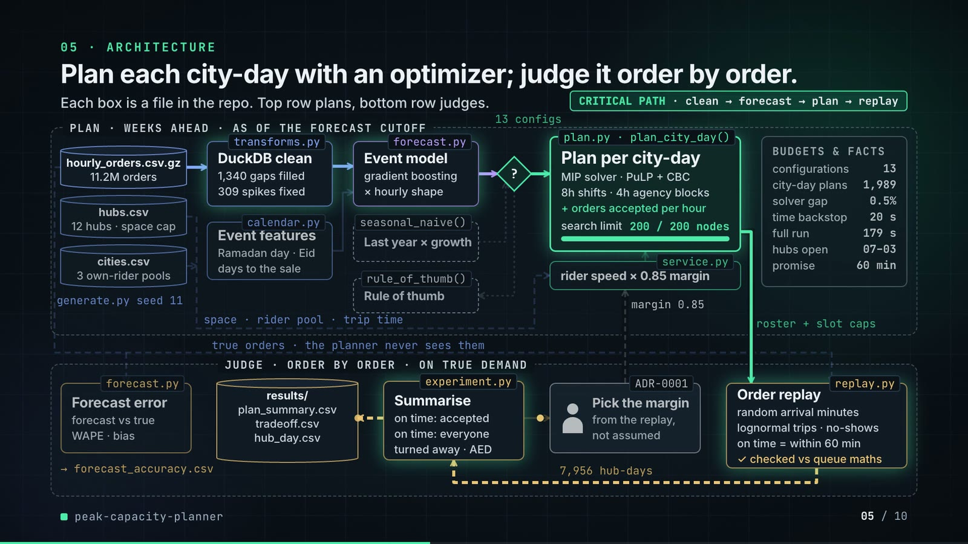
On-screen text (verbatim)
05 · ARCHITECTURE
Plan each city-day with an optimizer; judge it order by order.
Each box is a file in the repo. Top row plans, bottom row judges.
Legend: data · forecast · optimizer · scoring · person · in memory · file · baseline
PLAN · WEEKS AHEAD · AS OF THE FORECAST CUTOFF: generate.py seed 11 → hourly_orders.csv.gz (11.2M orders), hubs.csv (12 hubs · space cap), cities.csv (3 own-rider pools)
transforms.py DuckDB clean (1,340 gaps filled · 309 spikes fixed) · calendar.py Event features (Ramadan day · Eid · days to the sale)
forecast.py Event model (gradient boosting · × hourly shape) · seasonal_naive() Last year × growth (baseline)
decision ? (13 configs) → plan.py · plan_city_day() Plan per city-day (MIP solver · PuLP + CBC · 8h shifts · 4h agency blocks · + orders accepted per hour · search limit 200 / 200 nodes) | rule_of_thumb() (baseline)
service.py rider speed × 0.85 margin ← space · rider pool · trip time
BUDGETS & FACTS: configurations 13 · city-day plans 1,989 · solver gap 0.5% · time backstop 20 s · full run 179 s · hubs open 07–03 · promise 60 min
JUDGE · ORDER BY ORDER · ON TRUE DEMAND: true orders (the planner never sees them) → replay.py Order replay (random arrival minutes · lognormal trips · no-shows · on time = within 60 min · ✓ checked vs queue maths) ← roster + slot caps
7,956 hub-days → experiment.py Summarise (on time: accepted · on time: everyone · turned away · AED) → results/ (plan_summary.csv, tradeoff.csv, hub_day.csv) and → ADR-0001 Pick the margin (from the replay, not assumed) → margin 0.85 (feedback)
forecast.py Forecast error (forecast vs true · WAPE · bias) → forecast_accuracy.csv
CRITICAL PATH · clean → forecast → plan → replay
Figures on this slide
ID | Shown | Source · key | Calculation | Check
F-03 | 12 hubs | data/hubs.csv · row count | - | ✓
F-04 | 3 cities / 3 own-rider pools | data/cities.csv · row count | - | ✓
F-06 | On time = delivered within 60 minutes of the order / promise 60 min | src/peak_capacity/config.py:17 · PROMISE_MINUTES | - | ✓
F-11 | 85% / 0.85 margin / margin 0.85 / 85% margin / riders at 85% | src/peak_capacity/experiment.py:64 · Config('mip_t99_d85', ..., 0.85) | - | ✓
F-15 | 11.2M orders | data/hourly_orders.csv.gz · sum(orders) | 11,198,428 / 1e6, 1 dp | ✓
F-16 | generate.py seed 11 | scripts/generate_data.py:14 · --seed default | - | ✓
F-17 | 1,340 gaps filled | results/cleaning.csv · gaps_filled | - | ✓
F-18 | 309 spikes fixed | results/cleaning.csv · spikes_replaced | - | ✓
F-19 | gradient boosting | src/peak_capacity/forecast.py:71-72 · HistGradientBoostingRegressor(loss='poisson') | - | ✓
F-20 | 13 configs / configurations 13 | results/plan_summary.csv · row count | - | ✓
F-21 | 1,989 | results/run_log.txt · 'solving 1989 city-day plans' | - | ✓
F-22 | solver gap 0.5% | src/peak_capacity/plan.py:129 · gapRel=0.005 | - | ✓
F-23 | 200 / 200 nodes | src/peak_capacity/plan.py:82 · max_nodes: int = 200 | - | ✓
F-24 | time backstop 20 s | src/peak_capacity/plan.py:83 · time_limit: int = 20 | - | ✓
F-25 | full run 179 s / ~3 min | results/run_log.txt · '[ 179.3s] done' | 179.3 s, rounded; ~3 min on slide 10 | ✓
F-26 | hubs open 07–03 | src/peak_capacity/config.py:14-15 · OPEN_CLOCK_HOUR = 7, N_HOURS = 20 | 07:00 + 20 h = 03:00 | ✓
F-27 | 7,956 hub-days | results/hub_day.csv · row count | 13 configs x 612 hub-days | ✓
F-28 | ✓ checked vs queue maths | tests/test_replay.py:20 · test_dispatch_matches_erlang_c_waiting_probabilities | - | ✓
F-29 | Pick the margin · from the replay, not assumed · margin 0.85 | docs/adr/0001-plan-with-a-fluid-mip-judge-with-an-order-replay.md · Decision bullet 4 | - | ✓
F-30 | 8h shifts · 4h agency blocks | src/peak_capacity/config.py:53, :55 · OWN_SHIFT_HOURS, GIG_BLOCK_HOURS | - | ✓
F-31 | transforms.py, calendar.py, forecast.py, seasonal_naive(), rule_of_thumb(), plan.py · plan_city_day(), service.py, experiment.py, replay.py, generate.py | src/peak_capacity/ · def names | - | ✓

F-18 note: README: the three planted spikes are among them; the rest are high-noise hours the rule should have left alone.
F-23 note: The node counter animates 0 -> 200 for illustration; the pace is not a measured solve time.
F-25 note: README says 'about 2 min on a quiet machine'; the logged run took 179 s.
Assumptions: A-01, A-02, A-06, A-07, A-08
Illustrative, not data:
• Packets moving along the wires are decoration in execution order, not measured timings.
• The CBC node counter animates to its real limit (200); the pace is not a measured solve.
• 'Pick the margin' (the derate) is the decision recorded in ADR-0001 (one derate for the run), not an interactive step in the code.
To change this slide: Node boxes (#n-*), cylinders (CYL) and the wires object W in compositions/s03-architecture.html.

Slide 06a: The system running: 51 replayed days
41.0-48.6 s · composition compositions/s04-routes.html (SERIES block from tools/export_series.py)
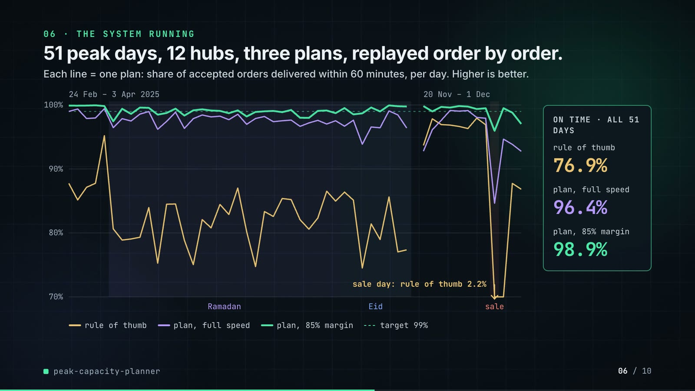
On-screen text (verbatim)
06 · THE SYSTEM RUNNING
51 peak days, 12 hubs, three plans, replayed order by order.
Each line = one plan: share of accepted orders delivered within 60 minutes, per day. Higher is better.
legend (under the chart): rule of thumb · plan, full speed · plan, 85% margin · target 99%
Panels: 24 Feb – 3 Apr 2025 (Ramadan, Eid bands) | 20 Nov – 1 Dec (sale band); y axis 70%–100%
sale day: rule of thumb 2.2% (arrow: the line leaves the axis)
ON TIME · ALL 51 DAYS: rule of thumb 76.9% · plan, full speed 96.4% · plan, 85% margin 98.9%
Assumptions: A-02, A-05, A-09
Illustrative, not data:
• Values below 70% are drawn at the axis floor; the arrow and label give the real sale-day value.
To change this slide: Regenerate assets/run_series.json with tools/export_series.py and inject it; styling in compositions/s04-routes.html.

Slide 06b: The system running: the metric that disagrees
48.6-55.6 s · composition compositions/s04-routes.html (#routes-dg)
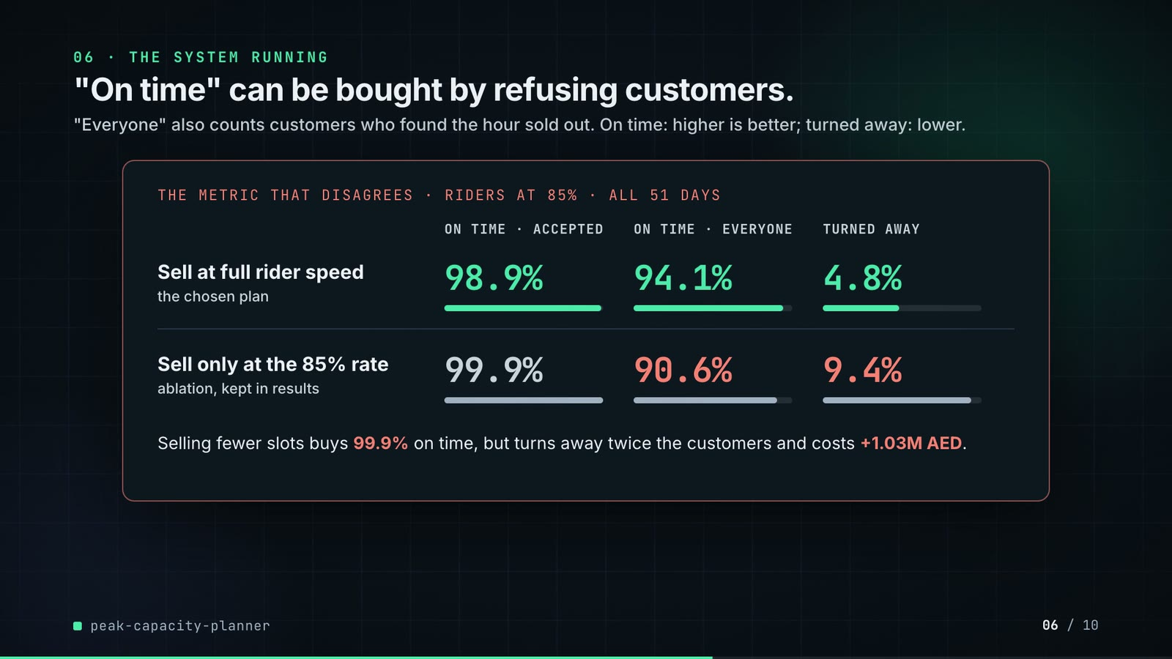
On-screen text (verbatim)
"On time" can be bought by refusing customers.
"Everyone" also counts customers who found the hour sold out. On time: higher is better; turned away: lower.
THE METRIC THAT DISAGREES · RIDERS AT 85% · ALL 51 DAYS
columns: ON TIME · ACCEPTED | ON TIME · EVERYONE | TURNED AWAY
Sell at full rider speed (the chosen plan): 98.9% · 94.1% · 4.8%
Sell only at the 85% rate (ablation, kept in results): 99.9% · 90.6% · 9.4%
Selling fewer slots buys 99.9% on time, but turns away twice the customers and costs +1.03M AED.
Assumptions: A-04, A-10
Illustrative, not data:
• Bar lengths: on-time bars on a 0-100% scale, turned-away bars on a 0-10% scale.
To change this slide: NAMES and the dg rows in compositions/s04-routes.html; values come from SERIES.disagree.

Slide 07: End-user value (white)
55.3-68.3 s · composition compositions/value.html (SHEET block from tools/export_roster.py)
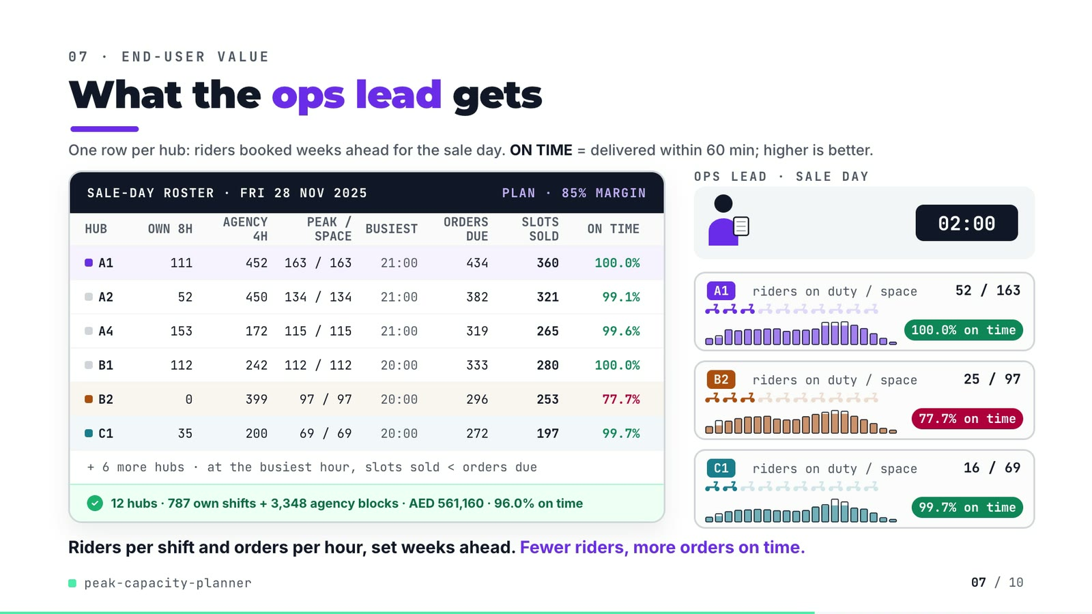
On-screen text (verbatim)
07 · END-USER VALUE
What the ops lead gets
One row per hub: riders booked weeks ahead for the sale day. ON TIME = delivered within 60 min; higher is better.
SALE-DAY ROSTER · FRI 28 NOV 2025 · PLAN · 85% MARGIN
HUB · OWN 8H · AGENCY 4H · PEAK / SPACE · BUSIEST · ORDERS DUE · SLOTS SOLD · ON TIME
A1 111 452 163/163 21:00 434 360 100.0% · A2 52 450 134/134 21:00 382 321 99.1% · A4 153 172 115/115 21:00 319 265 99.6% · B1 112 242 112/112 20:00 333 280 100.0% · B2 0 399 97/97 20:00 296 253 77.7% · C1 35 200 69/69 20:00 272 197 99.7%
+ 6 more hubs · at the busiest hour, slots sold < orders due
12 hubs · 787 own shifts + 3,348 agency blocks · AED 561,160 · 96.0% on time
Scene: OPS LEAD · SALE DAY, clock 07:00 → 02:00; hub cards A1, B2, C1 with riders on duty / space, hourly bars, badges 100.0% / 77.7% / 99.7% on time
Riders per shift and orders per hour, set weeks ahead. Fewer riders, more orders on time.
Figures on this slide
ID | Shown | Source · key | Calculation | Check
F-11 | 85% / 0.85 margin / margin 0.85 / 85% margin / riders at 85% | src/peak_capacity/experiment.py:64 · Config('mip_t99_d85', ..., 0.85) | - | ✓
F-49 | rows A1, A2, A4, B1, B2, C1 | demo:assets/sale_day_roster.json -> value.html SHEET block · own_riders, gig_total, peak_riders, max_on_duty, busiest_hour, busiest_forecast, busiest_slots, otd | - | ✓
F-50 | the whole sheet | tools/export_roster.py vs results/hub_day.csv (config mip_t99_d85, 2025-11-28) · per hub | - | ✓
F-51 | 787 own shifts | results/hub_day.csv · sum(own_riders), mip_t99_d85, sale_day | - | ✓
F-52 | 3,348 agency blocks | results/hub_day.csv · sum(gig_blocks) | - | ✓
F-53 | AED 561,160 | results/hub_day.csv · sum(rider_cost) | - | ✓
F-54 | 96.0% on time | results/hub_day.csv · sum(on_time)/sum(accepted) | 43,782 / 45,628 = 95.954% -> 96.0% | ✓
F-55 | FRI 28 NOV 2025 | results/hub_day.csv · segment=sale_day date | last Friday of November (config.mega_sale_day) | ✓
F-56 | at the busiest hour, slots sold < orders due | demo:assets/sale_day_roster.json · busiest_slots < busiest_forecast for all 12 hubs | - | ✓
F-57 | 77.7% | results/hub_day.csv · config=mip_t99_d85, date=2025-11-28, hub=B2 | on_time / accepted | ✓

F-54 note: The README quotes 95.9% for the sale day; correct rounding of 95.954% is 96.0%.
Assumptions: A-02, A-04, A-06, A-10
Illustrative, not data:
• Scooter icons: 10 per hub = hub space; lit icons = riders on duty / space, rounded to tenths.
• Hourly bars: outline = forecast orders due, fill = orders the hour's slots can take (min of slots and forecast).
• The roster hand-off animation is decoration.
• 'Fewer riders' in the caption refers to rider cost vs the rule of thumb over the 51 days (F-58), not to this one day.
To change this slide: Re-run tools/export_roster.py, then tools/inject_sheet.py --marker SHEET (pick --rows / --animate); layout in compositions/value.html.

Slide 08: Results
68.0-76.8 s · composition compositions/s05-results.html
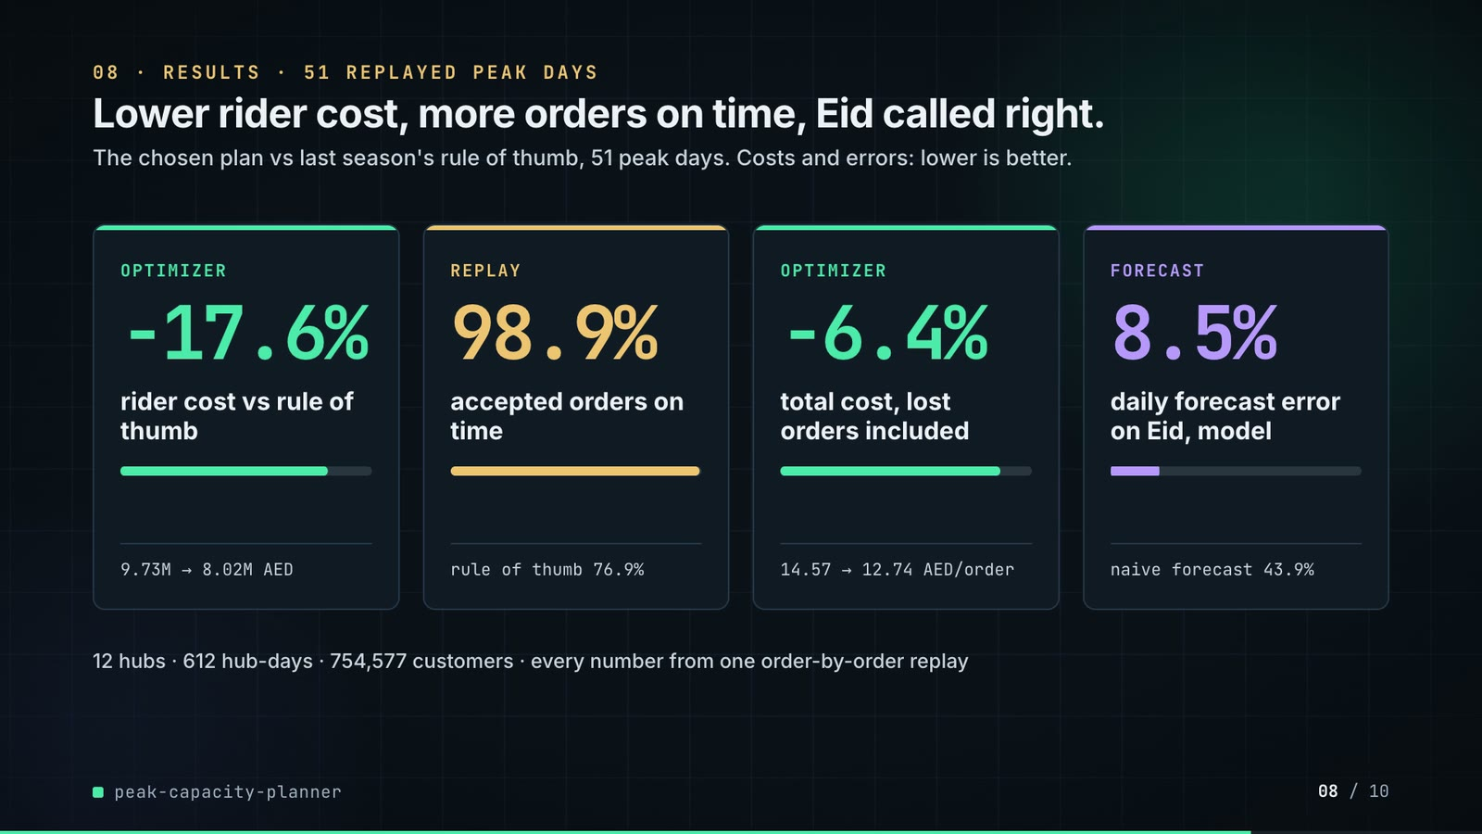
On-screen text (verbatim)
08 · RESULTS · 51 REPLAYED PEAK DAYS
Lower rider cost, more orders on time, Eid called right.
The chosen plan vs last season's rule of thumb, 51 peak days. Costs and errors: lower is better.
OPTIMIZER −17.6% rider cost vs rule of thumb · 9.73M → 8.02M AED
REPLAY 98.9% accepted orders on time · rule of thumb 76.9%
OPTIMIZER −6.4% total cost, lost orders included · 14.57 → 12.74 AED/order
FORECAST 8.5% daily forecast error on Eid, model · naive forecast 43.9%
12 hubs · 612 hub-days · 754,577 customers · every number from one order-by-order replay
Figures on this slide
ID | Shown | Source · key | Calculation | Check
F-03 | 12 hubs | data/hubs.csv · row count | - | ✓
F-36 | 76.9% | results/plan_summary.csv · config=rule_of_thumb, replay_otd | x 100 | ✓
F-38 | 98.9% | results/plan_summary.csv · config=mip_t99_d85, replay_otd | x 100 | ✓
F-58 | −17.6% | results/plan_summary.csv · rider_cost | 8,015,150 / 9,731,060 - 1 | ✓
F-59 | 9.73M → 8.02M AED | results/plan_summary.csv · rider_cost | /1e6, 2 dp | ✓
F-60 | 98.9% · rule of thumb 76.9% | results/plan_summary.csv · replay_otd | see F-36, F-38 | manual
F-61 | −6.4% | results/plan_summary.csv · total_cost | 9,107,180 / 9,731,060 - 1 | ✓
F-62 | 14.57 → 12.74 AED/order | results/plan_summary.csv · cost_per_delivered | 2 dp | ✓
F-63 | 8.5% | results/forecast_accuracy.csv · segment=eid, forecaster=model, daily_wape | x 100 | ✓
F-64 | naive forecast 43.9% / 43.9% on Eid | results/forecast_accuracy.csv · segment=eid, forecaster=naive, daily_wape | x 100 | ✓
F-65 | 612 hub-days | results/plan_summary.csv · hub_days | 12 hubs x 51 days | ✓
F-66 | 754,577 customers | results/hub_day.csv · sum(demand) per config | - | ✓

Assumptions: A-02, A-04, A-08, A-09
Illustrative, not data:
• Mini bars show the ratio of the two values in each card's footer.
To change this slide: The stats array and footers in compositions/s05-results.html.

Slide 09: Lesson and fix
76.4-85.8 s · composition compositions/s06-twist.html
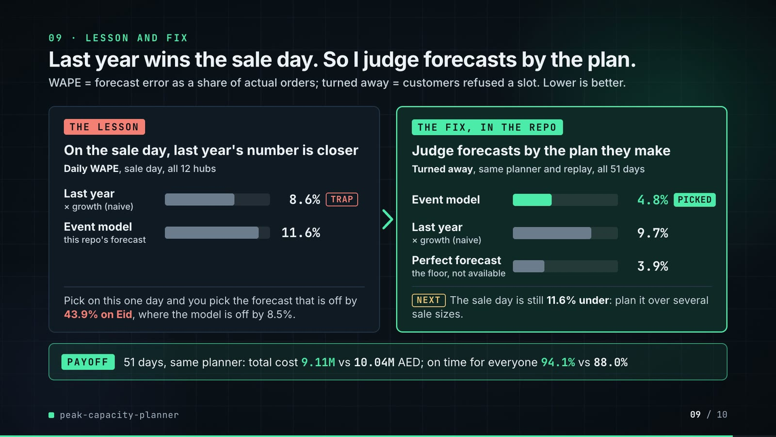
On-screen text (verbatim)
09 · LESSON AND FIX
Last year wins the sale day. So I judge forecasts by the plan.
WAPE = forecast error as a share of actual orders; turned away = customers refused a slot. Lower is better.
THE LESSON: On the sale day, last year's number is closer · Daily WAPE, sale day, all 12 hubs · Last year × growth (naive) 8.6% TRAP · Event model (this repo's forecast) 11.6%
Pick on this one day and you pick the forecast that is off by 43.9% on Eid, where the model is off by 8.5%.
THE FIX, IN THE REPO: Judge forecasts by the plan they make · Turned away, same planner and replay, all 51 days · Event model 4.8% PICKED · Last year × growth (naive) 9.7% · Perfect forecast (the floor, not available) 3.9%
NEXT The sale day is still 11.6% under: plan it over several sale sizes.
PAYOFF 51 days, same planner: total cost 9.11M vs 10.04M AED; on time for everyone 94.1% vs 88.0%
Figures on this slide
ID | Shown | Source · key | Calculation | Check
F-42 | 94.1% | results/plan_summary.csv · mip_t99_d85 served_on_time_share | x 100 | ✓
F-43 | 4.8% | results/plan_summary.csv · mip_t99_d85 lost_share | x 100 | ✓
F-63 | 8.5% | results/forecast_accuracy.csv · segment=eid, forecaster=model, daily_wape | x 100 | ✓
F-64 | naive forecast 43.9% / 43.9% on Eid | results/forecast_accuracy.csv · segment=eid, forecaster=naive, daily_wape | x 100 | ✓
F-67 | 8.6% (TRAP) | results/forecast_accuracy.csv · segment=sale_day, forecaster=naive | x 100 | ✓
F-69 | 11.6% | results/forecast_accuracy.csv · segment=sale_day, forecaster=model | x 100 | ✓
F-70 | still 11.6% under | results/forecast_accuracy.csv · segment=sale_day, forecaster=model, bias | x 100 (negative = under) | ✓
F-75 | Judge forecasts by the plan they make · same planner and replay | src/peak_capacity/experiment.py:71 · Config('mip_t99_d85_naive', 'naive', 'mip', 0.99, 0.85) | - | ✓
F-76 | 9.7% | results/plan_summary.csv · mip_t99_d85_naive lost_share | x 100 | ✓
F-77 | 3.9% (the floor, not available) | results/plan_summary.csv · mip_t99_d85_oracle lost_share | x 100 | ✓
F-78 | 9.11M vs 10.04M AED | results/plan_summary.csv · total_cost | /1e6, 2 dp | ✓
F-79 | 88.0% | results/plan_summary.csv · mip_t99_d85_naive served_on_time_share | x 100 | ✓
F-80 | NEXT · plan it over several sale sizes | README 'Known limitations' and 'Insights and learning' · scenario-based plan over sale intensity | - | ✓

F-75 note: Same target, margin and cap rule as the chosen plan mip_t99_d85; only the forecaster differs. tests/test_forecast.py:14 checks the event model beats the naive forecast on Ramadan's last ten nights and Eid.
Assumptions: A-02, A-04, A-05, A-08, A-10
Illustrative, not data:
• Bars in both panels share one scale: 20 px per percentage point (13% = the 260 px track). Left bars are daily WAPE, right bars are turned-away shares; both are percentages where lower is better.
• Grey = options being compared; mint = the picked forecast; coral only on the TRAP label; amber on NEXT (a next step the repo does not implement).
To change this slide: Panels and payoff strip in compositions/s06-twist.html; the fix is the mip_t99_d85_naive configuration in src/peak_capacity/experiment.py:71 (F-75).

Slide 10: End card
85.4-89.8 s · composition compositions/s07-end.html

On-screen text (verbatim)
10 · OPEN SOURCE · MIT · RUNS ON A LAPTOP
peak-capacity-planner
github.com/kavya2693/peak-capacity-planner
PuLP + CBC · scikit-learn · DuckDB · Python
$ make run # 12 hubs, 1,989 city-day plans, ~3 min
One command rebuilds every table the numbers in this video come from.
Figures on this slide
ID | Shown | Source · key | Calculation | Check
F-21 | 1,989 | results/run_log.txt · 'solving 1989 city-day plans' | - | ✓
F-25 | full run 179 s / ~3 min | results/run_log.txt · '[ 179.3s] done' | 179.3 s, rounded; ~3 min on slide 10 | ✓
F-73 | PuLP + CBC · scikit-learn · DuckDB · Python · MIT | pyproject.toml · dependencies, license | - | ✓
F-74 | faded bars | demo:assets/sale_day_roster.json -> s07-end.html SALE block · sum of hub forecasts per hour | - | ✓

F-25 note: README says 'about 2 min on a quiet machine'; the logged run took 179 s.
Assumptions: A-12
Illustrative, not data:
• The faded bars are the sale day's network forecast per operating hour (F-74), used as a backdrop.
To change this slide: Text in compositions/s07-end.html; backdrop via inject_sheet.py --marker SALE.

5. Change-impact matrix
Input / assumption | Affected figures | Slides | Files to edit | Re-run
A-01: All data is synthetic, produced by a seeded generator sized to the production problem (12 hubs, 3 cities, 2023-2025 hourly orders, about 11 | all figures | 01, 02, 03, 04, 05, 06, 07, 08, 09, 10 | src/peak_capacity/generate.py; src/peak_capacity/config.py (HUBS) | make data; make run; export_series.py + export_roster.py + inject_sheet.py
A-02: Rider throughput is derated to 85% of the fluid rate (60 / trip minutes per rider-hour) for the chosen plan | F-11, F-12, F-13, F-14, F-29, F-36, F-37, F-38, F-41, F-42, F-43, F-44, F-45, F-46, F-47, F-48, F-50, F-51, F-52, F-53, F-54, F-58, F-59, F-61, F-62 | 04, 05, 06, 07, 08, 09 | src/peak_capacity/experiment.py:64-74 | make run; export_series.py + export_roster.py + inject_sheet.py
A-03: Delivered on time = within 60 minutes of the order being placed; an order is ready 6 minutes after it is placed | F-06, F-12, F-13, F-36, F-37, F-38, F-39, F-41, F-42, F-44, F-45, F-50, F-54, F-58, F-60 | 02, 04, 05, 06, 07, 08, 09 | src/peak_capacity/config.py:17-18 | make run; export_series.py + export_roster.py + inject_sheet.py
A-04: Rider economics in AED: own rider 160 per 8-hour shift, agency rider 130 per 4-hour block, a turned-away order costs 30 in lost margin | F-47, F-53, F-58, F-59, F-61, F-62 | 06, 07, 08 | src/peak_capacity/config.py:53-57 | make run; export_roster.py + inject_sheet.py
A-05: Replay randomness: trips are lognormal around each hub's mean with CV 0 | F-12, F-13, F-36, F-37, F-38, F-39, F-41, F-42, F-43, F-44, F-45, F-46, F-48, F-50, F-54, F-58, F-60 | 04, 06, 07, 08, 09 | src/peak_capacity/config.py:47-68 | make run; export_series.py + export_roster.py + inject_sheet.py
A-06: Hub space caps riders on duty at 3x the riders an ordinary weekday's busiest hour needs; own riders work 6 days in 7, drawn from a city pool | F-03, F-04, F-50, F-51, F-52, F-56 | 02, 05, 06, 07, 08 | src/peak_capacity/config.py:71-75 | make data; make run; export_roster.py + inject_sheet.py
A-07: CBC stops at a 0 | F-22, F-23, F-24, F-50, F-58, F-59, F-61 | 05, 07, 08 | src/peak_capacity/plan.py:82-83 | make run
A-08: Forecasts are made as of a cutoff (31 Jan 2025 for Ramadan, 31 Oct 2025 for the sale) with no data after it; the event model is gradient-boosted (Poisson) on the ratio to each hub's 28-day ordinary level | F-19, F-63, F-64, F-67, F-69, F-70, F-75, F-76, F-77, F-78, F-79 | 05, 08, 09 | src/peak_capacity/config.py:112-115; src/peak_capacity/forecast.py | make run
A-09: The rule of thumb sizes own riders to the day's forecast at 70% utilisation over three fixed shift starts, adds evening agency blocks, and never closes a slot | F-09, F-36, F-39, F-58, F-59, F-60, F-61, F-62 | 03, 06, 08 | src/peak_capacity/plan.py:170 | make run; export_series.py + inject_sheet.py
A-10: Slots are sold up to the roster's flat-out rider throughput (cap rule 'fluid'); the derated-cap rule is kept as an ablation | F-41, F-42, F-43, F-44, F-45, F-46, F-47, F-48, F-56, F-75, F-76, F-77 | 06, 07, 09 | src/peak_capacity/experiment.py:74 | make run; export_series.py + inject_sheet.py
A-11: 'Ordinary weekday' for the slide 02 multiples = Monday-Friday in the 10 weeks before the sale ramp (2025-09-01 | F-05, F-07 | 02 | audit/facts.yaml helpers (sale_multiple) | build_audit_report.py
A-12: Video rounding: percentages to 1 decimal, AED millions to 2 decimals, counts with thousands separators; '~11 days', '~3 min' and '11 | F-05, F-07, F-08, F-15, F-25, F-47, F-48, F-54, F-59, F-62, F-73 | 02, 05, 06, 07, 08, 10 | the composition file named on each slide | hyperframes render
A-13: Slide 01 (industries, everyday problems) is general delivery-operations knowledge used as context, not a result of this repo, and carries no numbers | F-01, F-02 | 01 | compositions/s01-context.html | hyperframes render

6. Known differences and caveats
• Slide 09 drops the old 'what didn't win' detail now that it shows lesson and fix: the event model's sale-day bias against the naive forecast's (-11.6% vs -7.2%), its rest-of-sale-week WAPE (7.5%) and the 6 of 12 hubs below 99% on the sale day. All three are still in README 'The result' (forecast accuracy table and 'The sale day itself').
• Slide 09's fix does not repair the sale-day forecast: nothing in the plan hedges the sale (README 'Known limitations'). The slide labels the scenario-based sale plan as NEXT because the repo does not implement it.
• Sale-day on time: slide 07 shows 96.0% (43,782 / 45,628 = 95.954%, correctly rounded); README 'The sale day itself' says 95.9%.
• Full-run time: the logged make run took 179 s (results/run_log.txt); README 'Running it' says 'about 2 min on a quiet machine'. Slides use 179 s and ~3 min.
• The slide 02 multiples (4.2×, 3.9×) depend on the definition of an ordinary weekday (A-11); they match the README's figures.
• 'Rule of thumb 2.2%' on the sale day is a backlog that never clears in a replay with no cancellations; the README asks to read it as collapsed, not as a precise figure.
• All data is synthetic (A-01). Trip times are a per-hub mean with lognormal noise, not a road network; riders do not batch orders.
• The derate is one number for every hub and hour (README 'Known limitations'), and it was chosen from the replay that also scores the plans, so the chosen plan's on-time share is not an out-of-sample estimate.
• CBC can stop on its CPU backstop on a busy machine; README reports reruns differing by under 0.01% of cost in three configurations (A-07). The slide 07 re-run reproduced every sale-day hub exactly (F-50).
• Slide 01 statements are general industry knowledge (A-13).
• Hub names (A1...C3) and cities (A, B, C) are the repo's generic labels; no real places or people.

Appendix: environment
Item | Value
Commit | e7248d751fba80345b2c28598d66cd4727f348b3
Python | 3.11.7
pulp | 3.3.2
sklearn | 1.9.1
duckdb | 1.5.6
pandas | 3.0.6
numpy | 2.4.6
Profile / seeds | data_seed=11, replay_and_model_seed=0, workers=4
Run time | results/run_log.txt: 'done' at 179.3 s for make run (4 workers) on the author's laptop

