AUDIT REPORT

predictive-maintenance: demo video audit report
A slide-by-slide record of every number, assumption and calculation in the demo video, with its source.
Item | Value
Repository | https://github.com/kavya2693/predictive-maintenance
Numbers taken from commit | 70531ff3190a5ff2de81b5edc3ef1ee5888ae47c (outputs last changed in 70531ff (2026-10-13 21:58:39 +0400))
Video | docs/demo/demo.mp4 · 88.8 s · 1920x1080 · 30 fps · silent
Generated | 2026-10-14 18:56
Automated checks | 63 pass · 0 fail · 1 manual (of 64 figures)
Assumptions | 10 (A-01 to A-10)

How to use this report
Every number or claim on screen has an ID (F-01, F-02, ...) and every modelling assumption has an ID (A-01, ...). Cite the ID. Each figure lists its source file, the exact column, row or key, the formula for derived numbers, and an automated check result. The change-impact matrix (section 5) shows which slides and files change if an input or assumption changes.
Types: direct = read straight from a repo output; derived = computed from direct values (formula given); illustrative = drawing or example, not data; general knowledge = context not produced by the repo.

Regenerate
make run # data/*.csv + outputs/results.json, closed_loop_runs.csv, work_orders.json (~2 min)
.venv/bin/python docs/demo/source/tools/export_work_orders.py docs/demo/source/assets/plant_run.json # ~25 s
python3 docs/demo/source/tools/inject_sheet.py docs/demo/source/assets/plant_run.json docs/demo/source/compositions --rows 0,1,2,3,4,5
cd docs/demo/source && npx --yes hyperframes@0.8.156 check && npx --yes hyperframes@0.8.156 render -f 30 -q looks -o renders/predictive-maintenance-master.mp4 && cd -
ffmpeg -y -i docs/demo/source/renders/predictive-maintenance-master.mp4 -c:v libx264 -preset slow -crf 25 -pix_fmt yuv420p -movflags +faststart -an docs/demo/demo.mp4
python3 docs/demo/source/tools/build_audit_report.py docs/demo/source/audit/facts.yaml # stills, checks, MD/DOCX/PDF

1. Figures
ID | Shown | Slides | Source | Column / row / key | How computed | Type | Check
F-01 | 3 industry chips | 01 | author's framing | - | - | general knowledge | manual: Context statement, not a repo output.
F-02 | 4 problem cards | 01 | README 'The problem' (problems 1-3) | README lines 10-22 | - | general knowledge | ✓ verified
F-03 | 200 machines | 02, 05, 08 | data/assets.csv | row count | - | direct | ✓ verified
F-04 | About 6 planned jobs a week / crew 6 jobs / week | 02, 08 | outputs/results.json | crew_jobs_per_week | - | direct | ✓ verified
F-05 | 110 pumps · 40 compressors · 50 heat exchangers | 02 | data/assets.csv | asset_type counts | - | direct | ✓ verified
F-06 | 219,000 daily sensor readings / .csv.gz · 219,000 | 02, 05 | data/sensor_readings.csv.gz | row count | - | direct | ✓ verified
F-07 | 130–157 breakdowns a year on the calendar | 02 | data/maintenance_log.csv | kind=corrective per year: 143, 130, 157 | min..max of yearly corrective counts | derived | ✓ verified
F-08 | SENSORS · SERVICE LOG · RISK MODEL · WORTH A JOB? · CREW PLAN · WORK ORDERS | 03 | src/predictive_maintenance/ | functions | - | direct | ✓ verified
F-09 | fewer breakdowns / lower cost / higher uptime | 03 | outputs/results.json closed_loop | gbm-sensors vs fixed-interval at crew 6 | failures, cost_total lower; uptime higher | derived | ✓ verified
F-10 | EVERY WORKING DAY | 03 | src/predictive_maintenance/config.py:107 | working_days = (0..4) | - | direct | ✓ verified
F-11 | Replay the plant to today, then fork it | 04 | src/predictive_maintenance/plant.py:281-293; tests/test_plant.py:48 | fork(); test_fork_gives_every_policy_the_same_future | - | direct | ✓ verified
F-12 | Each policy runs a full year | 04 | src/predictive_maintenance/cli.py (run_policy(..., DAYS_PER_YEAR, ...)); config.py:13 | DAYS_PER_YEAR = 365 | - | direct | ✓ verified
F-13 | tick barcodes (no numbers) | 04 | demo assets/plant_run.json (export_work_orders.py); outputs/closed_loop_runs.csv | LOOP block in compositions/explainer.html | number of ticks per branch = failures for seed 101, crew 6 | derived | ✓ verified
F-14 | 0.779 | 09 | outputs/results.json | offline.policies.cox-sensors.c_index | - | direct | ✓ verified
F-15 | 0.753 | 09 | outputs/results.json | offline.policies.gbm-sensors.c_index | - | direct | ✓ verified
F-16 | 29% | 04 | outputs/results.json closed_loop | cox-sensors, crew 6, failures_caught_share (0.2929) | x100, rounded | direct | ✓ verified
F-17 | 69% | 04 | outputs/results.json closed_loop | gbm-sensors, crew 6, failures_caught_share (0.6868) | x100, rounded | direct | ✓ verified
F-18 | seed 7 · 3 years | 05 | src/predictive_maintenance/cli.py (--data-seed default 7); config.py:14 | HISTORY_YEARS = 3 | - | direct | ✓ verified
F-19 | .csv · 1,005 jobs | 05 | data/maintenance_log.csv | row count | - | direct | ✓ verified
F-20 | eval only · 1,205 | 05 | data/lives_truth.csv | row count | - | direct | ✓ verified
F-21 | observable only | 05 | src/predictive_maintenance/features.py (_labels); tests/test_features.py:33 | test_labels_drop_rows_a_preventive_job_hides | - | direct | ✓ verified
F-22 | plant.py, features.py, models.py (LightGBM, Cox, Weibull, AFT), config.py, policy.py (CostAwareModel, schedule, other policies), workorders.py, simulate.py, evaluate.py | 05 | src/predictive_maintenance/ | classes and functions | - | direct | ✓ verified
F-23 | 60-day window | 05 | src/predictive_maintenance/config.py:19 | WINDOW_DAYS = 60 | - | direct | ✓ verified
F-24 | 26 per asset-day | 05 | src/predictive_maintenance/features.py:20-28 (FEATURE_NAMES) | 5 sensors x 4 + load_m7 + load_rel3 + days_since_maint + 3 type flags | 5 x 4 + 3 + 3 = 26 | derived | ✓ verified
F-25 | p(fail ≤ 14 d) / fail within 14 d / p(14 d) | 05, 06 | outputs/results.json | horizon_days | - | direct | ✓ verified
F-26 | 119 trees | 05 | outputs/results.json | training.best_iteration | - | direct | ✓ verified
F-27 | calendar: 121–218 d | 05 | outputs/results.json | fixed_intervals_days (pump 187, compressor 121, heat exchanger 218) | min–max of the three intervals | derived | ✓ verified
F-28 | saving = p·C_fail − C_job; > 0 ? yes: propose | 05 | src/predictive_maintenance/policy.py:109-110 | saving = p * FAILURE_COST - PLANNED_COST; propose where saving > 0 | - | direct | ✓ verified
F-29 | ≤ 2 a day · ≤ 6 a week · 21-day cooldown | 05 | src/predictive_maintenance/policy.py:144-145; config.py:20, :106-107 | per_day = ceil(6 / 5); COOLDOWN_DAYS = 21 | ceil(6/5) = 2 | derived | ✓ verified
F-30 | 7 policies × 5 runs | 05, 10 | outputs/closed_loop_runs.csv | distinct policies at crew 6; distinct seeds (forks) | - | direct | ✓ verified
F-31 | make run ≈ 2 min / ~2 min | 05, 10 | outputs/results.json | runtime_seconds = 127.3 | 127.3 / 60 = 2.1 min | derived | ✓ verified
F-32 | Planner · accept → CMMS | 05 | src/predictive_maintenance/workorders.py:1-5 (docstring); README 'Known limitations' (schema mapping not done) | - | - | direct | ✓ verified
F-33 | daily vibration · last 60 days (line chart) | 06 | data/sensor_readings.csv.gz; demo assets/plant_run.json trace | asset_id = COMP-141, 2024-11-01..2024-12-30 | values compared to 3 decimals | direct | ✓ verified
F-34 | alert · 2024-12-31 | 06 | outputs/work_orders.json | [0].created_on | - | direct | ✓ verified
F-35 | +52% vs its baseline / vibration +52% | 06, 07 | outputs/work_orders.json | [0].evidence[0] = vibration, 0.521 | x100, rounded | direct | ✓ verified
F-36 | CBM-2024-00001 · COMP-141 · U200-K-141 · 0.736 · P1 · 2025-01-03 · rotating-equipment | 06 | outputs/work_orders.json | [0] | - | direct | ✓ verified
F-37 | hidden life ended 1.8 days later (bearing) | 06 | demo assets/plant_run.json work_orders[0].truth (Plant.latent_remaining at the alert, fork seed 101); corroborated by data/lives_truth.csv (the same life, in the history run, ended by a bearing failure on day 731) | latent_days_to_failure, latent_mode | - | direct | ✓ verified
F-38 | 232 · 138 · 111 · 56 · 43 · 3 | 06 | outputs/closed_loop_runs.csv (seed 101, crew 6); curves from demo assets/plant_run.json | failures | - | direct | ✓ verified
F-39 | run 1 of 5 | 06 | src/predictive_maintenance/config.py:108; demo assets/plant_run.json seed | eval_seeds[0] = 101 | - | direct | ✓ verified
F-40 | CBM-2024-00001 … CBM-2025-00006 | 07 | outputs/work_orders.json [0:6], injected into compositions/value.html | work_order_id, asset_id, failure_probability, evidence[0], expected_saving, due_by, crew | p to 2 dp; saving / 1000 to 1 dp; crew shortened (rotating-equipment → rotating) | direct | ✓ verified
F-41 | + 6 more orders the following week | 07 | outputs/results.json | work_orders_first_two_weeks = 12 | 12 - 6 | derived | ✓ verified
F-42 | All 6 pass the format check (validate()) | 07 | src/predictive_maintenance/cli.py (assert not bad); tools/export_work_orders.py asserts the same | validate() | - | direct | ✓ verified
F-43 | 5 of 6 were under 14 days from failing | 07 | demo assets/plant_run.json work_orders[0:6].truth | latent_days_to_failure: 1.8, 0.3, 5.0, 11.0, 3.3, 18.1 | count(0 < d <= 14) | derived | ✓ verified
F-44 | CREW 6 / 6 | 07 | outputs/work_orders.json | orders created 2024-12-30..2025-01-03 | count | derived | ✓ verified
F-45 | TUE 31 DEC · WED 1 JAN · THU 2 JAN | 07 | outputs/work_orders.json | created_on of orders 1-6 | - | direct | ✓ verified
F-46 | 99.47% | 08 | outputs/results.json closed_loop | gbm-sensors, crew 6, uptime | x100 | direct | ✓ verified
F-47 | vs calendar 99.00% | 08 | outputs/results.json closed_loop | fixed-interval, crew 6, uptime | x100 | direct | ✓ verified
F-49 | 44.2 | 08, 09 | outputs/results.json closed_loop | gbm-sensors, crew 6, failures | - | direct | ✓ verified
F-50 | calendar 111.2 | 08 | outputs/results.json closed_loop | fixed-interval, crew 6, failures | - | direct | ✓ verified
F-51 | 2.02M | 08, 09 | outputs/results.json closed_loop | gbm-sensors, crew 6, cost_total = 2,015,700 | / 1e6 | direct | ✓ verified
F-52 | 4.01M | 08 | outputs/results.json closed_loop | fixed-interval, crew 6, cost_total = 4,009,400 | / 1e6 | direct | ✓ verified
F-53 | 68.7% | 08, 09 | outputs/results.json closed_loop | gbm-sensors, crew 6, failures_caught_share | x100 | direct | ✓ verified
F-54 | median warning 7.7 days | 08 | outputs/results.json closed_loop | gbm-sensors, crew 6, median_lead_days | - | direct | ✓ verified
F-55 | the model beat every other real policy in all 5 runs | 08 | outputs/results.json | paired_gbm_minus.*.seeds_gbm_better_uptime | all == 5 | direct | ✓ verified
F-64 | 0.647 | 09 | outputs/results.json | offline.policies.alarm-limits.c_index | - | direct | ✓ verified
F-65 | 29.3% | 09 | outputs/results.json closed_loop | cox-sensors, crew 6, failures_caught_share | x100 | direct | ✓ verified
F-66 | 59.6% | 09 | outputs/results.json closed_loop | alarm-limits, crew 6, failures_caught_share | x100 | direct | ✓ verified
F-67 | 128.6 | 09 | outputs/results.json closed_loop | cox-sensors, crew 6, failures | - | direct | ✓ verified
F-68 | 3.40M | 09 | outputs/results.json closed_loop | cox-sensors, crew 6, cost_total | / 1e6 | direct | ✓ verified
F-69 | higher uptime in all 5 runs | 09 | outputs/results.json | paired_gbm_minus.cox-sensors.seeds_gbm_better_uptime | == 5 | direct | ✓ verified
F-70 | Test each one in a simulated year · same plant and same random start · the crew's work orders come from the winner · PICKED | 09 | src/predictive_maintenance/cli.py (closed_loop, build(... 'gbm-sensors')); simulate.py (run_policy); tests/test_plant.py (test_fork_gives_every_policy_the_same_future); docs/adr/0001-judge-policies-in-closed-loop.md; README design decision 'Which risk model drives the crew' | - | - | direct | ✓ verified
F-61 | MIT | 10 | LICENSE line 1 | - | - | direct | ✓ verified
F-62 | LightGBM · lifelines · closed-loop sim · Python | 10 | pyproject.toml dependencies; src/predictive_maintenance/simulate.py | lightgbm, lifelines | - | direct | ✓ verified
F-63 | $ make run | 10 | Makefile | run target | - | direct | ✓ verified

2. Automated check run (2026-10-14 18:56)
ID | Expected on slide | Recomputed from repo | Result
F-01 | 3 industry chips | - | manual
F-02 | true | true | ✓ pass
F-03 | 200 | 200 | ✓ pass
F-04 | 6 | 6 | ✓ pass
F-05 | 110 pumps · 40 compressors · 50 heat exchangers | 110 pumps · 40 compressors · 50 heat exchangers | ✓ pass
F-06 | 219,000 | 219,000 | ✓ pass
F-07 | 130–157 | 130–157 | ✓ pass
F-08 | true | true | ✓ pass
F-09 | true | true | ✓ pass
F-10 | true | true | ✓ pass
F-11 | true | true | ✓ pass
F-12 | true | true | ✓ pass
F-13 | true | true | ✓ pass
F-14 | 0.779 | 0.779 | ✓ pass
F-15 | 0.753 | 0.753 | ✓ pass
F-16 | 29% | 29% | ✓ pass
F-17 | 69% | 69% | ✓ pass
F-18 | true | true | ✓ pass
F-19 | 1,005 | 1,005 | ✓ pass
F-20 | 1,205 | 1,205 | ✓ pass
F-21 | true | true | ✓ pass
F-22 | true | true | ✓ pass
F-23 | true | true | ✓ pass
F-24 | 26 | 26 | ✓ pass
F-25 | 14 | 14 | ✓ pass
F-26 | 119 | 119 | ✓ pass
F-27 | 121–218 | 121–218 | ✓ pass
F-28 | true | true | ✓ pass
F-29 | true | true | ✓ pass
F-30 | 7 policies × 5 runs | 7 policies × 5 runs | ✓ pass
F-31 | ~2 min | ~2 min | ✓ pass
F-32 | true | true | ✓ pass
F-33 | true | true | ✓ pass
F-34 | 2024-12-31 | 2024-12-31 | ✓ pass
F-35 | vibration +52% | vibration +52% | ✓ pass
F-36 | CBM-2024-00001 · COMP-141 · U200-K-141 · 0.736 · P1 · 2025-01-03 · rotating-equipment | CBM-2024-00001 · COMP-141 · U200-K-141 · 0.736 · P1 · 2025-01-03 · rotating-equipment | ✓ pass
F-37 | 1.8 bearing | 1.8 bearing | ✓ pass
F-38 | 232 · 138 · 111 · 56 · 43 · 3 | 232 · 138 · 111 · 56 · 43 · 3 | ✓ pass
F-39 | true | true | ✓ pass
F-40 | true | true | ✓ pass
F-41 | 6 | 6 | ✓ pass
F-42 | true | true | ✓ pass
F-43 | 5 of 6 | 5 of 6 | ✓ pass
F-44 | 6 / 6 | 6 / 6 | ✓ pass
F-45 | true | true | ✓ pass
F-46 | 99.47% | 99.47% | ✓ pass
F-47 | 99.00% | 99.00% | ✓ pass
F-49 | 44.2 | 44.2 | ✓ pass
F-50 | 111.2 | 111.2 | ✓ pass
F-51 | 2.02M | 2.02M | ✓ pass
F-52 | 4.01M | 4.01M | ✓ pass
F-53 | 68.7% | 68.7% | ✓ pass
F-54 | 7.7 | 7.7 | ✓ pass
F-55 | true | true | ✓ pass
F-64 | 0.647 | 0.647 | ✓ pass
F-65 | 29.3% | 29.3% | ✓ pass
F-66 | 59.6% | 59.6% | ✓ pass
F-67 | 128.6 | 128.6 | ✓ pass
F-68 | 3.40M | 3.40M | ✓ pass
F-69 | 5 | 5 | ✓ pass
F-70 | true | true | ✓ pass
F-61 | true | true | ✓ pass
F-62 | true | true | ✓ pass
F-63 | true | true | ✓ pass

3. Assumptions register
ID | Assumption | Source | Figures affected | Slides affected
A-01 | All data is synthetic: a seeded day-by-day plant model (200 assets, 3 years) generates the sensor history, the maintenance log and the latent lives. The same plant model also runs the closed-loop evaluation, so results describe a plant with these physics, not a given real plant (README 'Known limitations', the biggest gap). | src/predictive_maintenance/plant.py; data.py:152-160 (generate, seed 7); config.py:14; README 'The data' | all figures | slides 01, 02, 03, 04, 05, 06, 07, 08, 09, 10
A-02 | Failure precursors: each failure mode drifts the sensors for a mode-specific number of days before the failure (bearing 21 d, fouling 35 d, overheating 4 d, ...); sudden failures give no warning. These lengths are assumptions. | src/predictive_maintenance/config.py:93-101 (PRECURSOR_DAYS) | F-17, F-34, F-35, F-37, F-53, F-54 | slides 04, 06, 07, 08, 09
A-03 | Costs: a planned job costs 1,500 plus one day of downtime; a failure costs its repair (9k pump, 22k compressor, 12k heat exchanger) plus 3-5 days of downtime at 3,000 a day. One downtime cost for every asset. | src/predictive_maintenance/config.py:32-34, :61-62, :72-73, :83-84 | F-28, F-40, F-51, F-52 | slides 05, 07, 08, 09
A-04 | Crew budget: 6 planned jobs a week, Monday to Friday, at most ceil(6/5) = 2 a day; an asset serviced in the last 21 days is not offered again. | src/predictive_maintenance/config.py:106 (crew_jobs_per_week), :20 (COOLDOWN_DAYS); policy.py:144-145 (per_day) | F-04, F-29, F-44, F-45, F-46, F-49, F-51, F-53 | slides 02, 05, 07, 08, 09
A-05 | Prediction horizon 14 days, feature window 60 days, baseline = window median excluding the last 14 days. | src/predictive_maintenance/config.py:18-19; features.py:18 (RECENT = 14) | F-23, F-25, F-34, F-35 | slides 05, 06, 07
A-06 | Every job is a perfect repair (the asset is as good as new); imperfect repair and infant mortality are not modelled. | README 'Known limitations'; plant.py (_new_life on service) | F-46, F-49, F-51, F-53 | slides 08, 09
A-07 | Closed-loop evaluation: the plant is replayed to the end of the 2-year training history (2024-12-31), forked with seeds 101-105, and each policy runs 365 days from the same fork with the same random stream. Slides 08-09 show the mean of the 5 forks (called 'runs' on screen); slides 04 and 06 show fork 1 (seed 101). | src/predictive_maintenance/cli.py:146-168 (closed_loop); plant.py:281-293 (fork); config.py:108 (eval_seeds); docs/adr/0001-judge-policies-in-closed-loop.md | F-11, F-12, F-13, F-30, F-38, F-39, F-46, F-47, F-49, F-50, F-51, F-52, F-53, F-54, F-55, F-65, F-66, F-67, F-68, F-69, F-70 | slides 04, 05, 06, 08, 09, 10
A-08 | Truth for scoring: an alert is a catch when the asset's latent life would have ended within 14 days; the latent failure day comes from the plant model (lives_truth.csv / Plant.latent_remaining) and is never a feature. | src/predictive_maintenance/simulate.py:31-33 (true_alerts); features.py (latent_labels); data.py:1-9 | F-16, F-17, F-37, F-43, F-53, F-65, F-66 | slides 04, 06, 07, 08, 09
A-09 | Video rounding: uptime to 2 decimals, percentages to whole numbers or 1 decimal as shown, costs in millions to 2 decimals, savings in thousands to 1 decimal, failure probability to 2 decimals on the sheet (3 on the work-order card), failure means to 1 decimal or whole numbers as shown. | this audit (display convention) | F-07, F-14, F-15, F-16, F-17, F-31, F-35, F-40, F-46, F-47, F-49, F-50, F-51, F-52, F-53, F-54, F-64, F-65, F-66, F-67, F-68 | slides 02, 04, 05, 06, 07, 08, 09, 10
A-10 | Slide 01 (industries, everyday problems) is general maintenance knowledge used as context; it is not a result of this repo and carries no numbers. | author's framing; README 'The problem' supports problems 1-3 | F-01, F-02 | slides 01

4. Slide by slide

Slide 01: The industry
0.0-7.2 s · composition compositions/s01-context.html
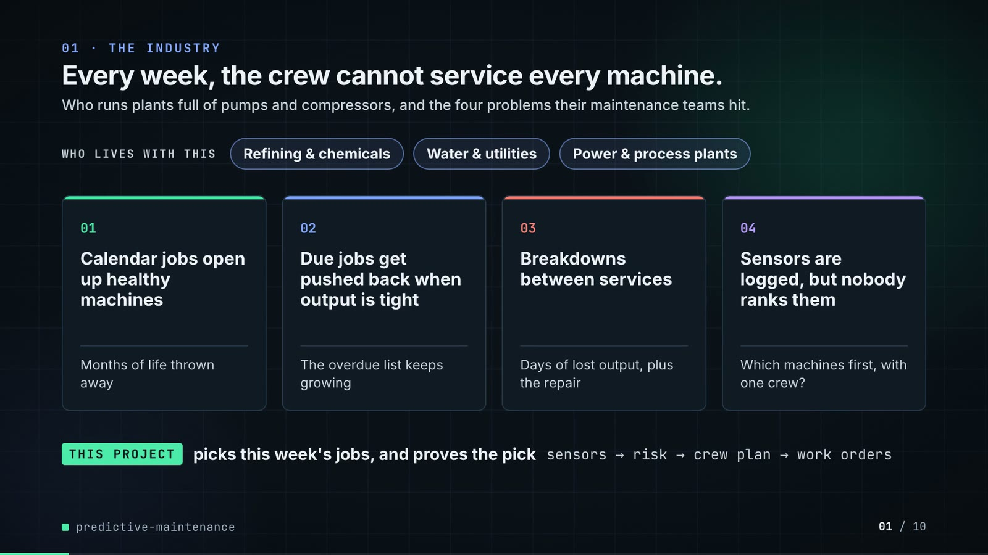
On-screen text (verbatim)
01 · THE INDUSTRY
Every week, the crew cannot service every machine.
Who runs plants full of pumps and compressors, and the four problems their maintenance teams hit.
WHO LIVES WITH THIS · Refining & chemicals · Water & utilities · Power & process plants
01 Calendar jobs open up healthy machines — Months of life thrown away
02 Due jobs get pushed back when output is tight — The overdue list keeps growing
03 Breakdowns between services — Days of lost output, plus the repair
04 Sensors are logged, but nobody ranks them — Which machines first, with one crew?
THIS PROJECT picks this week's jobs, and proves the pick · sensors → risk → crew plan → work orders
Figures on this slide
ID | Shown | Source · key | Calculation | Check
F-01 | 3 industry chips | author's framing · - | - | manual
F-02 | 4 problem cards | README 'The problem' (problems 1-3) · README lines 10-22 | - | ✓

Assumptions: A-10
Illustrative, not data:
• The whole slide is context; no repo figures.
To change this slide: Edit the chips (#ctx-c1..3) and cards (#ctx-k1..4) in compositions/s01-context.html.

Slide 02: This project
6.8-11.6 s · composition compositions/s02-hook.html
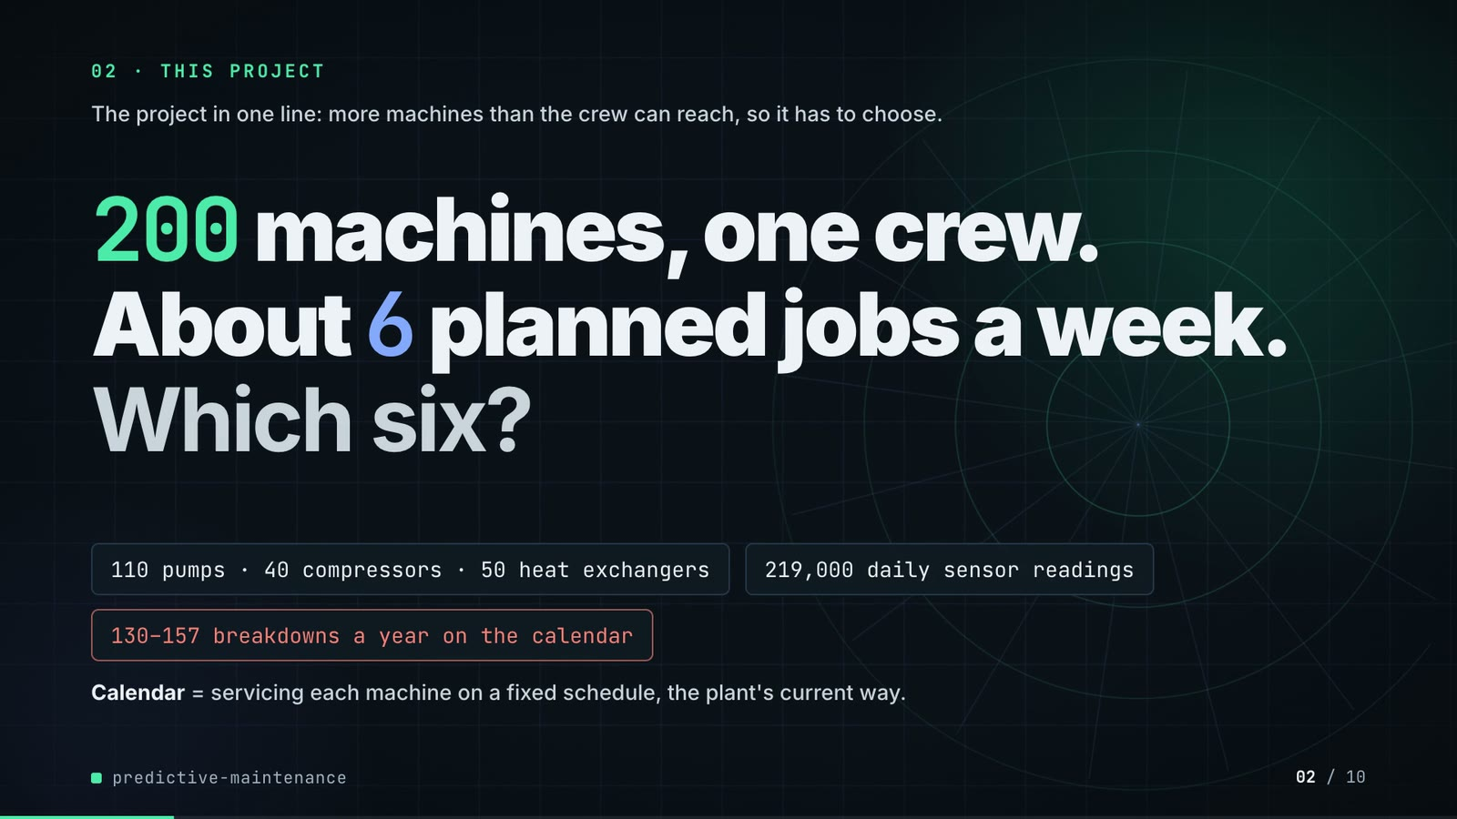
On-screen text (verbatim)
02 · THIS PROJECT
The project in one line: more machines than the crew can reach, so it has to choose.
200 machines, one crew. About 6 planned jobs a week. Which six?
110 pumps · 40 compressors · 50 heat exchangers · 219,000 daily sensor readings · 130–157 breakdowns a year on the calendar
Calendar = servicing each machine on a fixed schedule, the plant's current way.
Figures on this slide
ID | Shown | Source · key | Calculation | Check
F-03 | 200 machines | data/assets.csv · row count | - | ✓
F-04 | About 6 planned jobs a week / crew 6 jobs / week | outputs/results.json · crew_jobs_per_week | - | ✓
F-05 | 110 pumps · 40 compressors · 50 heat exchangers | data/assets.csv · asset_type counts | - | ✓
F-06 | 219,000 daily sensor readings / .csv.gz · 219,000 | data/sensor_readings.csv.gz · row count | - | ✓
F-07 | 130–157 breakdowns a year on the calendar | data/maintenance_log.csv · kind=corrective per year: 143, 130, 157 | min..max of yearly corrective counts | ✓

Assumptions: A-01, A-04
Illustrative, not data:
• Rings in the background are decoration.
• 'one crew': the scheduler treats the crew as one pool (README 'Known limitations').
To change this slide: Headline spans #hook-l1..l3 and chips #hook-f1..f3 in compositions/s02-hook.html; plant size is config.py ASSET_TYPES.

Slide 03: How it works (white chapter, slide A)
11.3-18.7 s · composition compositions/explainer.html (CONFIG.blocks, CONFIG.groups, CONFIG.loop)
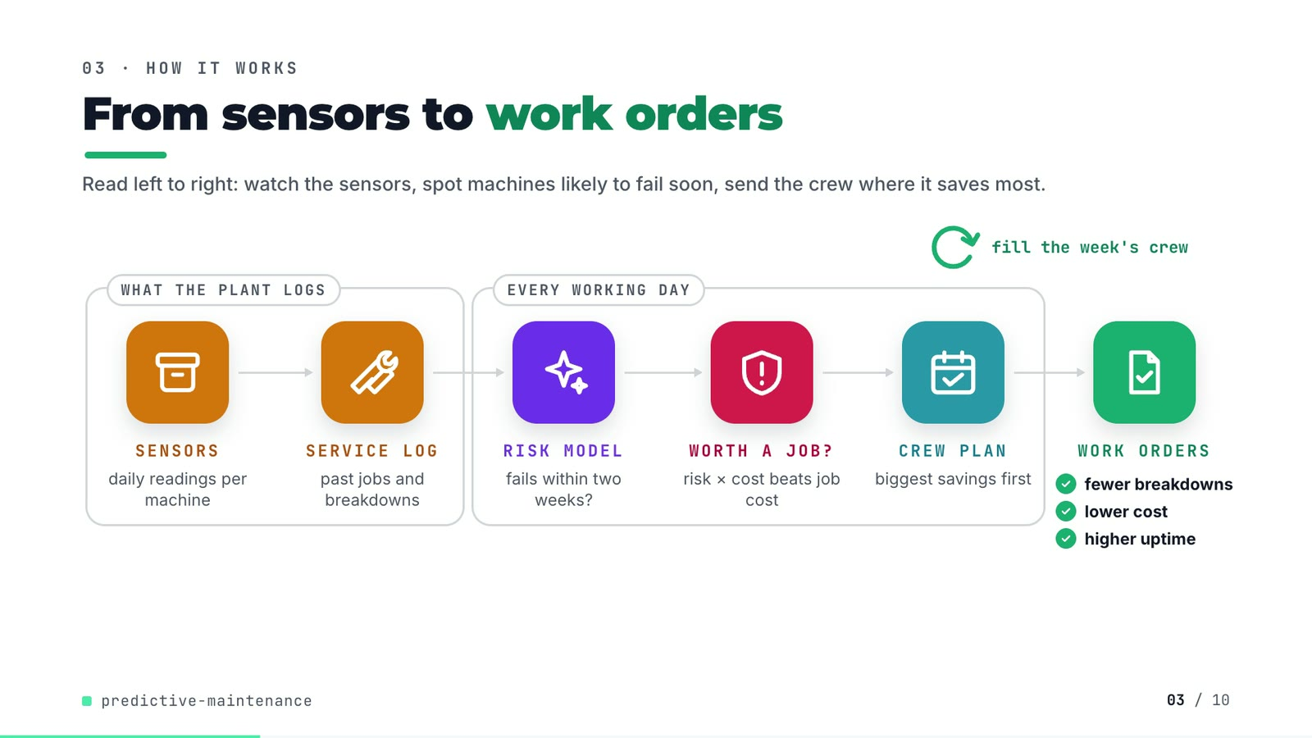
On-screen text (verbatim)
03 · HOW IT WORKS
From sensors to work orders
Read left to right: watch the sensors, spot machines likely to fail soon, send the crew where it saves most.
[WHAT THE PLANT LOGS: SENSORS daily readings per machine → SERVICE LOG past jobs and breakdowns] → [EVERY WORKING DAY: RISK MODEL fails within two weeks? → WORTH A JOB? risk × cost beats job cost → CREW PLAN biggest savings first] → WORK ORDERS ✓ fewer breakdowns ✓ lower cost ✓ higher uptime
fill the week's crew (loop over the crew plan)
Figures on this slide
ID | Shown | Source · key | Calculation | Check
F-08 | SENSORS · SERVICE LOG · RISK MODEL · WORTH A JOB? · CREW PLAN · WORK ORDERS | src/predictive_maintenance/ · functions | - | ✓
F-09 | fewer breakdowns / lower cost / higher uptime | outputs/results.json closed_loop · gbm-sensors vs fixed-interval at crew 6 | failures, cost_total lower; uptime higher | ✓
F-10 | EVERY WORKING DAY | src/predictive_maintenance/config.py:107 · working_days = (0..4) | - | ✓

Assumptions: A-03, A-04, A-05
Illustrative, not data:
• Icons and colours are a visual language, not data.
To change this slide: Edit CONFIG in compositions/explainer.html; badge truth is F-09.

Slide 04: The key idea (white chapter, slide B)
18.7-26.3 s · composition compositions/explainer.html (#ex-b ..., LOOP block injected by tools/inject_sheet.py)
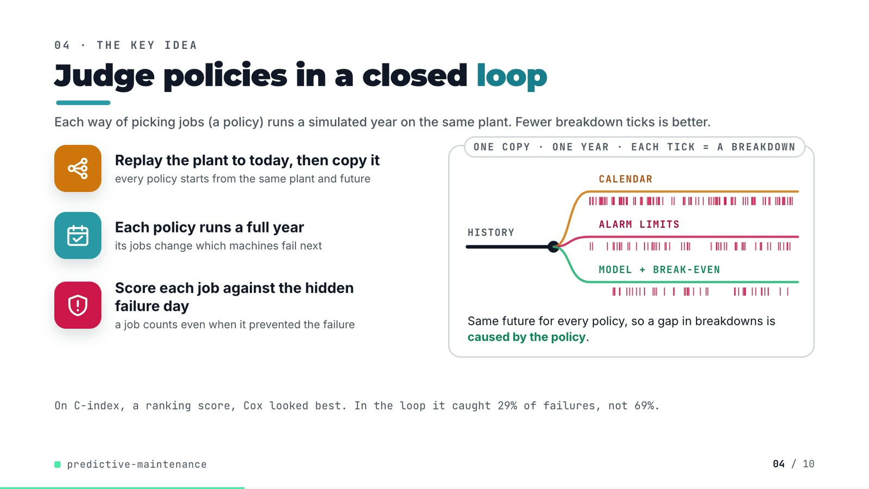
On-screen text (verbatim)
04 · THE KEY IDEA
Judge policies in a closed loop
Each way of picking jobs (a policy) runs a simulated year on the same plant. Fewer breakdown ticks is better.
Replay the plant to today, then copy it — every policy starts from the same plant and future
Each policy runs a full year — its jobs change which machines fail next
Score each job against the hidden failure day — a job counts even when it prevented the failure
ONE COPY · ONE YEAR · EACH TICK = A BREAKDOWN: HISTORY → CALENDAR / ALARM LIMITS / MODEL + BREAK-EVEN
Same future for every policy, so a gap in breakdowns is caused by the policy.
On C-index, a ranking score, Cox looked best. In the loop it caught 29% of failures, not 69%.
Figures on this slide
ID | Shown | Source · key | Calculation | Check
F-11 | Replay the plant to today, then fork it | src/predictive_maintenance/plant.py:281-293; tests/test_plant.py:48 · fork(); test_fork_gives_every_policy_the_same_future | - | ✓
F-12 | Each policy runs a full year | src/predictive_maintenance/cli.py (run_policy(..., DAYS_PER_YEAR, ...)); config.py:13 · DAYS_PER_YEAR = 365 | - | ✓
F-13 | tick barcodes (no numbers) | demo assets/plant_run.json (export_work_orders.py); outputs/closed_loop_runs.csv · LOOP block in compositions/explainer.html | number of ticks per branch = failures for seed 101, crew 6 | ✓
F-16 | 29% | outputs/results.json closed_loop · cox-sensors, crew 6, failures_caught_share (0.2929) | x100, rounded | ✓
F-17 | 69% | outputs/results.json closed_loop · gbm-sensors, crew 6, failures_caught_share (0.6868) | x100, rounded | ✓

Assumptions: A-07, A-08
Illustrative, not data:
• The fork drawing is schematic; tick positions are the real failure days of fork 1 (seed 101), scaled to the branch length.
To change this slide: Markup under #ex-b in compositions/explainer.html; ticks come from tools/inject_sheet.py (LOOP block); footnote figures are F-16, F-17.

Slide 05: Architecture
26.0-40.8 s · composition compositions/s03-architecture.html
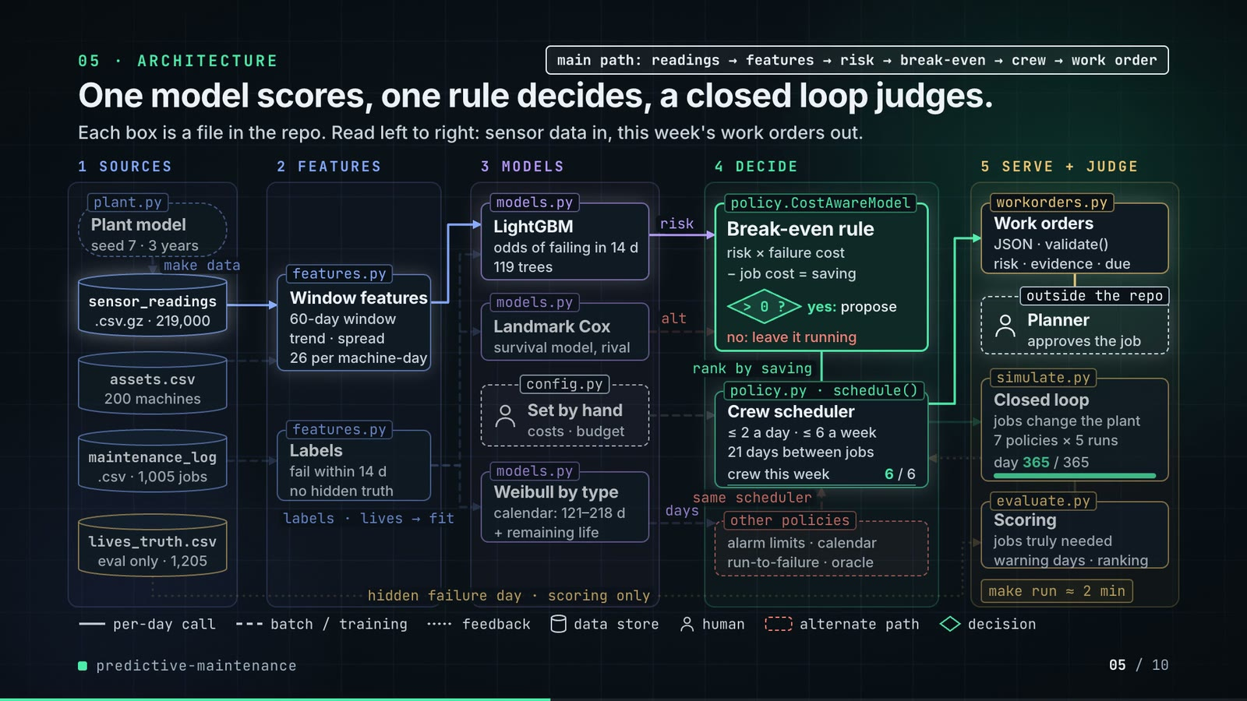
On-screen text (verbatim)
05 · ARCHITECTURE
One model scores, one rule decides, a closed loop judges.
Each box is a file in the repo. Read left to right: sensor data in, this week's work orders out.
1 SOURCES: plant.py Plant model (seed 7 · 3 years) → make data → sensor_readings .csv.gz · 219,000 · assets.csv 200 machines · maintenance_log .csv · 1,005 jobs · lives_truth.csv eval only · 1,205
2 FEATURES: features.py Window features (60-day window · trend · spread · 26 per machine-day) · features.py Labels (fail within 14 d · no hidden truth) · labels · lives → fit
3 MODELS: models.py LightGBM (odds of failing in 14 d · 119 trees) · models.py Landmark Cox (survival model, rival) · config.py Set by hand (costs · budget) · models.py Weibull by type (calendar: 121–218 d · + remaining life)
4 DECIDE: policy.CostAwareModel Break-even rule (risk × failure cost − job cost = saving; > 0 ? yes: propose; no: leave it running) → rank by saving → policy.py · schedule() Crew scheduler (≤ 2 a day · ≤ 6 a week · 21 days between jobs · crew this week 0..6 / 6) · other policies (alarm limits · calendar · run-to-failure · oracle) → same scheduler
5 SERVE + JUDGE: workorders.py Work orders (JSON · validate() · risk · evidence · due) → Planner (outside the repo · approves the job) · simulate.py Closed loop (jobs change the plant · 7 policies × 5 runs · day 0..365 / 365) → evaluate.py Scoring (jobs truly needed · warning days · ranking) · make run ≈ 2 min
hidden failure day · scoring only (lives_truth.csv → Scoring)
main path: readings → features → risk → break-even → crew → work order
Legend: per-day call · batch / training · feedback · data store · human · alternate path · decision
Figures on this slide
ID | Shown | Source · key | Calculation | Check
F-03 | 200 machines | data/assets.csv · row count | - | ✓
F-06 | 219,000 daily sensor readings / .csv.gz · 219,000 | data/sensor_readings.csv.gz · row count | - | ✓
F-18 | seed 7 · 3 years | src/predictive_maintenance/cli.py (--data-seed default 7); config.py:14 · HISTORY_YEARS = 3 | - | ✓
F-19 | .csv · 1,005 jobs | data/maintenance_log.csv · row count | - | ✓
F-20 | eval only · 1,205 | data/lives_truth.csv · row count | - | ✓
F-21 | observable only | src/predictive_maintenance/features.py (_labels); tests/test_features.py:33 · test_labels_drop_rows_a_preventive_job_hides | - | ✓
F-22 | plant.py, features.py, models.py (LightGBM, Cox, Weibull, AFT), config.py, policy.py (CostAwareModel, schedule, other policies), workorders.py, simulate.py, evaluate.py | src/predictive_maintenance/ · classes and functions | - | ✓
F-23 | 60-day window | src/predictive_maintenance/config.py:19 · WINDOW_DAYS = 60 | - | ✓
F-24 | 26 per asset-day | src/predictive_maintenance/features.py:20-28 (FEATURE_NAMES) · 5 sensors x 4 + load_m7 + load_rel3 + days_since_maint + 3 type flags | 5 x 4 + 3 + 3 = 26 | ✓
F-25 | p(fail ≤ 14 d) / fail within 14 d / p(14 d) | outputs/results.json · horizon_days | - | ✓
F-26 | 119 trees | outputs/results.json · training.best_iteration | - | ✓
F-27 | calendar: 121–218 d | outputs/results.json · fixed_intervals_days (pump 187, compressor 121, heat exchanger 218) | min–max of the three intervals | ✓
F-28 | saving = p·C_fail − C_job; > 0 ? yes: propose | src/predictive_maintenance/policy.py:109-110 · saving = p * FAILURE_COST - PLANNED_COST; propose where saving > 0 | - | ✓
F-29 | ≤ 2 a day · ≤ 6 a week · 21-day cooldown | src/predictive_maintenance/policy.py:144-145; config.py:20, :106-107 · per_day = ceil(6 / 5); COOLDOWN_DAYS = 21 | ceil(6/5) = 2 | ✓
F-30 | 7 policies × 5 runs | outputs/closed_loop_runs.csv · distinct policies at crew 6; distinct seeds (forks) | - | ✓
F-31 | make run ≈ 2 min / ~2 min | outputs/results.json · runtime_seconds = 127.3 | 127.3 / 60 = 2.1 min | ✓
F-32 | Planner · accept → CMMS | src/predictive_maintenance/workorders.py:1-5 (docstring); README 'Known limitations' (schema mapping not done) · - | - | ✓

Assumptions: A-01, A-03, A-04, A-05, A-07, A-08
Illustrative, not data:
• Packets moving along the wires are decoration; the day counter and crew bar animate the loop, they are not timings.
• Arrows are the main data flows, not every call (e.g. days since service from the maintenance log into the features is not drawn).
To change this slide: Node boxes (#n-*) and the wires array in compositions/s03-architecture.html.

Slide 06: The system running
40.4-55.0 s · composition compositions/s04-running.html (RUN block injected by tools/inject_sheet.py)
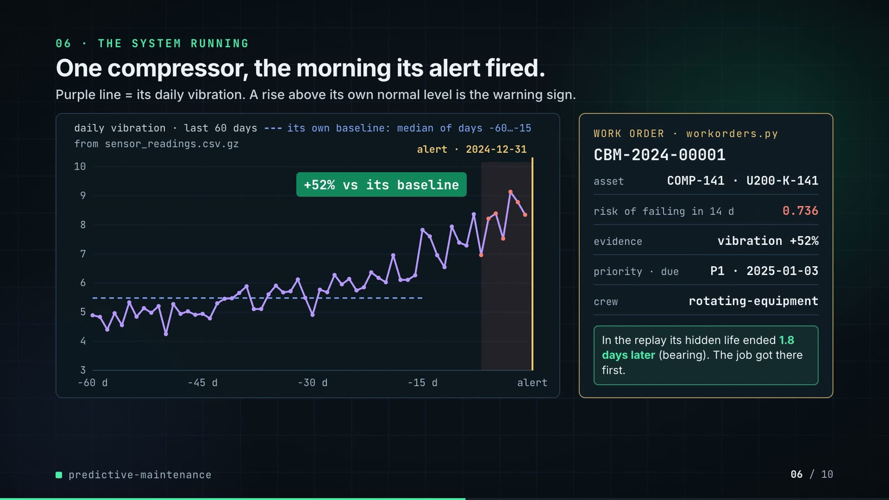
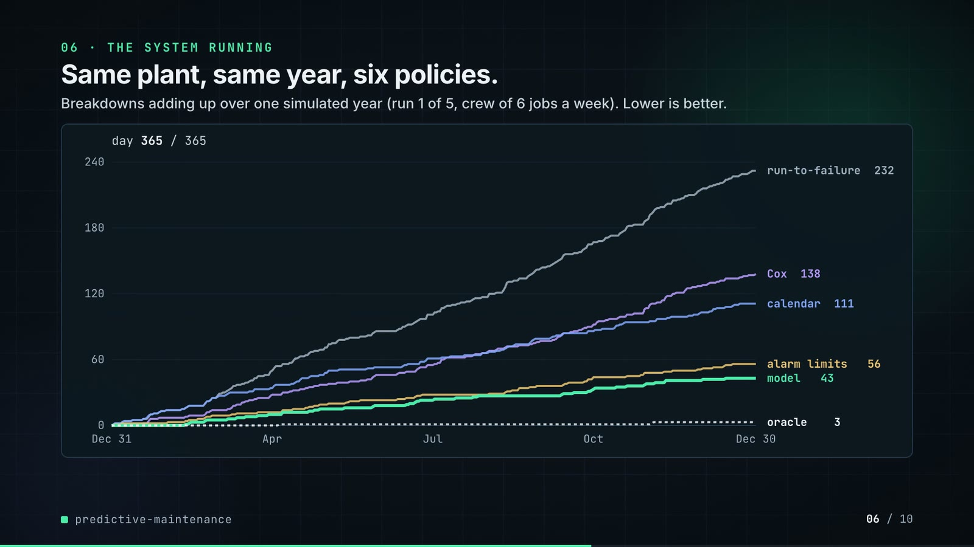
On-screen text (verbatim)
06 · THE SYSTEM RUNNING
One compressor, the morning its alert fired. — Purple line = its daily vibration. A rise above its own normal level is the warning sign. — daily vibration · last 60 days · from sensor_readings.csv.gz · its own baseline: median of days −60…−15 · +52% vs its baseline · alert · 2024-12-31
WORK ORDER · workorders.py CBM-2024-00001 · asset COMP-141 · U200-K-141 · risk of failing in 14 d 0.736 · evidence vibration +52% · priority · due P1 · 2025-01-03 · crew rotating-equipment
In the replay its hidden life ended 1.8 days later (bearing). The job got there first.
Same plant, same year, six policies. — Breakdowns adding up over one simulated year (run 1 of 5, crew of 6 jobs a week). Lower is better. · day 0..365 / 365
run-to-failure 232 · Cox 138 · calendar 111 · alarm limits 56 · model 43 · oracle 3
Figures on this slide
ID | Shown | Source · key | Calculation | Check
F-25 | p(fail ≤ 14 d) / fail within 14 d / p(14 d) | outputs/results.json · horizon_days | - | ✓
F-33 | daily vibration · last 60 days (line chart) | data/sensor_readings.csv.gz; demo assets/plant_run.json trace · asset_id = COMP-141, 2024-11-01..2024-12-30 | values compared to 3 decimals | ✓
F-34 | alert · 2024-12-31 | outputs/work_orders.json · [0].created_on | - | ✓
F-35 | +52% vs its baseline / vibration +52% | outputs/work_orders.json · [0].evidence[0] = vibration, 0.521 | x100, rounded | ✓
F-36 | CBM-2024-00001 · COMP-141 · U200-K-141 · 0.736 · P1 · 2025-01-03 · rotating-equipment | outputs/work_orders.json · [0] | - | ✓
F-37 | hidden life ended 1.8 days later (bearing) | demo assets/plant_run.json work_orders[0].truth (Plant.latent_remaining at the alert, fork seed 101); corroborated by data/lives_truth.csv (the same life, in the history run, ended by a bearing failure on day 731) · latent_days_to_failure, latent_mode | - | ✓
F-38 | 232 · 138 · 111 · 56 · 43 · 3 | outputs/closed_loop_runs.csv (seed 101, crew 6); curves from demo assets/plant_run.json · failures | - | ✓
F-39 | run 1 of 5 | src/predictive_maintenance/config.py:108; demo assets/plant_run.json seed · eval_seeds[0] = 101 | - | ✓

Assumptions: A-02, A-05, A-07, A-08
Illustrative, not data:
• Charts are drawn from exported numbers (the repo saves no plots): the trace is read from sensor_readings.csv.gz and the curves are recorded by tools/export_work_orders.py with the repo's own schedule() and Plant.step(); their year-end totals are checked against closed_loop_runs.csv (F-38).
• Baseline line is recomputed in the composition as the window median of days −60…−15, the definition in features.py.
To change this slide: Phase A/B markup and the RUN block in compositions/s04-running.html; re-run export_work_orders.py + inject_sheet.py after make run.

Slide 07: End-user value (white)
54.7-67.7 s · composition compositions/value.html (SHEET block injected by tools/inject_sheet.py)
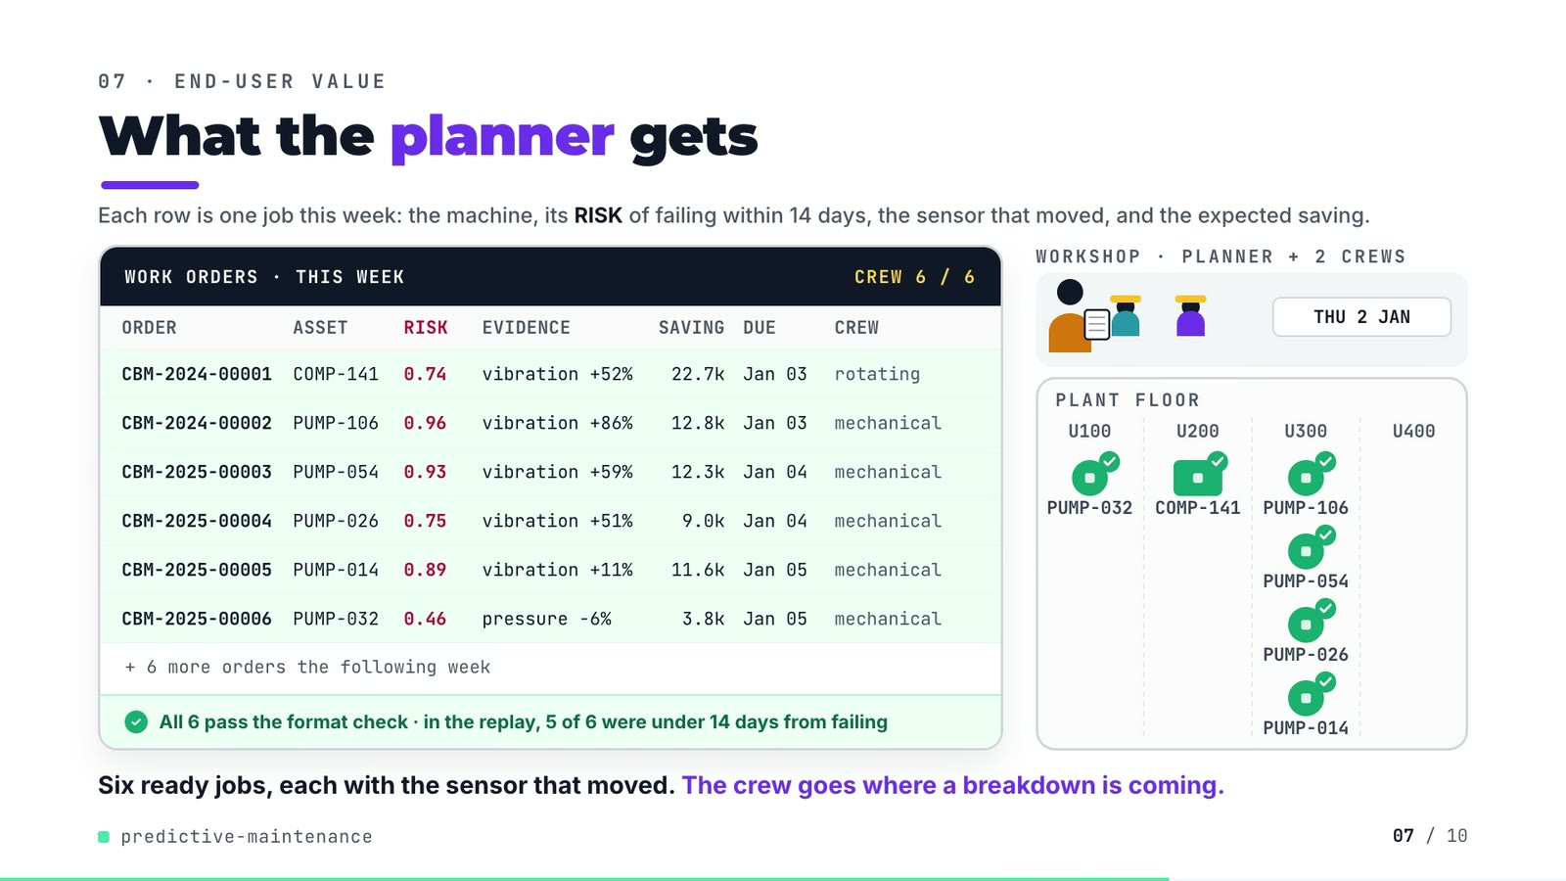
On-screen text (verbatim)
07 · END-USER VALUE
What the planner gets
Each row is one job this week: the machine, its RISK of failing within 14 days, the sensor that moved, and the expected saving.
WORK ORDERS · THIS WEEK · CREW 6 / 6 — columns ORDER, ASSET, RISK, EVIDENCE, SAVING, DUE, CREW
CBM-2024-00001 COMP-141 0.74 vibration +52% 22.7k Jan 03 rotating
CBM-2024-00002 PUMP-106 0.96 vibration +86% 12.8k Jan 03 mechanical
CBM-2025-00003 PUMP-054 0.93 vibration +59% 12.3k Jan 04 mechanical
CBM-2025-00004 PUMP-026 0.75 vibration +51% 9.0k Jan 04 mechanical
CBM-2025-00005 PUMP-014 0.89 vibration +11% 11.6k Jan 05 mechanical
CBM-2025-00006 PUMP-032 0.46 pressure -6% 3.8k Jan 05 mechanical
+ 6 more orders the following week · ✓ All 6 pass the format check · in the replay, 5 of 6 were under 14 days from failing
WORKSHOP · PLANNER + 2 CREWS · TUE 31 DEC / WED 1 JAN / THU 2 JAN · PLANT FLOOR U100 U200 U300 U400
Six ready jobs, each with the sensor that moved. The crew goes where a breakdown is coming.
Figures on this slide
ID | Shown | Source · key | Calculation | Check
F-35 | +52% vs its baseline / vibration +52% | outputs/work_orders.json · [0].evidence[0] = vibration, 0.521 | x100, rounded | ✓
F-40 | CBM-2024-00001 … CBM-2025-00006 | outputs/work_orders.json [0:6], injected into compositions/value.html · work_order_id, asset_id, failure_probability, evidence[0], expected_saving, due_by, crew | p to 2 dp; saving / 1000 to 1 dp; crew shortened (rotating-equipment → rotating) | ✓
F-41 | + 6 more orders the following week | outputs/results.json · work_orders_first_two_weeks = 12 | 12 - 6 | ✓
F-42 | All 6 pass the format check (validate()) | src/predictive_maintenance/cli.py (assert not bad); tools/export_work_orders.py asserts the same · validate() | - | ✓
F-43 | 5 of 6 were under 14 days from failing | demo assets/plant_run.json work_orders[0:6].truth · latent_days_to_failure: 1.8, 0.3, 5.0, 11.0, 3.3, 18.1 | count(0 < d <= 14) | ✓
F-44 | CREW 6 / 6 | outputs/work_orders.json · orders created 2024-12-30..2025-01-03 | count | ✓
F-45 | TUE 31 DEC · WED 1 JAN · THU 2 JAN | outputs/work_orders.json · created_on of orders 1-6 | - | ✓

Assumptions: A-03, A-04, A-08, A-09
Illustrative, not data:
• Planner, the two crews (the repo has one crew pool with typed crew labels), hard hats, machine drawings and walking speed are illustrative.
• Machines are placed in the unit from their functional location (U100-U400); positions inside a unit are not real.
• SAVING is the model's expected saving (p x failure cost - planned cost), not a realised saving.
• '5 of 6' uses the plant's latent truth, which a real planner would not see.
To change this slide: Re-run tools/export_work_orders.py, then tools/inject_sheet.py (--rows picks the orders); layout in compositions/value.html.

Slide 08: Results
67.4-76.2 s · composition compositions/s05-results.html (stats array)
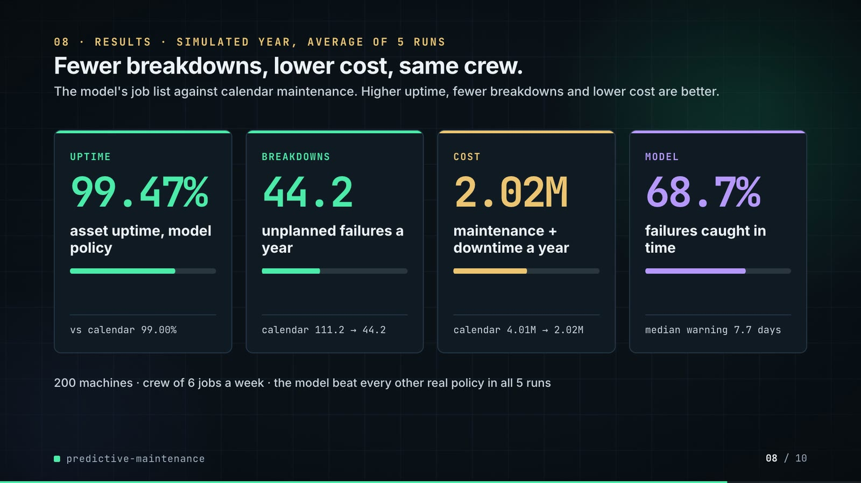
On-screen text (verbatim)
08 · RESULTS · SIMULATED YEAR, AVERAGE OF 5 RUNS
Fewer breakdowns, lower cost, same crew.
The model's job list against calendar maintenance. Higher uptime, fewer breakdowns and lower cost are better.
UPTIME 99.47% asset uptime, model policy · vs calendar 99.00%
BREAKDOWNS 44.2 unplanned failures a year · calendar 111.2 → 44.2
COST 2.02M maintenance + downtime a year · calendar 4.01M → 2.02M
MODEL 68.7% failures caught in time · median warning 7.7 days
200 machines · crew of 6 jobs a week · the model beat every other real policy in all 5 runs
Figures on this slide
ID | Shown | Source · key | Calculation | Check
F-03 | 200 machines | data/assets.csv · row count | - | ✓
F-04 | About 6 planned jobs a week / crew 6 jobs / week | outputs/results.json · crew_jobs_per_week | - | ✓
F-46 | 99.47% | outputs/results.json closed_loop · gbm-sensors, crew 6, uptime | x100 | ✓
F-47 | vs calendar 99.00% | outputs/results.json closed_loop · fixed-interval, crew 6, uptime | x100 | ✓
F-49 | 44.2 | outputs/results.json closed_loop · gbm-sensors, crew 6, failures | - | ✓
F-50 | calendar 111.2 | outputs/results.json closed_loop · fixed-interval, crew 6, failures | - | ✓
F-51 | 2.02M | outputs/results.json closed_loop · gbm-sensors, crew 6, cost_total = 2,015,700 | / 1e6 | ✓
F-52 | 4.01M | outputs/results.json closed_loop · fixed-interval, crew 6, cost_total = 4,009,400 | / 1e6 | ✓
F-53 | 68.7% | outputs/results.json closed_loop · gbm-sensors, crew 6, failures_caught_share | x100 | ✓
F-54 | median warning 7.7 days | outputs/results.json closed_loop · gbm-sensors, crew 6, median_lead_days | - | ✓
F-55 | the model beat every other real policy in all 5 runs | outputs/results.json · paired_gbm_minus.*.seeds_gbm_better_uptime | all == 5 | ✓

Assumptions: A-03, A-04, A-06, A-07, A-09
Illustrative, not data:
• Mini bars: uptime bar = model gain / oracle gain over calendar (0.47 / 0.66); failures and cost bars = after / before; caught bar = 68.7%.
To change this slide: The stats array and card text in compositions/s05-results.html.

Slide 09: Lesson and fix
75.8-84.8 s · composition compositions/s06-twist.html
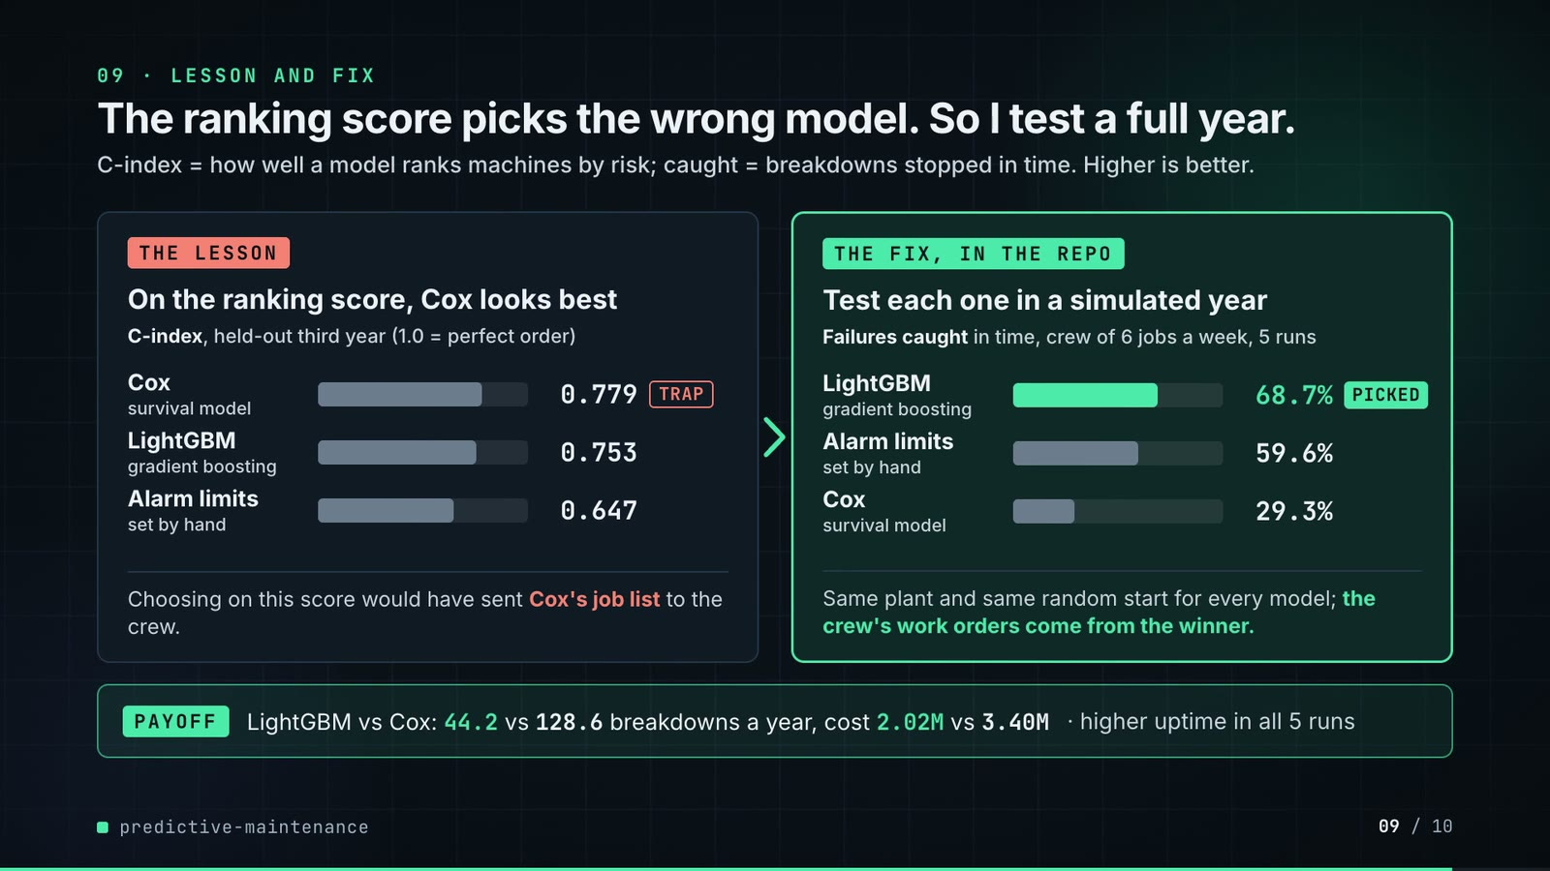
On-screen text (verbatim)
09 · LESSON AND FIX
The ranking score picks the wrong model. So I test a full year.
C-index = how well a model ranks machines by risk; caught = breakdowns stopped in time. Higher is better.
THE LESSON · On the ranking score, Cox looks best · C-index, held-out third year (1.0 = perfect order) · Cox (survival model) 0.779 TRAP · LightGBM (gradient boosting) 0.753 · Alarm limits (set by hand) 0.647 · Choosing on this score would have sent Cox's job list to the crew.
THE FIX, IN THE REPO · Test each one in a simulated year · Failures caught in time, crew of 6 jobs a week, 5 runs · LightGBM 68.7% PICKED · Alarm limits 59.6% · Cox 29.3% · Same plant and same random start for every model; the crew's work orders come from the winner.
PAYOFF · LightGBM vs Cox: 44.2 vs 128.6 breakdowns a year, cost 2.02M vs 3.40M · higher uptime in all 5 runs
Figures on this slide
ID | Shown | Source · key | Calculation | Check
F-14 | 0.779 | outputs/results.json · offline.policies.cox-sensors.c_index | - | ✓
F-15 | 0.753 | outputs/results.json · offline.policies.gbm-sensors.c_index | - | ✓
F-49 | 44.2 | outputs/results.json closed_loop · gbm-sensors, crew 6, failures | - | ✓
F-51 | 2.02M | outputs/results.json closed_loop · gbm-sensors, crew 6, cost_total = 2,015,700 | / 1e6 | ✓
F-53 | 68.7% | outputs/results.json closed_loop · gbm-sensors, crew 6, failures_caught_share | x100 | ✓
F-64 | 0.647 | outputs/results.json · offline.policies.alarm-limits.c_index | - | ✓
F-65 | 29.3% | outputs/results.json closed_loop · cox-sensors, crew 6, failures_caught_share | x100 | ✓
F-66 | 59.6% | outputs/results.json closed_loop · alarm-limits, crew 6, failures_caught_share | x100 | ✓
F-67 | 128.6 | outputs/results.json closed_loop · cox-sensors, crew 6, failures | - | ✓
F-68 | 3.40M | outputs/results.json closed_loop · cox-sensors, crew 6, cost_total | / 1e6 | ✓
F-69 | higher uptime in all 5 runs | outputs/results.json · paired_gbm_minus.cox-sensors.seeds_gbm_better_uptime | == 5 | ✓
F-70 | Test each one in a simulated year · same plant and same random start · the crew's work orders come from the winner · PICKED | src/predictive_maintenance/cli.py (closed_loop, build(... 'gbm-sensors')); simulate.py (run_policy); tests/test_plant.py (test_fork_gives_every_policy_the_same_future); docs/adr/0001-judge-policies-in-closed-loop.md; README design decision 'Which risk model drives the crew' · - | - | ✓

Assumptions: A-07, A-08, A-09
Illustrative, not data:
• Bars share one scale in both panels: 260 px track = 1.0 (C-index) or 100% (failures caught). Grey bars are the options compared; mint marks the picked policy; coral only labels the trap.
• 'PICKED' is the author's choice recorded in the README design decisions and enforced in cli.py, where the work orders are built from gbm-sensors; the code does not pick the model automatically.
To change this slide: Rows #twist-l1..l3 and #twist-r1..r3 (bar widths are inline styles), notes and payoff in compositions/s06-twist.html.

Slide 10: End card
84.4-88.8 s · composition compositions/s07-end.html
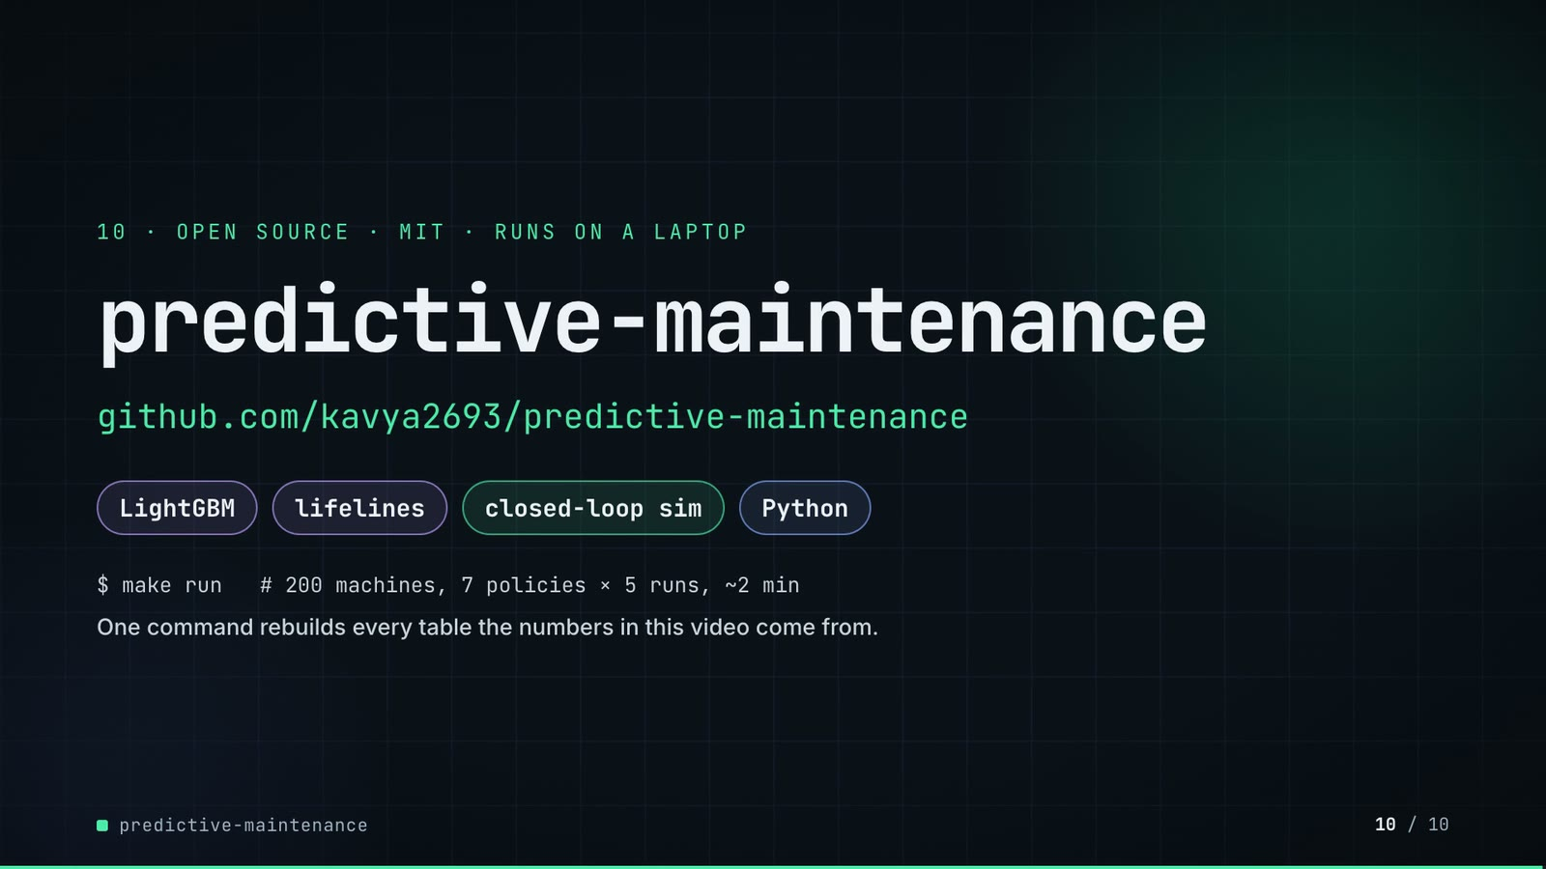
On-screen text (verbatim)
10 · OPEN SOURCE · MIT · RUNS ON A LAPTOP
predictive-maintenance
github.com/kavya2693/predictive-maintenance
LightGBM · lifelines · closed-loop sim · Python
$ make run # 200 machines, 7 policies × 5 runs, ~2 min
One command rebuilds every table the numbers in this video come from.
Figures on this slide
ID | Shown | Source · key | Calculation | Check
F-30 | 7 policies × 5 runs | outputs/closed_loop_runs.csv · distinct policies at crew 6; distinct seeds (forks) | - | ✓
F-31 | make run ≈ 2 min / ~2 min | outputs/results.json · runtime_seconds = 127.3 | 127.3 / 60 = 2.1 min | ✓
F-61 | MIT | LICENSE line 1 · - | - | ✓
F-62 | LightGBM · lifelines · closed-loop sim · Python | pyproject.toml dependencies; src/predictive_maintenance/simulate.py · lightgbm, lifelines | - | ✓
F-63 | $ make run | Makefile · run target | - | ✓

Assumptions: A-09
To change this slide: Text in compositions/s07-end.html.

5. Change-impact matrix
Input / assumption | Affected figures | Slides | Files to edit | Re-run
A-01: All data is synthetic: a seeded day-by-day plant model (200 assets, 3 years) generates the sensor history, the maintenance log and the latent lives | all figures | 01, 02, 03, 04, 05, 06, 07, 08, 09, 10 | src/predictive_maintenance/config.py; src/predictive_maintenance/plant.py | make data; make run; export_work_orders.py + inject_sheet.py
A-02: Failure precursors: each failure mode drifts the sensors for a mode-specific number of days before the failure (bearing 21 d, fouling 35 d, overheating 4 d, | F-17, F-34, F-35, F-37, F-53, F-54 | 04, 06, 07, 08, 09 | src/predictive_maintenance/config.py:93-101 | make data; make run; export_work_orders.py + inject_sheet.py
A-03: Costs: a planned job costs 1,500 plus one day of downtime; a failure costs its repair (9k pump, 22k compressor, 12k heat exchanger) plus 3-5 days of downtime at 3,000 a day | F-28, F-40, F-51, F-52 | 05, 07, 08, 09 | src/predictive_maintenance/config.py:32-34 and the AssetType blocks | make run; export_work_orders.py + inject_sheet.py
A-04: Crew budget: 6 planned jobs a week, Monday to Friday, at most ceil(6/5) = 2 a day; an asset serviced in the last 21 days is not offered again | F-04, F-29, F-44, F-45, F-46, F-49, F-51, F-53 | 02, 05, 07, 08, 09 | src/predictive_maintenance/config.py:106, :20 | make run; export_work_orders.py + inject_sheet.py
A-05: Prediction horizon 14 days, feature window 60 days, baseline = window median excluding the last 14 days | F-23, F-25, F-34, F-35 | 05, 06, 07 | src/predictive_maintenance/config.py:18-19; src/predictive_maintenance/features.py:18 | make run; export_work_orders.py + inject_sheet.py
A-06: Every job is a perfect repair (the asset is as good as new); imperfect repair and infant mortality are not modelled | F-46, F-49, F-51, F-53 | 08, 09 | src/predictive_maintenance/plant.py | make run
A-07: Closed-loop evaluation: the plant is replayed to the end of the 2-year training history (2024-12-31), forked with seeds 101-105, and each policy runs 365 days from the same fork with the same random stream | F-11, F-12, F-13, F-30, F-38, F-39, F-46, F-47, F-49, F-50, F-51, F-52, F-53, F-54, F-55, F-65, F-66, F-67, F-68, F-69, F-70 | 04, 05, 06, 08, 09, 10 | src/predictive_maintenance/config.py:108 | make run; export_work_orders.py + inject_sheet.py
A-08: Truth for scoring: an alert is a catch when the asset's latent life would have ended within 14 days; the latent failure day comes from the plant model (lives_truth | F-16, F-17, F-37, F-43, F-53, F-65, F-66 | 04, 06, 07, 08, 09 | src/predictive_maintenance/simulate.py | make run
A-09: Video rounding: uptime to 2 decimals, percentages to whole numbers or 1 decimal as shown, costs in millions to 2 decimals, savings in thousands to 1 decimal, failure probability to 2 decimals on the sheet (3 on the work-order card), failure means to 1 decimal or whole numbers as shown | F-07, F-14, F-15, F-16, F-17, F-31, F-35, F-40, F-46, F-47, F-49, F-50, F-51, F-52, F-53, F-54, F-64, F-65, F-66, F-67, F-68 | 02, 04, 05, 06, 07, 08, 09, 10 | the composition file named on each slide | hyperframes render
A-10: Slide 01 (industries, everyday problems) is general maintenance knowledge used as context; it is not a result of this repo and carries no numbers | F-01, F-02 | 01 | compositions/s01-context.html | hyperframes render

6. Known differences and caveats
• The biggest gap (README): the same plant model generated the training data and runs the evaluation, so every result says the method works on a plant with these physics, not what it would achieve on a given real plant.
• Slides 04 and 06 show one fork (seed 101); slides 08-09 show the mean of five forks. Seed-101 totals (e.g. model 43 failures) differ from the 5-fork means (44.2).
• 'Hidden life ended 1.8 days later' and '5 of 6 under 14 days from failing' use the plant's latent truth (Plant.latent_remaining), which exists only in simulation.
• Expected saving on the sheet is the model's own estimate (p x failure cost - planned cost); it is not a realised saving.
• The repo saves no plots; slide 06 charts are drawn from exported numbers (F-33, F-38), not from matplotlib output.
• On screen, 'runs' means the 5 closed-loop forks (seeds 101-105); 'simulated year' means one 365-day closed-loop run from a fork.
• Dropped from slide 09 in this version (README 'What disappoints' still reports both): hand-set alarm limits get most of the way (the model adds +0.17 pp uptime over them, +0.47 pp over the calendar), and sudden failures are untouched (1 of 189 caught; 38 of the 44 breakdowns a year that remain). The repo implements no fix for either; README 'Known limitations' and 'Insights' name the next steps (vibration spectra, an inspect-or-repair policy).
• Slide 09's fix is about how the model was chosen (closed-loop year vs C-index); the C-index figures are offline on the held-out third year, the failures-caught figures are closed-loop means of 5 forks at crew 6.
• Precision at budget (46%) is not on screen: half the model's jobs land on an asset that would not have failed inside 14 days (README 'What disappoints').
• Slide 01 statements are general industry knowledge (A-10).

Appendix: environment
Item | Value
Commit | 70531ff3190a5ff2de81b5edc3ef1ee5888ae47c
Python | 3.11.7
lightgbm | 4.7.0
lifelines | 0.30.3
pandas | 2.3.3
numpy | 2.4.6
sklearn | 1.9.1
Profile / seeds | data_seed=7, closed_loop_seeds=101-105 (5 forks), fork_shown_on_slides_04_06=101, lightgbm_random_state=0
Run time | results.json runtime_seconds = 127.3 s (about 2 min) for make run on the author's laptop

