AUDIT REPORT

supply-chain-twin: demo video audit report
A slide-by-slide record of every number, assumption and calculation in the demo video, with its source.
Item | Value
Repository | https://github.com/kavya2693/supply-chain-twin
Numbers taken from commit | a4f50f5289cc8c298a8e842f8aadd139c609579c (outputs last changed in a4f50f5 (2026-10-13 19:09:20 +0400))
Video | docs/demo/demo.mp4 · 90.6 s · 1920x1080 · 30 fps · silent
Generated | 2026-10-14 14:16
Automated checks | 63 pass · 0 fail · 1 manual (of 64 figures)
Assumptions | 10 (A-01 to A-10)

How to use this report
Every number or claim on screen has an ID (F-01, F-02, ...) and every modelling assumption has an ID (A-01, ...). Cite the ID. Each figure lists its source file, the exact column, row or key, the formula for derived numbers, and an automated check result. The change-impact matrix (section 5) shows which slides and files change if an input or assumption changes.
Types: direct = read straight from a repo output; derived = computed from direct values (formula given); illustrative = drawing or example, not data; general knowledge = context not produced by the repo.

Regenerate
make run # data/ + outputs/*.csv|json (about 2.5 min on 4 cores)
python3 docs/demo/source/tools/export_search_walk.py docs/demo/source/assets/search_walk.json
PYTHONPATH=src .venv/bin/python docs/demo/source/tools/export_change_sheet.py docs/demo/source/assets/change_sheet.json
python3 docs/demo/source/tools/inject_sheet.py docs/demo/source/assets/search_walk.json docs/demo/source/compositions/s04-running.html --name WALK
python3 docs/demo/source/tools/inject_sheet.py docs/demo/source/assets/change_sheet.json docs/demo/source/compositions/value.html --name SHEET
cd docs/demo/source && npx --yes hyperframes@0.8.156 check && npx --yes hyperframes@0.8.156 render -f 30 -q looks -o renders/supply-chain-twin-master.mp4 && cd -
ffmpeg -y -i docs/demo/source/renders/supply-chain-twin-master.mp4 -c:v libx264 -preset slow -crf 25 -pix_fmt yuv420p -movflags +faststart -an docs/demo/demo.mp4
python3 docs/demo/source/tools/build_audit_report.py docs/demo/source/audit/facts.yaml # stills, checks, MD/DOCX/PDF

1. Figures
ID | Shown | Slides | Source | Column / row / key | How computed | Type | Check
F-01 | 3 industry chips | 01 | author's framing | - | - | general knowledge | manual: Context statement, not a repo output.
F-02 | 4 problem cards | 01 | README 'The problem', 'Why it is hard' | README lines 9-31 | - | general knowledge | ✓ verified
F-03 | 2 DCs | 02, 05, 10 | data/mms_locations.csv | distinct dc_id | - | direct | ✓ verified
F-04 | 36 stores | 02, 05, 08, 10 | outputs/data_quality.json | stores | - | direct | ✓ verified
F-05 | 26 trucks | 02, 10 | outputs/data_quality.json | trucks_dispatchable | 28 in source - 2 not dispatchable | direct | ✓ verified
F-06 | 3.1M order lines | 02, 05 | outputs/data_quality.json | order_lines = 3,126,764 | 3,126,764 / 1e6, 1 decimal | derived | ✓ verified
F-07 | 2 years | 02, 05 | src/supply_twin/calendar.py:12 | HISTORY_DAYS = 731 (2024-01-01..2025-12-31) | - | direct | ✓ verified
F-08 | 120 SKUs in 8 categories | 02, 05 | data/mms_items.csv; outputs/data_quality.json | skus; distinct category | - | direct | ✓ verified
F-09 | 91-day quarter × 30 paired seeds | 02 | src/supply_twin/sim.py:60; outputs/strategy_table.csv | horizon_days = 91; n_seeds | - | direct | ✓ verified
F-10 | the twin itself is 3.3% low / −3.3% demand bias | 02, 04 | outputs/fidelity.json | bias.twin = -0.0327 | x 100, 1 decimal | direct | ✓ verified
F-11 | SOURCE DATA → DIGITAL TWIN → PROPOSE → SIMULATE → FAIR TEST → DECISION | 03 | src/supply_twin/ | load_sources, build_twin, NeighbourProposer.propose, simulate, Evaluator.compare, search | - | direct | ✓ verified
F-12 | ✓ cheaper than today ✓ re-tested on new days ✓ weak spots shown | 03 | outputs/search_neighbour_promo.json; outputs/search_neighbour_promo_robustness.csv | holdout.cost_diff < 0; holdout.n_seeds = 30; any robustness row not accepted | - | derived | ✓ verified
F-13 | until nothing wins | 03 | outputs/search_neighbour_promo.csv; agent.py:118-119 | last round has 0 accepted candidates | - | direct | ✓ verified
F-14 | Less stock cover (crosses 0) · Promotion-aware ordering (below 0, above floor) · Two fewer trucks (clears floor) | 04 | outputs/search_neighbour_promo.csv | round 1 cover=0.5d: +0.139 (-0.078..+0.355); round 3 promo_aware=yes: -0.516 (-0.785..-0.247); round 2 trucks-2: -2.169 (-2.385..-1.954) | cost_diff{,_low,_high} / baseline_cost x 100, 3 decimals; must equal the IV array in compositions/explainer.html | derived | ✓ verified
F-15 | ✗ could be noise · ✗ real, but inside twin error · ✓ clears the floor | 04 | outputs/search_neighbour_promo.csv | accepted, p_value vs alpha | A: p >= alpha, not accepted; B: p < alpha, not accepted, fill ok; C: accepted | derived | ✓ verified
F-16 | Floor = 0.5% of quarterly cost / cost CI < −0.5% / floor −0.5% | 04, 05, 06 | src/supply_twin/harness.py:34 | MIN_COST_GAIN_SHARE = 0.005 | - | direct | ✓ verified
F-17 | twin.py · TwinState · fidelity.py · sim.py · simulate() · harness.py · llm.py · agent.py · cli.py · load_sources() | 05 | src/supply_twin/ | classes and functions | - | direct | ✓ verified
F-18 | 28 trucks | 05 | outputs/data_quality.json | trucks_in_source | - | direct | ✓ verified
F-19 | 4,320 store-SKU rates | 05, 08 | outputs/data_quality.json | stores x skus | 36 x 120 = 4,320 | derived | ✓ verified
F-20 | Data quality · data_quality.json | 05 | src/supply_twin/cli.py:49 | _write_json(out / 'data_quality.json') | - | direct | ✓ verified
F-21 | load_sources() · 4 CSV files | 05 | src/supply_twin/twin.py:74-80 | four read_csv calls | - | direct | ✓ verified
F-22 | Backtest · 13 weeks | 05 | outputs/fidelity.json | holdout_days = 91 | 91 / 7 = 13 | derived | ✓ verified
F-23 | WAPE 17.8% / 17.8% | 05, 08 | outputs/fidelity.json | wape_store_sku_week.twin | x 100 | direct | ✓ verified
F-24 | σ = 0.104 demand error | 05 | outputs/fidelity.json | rate_error_sigma | - | direct | ✓ verified
F-25 | bias −3.3% | 05 | outputs/fidelity.json | bias.twin | x 100 | direct | ✓ verified
F-26 | 91 days · sell 21:00 · trucks 05–19 h | 05 | src/supply_twin/sim.py:27-28, :60 | SHIFT_START, SHIFT_END, SALES_HOUR, horizon_days | - | direct | ✓ verified
F-27 | ≈0.1–0.2 s per simulated quarter | 05 | docs/adr/0001-paired-seeds-and-a-practical-floor-decide-strategies.md:21 | 'runs in about 0.1-0.2 s' | - | direct | ✓ verified
F-28 | 1,930 runs | 05 | outputs/search_neighbour_promo.json | simulation_runs_total (Evaluator.runs: unique runs executed, including the evaluation table) | - | direct | ✓ verified
F-29 | pool ≤ 4 | 05 | src/supply_twin/harness.py:107 | min(4, os.cpu_count()) | - | direct | ✓ verified
F-30 | 180 s timeout | 05 | src/supply_twin/llm.py:25 | timeout: float = 180 | - | direct | ✓ verified
F-31 | accept if cost CI < −0.5% and fill loss < 0.2 pts | 05 | src/supply_twin/harness.py:29, :34, :76-86 | MIN_COST_GAIN_SHARE, FILL_NON_INFERIORITY | - | direct | ✓ verified
F-32 | 30 hold-out seeds × 3 scenarios | 05 | outputs/search_neighbour_promo.json; outputs/search_neighbour_promo_robustness.csv | holdout.n_seeds; robustness rows | - | direct | ✓ verified
F-33 | round 8 · 71 tested (counts up through rounds 1-8) | 05 | outputs/search_neighbour_promo.csv / .json | rounds, candidates_tested, cumulative per round | cumulative tested per round = 8, 17, 26, 35, 44, 53, 62, 71 | direct | ✓ verified
F-34 | make run ≈ 2.5 min / ~2.5 min | 05, 10 | outputs/run_log.txt | '2:26.26 total' | 146.26 s / 60 = 2.44 min, rounded to the nearest half minute | derived | ✓ verified
F-35 | 3 scenarios · base · promo · outage | 05 | src/supply_twin/sim.py:71-75 | SCENARIOS keys base, promo, fleet_outage | - | direct | ✓ verified
F-36 | 71 candidates over 8 rounds; ▲ = 6 far costlier ones | 06 | outputs/search_neighbour_promo.csv → demo assets/search_walk.json, injected into compositions/s04-running.html | round, cost_diff, accepted, chosen | dot y = cost_diff / 1000 (k); off-chart if > 320k | direct | ✓ verified
F-37 | 1 review 2d −143,755 · 2 trucks −2 −50,217 · 3 trucks −4 −56,085 · 4 trucks −6 −44,795 · 5 trucks −8 −46,004 · 6 promo-aware −20,339 · 7 z 0.84 −49,375 · 8 nothing passes | 06 | outputs/search_neighbour_promo.csv | rows with chosen = True | rounded to whole units | direct | ✓ verified
F-38 | 2,458,533 (start of the counter) | 06 | outputs/search_neighbour_promo.csv | round 1 baseline_cost | - | direct | ✓ verified
F-39 | 2,047,964 | 06 | outputs/search_neighbour_promo.csv | round 8 baseline_cost | - | direct | ✓ verified
F-40 | 20 paired seeds per test | 06 | outputs/search_neighbour_promo.json | search_seeds | - | direct | ✓ verified
F-41 | 2,458,347 → 2,051,146 | 06, 08 | outputs/search_neighbour_promo.json | holdout.baseline_cost, holdout.cost_diff | 2,458,346.6 - 407,200.4 = 2,051,146.1 | derived | ✓ verified
F-42 | −16.6% | 06, 08 | outputs/search_neighbour_promo.json | holdout.cost_diff / holdout.baseline_cost | -407,200.4 / 2,458,346.6 x 100 = -16.56% | derived | ✓ verified
F-43 | fill −0.13 pts | 06 | outputs/search_neighbour_promo.json | holdout.fill_diff_pts | - | direct | ✓ verified
F-44 | truck use +12.9 pts | 06 | outputs/search_neighbour_promo.json | holdout.util_diff_pts | - | direct | ✓ verified
F-45 | searched plan: z=0.84 review=2d cover=1d trucks-8 promo_aware=yes | 06 | outputs/search_neighbour_promo.json | final | - | direct | ✓ verified
F-46 | Current policy 2,460,080 … High service 2,616,577 (+156,497 ±2,984) | 07 | demo assets/change_sheet.json (re-run of the repo's evaluation, seeds 1000-1029), injected into compositions/value.html; equals outputs/strategy_table.csv scenario=promo | total_cost, cost_vs_current, cost_vs_current_ci_half, fill_rate, promo_fill_rate, beats_current | - | direct | ✓ verified
F-47 | 3 of 6 changes clear the gate | 07 | outputs/strategy_table.csv | scenario=promo, beats_current | - | direct | ✓ verified
F-48 | best: order every 2 days, −142,008 a quarter | 07 | outputs/strategy_table.csv | scenario=promo, strategy='order every 2 days', cost_vs_current | - | direct | ✓ verified
F-49 | 65% → 78% | 07 | outputs/strategy_table.csv | scenario=promo, load_fill (0.6461, 0.7760) | x 100, whole percent | direct | ✓ verified
F-50 | 98.4% → 96.8% | 07 | outputs/strategy_table.csv | scenario=promo, promo_fill_rate (0.9844, 0.9679) | x 100, 1 decimal | direct | ✓ verified
F-51 | PROMO QUARTER · 30 SEEDS / 30 seeds | 07 | demo assets/change_sheet.json | n_seeds | - | direct | ✓ verified
F-52 | DCs → 36 stores, deliveries on alternating days | 07 | data/mms_locations.csv; src/supply_twin/sim.py:291 ((day + s) % review_days) | store_id, dc_id, distance_km | radius = 26 px + km x 0.68 px; angle illustrative | direct | ✓ verified
F-53 | −5.8% | 08 | outputs/strategy_table.csv | scenario=promo, total_cost: 2,318,072 vs 2,460,080 | (2,318,072 / 2,460,080 - 1) x 100 = -5.77% | derived | ✓ verified
F-54 | 2,460,080 → 2,318,072 | 08 | outputs/strategy_table.csv | scenario=promo, total_cost | - | direct | ✓ verified
F-55 | naive: 24.5% · 29.1% | 08 | outputs/fidelity.json | wape_store_sku_week.recent_8wk_mean, same_day_last_year | x 100 | direct | ✓ verified
F-56 | 99.95% · current policy 98.44% | 08 | outputs/strategy_table.csv | scenario=promo, promo_fill_rate | x 100, 2 decimals | direct | ✓ verified
F-57 | −0.13 · −407,200 cost · holds | 09 | outputs/search_neighbour_promo_robustness.csv | scenario=promo | - | direct | ✓ verified
F-58 | −0.21 · −398,970 cost · fails | 09 | outputs/search_neighbour_promo_robustness.csv | scenario=base | - | direct | ✓ verified
F-59 | −1.88 · +63,322 cost · 1,336 late loads · fails | 09 | outputs/search_neighbour_promo_robustness.csv | scenario=fleet_outage | late loads = final_late_loads (mean over 30 seeds) rounded | direct | ✓ verified
F-60 | 0.2-pt limit | 09 | src/supply_twin/harness.py:29 | FILL_NON_INFERIORITY = 0.002 | - | direct | ✓ verified
F-61 | Ordering every 2 days alone is the robust win. | 09 | outputs/strategy_table.csv | strategy='order every 2 days', beats_current per scenario | - | derived | ✓ verified
F-62 | MIT | 10 | LICENSE line 1 | - | - | direct | ✓ verified
F-63 | SimPy · pandas · SciPy · Python | 10 | pyproject.toml dependencies | simpy, pandas, scipy | - | direct | ✓ verified
F-64 | $ make run | 10 | Makefile | run target | - | direct | ✓ verified

2. Automated check run (2026-10-14 14:16)
ID | Expected on slide | Recomputed from repo | Result
F-01 | 3 industry chips | - | manual
F-02 | true | true | ✓ pass
F-03 | 2 | 2 | ✓ pass
F-04 | 36 | 36 | ✓ pass
F-05 | 26 | 26 | ✓ pass
F-06 | 3.1M | 3.1M | ✓ pass
F-07 | true | true | ✓ pass
F-08 | true | true | ✓ pass
F-09 | true | true | ✓ pass
F-10 | -3.3% | -3.3% | ✓ pass
F-11 | true | true | ✓ pass
F-12 | true | true | ✓ pass
F-13 | true | true | ✓ pass
F-14 | true | true | ✓ pass
F-15 | true | true | ✓ pass
F-16 | true | true | ✓ pass
F-17 | true | true | ✓ pass
F-18 | 28 | 28 | ✓ pass
F-19 | 4,320 | 4,320 | ✓ pass
F-20 | true | true | ✓ pass
F-21 | true | true | ✓ pass
F-22 | 13 | 13 | ✓ pass
F-23 | 17.8% | 17.8% | ✓ pass
F-24 | 0.104 | 0.104 | ✓ pass
F-25 | -3.3% | -3.3% | ✓ pass
F-26 | true | true | ✓ pass
F-27 | true | true | ✓ pass
F-28 | 1,930 | 1,930 | ✓ pass
F-29 | true | true | ✓ pass
F-30 | true | true | ✓ pass
F-31 | true | true | ✓ pass
F-32 | true | true | ✓ pass
F-33 | true | true | ✓ pass
F-34 | 2.5 min | 2.5 min | ✓ pass
F-35 | true | true | ✓ pass
F-36 | true | true | ✓ pass
F-37 | true | true | ✓ pass
F-38 | 2,458,533 | 2,458,533 | ✓ pass
F-39 | 2,047,964 | 2,047,964 | ✓ pass
F-40 | 20 | 20 | ✓ pass
F-41 | 2,458,347 -> 2,051,146 | 2,458,347 -> 2,051,146 | ✓ pass
F-42 | -16.6% | -16.6% | ✓ pass
F-43 | -0.13 | -0.13 | ✓ pass
F-44 | +12.9 | +12.9 | ✓ pass
F-45 | z=0.84 review=2d cover=1d trucks-8 promo_aware=yes | z=0.84 review=2d cover=1d trucks-8 promo_aware=yes | ✓ pass
F-46 | true | true | ✓ pass
F-47 | 3 of 6 | 3 of 6 | ✓ pass
F-48 | -142,008 | -142,008 | ✓ pass
F-49 | 65% -> 78% | 65% -> 78% | ✓ pass
F-50 | 98.4% -> 96.8% | 98.4% -> 96.8% | ✓ pass
F-51 | 30 | 30 | ✓ pass
F-52 | true | true | ✓ pass
F-53 | -5.8% | -5.8% | ✓ pass
F-54 | 2,460,080 -> 2,318,072 | 2,460,080 -> 2,318,072 | ✓ pass
F-55 | 24.5% / 29.1% | 24.5% / 29.1% | ✓ pass
F-56 | 99.95% / 98.44% | 99.95% / 98.44% | ✓ pass
F-57 | -0.13 -407,200 True | -0.13 -407,200 True | ✓ pass
F-58 | -0.21 -398,970 False | -0.21 -398,970 False | ✓ pass
F-59 | -1.88 +63,322 1,336 False | -1.88 +63,322 1,336 False | ✓ pass
F-60 | true | true | ✓ pass
F-61 | true | true | ✓ pass
F-62 | true | true | ✓ pass
F-63 | true | true | ✓ pass
F-64 | true | true | ✓ pass

3. Assumptions register
ID | Assumption | Source | Figures affected | Slides affected
A-01 | All data is synthetic, written by a seeded generator (seed 7) shaped like the three source systems: 28 trucks, 120 SKUs, 36 stores, 2 DCs, two years of daily order lines with 4% annual growth, holidays and category promotions. The production data it mirrors is proprietary. | scripts/generate_data.py:151 (generate, seed=7), :110 (4% growth); README 'The data' | all figures | slides 01, 02, 03, 04, 05, 06, 07, 08, 09, 10
A-02 | Acceptance floor: a change is accepted only if the whole 95% interval of its total-cost change lies below -0.5% of baseline cost. The 0.5% is a judgement set from the twin's -3.3% demand bias, not a statistical result. | src/supply_twin/harness.py:34 (MIN_COST_GAIN_SHARE = 0.005); docs/adr/0001 'Alternatives rejected' | F-14, F-15, F-16, F-31, F-36, F-37, F-39, F-46, F-47, F-48 | slides 04, 05, 06, 07
A-03 | Fill non-inferiority: a change may lose at most 0.2 points of fill rate (lower bound of the fill-change interval). | src/supply_twin/harness.py:29 (FILL_NON_INFERIORITY = 0.002) | F-31, F-36, F-37, F-46, F-47, F-57, F-58, F-59, F-60 | slides 05, 06, 07, 09
A-04 | Seeds: the search uses 20 seeds (0-19) with a Bonferroni split of alpha per round; the evaluation table uses 30 seeds (1000-1029); the searched plan is confirmed on 30 hold-out seeds (5000-5029) the search never saw. | src/supply_twin/cli.py:189-191, :207-209; agent.py:110 | F-09, F-12, F-32, F-40, F-41, F-42, F-43, F-44, F-51 | slides 02, 03, 05, 06, 07, 08
A-05 | Cost constants are stated, not estimated: holding 25% a year, backroom overflow 1.0 per case-day, driver 28 per hour, trucks at 50 km/h, fleet daily fixed cost from the fleet file. Changing the overflow price changes which review period wins. | src/supply_twin/sim.py:29-34; README 'Known limitations' | F-14, F-36, F-37, F-39, F-41, F-42, F-46, F-48, F-53, F-54, F-57, F-58, F-59 | slides 04, 06, 07, 08, 09
A-06 | Scenarios: a 91-day horizon; the promotion quarter puts beverages and snacks on a 14-day promotion from day 35; the outage scenario takes 20% of each DC's trucks out of service for the whole quarter. | src/supply_twin/sim.py:60-64, :73-74 | F-09, F-26, F-35, F-59 | slides 02, 05, 09
A-07 | Simulated demand carries the store-SKU error spread measured in the 13-week backtest (sigma 0.104), so the simulated customers are as unpredictable as the history showed. | src/supply_twin/fidelity.py:37 (holdout_days=91), :80-89 (rate_error_sigma); cli.py:202-204 | F-10, F-23, F-24, F-25, F-56 | slides 02, 04, 05, 08
A-08 | The neighbour proposer moves one lever one grid step at a time (z, review days, cover days, fleet size, promotion awareness); the search stops when a round accepts nothing (here after 8 rounds). | src/supply_twin/agent.py:23-29 (GRID), :49-63 (NeighbourProposer), :105-121 (search) | F-13, F-33, F-36, F-37, F-45 | slides 03, 05, 06
A-09 | Video rounding: money to whole units with thousands separators, percentages to 1 decimal (fill rates to 2), points to 2 decimals; '3.1M', '~2.5 min' and '≈0.1-0.2 s' are rounded labels. | this audit (display convention) | F-06, F-10, F-14, F-24, F-34, F-42, F-49, F-50, F-53, F-56 | slides 02, 04, 05, 06, 07, 08, 10
A-10 | Slide 01 (industry, everyday problems) is general retail-planning knowledge used as context. It is not a result of this repo and carries no numbers. | author's framing; README 'The problem' supports problems 1, 2 and 4 | F-01, F-02 | slides 01

4. Slide by slide

Slide 01: The industry
0.0-7.2 s · composition compositions/s01-context.html
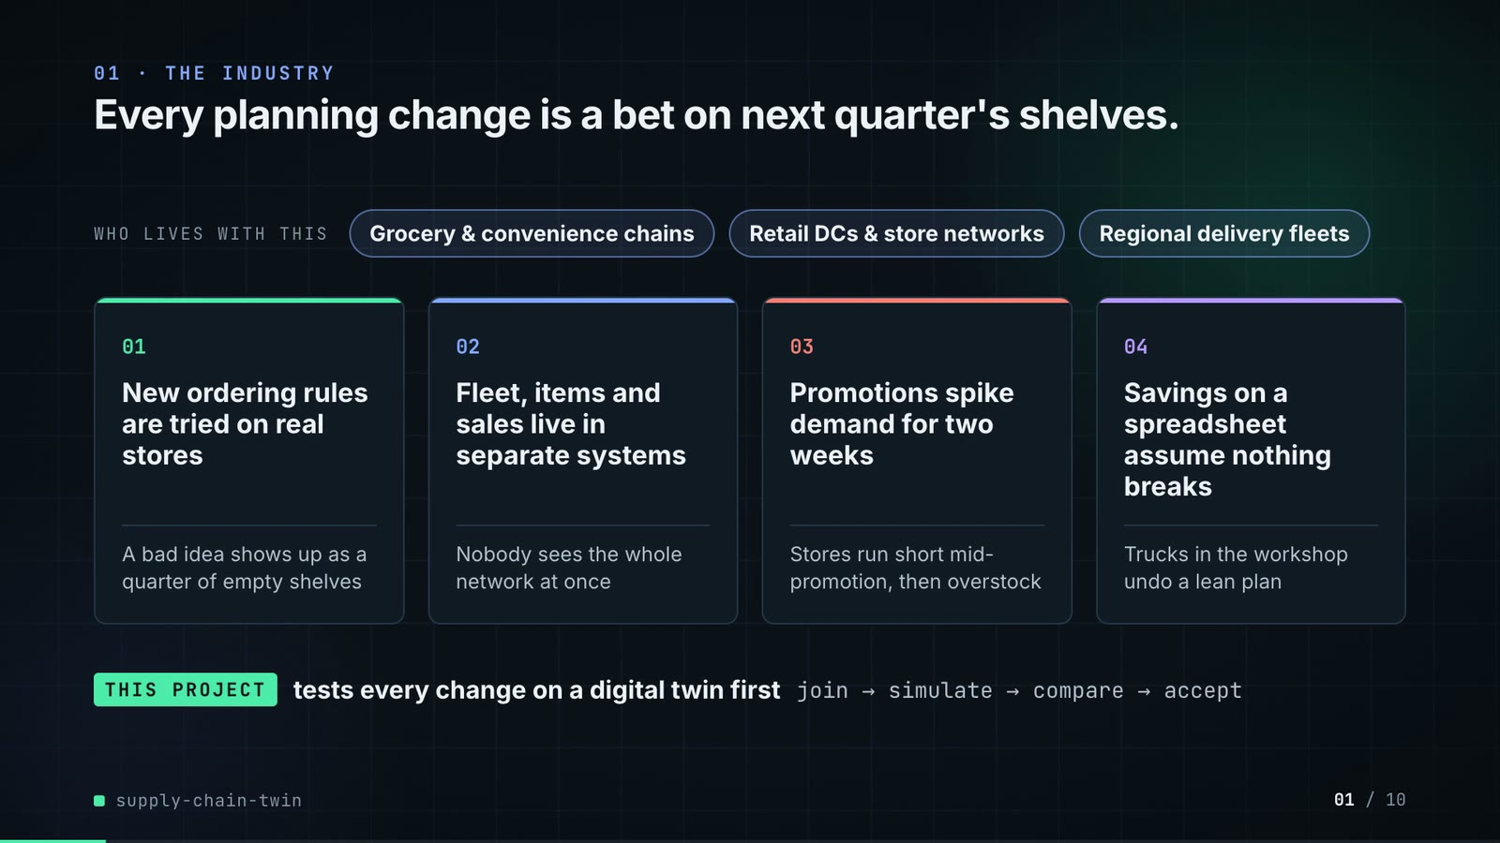
On-screen text (verbatim)
01 · THE INDUSTRY
Every planning change is a bet on next quarter's shelves.
WHO LIVES WITH THIS · Grocery & convenience chains · Retail DCs & store networks · Regional delivery fleets
01 New ordering rules are tried on real stores — A bad idea shows up as a quarter of empty shelves
02 Fleet, items and sales live in separate systems — Nobody sees the whole network at once
03 Promotions spike demand for two weeks — Stores run short mid-promotion, then overstock
04 Savings on a spreadsheet assume nothing breaks — Trucks in the workshop undo a lean plan
THIS PROJECT tests every change on a digital twin first · join → simulate → compare → accept
Figures on this slide
ID | Shown | Source · key | Calculation | Check
F-01 | 3 industry chips | author's framing · - | - | manual
F-02 | 4 problem cards | README 'The problem', 'Why it is hard' · README lines 9-31 | - | ✓

Assumptions: A-10
Illustrative, not data:
• The whole slide is context; no repo figures.
To change this slide: Edit the chips (#ctx-c1..3) and cards (#ctx-k1..4) in compositions/s01-context.html.

Slide 02: This project
6.8-11.6 s · composition compositions/s02-hook.html
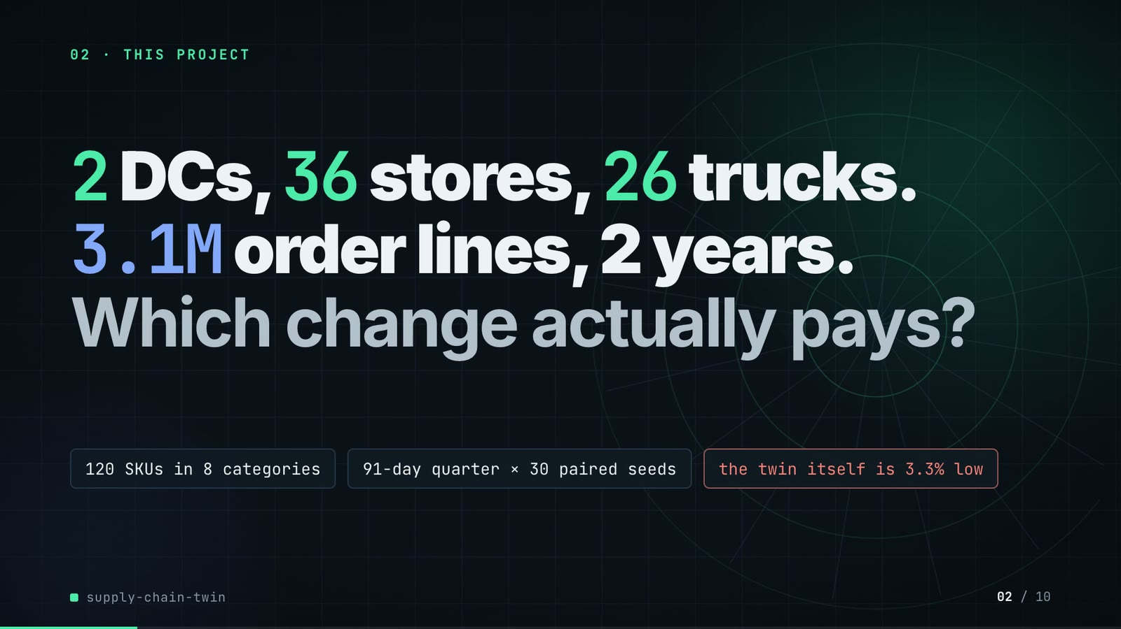
On-screen text (verbatim)
02 · THIS PROJECT
2 DCs, 36 stores, 26 trucks. 3.1M order lines, 2 years. Which change actually pays?
120 SKUs in 8 categories · 91-day quarter × 30 paired seeds · the twin itself is 3.3% low
Figures on this slide
ID | Shown | Source · key | Calculation | Check
F-03 | 2 DCs | data/mms_locations.csv · distinct dc_id | - | ✓
F-04 | 36 stores | outputs/data_quality.json · stores | - | ✓
F-05 | 26 trucks | outputs/data_quality.json · trucks_dispatchable | 28 in source - 2 not dispatchable | ✓
F-06 | 3.1M order lines | outputs/data_quality.json · order_lines = 3,126,764 | 3,126,764 / 1e6, 1 decimal | ✓
F-07 | 2 years | src/supply_twin/calendar.py:12 · HISTORY_DAYS = 731 (2024-01-01..2025-12-31) | - | ✓
F-08 | 120 SKUs in 8 categories | data/mms_items.csv; outputs/data_quality.json · skus; distinct category | - | ✓
F-09 | 91-day quarter × 30 paired seeds | src/supply_twin/sim.py:60; outputs/strategy_table.csv · horizon_days = 91; n_seeds | - | ✓
F-10 | the twin itself is 3.3% low / −3.3% demand bias | outputs/fidelity.json · bias.twin = -0.0327 | x 100, 1 decimal | ✓

Assumptions: A-01, A-04, A-06, A-07
Illustrative, not data:
• Rings in the background are decoration.
To change this slide: Headline spans #hook-l1..l3 and chips #hook-f1..f3 in compositions/s02-hook.html; counts come from outputs/data_quality.json.

Slide 03: How it works (white chapter, slide A)
11.3-19.3 s · composition compositions/explainer.html (CONFIG.blocks, CONFIG.groups, CONFIG.loop)
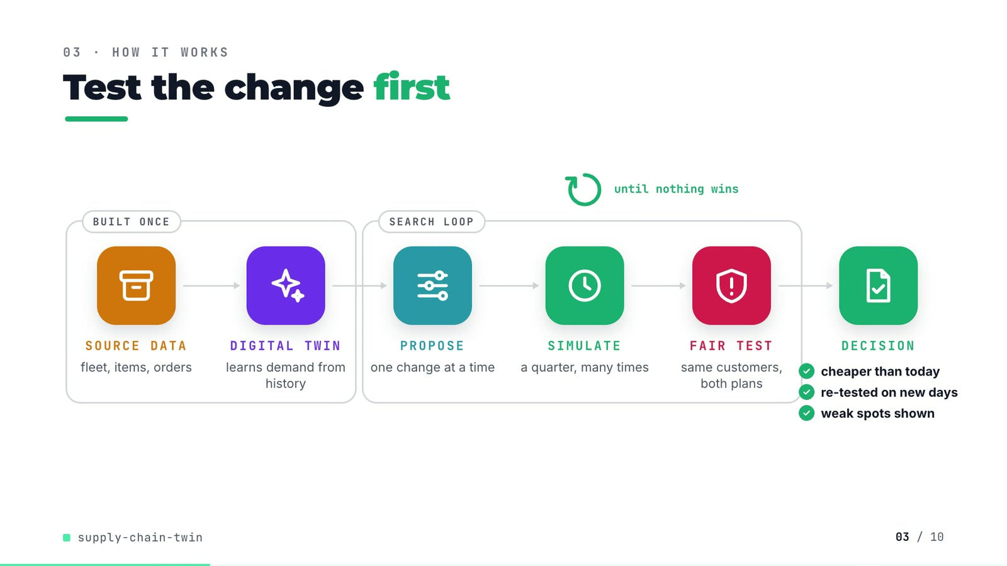
On-screen text (verbatim)
03 · HOW IT WORKS
Test the change first
[BUILT ONCE: SOURCE DATA fleet, items, orders → DIGITAL TWIN learns demand from history] → [SEARCH LOOP: PROPOSE one change at a time → SIMULATE a quarter, many times → FAIR TEST same customers, both plans] → DECISION ✓ cheaper than today ✓ re-tested on new days ✓ weak spots shown
until nothing wins (loop over SIMULATE)
Figures on this slide
ID | Shown | Source · key | Calculation | Check
F-11 | SOURCE DATA → DIGITAL TWIN → PROPOSE → SIMULATE → FAIR TEST → DECISION | src/supply_twin/ · load_sources, build_twin, NeighbourProposer.propose, simulate, Evaluator.compare, search | - | ✓
F-12 | ✓ cheaper than today ✓ re-tested on new days ✓ weak spots shown | outputs/search_neighbour_promo.json; outputs/search_neighbour_promo_robustness.csv · holdout.cost_diff < 0; holdout.n_seeds = 30; any robustness row not accepted | - | ✓
F-13 | until nothing wins | outputs/search_neighbour_promo.csv; agent.py:118-119 · last round has 0 accepted candidates | - | ✓

Assumptions: A-04, A-08
Illustrative, not data:
• Icons and colours are a visual language, not data.
• 'new days' means new random seeds, i.e. new simulated customers.
To change this slide: Edit CONFIG in compositions/explainer.html; badge truth comes from the search JSON and robustness CSV (F-12).

Slide 04: The key idea (white chapter, slide B)
19.3-27.3 s · composition compositions/explainer.html (#ex-b ..., IV array)
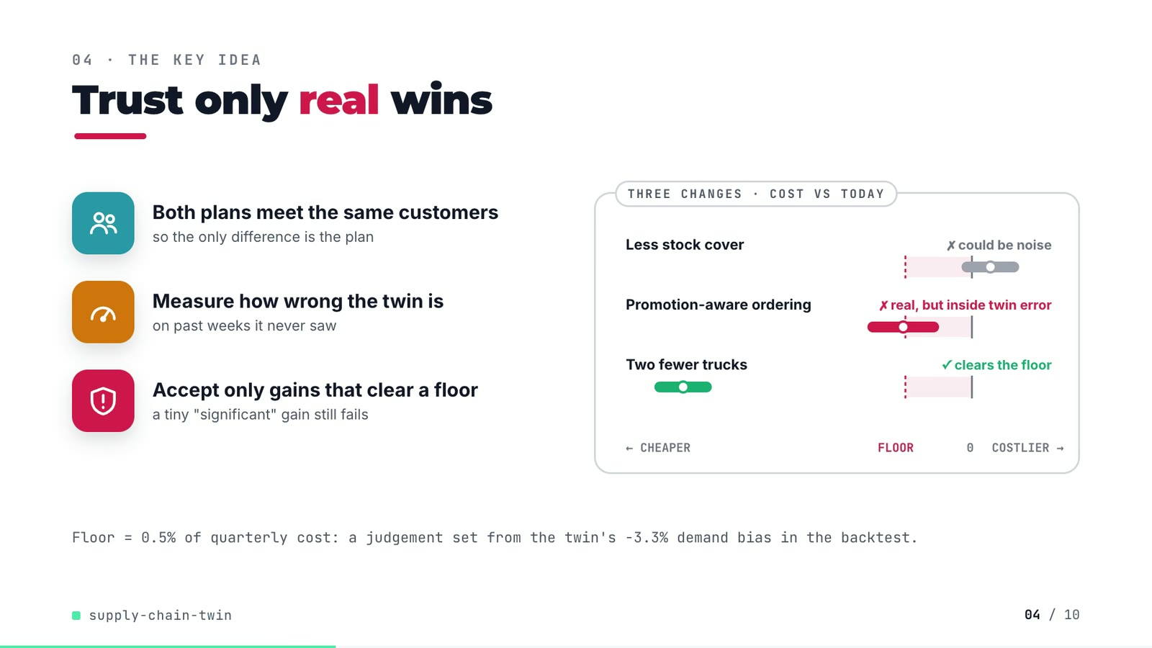
On-screen text (verbatim)
04 · THE KEY IDEA
Trust only real wins
Both plans meet the same customers — so the only difference is the plan
Measure how wrong the twin is — on past weeks it never saw
Accept only gains that clear a floor — a tiny "significant" gain still fails
THREE CHANGES · COST VS TODAY: Less stock cover ✗ could be noise · Promotion-aware ordering ✗ real, but inside twin error · Two fewer trucks ✓ clears the floor · ← CHEAPER · FLOOR · 0 · COSTLIER →
Floor = 0.5% of quarterly cost: a judgement set from the twin's −3.3% demand bias in the backtest.
Figures on this slide
ID | Shown | Source · key | Calculation | Check
F-10 | the twin itself is 3.3% low / −3.3% demand bias | outputs/fidelity.json · bias.twin = -0.0327 | x 100, 1 decimal | ✓
F-14 | Less stock cover (crosses 0) · Promotion-aware ordering (below 0, above floor) · Two fewer trucks (clears floor) | outputs/search_neighbour_promo.csv · round 1 cover=0.5d: +0.139 (-0.078..+0.355); round 3 promo_aware=yes: -0.516 (-0.785..-0.247); round 2 trucks-2: -2.169 (-2.385..-1.954) | cost_diff{,_low,_high} / baseline_cost x 100, 3 decimals; must equal the IV array in compositions/explainer.html | ✓
F-15 | ✗ could be noise · ✗ real, but inside twin error · ✓ clears the floor | outputs/search_neighbour_promo.csv · accepted, p_value vs alpha | A: p >= alpha, not accepted; B: p < alpha, not accepted, fill ok; C: accepted | ✓
F-16 | Floor = 0.5% of quarterly cost / cost CI < −0.5% / floor −0.5% | src/supply_twin/harness.py:34 · MIN_COST_GAIN_SHARE = 0.005 | - | ✓

Assumptions: A-02, A-03, A-07
Illustrative, not data:
• The three intervals are real candidates from the search log (F-14), drawn to scale on a -2.6%..+0.6% axis; 'today' in the pill means the plan in hand at that round, not always the original policy.
To change this slide: Markup under #ex-b and the IV array in compositions/explainer.html; F-14 checks the IV values against the CSV.

Slide 05: Architecture
27.0-43.0 s · composition compositions/s03-architecture.html (BANDS, NODES, WIRES, LABELS)
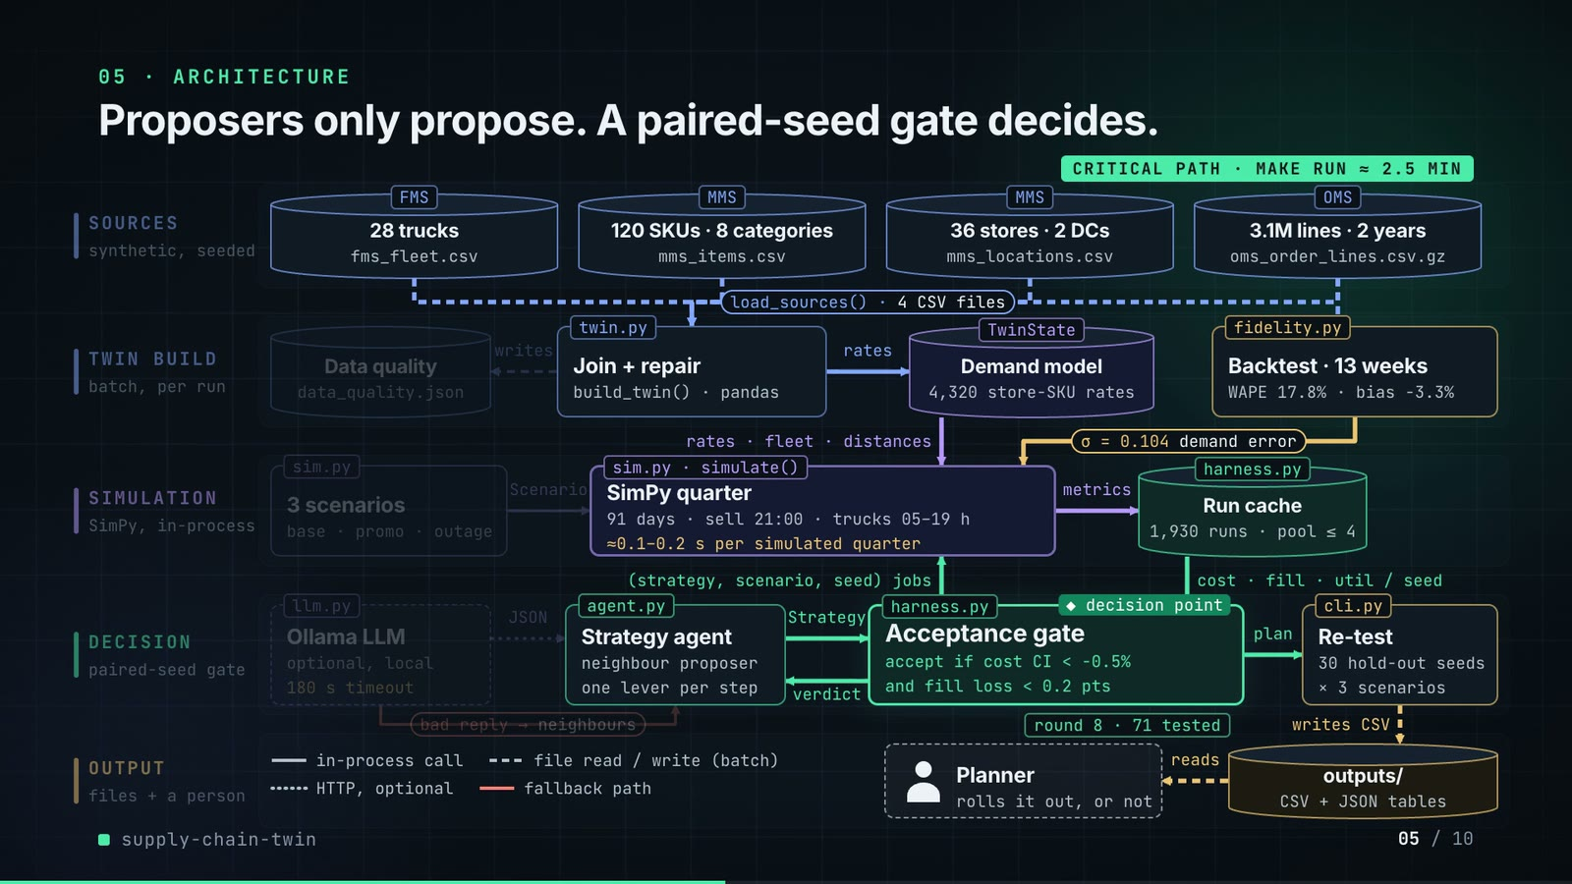
On-screen text (verbatim)
05 · ARCHITECTURE
Proposers only propose. A paired-seed gate decides.
SOURCES (synthetic, seeded): FMS 28 trucks fms_fleet.csv · MMS 120 SKUs · 8 categories mms_items.csv · MMS 36 stores · 2 DCs mms_locations.csv · OMS 3.1M lines · 2 years oms_order_lines.csv.gz → load_sources() · 4 CSV files
TWIN BUILD (batch, per run): twin.py Join + repair build_twin() · pandas → writes Data quality data_quality.json; → rates TwinState Demand model 4,320 store-SKU rates; fidelity.py Backtest · 13 weeks WAPE 17.8% · bias −3.3%
SIMULATION (SimPy, in-process): sim.py 3 scenarios base · promo · outage → Scenario → sim.py · simulate() SimPy quarter 91 days · sell 21:00 · trucks 05–19 h ≈0.1–0.2 s per simulated quarter → metrics → harness.py Run cache 1,930 runs · pool ≤ 4; rates · fleet · distances; σ = 0.104 demand error
DECISION (paired-seed gate): llm.py Ollama LLM optional, local 180 s timeout → JSON → agent.py Strategy agent neighbour proposer, one lever per step → Strategy → harness.py Acceptance gate ◆ decision point accept if cost CI < −0.5% and fill loss < 0.2 pts → verdict; (strategy, scenario, seed) jobs; cost · fill · util / seed; bad reply → neighbours; round 8 · 71 tested → plan → cli.py Re-test 30 hold-out seeds × 3 scenarios
OUTPUT (files + a person): writes CSV → outputs/ CSV + JSON tables → reads → Planner rolls it out, or not
Legend: in-process call · file read / write (batch) · HTTP, optional · fallback path · CRITICAL PATH · MAKE RUN ≈ 2.5 MIN
Figures on this slide
ID | Shown | Source · key | Calculation | Check
F-03 | 2 DCs | data/mms_locations.csv · distinct dc_id | - | ✓
F-04 | 36 stores | outputs/data_quality.json · stores | - | ✓
F-06 | 3.1M order lines | outputs/data_quality.json · order_lines = 3,126,764 | 3,126,764 / 1e6, 1 decimal | ✓
F-07 | 2 years | src/supply_twin/calendar.py:12 · HISTORY_DAYS = 731 (2024-01-01..2025-12-31) | - | ✓
F-08 | 120 SKUs in 8 categories | data/mms_items.csv; outputs/data_quality.json · skus; distinct category | - | ✓
F-16 | Floor = 0.5% of quarterly cost / cost CI < −0.5% / floor −0.5% | src/supply_twin/harness.py:34 · MIN_COST_GAIN_SHARE = 0.005 | - | ✓
F-17 | twin.py · TwinState · fidelity.py · sim.py · simulate() · harness.py · llm.py · agent.py · cli.py · load_sources() | src/supply_twin/ · classes and functions | - | ✓
F-18 | 28 trucks | outputs/data_quality.json · trucks_in_source | - | ✓
F-19 | 4,320 store-SKU rates | outputs/data_quality.json · stores x skus | 36 x 120 = 4,320 | ✓
F-20 | Data quality · data_quality.json | src/supply_twin/cli.py:49 · _write_json(out / 'data_quality.json') | - | ✓
F-21 | load_sources() · 4 CSV files | src/supply_twin/twin.py:74-80 · four read_csv calls | - | ✓
F-22 | Backtest · 13 weeks | outputs/fidelity.json · holdout_days = 91 | 91 / 7 = 13 | ✓
F-23 | WAPE 17.8% / 17.8% | outputs/fidelity.json · wape_store_sku_week.twin | x 100 | ✓
F-24 | σ = 0.104 demand error | outputs/fidelity.json · rate_error_sigma | - | ✓
F-25 | bias −3.3% | outputs/fidelity.json · bias.twin | x 100 | ✓
F-26 | 91 days · sell 21:00 · trucks 05–19 h | src/supply_twin/sim.py:27-28, :60 · SHIFT_START, SHIFT_END, SALES_HOUR, horizon_days | - | ✓
F-27 | ≈0.1–0.2 s per simulated quarter | docs/adr/0001-paired-seeds-and-a-practical-floor-decide-strategies.md:21 · 'runs in about 0.1-0.2 s' | - | ✓
F-28 | 1,930 runs | outputs/search_neighbour_promo.json · simulation_runs_total (Evaluator.runs: unique runs executed, including the evaluation table) | - | ✓
F-29 | pool ≤ 4 | src/supply_twin/harness.py:107 · min(4, os.cpu_count()) | - | ✓
F-30 | 180 s timeout | src/supply_twin/llm.py:25 · timeout: float = 180 | - | ✓
F-31 | accept if cost CI < −0.5% and fill loss < 0.2 pts | src/supply_twin/harness.py:29, :34, :76-86 · MIN_COST_GAIN_SHARE, FILL_NON_INFERIORITY | - | ✓
F-32 | 30 hold-out seeds × 3 scenarios | outputs/search_neighbour_promo.json; outputs/search_neighbour_promo_robustness.csv · holdout.n_seeds; robustness rows | - | ✓
F-33 | round 8 · 71 tested (counts up through rounds 1-8) | outputs/search_neighbour_promo.csv / .json · rounds, candidates_tested, cumulative per round | cumulative tested per round = 8, 17, 26, 35, 44, 53, 62, 71 | ✓
F-34 | make run ≈ 2.5 min / ~2.5 min | outputs/run_log.txt · '2:26.26 total' | 146.26 s / 60 = 2.44 min, rounded to the nearest half minute | ✓
F-35 | 3 scenarios · base · promo · outage | src/supply_twin/sim.py:71-75 · SCENARIOS keys base, promo, fleet_outage | - | ✓

F-27 note: Stated in the ADR from the author's runs; not re-timed by this audit.
Assumptions: A-01, A-02, A-03, A-04, A-07, A-08
Illustrative, not data:
• Packets moving along the edges show execution order, not timing; the search loop is shown as 3 laps for the 8 real rounds while the counter steps through the real cumulative counts.
• The Planner box is the human decision the README describes ('a yes or no they can roll out'); the repo has no UI for it.
• 'Run cache' is the Evaluator's in-memory cache keyed by (strategy, scenario, seed) in harness.py; drawn as a store because it holds results.
To change this slide: Edit NODES / WIRES / LABELS in compositions/s03-architecture.html; F-17 checks every named module/function exists.

Slide 06: The system running
42.6-57.6 s · composition compositions/s04-running.html (WALK block injected by tools/inject_sheet.py from assets/search_walk.json)
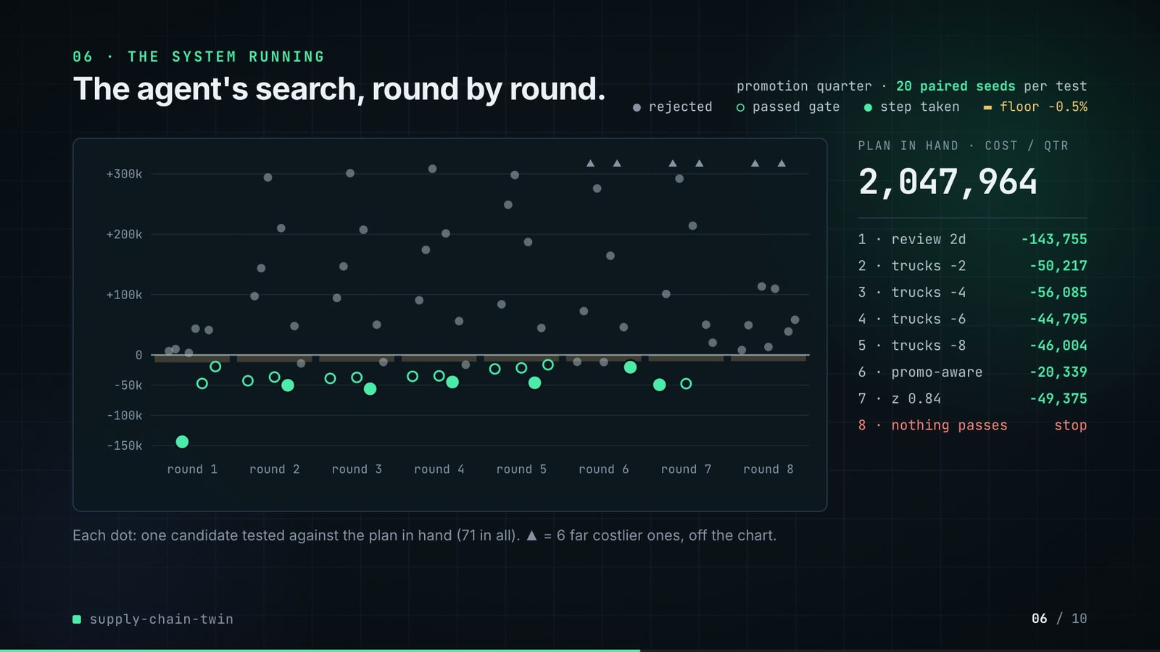
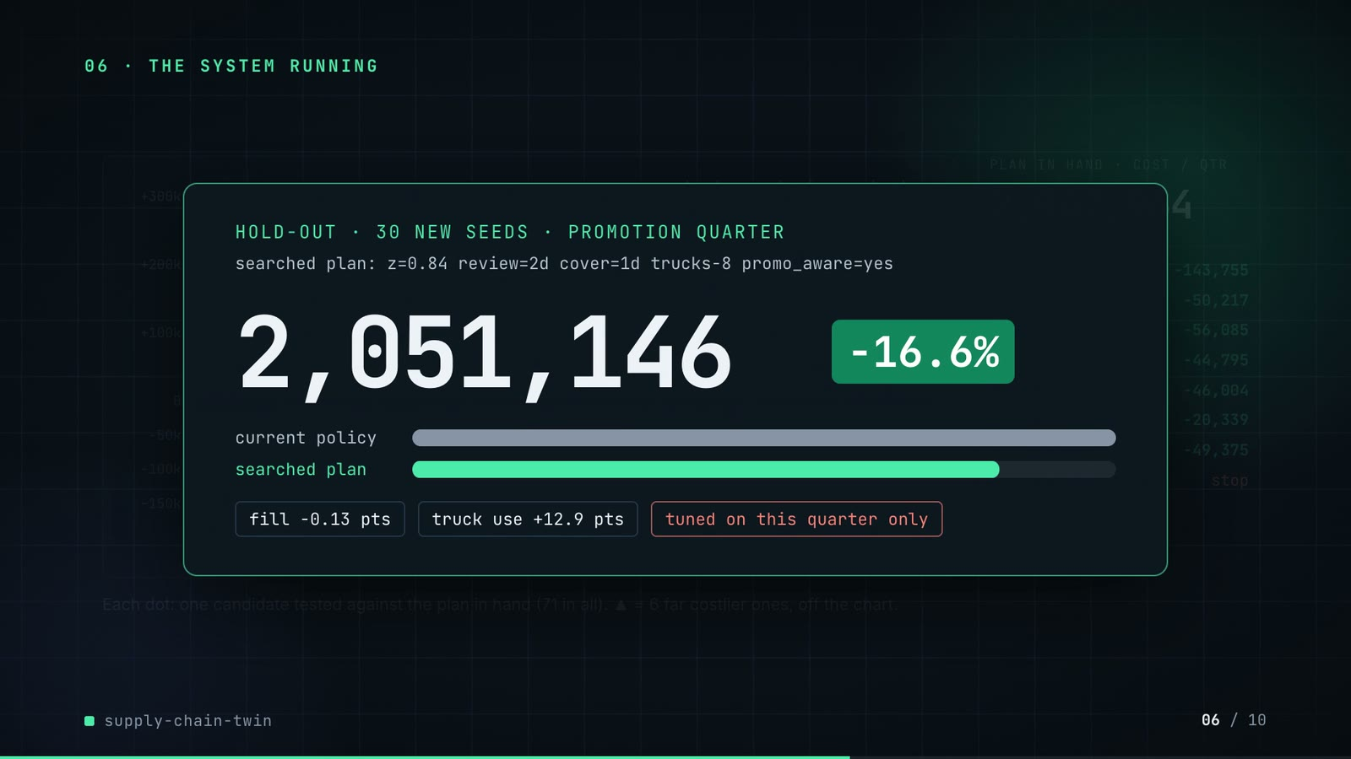
On-screen text (verbatim)
06 · THE SYSTEM RUNNING
The agent's search, round by round.
promotion quarter · 20 paired seeds per test · ● rejected ○ passed gate ● step taken ▬ floor −0.5%
Chart: cost change vs the plan in hand (−150k..+300k) by round 1..8
PLAN IN HAND · COST / QTR 2,458,533 → 2,047,964 · 1 review 2d −143,755 · 2 trucks −2 −50,217 · 3 trucks −4 −56,085 · 4 trucks −6 −44,795 · 5 trucks −8 −46,004 · 6 promo-aware −20,339 · 7 z 0.84 −49,375 · 8 nothing passes stop
Each dot: one candidate tested against the plan in hand (71 in all). ▲ = 6 far costlier ones, off the chart.
HOLD-OUT · 30 NEW SEEDS · PROMOTION QUARTER · searched plan: z=0.84 review=2d cover=1d trucks-8 promo_aware=yes · 2,458,347 → 2,051,146 · −16.6% · fill −0.13 pts · truck use +12.9 pts · tuned on this quarter only
Figures on this slide
ID | Shown | Source · key | Calculation | Check
F-16 | Floor = 0.5% of quarterly cost / cost CI < −0.5% / floor −0.5% | src/supply_twin/harness.py:34 · MIN_COST_GAIN_SHARE = 0.005 | - | ✓
F-36 | 71 candidates over 8 rounds; ▲ = 6 far costlier ones | outputs/search_neighbour_promo.csv → demo assets/search_walk.json, injected into compositions/s04-running.html · round, cost_diff, accepted, chosen | dot y = cost_diff / 1000 (k); off-chart if > 320k | ✓
F-37 | 1 review 2d −143,755 · 2 trucks −2 −50,217 · 3 trucks −4 −56,085 · 4 trucks −6 −44,795 · 5 trucks −8 −46,004 · 6 promo-aware −20,339 · 7 z 0.84 −49,375 · 8 nothing passes | outputs/search_neighbour_promo.csv · rows with chosen = True | rounded to whole units | ✓
F-38 | 2,458,533 (start of the counter) | outputs/search_neighbour_promo.csv · round 1 baseline_cost | - | ✓
F-39 | 2,047,964 | outputs/search_neighbour_promo.csv · round 8 baseline_cost | - | ✓
F-40 | 20 paired seeds per test | outputs/search_neighbour_promo.json · search_seeds | - | ✓
F-41 | 2,458,347 → 2,051,146 | outputs/search_neighbour_promo.json · holdout.baseline_cost, holdout.cost_diff | 2,458,346.6 - 407,200.4 = 2,051,146.1 | ✓
F-42 | −16.6% | outputs/search_neighbour_promo.json · holdout.cost_diff / holdout.baseline_cost | -407,200.4 / 2,458,346.6 x 100 = -16.56% | ✓
F-43 | fill −0.13 pts | outputs/search_neighbour_promo.json · holdout.fill_diff_pts | - | ✓
F-44 | truck use +12.9 pts | outputs/search_neighbour_promo.json · holdout.util_diff_pts | - | ✓
F-45 | searched plan: z=0.84 review=2d cover=1d trucks-8 promo_aware=yes | outputs/search_neighbour_promo.json · final | - | ✓

Assumptions: A-02, A-03, A-04, A-05, A-08
Illustrative, not data:
• Dots within a round are spread sideways only so they do not overlap; their height is the real cost change.
• The amber strips under zero are the gate's floor for that round (0.5% of the plan in hand).
To change this slide: Re-run tools/export_search_walk.py and tools/inject_sheet.py (--name WALK); layout in compositions/s04-running.html.

Slide 07: End-user value (white)
57.3-71.3 s · composition compositions/value.html (SHEET block injected by tools/inject_sheet.py from assets/change_sheet.json)
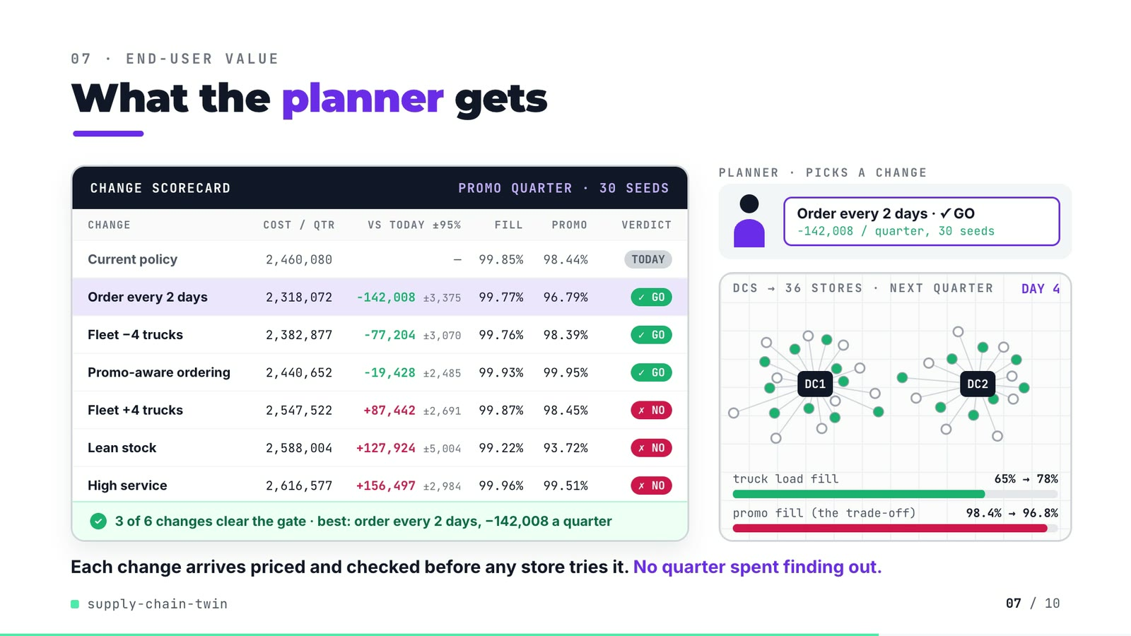
On-screen text (verbatim)
07 · END-USER VALUE
What the planner gets
CHANGE SCORECARD · PROMO QUARTER · 30 SEEDS — CHANGE, COST / QTR, VS TODAY ±95%, FILL, PROMO, VERDICT
Current policy 2,460,080 — 99.85% 98.44% TODAY
Order every 2 days 2,318,072 −142,008 ±3,375 99.77% 96.79% ✓ GO
Fleet −4 trucks 2,382,877 −77,204 ±3,070 99.76% 98.39% ✓ GO
Promo-aware ordering 2,440,652 −19,428 ±2,485 99.93% 99.95% ✓ GO
Fleet +4 trucks 2,547,522 +87,442 ±2,691 99.87% 98.45% ✗ NO
Lean stock 2,588,004 +127,924 ±5,004 99.22% 93.72% ✗ NO
High service 2,616,577 +156,497 ±2,984 99.96% 99.51% ✗ NO
✓ 3 of 6 changes clear the gate · best: order every 2 days, −142,008 a quarter
PLANNER · PICKS A CHANGE: Order every 2 days · ✓ GO −142,008 / quarter, 30 seeds
DCS → 36 STORES · NEXT QUARTER · DAY 1..4 · truck load fill 65% → 78% · promo fill (the trade-off) 98.4% → 96.8%
Each change arrives priced and checked before any store tries it. No quarter spent finding out.
Figures on this slide
ID | Shown | Source · key | Calculation | Check
F-46 | Current policy 2,460,080 … High service 2,616,577 (+156,497 ±2,984) | demo assets/change_sheet.json (re-run of the repo's evaluation, seeds 1000-1029), injected into compositions/value.html; equals outputs/strategy_table.csv scenario=promo · total_cost, cost_vs_current, cost_vs_current_ci_half, fill_rate, promo_fill_rate, beats_current | - | ✓
F-47 | 3 of 6 changes clear the gate | outputs/strategy_table.csv · scenario=promo, beats_current | - | ✓
F-48 | best: order every 2 days, −142,008 a quarter | outputs/strategy_table.csv · scenario=promo, strategy='order every 2 days', cost_vs_current | - | ✓
F-49 | 65% → 78% | outputs/strategy_table.csv · scenario=promo, load_fill (0.6461, 0.7760) | x 100, whole percent | ✓
F-50 | 98.4% → 96.8% | outputs/strategy_table.csv · scenario=promo, promo_fill_rate (0.9844, 0.9679) | x 100, 1 decimal | ✓
F-51 | PROMO QUARTER · 30 SEEDS / 30 seeds | demo assets/change_sheet.json · n_seeds | - | ✓
F-52 | DCs → 36 stores, deliveries on alternating days | data/mms_locations.csv; src/supply_twin/sim.py:291 ((day + s) % review_days) · store_id, dc_id, distance_km | radius = 26 px + km x 0.68 px; angle illustrative | ✓

Assumptions: A-02, A-03, A-04, A-05, A-06
Illustrative, not data:
• Planner figure is a placeholder (no real person).
• Store angles around each DC are evenly spaced (the data has no coordinates); each store's distance from its DC is real.
• Purple trips and green dots replay the review stagger of 'order every 2 days' (which half of the stores orders each day); they are not simulated truck movements.
• 'No quarter spent finding out' is framing from the README problem statement, not a measured result.
To change this slide: Re-run tools/export_change_sheet.py, then tools/inject_sheet.py (--name SHEET); CONFIG.pick chooses the row the planner hands over.

Slide 08: Results
71.0-79.8 s · composition compositions/s05-results.html (stats array)
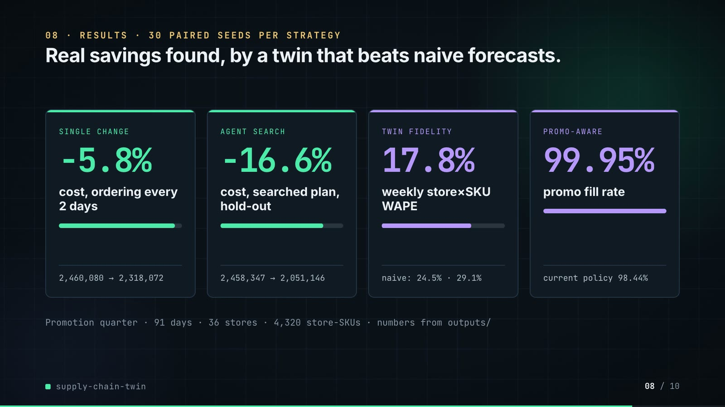
On-screen text (verbatim)
08 · RESULTS · 30 PAIRED SEEDS PER STRATEGY
Real savings found, by a twin that beats naive forecasts.
SINGLE CHANGE −5.8% cost, ordering every 2 days · 2,460,080 → 2,318,072
AGENT SEARCH −16.6% cost, searched plan, hold-out · 2,458,347 → 2,051,146
TWIN FIDELITY 17.8% weekly store×SKU WAPE · naive: 24.5% · 29.1%
PROMO-AWARE 99.95% promo fill rate · current policy 98.44%
Promotion quarter · 91 days · 36 stores · 4,320 store-SKUs · numbers from outputs/
Figures on this slide
ID | Shown | Source · key | Calculation | Check
F-04 | 36 stores | outputs/data_quality.json · stores | - | ✓
F-19 | 4,320 store-SKU rates | outputs/data_quality.json · stores x skus | 36 x 120 = 4,320 | ✓
F-23 | WAPE 17.8% / 17.8% | outputs/fidelity.json · wape_store_sku_week.twin | x 100 | ✓
F-41 | 2,458,347 → 2,051,146 | outputs/search_neighbour_promo.json · holdout.baseline_cost, holdout.cost_diff | 2,458,346.6 - 407,200.4 = 2,051,146.1 | ✓
F-42 | −16.6% | outputs/search_neighbour_promo.json · holdout.cost_diff / holdout.baseline_cost | -407,200.4 / 2,458,346.6 x 100 = -16.56% | ✓
F-53 | −5.8% | outputs/strategy_table.csv · scenario=promo, total_cost: 2,318,072 vs 2,460,080 | (2,318,072 / 2,460,080 - 1) x 100 = -5.77% | ✓
F-54 | 2,460,080 → 2,318,072 | outputs/strategy_table.csv · scenario=promo, total_cost | - | ✓
F-55 | naive: 24.5% · 29.1% | outputs/fidelity.json · wape_store_sku_week.recent_8wk_mean, same_day_last_year | x 100 | ✓
F-56 | 99.95% · current policy 98.44% | outputs/strategy_table.csv · scenario=promo, promo_fill_rate | x 100, 2 decimals | ✓

Assumptions: A-04, A-05, A-07, A-09
Illustrative, not data:
• Mini bars under each number are drawn to the ratio after / before (card 3: twin / 8-week mean).
To change this slide: The stats array and card text in compositions/s05-results.html.

Slide 09: What didn't win
79.4-86.6 s · composition compositions/s06-twist.html
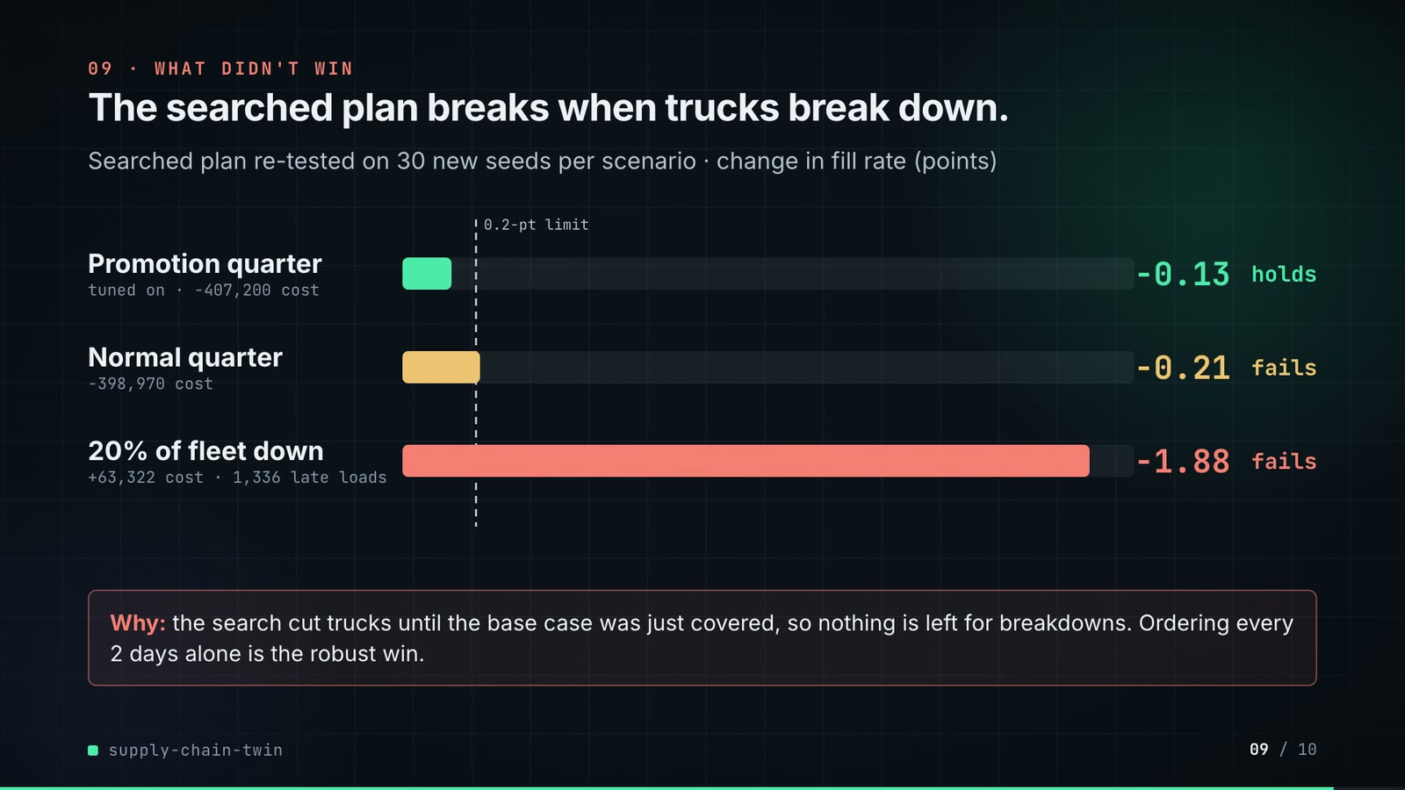
On-screen text (verbatim)
09 · WHAT DIDN'T WIN
The searched plan breaks when trucks break down.
Searched plan re-tested on 30 new seeds per scenario · change in fill rate (points)
Promotion quarter (tuned on · −407,200 cost) −0.13 holds · Normal quarter (−398,970 cost) −0.21 fails · 20% of fleet down (+63,322 cost · 1,336 late loads) −1.88 fails · 0.2-pt limit
Why: the search cut trucks until the base case was just covered, so nothing is left for breakdowns. Ordering every 2 days alone is the robust win.
Figures on this slide
ID | Shown | Source · key | Calculation | Check
F-57 | −0.13 · −407,200 cost · holds | outputs/search_neighbour_promo_robustness.csv · scenario=promo | - | ✓
F-58 | −0.21 · −398,970 cost · fails | outputs/search_neighbour_promo_robustness.csv · scenario=base | - | ✓
F-59 | −1.88 · +63,322 cost · 1,336 late loads · fails | outputs/search_neighbour_promo_robustness.csv · scenario=fleet_outage | late loads = final_late_loads (mean over 30 seeds) rounded | ✓
F-60 | 0.2-pt limit | src/supply_twin/harness.py:29 · FILL_NON_INFERIORITY = 0.002 | - | ✓
F-61 | Ordering every 2 days alone is the robust win. | outputs/strategy_table.csv · strategy='order every 2 days', beats_current per scenario | - | ✓

Assumptions: A-03, A-04, A-06
Illustrative, not data:
• Bar lengths: 1,000 px track = 2.0 points of fill loss; the dashed line is the 0.2-point limit.
To change this slide: Rows #twist-r1..r3 (bar widths are inline styles) in compositions/s06-twist.html.

Slide 10: End card
86.2-90.6 s · composition compositions/s07-end.html
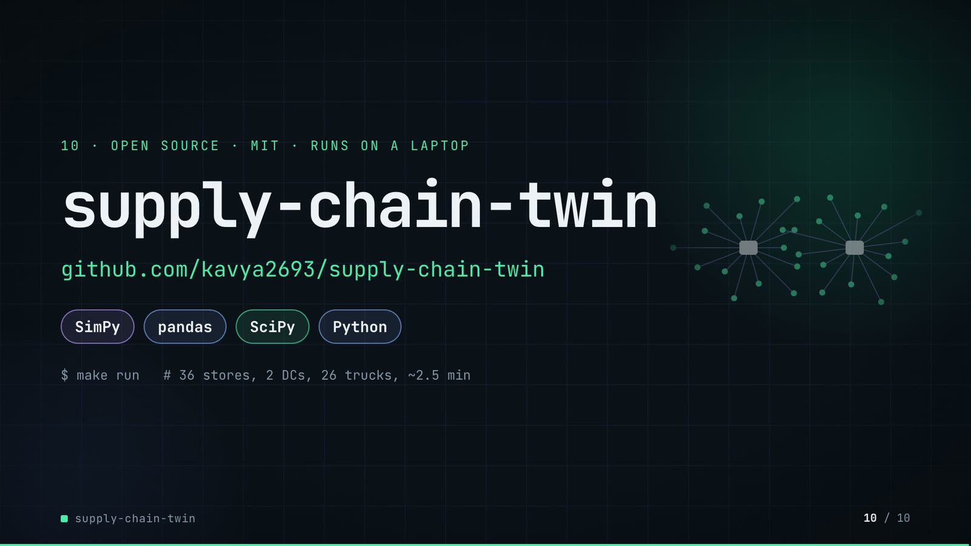
On-screen text (verbatim)
10 · OPEN SOURCE · MIT · RUNS ON A LAPTOP
supply-chain-twin
github.com/kavya2693/supply-chain-twin
SimPy · pandas · SciPy · Python
$ make run # 36 stores, 2 DCs, 26 trucks, ~2.5 min
Figures on this slide
ID | Shown | Source · key | Calculation | Check
F-03 | 2 DCs | data/mms_locations.csv · distinct dc_id | - | ✓
F-04 | 36 stores | outputs/data_quality.json · stores | - | ✓
F-05 | 26 trucks | outputs/data_quality.json · trucks_dispatchable | 28 in source - 2 not dispatchable | ✓
F-34 | make run ≈ 2.5 min / ~2.5 min | outputs/run_log.txt · '2:26.26 total' | 146.26 s / 60 = 2.44 min, rounded to the nearest half minute | ✓
F-62 | MIT | LICENSE line 1 · - | - | ✓
F-63 | SimPy · pandas · SciPy · Python | pyproject.toml dependencies · simpy, pandas, scipy | - | ✓
F-64 | $ make run | Makefile · run target | - | ✓

Assumptions: A-09
Illustrative, not data:
• The faded network on the right is decoration drawn from geometry, not data.
To change this slide: Text in compositions/s07-end.html.

5. Change-impact matrix
Input / assumption | Affected figures | Slides | Files to edit | Re-run
A-01: All data is synthetic, written by a seeded generator (seed 7) shaped like the three source systems: 28 trucks, 120 SKUs, 36 stores, 2 DCs, two years of daily order lines with 4% annual growth, holidays and category promotions | all figures | 01, 02, 03, 04, 05, 06, 07, 08, 09, 10 | scripts/generate_data.py | make data; make run
A-02: Acceptance floor: a change is accepted only if the whole 95% interval of its total-cost change lies below -0 | F-14, F-15, F-16, F-31, F-36, F-37, F-39, F-46, F-47, F-48 | 04, 05, 06, 07 | src/supply_twin/harness.py:34 | make run; export_search_walk.py + export_change_sheet.py + inject_sheet.py
A-03: Fill non-inferiority: a change may lose at most 0 | F-31, F-36, F-37, F-46, F-47, F-57, F-58, F-59, F-60 | 05, 06, 07, 09 | src/supply_twin/harness.py:29 | make run
A-04: Seeds: the search uses 20 seeds (0-19) with a Bonferroni split of alpha per round; the evaluation table uses 30 seeds (1000-1029); the searched plan is confirmed on 30 hold-out seeds (5000-5029) the search never saw | F-09, F-12, F-32, F-40, F-41, F-42, F-43, F-44, F-51 | 02, 03, 05, 06, 07, 08 | src/supply_twin/cli.py:189-191 | make run
A-05: Cost constants are stated, not estimated: holding 25% a year, backroom overflow 1 | F-14, F-36, F-37, F-39, F-41, F-42, F-46, F-48, F-53, F-54, F-57, F-58, F-59 | 04, 06, 07, 08, 09 | src/supply_twin/sim.py:29-34 | make run; export_search_walk.py + export_change_sheet.py + inject_sheet.py
A-06: Scenarios: a 91-day horizon; the promotion quarter puts beverages and snacks on a 14-day promotion from day 35; the outage scenario takes 20% of each DC's trucks out of service for the whole quarter | F-09, F-26, F-35, F-59 | 02, 05, 09 | src/supply_twin/sim.py:60-74 | make run
A-07: Simulated demand carries the store-SKU error spread measured in the 13-week backtest (sigma 0 | F-10, F-23, F-24, F-25, F-56 | 02, 04, 05, 08 | src/supply_twin/fidelity.py | make run
A-08: The neighbour proposer moves one lever one grid step at a time (z, review days, cover days, fleet size, promotion awareness); the search stops when a round accepts nothing (here after 8 rounds) | F-13, F-33, F-36, F-37, F-45 | 03, 05, 06 | src/supply_twin/agent.py:23-29 | make run
A-09: Video rounding: money to whole units with thousands separators, percentages to 1 decimal (fill rates to 2), points to 2 decimals; '3 | F-06, F-10, F-14, F-24, F-34, F-42, F-49, F-50, F-53, F-56 | 02, 04, 05, 06, 07, 08, 10 | the composition file named on each slide | hyperframes render
A-10: Slide 01 (industry, everyday problems) is general retail-planning knowledge used as context | F-01, F-02 | 01 | compositions/s01-context.html | hyperframes render

6. Known differences and caveats
• The whole dataset is synthetic and the twin is estimated from data produced by the same family of assumptions it then simulates, so fidelity (17.8% WAPE) is an upper bound on what a real extract would give (README 'The data').
• −16.6% (slides 06, 08) is the searched plan on the quarter it was tuned on; it fails the fill limit on a normal quarter and fails on cost and fill with 20% of the fleet down (slide 09).
• '1,930 runs' is the number of unique simulations executed when the search finished, including the evaluation table; the robustness re-test ran more afterwards.
• '≈0.1–0.2 s per simulated quarter' is quoted from ADR-0001, not re-timed by this audit.
• 'make run ≈ 2.5 min' is the author's run_log (2:26); the README says about 3 minutes on 4 cores.
• Slide 04's three intervals compare each candidate with the plan in hand at that round of the search, not always with the original policy.
• The language-model proposer is drawn in the architecture but was only tested with stubbed replies (README 'Known limitations'); every number in the video comes from the neighbour proposer.
• Slide 01 statements are general retail-planning knowledge (A-10).

Appendix: environment
Item | Value
Commit | a4f50f5289cc8c298a8e842f8aadd139c609579c
Python | 3.11.7
simpy | 4.1.2
pandas | 3.0.6
numpy | 2.4.6
scipy | 1.17.1
Profile / seeds | data_generator=7, search_seeds=0-19, evaluation_seeds=1000-1029, holdout_seeds=5000-5029
Run time | outputs/run_log.txt: make run 2:26.26 total (about 2.4 min) on the author's laptop; README says about 3 minutes on 4 cores

