**KAVYA S** 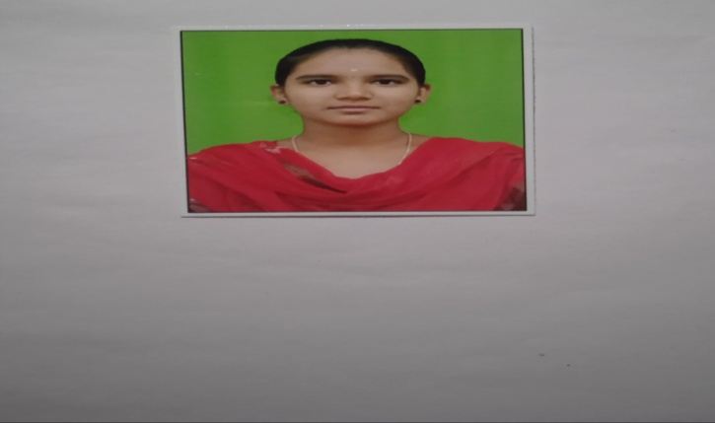

132**,**veenampalayam**,**

Kadaiyur **(**po**),**

Kangayam,

Tirupur-638701.

[Kavyasakthivel00@gmail.com](mailto:Kavyasakthivel00@gmail.com)

8610800651

**CARREER OBJECTIVE**

* To secure a challenging position where I can effectively contribute my skill as software professional

**ACADAMIC QUALIFICATION**

|  |  |  |  |  |
| --- | --- | --- | --- | --- |
| **COURSE** | **INSTITUTION** | **UNIVERSITY/**  **BOARD** | **YEAR OF PASSING** | **AGGREGATE** |
| B.sc.Informatiom Technology | Navarasam arts science college | Bharathiar University | 2024 | 83.6% |
| HSC | Carmel girls higher secondary shcool | StateBoard | 2019 | 81.69% |
| SSLC | Carmel girls higher secondary school | StateBoard | 2021 | 67% |

**SKILLS:**

* Technical Skills:Java programming,Python programming,and power BI
* Web Technologies:HTML,Javascript.
* Interest to work in a team players

**EXTRA CURRICULAR ACTIVITES:**

* I learning in the Typewritting

**CO-CURRICULAR ACTIVITIES:**

* I did my paper presentation on digital marketing.
* I attended in webinar on Big Data and Data Analytics.

**PERSIONAL DETAILS:**

**DOB :** 29**.**05**.**2004

**Parent;s Name :Mr.Sakthivel.p**

**Mrs.Vasanthi.S**

Father **Occupation :Dailywages**

Nationality :Indian

Languages known :Tamil,English

Hobbies :make a hand craft,striching

**DECLARATION:**

I hereby declare that the above details are true the best of my knowledge. If I have been recruited,I will be sincere and dedicated to my job.

**Place:Kangayam,**

**Date:**