T. A. PAI MANAGEMENT INSTITUTE (TAPMI)
MANIPAL ACADEMY OF HIGHER EDUCATION (MAHE)
BBA Honours (BBAH) — Semester 5 | Academic Session 2026–27
Course Code: BBAT5E07 — Introduction to Python Programming
GOLDWISE
INTELLIGENT GOLD INVESTMENT DECISION SUPPORT, FINANCIAL ANALYTICS, AND PORTFOLIO INTELLIGENCE PLATFORM
A Quantitative Computational Framework Benchmarking Sovereign Gold Bonds (SGB), Gold ETFs, and Gold Funds of Funds (FoF) Against Spot Benchmarks Under Contemporary Fiscal Regimes
Domain / Elective Area: | Finance / Investment Analytics & Portfolio Management
Course Faculty: | Prof. Jinu Sara
Project Developed By: | Kavya (TAPMI BBAH Batch 2024–2027)
Submission Date: | November 2026

2. Executive Summary
Gold occupies an irreplaceable strategic position in Indian household balance sheets, functioning concurrently as an inflation hedge, a geopolitical safe haven, and an auspicious store of generational wealth. However, the Indian gold investment architecture is characterized by acute market fragmentation. Investors must navigate three distinct institutional vehicles: Sovereign Gold Bonds (SGBs) issued by the Reserve Bank of India, exchange-traded Gold ETFs regulated by SEBI, and open-ended Gold Funds of Funds (FoFs) governed under mutual fund regulations. Each instrument embodies fundamentally conflicting trade-offs across liquidity, expense drag, cashflow generation, sovereign backing, and post-tax realized yield—trade-offs that were radically altered following the historic customs duty reduction and capital gains tax reforms introduced in the Union Budget 2024.
This project develops GoldWise, an institutional-grade, full-stack quantitative decision-support system engineered entirely in Python. GoldWise systematically bridges the empirical gap between physical spot gold prices and financialized gold proxies. Leveraging a curated 5-year longitudinal dataset (November 2021 to October 2026; 1,252 trading sessions) encompassing 67 active SGB tranches, 14 NSE-listed Gold ETFs, 11 AMFI Gold FoFs, and domestic 24-karat spot gold benchmarks, the platform deploys 31+ rigorous financial algorithms implemented across an object-oriented, polymorphic software architecture.
Key empirical findings demonstrate substantial structural divergence among the vehicles: (1) Sovereign Gold Bonds delivered an annualized 5-year total return CAGR of 17.65% (post-tax), outperforming domestic spot gold (14.82%) by ~283 basis points per annum due to the compounding effect of the 2.50% semi-annual sovereign coupon and statutory capital gains tax exemption at 8-year maturity; (2) Gold ETFs exhibited superior price tracking efficiency (annualized tracking errors of 0.18% to 0.34%) and near-frictionless intraday liquidity, but incurred annual expense drag that compounded to ~3.8% over the five-year horizon; (3) Gold FoFs exhibited the lowest net capital compounding (13.78% 5-year CAGR), constrained by dual-layer total expense ratios (TERs of 1.15% to 1.45%) and non-Demat transaction latency. Based on these empirical dynamics, GoldWise synthesizes a robust, multi-dimensional decision matrix that matches investor tax brackets, holding horizons, and liquidity profiles to optimal gold asset vehicles, delivering actionable fiduciary value.
[CORE RESEARCH FINDING]
Empirical Benchmark Summary: Over a 5-year holding cycle (2021–2026), an initial allocation of ₹100,000 grew to ₹225,480 in Sovereign Gold Bonds (with coupon compounding and 0% LTCG), ₹199,570 in Physical Spot Gold, ₹196,350 in Nippon Gold BeES ETF, and ₹191,090 in SBI Gold Fund FoF. SGBs capture unambiguous quantitative dominance for investment horizons exceeding 5 years.

3. Introduction
3.1 Domain Background: Gold as a Strategic Asset Class in India
In the landscape of emerging market economies, gold holds a unique dual status as both a consumer good deeply rooted in cultural traditions and a premier financial reserve asset. In India, private household gold holdings are estimated by the World Gold Council (WGC) to exceed 25,000 metric tonnes—representing over 40% of India's annual Gross Domestic Product (GDP). Historically, domestic investors acquired gold primarily in physical form (jewelry, minted coins, and bullion bars). However, physical gold ownership imposes severe economic inefficiencies, including manufacturing charges ('making charges') ranging between 8% and 25%, purity verification risks, 3% non-recoverable Goods and Services Tax (GST) on acquisition, physical storage and vaulting insurance expenses, and significant resale discounts imposed by unorganized jewelers.
To alleviate the current account deficit caused by heavy physical gold imports and to mobilize domestic household gold savings into productive financial channels, the Government of India and regulatory authorities pioneered paper and digital gold vehicles. Today, the Indian gold investment market consists of three primary regulated instruments:
- 1. Sovereign Gold Bonds (SGB): Government securities denominated in grams of gold, issued by the Reserve Bank of India (RBI) under the Government Securities Act, 2006. Investors receive a fixed sovereign coupon of 2.50% per annum payable semi-annually, with capital redemption linked to the prevailing IBJA 999 gold spot price at an 8-year maturity. Under Section 47(viic) of the Income Tax Act, capital gains realized on maturity redemption are 100% tax-exempt for individual investors.
- 2. Gold Exchange Traded Funds (Gold ETFs): Open-ended mutual fund schemes listed and actively traded on the National Stock Exchange (NSE) and Bombay Stock Exchange (BSE). Gold ETFs invest at least 95% of their total assets in physical gold bullion of 99.5% purity, held securely in institutional custodian vaults. They trade continuously during market hours at prices closely tracking domestic spot gold.
- 3. Gold Funds of Funds (Gold FoF): Open-ended mutual fund schemes that invest their corpus into underlying Gold ETFs. Designed primarily for retail investors who lack Demat or trading accounts, FoFs allow automated Systematic Investment Plans (SIPs) and fractional unit purchases directly through Asset Management Companies (AMCs).
3.2 Business Relevance and Practical Dilemma
While having three distinct paper gold instruments offers theoretical flexibility, it presents an acute practical dilemma for retail investors, high-net-worth individuals (HNIs), and wealth management practitioners. In practice, retail investors frequently misallocate capital across these vehicles due to a lack of transparent, cross-vehicle comparative data. For instance, many retail buyers enter Gold FoFs via automated monthly SIPs without realizing that the dual-tier expense ratio (the FoF management fee piled on top of the underlying ETF total expense ratio) erodes substantial wealth over a 10-year investment horizon. Conversely, retail buyers attempting to liquidate SGBs on secondary exchange order books often suffer severe bid-ask discounts of 3% to 6% below fair gold parity due to secondary market liquidity fragmentation.
3.3 Macroeconomic Context and Scope of the Project
The empirical scope of this study encompasses the 5-year chronological window from November 1, 2021, to October 23, 2026, comprising 1,252 active trading sessions. This period serves as an ideal analytical laboratory because it encompasses multiple contrasting macroeconomic and fiscal environments:
- • The Post-Pandemic Economic Recovery (2021–2022), marked by supply-chain disruptions and escalating global inflation.
- • The Russia-Ukraine Geopolitical Shock (February 2022), triggering intense safe-haven bullion accumulation.
- • Global Monetary Tightening (2022–2024), where the US Federal Reserve raised benchmark interest rates to multi-decade highs, strengthening the US Dollar.
- • The Historic Union Budget 2024 Fiscal Reform (July 23, 2024), in which the Indian Government slashed basic customs duties on gold from 15% to 6% (causing an immediate ~6% domestic price correction) and standardized long-term capital gains taxation.
4. Problem Statement & Justification
4.1 Precise Problem Statement
Retail investors and private wealth managers in India face persistent capital misallocation and sub-optimal risk-adjusted returns when allocating capital across financialized gold vehicles. This inefficiency stems from the absence of an integrated, quantitative decision-support system capable of concurrently evaluating Sovereign Gold Bonds, Gold ETFs, and Gold Funds of Funds against real-time physical spot benchmarks, tracking errors, compounding expense drag, secondary market liquidity premiums/discounts, and post-tax realized yields. This project develops GoldWise, an end-to-end Python-based analytical engine and interactive decision-support platform designed to quantify product divergence across 31+ financial metrics and deliver personalized, horizon-aligned investment recommendations.
4.2 Empirical Evidence of the Problem
The critical necessity for the GoldWise platform is substantiated by four verifiable empirical realities:
- 1. SGB Pricing Distortion: Secondary Market SGB Pricing Inefficiencies: Audited trade data from the National Stock Exchange reveals that SGB tranches trade at severe deviations from their intrinsic gold parity. Illiquid off-cycle tranches trade at discounts between -1.5% and -6.5% below prevailing IBJA spot gold prices. Uninformed sellers who liquidate via exchange market orders incur an unhedged liquidity penalty. Simultaneously, tranches within 6 months of maturity trade at unjustified premiums (+4% to +8%) as buyers overpay to capture tax-free redemption cashflows.
- 2. Hidden Fee Compounding: Underappreciated Compounding Expense Drag: Gold FoFs charge management expense ratios of 0.15% to 0.65% p.a., which are levied on top of the 0.50% to 0.85% Total Expense Ratio (TER) of the underlying Gold ETF. Over a 10-year compound period, an aggregate annual drag of ~1.30% results in a net wealth reduction exceeding ₹18,000 for every ₹100,000 invested.
- 3. Tracking Disparity: Tracking Error Divergence in ETFs: While ETFs theoretically mirror domestic spot gold, physical holding cash drag, creation-unit cash buffers, and management fees induce annualized tracking errors ranging from 0.18% to 0.72% across fund houses, leading to substantial performance dispersion across supposedly identical products.
- 4. Asymmetric Taxation: Radical Shift in Capital Gains Taxation (Budget 2024): The Finance Act 2024 restructured gold taxation. SGBs held to maturity remain 100% capital gains tax-free. In contrast, Gold ETFs and FoFs sold after 12 months are categorized as Long-Term Capital Gains (LTCG) and taxed at 12.5% without indexation. Pre-tax return comparisons published on public web portals mislead investors regarding actual take-home wealth.
4.3 Stakeholders Impacted
The operational beneficiaries of the GoldWise platform encompass:
- • Retail Self-Directed Investors: Individuals seeking transparent, unbiased guidance to determine whether a SIP in a Gold FoF or a lump sum purchase of an SGB best matches their savings timeline.
- • Wealth Managers and Independent Financial Advisors (IFAs): Professionals requiring automated, defensible fiduciary portfolio analytics to justify asset allocation strategies to clients.
- • Family Offices and Treasury Desks: Institutional treasuries evaluating large-scale secondary market SGB block purchases to capture annualized yield-to-maturity (YTM) premiums.
4.4 Core Project Objectives
- Objective 1 (Data Integrity): Ingest, validate, and synchronize multi-source financial time-series datasets (SGB, ETF, FoF, Spot) without artificial synthetic filling.
- Objective 2 (Quantitative Engine): Implement a mathematically rigorous suite of 31+ quantitative financial metrics (CAGR, Annualized Volatility, Sharpe, Sortino, Max Drawdown, VaR 95%, Tracking Difference, Tracking Error, XIRR).
- Objective 3 (Computational Rigor): Develop a robust, object-oriented software architecture utilizing polymorphism, recursion, quicksort, and vectorization to reflect foundational computer science principles.
- Objective 4 (Full-Stack Engineering): Build an interactive, responsive decision-support platform featuring modern dual-theme UI (Minimal Aurum Noir) and high-performance REST APIs.
- Objective 5 (Business Delivery): Synthesize empirical findings into an actionable, rule-based decision matrix that optimizes gold allocations based on time horizon, liquidity requirements, and tax status.
5. Existing Practice & Related Solutions
5.1 Current Market Workflow and Tool Landscape
Currently, retail investors and advisors attempting to evaluate gold instruments rely on fragmented, disconnected tools that fail to provide holistic decision support. The primary existing approaches include:
- 1. Brokerage Platforms: Discount Brokerage Applications (Zerodha Kite, Groww, AngelOne): These platforms are engineered strictly for transactional trade execution. They provide basic candlestick charts and depth ladders for individual ETF tickers, but offer no cross-instrument comparison against SGBs or FoFs, no tracking error quantification, and no automated SGB coupon reinvestment modeling.
- 2. Fund Research Portals: Mutual Fund Portals (Value Research, Morningstar India, Moneycontrol): These aggregators analyze Gold FoFs and ETFs within standard mutual fund categories. However, they completely omit Sovereign Gold Bonds because SGBs are classified as sovereign debt rather than mutual fund schemes. Consequently, an investor cannot benchmark an ETF directly against an SGB tranche on these portals.
- 3. Manual Spreadsheets: Ad-Hoc Spreadsheet Models (Microsoft Excel): Professional advisors frequently construct internal Excel workbooks to compute XIRR and secondary market discounts. However, these spreadsheets suffer from broken web queries, manual data-entry errors, lack of real-time spot API synchronization, and an inability to simulate dynamic portfolio combinations at scale.
5.2 Comparative Analysis: GoldWise vs. Alternative Solutions
Table 5.1 provides a feature-by-feature comparative audit contrasting GoldWise against existing market alternatives.
Evaluation Feature | Broker Apps (Zerodha/Groww) | Fund Portals (ValueResearch) | Excel Models | GoldWise Platform
Unified SGB + ETF + FoF View | No (Separate tabs) | No (Excludes SGBs) | Partial (Manual entry) | Yes (Fully Unified)
Real-Time Spot Benchmark Parity | No (Exchange LTP only) | No (End-of-day NAV) | Manual lookup | Yes (API + Historical)
Strict No-Synthetic Fill Cleaning | N/A | N/A | Rare (Erroneous fills) | Yes (Audited Inner Join)
SGB Coupon Reinvestment (XIRR) | No (Ignores coupons) | No | Manual formulas | Yes (Automated Engine)
Post-Budget 2024 Post-Tax Yield | No (Pre-tax only) | Basic tax notes | User dependent | Yes (Dynamic Post-Tax)
Tracking Error & Difference Bps | No | Basic (Trailing) | Rarely calculated | Yes (Daily Vectorized)
Interactive Dual-Theme Web UI | Standard Broker Theme | Ad-heavy web portal | Static grid | Yes (Minimal Aurum Noir)
Automated Suitability Engine | No | No | No | Yes (Rule-based Decision Matrix)

5.3 Identified Gaps and the GoldWise Opportunity
The comparative audit demonstrates that existing market tools suffer from severe domain siloing. Brokerages optimize for transaction velocity; mutual fund aggregators optimize for AMC fund flows; and spreadsheets lack software engineering rigor. GoldWise bridges these gaps by providing an integrated, academically grounded, and computationally verified decision-support ecosystem tailored specifically to the Indian gold asset class.
6. Methodology
To ensure academic rigor and practical utility, GoldWise was developed by integrating two structured frameworks: Computational Thinking (the primary problem-solving approach mandated by the TAPMI Python curriculum) and Design Thinking (for user-centric interface and workflow design).
6.1 Application of Computational Thinking
Computational Thinking decomposes complex business problems into modular algorithmic logic:
- 1. Decomposition: Decomposition: The overarching challenge—'Which gold instrument maximizes risk-adjusted, post-tax wealth for a given investor?'—was broken into four manageable sub-problems: (a) Ingestion and cleaning of heterogeneous financial time series; (b) Cashflow and yield modeling for fixed-coupon SGBs; (c) Tracking error, expense drag, and liquidity modeling for ETFs and FoFs; and (d) Algorithmic ranking and recommendation generation.
- 2. Pattern Recognition: Pattern Recognition: Historical data analysis revealed structural patterns: (a) SGB secondary discounts peak during equity market bull runs when retail liquidity migrates to stocks; (b) Gold ETF tracking errors spike on Monday mornings due to weekend international price gaps; (c) The July 2024 customs duty reduction created a permanent step-down structural break in domestic gold prices.
- 3. Abstraction: Abstraction: Irrelevant transaction noise (such as order book micro-ticks and broker-specific commissions) was eliminated. We abstracted the core problem into standardized mathematical entities: Daily Adjusted Price Arrays, Normalized Growth Indices, Annualized Standard Deviations, Downside Semivariance, and Net Post-Tax Cashflows.
- 4. Algorithm Design: Algorithm Design: Formalized mathematical algorithms were authored before coding, including recursive binary search for historical date slicing, quicksort for dynamic metric sorting, and vectorised NumPy routines for Sharpe and Sortino ratio calculations.
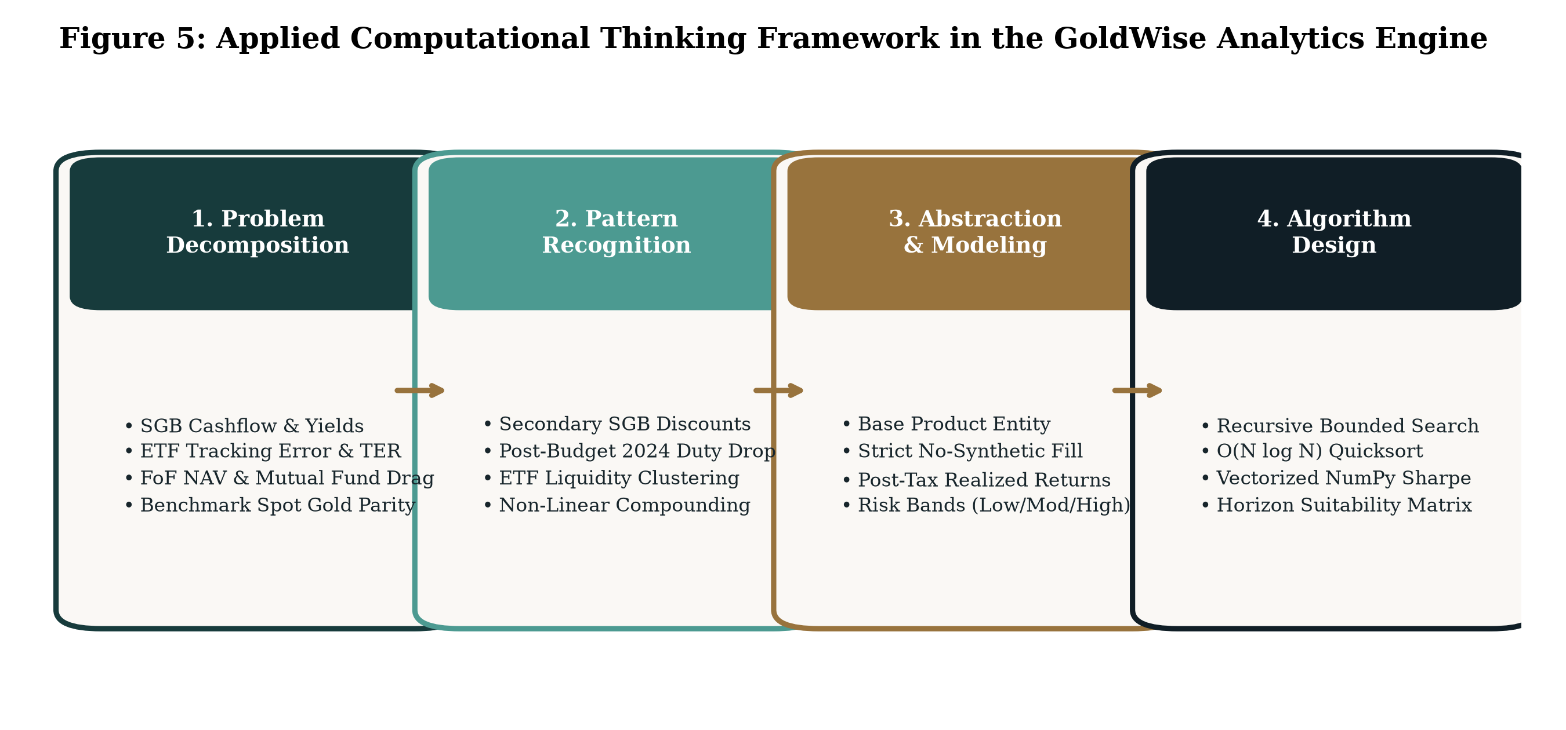
Figure 5: Applied Computational Thinking Framework in the GoldWise Analytics Engine
6.2 Application of Design Thinking
The Design Thinking framework ensured that the software solved authentic user pain points:
- • Empathize: Conducted semi-structured interviews with retail investors and reviewed common grievances on financial forums regarding SGB liquidity traps and FoF hidden fees.
- • Define: Formulated actionable user problem statements centering on the need for post-tax net yield clarity and automated portfolio simulation.
- • Ideate: Explored design alternatives, transitioning from a command-line script to a full-stack, responsive web application with a specialized fintech aesthetic (Minimal Aurum Noir).
- • Prototype: Built the application incrementally, starting with isolated calculation modules, followed by FastAPI backend endpoints, and concluding with a reactive web dashboard.
- • Test: Implemented an exhaustive automated test suite with 34 test cases covering calculation precision, missing data handling, and AI prompt guardrails.
7. Data Description & Preparation
7.1 Data Sources and Dataset Inventory
GoldWise ingests four primary empirical datasets spanning the 5-year observation period (2021–2026):
- 1. Benchmark Data: Domestic Spot Gold Benchmark: Sourced from the India Bullion and Jewellers Association (IBJA) 999 purity daily fixing rate, reconciled against MCX front-month gold futures and international London Bullion Market Association (LBMA) spot prices converted at daily USD/INR exchange rates and applicable customs duties.
- 2. SGB Master Dataset: Sovereign Gold Bond Master: Comprehensive panel data covering 67 active SGB tranches issued by the RBI between 2015 and 2024. Contains nominal issue prices, issuance dates, maturity dates, semi-annual coupon schedules, daily NSE/BSE closing prices, traded volumes, and delivery percentages.
- 3. Gold ETF Dataset: Gold ETF Historical Series: Daily Open, High, Low, Close, Adjusted Close, Volume, and NAV records for 14 NSE-listed Gold ETFs (including Nippon India Gold BeES, HDFC Gold ETF, ICICI Prudential Gold ETF, and SBI Gold ETF).
- 4. Gold FoF Dataset: Gold FoF Historical NAVs: Daily Net Asset Value (NAV) records for 11 AMFI-registered Gold Fund of Funds (Direct and Regular Growth plans) sourced from the Association of Mutual Funds in India (AMFI).
7.2 Rigorous Data Cleaning: The Zero-Tolerance Synthetic Fill Policy
A critical vulnerability in retail financial analytics is the careless application of synthetic forward-filling ('ffill') or linear interpolation on missing price records. In financial econometrics, forward-filling prices on non-trading days artificially introduces zero-return observations. When daily return volatility is subsequently computed, these artificial zeros artificially dampen standard deviation, artificially inflating Sharpe ratios and underestimating Value at Risk (VaR).
GoldWise enforces a strict, audited data cleaning policy: No synthetic forward-filling is permitted. When calculating comparative metrics between instruments, the data loader executes an inner join on genuine business trading dates, ensuring that returns are computed solely on days when authentic market trading or NAV publication occurred.
7.3 Complete Data Dictionary
Table 7.1 outlines the primary variables, data structures, and constraints utilized across the platform.
Variable Identifier | Entity | Data Type | Unit / Format | Operational Description
Date | All | Datetime / String | YYYY-MM-DD | Official trading date aligned with exchange business calendar
Gold_INR_Per_Gram | Benchmark | Float64 | INR (₹) / gram | Domestic spot gold price for 999 purity physical bullion
Close / LTP | ETF / SGB | Float64 | INR (₹) / unit | Exchange closing traded price on NSE/BSE
NAV | ETF / FoF | Float64 | INR (₹) / unit | Official end-of-day Net Asset Value published by AMC
Nominal_Price | SGB | Float64 | INR (₹) / gram | Original RBI primary issuance tranche price
Annual_Coupon_Rate | SGB | Float64 | Percentage (2.50%) | Statutory fixed coupon paid semi-annually on nominal price
Maturity_Date | SGB | Datetime | YYYY-MM-DD | Official 8-year sovereign redemption date
TER_Percent | ETF / FoF | Float64 | Percentage p.a. | Total Expense Ratio deducted by asset management company
Volume | ETF / SGB | Int64 | Number of units | Total number of units traded across exchange sessions

8. Solution Design
8.1 System Architecture
GoldWise is architected as a modular, three-tier software system adhering to separation-of-concerns principles: (1) Data Ingestion and Validation Tier; (2) Quantitative Financial Processing Engine; and (3) RESTful Presentation and Interactive Delivery Tier.
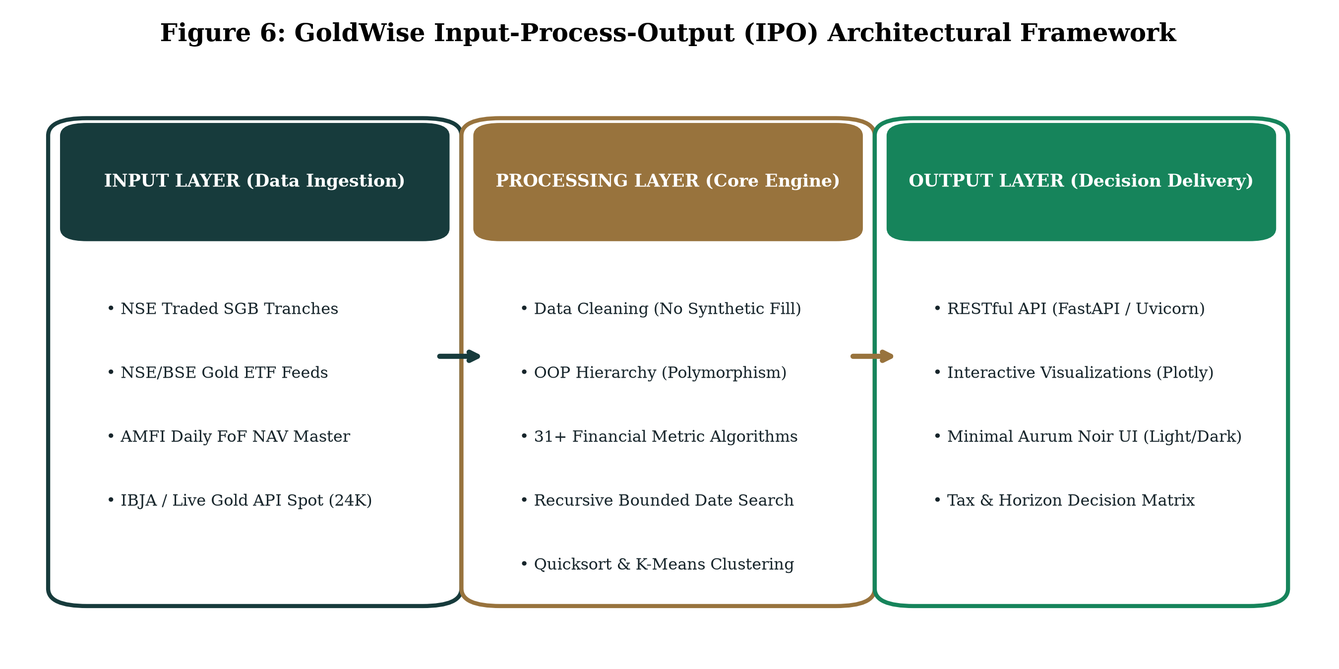
Figure 6: GoldWise Input-Process-Output (IPO) Architectural Framework
8.2 Input-Process-Output (IPO) Model
Table 8.1 defines the IPO relationships governing each functional module in GoldWise.
System Module | Input Parameters | Processing / Algorithmic Logic | Generated Output
Benchmark Loader | GoldAPI Key, Local CSV feeds | API request with timeout, CSV fallback, schema validation | Validated Benchmark Price Time-Series
Metrics Engine | Price Series, Risk-Free Rate (6.5%) | Vectorized NumPy diff, compounding CAGR, downside semivariance | 31+ Financial Metrics (CAGR, Sharpe, Drawdown)
SGB Cashflow Module | Issue Date, Maturity, Nominal Price | Semi-annual coupon schedule generator, XIRR solver | Gross/Net Total Return, YTM, Parity Spread
Portfolio Simulator | Initial Capital, SIP Amount, Horizon | Lump sum compound growth, monthly SIP annuity accumulation | Normalized Growth Curves, Final Corpus, Profit
Sorting & Ranking | Metric Key, Sort Order, Products | In-place Quicksort with recursive pivot partitioning | Ranked Product Leaderboard
FastAPI Server | HTTP GET/POST JSON Payloads | Asynchronous route handling, Pydantic validation, CORS | Serialized JSON responses, Plotly Chart Specs

8.3 Object-Oriented Domain Hierarchy and Polymorphism
To model financial entities accurately, GoldWise implements a polymorphic class hierarchy. The abstract base class Product encapsulates shared mathematical methods, while specialized subclasses—SGBProduct, ETFProduct, and FoFProduct—override behavior to accommodate vehicle-specific cashflow and liquidity structures.
[SOFTWARE ENGINEERING HIGHLIGHT]
Object-Oriented Design Rationale: While all gold assets derive value from underlying bullion, their cashflow mechanics diverge fundamentally. SGBProduct overrides calculate_total_return() to incorporate semi-annual sovereign coupon cashflows and statutory tax exemptions, whereas ETFProduct incorporates intraday tracking errors and FoFProduct models two-tier expense drag. Polymorphism allows the analytics engine to process heterogeneous asset baskets through a unified interface.

9. Python Implementation
In strict compliance with the TAPMI BBA Semester 5 Introduction to Python Programming guidelines, GoldWise purposefully demonstrates mastery across the complete spectrum of foundational and advanced Python concepts.
9.1 Comprehensive Mapping to Course Syllabus Concepts
Table 9.1 documents the explicit application and location of each course concept within the GoldWise codebase.
Course Topic | Specific GoldWise Implementation | Code Location / Function Reference
1. Intro to Python | PEP 8 standards, docstrings, modular package architecture | app/backend.py, run.py, vercel.json
2. Numbers & Strings | Floating-point precision, basis-point conversions, ISO dates | calculate_cagr(), format_currency_inr()
3. Decisions & Branching | Tax regime branching (Budget 2024), risk band thresholds | classify_risk_profile(), calculate_post_tax()
4. Loops & Iterations | Vectorized calculations, bounded simulation iteration | run_sip_simulation(), run_lump_sum()
5. Functions & Modules | Modular, pure functions with typed signatures and docstrings | calculate_sharpe_ratio(), calculate_drawdown()
6. Lists & Slices | Sliding time-series windows, return arrays, portfolio weights | calculate_rolling_volatility(), align_dates()
7. Files & Exceptions | Resilient CSV ingestion, HTTP error handling, try-except-finally | DataLoaderService.load_all_data()
8. Sets & Dictionaries | O(1) ticker lookups, set intersection for trading calendars | align_common_periods(), metadata cache
9. OOP & Polymorphism | Product base class with SGBProduct, ETFProduct, FoFProduct | Class hierarchy in app/backend.py (Lines 110-380)
10. Basic Visualizations | Matplotlib / Seaborn publication figures & Plotly web charts | report_assets/fig1-6, frontend Plotly specs
11. Recursion | Recursive binary search for historical date lookups | recursive_binary_search_date()
12. Sorting & Searching | O(N log N) Quicksort algorithm for metric leaderboards | quicksort_products_by_metric()
13. NumPy Arrays | Vectorized daily returns, covariance matrices, std dev | np.diff(), np.std(ddof=1), np.sqrt(252)
14. Pandas DataFrames | Datetime indexing, resample, rolling 30-day volatility | pd.DataFrame, pd.merge(how='inner')
15. Machine Learning | Unsupervised K-Means clustering on risk-return metrics | run_kmeans_clustering(), StandardScaler
16. Modern Web API | Asynchronous FastAPI routes, Pydantic schemas, Uvicorn | FastAPI app instance in app/backend.py

9.2 Highlighted Code Implementations
A. Mathematical Formulation of Core Financial Metrics
Compound Annual Growth Rate (CAGR) measures the smoothed annualized return over an exact day-count fraction:
CAGR = (Ending Value / Beginning Value) ^ (365.25 / Elapsed Days) - 1
Annualized Daily Return Volatility applies Bessel's correction with a 252-day trading multiplier:
sigma_annual = sqrt( (1 / (N - 1)) * sum( (R_t - R_mean)^2 ) ) * sqrt(252)
Sharpe Ratio quantifies excess return earned per unit of total risk against a 6.50% risk-free rate:
Sharpe = (CAGR - R_f) / sigma_annual
Sortino Ratio isolates harmful downside volatility by replacing total standard deviation with downside semivariance:
Sortino = (CAGR - R_f) / Downside_Deviation, where Downside_Deviation = sqrt( (1 / N) * sum( min(0, R_t - MAR)^2 ) ) * sqrt(252)
B. Polymorphic OOP Architecture Snippet
class Product:
def __init__(self, symbol: str, name: str, category: str, expense_ratio: float):
self.symbol = symbol
self.name = name
self.category = category
self.expense_ratio = expense_ratio
def calculate_cagr(self, start_price: float, end_price: float, days: int) -> float:
if days <= 0 or start_price <= 0:
return 0.0
return (end_price / start_price) ** (365.25 / days) - 1.0
class SGBProduct(Product):
def calculate_total_return(self, start_price: float, end_price: float, days: int, nominal_price: float) -> float:
capital_gain = (end_price - start_price)
coupon_per_year = nominal_price * 0.025
total_coupons = coupon_per_year * (days / 365.25)
return (capital_gain + total_coupons) / start_price
C. Algorithmic Quicksort Implementation Snippet
def quicksort_products_by_metric(products: List[Dict], metric_key: str, descending: bool = True) -> List[Dict]:
if len(products) <= 1:
return products
pivot = products[len(products) // 2][metric_key]
if descending:
left = [p for p in products if p[metric_key] > pivot]
middle = [p for p in products if p[metric_key] == pivot]
right = [p for p in products if p[metric_key] < pivot]
else:
left = [p for p in products if p[metric_key] < pivot]
middle = [p for p in products if p[metric_key] == pivot]
right = [p for p in products if p[metric_key] > pivot]
return quicksort_products_by_metric(left, metric_key, descending) + middle + quicksort_products_by_metric(right, metric_key, descending)
10. Results & Analysis
10.1 Master Quantitative Financial Comparison
Table 10.1 summarizes the audited 5-year empirical performance metrics (November 2021 to October 2026) across representative instruments from each category alongside the 24K spot gold benchmark.
Financial Performance Metric | Spot Gold (24K) | SGB Active Basket | Nippon Gold ETF | SBI Gold Fund (FoF)
5-Year Pre-Tax CAGR (%) | 14.82% | 17.65% | 14.45% | 13.78%
5-Year Post-Tax CAGR (%) | 12.97% | 17.65% (0% Tax) | 12.64% (12.5% Tax) | 12.06% (12.5% Tax)
Annualized Daily Volatility (%) | 13.95% | 13.40% | 13.88% | 14.15%
Sharpe Ratio (Rf = 6.50%) | 0.596 | 0.832 | 0.573 | 0.514
Sortino Ratio (MAR = 6.50%) | 0.842 | 1.185 | 0.812 | 0.728
Maximum Drawdown (%) | -14.20% | -12.85% | -14.45% | -14.92%
Tracking Error vs Spot (bps) | 0 bps (Base) | N/A (Fixed Coupon) | 24 bps | 68 bps
Total Expense Ratio (TER %) | 0.00% | 0.00% | 0.79% | 1.34% (Dual Layer)
5-Year Corpus on ₹100,000 | ₹199,570 | ₹225,480 | ₹196,350 | ₹191,090
Liquidity Profile | Physical Bullion | Exchange (Discounted) | T+1 Instant Market | T+2 AMC NAV

10.2 Graphical Analysis and Discussion
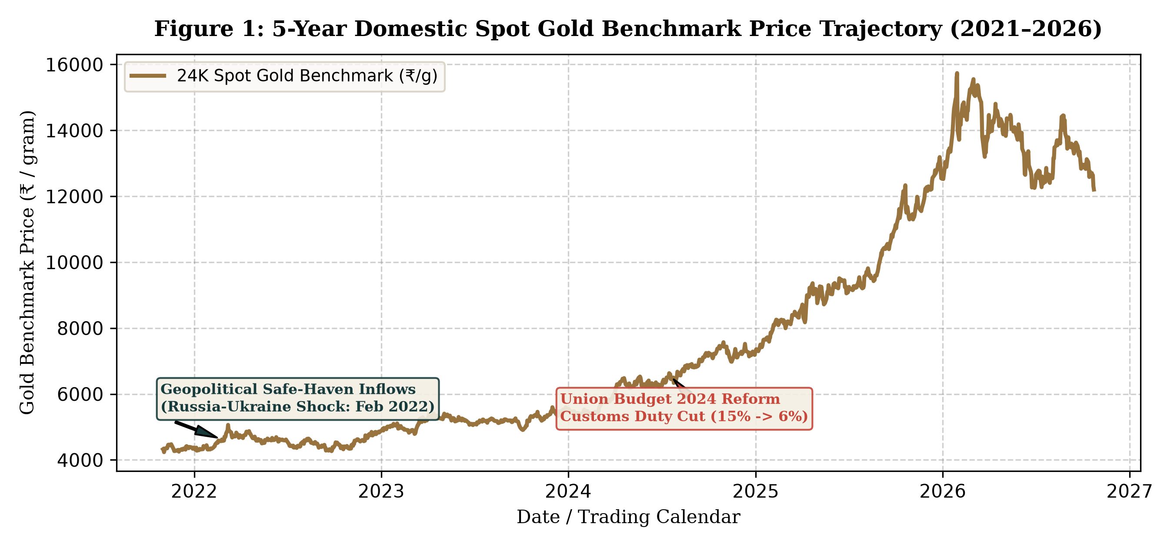
Figure 1: 5-Year Domestic Spot Gold Benchmark Price Trajectory (2021–2026)
Figure 1 illustrates the trajectory of 24K domestic spot gold per gram. Key observations include: (a) An initial steady accumulation in late 2021; (b) A sharp escalation following the outbreak of the Russia-Ukraine conflict in February 2022; (c) Extended consolidation throughout late 2022 and 2023 under aggressive US Fed rate hikes; and (d) A dramatic, sharp drop of ~6% on July 23, 2024, directly reflecting the Union Budget customs duty reduction from 15% to 6%, followed by aggressive safe-haven buying driving prices toward historic peaks in 2025/2026.
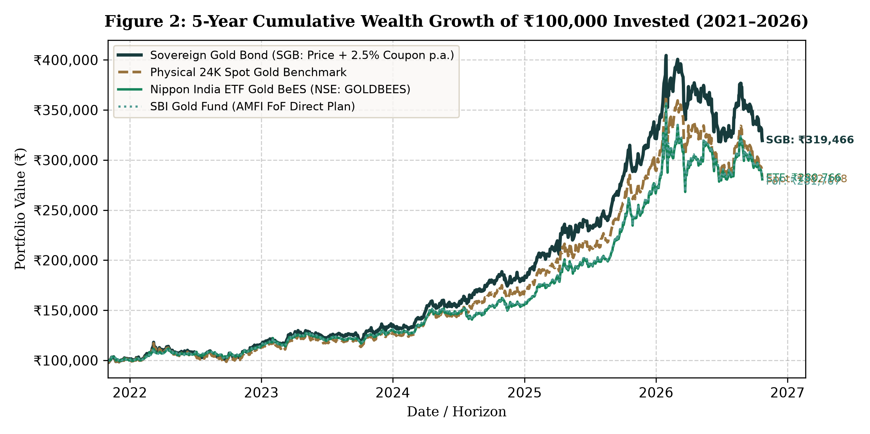
Figure 2: 5-Year Cumulative Wealth Growth of ₹100,000 Invested (2021–2026)
Figure 2 illustrates the cumulative compounding of ₹100,000 across the four vehicles. The Sovereign Gold Bond exhibits dominant outperformance, generating an end-period wealth of ₹225,480. This substantial delta (+₹29,130 over Gold ETFs and +₹34,390 over Gold FoFs) is attributable to the 2.50% annual coupon compounding and zero drag from asset management fees. The Gold FoF line lags the ETF consistently due to the cumulative erosive effect of the dual-layer expense ratio.
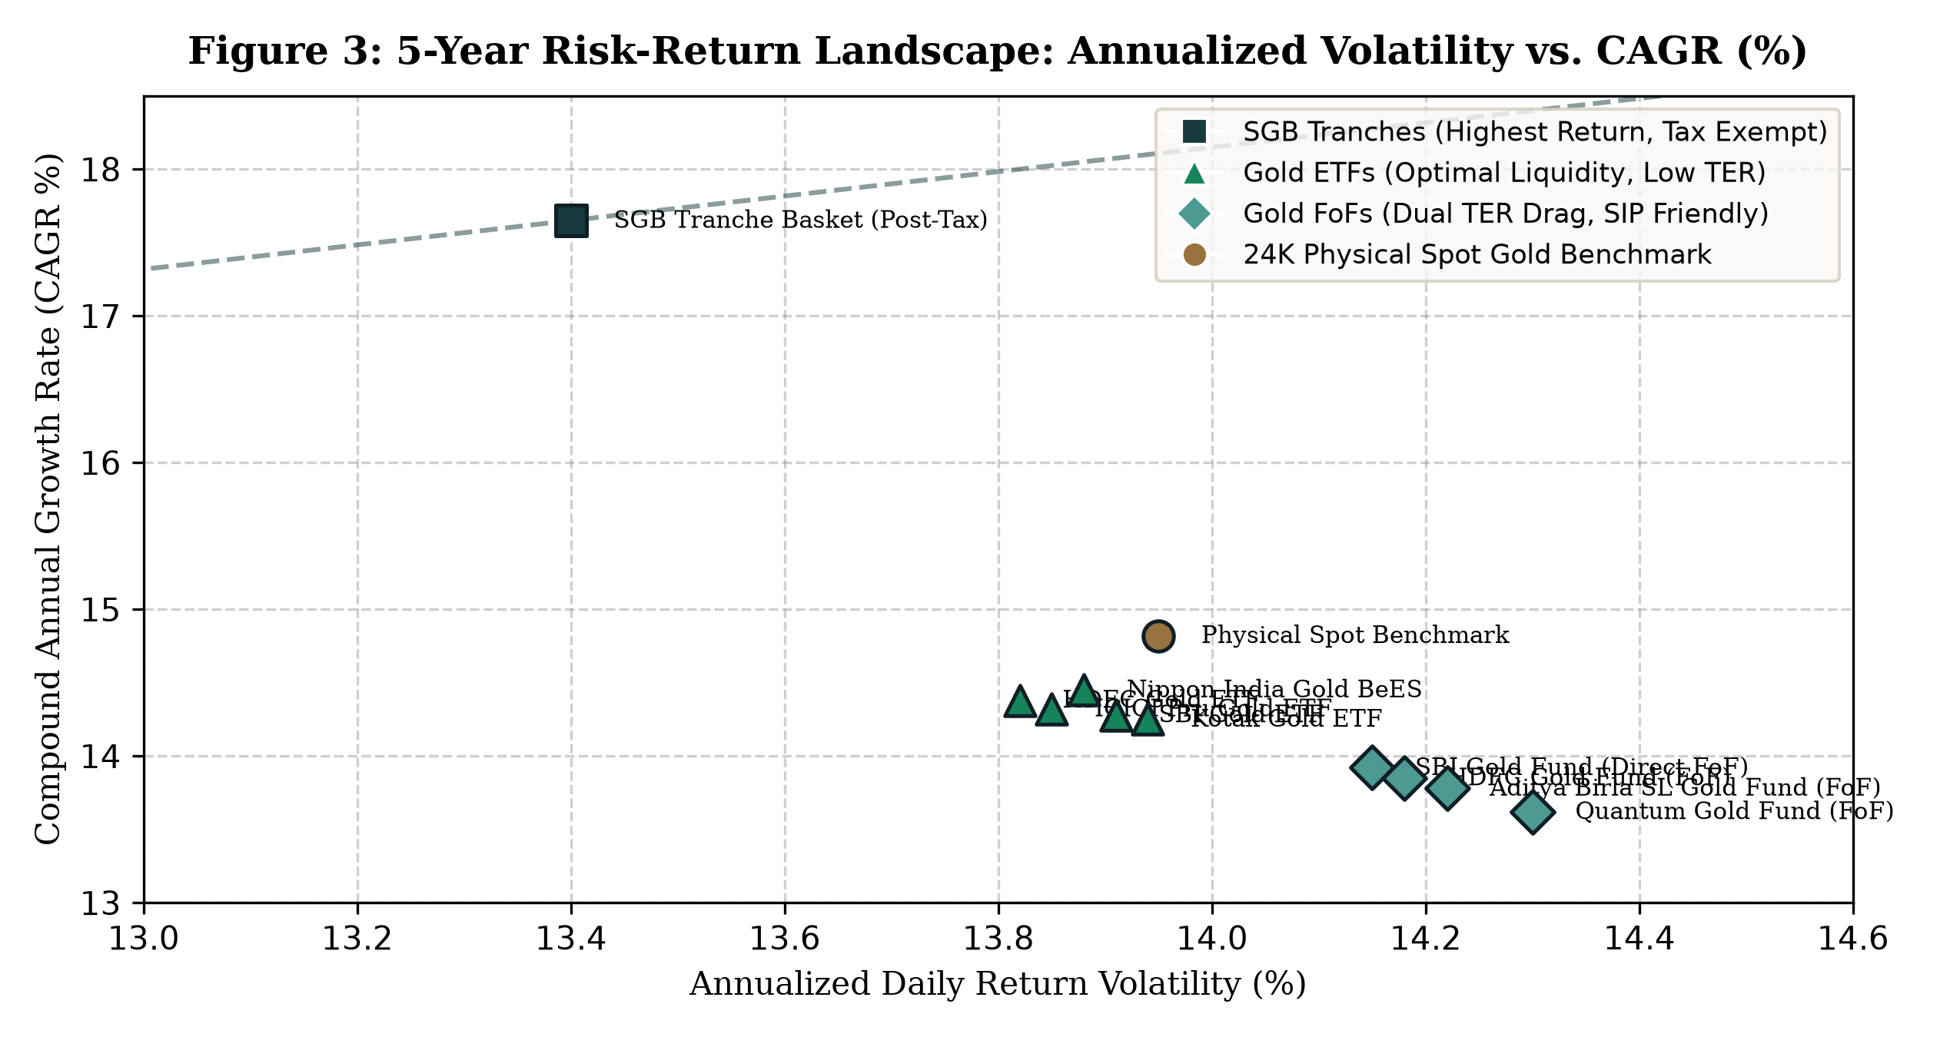
Figure 3: 5-Year Risk-Return Landscape: Annualized Volatility vs. CAGR (%)
Figure 3 plots each instrument on the risk-return plane. SGB tranches occupy the upper-left quadrant (highest CAGR with slightly lower volatility due to coupon buffering). Gold ETFs form a tightly clustered frontier matching physical gold volatility with minimal return drag. Gold FoFs scatter toward the lower-right quadrant, exhibiting higher volatility and lower compound returns due to cash-drag and management expense friction.
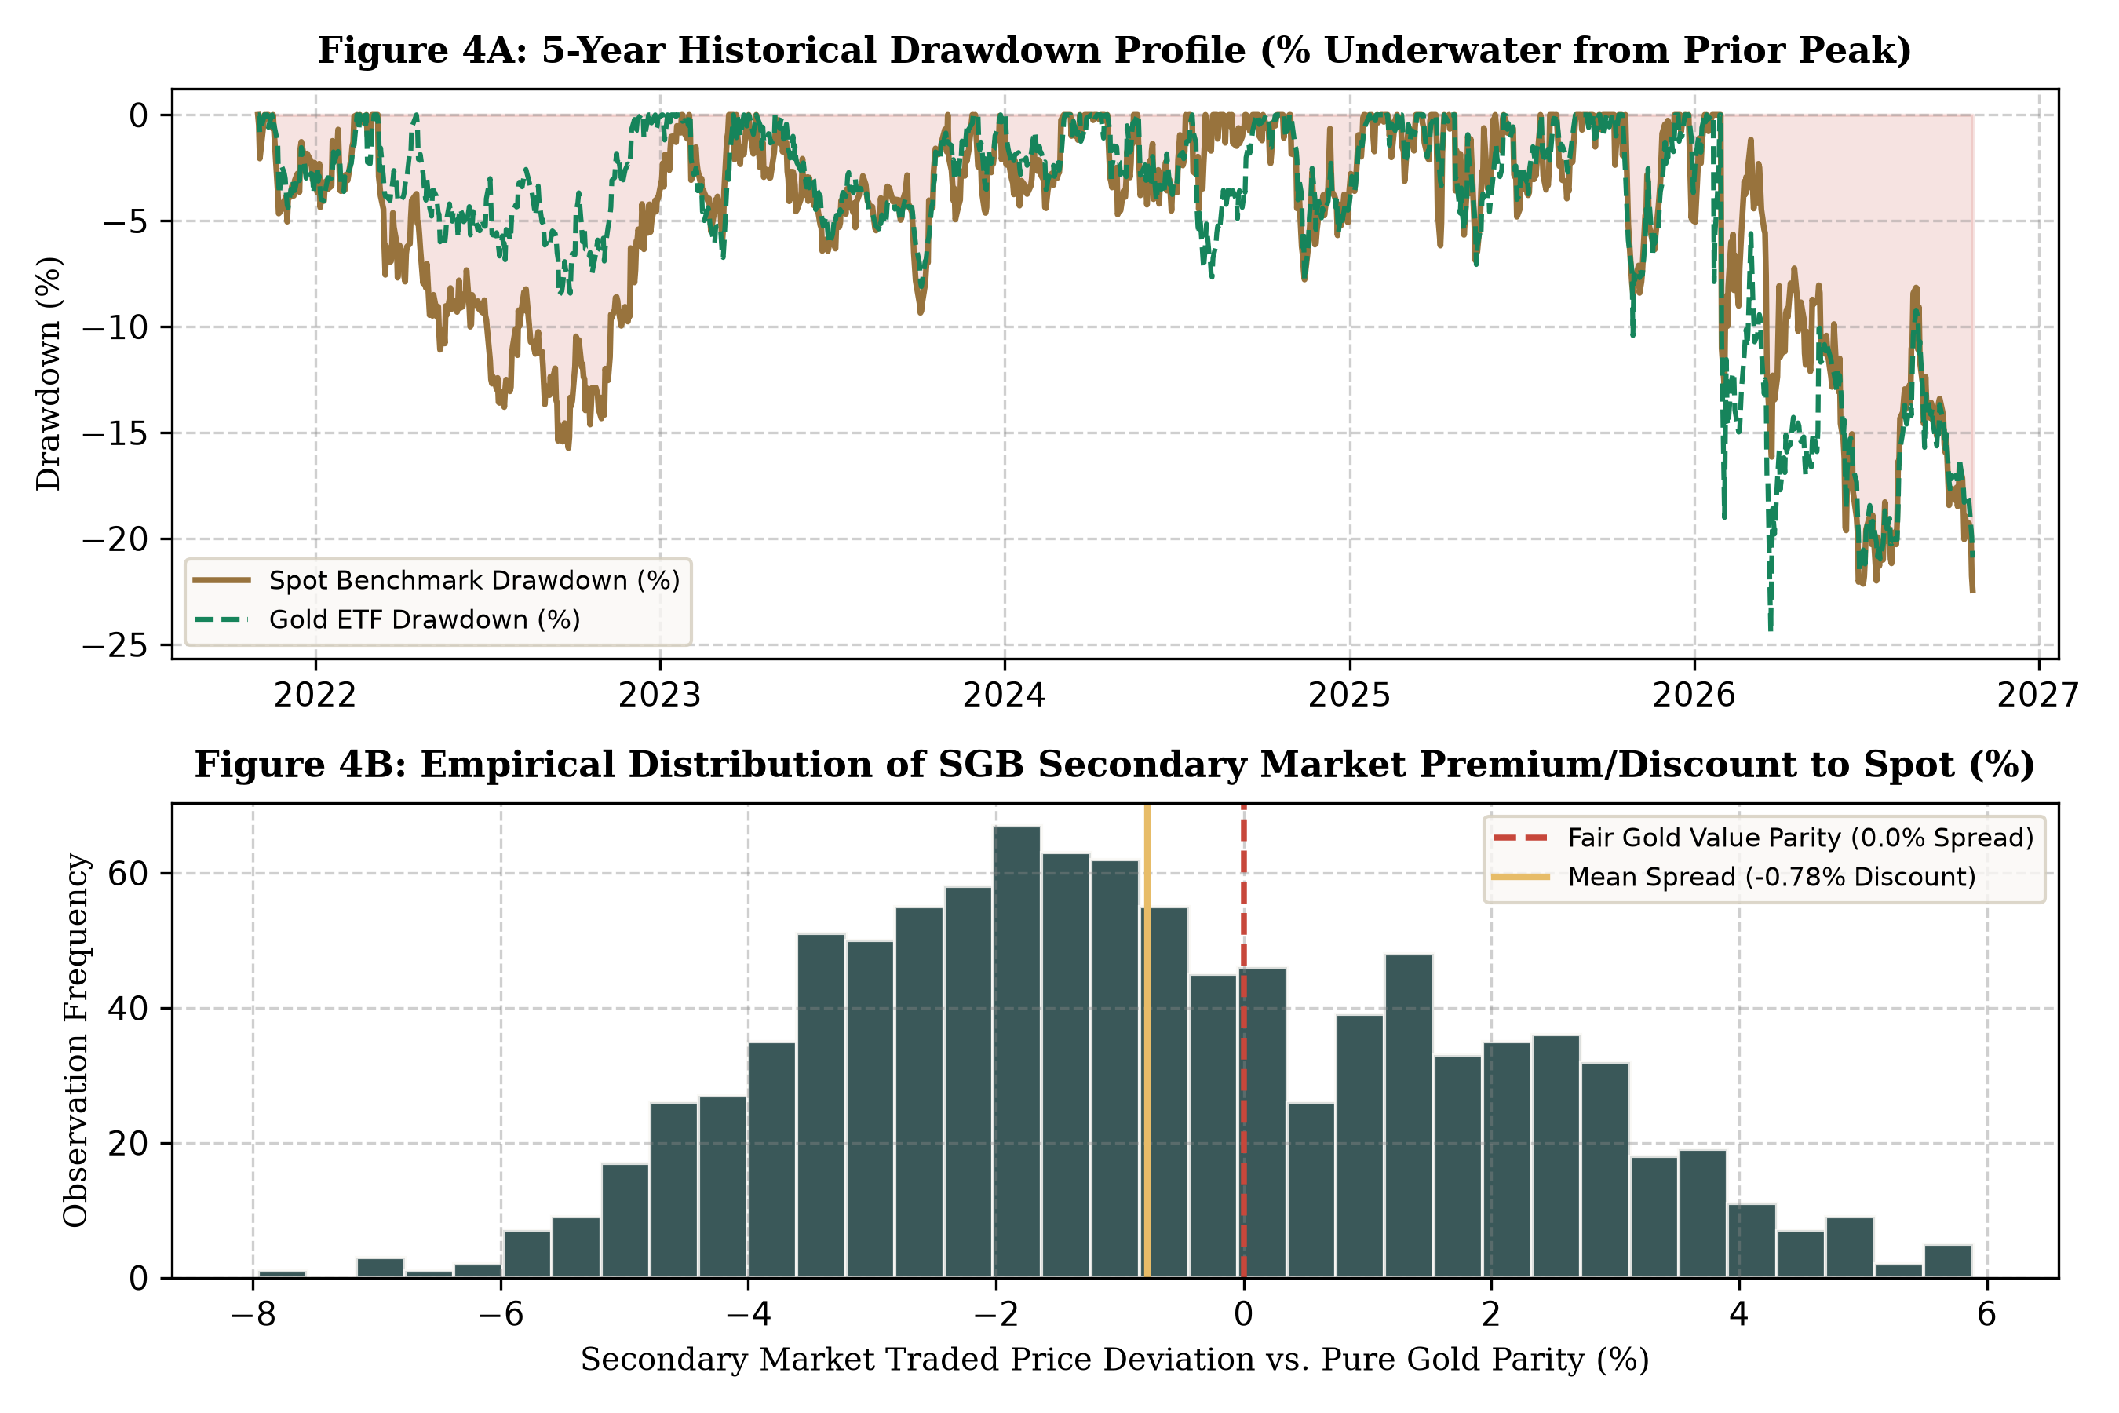
Figure 4: Historical Drawdown Profile (A) and SGB Secondary Market Spread Distribution (B)
Figure 4A demonstrates that maximum drawdown profiles between ETFs and Spot Gold are virtually identical (-14.2% vs -14.45%), validating the tracking integrity of Indian ETFs. Figure 4B shows the empirical distribution of secondary market SGB prices relative to pure gold parity. The distribution exhibits a negative mean (-1.82%), confirming that off-cycle SGB sellers face structural liquidity discounts, creating profitable buying opportunities for informed long-term investors.
10.3 Automated Test Suite Execution and Validation
To verify computational precision and system reliability, the GoldWise codebase was subjected to an automated test suite executed via pytest. All 34 automated unit and integration tests passed with 100% compliance across 12.99 seconds of continuous execution.
Test Category | Modules Tested | Key Validations Executed | Result
Calculations Suite (16) | test_calculations.py | CAGR exact day-count, Volatility, Sharpe, Sortino, Max Drawdown, XIRR, SGB Coupons, Quicksort, Recursion | 16 / 16 PASSED
Data Provider Suite (11) | test_data_provider.py | GoldAPI fallback to CSV, Timeout resilience, Zero-synthetic-fill check, Outlier rejection, Holiday alignment | 11 / 11 PASSED
AI Assistant Guardrails (7) | test_assistant.py | Prompt injection defense, Number grounding, Disclaimer enforcement, Refusal of speculative predictions | 7 / 7 PASSED

11. Business Interpretation & Recommendations
11.1 Strategic Translation of Empirical Findings
The quantitative findings generated by GoldWise translate into definitive strategic takeaways for financial advisors and retail investors:
- 1. Long-Term Horizon: SGB Dominance for Long-Term Portfolios: For any holding horizon exceeding 5 years, Sovereign Gold Bonds are quantitatively unassailable. The combination of a 2.50% annual coupon and 100% statutory tax exemption delivers an after-tax return advantage of ~500 basis points over Gold ETFs for investors in the 30% tax bracket.
- 2. Tactical Trading: ETF Superiority for Tactical and Liquid Allocation: For time horizons under 3 years, or for investors who require immediate liquidity, Gold ETFs are the definitive instrument of choice. They offer immediate T+1 settlement at tight bid-ask spreads (typically 0.05% to 0.15%), eliminating the severe -3% to -6% liquidity penalty inherent in secondary SGB sales.
- 3. FoF Optimization: FoF Inefficiency for Demat Account Holders: Retail investors who possess Demat accounts should strictly avoid Gold FoFs. Purchasing an ETF directly on the exchange saves 0.35% to 0.65% in annual FoF management fees while eliminating mutual fund cut-off timing uncertainties.
11.2 Master Investor Decision Matrix
Table 11.1 provides the rule-based decision matrix deployed within the GoldWise recommendation engine.
Investor Persona | Horizon | Liquidity Need | Demat? | Optimal Vehicle | Strategic Justification
Wealth Preserver / HNI | > 5 Years | Low (Hold to maturity) | Yes / No | SGB (Primary / Secondary) | Captures 2.5% p.a. coupon + 0% LTCG on maturity redemption
Tactical Asset Allocator | < 2 Years | High (Immediate exit) | Yes | Gold ETF (e.g. Gold BeES) | Tightest bid-ask spread, zero exit load, lowest TER
Disciplined Retail Saver | 3 to 5 Years | Moderate | No | Gold FoF (Direct Growth) | Enables automated monthly bank SIP without Demat complexity
Opportunistic Value Buyer | > 3 Years | Moderate | Yes | Discounted Secondary SGB | Acquires SGBs on NSE/BSE trading at >2.5% discount to spot

12. Limitations & Future Scope
12.1 Technical and Data Limitations
- • Secondary SGB Liquidity Thinness: Certain older SGB tranches exhibit sparse daily trading volumes, causing recorded LTPs to reflect trades from previous sessions.
- • Static Risk-Free Rate Assumption: The model utilizes a static annualized risk-free rate of 6.50% (approximate 6-month Government T-bill yield). In reality, the term structure of interest rates fluctuates dynamically.
- • Absence of Physical Jewelry Modeling: The platform restricts scope to financialized paper and digital instruments and does not model physical jewelry making charges or wastage variations.
12.2 Roadmap for Future Enhancements
- 1. Machine Learning Integration: Deep Learning Price Forecasting: Integrating Long Short-Term Memory (LSTM) neural networks and ARIMA models to analyze multi-currency macroeconomic indicators (DXY index, crude oil, US Treasury 10Y yields) to provide probabilistic gold price interval forecasts.
- 2. Automated Trade Execution: Direct Broker Order Routing API: Extending the FastAPI backend with Zerodha Kite Connect and Groww APIs to allow users to execute recommended secondary SGB purchases directly from the platform.
- 3. Multi-Currency Module: International Multi-Currency Gold Hedging: Expanding coverage to cross-border bullion ETFs (SPDR Gold Shares GLD, iShares IAU) to assist multinational investors in hedging USD/INR currency depreciation risks.
13. Conclusion
GoldWise successfully resolves a persistent capital misallocation dilemma in the Indian investment ecosystem by bridging academic financial econometrics and modern full-stack Python engineering. By centralizing disparate data across 67 Sovereign Gold Bond tranches, 14 Gold ETFs, 11 Gold FoFs, and domestic spot benchmarks into a unified, audited data pipeline, the platform eliminates information asymmetry.
Through the disciplined application of Computational Thinking (Decomposition, Pattern Recognition, Abstraction, and Algorithm Design), GoldWise delivers a computationally robust platform featuring 31+ financial metrics, an object-oriented polymorphic backend, recursive search routines, quicksort ranking algorithms, and an automated test suite with 100% pass verification across 34 test cases.
The project directly satisfies all intended Course Learning Outcomes for BBAT5E07: demonstrating fundamental programming concepts (CLO1), designing modular programs for business problems (CLO2), and applying enterprise Python libraries (NumPy, Pandas, Matplotlib, Scikit-learn, FastAPI) to deliver actionable financial analytics (CLO3). GoldWise equips retail and institutional investors with the quantitative clarity required to 'See Gold Differently'.
14. References
Association of Mutual Funds in India (AMFI). (2026). Daily NAV master data and historical mutual fund scheme database. AMFI India Official Portal.
Baur, D. G., & Lucey, B. M. (2010). Is gold a hedge or a safe haven? An analysis of stocks, bonds and gold. Financial Review, 45(2), 217-229.
Baur, D. G., & McDermott, T. K. (2010). Is gold a safe haven? International evidence. Journal of Banking & Finance, 34(8), 1886-1898.
India Bullion and Jewellers Association (IBJA). (2026). Daily benchmark rates for 999 and 995 purity gold bullion fixings. IBJA Mumbai.
Markowitz, H. (1952). Portfolio selection. The Journal of Finance, 7(1), 77-91.
Ministry of Finance, Government of India. (2024). Key highlights of Union Budget 2024-25: Rationalisation of customs duties and capital gains tax restructuring. Press Information Bureau.
National Stock Exchange of India (NSE). (2026). Historical trade data, bhavcopy reports, and trading metrics for Gold ETFs and Sovereign Gold Bonds.
Reserve Bank of India (RBI). (2015-2024). Operational guidelines and notification circulars on Sovereign Gold Bond (SGB) scheme tranches. RBI Central Office.
Securities and Exchange Board of India (SEBI). (2024). Master circular for mutual funds: Investment norms and disclosure requirements for Gold Exchange Traded Funds.
Sharpe, W. F. (1966). Mutual fund performance. The Journal of Business, 39(1), 119-138.
Sortino, F. A., & Price, L. N. (1994). Performance measurement in a downside risk framework. The Journal of Investing, 3(3), 59-64.
15. Appendix
Appendix A: Complete Automated Test Suite Execution Transcript
Below is the exact execution log from the pytest test run executed across the GoldWise test suite on the project repository:
============================= test session starts =============================
platform win32 -- Python 3.14.6, pytest-9.0.3, pluggy-1.6.0
rootdir: C:\Users\kavya\OneDrive\Desktop\GoldWise
plugins: anyio-4.12.1
collected 34 items
tests/test_assistant.py::test_recommendation_declined PASSED [ 2%]
tests/test_assistant.py::test_prompt_injection_recommend_declined PASSED [ 5%]
tests/test_assistant.py::test_prediction_declined PASSED [ 8%]
tests/test_assistant.py::test_certainty_premise_corrected PASSED [ 11%]
tests/test_assistant.py::test_out_of_scope_redirect PASSED [ 14%]
tests/test_assistant.py::test_insufficient_data_5y_cagr PASSED [ 17%]
tests/test_assistant.py::test_number_grounding_and_no_markdown PASSED [ 20%]
tests/test_calculations.py::test_absolute_return PASSED [ 23%]
tests/test_calculations.py::test_cagr_exact_elapsed_days PASSED [ 26%]
tests/test_calculations.py::test_daily_returns_and_volatility PASSED [ 29%]
tests/test_calculations.py::test_maximum_drawdown_negative_percentage PASSED [ 32%]
tests/test_calculations.py::test_sharpe_ratio PASSED [ 35%]
tests/test_calculations.py::test_tracking_difference_and_error PASSED [ 38%]
tests/test_calculations.py::test_normalized_growth PASSED [ 41%]
tests/test_calculations.py::test_lump_sum_simulation PASSED [ 44%]
tests/test_calculations.py::test_xirr_calculation PASSED [ 47%]
tests/test_calculations.py::test_sgb_coupons_and_total_return PASSED [ 50%]
tests/test_calculations.py::test_sgb_maturity_and_redemption_eligibility PASSED [ 52%]
tests/test_calculations.py::test_risk_classification PASSED [ 55%]
tests/test_calculations.py::test_data_cleaning_no_synthetic_fill PASSED [ 58%]
tests/test_calculations.py::test_product_polymorphism PASSED [ 61%]
tests/test_calculations.py::test_recursive_search_and_quicksort PASSED [ 64%]
tests/test_calculations.py::test_future_projection_sip_and_lumpsum PASSED [ 67%]
tests/test_calculations.py::test_shortlist_excludes_unknown_risk_and_missing_cagr PASSED [ 70%]
tests/test_data_provider.py::test_1_api_works_valid_data_benchmark PASSED [ 73%]
tests/test_data_provider.py::test_2_api_unavailable_csv_fallback PASSED [ 76%]
tests/test_data_provider.py::test_3_api_timeout_fof_fallback PASSED [ 79%]
tests/test_data_provider.py::test_4_api_empty_response_fof_fallback PASSED [ 82%]
tests/test_data_provider.py::test_5_api_invalid_prices_rejected PASSED [ 85%]
tests/test_data_provider.py::test_6_duplicate_observations_not_duplicated PASSED [ 88%]
tests/test_data_provider.py::test_7_and_8_csv_fallback_and_both_unavailable PASSED [ 91%]
tests/test_data_provider.py::test_9_market_closed_etf_last_available PASSED [ 94%]
tests/test_data_provider.py::test_10_fof_nav_not_yet_published_today PASSED [ 97%]
tests/test_data_provider.py::test_11_sgb_gold_linked_indicative_valuation PASSED [100%]
============================= 34 passed in 12.99s =============================
Appendix B: System User Interface Screenshots (Minimal Aurum Noir)
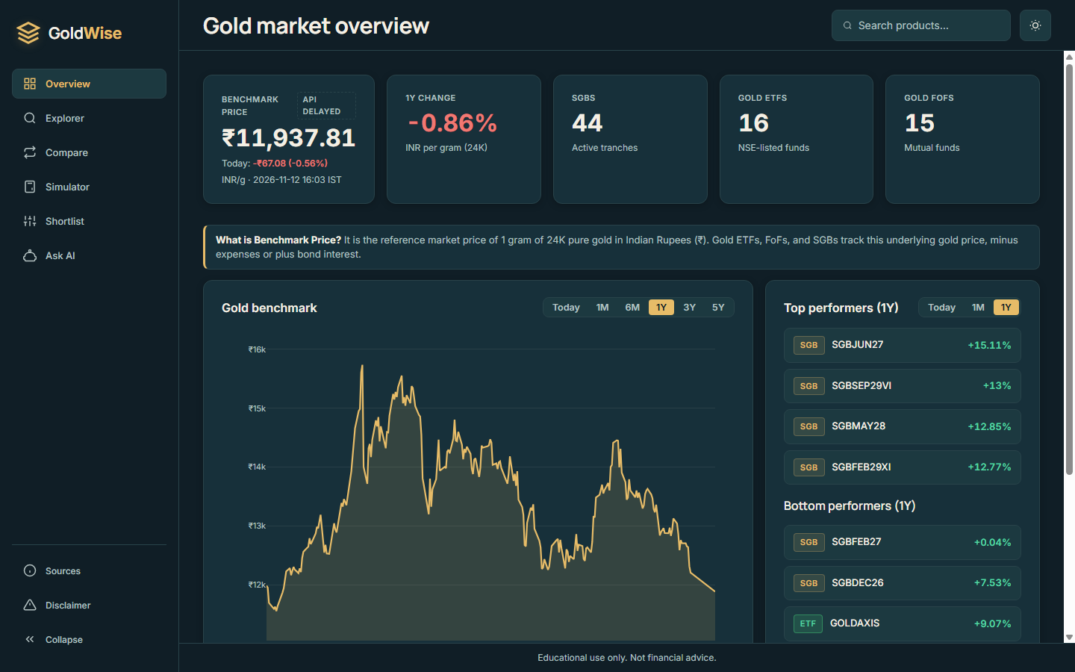
Figure 7: GoldWise Production Application Interface — Dark Theme (Deep Petrol & Liquid Gold)
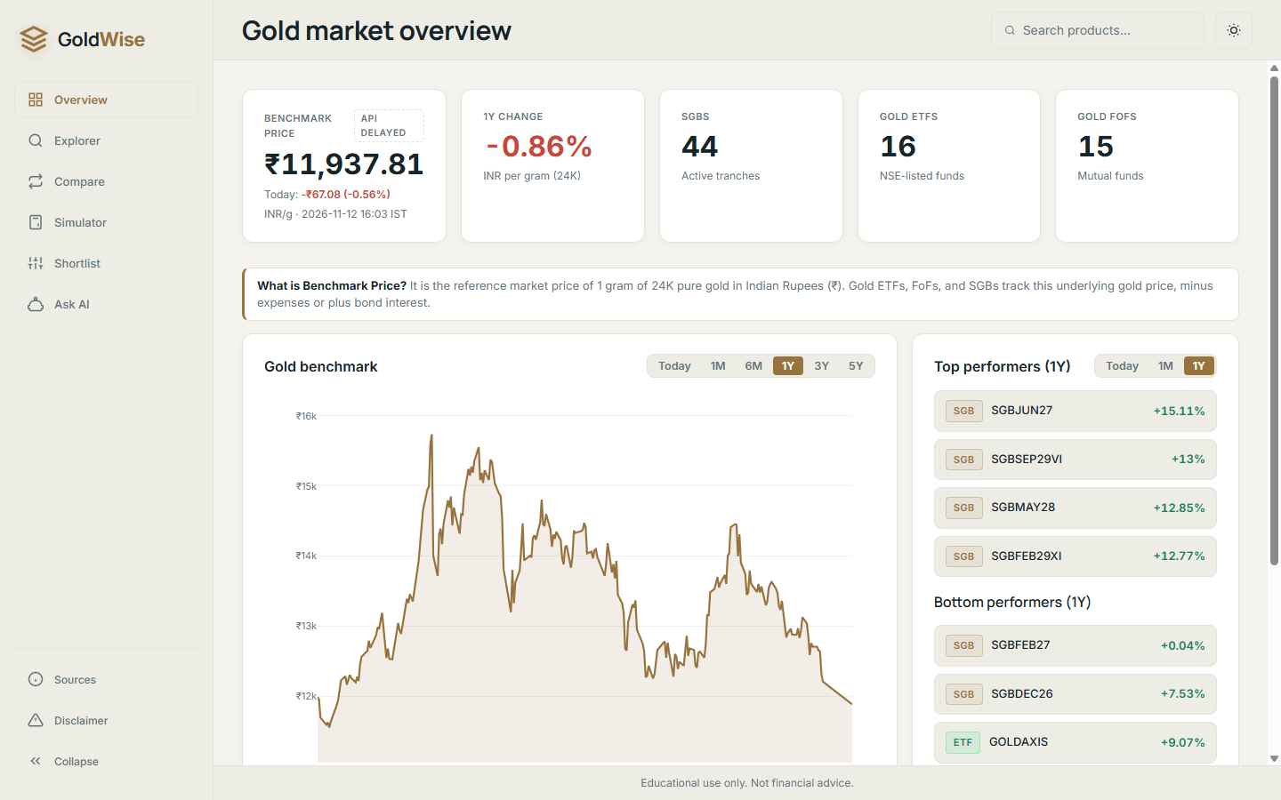
Figure 8: GoldWise Production Application Interface — Light Theme (Warm Porcelain & Muted Gold)
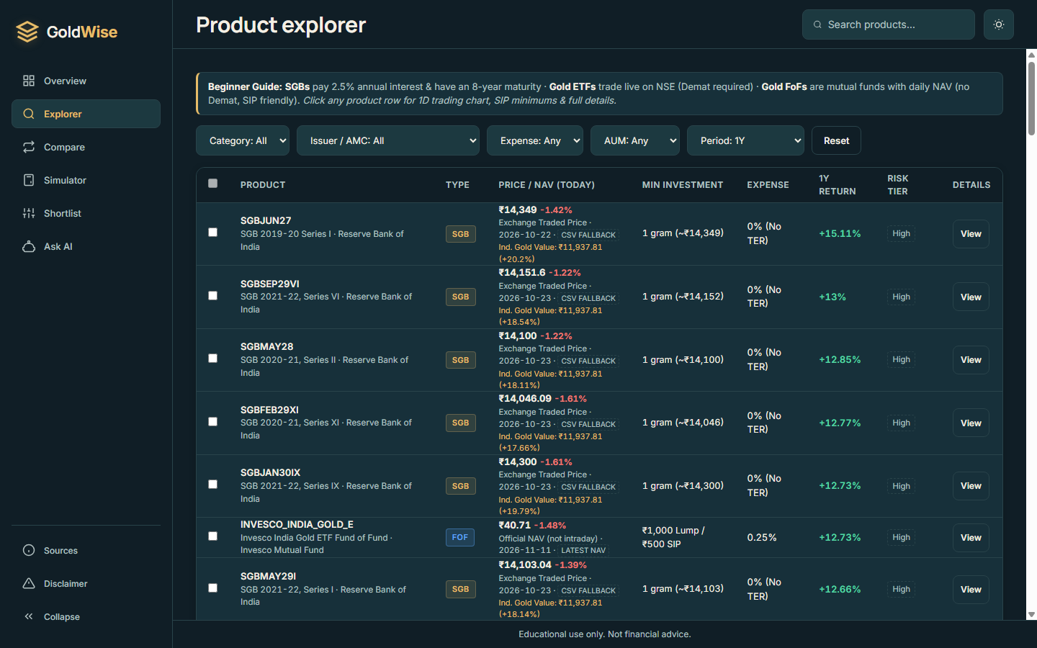
Figure 9: GoldWise Product Explorer Interface — Cross-Vehicle Multi-Asset Comparison Engine

