**Baby Safety and Monitoring Device**

**Components used: -**

|  |  |  |
| --- | --- | --- |
| S. N. | Name of the component | Quantity |
| 1 | NodeMcu (ESP8266) | 1 |
| 2 | ESP32 cam | 1 |
| 3 | GPS module | 1 |
| 4 | Temperature sensor | 1 |

**Connections: -**

ESP8266 connected to GPS module and LM35: - Refer ‘firebasetemp.ino’ file to code this with ‘NodeMCU 1.0 (ESP- 12E module)’ board.

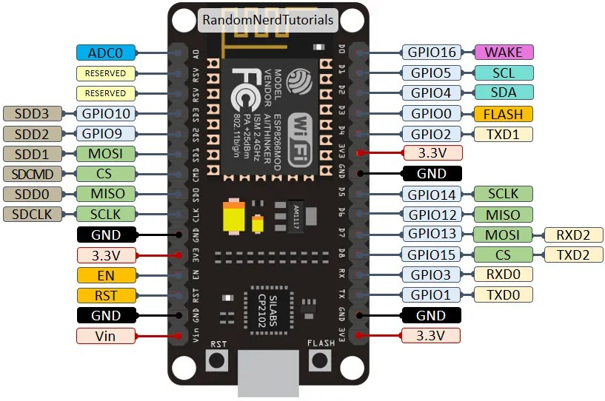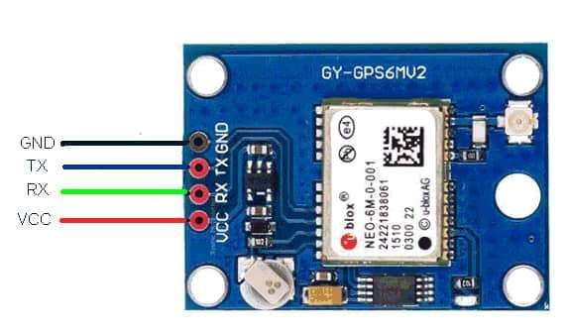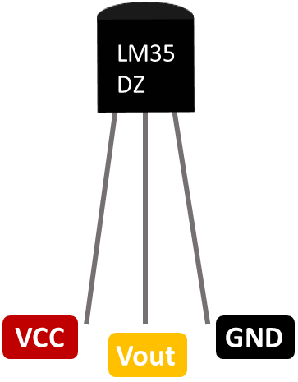

Rx-D1

Tx-D2



ESP8266 connected with ESP32 cam: - Refer ‘CameraWebServer.ino’ file to code ESP32 cam module. Use ‘ESP32 Wrover Module’ board. While uploading the code disconnect GPIO0 and GND connection on ESP32 cam module.

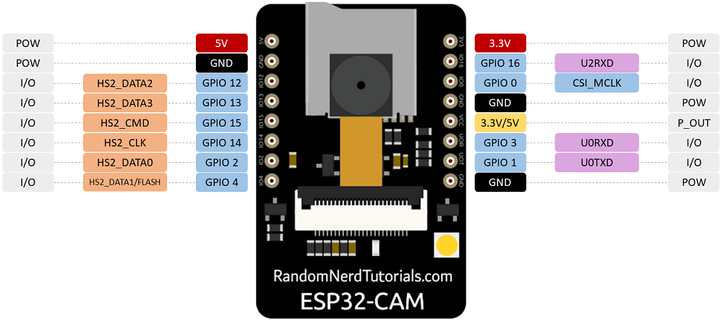

After doing above connection, login/ signup in google firebase. Create a project and use its token ID and url to print the real time data on firebase. For detailed step refer any YouTube video.

Note: - Firebase provides more accurate data to app.

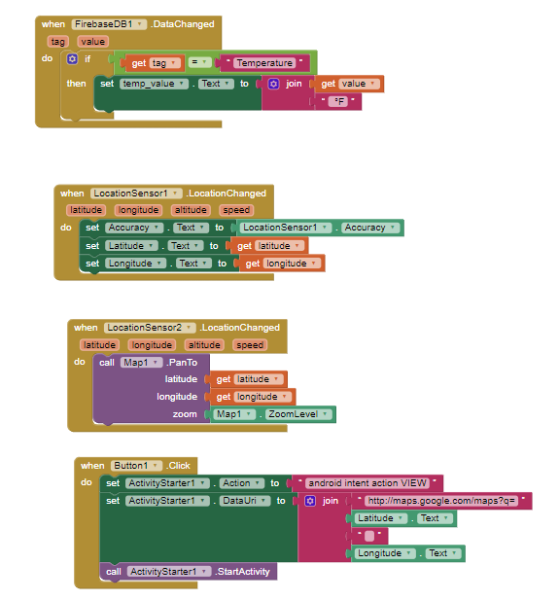 To develop an application, we make use of MIT app inventor. Just by using firebase token ID we can get real time data on app. For reference you can use following blocks in MIT app inventor. For more details see any reference video on You Tube.