**DN 4.0 JAVA FSE SOLUTIONS – WEEK 6**

**SKILL: React**

**HandsOn 1:**

* Created react app using command -

npx create-react-app myfirstreact

* Command used to run react app -

npm start

**Code:**

**src/App.js -**

function App() {

  return (

    <h1 style={{ textAlign: "center" }}>Welcome the first session of React</h1>

  );

}

export default App;

**Output:**

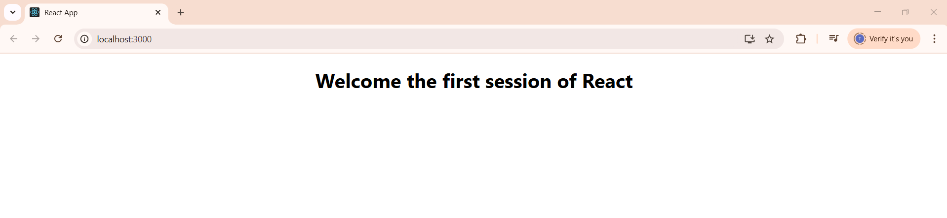

**HandsOn 2:**

* Created react app using command -

npx create-react-app studentapp

* Command used to run react app -

npm start

**Code:**

**src/Components/:**

**Home.js -**

import React, {Component} from 'react';

class Home extends Component{

    render(){

        return(

        <div>

        <h3> Welcome to the Home Page of Student Management Portal </h3>

        </div>

        );

    }

}

export default Home;

**About.js -**

import React, {Component} from 'react';

class About extends Component{

    render(){

        return(

        <div>

        <h3> Welcome to the About Page of Student Management Portal </h3>

        </div>

        );

    }

}

export default About;

**Contact.js -**

import React, {Component} from 'react';

class Contact extends Component{

    render(){

        return(

        <div>

        <h3> Welcome to the Contact Page of Student Management Portal </h3>

        </div>

        );

    }

}

export default Contact;

**src/App.js -**

import'./App.css';

import Home from './Components/Home';

import About from './Components/About';

import Contact from './Components/Contact';

function App() {

  return (

  <div className="container">

    <Home/>

    <About/>

    <Contact/>

  </div>

  );

}

export default App;

**Output:**

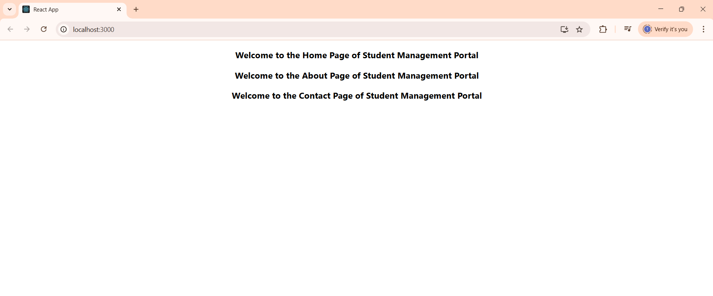

**HandsOn 3:**

* Created react app using command -

npx create-react-app scorecalculatorapp

* Command used to run react app -

npm start

**Code:**

**src/Stylesheets/mystyle.css -**

.Name

{

    font-weight:300;

    color:blue;

}

.School

{

    color:crimson;

}

.Total

{

    color:darkmagenta;

}

.formatstyle

{

    text-align:center;

    font-size:large;

}

.Score

{

    color:forestgreen;

}

**src/Components/CalculateScore.js -**

import '../Stylesheets/mystyle.css'

const percentToDecimal= (decimal) => {

    return (decimal.toFixed(2) +'%')

}

const calcScore = (total, goal) => {

    return percentToDecimal(total/goal)

}

export const CalculateScore = ({Name,School, total, goal}) => (

<div className="formatstyle">

    <h1><font color="Brown">Student Details:</font></h1>

    <div className="Name">

        <b> <span> Name: </span> </b>

        <span>{Name}</span>

    </div>

    <div className="School">

        <b> <span> School: </span> </b>

        <span>{School}</span>

    </div>

    <div className="Total">

        <b><span>Total :</span> </b>

        <span>{total}</span>

        <span>Marks</span>

    </div>

    <div className="Score">

        <b>Score : </b>

        <span>

            {calcScore(

                total,

                goal

            )}

        </span>

    </div>

</div>)

**src/App.js -**

import {CalculateScore} from '../src/Components/CalculateScore';

function App()

{

  return(

  <div>

    <CalculateScore Name={"Steeve"}

    School={"DNV Public School"}

    total={284}

    goal={3}/>

  </div>

)

}

export default App;

**Output:**

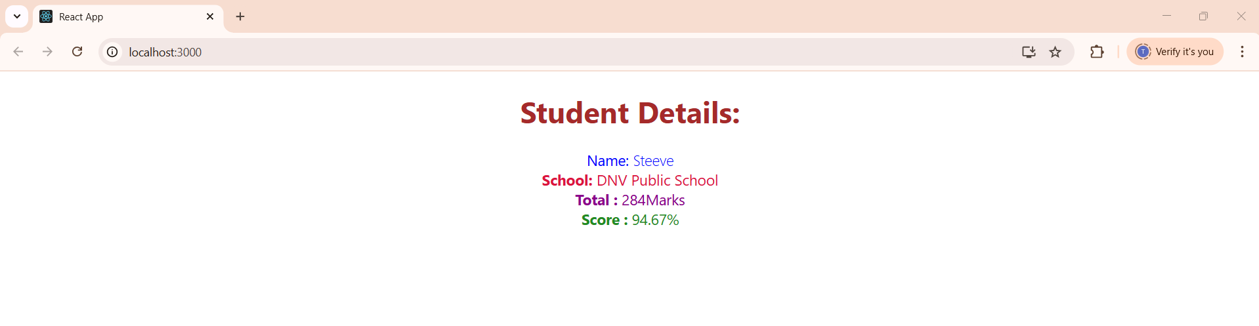

**HandsOn 4:**

* Created react app using command -

npx create-react-app blogapp

* Command used to run react app -

npm start

**Code:**

**src/Post.js -**

class Post {

  constructor(id, title, body) {

    this.id = id;

    this.title = title;

    this.body = body;

  }}

export default Post;

**src/Posts.js -**

import React from "react";

import Post from "./Post";

class Posts extends React.Component {

  constructor(props) {

    super(props);

    this.state = {

      posts: [],

    };}

  loadPosts() {

    fetch("https://jsonplaceholder.typicode.com/posts")

      .then((response) => response.json())

      .then((data) => {

        const postsData = data.map(

          (item) => new Post(item.id, item.title, item.body)

        );

        this.setState({ posts: postsData });

      })

      .catch((error) => {

        alert("Error fetching posts: " + error);

      });

  }

  componentDidMount() {

    this.loadPosts();

  }

  componentDidCatch(error, info) {

    alert("An error occurred: " + error);

  }

  render() {

  return (

    <div>

      <h2>Blog Posts</h2>

      {this.state.posts.map((post) => (

        <div key={post.id}>

          <h3>{post.title}</h3>

          <p>{post.body}</p>

        </div>

      ))}

    </div>

  );

}}

export default Posts;

**App.js -**

import React from "react";

import Posts from "./Posts";

function App() {

  return (

    <div className="App" style={{ padding: "20px" }}>

      <h1>Welcome to Blog App</h1>

      <Posts />

    </div>

  );}

export default App;

**Output:**

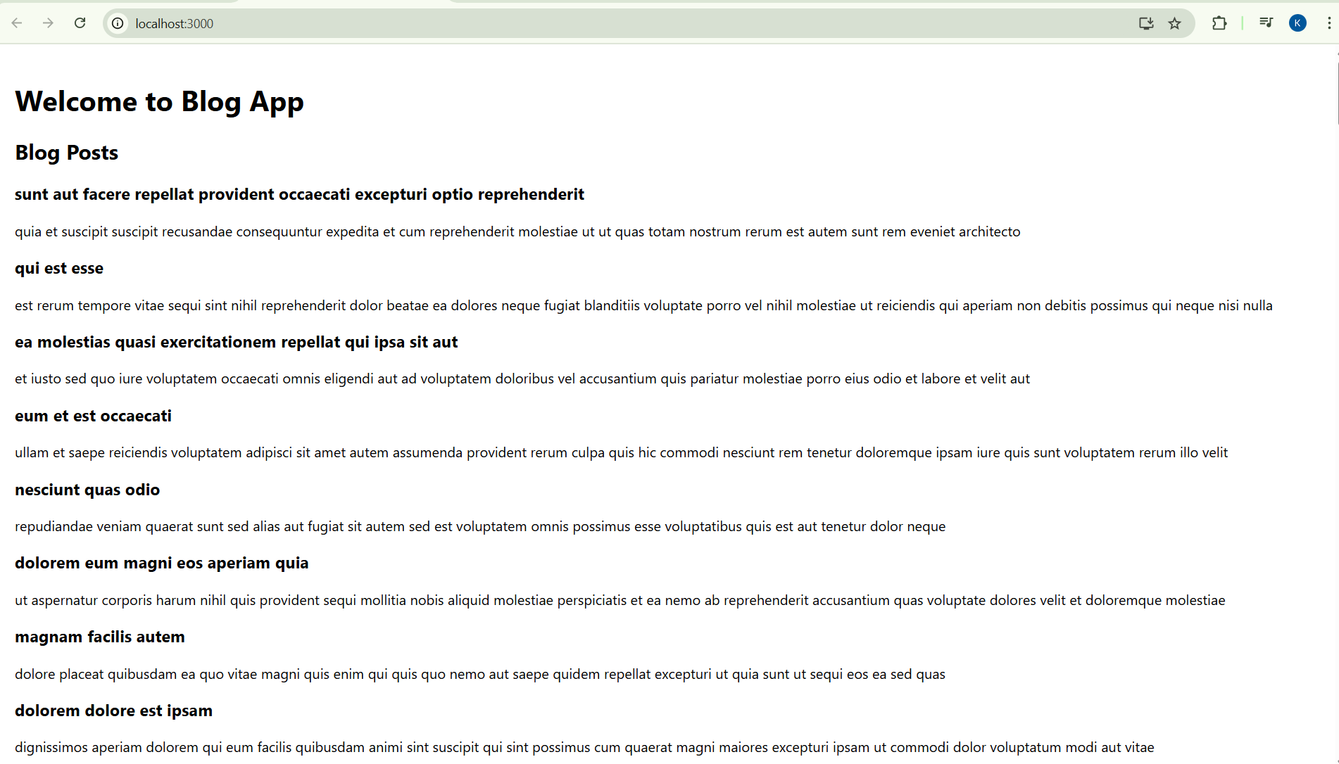

**HandsOn 5:**

* Unizipped react folder(cohorttrack) and used command-

npm install

* Command used to run react app -

npm start

**Code:**

**src/Cohort.js -**

class Cohort {

    constructor(cohortCode,

        startDate,

        technology,

        trainerName,

        coachName,

        currentStatus) {

        this.cohortCode = cohortCode;

        this.coachName = coachName;

        this.trainerName = trainerName;

        this.technology = technology;

        this.startDate = startDate;

        this.currentStatus = currentStatus;

    }

}

const CohortsData =[

    new Cohort('INTADMDF10','22-Feb-2022', '.NET FSD', 'Jojo Jose','Aathma', 'Scheduled'),

    new Cohort('ADM21JF014','10-Sep-2021', 'Java FSD', 'Elisa Smith','Apoorv', 'Ongoing'),

    new Cohort('CDBJF21025','24-Dec-2021', 'Java FSD', 'John Doe','Aathma', 'Ongoing'),

    new Cohort('INTADMJF12','22-Feb-2022', 'Java FSD', 'To Be Assigned','Ibrahim', 'Scheduled'),

    new Cohort('CDE22JF011','24-Dec-2021', 'Java FSD', 'Emma Swan','Apoorv', 'Ongoing'),

    new Cohort('INTADMDF09','22-Feb-2022', 'Dataware Housing', 'Babjee Rao','Aathma', 'Scheduled'),

    new Cohort('ADM22DF001','10-Sep-2021', '.NET FSD', 'Marie Curie','Ibrahim', 'Ongoing'),

];

export {Cohort, CohortsData};

**src/CohortDetails.module.css -**

.box {

  width: 300px;

  display: inline-block;

  margin: 10px;

  padding: 10px 20px;

  border: 1px solid black;

  border-radius: 10px;

}

dt {

  font-weight: 500;

}

**src/CohortDetails.js -**

import styles from "./CohortDetails.module.css";

function CohortDetails(props) {

    const { cohort } = props;

    const headingStyle = {

        color: cohort.currentStatus.toLowerCase() === "ongoing" ? "green" : "blue"

    };

    return (

        <div className={styles.box}>

            <h3 style={headingStyle}>

                {cohort.cohortCode} - <span>{cohort.technology}</span>

            </h3>

            <dl>

                <dt>Started On</dt>

                <dd>{cohort.startDate}</dd>

                <dt>Current Status</dt>

                <dd>{cohort.currentStatus}</dd>

                <dt>Coach</dt>

                <dd>{cohort.coachName}</dd>

                <dt>Trainer</dt>

                <dd>{cohort.trainerName}</dd>

            </dl>

        </div>

    );

}

export default CohortDetails;

**src/App.js -**

import { CohortsData } from "./Cohort";

import CohortDetails from "./CohortDetails";

function App() {

    return (

        <div>

            <h2>Cohorts Details</h2>

            {CohortsData.map((cohort, index) => (

                <CohortDetails key={index} cohort={cohort} />

            ))}

        </div>

    );

}

export default App;

**Output:**

