SMARTPARK
Intelligent Parking Slot Finder and Reservation System
Software Requirements Specification
Version 1.0 | IEEE-style format
Mini Project Documentation

Document Contents
- 1. Introduction
- 2. Overall Description
- 3. System Features and Functional Requirements
- 4. External Interface Requirements
- 5. Data Requirements and Database Design
- 6. Non-Functional Requirements
- 7. Use Cases and Workflows
- 8. Business Rules and Validation
- 9. System Architecture and Design
- 10. Testing Requirements
- 11. Deployment and Maintenance
- 12. Risks and Mitigation
- 13. Requirements Traceability
- 14. Project Schedule and Deliverables
- 15. Future Enhancements
- 16. Assumptions and Dependencies
- 17. Glossary
- 18. Approval and Sign-off

1. Introduction

1.1 Purpose
This Software Requirements Specification (SRS) defines the requirements for SmartPark, an intelligent parking slot finder and reservation system. It describes the system’s objectives, scope, users, functional behavior, interfaces, data, constraints, quality requirements, and verification criteria. It is intended to serve as a common reference for development, testing, demonstration, and evaluation.

1.2 Scope
SmartPark enables drivers to search for parking facilities, view slot availability, compare facility details, and reserve a parking slot for a selected time interval. Drivers can review and manage their reservations. Administrators can maintain parking facilities, slots, rates, and booking information.
- Search parking facilities by location or area.
- View facility information, availability, operating hours, and pricing.
- Filter and sort available parking options where supported.
- Reserve a slot for a valid date and time range.
- View reservation details and history.
- Cancel eligible reservations.
- Manage facilities, slots, availability, and pricing through an administrator interface.
- Provide a responsive web experience for desktop and mobile users.
The MVP uses administrator-maintained or sample availability data. Physical sensor integration, payment processing, automatic number-plate recognition, and advanced navigation are optional future capabilities.

1.3 Intended Audience
- Developers and project team members.
- Project guide, evaluator, and academic reviewers.
- Drivers using the parking service.
- Parking administrators managing inventory and reservations.
- Testers validating the application.

1.4 Definitions and Acronyms
Term | Definition
SRS | Software Requirements Specification
MVP | Minimum Viable Product
UI | User Interface
API | Application Programming Interface
DBMS | Database Management System
Slot | A single parking space
Reservation | A time-bounded booking of a parking slot
Availability | Slots that can be booked for a specified interval
Admin | Authorized user who manages facilities and system data

1.5 Document Conventions
Requirements use identifiers such as FR and NFR. “Shall” and “must” indicate mandatory requirements; “should” indicates a recommendation; “may” indicates an optional feature.

1.6 References
- Project problem statement for SmartPark – Intelligent Parking Slot Finder and Reservation System.
- IEEE-style requirements specification practices.
- Documentation for the selected frontend, backend, database, and hosting technologies.

2. Overall Description

2.1 Product Perspective
SmartPark follows a client-server model. A React-based web interface communicates with a Java/Spring Boot backend. The backend implements authentication, search, availability, reservation, and administration logic. PostgreSQL stores users, parking facilities, slots, rates, and reservations. External services such as maps or notifications may be integrated through separate interfaces.

2.2 Product Functions
- Account registration, login, and logout.
- Parking search and facility details.
- Availability lookup and slot status display.
- Reservation creation, confirmation, history, and cancellation.
- Administrator inventory and booking management.
- Input validation, error handling, and operational feedback.

2.3 User Classes
User class | Description | Permissions
Visitor | Unauthenticated user exploring options | Search and view public facility information
Registered Driver | User who books parking | Reserve, view own bookings, cancel eligible bookings
Administrator | Parking operations manager | Manage lots, slots, rates, and bookings
System Operator | Technical maintainer | Configure, monitor, back up, and maintain the application

2.4 Operating Environment
- Current Chrome, Edge, Firefox, or Safari browser.
- Desktop, tablet, and mobile web browsers.
- React frontend and Java/Spring Boot backend.
- PostgreSQL relational database.
- Local or cloud-hosted deployment with network access.

2.5 Constraints
- The MVP must fit the mini-project schedule and available resources.
- Only authorized administrators may modify inventory.
- Overlapping active reservations for the same slot must be prevented.
- Passwords must not be stored in plain text.
- Core functions should work without optional third-party integrations.

2.6 Assumptions and Dependencies
- Parking and slot data is supplied by administrators or sample data.
- Users have a supported browser and network connection.
- Displayed availability reflects the latest stored data and is revalidated at booking time.
- Maps, payments, and notifications depend on external providers if enabled.

3. System Features and Functional Requirements

3.1 Authentication and User Management
- FR-AUTH-01: The system shall allow a visitor to register using required account details.
- FR-AUTH-02: The system shall validate required fields and reject duplicate email addresses.
- FR-AUTH-03: The system shall allow registered users to log in with valid credentials.
- FR-AUTH-04: The system shall allow users to log out and terminate their session.
- FR-AUTH-05: The system shall store passwords using secure password hashing.
- FR-AUTH-06: The system shall restrict administrator features to authorized administrator accounts.

3.2 Facility Management
- FR-FAC-01: The system shall display active parking facilities with name, address, operating hours, and supported details.
- FR-FAC-02: The administrator shall be able to create, view, update, and deactivate a parking facility.
- FR-FAC-03: The system shall store facility location and contact information when provided.
- FR-FAC-04: The administrator shall be able to configure pricing and facility attributes.
- FR-FAC-05: Inactive facilities shall not accept new reservations.

3.3 Slot and Availability Management
- FR-SLOT-01: The system shall associate each slot with a parking facility.
- FR-SLOT-02: The system shall distinguish available, reserved, occupied, and out-of-service slots.
- FR-SLOT-03: The administrator shall be able to add, update, deactivate, or change slot status.
- FR-SLOT-04: The system shall retrieve availability for a selected date and time range.
- FR-SLOT-05: The system shall revalidate availability before creating a reservation.

3.4 Reservation Management
- FR-BOOK-01: An authenticated driver shall be able to select a facility, slot where applicable, date, start time, and end time.
- FR-BOOK-02: The system shall reject a reservation if the start time is not earlier than the end time.
- FR-BOOK-03: The system shall prevent conflicting or overlapping reservations for the same slot.
- FR-BOOK-04: The system shall save a valid reservation and assign a unique identifier.
- FR-BOOK-05: The system shall display a booking confirmation and reservation details.
- FR-BOOK-06: The system shall update availability after a reservation is created or cancelled.

3.5 Reservation History and Cancellation
- FR-HIST-01: A driver shall be able to view their active and past reservations.
- FR-HIST-02: A driver shall be able to open the details of their own reservation.
- FR-HIST-03: A driver shall be able to cancel an eligible reservation.
- FR-HIST-04: The system shall enforce ownership and cancellation-policy checks.
- FR-HIST-05: The system shall show the updated reservation status after cancellation.

3.6 Search
- FR-SEARCH-01: The system shall allow search by location name or area.
- FR-SEARCH-02: The system shall show matching active facilities.
- FR-SEARCH-03: The system should support filters such as price, availability, vehicle type, or features when those fields exist.
- FR-SEARCH-04: The system should support sorting by price, distance, or availability when the required data is available.
- FR-SEARCH-05: The system shall display a useful empty state when no results match.

3.7 Administration and Reporting
- FR-ADMIN-01: The administrator shall be able to view facility inventory and reservation summaries.
- FR-ADMIN-02: The administrator shall be able to view reservations associated with managed facilities.
- FR-ADMIN-03: The system shall validate administrative changes before saving.
- FR-ADMIN-04: Important administrative changes should record the actor and timestamp.
- FR-ADMIN-05: The system should provide counts of total, available, and reserved slots.

3.8 Notifications and Feedback
- The system shall display success messages after successful operations.
- The system shall show actionable validation and error messages.
- In-app booking or cancellation notifications may be provided.
- Email or SMS notifications may be integrated through an external service.

4. External Interface Requirements

4.1 User Interface
- Provide navigation for search, reservations, profile/login, and administration where authorized.
- Label all form fields and clearly indicate required fields.
- Display validation errors near the relevant controls.
- Use text or icons along with color to communicate slot status.
- Show facility, selected time, and applicable price before reservation confirmation.
- Adapt layouts to mobile and desktop screens.
- Require confirmation for destructive actions such as cancellation or deactivation.

4.2 Hardware Interface
The MVP does not require direct hardware interfaces. Future versions may integrate sensors, barriers, cameras, or ticket printers through a gateway or vendor API.

4.3 Software Interface
- Frontend: React and supporting web technologies.
- Backend: Java with Spring Boot.
- Database: PostgreSQL.
- Optional mapping/geocoding provider for location visualization.
- Optional payment gateway for online payment.
- Optional email/SMS provider for notifications.

4.4 Communication Interface
- Production client-server communication shall use HTTPS.
- The application may use REST APIs with JSON request and response bodies.
- APIs shall use suitable HTTP status codes and a consistent error structure.
- Protected operations shall use secure sessions or appropriately managed tokens.

4.5 Indicative API Endpoints
Method | Endpoint | Purpose
POST | /api/auth/register | Register account
POST | /api/auth/login | Authenticate user
POST | /api/auth/logout | End session
GET | /api/parking?query= | Search facilities
GET | /api/parking/{id} | Facility details
GET | /api/parking/{id}/availability | Availability lookup
POST | /api/reservations | Create reservation
GET | /api/reservations/me | List own reservations
GET | /api/reservations/{id} | Reservation details with ownership check
PATCH | /api/reservations/{id}/cancel | Cancel eligible reservation
POST | /api/admin/parking | Create facility
PATCH | /api/admin/parking/{id} | Update facility
POST | /api/admin/slots | Create slot
PATCH | /api/admin/slots/{id} | Update slot
GET | /api/admin/reservations | Admin reservation list

These endpoints are indicative and may be adapted to the implementation. Authorization must be enforced on the server, not only in the frontend.

5. Data Requirements and Database Design

5.1 Main Entities
Entity | Important fields | Purpose
User | user_id, name, email, password_hash, role, created_at | Account and access data
ParkingLot | lot_id, name, address, latitude, longitude, opening_time, closing_time, active | Parking facility data
ParkingSlot | slot_id, lot_id, slot_code, vehicle_type, status, active | Individual parking spaces
Reservation | reservation_id, user_id, slot_id, start_time, end_time, status, created_at | Booking details
Rate | rate_id, lot_id, vehicle_type, amount, unit | Pricing rules
AuditLog (optional) | log_id, actor_id, action, entity_type, entity_id, timestamp | Administrative audit trail

5.2 Relationships
- One user may have many reservations.
- One parking lot may contain many parking slots.
- One parking slot may have many reservations over time, but not overlapping active reservations.
- One parking lot may have one or more pricing rules.
- An audit log entry may reference the user who performed an action.

5.3 Textual ER Model
USER (1) ─── (M) RESERVATION (M) ─── (1) PARKING_SLOT (M) ─── (1) PARKING_LOT
PARKING_LOT (1) ─── (M) RATE
USER (1) ─── (M) AUDIT_LOG (optional)

5.4 Integrity Rules
- Email addresses shall be unique after normalization.
- Every slot shall reference an existing parking lot.
- Every reservation shall reference an existing user and slot.
- Reservation start time shall be earlier than end time.
- Reservation status shall use a defined value.
- Transactions or equivalent locking shall prevent concurrent double-booking.
- Referenced reservation records should not be physically deleted without a retention policy.

5.5 Suggested Status Values
Object | Values
Slot | AVAILABLE, RESERVED, OCCUPIED, OUT_OF_SERVICE
Reservation | PENDING, CONFIRMED, CANCELLED, COMPLETED, EXPIRED
User | ACTIVE, DISABLED
Parking lot | ACTIVE, INACTIVE

5.6 Retention and Backup
Reservation history should be retained for demonstration and operational review. Production retention periods must be defined according to organizational and legal requirements. Database backups should be taken regularly and restoration should be tested.

6. Non-Functional Requirements
ID | Category | Requirement
NFR-001 | Performance | Common search and page operations should complete within 3 seconds under expected project load, excluding slow third-party services.
NFR-002 | Concurrency | The system shall prevent two users from successfully booking the same slot for overlapping periods.
NFR-003 | Security | Passwords shall be hashed using a suitable password-hashing algorithm and never stored in plain text.
NFR-004 | Security | Protected operations shall enforce authentication, role checks, and ownership checks.
NFR-005 | Security | Inputs shall be validated on the server; database access shall use parameterized queries or a safe ORM.
NFR-006 | Privacy | Only information necessary for the service shall be collected and exposed.
NFR-007 | Usability | A first-time user should be able to complete a basic reservation with clear guidance.
NFR-008 | Accessibility | Controls should have labels, visible focus states, and sufficient contrast where practical.
NFR-009 | Compatibility | The web interface should work on current versions of major browsers.
NFR-010 | Responsive design | Core workflows shall remain usable on common mobile and desktop screen sizes.
NFR-011 | Reliability | Failed booking operations shall not leave partial or inconsistent reservation records.
NFR-012 | Maintainability | The application should separate UI, business logic, and persistence concerns.
NFR-013 | Scalability | The design should permit additional facilities, slots, and users without complete redesign.
NFR-014 | Availability | Prototype availability depends on hosting; production uptime targets must be defined separately.
NFR-015 | Logging | Operational errors should be logged without exposing passwords, tokens, or unnecessary personal data.

7. Use Cases and Workflows

7.1 Search for Parking
Actor: Visitor or registered driver.
Preconditions: The application is accessible.
Main flow: (1) User opens the search page. (2) User enters an area or location. (3) System validates the query. (4) System retrieves matching active facilities. (5) System displays facility details and availability.
Alternate flow: If no result matches, the system displays an empty-state message and allows the user to revise the search.
Postcondition: Matching parking options are displayed; no reservation is created.

7.2 Reserve a Slot
Actor: Authenticated driver.
Preconditions: The driver is logged in and has selected a facility and valid time range.
Main flow: (1) Driver selects a facility or slot. (2) Driver enters start and end times. (3) System validates the interval. (4) System rechecks availability. (5) System creates the reservation atomically. (6) System displays confirmation and a unique reservation identifier.
Alternate flow: If the slot is unavailable, the request is rejected and another option is requested. If validation fails, the relevant field is identified.
Postcondition: A confirmed reservation exists and conflicting bookings are prevented.

7.3 Cancel a Reservation
Actor: Authenticated driver who owns the reservation.
Preconditions: The reservation exists and is eligible for cancellation.
Main flow: (1) Driver opens My Reservations. (2) Driver selects a reservation. (3) System displays details and cancellation action. (4) Driver confirms. (5) System changes the status to CANCELLED. (6) System updates availability and confirms the action.
Alternate flow: If the reservation is not owned by the user or cancellation is not allowed, the system rejects the action.
Postcondition: The reservation is cancelled and the time range may become available.

7.4 Manage Parking Inventory
Actor: Administrator.
Preconditions: Administrator is authenticated and authorized.
Main flow: (1) Administrator opens the dashboard. (2) Selects a facility or slot operation. (3) Enters or edits details. (4) System validates permissions and data. (5) System saves accepted changes. (6) Updated information is displayed.
Alternate flow: Invalid changes are rejected with validation feedback.
Postcondition: Inventory reflects accepted administrative changes.

7.5 Reservation Workflow
Search facility → View details → Select date and time → Revalidate availability → Confirm reservation → Save reservation → Display confirmation.

7.6 Cancellation Workflow
Open My Reservations → Select reservation → Check cancellation eligibility → Confirm cancellation → Update status → Release availability → Display result.

8. Business Rules and Validation
- BR-001: Only active facilities and slots may be offered for new reservations.
- BR-002: Reservation start time must precede end time.
- BR-003: A slot cannot have two active reservations with overlapping intervals.
- BR-004: Availability must be rechecked at booking time to handle concurrent users.
- BR-005: Only the reservation owner or an authorized administrator may perform reservation-specific operations.
- BR-006: Cancellation may depend on a configured cutoff or facility policy.
- BR-007: A deactivated slot cannot receive new reservations; existing bookings require a defined handling policy.
- BR-008: Pricing must use the applicable facility rate and reservation duration when pricing is implemented.
- BR-009: User input must be normalized and validated before storage or query use.
- BR-010: Authentication errors should not unnecessarily reveal whether an account exists.

8.1 Validation Cases
Input/action | Validation | Expected result
Registration email | Required, valid format, unique | Accept or show field-specific error
Password | Meets configured policy | Accept or explain policy
Reservation time | Start before end; valid date/time | Reject invalid range
Slot booking | Active slot and no overlapping booking | Create only if available
Cancellation | Existence, ownership, and policy pass | Cancel or reject safely
Admin update | Authorized role and valid values | Save or report errors

9. System Architecture and Design

9.1 Logical Architecture
Presentation Layer (React Web UI) ⇄ Application/API Layer (Spring Boot authentication, search, reservation, and administration services) ⇄ Data Layer (PostgreSQL). Optional maps, payments, notifications, and sensor services connect through dedicated integration modules.

9.2 Component Responsibilities
Component | Responsibilities
Web UI | Forms, search results, slot display, booking screens, admin dashboard, user feedback
Authentication module | Registration, login, sessions/tokens, role checks
Parking module | Facility search, details, slot inventory, availability queries
Reservation module | Time validation, conflict checks, booking and cancellation transactions
Administration module | Facility and slot maintenance, rates, operational views
Persistence layer | Data storage, relationships, constraints, transaction support
Integration layer (optional) | Maps, payment, email/SMS, sensor services

9.3 Reservation Conflict Handling
The backend must perform the availability check and reservation creation as one safe operation. Use a database transaction, appropriate locking, or a database constraint where supported. A frontend-only availability check is insufficient because another user may book the slot concurrently.

9.4 Security Design
- Use HTTPS in deployed environments.
- Hash passwords with a suitable adaptive password-hashing algorithm.
- Apply least-privilege access and server-side role enforcement.
- Check reservation ownership on every user-specific operation.
- Use parameterized queries or a safe ORM.
- Avoid logging secrets or full authentication tokens.
- Use secure session-cookie settings or appropriately managed tokens.
- Protect state-changing requests against relevant web threats, including CSRF where applicable.

10. Testing Requirements

10.1 Testing Strategy
- Unit tests for validation, availability, pricing, and reservation rules.
- Integration tests for API/database operations and authentication.
- System tests for end-to-end search, reservation, and cancellation.
- Responsive and browser testing for the UI.
- Security testing for authorization, input handling, and sessions.
- Concurrency testing to confirm conflicting booking attempts cannot both succeed.

10.2 Acceptance Tests
Test ID | Scenario | Expected result
AT-001 | Search using a valid area | Matching active facilities are displayed
AT-002 | Search with no matching facility | Empty-state message is displayed
AT-003 | Register using a unique valid email | Account is created
AT-004 | Register using an existing email | Registration is rejected with a useful message
AT-005 | Reserve an available slot for a valid interval | Reservation is saved and confirmation is shown
AT-006 | Reserve a slot already booked for an overlapping interval | Request is rejected; no duplicate booking is created
AT-007 | Submit an end time earlier than start time | Validation error is shown
AT-008 | Cancel an eligible reservation as its owner | Reservation is cancelled and availability updates
AT-009 | Attempt to cancel another user's reservation | Request is denied
AT-010 | Access admin endpoint as a driver | Request is denied
AT-011 | Update a slot as an administrator | Valid changes are saved
AT-012 | Send simultaneous conflicting booking requests | At most one conflicting request succeeds

10.3 Exit Criteria
- All critical reservation and authorization tests pass.
- No known critical defect blocks primary workflows.
- Core pages are usable on target browsers and screen sizes.
- Test results and known limitations are documented.

11. Deployment and Maintenance

11.1 Deployment Requirements
- Configure frontend, backend, and database environments.
- Store secrets and environment-specific settings outside source code.
- Apply schema setup or migrations before application startup.
- Create an administrator account securely.
- Load sample facilities and slots for demonstration where appropriate.
- Verify application URL, database connectivity, and core workflows after deployment.

11.2 Maintenance
- Monitor application errors and service availability.
- Back up the database and test restoration.
- Apply security and dependency updates.
- Review logs and exclude sensitive information from diagnostic output.
- Maintain setup, deployment, and known-limitation documentation.

12. Risks and Mitigation
Risk | Impact | Mitigation
Stale availability data | Users may see unavailable slots | Revalidate at booking and define an update process
Concurrent booking conflict | Double-booking | Use atomic transactions and database-level protection
Incorrect facility data | Poor results and booking errors | Validate admin inputs and review data periodically
Limited development time | Incomplete or unstable MVP | Prioritize search, availability, booking, and cancellation
Third-party service failure | Maps or notifications may fail | Keep core booking independent and handle integration errors
Unauthorized access | Data exposure or modification | Enforce authentication, authorization, and ownership checks
Database loss | Loss of operational data | Maintain backups and verify recovery procedures

13. Requirements Traceability
This matrix links major project objectives to requirements and verification methods.
Objective | Related requirements | Verification
Find parking options | FR-SEARCH-01 to FR-SEARCH-05 | Search and UI tests
View slot availability | FR-SLOT-01 to FR-SLOT-05 | Availability and revalidation tests
Reserve a parking slot | FR-BOOK-01 to FR-BOOK-06 | Reservation integration and acceptance tests
Manage bookings | FR-HIST-01 to FR-HIST-05 | History and cancellation tests
Manage inventory | FR-FAC and FR-ADMIN requirements | Administrator workflow tests
Protect user data | FR-AUTH-05, FR-AUTH-06, NFR-003 to NFR-006 | Security and authorization tests
Provide responsive UI | NFR-007 to NFR-010 | Usability, accessibility, and browser checks
Prevent inconsistent bookings | FR-BOOK-03, FR-SLOT-05, NFR-002, NFR-011 | Concurrency and transaction tests

14. Project Schedule and Deliverables
Indicative schedule for a short 3–5 day MVP. The schedule may be adjusted according to team size, selected technology, and evaluation requirements.
Phase | Activities | Deliverable
Day 1 – Planning and design | Confirm scope, roles, screens, data model, and booking rules | Requirements baseline, wireframes, schema
Day 2 – Core implementation | Build authentication, search, facility details, and sample data | Working search and account flow
Day 3 – Reservation workflow | Implement availability checks, booking, history, and cancellation | End-to-end booking flow
Day 4 – Administration and polish | Implement inventory management, validation, responsive UI, and error handling | Admin flow and refined interface
Day 5 – Testing and presentation | Run acceptance tests, fix critical issues, prepare documentation and demo | Test evidence, MVP, presentation

14.1 Project Deliverables
- SRS document.
- UI wireframes or screen designs.
- Frontend and backend source code.
- Database schema and sample data.
- Test cases and test results.
- Setup and deployment instructions.
- Mini-project demonstration and presentation materials.

15. Future Enhancements
- GPS-based nearby parking discovery and route guidance.
- Live sensor-based occupancy updates.
- Online payment and digital receipts.
- QR-code entry and exit validation.
- Automatic number-plate recognition where lawful and appropriate.
- Dynamic pricing and demand analytics.
- Waitlists and automatic slot suggestions.
- Push, email, or SMS reminders.
- Multi-facility operator dashboards and analytics.
- Native mobile application and accessibility enhancements.

16. Assumptions and Dependencies
- The initial release is a project prototype, not a certified parking-control or payment platform.
- Facility, slot, and rate information is supplied by an administrator or sample dataset.
- Users are responsible for accurate reservation times and vehicle details if collected.
- Map, payment, and notification providers may require API credentials, billing, and separate terms.
- Hosting and database services determine practical performance and availability.
- The project team will define cancellation, grace-period, and overstay policies before implementation.

17. Glossary
Term | Definition
Availability check | Determines whether a slot can be reserved for a specified interval
Booking conflict | Two or more active reservations overlapping for the same slot
Facility | A parking lot or parking location managed by SmartPark
MVP | Smallest useful implementation demonstrating core workflows
Occupancy | Whether a physical parking space is currently occupied
Reservation interval | Period from reservation start time to end time
Role-based access control | Permissions granted according to a user's role
Slot inventory | Set of parking spaces associated with a facility

18. Approval and Sign-off
This document serves as the baseline for the SmartPark mini-project. Changes to scope or requirements should be reviewed and recorded by the project team and project guide.
Role | Name | Signature | Date
Project Team
Project Guide
Evaluator / Reviewer

Visual Diagrams and Models
The following diagrams complement the written requirements and illustrate the main system structure, actors, data relationships, information flows, and reservation logic.

Architecture Diagram
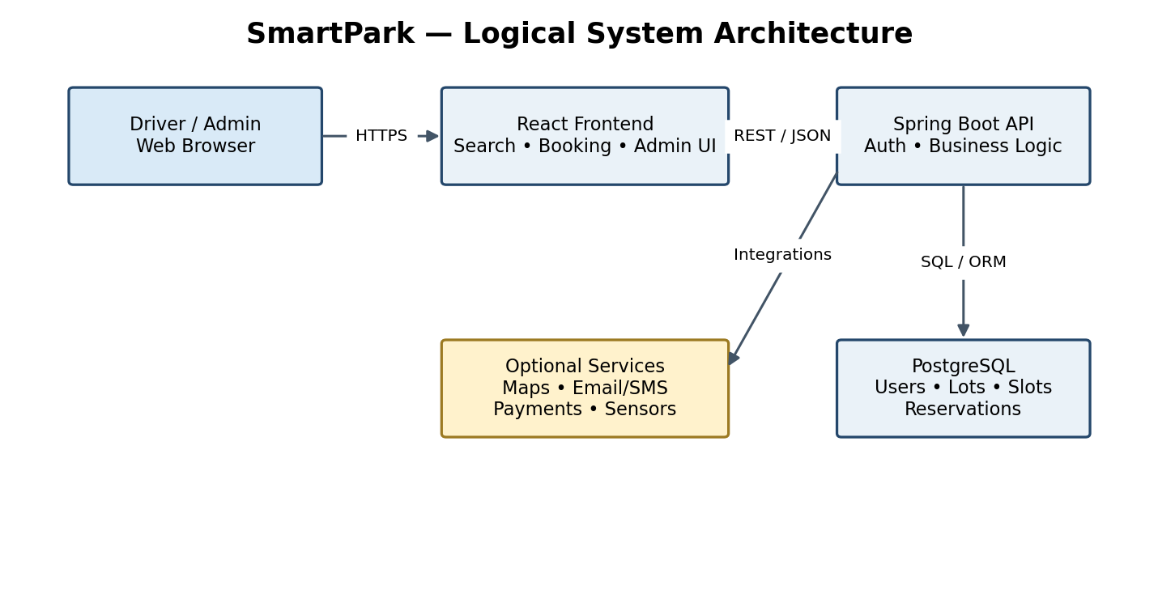

Use Case Diagram
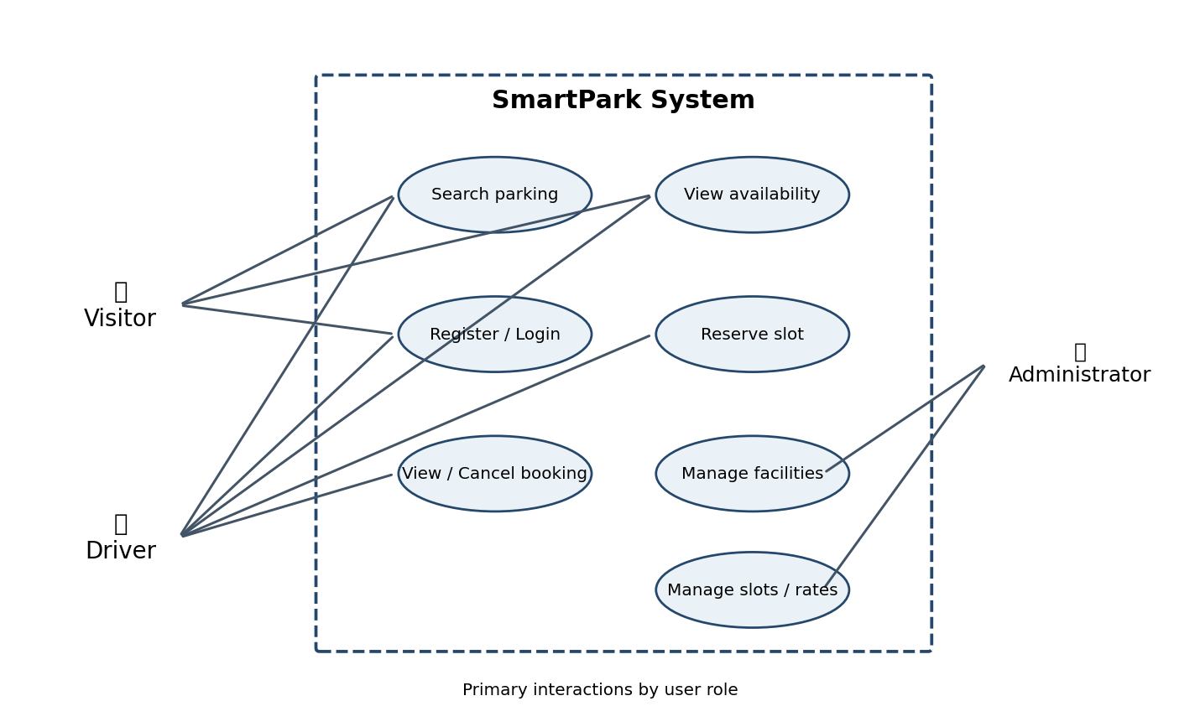

Entity Relationship Diagram
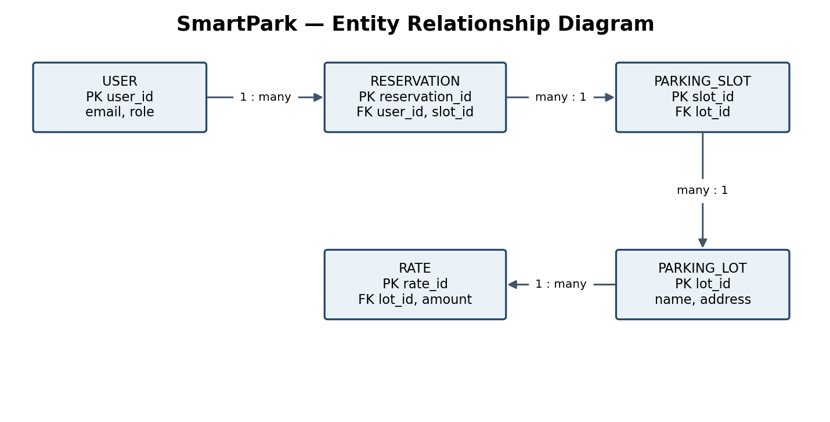

DFD Level 0
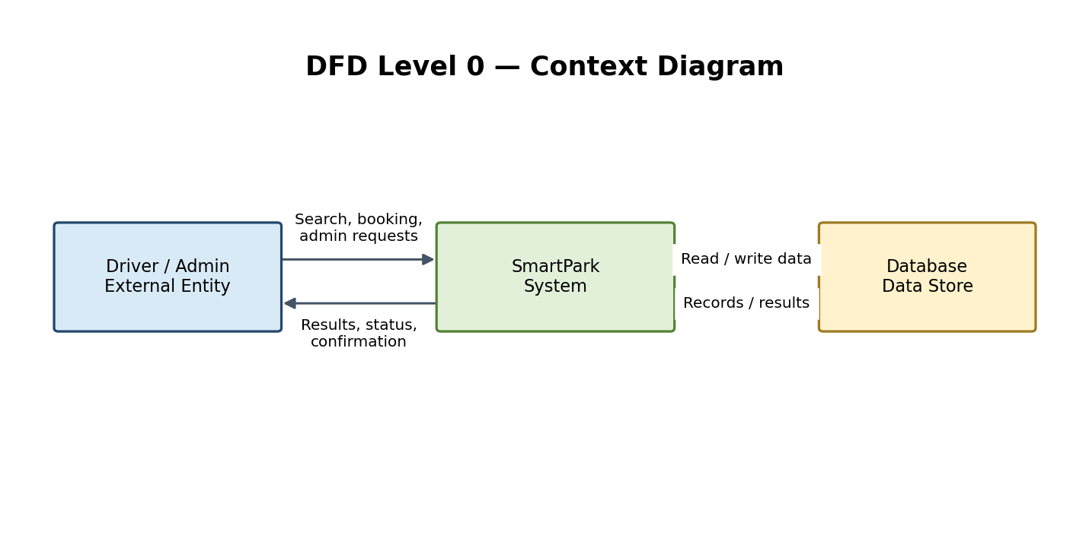

DFD Level 1
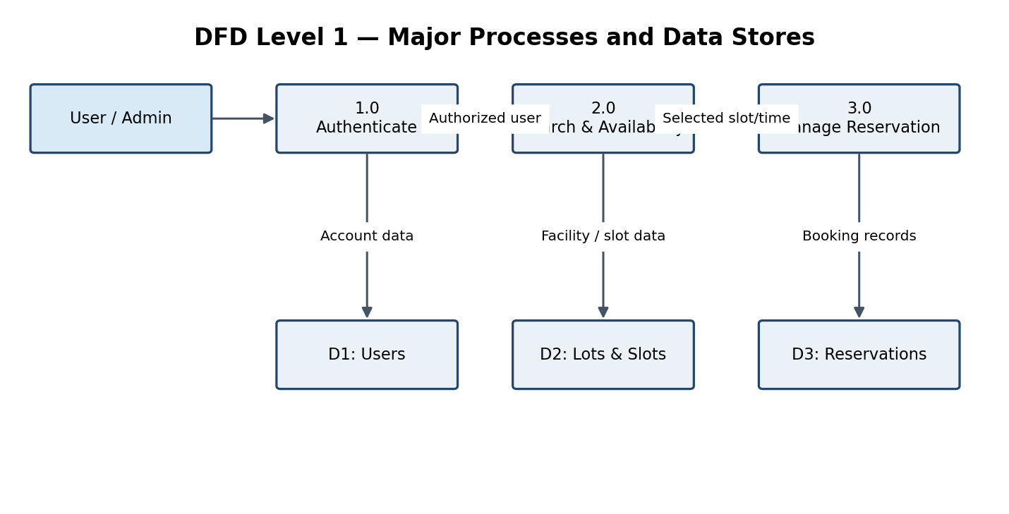

Reservation Flowchart
