SMARTPARK
SYSTEM DESIGN DOCUMENT
Intelligent Parking Slot Finder and Reservation System

Document detail | Value
Version | 1.0
Document type | Technical System Design
Status | Proposed design baseline
Prepared for | SmartPark Project
Technology baseline | React, Spring Boot, PostgreSQL

This document defines a practical, modular design for discovering parking facilities, viewing slot availability, and reserving a parking slot. Where implementation-specific decisions are not yet confirmed, they are explicitly treated as assumptions or options.

Document Control
Version | Date | Description
1.0 | 03 October 2026 | Initial detailed system design

Contents
- 1. Purpose and scope
- 2. Goals, assumptions and constraints
- 3. Architecture overview
- 4. Component design
- 5. Data design
- 6. Reservation lifecycle and concurrency
- 7. API design
- 8. Security design
- 9. Error handling and reliability
- 10. Deployment and operations
- 11. Testing strategy
- 12. Design decisions and future enhancements

1. Purpose and Scope
SmartPark is a web-based parking discovery and reservation platform. It helps drivers locate participating parking facilities, inspect available spaces, and create or manage reservations. Parking operators maintain facility, zone, slot, pricing, and operational information. Administrators oversee users, facilities, reports, and platform configuration.

1.1 In scope
- User registration, sign-in, profile management, and role-based access.
- Search and filter parking facilities by area, date/time, vehicle type, and availability.
- View facility details, pricing, operating hours, and slot availability.
- Create, confirm, view, and cancel reservations subject to policy.
- Operator tools for facility, zone, slot, schedule, and reservation management.
- Administrative oversight, audit trail, and operational reporting.
- Optional payment-provider integration and notifications, depending on project scope.

1.2 Out of scope for the baseline
- Physical gate control, license-plate recognition, and sensor hardware integration.
- Guaranteed live occupancy where no sensor/operator feed exists.
- Complex dynamic pricing, subscriptions, and multi-city optimization.

2. Goals, Assumptions and Constraints
Area | Design position
Correctness | Prevent overlapping active reservations for the same slot and time window.
Usability | Responsive browser interface with clear availability and reservation status.
Security | Authenticated user actions; operator/admin permissions enforced on the server.
Availability data | Availability is only as current as the operator or sensor updates feeding the system.
Time | Persist timestamps in UTC; display in the facility’s local time zone.
Payments | Payment is an optional integration; booking rules must define whether payment is required before confirmation.
Scale | Start as a modular monolith; split services only when operational needs justify it.
Stack | React client, Spring Boot application, PostgreSQL relational store.

3. Architecture Overview
The recommended baseline is a three-tier web architecture implemented as a modular monolith. A single Spring Boot deployment contains clearly separated domain modules. This keeps the mini-project maintainable while preserving boundaries that could later become independent services.
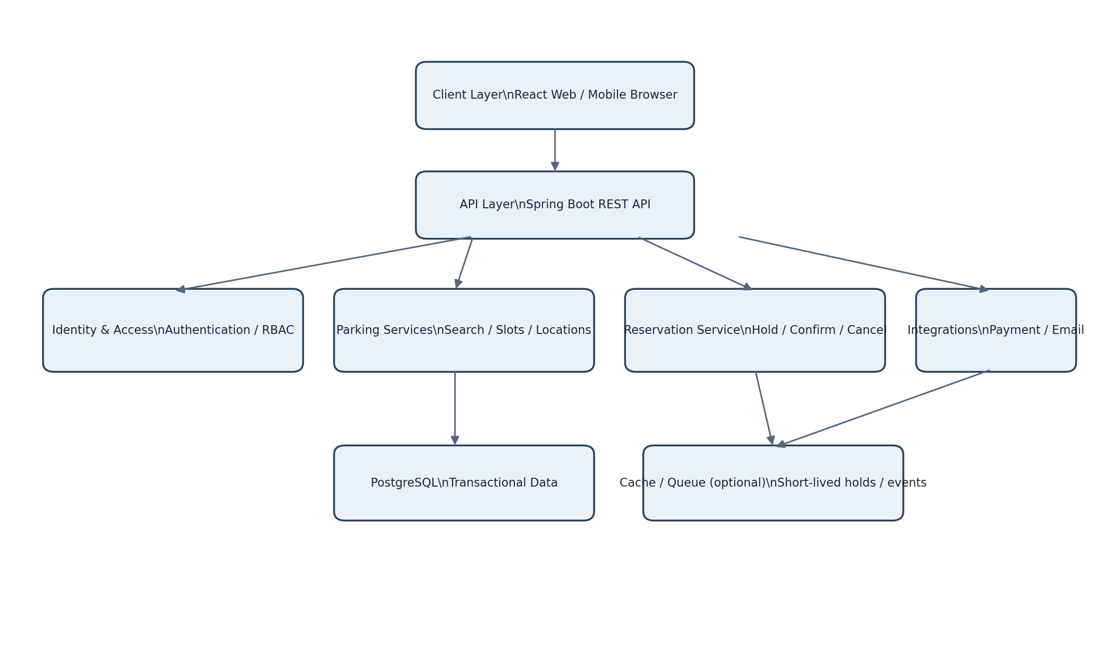
Figure 1. Logical system architecture.

3.1 Architectural layers
Layer | Responsibilities | Key rules
Presentation | React pages, forms, search results, map/list view, operator dashboard. | No secrets or business authorization logic in the browser.
API / application | REST controllers, request validation, authentication filters, use-case orchestration. | Controllers remain thin; use DTOs rather than exposing entities.
Domain modules | Parking, inventory, reservation, identity, payments, notifications, reporting. | Business invariants live in domain/application services.
Persistence | Repositories, PostgreSQL transactions, migrations. | Use constraints and transactions for critical booking correctness.
External adapters | Payment, email/SMS, maps, optional sensor feeds. | Use timeouts, retries where safe, and idempotency.

3.2 Module boundaries
Module | Main responsibilities | Owns / manages
Identity | Registration, login, password reset, roles, account status. | User and role data
Facility | Parking operators, facilities, addresses, hours, zones, pricing. | Facility configuration
Inventory | Slots, slot type, operational status, availability queries. | Slot state and availability rules
Reservation | Hold, confirm, cancel, expiry, check-in/out, reservation history. | Reservation lifecycle and booking invariants
Payment (optional) | Payment intent, provider callbacks, refunds, reconciliation. | Payment records and provider references
Notification | Email/SMS/in-app messages and delivery status. | Notification jobs and templates
Admin/reporting | Moderation, audit search, usage summaries, exports. | Administrative actions and reports

4. Component Design

4.1 User interface
- Search screen: location/area, arrival and departure time, vehicle or slot type, filters, and sort options.
- Results: facility cards or map markers with distance, price basis, operating status, and availability timestamp.
- Facility detail: facility rules, entry instructions, zones, slot choices, and booking summary.
- Reservation screen: active/upcoming/past reservations, cancellation action, receipt/reference.
- Operator dashboard: facility setup, slot status updates, reservation list, and occupancy view.
- Admin console: account/facility moderation, audit events, and platform-level reports.

4.2 Backend request flow
- The client sends an HTTPS request with an access token when authentication is required.
- The API gateway/filter chain validates token signature, expiry, and account status.
- The controller validates input shape and delegates to an application service.
- The service checks business permissions and calls domain/repository operations.
- The database enforces referential integrity and booking constraints inside a transaction.
- The API returns a stable response DTO; side effects such as email are queued or performed after commit.

4.3 Reservation service responsibilities
- Validate facility hours, slot eligibility, requested time range, and booking policy.
- Create a short-lived hold when the UI needs a checkout interval.
- Confirm a reservation only if the hold is valid and payment requirements are satisfied.
- Release expired holds and make inventory searchable again.
- Apply cancellation cutoff, refund rules, and status transitions consistently.
- Use idempotency keys for retryable create/confirm operations.

5. Data Design
Use PostgreSQL as the system of record. The following logical model is normalized around facilities, slots, users, and reservations. Exact columns may be adjusted to the final feature scope.
Entity | Important fields | Notes / constraints
users | id UUID PK, name, email, password_hash, phone, status, created_at | Unique normalized email; never store plaintext passwords.
roles / user_roles | role_id, user_id, role_name | Roles such as DRIVER, OPERATOR, ADMIN.
facilities | id UUID PK, operator_id FK, name, address, latitude, longitude, timezone, status | Index status and geographic search fields.
zones | id UUID PK, facility_id FK, name, floor_label | Facility contains one or more zones.
parking_slots | id UUID PK, zone_id FK, code, vehicle_type, operational_status | Unique slot code within zone. Operational status is separate from booking.
pricing_rules | id UUID PK, facility_id FK, slot_type, amount, currency, unit, effective_from/to | Store pricing basis and effective period explicitly.
reservations | id UUID PK, user_id FK, slot_id FK, start_at, end_at, status, hold_expires_at, total_amount, created_at | Require start_at < end_at; indexed by slot/time/status.
payments (optional) | id UUID PK, reservation_id FK, provider_ref, amount, currency, status | Provider reference unique; never store card credentials.
audit_logs | id UUID PK, actor_id, action, entity_type, entity_id, occurred_at, metadata | Append-only record for sensitive operator/admin actions.
notifications | id UUID PK, user_id FK, type, destination, status, created_at, sent_at | Delivery attempts and errors tracked.

5.1 Relationship summary
- One operator account may manage multiple facilities.
- A facility contains zones; each zone contains parking slots.
- A user may create many reservations; each reservation refers to one slot and a time interval.
- A reservation may have zero or more payment attempts if payments are enabled.
- Audit records reference an actor and target entity without requiring hard deletion of business history.

5.2 ER diagram
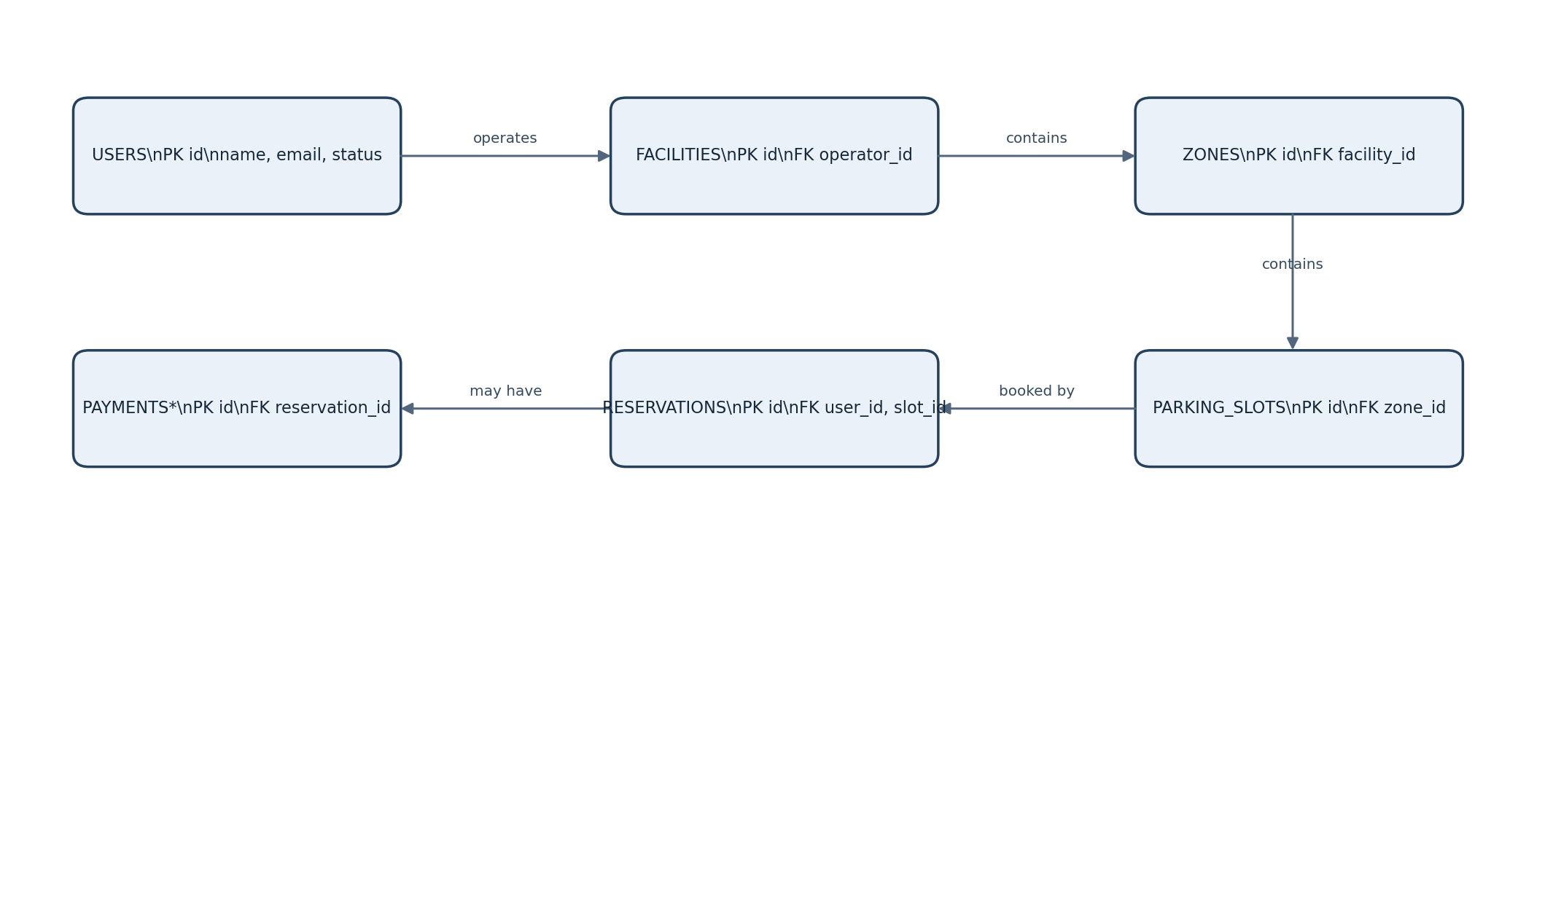
Figure 2. Simplified entity relationship view. *Payments are optional.

5.3 Indexes and integrity
- Unique index on lower(email) for case-insensitive account identity.
- Index parking_slots(zone_id, operational_status).
- Index reservations(slot_id, start_at, end_at) and reservations(user_id, created_at DESC).
- Check constraint end_at > start_at and non-negative monetary values.
- Foreign keys should use restrictive deletion for reservations and payments; prefer status/soft deletion for facilities and users.
- For PostgreSQL, consider an exclusion constraint using a timestamp range and slot identifier to prevent overlapping active reservations. If the project uses discrete time blocks, enforce uniqueness per slot and block instead.

6. Reservation Lifecycle and Concurrency
Reservation correctness is the most critical part of SmartPark. A frontend availability result is advisory; the backend must re-check and atomically claim inventory at the moment of booking.
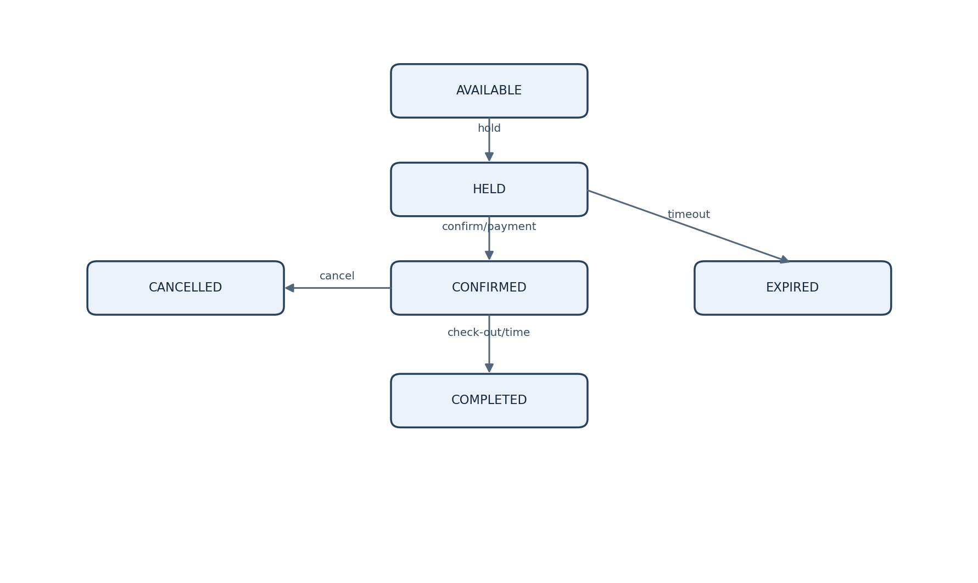
Figure 3. Reservation lifecycle. Exact transitions depend on payment and check-in policy.

6.1 Recommended booking algorithm
- Receive slot_id, start_at, end_at, and an idempotency key.
- Validate the user, facility schedule, slot status, and request duration.
- Begin a database transaction.
- Acquire a row lock on the slot or use a database exclusion constraint to serialize conflicting claims.
- Check for overlapping active HELD or CONFIRMED reservations. Ignore expired holds only after marking them expired or evaluating their expiry safely.
- Insert a HELD reservation with a short hold expiry, or insert CONFIRMED directly if no checkout/payment step is needed.
- Commit and return reservation ID, status, expiry, and quoted amount.
- On confirmation, revalidate the hold and payment result in a transaction, then transition to CONFIRMED.

6.2 Concurrency and double-booking prevention
- Do not rely on “check availability, then insert” as two independent operations without locking or a database constraint.
- Use SERIALIZABLE isolation, row-level locking, or a PostgreSQL exclusion constraint for overlapping time ranges. Select one strategy and test it under simultaneous requests.
- Use idempotency keys to ensure client retries do not create duplicate reservations.
- Treat payment-provider callbacks as at-least-once: verify signatures and make callback processing idempotent.
- Use a scheduled cleanup job for expired holds; booking checks must still handle expiry correctly if the cleanup job is delayed.
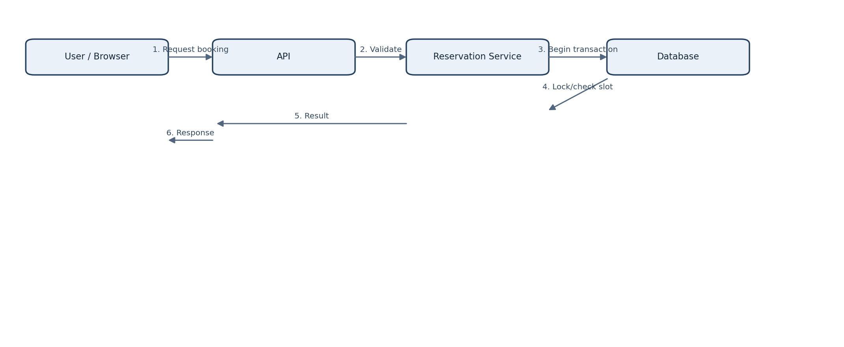
Figure 4. Simplified booking interaction sequence.

6.3 Suggested status model
Status | Meaning | Allowed next states (typical)
HELD | Slot temporarily claimed during checkout. | CONFIRMED, EXPIRED, CANCELLED
CONFIRMED | Reservation is accepted and active. | CANCELLED, CHECKED_IN, NO_SHOW
CHECKED_IN | Driver has arrived/entered. | COMPLETED
COMPLETED | Parking session finished. | Terminal
CANCELLED | Cancelled by user/operator/system. | Terminal, unless explicit reinstatement policy exists
EXPIRED | Temporary hold elapsed without confirmation. | Terminal
NO_SHOW | Arrival window passed without check-in. | Terminal

7. API Design
Use versioned JSON REST endpoints under /api/v1. Return consistent error bodies and use ISO-8601 timestamps with offsets at the API boundary. The following is a baseline contract, not a claim of an existing implementation.
Method and endpoint | Purpose | Access
POST /auth/register | Create account | Public
POST /auth/login | Authenticate and issue tokens/session | Public
GET /facilities | Search facilities and filter by location/time | Public
GET /facilities/{id} | Facility details, rules, and pricing | Public
GET /facilities/{id}/availability?start=&end= | Query available slots or counts | Public
POST /reservations/holds | Create temporary hold | Driver
POST /reservations/{id}/confirm | Confirm hold / booking | Owner; payment callback if applicable
GET /reservations/me | List current user reservations | Driver
GET /reservations/{id} | Reservation detail | Owner/operator with permission
POST /reservations/{id}/cancel | Cancel under policy | Owner/operator with permission
PATCH /operator/slots/{id}/status | Update operational availability | Authorized operator
POST /payments/webhook | Receive provider event | Signed provider request
GET /admin/reports/occupancy | Operational summary | Admin

7.1 Example request: create hold

POST /api/v1/reservations/holds
{
"slotId": "UUID",
"startAt": "2026-10-05T10:00:00+05:30",
"endAt": "2026-10-05T12:00:00+05:30",
"idempotencyKey": "client-generated-unique-value"
}

7.2 Example successful response
{
"reservationId": "UUID",
"status": "HELD",
"holdExpiresAt": "2026-10-03T07:15:00Z",
"currency": "INR",
"quotedAmount": 120.00
}

7.3 Error contract
{
"type": "https://smartpark.example/errors/slot-unavailable",
"title": "Slot unavailable",
"status": 409,
"code": "SLOT_CONFLICT",
"detail": "The selected slot is no longer available for this time range.",
"traceId": "correlation-id"
}
HTTP status | When to use
400 | Malformed input or failed validation
401 | Missing, invalid, or expired authentication
403 | Authenticated but not authorized
404 | Resource does not exist or is not visible to caller
409 | Slot conflict, invalid state transition, or idempotency conflict
422 | Semantically invalid request under business rules
429 | Rate limit exceeded
500 | Unexpected server error; avoid exposing internals
503 | Temporary dependency or service unavailability

8. Security Design
Control | Implementation guidance
Transport | HTTPS everywhere; TLS to managed database and external providers.
Authentication | Use secure server-side sessions or short-lived signed access tokens with refresh/revocation strategy.
Password storage | Use Argon2id or bcrypt with a suitable work factor; enforce password reset safely.
Authorization | Enforce role and resource ownership checks in services, not only in UI routes.
Input handling | Validate types, lengths, time ranges, identifiers, and sort/filter allowlists. Use parameterized queries.
Secrets | Store DB credentials, token keys, and provider secrets in environment/secret management; never commit them.
Payments | Use hosted checkout/tokenization from a compliant provider; do not store card numbers or CVV.
Abuse controls | Rate-limit login, registration, booking, and search endpoints; add bot controls if needed.
Audit | Record operator/admin changes and security-sensitive events without logging passwords, tokens, or payment secrets.
Privacy | Collect only required personal data; define retention, deletion, and access policies.

9. Error Handling and Reliability
- Use structured logs with timestamp, severity, service, request ID, actor ID where appropriate, and error code.
- Set timeouts for external APIs. Retry only transient failures and only when the operation is safe or idempotent.
- Use a transactional outbox if reservation changes must reliably trigger notifications or downstream events.
- Keep payment status and reservation status distinct; reconcile mismatches rather than assuming callbacks always arrive.
- Back up PostgreSQL regularly and test restoration. Define recovery objectives appropriate to the project.
- Return user-safe error messages while preserving detailed diagnostics in protected logs.
- If availability data is stale, show its last-updated time and avoid presenting estimates as guaranteed live state.

10. Deployment and Operations
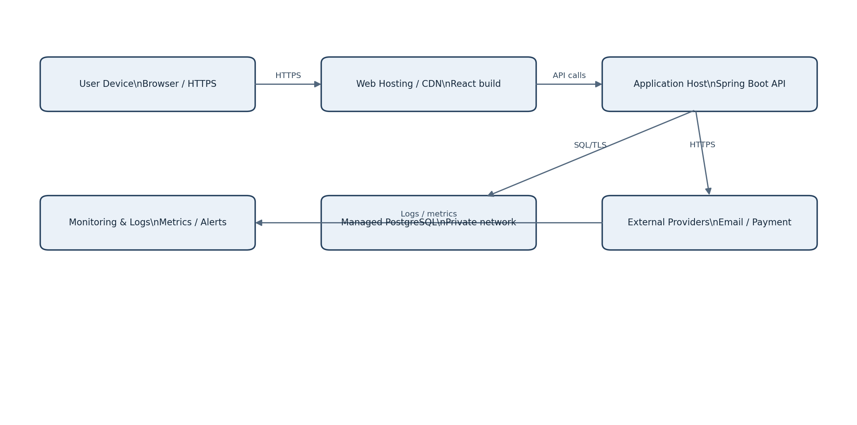
Figure 5. Example deployment topology.

10.1 Environments
Environment | Purpose | Controls
Local | Developer workflow | Local database/container, seeded test data, mock integrations.
Test / staging | Integration and acceptance testing | Production-like configuration, synthetic data, provider sandbox.
Production | Real users and operators | TLS, secret management, backups, monitoring, restricted admin access.

10.2 Deployment steps
- Build and test the React client and Spring Boot application in CI.
- Run static checks, dependency scanning, and automated tests.
- Build immutable versioned artifacts/images.
- Apply reviewed database migrations before or during a backward-compatible release.
- Deploy API and frontend; verify health/readiness endpoints.
- Run smoke tests for login, facility search, availability, hold, confirmation, and cancellation.
- Monitor error rate, latency, database health, booking conflicts, and provider failures.

10.3 Operational metrics
- API request rate, p95 latency, 4xx/5xx rates, and availability.
- Reservation hold-to-confirm conversion and booking conflict rate.
- Expired hold count and cleanup lag.
- Database connection pool use, slow queries, lock waits, and storage growth.
- Payment callback failures and reconciliation backlog, if payments are enabled.
- Notification delivery rate and queue depth.

11. Testing Strategy
Test level | Coverage examples
Unit | Pricing calculations, time-window validation, role checks, state transitions, cancellation policy.
Repository/integration | Transactions, exclusion/locking behavior, migrations, foreign keys, query correctness.
API | Schema validation, auth, permissions, error contract, pagination, idempotency.
Concurrency | Many simultaneous attempts for the same slot/time; prove no overlapping active bookings.
End-to-end | Search → details → hold → confirm → view → cancel; operator slot updates.
Security | Broken access control, injection, brute force/rate limits, token expiry, webhook signature checks.
Performance | Search latency and booking throughput with realistic facility/slot/reservation volumes.
Recovery | Database restore, app restart, delayed queue processing, provider timeout and retry scenarios.

12. Design Decisions and Trade-offs
Decision | Reason | Trade-off / revisit when
Modular monolith | Simpler development, deployment, and debugging for a student project. | Split modules only when independent scaling or team ownership requires it.
PostgreSQL | Relational integrity and strong transaction support suit reservation data. | Geospatial extension or dedicated search may be added if location search grows complex.
REST/JSON | Simple browser integration and easy testing/documentation. | Consider event-driven integration for high-volume asynchronous workflows.
Database-enforced conflict prevention | Protects correctness even under concurrent requests. | Requires careful migration and query design; test exact interval semantics.
Optional payment integration | Keeps core booking demonstrable without payment-provider complexity. | If payment is required, define payment authorization, confirmation, refund, and reconciliation policies first.
Operator-fed availability baseline | Allows a functioning system without hardware. | Real-time sensor integration requires device identity, freshness, fault detection, and reconciliation.

13. Future Enhancements
- Map-based discovery with routing and distance estimates.
- Sensor/IoT integration for occupancy and gate events.
- QR-based check-in and operator verification.
- Dynamic pricing, subscriptions, coupons, and corporate accounts.
- Waitlists and alternative-slot suggestions when a facility is full.
- Analytics dashboards for demand patterns and facility utilization.
- Native mobile applications and push notifications.

14. Open Decisions Before Implementation
- Are bookings for exact slots or only a facility capacity count?
- Are reservations time-window based or fixed-duration blocks?
- Is payment mandatory, optional, or outside the project scope?
- What is the grace period, cancellation cutoff, and no-show policy?
- Who updates slot occupancy: operator, user, sensors, or a combination?
- Can a driver hold multiple slots simultaneously?
- Which map, email/SMS, and payment providers are approved?

Appendix A: Core Business Rules
- A reservation interval must have a valid start and end, with start earlier than end.
- A slot cannot have overlapping active reservations.
- A slot marked OUT_OF_SERVICE cannot be booked, even if no reservation overlaps.
- Only the reservation owner or an authorized operator/admin may cancel or view protected reservation details.
- A hold is not a confirmed booking. Its expiry must be visible and enforced server-side.
- All money values include currency and pricing unit; do not assume every facility charges per hour.
- All facility-local opening-hour rules must be evaluated using the facility time zone, including daylight-saving transitions where applicable.

Appendix B: Glossary
Term | Definition
Facility | A parking location managed by an operator.
Zone | A section, floor, or area within a facility.
Slot | An individually identifiable parking space.
Availability | A computed view of slots not blocked by operational status or overlapping active reservations.
Hold | A temporary reservation claim pending confirmation.
Idempotency key | A client-supplied unique key that makes retries safe against duplicate processing.
RBAC | Role-based access control.
Outbox | A persistence pattern that records an event in the same transaction as business data for reliable later delivery.

