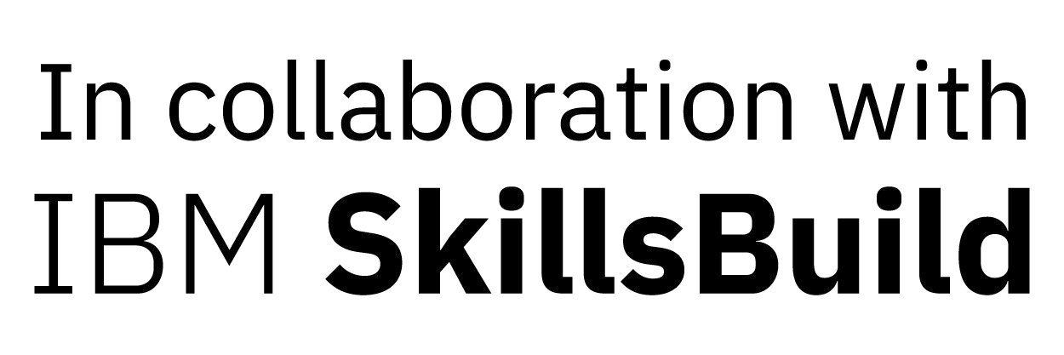
AI-Powered Chatbot using IBM Watson Assistante

Student Name : Kavya Kalpeshkumar Jain
College Name : Gujarat University (Centre for Professional Courses)
Branch and Year : B.Sc. IT FinTech, 2026
Gender : Female
Registered Mail ID : kavyajain1201@gmail.com
Contact No. +91 97240 72819

What did you learned in this Program?

- Fundamentals of Artificial Intelligence
- Machine Learning and Deep Learning concepts
- Artificial Neural Networks
- Natural Language Processing (NLP)
- Computer Vision
- AI Ethics and Responsible AI
- Chatbot Development
- AI Applications and Capabilities
- IBM Watson Studio tools

Project Purpose (Why do you made this project?)

The purpose of this project is to develop an AI-powered chatbot that can answer user queries efficiently and provide instant responses using Natural Language Processing techniques.
Project Objectives (What do you made in this project)

- Understand AI and NLP concepts.
- Build an intelligent Chatbot.
- Learn IBM Watson tools and their applications.
- Improve problem-solving and analytical skills.
- Explore real-world applications of AI.
Structure of Your project (What are the steps you follows?)

- Problem Identification
- Requirement Analysis
- Design of Chatbot
- Data Collection and Training
- Implementation using IBM Watson
- Testing and Evaluation
- Final Deployment

Git Hub Link for Project
https://github.com/ayushk-arch/Ayush-kumar-125.gi t

Advantages and Limitations of Your Project
ADVANTAGES | LIMITATIONS
Provides instant responses. | Depends on training data quality.
Available 24/7. | Cannot understand every complex query.
Reduces manual effort. | Requires internet connectivity.
Improves user experience. | Limited emotional understanding.

Challenges you faced (What difficulties you face?)

- Understanding AI concepts initially.
- Learning NLP and chatbot development.
- Training the chatbot with appropriate responses.
- Integrating IBM tools.
- Debugging and testing issues.
Conclusion

This project helped me understand the fundamentals of Artificial Intelligence and its real-world applications. I gained knowledge of Machine Learning, NLP, Chatbots, and IBM Watson tools, which enhanced my technical and analytical skills.
Thank You

