MAPS/IMAGES:

3)a) Top areas with highest number of listing

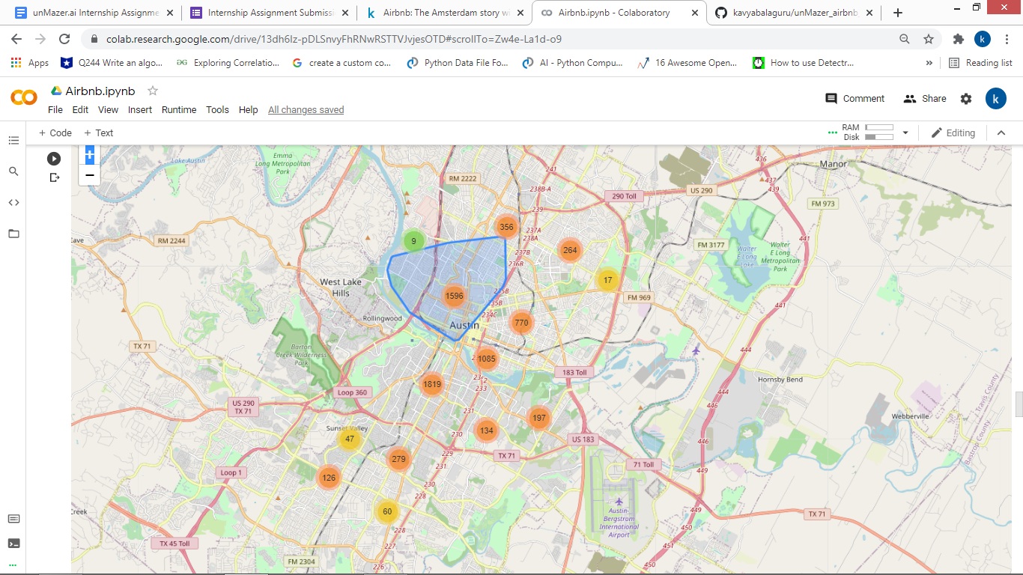

b) Thematic map- dot distribution map

