Design and Analysis of Algorithms

Assignment 1

Name: Kavya Bhand
Academic Year: TY
Class: CS-F
Roll No: 45
PRN: 12413605

Enumeration of Combinatorial Objects

1. Enumeration of subsets:
Write a program which takes natural number n as input and prints all subsets of {1, 2, ..., n}. The subsets can be printed in any sequence. For example: For n=3, a possible output is
phi
{1}
{1,2}
{1,2,3}
{1,3}
{2,3}
{2}
{3}

Algorithm (Recursive Approach):
- Read the value of n
- Start from the first element
- For every element,
  - Include it in the current subset
  - Recur for the next element
  - Exclude it and recur again
- When all elements are processed, print the current subset
- Stop

Complexity:
There are 2^n subsets:
- Time Complexity = O(2^n)
- Space Complexity = O(n)

Program 1: Global Array Method:

#include <stdio.h>

int set[100];
int n;

void subset(int index)
{
if(index > n)
{
int empty = 1;
printf("{");

for(int i = 1; i <= n; i++)
{
if(set[i])
{
printf(" %d ",i);
empty = 0;
}
}

if(empty)
printf("phi");

printf("}\n");
return;
}

set[index] = 0;
subset(index + 1);

set[index] = 1;
subset(index + 1);
}

int main()
{
printf("Enter n : ");
scanf("%d",&n);

subset(1);

return 0;
}

Output:

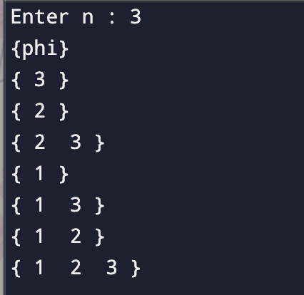

Program 2: Iterative Method

#include <stdio.h>

int main()
{
int n;

printf("Enter n : ");
scanf("%d",&n);

int total = 1 << n;

for(int mask = 0; mask < total; mask++)
{
int empty = 1;

printf("{");

for(int i = 0; i < n; i++)
{
if(mask & (1 << i))
{
printf(" %d ",i+1);
empty = 0;
}
}

if(empty)
printf("phi");

printf("}\n");
}

return 0;
}

Output:

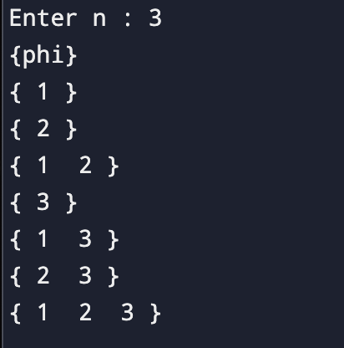

Program 3: Recursive Method

#include <stdio.h>

int arr[100];

void subset(int index, int n)
{
if(index > n)
{
int empty = 1;

printf("{");

for(int i = 1; i <= n; i++)
{
if(arr[i])
{
printf(" %d ",i);
empty = 0;
}
}

if(empty)
printf("phi");

printf("}\n");

return;
}

arr[index] = 1;
subset(index + 1, n);

arr[index] = 0;
subset(index + 1, n);
}

int main()
{
int n;

printf("Enter n : ");
scanf("%d",&n);

subset(1,n);

return 0;
}

Output:

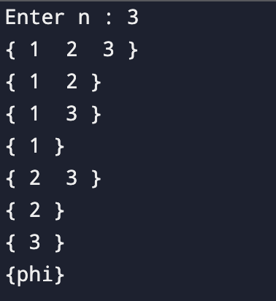

2. Enumeration of permutations:
Write a program which takes natural number n as input and prints all permutations of 1, 2, ..., n. The permutations can be printed in any sequence. For example: For n=3, a possible output is
1, 2, 3
1, 3, 2
2, 1, 3
2, 3, 1
3, 1, 2
3, 2, 1

Algorithm:
- Read the value of n
- Store the numbers 1 to n in an array
- Start recursion from the first position
- Swap the current element with every element from the current to the last position
- Recursively generate the permutations for the remaining positions
- Backtrack by swapping the elements again to restore the original order
- When the current position reaches the end of the array, print the permutation

Complexity:
- Time Complexity: O(n x n!)
- Space Complexity: O(n)

Program:

#include <stdio.h>

void swap(int *a, int *b)
{
int temp = *a;
*a = *b;
*b = temp;
}

void permutation(int arr[], int start, int n)
{
if(start == n)
{
for(int i = 0; i < n; i++)
printf("%d ", arr[i]);

printf("\n");
return;
}

for(int i = start; i < n; i++)
{
swap(&arr[start], &arr[i]);
permutation(arr, start + 1, n);
swap(&arr[start], &arr[i]);
}
}

int main()
{
int n;

printf("Enter n : ");
scanf("%d", &n);

int arr[n];

for(int i = 0; i < n; i++)
arr[i] = i + 1;

permutation(arr, 0, n);

return 0;
}

Output:

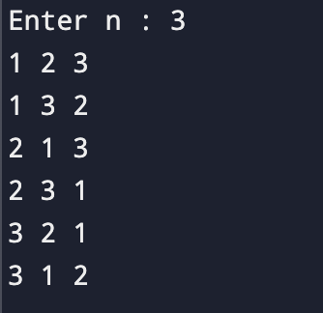

3. Enumeration of combinations:
Write a program which takes natural numbers n and k as input, k <= n and prints all subsets of {1, 2, ..., n } of size k. The subsets can be printed in any sequence. For example: For n=4 and k=2, a possible output is
{1, 2}
{1, 3}
{1, 4}
{2, 3}
{2, 4}
{3, 4}

Algorithm:
- Read the values of n and k
- Create an array to store the current combination
- Start from the first element of the set
- Add the current element to the combination
- Recursively select the remaining elements
- When k elements have been selected, print the combination
- Backtrack and continue with the next element until all combinations are generated

Complexity:
- Time Complexity = O(nCk)
- Space Complexity = O(k)

Program:

#include <stdio.h>

int comb[100];

void combination(int start, int index, int n, int k)
{
if(index == k)
{
printf("{");

for(int i = 0; i < k; i++)
{
printf("%d", comb[i]);

if(i != k - 1)
printf(", ");
}

printf("}\n");
return;
}

for(int i = start; i <= n; i++)
{
comb[index] = i;
combination(i + 1, index + 1, n, k);
}
}

int main()
{
int n, k;

printf("Enter n and k : ");
scanf("%d %d", &n, &k);

if(k > n || k <= 0)
{
printf("Invalid Input");
return 0;
}

combination(1, 0, n, k);

return 0;
}

Output:

