# Logistic Regression

Logistic regression is the suitable regression analysis to conduct when the dependent variable is dichotomous or having binary response.It is used to define data and to explain the relationship between one dependent binary variable and one or more independent variables.

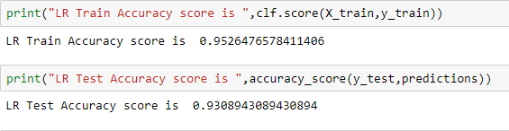

#### Decision Tree

Decision Trees are a non-parametric supervised learning method used for classification and regression. The goal is to create a model that predicts the value of a target variable by learning simple decision rules inferred from the data features. Also Result interpretation is easy.

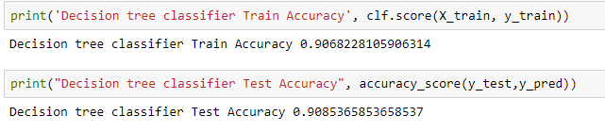

**XG Boost**

XGBoostis a scalable and accurate implementation of gradient boosting machines and it has proven to push the limits of computing power for boosted trees algorithms as it was built and developed for the sole purpose of model performance and computational swiftness. This approach suitable for both regression and classification predictive modeling problems.

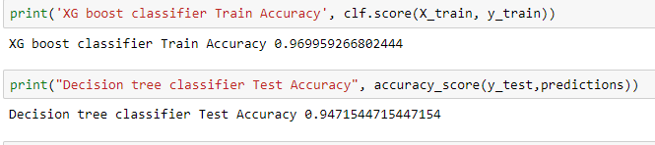

**Random Forest**

Random forest are an ensemble learning method. Both regression and classification task, random forest is an appropriate model for our needs. It can handle binary features, categorical features, and numerical features. There is a little pre-processing that needs to be done. The data which we get does not need to be rescaled or transformed. It is faster to train and test than decision trees or compared with other algorithms, because we are working only on a subset of features in this model, so we can easily work with hundreds of features. Prediction speed is significantly faster than training speed because we can save generated forests for approaching uses. It also handles outliers easily.

