Hello , my name is Krishnapriya Sarojam



Hello , my name is Chris Dyck

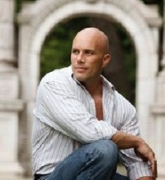

Hello , my name is Junseob Noh

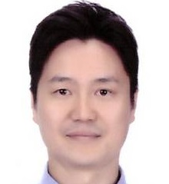

Hello , my name is Sathish Parthasarathi

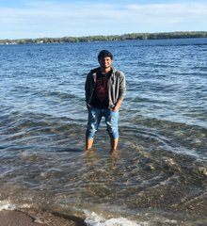

Hello , my name is Sukanya Chulliparambil Mohanan

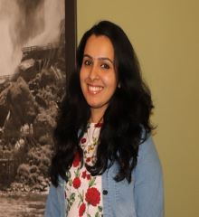

Hello , my name is MaryPravalika Jaddu

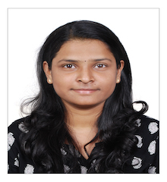

Hello , my name is Mostafizur Rahman

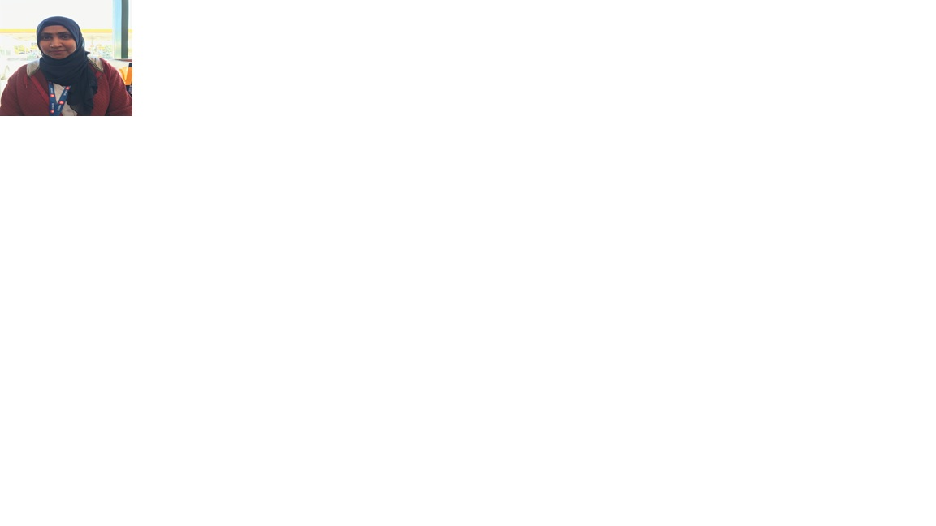

Hello , my name is Ankita Singh

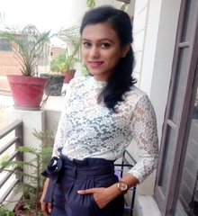

Hello , my name is Prakash Gurung

