A Mini Project Report

On

**Online Grocery Website**



**Submitted By**

**Ms. CHINTA RENUSREE MAHALAKSHMI Regd. Number: 21B91A0567**

**DEPARTMENT OF COMPUTER SCIENCE ENGINEERING**

**S. R. K. R ENGINEERING COLLEGE (A)**

**(Affiliated to JNTU, KAKINADA) BHIMAVARAM-534204**

**(2022-2023)**

**DEPARTMENT OF COMPUTER SCIENCE AND ENGINEERING S. R. K. R ENGINEERING COLLEGE BHIMAVARAM**



**CERTIFICATE**

This is to certify that this is a bonafide work on “**ONLINE GROCERY WEBSITE**” for and has been submitted by Ms.Chinta Renusree Mahalakshmi(**21B91A0567**) as a **Web Application Development Using Full Stack** laboratory report, in partial fulfilment of the requirements for the award of the Degree of Bachelor of Technology in Computer Science and Engineering, during the academic year 2022-2023. The candidate worked right under my Supervision and guidance.

**Lecturers In-Charge Head of the Department**

K.D.V.PAVAN KUMAR VARMA Dr. V. CHANDRA SHEKHAR

CH Vinod Varma Head of the Department,

S Suryanarayana Raju Department of CSE,

Assistant professor, S.R.K.R. Engineering College, Department of CSE, Bhimavaram.

Bhimavaram.

### ACKNOWLEDGEMENT

I take immense pleasure in thanking **Dr. M. Jagapathi Raju**, beloved principal of S.R.K.R Engineering College, Bhimavaram, and **Dr. V. Chandra Shekar**, esteemed **Head of the Department** (C.S.E), for having permitted me to carry out this Web Application Development Using Full Stack mini project work.

I wish to express my deep sense of gratitude especially to my project Guide**,Sri. K D V PAVAN**

**KUMAR VARMA,Assistant Professor, Sri Ch Vinod Varma, Assistant Professor, Sri S Suryanarayana Raju, Assistant Professor**, for their guidance and useful suggestions, which helped me in completing the project work, on time.

Finally, yet importantly, I would like to express my heartful thanks to my beloved parents, faculty, my friends/classmates for their help, and my wishes for the successful completion of this project.

Chinta Renusree Mahalakshmi

(21B91A0567)

**TABLE OF CONTENTS**

**S. No CONTENTS PAGE NO**  1. ABSTRACT 5

2. MODULES 6

3. SOFTWARE REQUIREMENTS 7

4. HARDWARE REQUIREMENTS 7

5. TECHNICAL STACK 8

6. SAMPLE CODE 9-76

7.

**Abstract**

The project is about online grocery shop related website. Now-a-days online grocery shopping is very common in our daily life. This website will display the groceries which are we used in our daily life.. This website provides the groceries related things at reasonable cost.

This website displays a home page and there will be a login page. If the user doesn’t log in then user has to sign-up. The home page contains groceries like vegetables,fruits etc (for every catagory there will be list and details about the category of that grocery). The user should add the interested items to the cart. After adding the items to the cart, the user should proceed the payment.

## Modules

* Home page
* Login page
* Groceries

1.Vegetables page

2. Fruits page

3.Snacks page

4.Soaps page

5.Dals page

* Payment page

## SOFTWARE REQUIREMENTS

1. Text Editor: Visual Studio Code, Notepad
2. Front End: HTML,CSS
3. Internet Browser: Google Chrome/Mozilla Firefox/Internet Browser

## HARDWARE REQUIREMENTS

1. Processor-Intel Core I5
2. RAM-8GB

## TECHNICAL STACK

### HTML

**HTML** (HyperText Markup Language) is the most basic building block of the Web. It defines the meaning and structure of web content. "Hypertext" refers to links that connect web pages to one another, either within a single website or between websites. Links are a fundamental aspect of the Web. By uploading content to the Internet and linking it to pages created by other people, you become an active participant in the World Wide Web.

HTML uses "markup" to annotate text, images, and other content for display in a Web browser. HTML markup includes special "elements" such

as [<head>,](https://developer.mozilla.org/en-US/docs/Web/HTML/Element/head) [<title>,](https://developer.mozilla.org/en-US/docs/Web/HTML/Element/title) [<body>,](https://developer.mozilla.org/en-US/docs/Web/HTML/Element/body) [<header>,](https://developer.mozilla.org/en-US/docs/Web/HTML/Element/header) [<footer>,](https://developer.mozilla.org/en-US/docs/Web/HTML/Element/footer) [<article>,](https://developer.mozilla.org/en-US/docs/Web/HTML/Element/article) [<section>,](https://developer.mozilla.org/en-US/docs/Web/HTML/Element/section) [<p>,](https://developer.mozilla.org/en-US/docs/Web/HTML/Element/p) [<div>,](https://developer.mozilla.org/en-US/docs/Web/HTML/Element/div) [<span>,](https://developer.mozilla.org/en-US/docs/Web/HTML/Element/span) [<img>,](https://developer.mozilla.org/en-US/docs/Web/HTML/Element/img) [<asi de>,](https://developer.mozilla.org/en-US/docs/Web/HTML/Element/aside) [<audio>,](https://developer.mozilla.org/en-US/docs/Web/HTML/Element/audio) [<canvas>,](https://developer.mozilla.org/en-US/docs/Web/HTML/Element/canvas) [<datalist>,](https://developer.mozilla.org/en-US/docs/Web/HTML/Element/datalist) [<details>,](https://developer.mozilla.org/en-US/docs/Web/HTML/Element/details) [<embed>,](https://developer.mozilla.org/en-US/docs/Web/HTML/Element/embed) [<nav>,](https://developer.mozilla.org/en-US/docs/Web/HTML/Element/nav) [<output>,](https://developer.mozilla.org/en-US/docs/Web/HTML/Element/output) [<progress>,](https://developer.mozilla.org/en-US/docs/Web/HTML/Element/progress) [<video>,](https://developer.mozilla.org/en-US/docs/Web/HTML/Element/video) [<ul>,](https://developer.mozilla.org/en-US/docs/Web/HTML/Element/ul) [<ol>,](https://developer.mozilla.org/en-US/docs/Web/HTML/Element/ol) [<li>](https://developer.mozilla.org/en-US/docs/Web/HTML/Element/li) and many others.

### CSS

**Cascading Style Sheets** (**CSS**) is a [stylesheet](https://developer.mozilla.org/en-US/docs/Web/API/StyleSheet) language used to describe the presentation of a document written in [HTML](https://developer.mozilla.org/en-US/docs/Web/HTML) or [XML.](https://developer.mozilla.org/en-US/docs/Web/XML/XML_introduction) CSS describes how elements should be rendered on screen, on paper, in speech, or on other media.

**There are three types of CSS which are given below:**

* Inline CSS.
* Internal or Embedded CSS.
* External CSS.

#### JAVA SCRIPT

JavaScript is a dynamic computer programming language. It is lightweight and most commonly used as a part of web pages, whose implementations allow client-side script to interact with the user and make dynamic pages. It is an interpreted programming language with object-oriented capabilities.

#### Fast n Fresh SAMPLE CODE

##### 1.Homepage

<!DOCTYPE html>

<html>

<head>

<title>

Create a Search Bar using HTML and CSS

</title>

<meta name="viewport"

content="width=device-width, initial-scale=1">

<link rel="stylesheet" href=

"https://cdnjs.cloudflare.com/ajax/libs/font-awesome/4.7.0/css/font-awesome.min.css">

<style>

/* styling navlist */ #navlist {

background-color: #03c04a; position: absolute; width: 99%; margin-left:8px;

}

/* styling navlist anchor element */

#navlist a { float:left; display: block; color: #f2f2f2; text-align: center; padding: 12px; text-decoration: none; font-size: 15px;

}

.navlist-right{ float:right;

}

/* hover effect of navlist anchor element */

#navlist a:hover { background-color: #ddd; color: black; }

/* styling search bar */ .search input[type=text]{ width:300px; height:25px; border-radius:25px; border: none; }

.search{ float:right; margin:7px;

} .search button{ background-color: #03c04a;

color: #f2f2f2; float: right; padding: 5px 10px; margin-right: 16px; font-size: 12px; border: none; cursor: pointer; } body { margin: 0;

}

/* Style the header */ .header { background-color: #ffffff; padding: 3px; text-align: center;

}

* { box-sizing: border-box;

}

body { margin: 0;

}

/* Create three unequal columns that floats next to each other */

.column {

float: left;

padding: 10px;

}

/* Left and right column */ .column.side { width: 10%;

}

/* Middle column */ .column.middle { width: 80%;

}

/* Clear floats after the columns */

.row:after { content: ""; display: table; clear: both;

}

/* Responsive layout - makes the three columns stack on top of each other instead of next to each other */

@media screen and (max-width: 600px) { .column.side, .column.middle { width: 100%;

} } html {

box-sizing: border-box;

}

*, *:before, *:after { box-sizing: inherit;

}

.column {

float: left;

width: 50%; margin-bottom: 16px; padding: 0 8px;

}

@media screen and (max-width: 650px) {

.column { width: 100%; display: block; }

}

.card {

box-shadow: 0 4px 8px 0 rgba(0, 0, 0, 0.2);

}

.container { padding: 0 16px;

}

.container::after, .row::after { content: ""; clear: both; display: table;

}

.title { color: grey;

}

.button { border: none; outline: 0; display: inline-block; padding: 8px; color: white; background-color: #03ac13; text-align: center; cursor: pointer; width: 50%;

}

.button:hover { background-color: #234f1e;

} #a{ margin-top:50px; } th{ padding-top: 10px; padding-bottom: 20px; padding-left: 10px; padding-right: 20px; } td { padding-top: 10px; padding-bottom: 20px; padding-left: 10px; padding-right: 20px;

}

</style>

</head>

<body>

<div class="header">

<h1><img src="logo.png"></h1>

</div>

<!-- Navbar items -->

<div id="navlist">

<a href="homepage.html">Home</a>

<a href="login.html">Login/signup </a>

<a href="#"> </a>

<!-- search bar right align -->

<div class="search">

<form action="#">

<input type="text" placeholder=" Search..." name="search">

<button>

<i class="fa fa-search" style="font-size: 18px;">

</i>

</button>

</form>

</div>

</div>

<!-- logo with tag -->

<div class="content">

<h1></h1>

<h1></h1>

<h1></h1>

</div>

<h1></h1>

<table>

<tr>

<td>

<a href="vegtables.html"><img src="v1.jpg" height="210" style="margin-top:50px;marginleft:100px">

<td>

<td>

<a href="fruit.html"><img src="f1.jpg" height="210" style="margin-top:50px;"></a>

</td>

<td>

</td>

<td>

<a href="snacks.html">

<img src="sn1.jpg" height="200" style="margin-top:50px;margin-right:5px"></a>

</td>

</tr>

</table>

<table>

<tr>

<td>

<a href="soaps.html">

<img src="s2.jpg" height="200" width="340"style="margin-left:270px"></a>

</td>

<td>

<a href="dals.html">

<img src="d1.jpg" height="205" width="350" style="margin-top:18px;margin-left:100px">

</td>

</tr>

</table>

<br>

<table border="1">

<tr align="center">

<td>Fast 'N' Fresh – online grocery store</td></tr>

<tr>

<td>

Did you ever imagine that the freshest of fruits and vegetables, top quality pulses and food grains, dairy products and hundreds of branded items could be handpicked and delivered to your home, all at the click of a button? India’s first comprehensive online megastore, bigbasket.com, brings a whopping 20000+ products with more than 1000 brands, to over 4 million happy customers. From household cleaning products to beauty and makeup, bigbasket has everything you need for your daily needs. bigbasket.com is convenience personified We’ve taken away all the stress associated with shopping for daily essentials, and you can now order all your household products and even buy groceries online without travelling long distances or standing in serpentine queues. Add to this the convenience of finding all your requirements at one single source, along with great savings, and you will realize that bigbasket- India’s largest online supermarket, has revolutionized the way India shops for groceries. Online grocery shopping has never been easier. Need things fresh? Whether it’s fruits and vegetables or chips,daily staples and more online at your convenience. Hassle-free Home Delivery options

We deliver to 25 cities across India and maintain excellent delivery times, ensuring that all your products from groceries to snacks branded foods reach you in time.

Slotted Delivery: Pick the most convenient delivery slot to have your grocery delivered. From early morning delivery for early birds, to late-night delivery for people who work the late shift, bigbasket caters to every schedule.

Express Delivery: This super useful service can be availed by customers in cities like Bangalore, Mumbai, Pune, Chennai, Kolkata, Hyderabad and Delhi-NCR in which we deliver your orders to your doorstep in 90 Minutes. Specialty stores: Missed out on buying that essential item from your favorite neighborhood store for tonight’s party? We’ll deliver it for you! From bakery, sweets and meat to flowers and chocolates, we deliver your order in 90 minutes, through a special arrangement with a nearby specialty store, verified by us.

</td>

</tr>

</table>

</body>

</html>

##### 2.Loginpage

<!DOCTYPE html>

<html lang="en" dir="ltr">

<head>

<meta charset="utf-8">

<title>Login and Registration Form</title>

<link rel="stylesheet" href="login.css">

<meta name="viewport" content="width=device-width, initial-scale=1.0">

</head>

<body>

<div class="wrapper">

<div class="title-text">

<div class="title login">

Login Form

</div>

<div class="title signup">

Signup Form

</div>

</div>

<div class="form-container">

<div class="slide-controls">

<input type="radio" name="slide" id="login" checked>

<input type="radio" name="slide" id="signup">

<label for="login" class="slide login">Login</label>

<label for="signup" class="slide signup">Signup</label>

<div class="slider-tab"></div>

</div>

<div class="form-inner">

<form action="homepage.html" class="login">

<div class="field">

<input type="text" placeholder="Email Address" required>

</div>

<div class="field">

<input type="password" placeholder="Password" required>

</div>

<div class="pass-link">

<a href="#">Forgot password?</a>

</div>

<div class="field btn">

<div class="btn-layer"></div>

<input type="submit" value="Login">

</div>

<div class="signup-link">

Not a member? <a href="">Signup now</a>

</div>

</form>

<form action="homepage.html" class="signup">

<div class="field">

<input type="text" placeholder="Email Address" required>

</div>

<div class="field">

<input type="password" placeholder="Password" required>

</div>

<div class="field">

<input type="password" placeholder="Confirm password" required>

</div>

<div class="field btn">

<div class="btn-layer"></div>

<input type="submit" value="Signup">

</div>

</form>

</div>

</div>

</div> <script>

const loginText = document.querySelector(".title-text .login"); const loginForm = document.querySelector("form.login"); const loginBtn = document.querySelector("label.login"); const signupBtn = document.querySelector("label.signup"); const signupLink = document.querySelector("form .signup-link a"); signupBtn.onclick = (()=>{ loginForm.style.marginLeft = "-50%"; loginText.style.marginLeft = "-50%";

});

loginBtn.onclick = (()=>{ loginForm.style.marginLeft = "0%"; loginText.style.marginLeft = "0%";

});

signupLink.onclick = (()=>{ signupBtn.click(); return false;

});

</script>

</body>

</html>

Login css

{ margin: 0; padding: 0; box-sizing: border-box; font-family: 'Poppins', sans-serif;

} html,body{

display: grid; height: 100%; width: 100%; place-items: center; background-image: url('2.png'); background-repeat: no-repeat;

}

::selection{ background: #fa4299; color: #fff; }

.wrapper{ overflow: hidden; max-width: 390px; background: #fff; padding: 30px; border-radius: 5px; box-shadow: 0px 15px 20px rgba(0,0,0,0.1);

} .wrapper .title-text{ display: flex; width: 200%; }

.wrapper .title{

width: 50%; font-size: 35px;

font-weight: 600; text-align: center;

transition: all 0.6s cubic-bezier(0.68,-0.55,0.265,1.55);

}

.wrapper .slide-controls{ position: relative; display: flex; height: 50px; width: 100%; overflow: hidden; margin: 30px 0 10px 0; justify-content: space-between; border: 1px solid lightgrey; border-radius: 5px;

}

.slide-controls .slide{ height: 100%; width: 100%; color: #fff; font-size: 18px; font-weight: 500; text-align: center; line-height: 48px; cursor: pointer; z-index: 1; transition: all 0.6s ease;

}

.slide-controls label.signup{ color: #000;

}

.slide-controls .slider-tab{ position: absolute; height: 100%; width: 50%;

left: 0; z-index: 0; border-radius: 5px;

background: -webkit-linear-gradient(left,#03c04a, #41a317); transition: all 0.6s cubic-bezier(0.68,-0.55,0.265,1.55);

} input[type="radio"]{ display: none;

}

#signup:checked ~ .slider-tab{ left: 50%;

}

#signup:checked ~ label.signup{ color: #fff; cursor: default; user-select: none;

}

#signup:checked ~ label.login{ color: #000;

}

#login:checked ~ label.signup{ color: #000;

}

#login:checked ~ label.login{ cursor: default; user-select: none;

}

.wrapper .form-container{

width: 100%; overflow: hidden;

}

.form-container .form-inner{ display: flex; width: 200%;

}

.form-container .form-inner form{ width: 50%;

transition: all 0.6s cubic-bezier(0.68,-0.55,0.265,1.55);

}

.form-inner form .field{ height: 50px; width: 100%; margin-top: 20px;

}

.form-inner form .field input{ height: 100%; width: 100%; outline: none; padding-left: 15px; border-radius: 5px; border: 1px solid lightgrey; border-bottom-width: 2px; font-size: 17px; transition: all 0.3s ease;

}

.form-inner form .field input:focus{ border-color: #41a317;

/* box-shadow: inset 0 0 3px #fb6aae; */

}

.form-inner form .field input::placeholder{

color: #999; transition: all 0.3s ease; } form .field input:focus::placeholder{ color: #b3b3b3; }

.form-inner form .pass-link{ margin-top: 5px;

}

.form-inner form .signup-link{ text-align: center; margin-top: 30px;

}

.form-inner form .pass-link a, .form-inner form .signup-link a{ color: #03c04a; text-decoration: none;

}

.form-inner form .pass-link a:hover, .form-inner form .signup-link a:hover{ text-decoration: underline;

} form .btn{ height: 50px; width: 100%; border-radius: 5px; position: relative; overflow: hidden; } form .btn .btn-layer{ height: 100%; width: 300%; position: absolute; left: -100%;

background: -webkit-linear-gradient(right, #03c04a, #41a317,#03c04a, #41a317); border-radius: 5px; transition: all 0.4s ease;;

}

form .btn:hover .btn-layer{ left: 0; }

form .btn input[type="submit"]{ height: 100%; width: 100%; z-index: 1; position: relative; background: none; border: none; color: #fff; padding-left: 0; border-radius: 5px; font-size: 20px; font-weight: 500; cursor: pointer;

}

##### 3.Vegetables page

<!DOCTYPE html>

<html>

<head>

<title> vegetables</title> <meta name="viewport"

content="width=device-width, initial-scale=1">

<link rel="stylesheet" href= "https://cdnjs.cloudflare.com/ajax/libs/font-awesome/4.7.0/css/font-awesome.min.css">

<style>

/* styling navlist */ #navlist {

background-color: #03c04a; position: absolute; width: 99%; margin-left:8px;

}

/* styling navlist anchor element */

#navlist a { float:left; display: block; color: #f2f2f2; text-align: center; padding: 12px; text-decoration: none; font-size: 15px;

}

.navlist-right{ float:right;

}

/* hover effect of navlist anchor element */

#navlist a:hover { background-color: #ddd; color: black;

}

/* styling search bar */ .search input[type=text]{ width:300px; height:25px; border-radius:25px; border: none; }

.search{ float:right; margin:7px;

} .search button{ background-color: #03c04a;

color: #f2f2f2; float: right; padding: 5px 10px; margin-right: 16px; font-size: 12px; border: none; cursor: pointer; } body { margin: 0; }

/* Style the header */ .header { background-color: #ffffff; padding: 3px; text-align: center;

}

* { box-sizing: border-box;

}

body { margin: 0;

}

/* Create three unequal columns that floats next to each other */

.column {

float: left;

padding: 10px;

}

/* Left and right column */

.column.side { width: 10%;

}

/* Middle column */ .column.middle { width: 80%;

}

/* Clear floats after the columns */

.row:after { content: ""; display: table; clear: both;

}

/* Responsive layout - makes the three columns stack on top of each other instead of next to each other */

@media screen and (max-width: 600px) { .column.side, .column.middle { width: 100%;

}

}

html { box-sizing: border-box;

}

*, *:before, *:after { box-sizing: inherit;

}

.column {

float: left;

width: 50%; margin-bottom: 16px; padding: 0 8px;

}

@media screen and (max-width: 650px) {

.column { width: 100%; display: block;

}

}

.card {

box-shadow: 0 4px 8px 0 rgba(0, 0, 0, 0.2);

}

.container { padding: 0 16px;

}

.container::after, .row::after { content: "";

clear: both; display: table;

}

.title { color: grey; }

.button { border: none; outline: 0; display: inline-block; padding: 8px; color: white; background-color: #03ac13; text-align: center; cursor: pointer; width: 50%;

}

.button:hover { background-color: #234f1e;

}

</style>

</head>

<body>

<div class="header">

<h1><img src="logo.png"></h1>

</div>

<!-- Navbar items -->

<div id="navlist">

<a href="homepage.html">Home</a>

<a href="login.html">Login/signup</a>

<a href="#"></a>

<!-- search bar right align -->

<div class="search">

<form action="#"> <input type="text" placeholder=" Search..." name="search"> <button> <i class="fa fa-search" style="font-size: 18px;">

</i>

</button>

</form>

</div>

</div>

<!-- logo with tag -->

<div class="content">

</div>

<h1></h1>

<h1></h1>

<h1></h1>

<div class="row">

<div class="column side">

</div>

<div class="column middle">

<h1></h1>

<h1></h1>

<div class="row">

<div class="column">

<div class="card">

<center><img src="onion.jpg" alt="Jane" style="width:44%"></center>

<div class="container">

<center><h2>Fresho Onion</h2>

<p>1 kg</p></center>

<p style="text-decoration:line-through">MRP:Rs 39.31</p>

<h3>Price:Rs 34</p>

<h4 style="color:red">You save:31%</h4>

<p><center><a href="add.html"><button class="button">Buy now</button></a></p>

<p><button class="button">Add to Cart</button></center></p>

</div>

</div>

</div>

<div class="column">

<div class="card">

<center><img src="tomato.jpg" alt="Mike" style="width:57%"></center>

<div class="container">

<center><h2>Fresho Tomato</h2>

<p>500g</p></center>

<p style="text-decoration:line-through">MRP:Rs 17.50</p>

<h3>Price:Rs 12<h3>

<h4 style="color:red">You Save:20%</h4>

<p></p>

<center><a href="add.html"><button class="button">Buy now</button></a></p>

<p><button class="button">Add to Cart</button></p></center>

</div>

</div>

</div>

<div class="column">

<div class="card">

<center><img src="carrot.webp" alt="Mike" style="width:48%"></center>

<div class="container">

<center><h2>Fresho Carrot</h2>

<p>500g</p></center>

<p style="text-decoration:line-through">MRP:Rs 17.50</p>

<h3>Price:Rs 14<h3>

<h4 style="color:red">You Save:20%</h4>

<p></p>

<center><p><a href="add.html"><button class="button">Buy now</button></a></p>

<p><button class="button">Add to Cart</button></p></center>

</div>

</div>

</div>

<div class="column">

<div class="card">

<center><img src="gungoora.jpg" alt="Mike" style="width:50%"></center>

<div class="container">

<center><h2>Fresho Gongura Leaves</h2>

<p>250g</p></center>

<p style="text-decoration:line-through">MRP:Rs 36.49</p>

<h3>Price:Rs 29.9</h3>

<h4 style="color:red">you save:20%</h4>

<p></p>

<center><p><a href="add.html"><button class="button">Buy now</button></a></p>

<p><button class="button">Add to Cart</button></p></center>

</div>

</div>

</div>

<div class="column">

<div class="card">

<center><img src="potato1.jpg" alt="Mike" style="width:48%"></center>

<div class="container">

<center><h2>Fresho Potato</h2>

<p>5kg</p></center>

<p style="text-decoration:line-through">MRP:Rs 259.55</p>

<h3>Price:Rs 200</h3>

<h4 style="color:red">you save:23%</h4>

<p></p>

<center><p><a href="add.html"><button class="button">Buy now</button></a></p>

<p><button class="button">Add to Cart</button></center>

</div>

</div>

</div>

<div class="column">

<div class="card">

<center><img src="palak.jpg" alt="John" style="width:50%"></center>

<div class="container">

<center><h2>Fresho Palak/Paalakura</h2>

<p>250g</p></center>

<p style="text-decoration:line-through">MRP:Rs 41.19</p>

<h3>Price:Rs 32.95</h3>

<h4 style="color:red">you save:20%</h4>

<p></p>

<center><p><a href="add.html"><button class="button">Buy now</button></a></p>

<p><button class="button">Add to Cart</button></p></center>

</div>

</div>

</div>

</div>

</div><div class="column side">

</div></div>

</body>

</html>

##### 4.FRUITS PAGE

<!DOCTYPE html>

<html>

<head>

<title> fruit

</title>

<meta name="viewport"

content="width=device-width, initial-scale=1">

<link rel="stylesheet" href=

"https://cdnjs.cloudflare.com/ajax/libs/font-awesome/4.7.0/css/font-awesome.min.css">

<style>

/* styling navlist */ #navlist {

background-color: #03c04a; position: absolute; width: 99%; margin-left:8px;

}

/* styling navlist anchor element */

#navlist a { float:left; display: block; color: #f2f2f2; text-align: center; padding: 12px; text-decoration: none; font-size: 15px;

}

.navlist-right{ float:right;

}

/* hover effect of navlist anchor element */

#navlist a:hover {

background-color: #ddd; color: black; }

/* styling search bar */ .search input[type=text]{ width:300px; height:25px; border-radius:25px; border: none; }

.search{ float:right; margin:7px;

} .search button{ background-color: #03c04a;

color: #f2f2f2; float: right; padding: 5px 10px; margin-right: 16px; font-size: 12px; border: none; cursor: pointer; } body { margin: 0; }

/* Style the header */ .header { background-color: #ffffff; padding: 3px; text-align: center;

}

* { box-sizing: border-box;

}

body { margin: 0;

}

/* Create three unequal columns that floats next to each other */

.column {

float: left;

padding: 10px;

}

/* Left and right column */ .column.side { width: 10%;

}

/* Middle column */ .column.middle { width: 80%;

}

/* Clear floats after the columns */

.row:after { content: ""; display: table; clear: both;

}

/* Responsive layout - makes the three columns stack on top of each other instead of next to each other */

@media screen and (max-width: 600px) { .column.side, .column.middle { width: 100%;

} } html {

box-sizing: border-box;

}

*, *:before, *:after { box-sizing: inherit;

}

.column {

float: left;

width: 50%; margin-bottom: 16px; padding: 0 8px;

}

@media screen and (max-width: 650px) {

.column { width: 100%; display: block;

}

}

.card {

box-shadow: 0 4px 8px 0 rgba(0, 0, 0, 0.2);

}

.container { padding: 0 16px;

}

.container::after, .row::after { content: ""; clear: both; display: table;

}

.title { color: grey; }

.button { border: none; outline: 0; display: inline-block; padding: 8px; color: white; background-color: #03ac13; text-align: center; cursor: pointer; width: 50%; }

.button:hover { background-color: #234f1e;

}

</style>

</head>

<body>

<div class="header">

<h1><img src="logo.png"></h1>

</div>

<!-- Navbar items -->

<div id="navlist">

<a href="homepage.html">Home</a>

<a href="#">Login/signup</a>

<a href="#"></a>

<!-- search bar right align -->

<div class="search">

<form action="#"> <input type="text" placeholder=" Search..." name="search"> <button> <i class="fa fa-search" style="font-size: 18px;">

</i>

</button>

</form>

</div>

</div>

<!-- logo with tag -->

<div class="content">

<h1></h1>

<h1></h1>

<h1></h1>

</div>

<div class="row">

<div class="column side">

</div>

<div class="column middle">

<h1></h1>

<h1></h1>

<h1></h1>

<div class="row">

<div class="column">

<div class="card">

<center><img src="watermelon.webp" alt="Jane" style="width:50%"></center>

<div class="container">

<center><h2>Fresho Watermelon</h2>

<p>1pc 2.5-3.8kg</p></center>

<p style="text-decoration:line-through">MRP:Rs 69.28</p>

<h3>Price:Rs 55.42</h3>

<h4 style="color:red">you save:20%</h4>

<p></p>

<p><center><a href="add.html"><button class="button">Buy now</button></a></p>

<p><button class="button">Add to Cart</button></center></p>

</div>

</div>

</div>

<div class="column">

<div class="card">

<center><img src="kivi.jpg" alt="Mike" style="width:57%"></center>

<div class="container">

<center><h2>Fresho Kiwi</h2>

<p>3 pcs</p></center>

<p style="text-decoration:line-through">MRP:Rs 144.45</p>

<h3>Price:Rs 115.56</h3>

<h4 style="color:red">you save:20%</h4>

<p></p>

<center><a href="add.html"><button class="button">Buy now</button></a></p> <p><button class="button">Add to Cart</button></p></center>

</div>

</div>

</div>

<div class="column">

<div class="card">

<center><img src="apple.jpg" alt="Mike" style="width:50%"></center>

<div class="container">

<center><h2>Fresho Apple,Shimla</h2>

<p class="title">4 pcs(Approx.550-640 g)</p></center>

<p style="text-decoration:line-through">MRP:Rs 121.71</p>

<h3>Price:Rs 97.37</h3>

<h4 style="color:red">you save:20%</h4>

<p></p>

<center><p><a href="add.html"><button class="button">Buy now</button></a></p>

<p><button class="button">Add to Cart</button></p></center>

</div>

</div>

</div>

<div class="column">

<div class="card">

<center><img src="banana.jpg" alt="Mike" style="width:50%"></center>

<div class="container">

<center><h2>Fresho Banana</h2>

<p>1 kg</p></center>

<p style="text-decoration:line-through">MRP:Rs 54.57</p>

<h3>Price:Rs 34.30</h3>

<h4 style="color:red">you save:37%</h4>

<p></p>

<center><p><a href="add.html"><button class="button">Buy now</button></a></p>

<p><button class="button">Add to Cart</button></p></center>

</div>

</div>

</div>

<div class="column">

<div class="card">

<center><img src="orange1.jpg" alt="Mike" style="width:50%"></center>

<div class="container">

<center><h2>Fresho Oranges</h2>

<p>6 pcs</p></center>

<p style="text-decoration:line-through">MRP:Rs 217.66</p>

<h3>Price:Rs 174.13</h3>

<h4 style="color:red">you save:20%</h4>

<p></p>

<center><p><a href="add.html"><button class="button">Buy now</button></a></p>

<p><button class="button">Add to Cart</button></center>

</div>

</div>

</div>

<div class="column">

<div class="card">

<center><img src="pomogranate1.webp" alt="John" style="width:61%"></center>

<div class="container">

<center><h2>Fresho Pomogranate</h2>

<p>500 g</p></center>

<p style="text-decoration:line-through">MRP:Rs 119.16</p>

<h3>Price:Rs 95.33</h3>

<h4 style="color:red">you save:20%</h4>

<p></p>

<center><p><a href="add.html"><button class="button">Buy now</button></a></p>

<p><button class="button">Add to Cart</button></p></center>

</div>

</div>

</div>

</div>

</div>

<div class="column side">

</div>

</div>

</body>

</html>

##### 5.Snacks page

<!DOCTYPE html>

<html>

<head>

<title>

SNACKS

</title>

<meta name="viewport"

content="width=device-width, initial-scale=1">

<link rel="stylesheet" href=

"https://cdnjs.cloudflare.com/ajax/libs/font-awesome/4.7.0/css/font-awesome.min.css">

<style>

/* styling navlist */ #navlist {

background-color: #03c04a; position: absolute; width: 99%; margin-left:8px;

}

/* styling navlist anchor element */

#navlist a { float:left; display: block; color: #f2f2f2; text-align: center; padding: 12px; text-decoration: none; font-size: 15px; } .navlist-right{ float:right;

}

/* hover effect of navlist anchor element */

#navlist a:hover { background-color: #ddd; color: black; }

/* styling search bar */ .search input[type=text]{ width:300px; height:25px; border-radius:25px; border: none; }

.search{ float:right; margin:7px;

} .search button{ background-color: #03c04a;

color: #f2f2f2; float: right; padding: 5px 10px; margin-right: 16px; font-size: 12px; border: none; cursor: pointer; } body { margin: 0;

}

/* Style the header */ .header { background-color: #ffffff; padding: 3px; text-align: center;

}

* { box-sizing: border-box;

}

body { margin: 0;

}

/* Create three unequal columns that floats next to each other */

.column {

float: left;

padding: 10px;

}

/* Left and right column */ .column.side { width: 10%;

}

/* Middle column */

.column.middle { width: 80%;

}

/* Clear floats after the columns */

.row:after { content: ""; display: table; clear: both;

}

/* Responsive layout - makes the three columns stack on top of each other instead of next to each other */

@media screen and (max-width: 600px) { .column.side, .column.middle { width: 100%;

} } html {

box-sizing: border-box;

}

*, *:before, *:after { box-sizing: inherit;

}

.column {

float: left;

width: 50%; margin-bottom: 16px; padding: 0 8px;

}

@media screen and (max-width: 650px) {

.column { width: 100%; display: block;

}

}

.card {

box-shadow: 0 4px 8px 0 rgba(0, 0, 0, 0.2);

}

.container { padding: 0 16px;

}

.container::after, .row::after { content: ""; clear: both; display: table;

}

.title { color: grey;

}

.button { border: none; outline: 0; display: inline-block; padding: 8px; color: white; background-color: #03ac13; text-align: center; cursor: pointer; width: 50%;

}

.button:hover { background-color: #234f1e;

}

</style>

</head>

<body>

<div class="header">

<h1><img src="logo.png"></h1>

</div>

<!-- Navbar items -->

<div id="navlist">

<a href="homepage.html">Home</a>

<a href="login.html">Login/Signup</a>

<a href="#"></a>

<!-- search bar right align -->

<div class="search">

<form action="#"> <input type="text" placeholder=" Search..." name="search"> <button> <i class="fa fa-search" style="font-size: 18px;">

</i>

</button>

</form>

</div>

</div>

<!-- logo with tag -->

<div class="content">

</div>

<h1></h1>

<h1></h1>

<h1></h1>

<div class="row">

<div class="column side">

</div>

<div class="column middle">

<h1></h1>

<h1></h1>

<div class="row">

<div class="column">

<div class="card">

<center><img src="lays.jpg" alt="Jane" style="width:62%"></center>

<div class="container">

<center><h2>Bingo Yumitos Potato chips</h2>

<p>21 g</p>

<h3>Price:Rs 10</p>

<p><center><a href="homepage.html"><button class="button">Buy now</button></p>

<p><button class="button">Add to Cart</button></center></p>

</div>

</div>

</div>

<div class="column">

<div class="card">

<center><img src="dairymilk.jpg" alt="Mike" style="width:50%"></center>

<div class="container">

<center><h2>Cadbury Dairy Milk Fruit</h2>

<p>80 g</p></center>

<h4 style="text-decoration:line-through">MRP:Rs 360</h4>

<h3>Price Rs:342.22</h3>

<h4 style="color:red">You save 18%</h4>

<center><p><a href="homepage.html"><button class="button">Buy now</button></a></p>

<p><button class="button">Add to Cart</button></p></center>

</div>

</div>

</div>

<div class="column">

<div class="card">

<center><img src="happyhappy.webp" alt="Mike" style="width:63%"></center>

<div class="container">

<center><h2>Parle Happy Happy Choco-Chip cookies</h2>

<p>30 g Pouch</p></center>

<h3>Price:Rs 5<h3>

<center><p><a href="homepage.html"><button class="button">Buy now</button></p>

<p><button class="button">Add to Cart</button></p></center>

</div>

</div>

</div>

<div class="column">

<div class="card">

<center><img src="darkfantasy.jpg" alt="Mike" style="width:50%"></center>

<div class="container">

<center><h2>Sunfeast Dark Fantacy</h2>

<p>75 g Pouch</p></center>

<h4 style="text-decoration:line-through">MRP:Rs 40</h4>

<h3>Price:Rs 33</h3>

<h4 style="color:red">you save:18%</h4>

<p></p>

<p></p>

<center><p><a href="homepage.html"><button class="button">Buy now</button></p>

<p><button class="button">Add to Cart</button></p></center>

</div>

</div>

</div>

<div class="column">

<div class="card">

<center><img src="lays1.jpg" alt="Mike" style="width:50%"></center>

<div class="container">

<center><h2>Lays Potato Chips</h2>

<p>23g Pouch</p></center>

<h3>Price:Rs 10</h3>

<center><p><a href="homepage.html"><button class="button">Buy now</button></p>

<p><button class="button">Add to Cart</button></center>

</div>

</div>

</div>

<div class="column">

<div class="card">

<center><img src="oreo.jpg" alt="John" style="width:60%"></center>

<div class="container">

<center><h2>Cadbury Oreo Creme Biscuit</h2></center>

<center><p>vannila,original, 120 g</p></center>

<h3>Price:Rs 30</h3>

<center><p><a href="homepage.html"><button class="button">Buy now</button></p>

<p><button class="button">Add to Cart</button></p></center>

</div>

</div>

</div>

</div>

</div>

<div class="column side">

</div>

</div>

</body>

</html>

##### 6.Soaps page

<!DOCTYPE html>

<html>

<head>

<meta name="viewport"

content="width=device-width, initial-scale=1">

<link rel="stylesheet" href=

"https://cdnjs.cloudflare.com/ajax/libs/font-awesome/4.7.0/css/font-awesome.min.css">

<style>

/* styling navlist */ #navlist {

background-color: #03c04a; position: absolute; width: 99%; margin-left:8px;

}

/* styling navlist anchor element */

#navlist a { float:left; display: block; color: #f2f2f2; text-align: center; padding: 12px; text-decoration: none; font-size: 15px;

}

.navlist-right{

float:right;

}

/* hover effect of navlist anchor element */

#navlist a:hover { background-color: #ddd; color: black; }

/* styling search bar */ .search input[type=text]{ width:300px; height:25px; border-radius:25px; border: none; }

.search{ float:right; margin:7px;

} .search button{ background-color: #03c04a;

color: #f2f2f2; float: right; padding: 5px 10px; margin-right: 16px; font-size: 12px; border: none; cursor: pointer; } body { margin: 0; }

/* Style the header */ .header { background-color: #ffffff; padding: 3px; text-align: center;

}

* { box-sizing: border-box;

}

body { margin: 0;

}

/* Create three unequal columns that floats next to each other */

.column {

float: left;

padding: 10px;

}

/* Left and right column */ .column.side { width: 10%;

}

/* Middle column */ .column.middle { width: 80%;

}

/* Clear floats after the columns */

.row:after { content: ""; display: table; clear: both;

}

/* Responsive layout - makes the three columns stack on top of each other instead of next to each other */

@media screen and (max-width: 600px) { .column.side, .column.middle { width: 100%;

} } html {

box-sizing: border-box;

}

*, *:before, *:after { box-sizing: inherit;

}

.column {

float: left;

width: 50%; margin-bottom: 16px; padding: 0 8px;

}

@media screen and (max-width: 650px) {

.column { width: 100%; display: block;

}

}

.card {

box-shadow: 0 4px 8px 0 rgba(0, 0, 0, 0.2);

}

.container { padding: 0 16px;

}

.container::after, .row::after { content: ""; clear: both; display: table; }

.title { color: grey; } .button { border: none; outline: 0; display: inline-block; padding: 8px; color: white; background-color: #03ac13; text-align: center; cursor: pointer; width: 50%; } .button:hover { background-color: #234f1e;

}

</style>

</head>

<body>

<div class="header">

<h1><img src="logo.png"></h1>

</div>

<!-- Navbar items -->

<div id="navlist">

<a href="homepage.html">Home</a>

<a href="login.html">Lgin/Signup</a>

<a href="#"></a>

<!-- search bar right align -->

<div class="search">

<form action="#"> <input type="text" placeholder=" Search..." name="search"> <button> <i class="fa fa-search" style="font-size: 18px;">

</i>

</button>

</form>

</div>

</div>

<!-- logo with tag -->

<div class="content">

</div>

<h1></h1>

<h1></h1>

<h1></h1>

<div class="row">

<div class="column side">

</div>

<div class="column middle">

<h1></h1>

<h1></h1>

<div class="row">

<div class="column">

<div class="card">

<center><img src="ponds.jpg" alt="Jane" style="width:55%"></center>

<div class="container">

<center><h2>Ponds Starlight Talc</h2>

<p>100 g</p>

<h3>Price:Rs 132</p></center>

<p><center><a href="add.html"><button class="button">Buy now</button></a></p>

<p><button class="button">Add to Cart</button></center></p>

</div>

</div>

</div>

<div class="column">

<div class="card">

<center><img src="pears.jfif" alt="Mike" style="width:57%"></center>

<div class="container">

<center><h2>Pears Soap Bar</h2>

<p>100 g</p>

<h3>Price:Rs 54</p></center>

<center><p><a href="add.html"><button class="button">Buy now</button></a></p>

<p><button class="button">Add to Cart</button></center>

</div>

</div>

</div>

<div class="column">

<div class="card">

<center><img src="surfexcel.webp" alt="Mike" style="width:70%"></center>

<div class="container">

<center><h2>Surf Exce Detergent Bar</h2>

<p>250 g</p>

<h3>Price:Rs 35</p></center>

<center><p><a href="add.html"><button class="button">Buy now</button></a></p>

<p><button class="button">Add to Cart</button></p></center>

</div>

</div>

</div>

<div class="column">

<div class="card">

<center><img src="oil.webp" alt="Mike" style="width:50%"></center>

<div class="container">

<center><h2>Parachute Coconut Hair Oil</h2>

<p>400 ml</p></center>

<p style="align:left;text-decoration:line-through">MRP:Rs 225</p>

<h3>Price:Rs 146.25</p>

<h4 style="color:red">You save:35%</h4>

<center><p><a href="add.html"><button class="button">Buy now</button></a></p>

<p><button class="button">Add to Cart</button></p></center>

</div>

</div>

</div>

<div class="column">

<div class="card">

<center><img src="rin.webp" alt="Mike" style="width:50%"></center>

<div class="container">

<center><h2>Rin Detergent Powder</h2>

<p>1 kg</p>

<h3>Price:Rs 116</p></center>

<center><a href="add.html"><button class="button">Buy now</button></a></p>

<p><button class="button">Add to Cart</button></center>

</div>

</div>

</div>

<div class="column">

<div class="card">

<center><img src="headnshoulder.webp" alt="John" style="width:45%"></center>

<div class="container">

<center><h2>Head & Shoulders Shampoo</h2>

<p>650 ml</p></center>

<p style="align:left;text-decoration:line-through">MRP:Rs 799</p>

<h3>Price:Rs 519.35</p>

<h4 style="color:red">You save:35%</h4>

<center><p><a href="add.html"><button class="button">Buy now</button></a></p>

<p><button class="button">Add to Cart</button></p></center>

</div>

</div>

</div>

</div>

</div>

<div class="column side">

</div>

</div>

</body>

</html>

##### 7.Dals page

<!DOCTYPE html>

<html>

<head>

<meta name="viewport"

content="width=device-width, initial-scale=1">

<link rel="stylesheet" href=

"https://cdnjs.cloudflare.com/ajax/libs/font-awesome/4.7.0/css/font-awesome.min.css">

<style>

/* styling navlist */ #navlist {

background-color: #03c04a; position: absolute; width: 99%; margin-left:8px;

}

/* styling navlist anchor element */

#navlist a { float:left; display: block; color: #f2f2f2; text-align: center; padding: 12px; text-decoration: none; font-size: 15px;

}

.navlist-right{ float:right;

}

/* hover effect of navlist anchor element */

#navlist a:hover { background-color: #ddd; color: black;

}

/* styling search bar */ .search input[type=text]{ width:300px; height:25px; border-radius:25px; border: none; }

.search{ float:right; margin:7px;

} .search button{ background-color: #03c04a;

color: #f2f2f2; float: right; padding: 5px 10px; margin-right: 16px; font-size: 12px; border: none; cursor: pointer; } body { margin: 0; }

/* Style the header */ .header { background-color: #ffffff; padding: 3px; text-align: center; } * { box-sizing: border-box;

}

body { margin: 0;

}

/* Create three unequal columns that floats next to each other */

.column {

float: left;

padding: 10px;

}

/* Left and right column */

.column.side { width: 10%;

}

/* Middle column */ .column.middle { width: 80%;

}

/* Clear floats after the columns */

.row:after { content: ""; display: table; clear: both;

}

/* Responsive layout - makes the three columns stack on top of each other instead of next to each other */

@media screen and (max-width: 600px) { .column.side, .column.middle { width: 100%;

}

}

html { box-sizing: border-box;

}

*, *:before, *:after { box-sizing: inherit;

}

.column {

float: left;

width: 50%; margin-bottom: 16px; padding: 0 8px;

}

@media screen and (max-width: 650px) {

.column { width: 100%; display: block;

}

}

.card {

box-shadow: 0 4px 8px 0 rgba(0, 0, 0, 0.2);

} .container { padding: 0 16px;

}

.container::after, .row::after { content: ""; clear: both; display: table;

}

.title { color: grey;

}

.button { border: none; outline: 0; display: inline-block; padding: 8px; color: white; background-color: #03ac13; text-align: center; cursor: pointer; width: 50%;

}

.button:hover { background-color: #234f1e;

}

</style>

</head>

<body>

<div class="header">

<h1><img src="logo.png"></h1>

</div>

<!-- Navbar items -->

<div id="navlist">

<a href="homepage.html">Home</a>

<a href="login.html">Login/signup</a>

<a href="#"></a>

<!-- search bar right align -->

<div class="search">

<form action="#"> <input type="text" placeholder=" Search..." name="search"> <button>

<i class="fa fa-search" style="font-size: 18px;">

</i>

</button>

</form>

</div>

</div>

<!-- logo with tag -->

<div class="content">

</div>

<h1></h1>

<h1></h1>

<h1></h1>

<div class="row">

<div class="column side">

</div>

<div class="column middle">

<h1></h1>

<h1></h1>

<div class="row">

<div class="column">

<div class="card">

<center><img src="rice.png" alt="Jane" style="width:50%"></center>

<div class="container">

<center><h2>Super Sona Masoori Raw Rice</h2>

<p>10 kg</p></center>

<h4 style="text-decoration:line-through">MRP:Rs 550</h4>

<h3>Price:Rs 500</p>

<h4 style="color:red">You save:Rs 50</h4>

<p><center><a href="add.html"><button class="button">Buy now</button></a></p>

<p><button class="button">Add to Cart</button></center></p>

</div>

</div>

</div>

<div class="column">

<div class="card">

<center><img src="urad.webp" alt="Mike" style="width:57%"></center>

<div class="container">

<center><h2>Organic-Urad Dal</h2>

<p>Unpolished,1 kg</p></center>

<h4 style="text-decoration:line-through">MRP:Rs 199</h4>

<h3>Price:Rs 155</p>

<h4 style="color:red">You save:22%</h4>

<center><p><a href="add.html"><button class="button">Buy now</button></a</p>

<p><button class="button">Add to Cart</button></p></center>

</div>

</div>

</div>

<div class="column">

<div class="card">

<center><img src="fenugreek.webp" alt="Mike" style="width:50%"></center>

<div class="container">

<center><h2>Fenugreek</h2>

<p>500g</p></center>

<h4 style="text-decoration:line-through">MRP:Rs 100</h4>

<h3>Price:Rs 70</p>

<h4 style="color:red">You save: 30%</h4>

<p></p>

<center><p><a href="add.html"><button class="button">Buy now</button></a</p>

<p><button class="button">Add to Cart</button></p></center>

</div>

</div>

</div>

<div class="column">

<div class="card">

<center><img src="chanadal.png" alt="Mike" style="width:35%"></center>

<div class="container">

<center><h2>Chana Dal</h2>

<p>2 kg Pouch</p></center>

<h4 style="text-decoration:line-through">MRP:Rs 300</h4>

<h3>Price:Rs 182</p>

<h4 style="color:red">You save:Rs 39%</h4>

<center><p><a href="add.html"><button class="button">Buy now</button></a</p>

<p><button class="button">Add to Cart</button></p></center>

</div>

</div>

</div>

<div class="column">

<div class="card">

<center><img src="soya.jfif" alt="Mike" style="width:65%"></center>

<div class="container">

<center><h2>Soya Bean</h2>

<p>200 g Pouch</p></center>

<h4 style="text-decoration:line-through">MRP:Rs 40</h4>

<h3>Price:Rs 29</p>

<h4 style="color:red">You save:28%</h4>

<center><p><a href="add.html"><button class="button">Buy now</button></a</p>

<p><button class="button">Add to Cart</button></center>

</div>

</div>

</div>

<div class="column">

<div class="card">

<center><img src="greenpeas.webp" alt="John" style="width:45%"></center>

<div class="container">

<center><h2>Fresho Green Peas</h2>

<p>500 g Pouch</p></center>

<h4 style="text-decoration:line-through">MRP:Rs 135</h4>

<h3>Price:Rs 109</p>

<h4 style="color:red">You save: 19%</h4>

<center><p><a href="add.html"><button class="button">Buy now</button></a</p>

<p><button class="button">Add to Cart</button></p></center>

</div>

</div>

</div>

</div>

</div>

<div class="column side">

</div>

</div>

</body>

</html>

##### 8.Payment page

<!DOCTYPE html>

<html>

<head><title>payment</title>

<meta name="viewport" content="width=device-width, initial-scale=1">

<link rel="stylesheet" href="https://cdnjs.cloudflare.com/ajax/libs/font-awesome/4.7.0/css/fontawesome.min.css">

<style>

body { font-family: Arial; font-size: 17px; padding: 8px;

}

* { box-sizing: border-box;

}

.row { display: -ms-flexbox; /* IE10 */ display: flex; -ms-flex-wrap: wrap; /* IE10 */ flex-wrap: wrap; margin: 0 -16px;

}

.col-25 { -ms-flex: 25%; /* IE10 */ flex: 25%; }

.col-50 { -ms-flex: 50%; /* IE10 */ flex: 50%; }

.col-75 { -ms-flex: 75%; /* IE10 */ flex: 75%; }

.col-25,

.col-50, .col-75 { padding: 0 16px;

}

.container { background-color: #f2f2f2; padding: 5px 20px 15px 20px; border: 1px solid lightgrey; border-radius: 3px;

}

input[type=text] { width: 100%; margin-bottom: 20px; padding: 12px; border: 1px solid #ccc; border-radius: 3px;

}

label { margin-bottom: 10px; display: block;

}

.icon-container { margin-bottom: 20px; padding: 7px 0; font-size: 24px;

}

.btn {

background-color: #04AA6D; color: white; padding: 12px; margin: 10px 0; border: none; width: 100%; border-radius: 3px; cursor: pointer; font-size: 17px;

}

.btn:hover {

background-color: #45a049;

}

a {

color: #2196F3;

}

hr {

border: 1px solid lightgrey;

}

span.price { float: right; color: grey;

}

/* Responsive layout - when the screen is less than 800px wide, make the two columns stack on top of each other instead of next to each other (also change the direction - make the "cart" column go on top) */

@media (max-width: 800px) {

.row {

flex-direction: column-reverse;

}

.col-25 { margin-bottom: 20px;

}

}

</style>

</head>

<body>

<div class="row">

<div class="col-75">

<div class="container">

<div class="row">

<div class="col-50">

<h3>Billing Address</h3>

<label for="fname"><i class="fa fa-user"></i> Full Name</label>

<input type="text" id="fname" name="firstname" placeholder="Full name">

<label for="email"><i class="fa fa-envelope"></i> Email</label>

<input type="text" id="email" name="email" placeholder="E-mail">

<label for="adr"><i class="fa fa-address-card-o"></i> Address</label>

<input type="text" id="adr" name="address" placeholder="House/no-street">

<label for="city"><i class="fa fa-institution"></i> City</label>

<input type="text" id="city" name="city" placeholder="City">

<div class="row">

<div class="col-50">

<label for="state">State</label>

<input type="text" id="state" name="state" placeholder="State">

</div>

<div class="col-50">

<label for="zip">Pin code</label>

<input type="text" id="zip" name="Pin Code" placeholder="Code">

</div>

</div>

</div>

<div class="col-50"> <h3>Payment</h3>

<label for="fname">Accepted Cards</label>

<div class="icon-container">

<i class="fa fa-cc-visa" style="color:navy;"></i>

<i class="fa fa-cc-amex" style="color:blue;"></i>

<i class="fa fa-cc-mastercard" style="color:red;"></i>

<i class="fa fa-cc-discover" style="color:orange;"></i>

</div>

<label for="cname">Name on Card</label>

<input type="text" id="cname" name="cardname" placeholder="Card Name">

<label for="ccnum">Credit card number</label>

<input type="text" id="ccnum" name="cardnumber" placeholder="1111-2222-3333-4444">

<label for="expmonth">Exp Month</label>

<input type="text" id="expmonth" name="expmonth" placeholder="January">

<div class="row">

<div class="col-50">

<label for="expyear">Exp Year</label>

<input type="text" id="expyear" name="expyear" placeholder="2022">

</div>

<div class="col-50">

<label for="cvv">CVV</label>

<input type="text" id="cvv" name="cvv" placeholder="CVV">

</div>

</div>

</div>

</div>

<label>

<input type="checkbox" checked="checked" name="sameadr"> Shipping address same as billing

</label>

<input type="submit" value="Continue to checkout" class="btn">

</form>

</div>

</div>

</div>

</div>

</body>

</html>

##### 9.Lastpage

<html>

<head> <style> body{

background-image: url('thank1.png'); background-repeat: no-repeat; background-attatchment:fixed; background-size:cover

}

</style>

</head> <body>

<a href="homepage.html"><h1 style="margin-left:165px;margin-top:180px;color:white;font-family:

Tahoma, Verdana, sans-serif">HOME</h1></a>

</body>

</html>

### SCREENSHOTS

**1.Homepage**

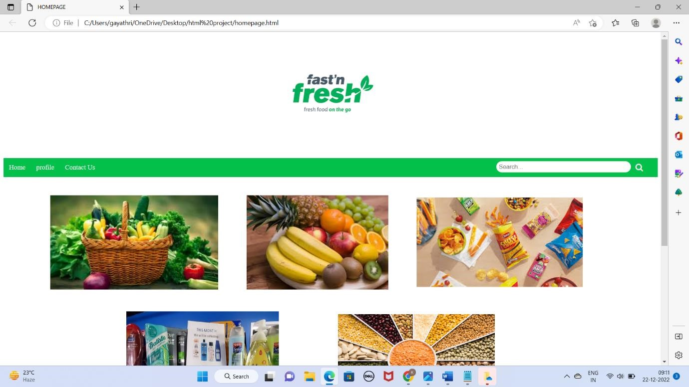

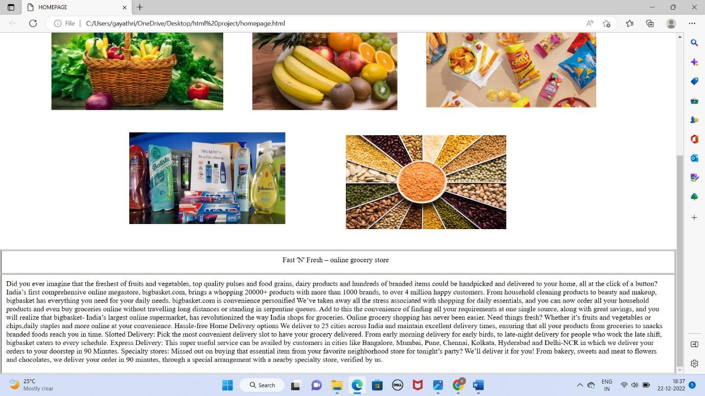

**2.Login page**

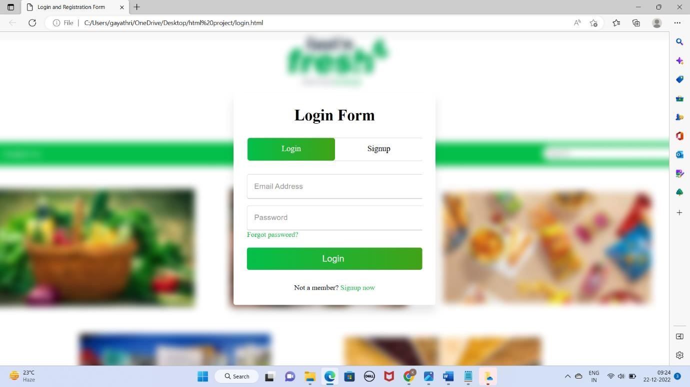

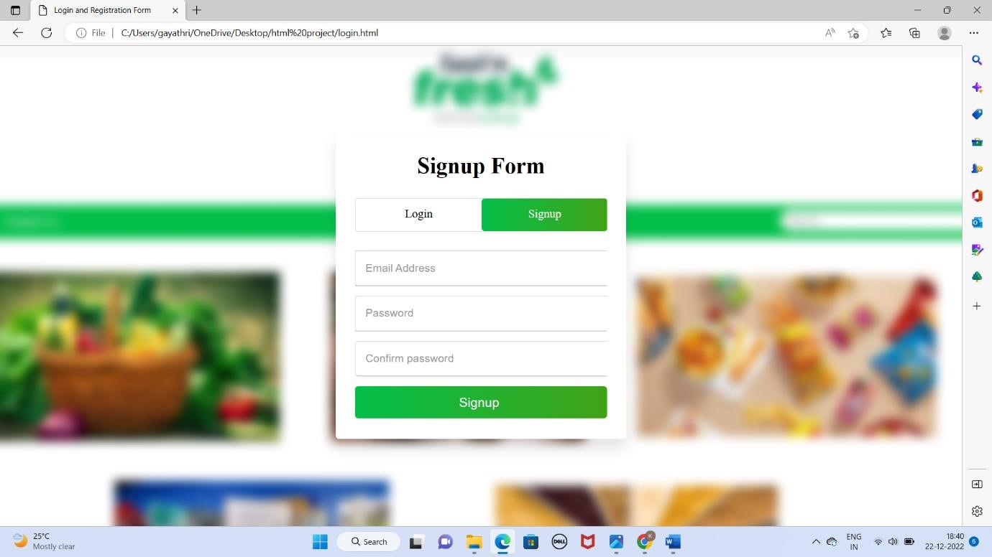

**3.Vegetables page**

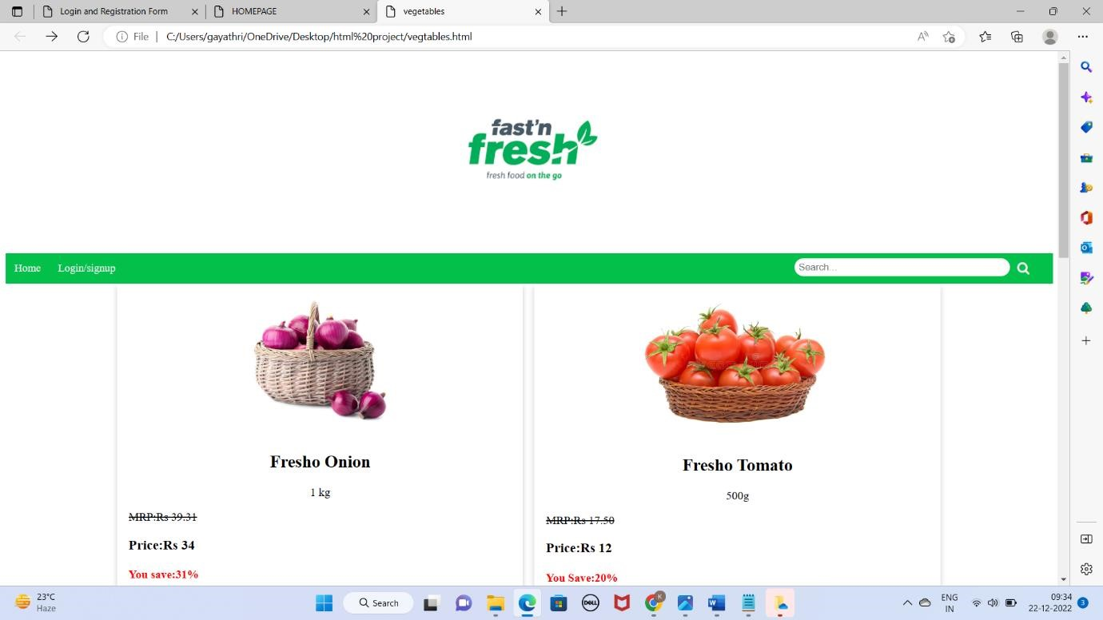

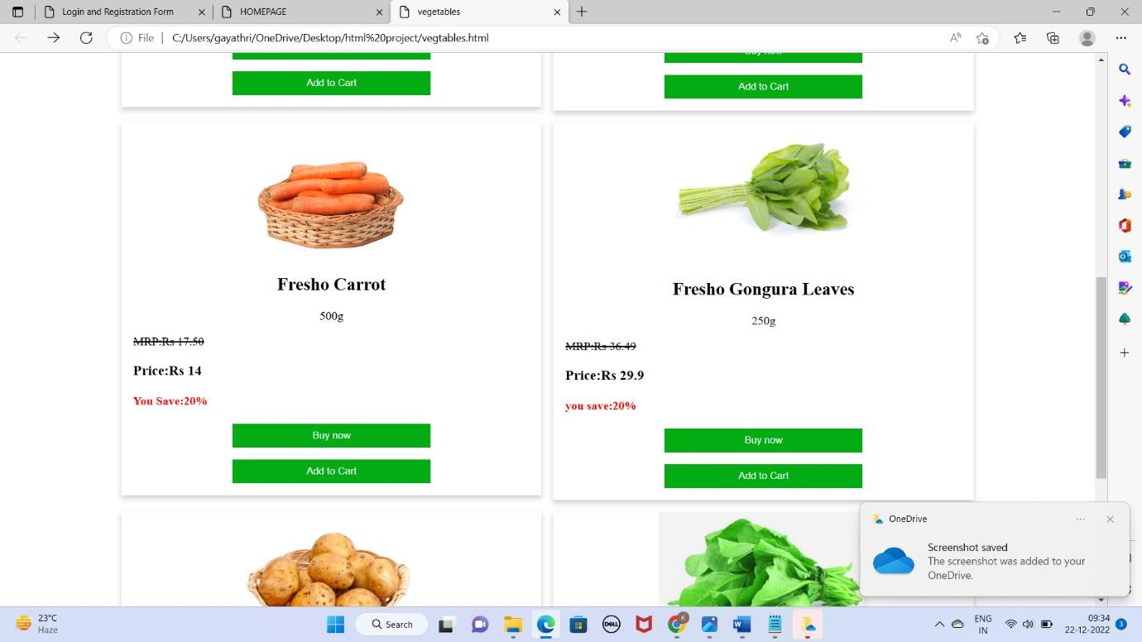

**4.Fruits page**

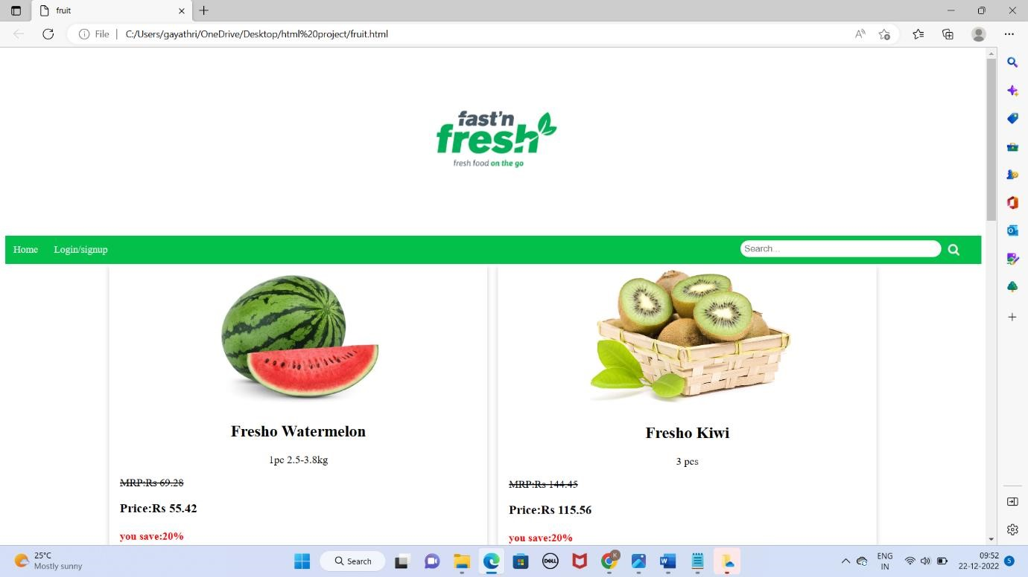

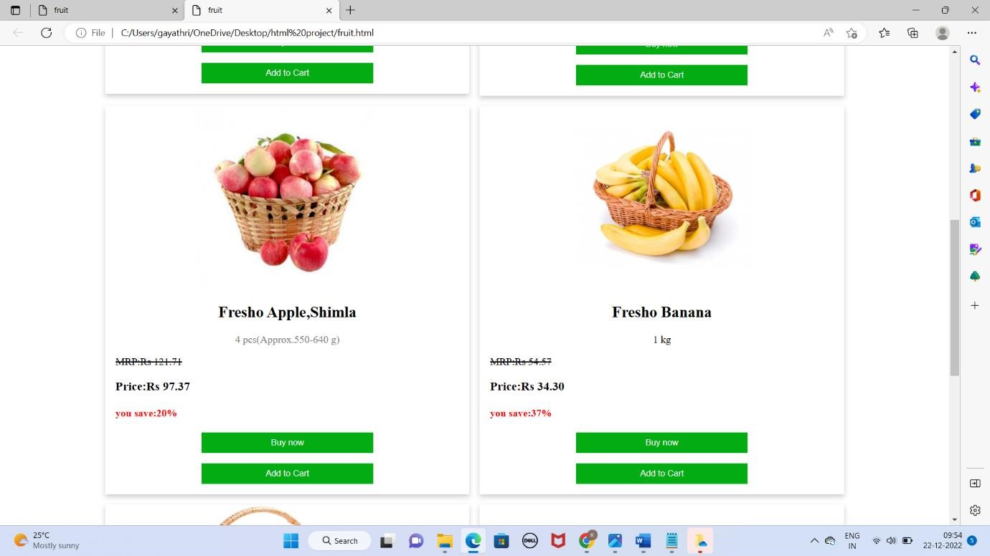

**5.Snacks page**

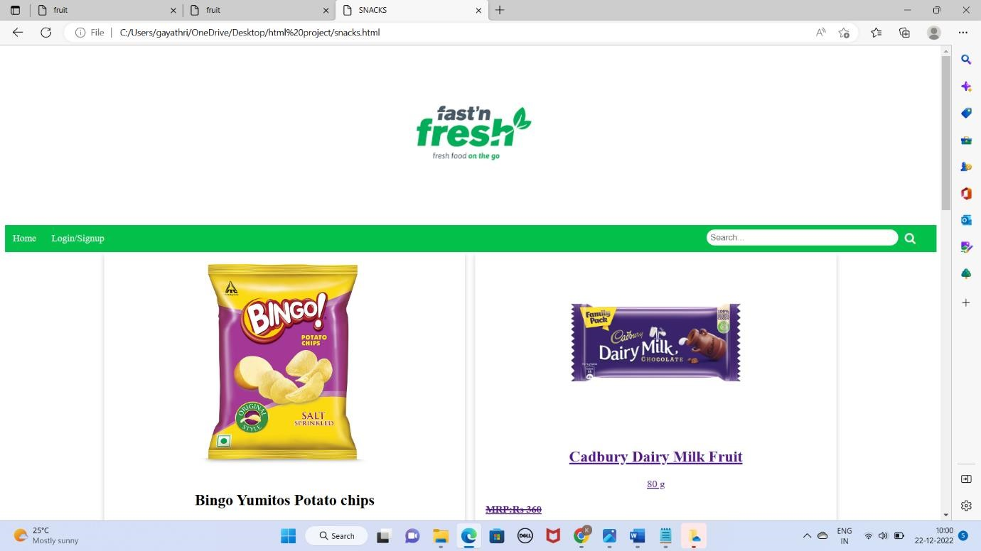

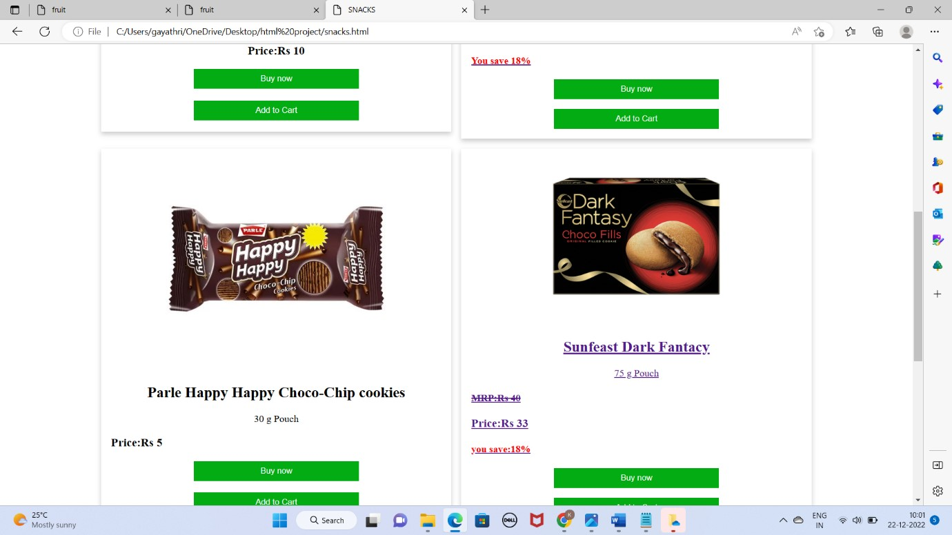

**6.Soaps page**

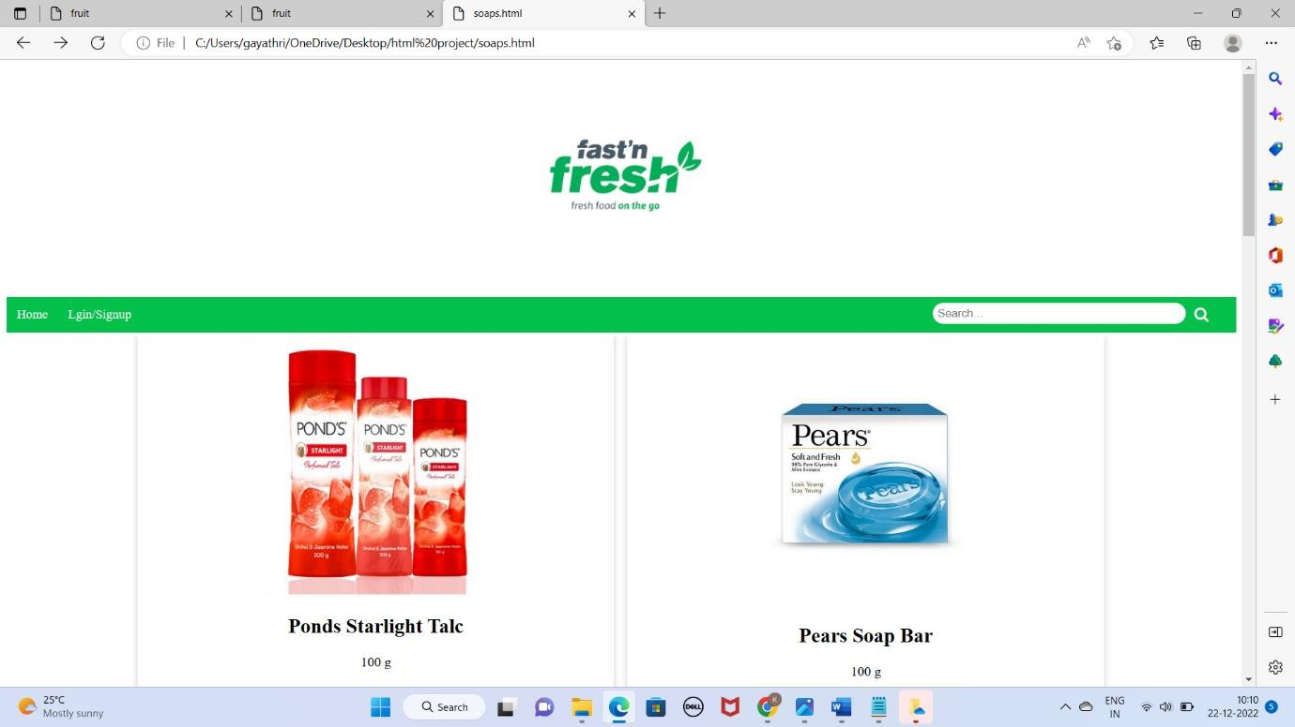

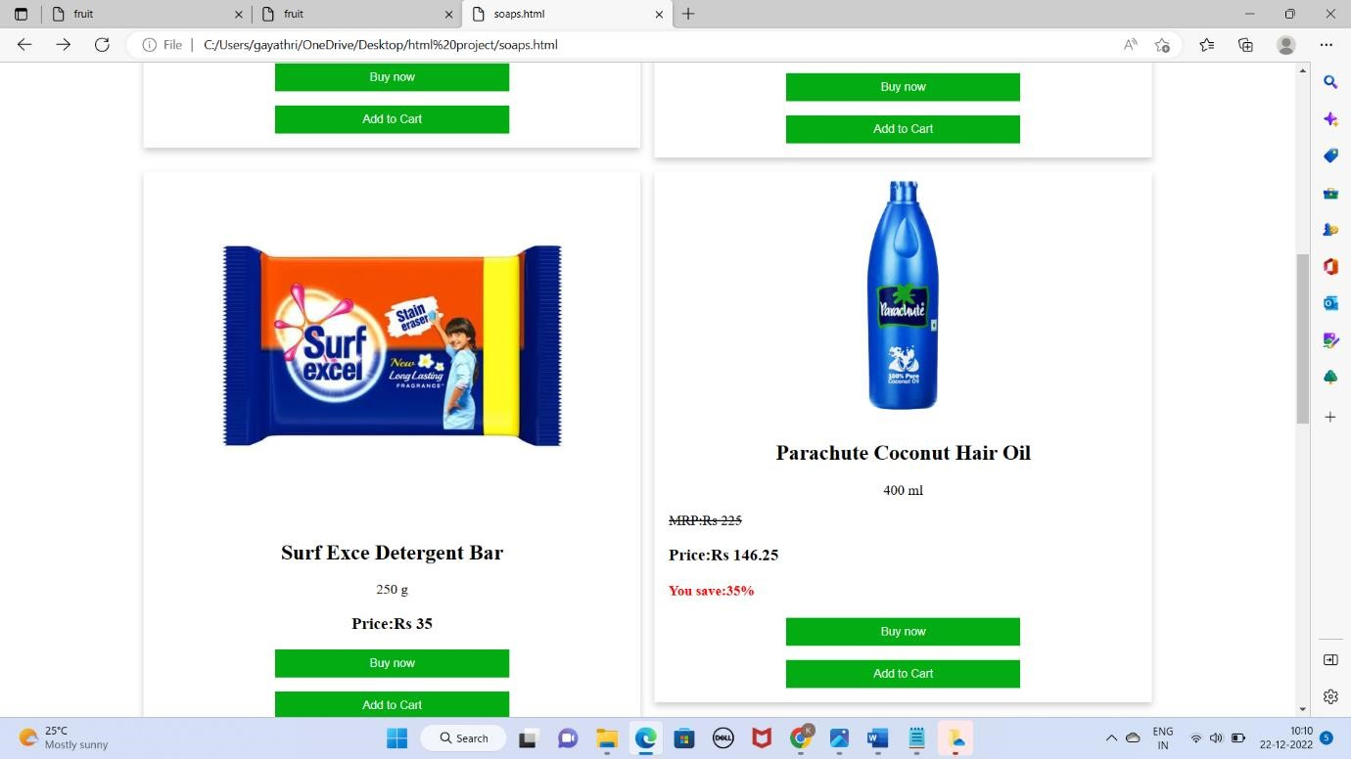

**7.Dals page**

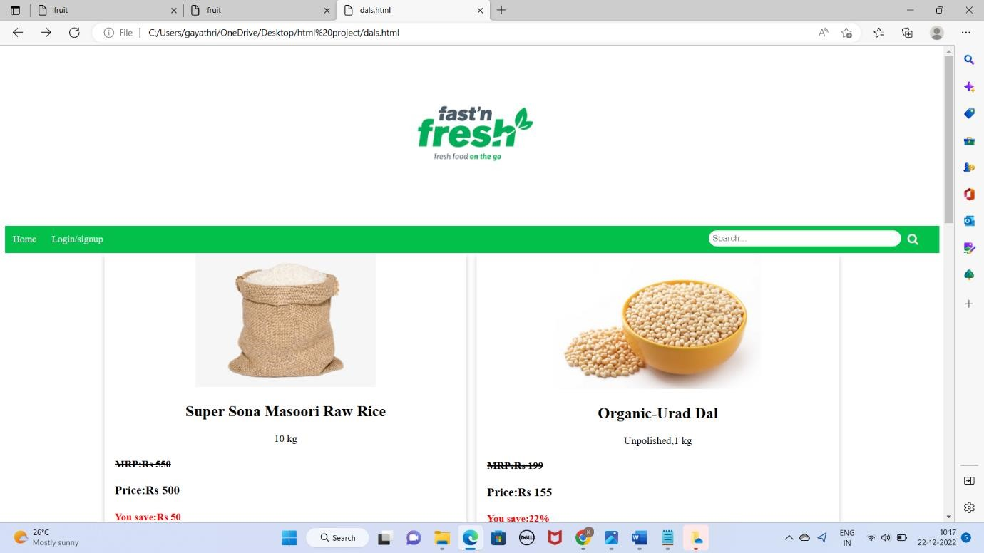

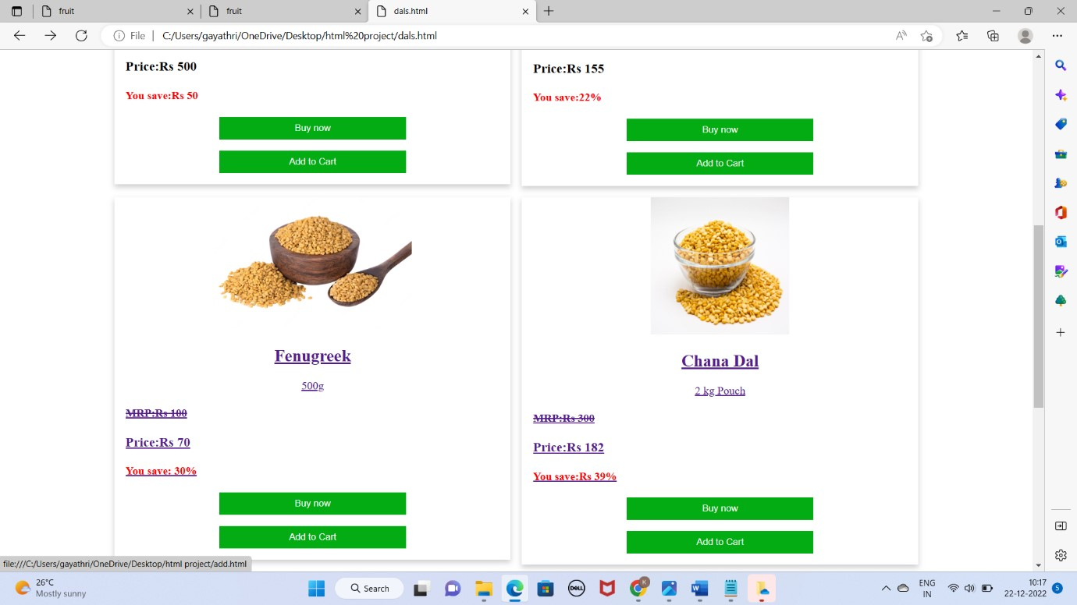

**8.Payment page**

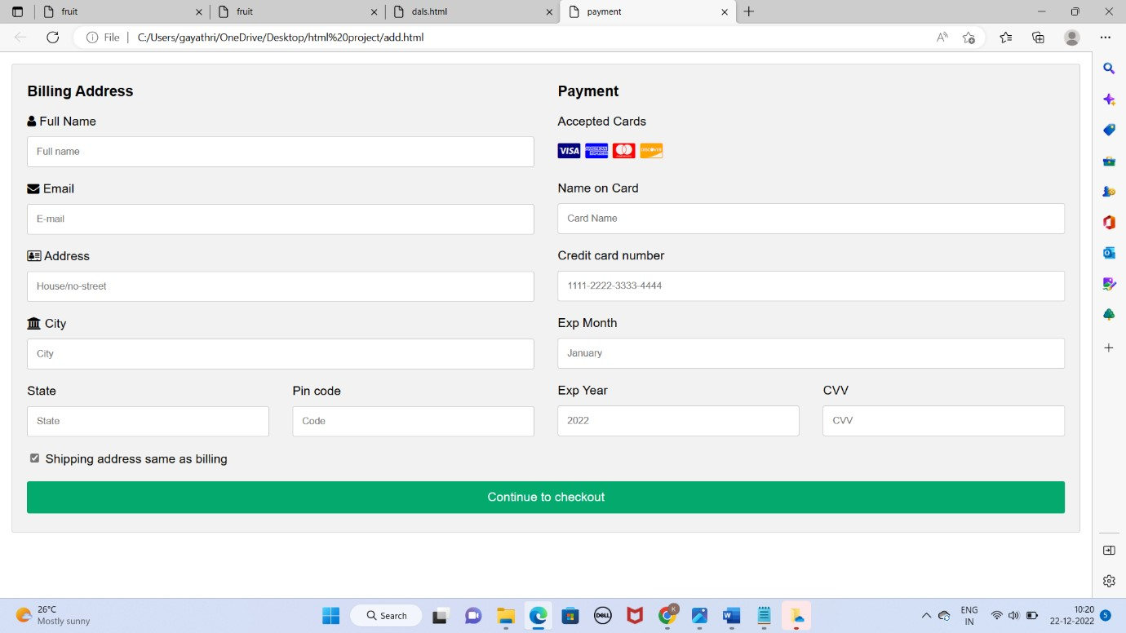

**9.Last page**

