**Note: Text highlighted in blue color denotes HackerRank questions**

**String (6 questions):**

1. Designer Door Mat
2. Mutations
3. Capitalize!
4. 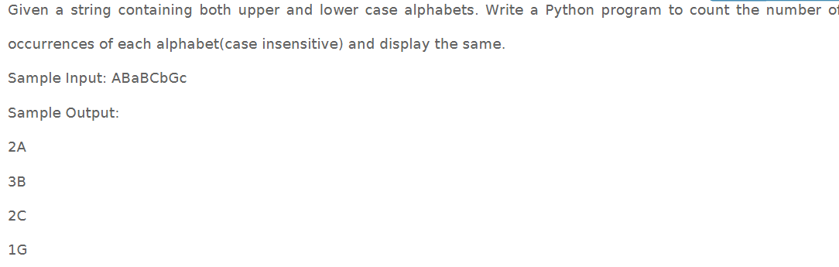

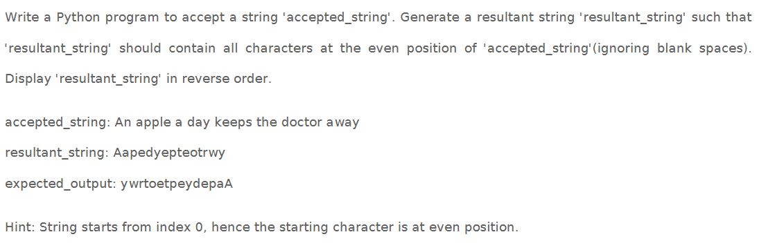

List, set, tuple, dictionary (No questions from HackerRank)

