**PREDICTIVE ANALYTICS LAB PROJECT**

**Project Report for**

Kidney Stone Detection Using Machine Learning and Deep Learning Techniques

Submitted By:

|  |  |  |
| --- | --- | --- |
| **Name** | **Roll No** | **Branch** |
| Samaksh Mittal | R2142220856 | AIML (H) |
| Kavya Dangi | R2142221184 | AIML (H) |

**Submitted To:**

Dr Achala Shakya



School of Computer Science

**UNIVERSITY OF PETROLEUM AND ENERGY STUDIES**

**Dehradun-248007 2024**

**School of Computer Science**

University of Petroleum & Energy Studies, Dehradun

**Table of Contents**

|  |  |  |
| --- | --- | --- |
| **Topic** | | **Page No** |
| Table of Contents | | 2 |
| 1 | Introduction | 3 – 4 |
|  | 1.1 Purpose of the Project | 3 |
|  | 1.2 Target Beneficiary | 3 |
|  | 1.3 Project Scope | 3 – 4 |
| 2 | Project Description | 4 – 46 |
|  | 2.1 SWOT Analysis | 4 – 5 |
|  | 2.2 Project Features | 5 – 6 |
|  | 2.3 Literature Review | 6 – 9 |
|  | 2.4 Project Code | 9 |
|  | 2.5 Design and Implementation Constraints | 9 – 10 |
|  | 2.6 Output | 10 – 45 |
|  | 2.7 Assumption and Dependencies | 45 – 46 |
| 3 | References | 46 – 48 |

### **1. INTRODUCTION**

**1.1 Purpose of the Project**

* The primary purpose of this project is to harness the power of machine learning to address the challenges associated with kidney stone diagnosis. Traditional methods of detecting kidney stones, while effective, often require significant time, expertise, and manual effort. This project aims to automate the diagnostic process by building a robust image classification model that distinguishes between normal kidney images and those with stones. By enhancing diagnostic accuracy and efficiency, the project seeks to reduce human error, support faster decision-making, and improve patient outcomes. Additionally, it aims to serve as a stepping stone for future advancements in medical imaging and AI-based healthcare solutions.

**1.2 Target Beneficiary**

* **Healthcare Professionals:** The project will assist doctors and radiologists by providing a reliable, automated diagnostic tool. It will reduce the cognitive load of manually interpreting medical images, saving time and improving accuracy, especially in resource-constrained settings.
* **Patients:** Patients will benefit from faster and more accurate diagnoses, enabling earlier intervention and treatment. This can significantly reduce complications and improve recovery rates for individuals with kidney stones.
* **Healthcare Systems:** The automated system will streamline diagnostic workflows in clinics and hospitals, reducing reliance on manual labor and cutting costs associated with prolonged diagnostic procedures. It will also enhance the scalability of healthcare services by handling a large volume of cases efficiently.
* **Research and Academic Community:** The project can serve as a benchmark for future research in AI-based medical diagnostics, offering insights into the application of machine learning in detecting kidney-related conditions.

**1.3 Project Scope**

* **Dataset Preparation:** The project will involve curating and pre-processing a dataset of medical images divided into two classes: Normal (healthy kidneys) and Stone (kidneys with stones). The quality and diversity of the dataset will be key to ensuring the model’s robustness.
* **Model Development:** The scope includes implementing and training various machine learning algorithms such as Random Forest, Support Vector Machine (SVM), Logistic Regression, and Decision Tree. The models will be evaluated based on performance metrics such as accuracy, precision, recall, and F1-score to identify the most effective one.
* **Automation of Detection:** An end-to-end system will be developed to automate the process of uploading medical images, classifying them into the appropriate category, and generating real-time predictions. This system will be designed to work seamlessly in clinical environments.
* **Performance Optimization:** The models will be fine-tuned using hyperparameter optimization techniques and validated on unseen data to ensure they are robust and generalize well across different scenarios.
* **Deployment Potential:** While the initial implementation will focus on research and development, the system will be designed with deployment in mind, making it suitable for integration into hospital workflows or standalone diagnostic tools.
* **Future Expansion:** The project provides a foundation for future enhancements, such as incorporating multi-class classification for detecting other kidney-related conditions, integrating with advanced diagnostic tools, or expanding to include 3D imaging data for better accuracy. It can also be adapted for detecting conditions in other organs, showcasing its versatility.

### **2. PROJECT DESCRIPTION**

**2.1 SWOT Analysis**

* **Strengths**:
  + Utilizes machine learning to automate kidney stone detection, reducing reliance on manual interpretation.
  + Implements multiple models (Random Forest, SVM, Logistic Regression, Decision Tree) to identify the most accurate solution.
  + Enhances diagnostic accuracy and efficiency, improving patient care.
  + Offers scalability for high-volume medical imaging applications.
* **Weaknesses**:
  + Limited availability of diverse and high-quality labeled datasets may restrict model generalization.
  + Requires significant computational resources for model training and testing.
  + Real-time predictions might demand trade-offs between speed and accuracy.
  + Ethical and regulatory compliance could delay deployment.
* **Opportunities**:
  + Potential to integrate with hospital management systems and diagnostic tools for seamless operation.
  + Scope for extending the model to detect other kidney conditions or organ-related issues.
  + Advancements in AI and deep learning can further enhance system performance.
  + Contributes to the growing field of AI-driven healthcare solutions.
* **Threats**:
  + High dependency on data quality; poor image resolution may lead to inaccurate predictions.
  + Competition from other AI-driven diagnostic tools in the healthcare sector.
  + Regulatory barriers and ethical concerns related to patient data usage.
  + Resistance to adoption due to trust issues in automated systems.

**2.2 Project Features**

* **Binary Classification System:** Distinguishes between Normal (healthy kidneys) and Stone (kidneys with stones) using medical images.
* **Model Diversity:** Implements multiple machine learning models, including Random Forest, SVM, Logistic Regression, and Decision Tree, for comparison and performance optimization.
* **Automated Detection:** Provides a fully automated system for real-time prediction, reducing manual diagnostic efforts.
* **Performance Metrics Evaluation:** Measures accuracy, precision, recall, F1-score, and runtime to identify the most effective model.
* **Scalable Design:** Capable of handling a large volume of medical images for high-demand clinical environments. User-Friendly Interface: Simple interface allowing healthcare professionals to upload images and receive instant results.
* **Extensibility:** Designed to accommodate future enhancements, such as multi-class classification or integration with advanced imaging techniques like 3D scans.
* **Compliance Focus:** Ensures adherence to privacy and ethical standards for medical data usage.

These features make the project a comprehensive solution for automated kidney stone detection, addressing both practical and technological needs.

**2.3 Literature Review**

| **S. No.** | **Authors** | **Title** | **Journal/Conference** | **Year** | **Key Focus** | **Major Findings** |
| --- | --- | --- | --- | --- | --- | --- |
| 1 | Saman Ebrahimi, Vladimir Y. Mariano | Image Quality Improvement in Kidney Stone Detection on Computed Tomography [1] | Journal of Image and Graphics | 2015 | Image quality improvement in kidney stone detection on CT images | Enhanced image quality led to better detection accuracy of kidney stones. |
| 2 | Prema T. Akkasaligar, Sunanda Biradar, Veena Kumbar | Kidney Stone Detection in Computed Tomography Images [2] | IEEE | 2017 | Kidney stone detection using CT images | Proposed techniques showed significant improvement in detecting kidney stones from CT scans. |
| 3 | Aniket Gaikwad, Azharuddin Inamdar, Vikas Behera | Lung Cancer Detection Using Digital Image Processing on CT Scan Images [3] | International Research Journal of Engineering and Technology | 2016 | Application of digital image processing for lung cancer detection in CT images | Effective preprocessing and segmentation methods improved detection accuracy for lung cancer. |
| 4 | Brisbane Wayne, R. Bailey Michael, D. Sorensen Mathew | An Overview of Kidney Stone Imaging Techniques [4] | Nature Reviews Urology | 2016 | Comparative analysis of kidney stone imaging methods | Detailed review of various imaging techniques like CT, ultrasound, and MRI for kidney stone diagnosis. |
| 5 | S. Asadi, H. Hassanpour, A. Pouyan | Texture-Based Image Enhancement Using Gamma Correction [5] | Middle-East Journal of Scientific Research | 2010 | Enhancing image textures using gamma correction | Improved visibility of medical images using gamma correction for texture-based image enhancement. |
| 6 | R. C. Gonzalez, R. E. Woods | Digital Image Processing [6] | Book | 1992 | Fundamentals of digital image processing | Introduced foundational concepts and algorithms in digital image processing. |
| 7 | D. Y. Kim, J. W. Park | Computer-Aided Detection of Kidney Tumor on Abdominal CT Scans [7] | Acta Radiologica | 2004 | Computer-aided detection of kidney tumors | Achieved improved tumor localization using computer-aided techniques. |
| 8 | D. T. Lin, C. C. Lei, S. W. Hung | Computer-Aided Kidney Segmentation on Abdominal CT Images [8] | IEEE Transactions on Information Technology in Biomedicine | 2006 | Automated kidney segmentation in CT images | Presented a reliable algorithm for segmenting kidneys in CT scans. |
| 9 | F. L. Coe, A. Evan, E. Worcester | Kidney Stone Disease [9] | Journal of Clinical Investigation | 2005 | Overview of kidney stone disease | Explored causes, prevention, and treatments for kidney stones. |
| 10 | F. Grases, A. Costa-Bauza, R. M. Prieto | Renal Lithiasis and Nutrition [10] | Nutrition Journal | 2006 | Role of nutrition in kidney stone formation | Found a significant relationship between dietary factors and kidney stone formation. |
| 11 | Sri Madhava Raja N, Rajinikanth V, Latha K | Otsu-Based Optimal Multilevel Image Thresholding Using Firefly Algorithm [11] | Modelling and Simulation in Engineering | 2014 | Image thresholding for segmentation | Proposed a firefly algorithm-based method for efficient image thresholding. |
| 12 | R. Vishnupriya, N. Sri Madhava Raja, V. Rajinikanth | An Efficient Clustering Technique and Analysis of Infrared Thermograms [12] | International Conference on Biosignals Images and Instrumentation | 2017 | Clustering analysis of infrared thermograms | Developed an efficient clustering method for thermal imaging analysis. |
| 13 | N. Sri Madhava Raja, S. L. Fernandes, Nilanjan Dev, S. Chandra Satapathy, V. Rajinikanth | Contrast-Enhanced Medical MRI Evaluation Using Tsallis Entropy and Region Growing Segmentation [13] | Journal of Ambient Intelligence and Humanized Computing | 2018 | MRI image evaluation using contrast enhancement | Applied Tsallis entropy for better segmentation and evaluation of medical MRI images. |
| 14 | N. S. M. Raja, P. R. V. Lakshmi, K. P. Gunasekaran | Firefly Algorithm-Assisted Segmentation of Brain Regions Using Tsallis Entropy and Markov Random Field [14] | Lecture Notes in Networks and Systems | 2018 | Brain region segmentation using firefly algorithm | Improved brain region segmentation in MRI images using entropy and Markov Random Field models. |

**Table 1 Literature Review**

* 1. **Project Code**

**Github Link:** [**https://github.com/kavyadangi/Kidney_Stone_Detection/tree/main/codes**](https://github.com/kavyadangi/Kidney_Stone_Detection/tree/main/codes)

* 1. **Design and Implementation Constraints**

The following constraints may impact the design and implementation of the kidney stone detection system:

1. **Data-Related Constraints:**

* Limited Dataset Availability: Access to a large, diverse, and labeled dataset of kidney images is critical for training machine learning models. Insufficient data or class imbalance could affect model accuracy.
* Data Quality: The quality of medical images, such as resolution and noise levels, can impact the model's ability to correctly classify images.

1. **Computational Constraints:** 
   * High Resource Requirements: Training machine learning models, especially on high-resolution images, requires substantial computational power (e.g., GPUs). Limited resources can slow down the development process.
   * Model Complexity: Advanced models like deep neural networks may demand more memory and processing power, which may not be feasible for deployment on low-end systems.
2. **Time Constraints:** 
   * Development Timeline: Limited time for designing, training, and testing multiple models might restrict the scope for extensive hyperparameter tuning or advanced optimization techniques.
   * Real-Time Predictions: The system must be designed to provide predictions in real-time, which could necessitate trade-offs between accuracy and speed.
3. **Ethical and Regulatory Constraints: Data Privacy:** 
   * Ensuring that medical images comply with data privacy laws (e.g., HIPAA, GDPR) and maintaining patient confidentiality throughout the project.
   * Regulatory Compliance: The system may need to meet specific standards for medical device software if intended for clinical use.
4. **Deployment Constraints: Hardware Limitations:** 
   * The final system may be required to run on standard hospital infrastructure, which might limit the use of computationally heavy models.
   * Scalability: The system must handle varying workloads, especially in hospitals or clinics with a high patient volume, requiring efficient design and optimization.
5. **Model Performance Constraints:** 
   * Generalization: The model must generalize well across diverse patient demographics, imaging conditions, and devices to avoid biases.
   * False Positives/Negatives: Minimizing incorrect classifications is crucial, as false negatives could delay treatment, and false positives might lead to unnecessary interventions. By acknowledging these constraints, the system design will focus on achieving a balance between performance, reliability, and practicality.

**2.6 Output**

**Data Analysis**

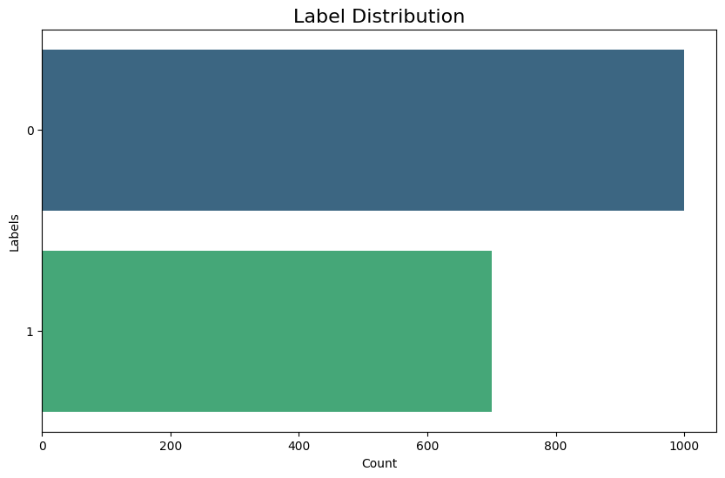

Fig. 1 Label Distribution

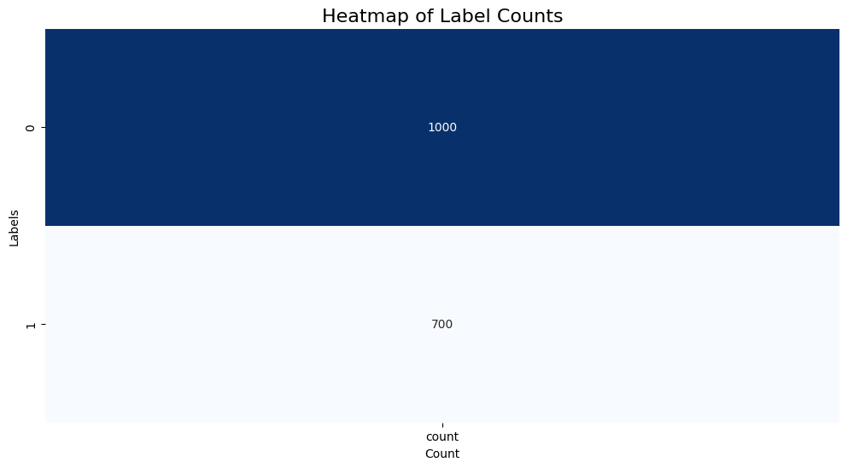

Fig. 2 Heatmap of Label Counts

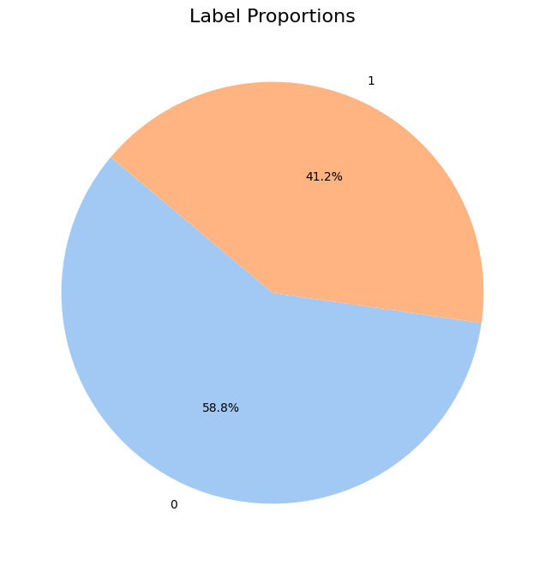

Fig. 3 Label Proportions

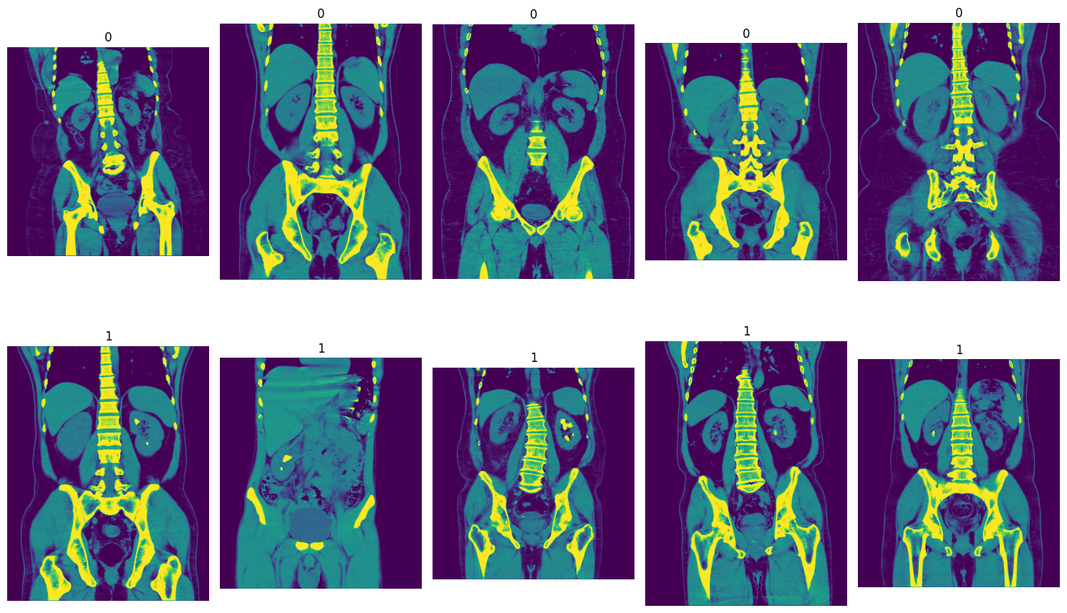

Fig. 4 Example Images

**Machine Learning Techniques**

**Logistic Regression:**

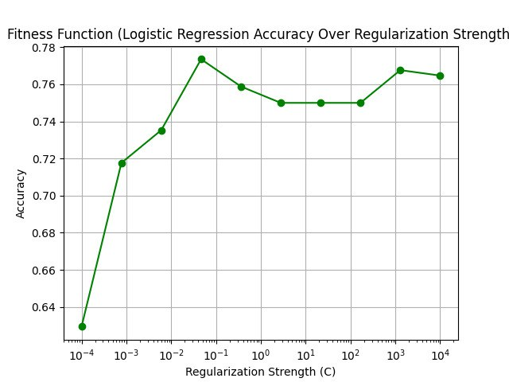

Fig. 5 Fitness Function for Logistic Regression

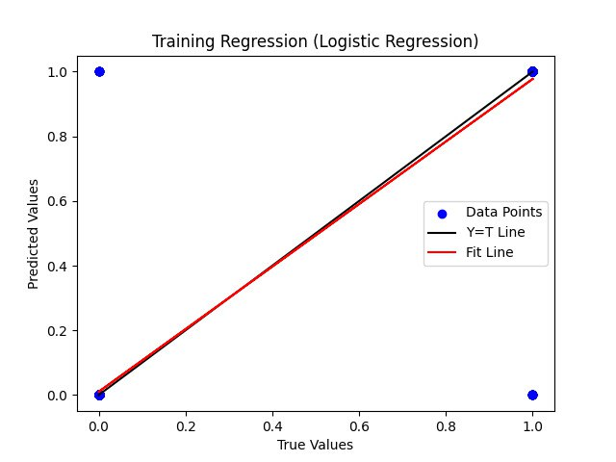

Fig. 6 Training Regression for Logistic Regression

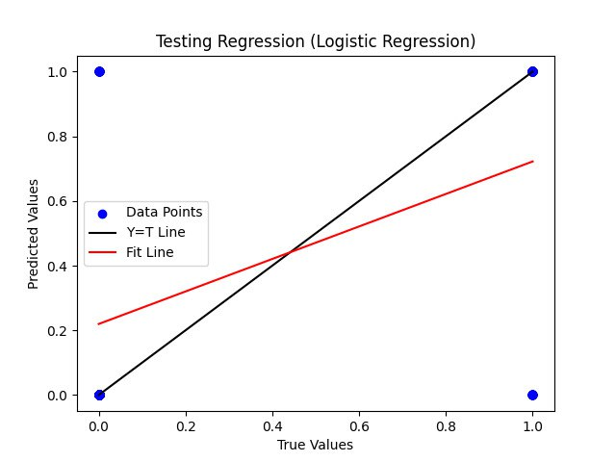

Fig. 7 Testing Regression for Logistic Regression

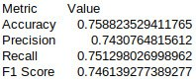

Fig. 8 Evaluation Metrics for Logistic Regression

**Naïve Bayes**

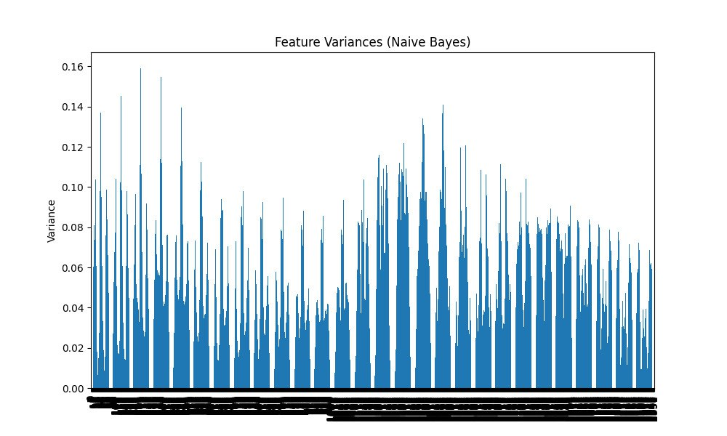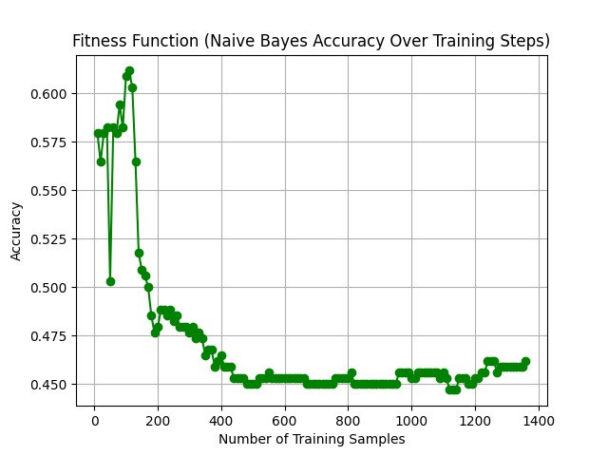

Fig. 10 Fitness Function for Naïve Bayes

Fig. 9 Feature Variances for Naïve Bayes

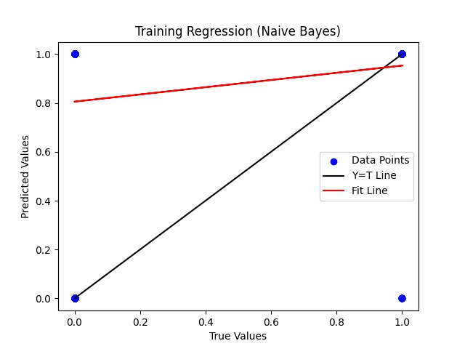

Fig. 11 Training Regression for Naïve Bayes

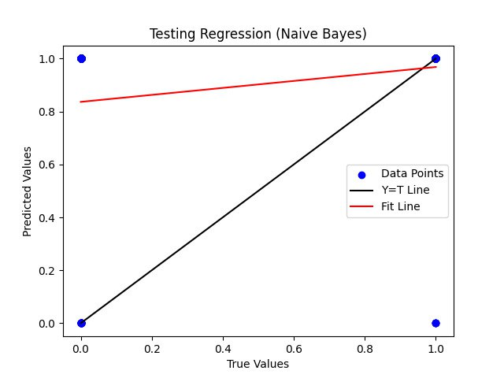

Fig. 12 Testing Regression for Naïve Bayes

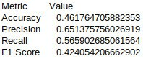

Fig. 13 Evaluation Metrics for Naïve Bayes

**K Nearest Neighbour**

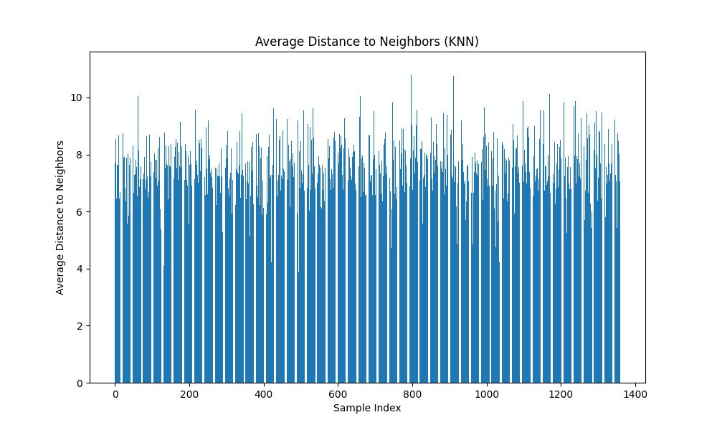

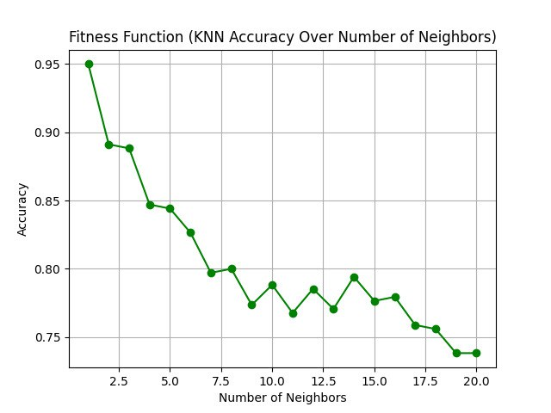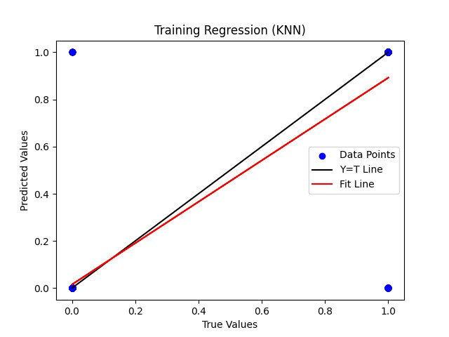

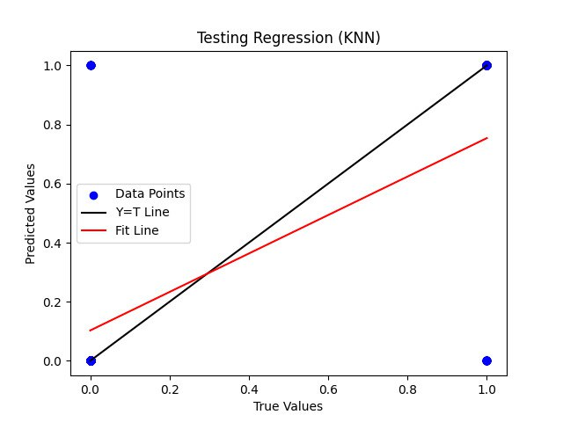

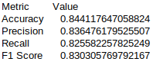

**Support Vector Machine**

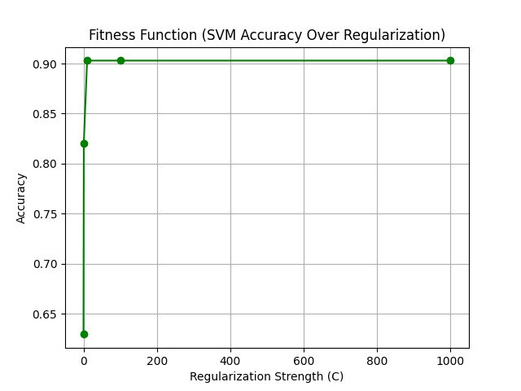

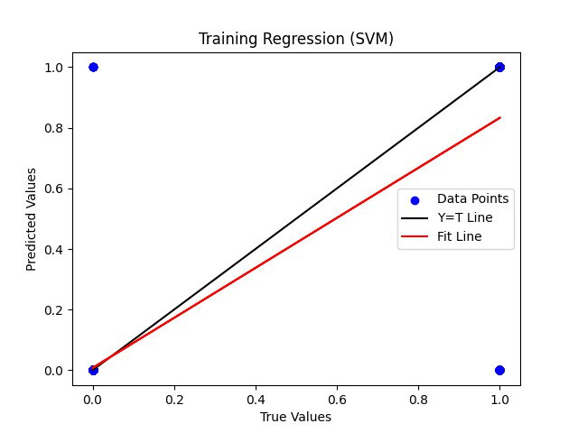

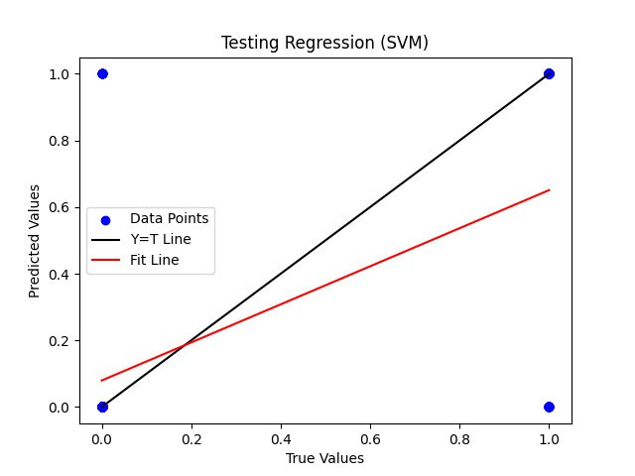

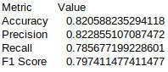

**Decision Tree**

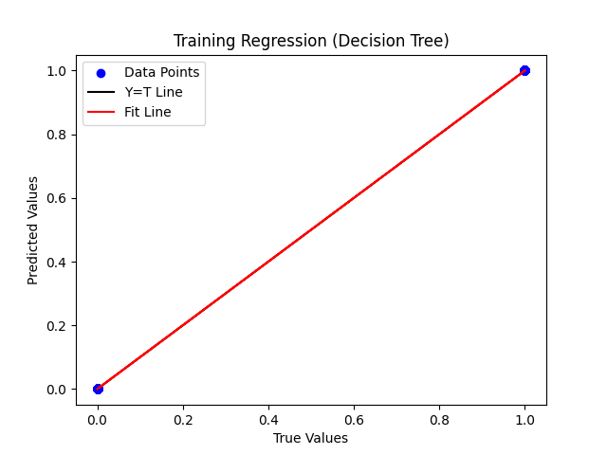

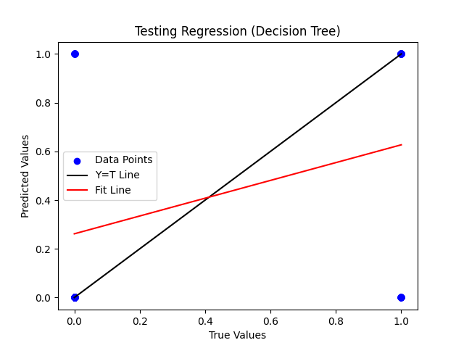

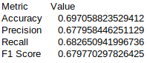

**Random Forest**

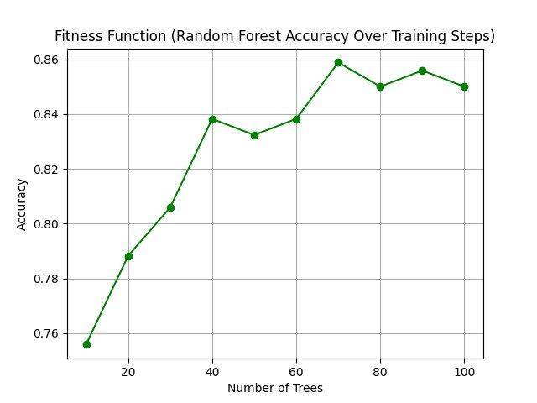

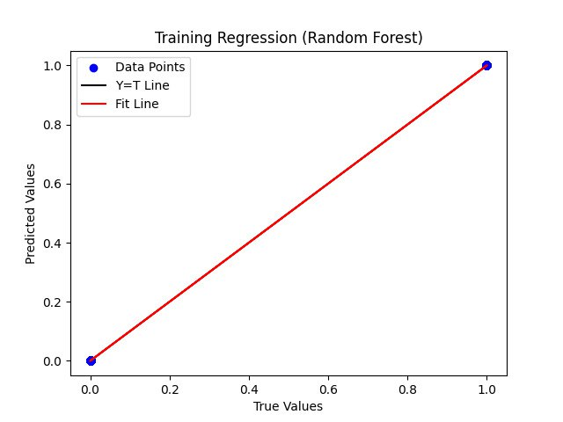

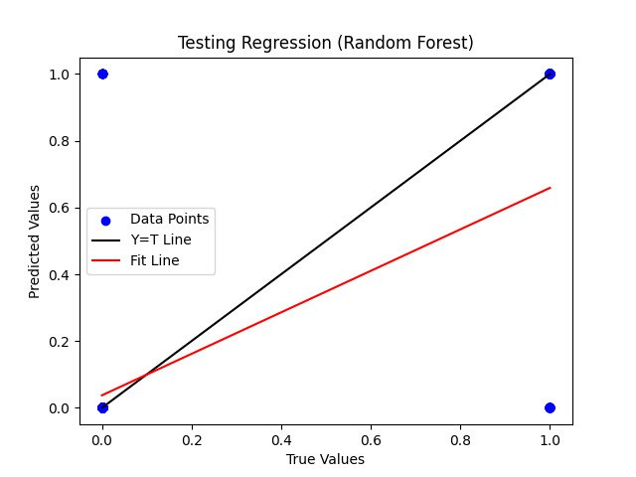

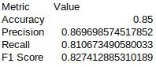

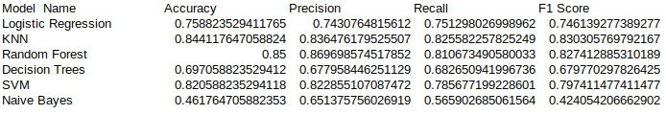

**All ML Models**

**Deep Learning Techniques:**

**Convolution Neural Network**

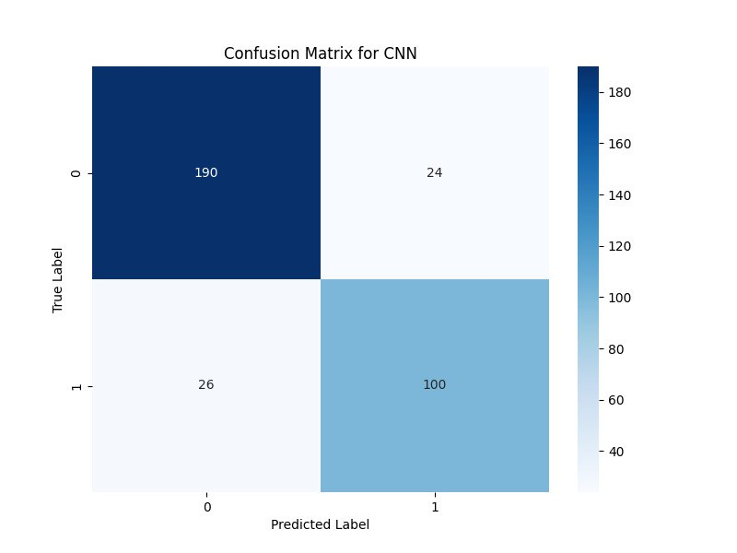

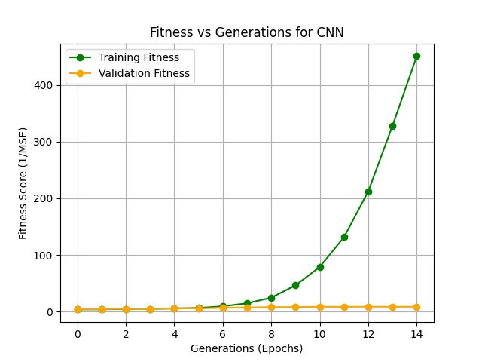

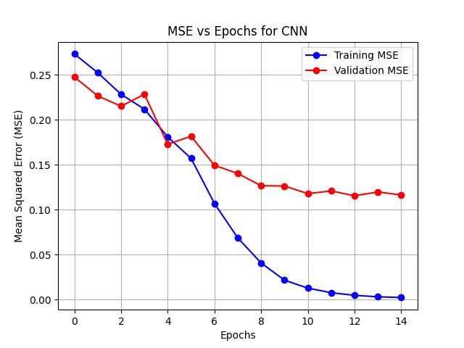

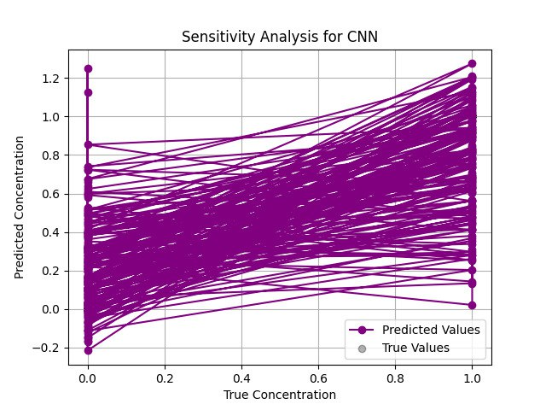

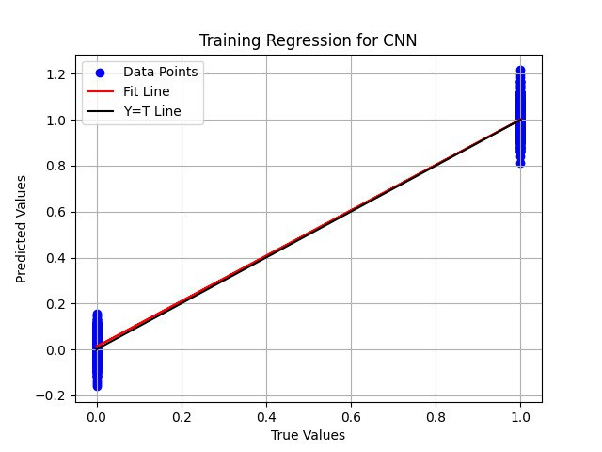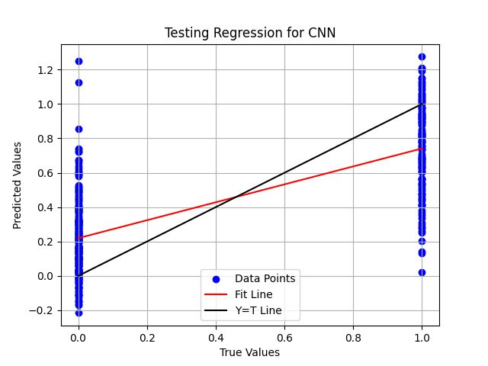

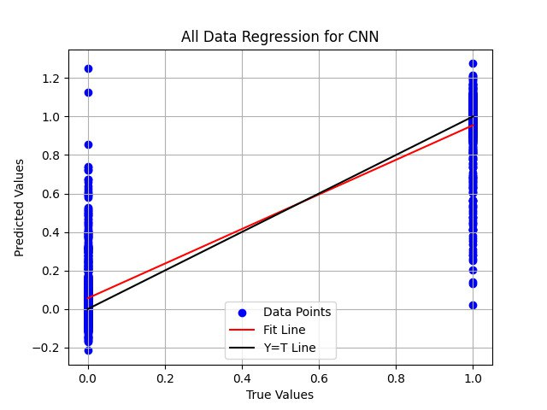

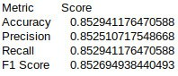



**Region Based CNN**

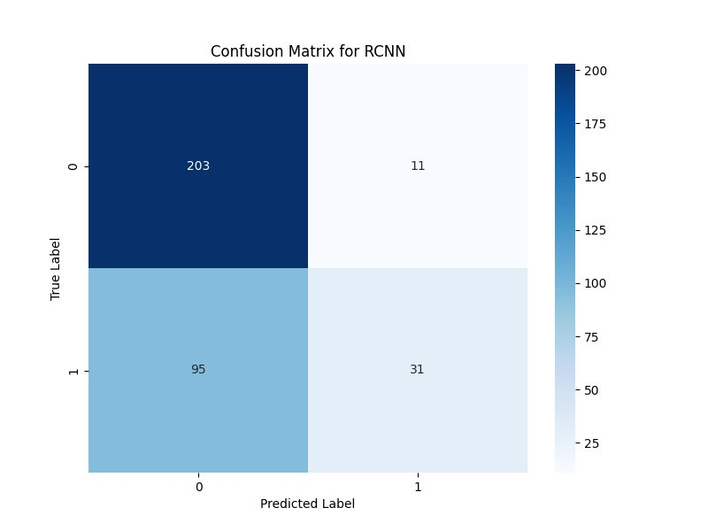

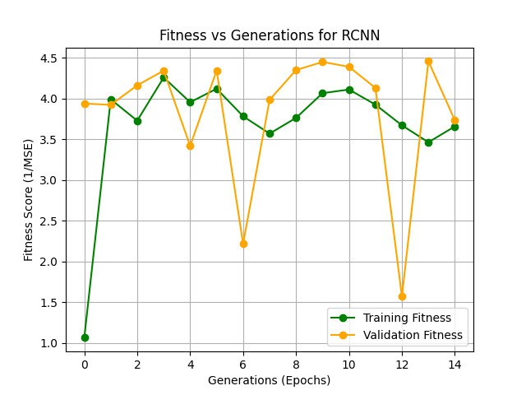

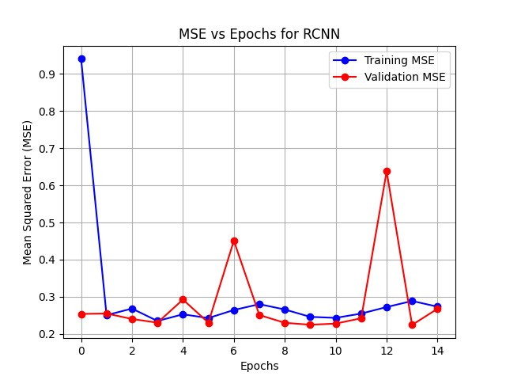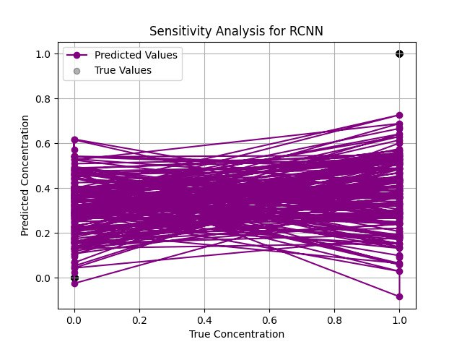

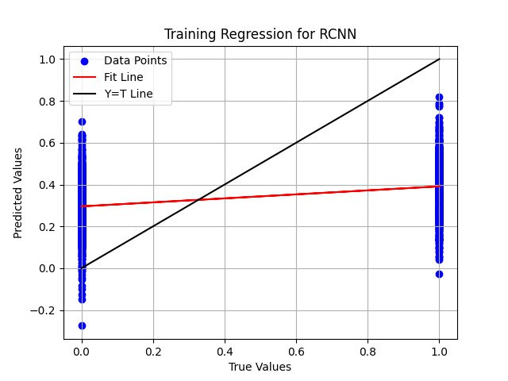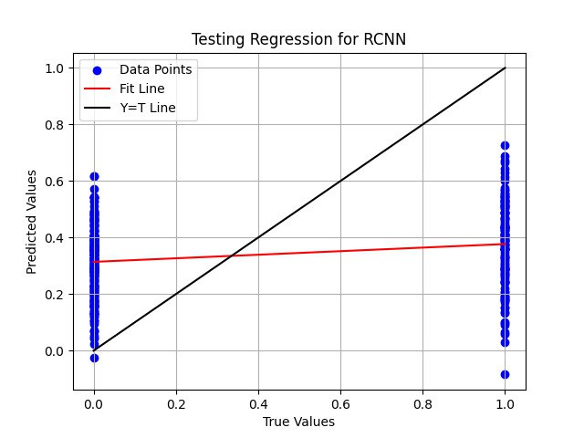

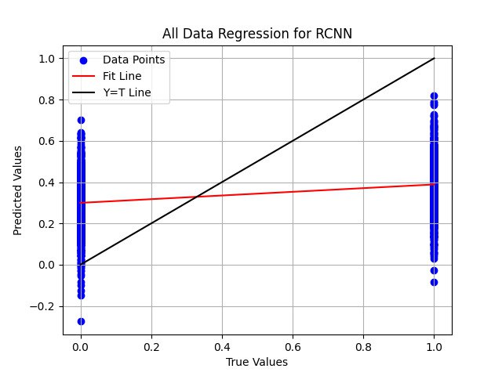

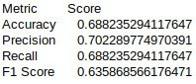



**MobileNet**

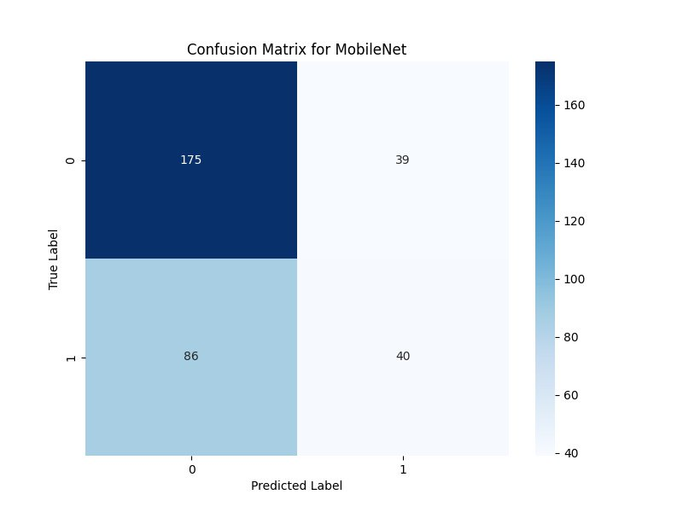

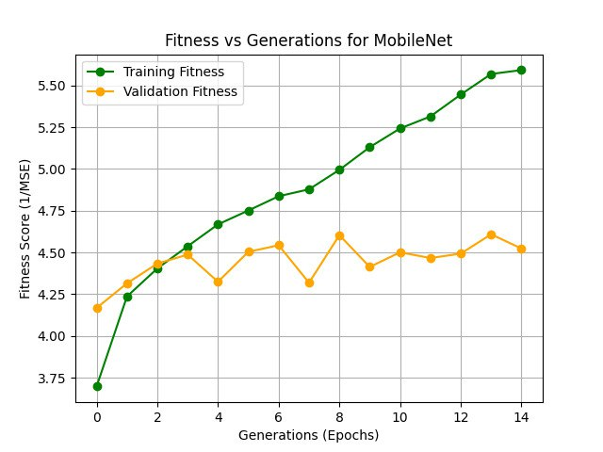

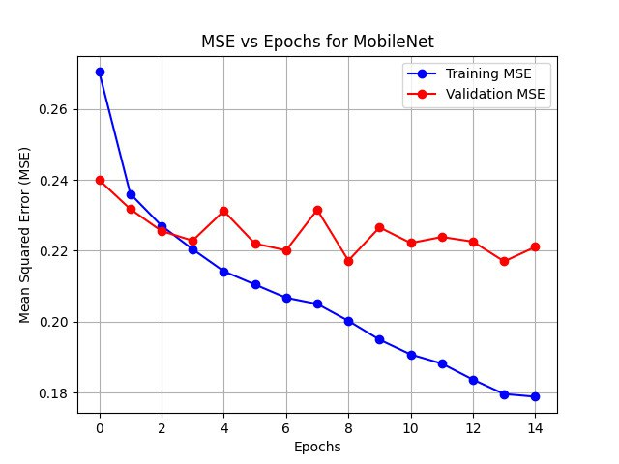

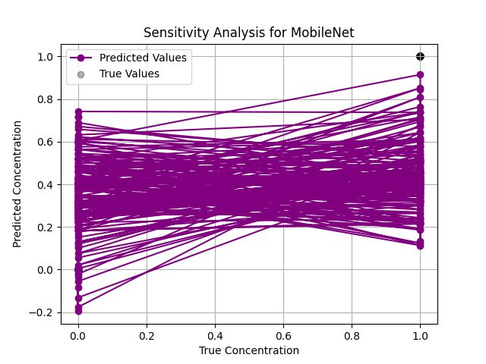

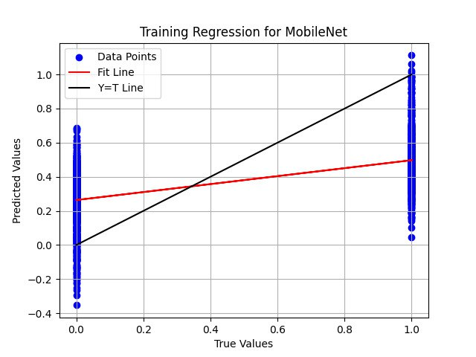

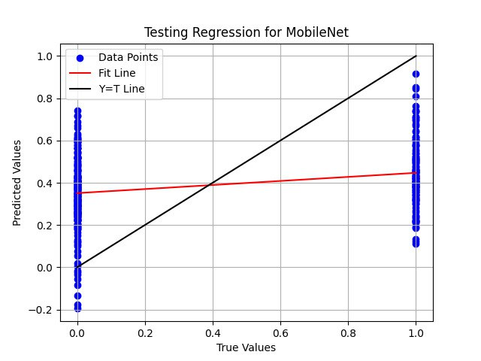

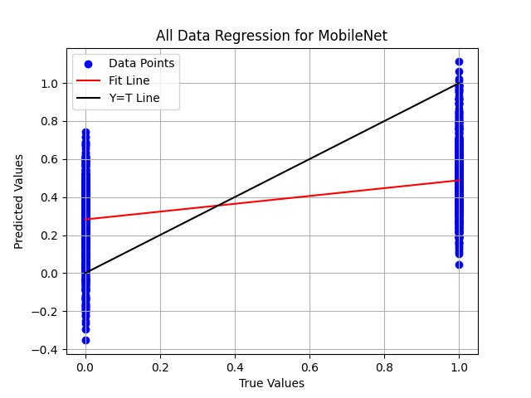

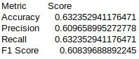



**VGG19**

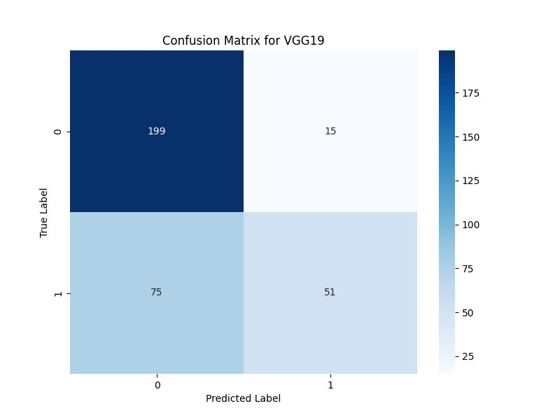

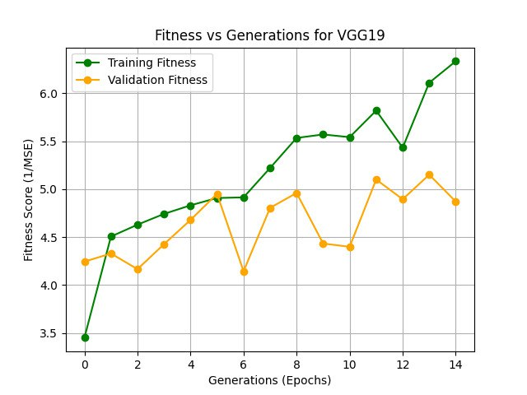



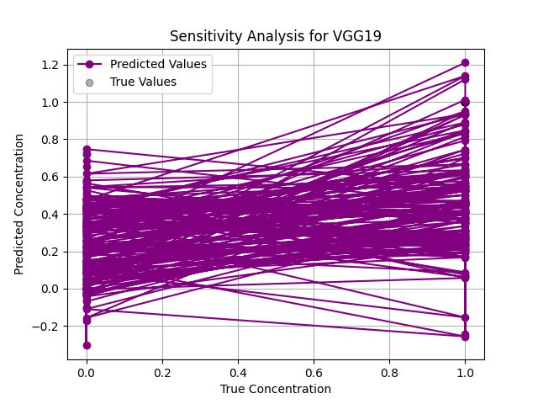

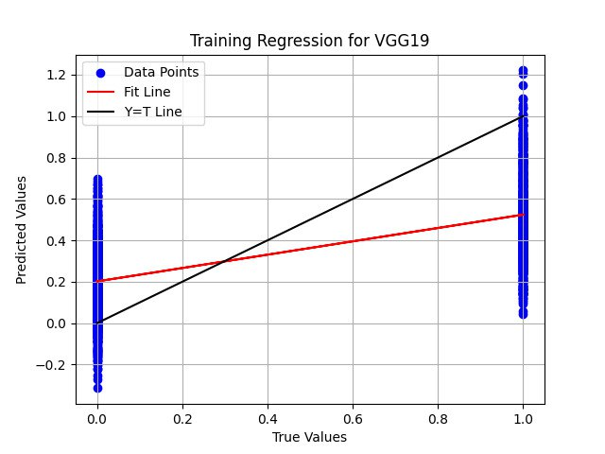



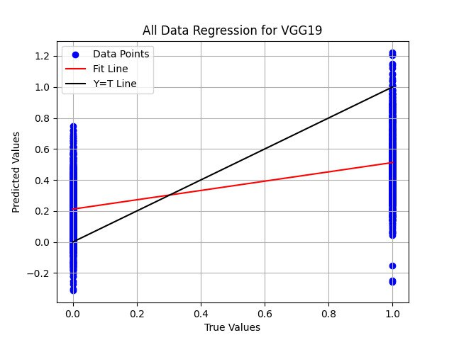

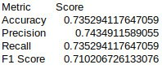



**ResNet50**

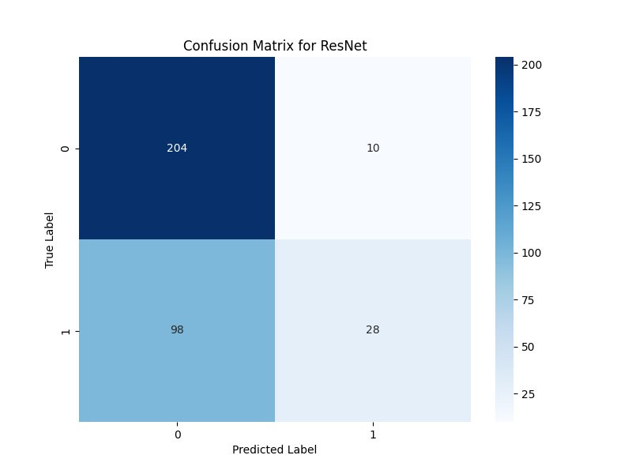

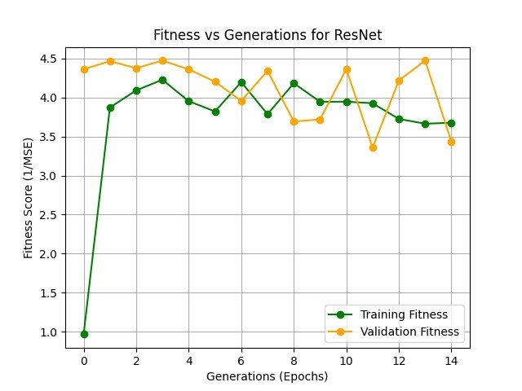

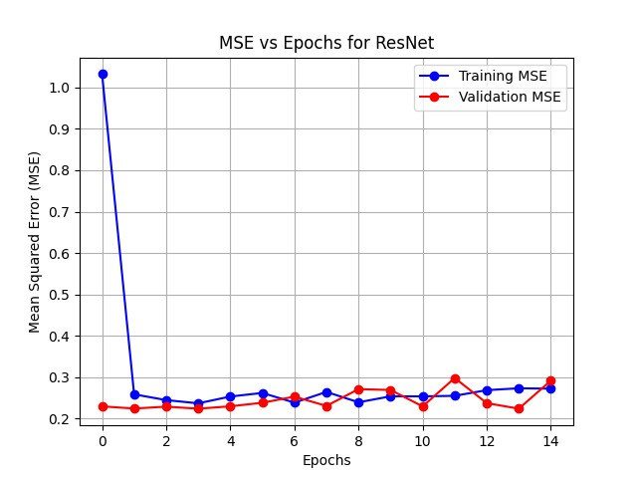

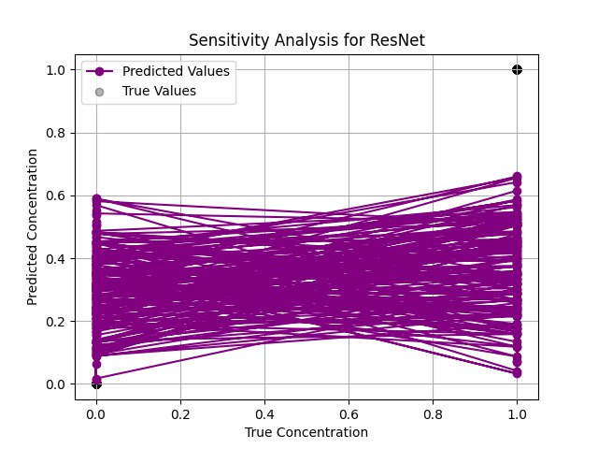

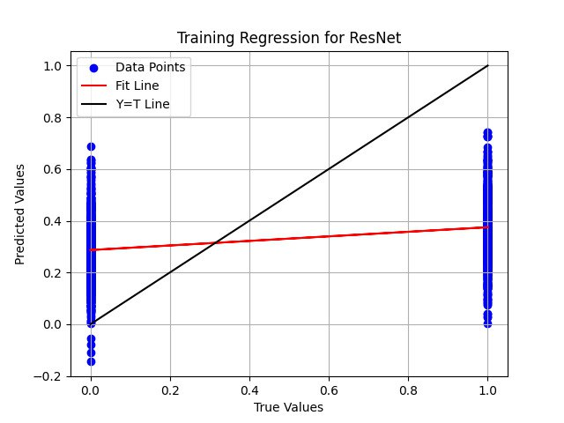

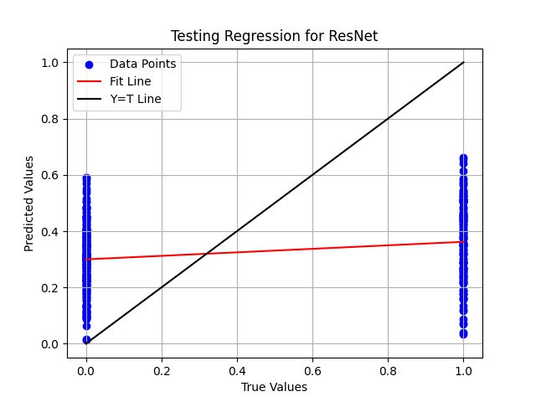

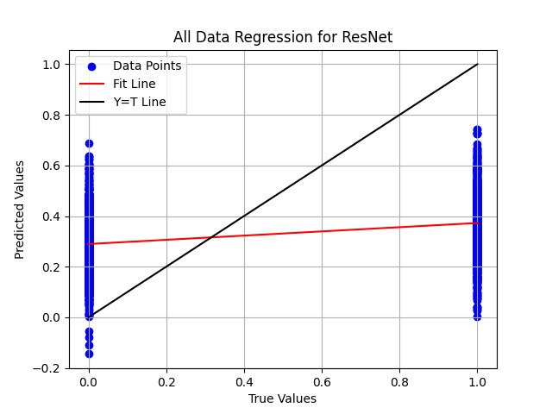

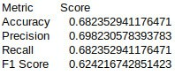



**All DL Models**

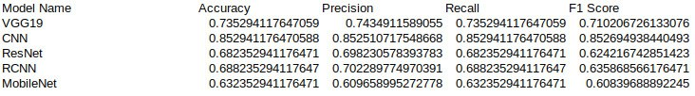

**Machine Learning VS Deep Learning**

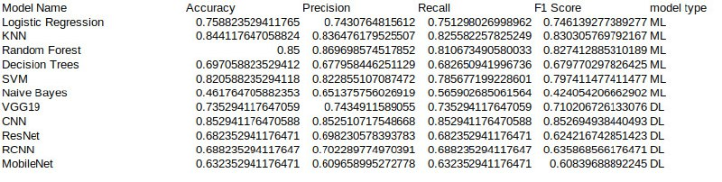

**2.7 Assumptions and Dependencies**

**Assumptions:**

* **Image Quality:** The dataset contains high-quality, labeled medical images that are sufficiently diverse to represent real-world scenarios. Images provided for testing and deployment are similar in quality and format to those used during training.
* **Label Accuracy:** The labels in the dataset (Normal or Stone) are accurate, as model performance depends heavily on correctly labeled training data.
* **Computational Resources:** Adequate computational resources (e.g., GPUs or high-performance CPUs) are available for model training, testing, and real-time predictions. Consistency in Imaging Techniques: The imaging techniques used for collecting the dataset are consistent, ensuring minimal variation in image features.
* **User Proficiency:** Healthcare professionals using the system have basic proficiency with technology and can operate the interface effectively.
* **Regulatory Compliance:** The dataset complies with all ethical and regulatory requirements for medical image usage and patient confidentiality.

**Dependencies:**

* **Data Availability:** The success of the project relies on access to a sufficiently large and balanced dataset of labeled kidney images for training and validation.
* **Hardware Infrastructure:** Training and deployment depend on the availability of suitable hardware, such as GPUs for deep learning or servers for real-time inference.
* **Software and Libraries:** The project depends on machine learning libraries like TensorFlow, PyTorch, or Scikit-learn for model development. Compatibility issues or software bugs could affect progress.
* **Image Preprocessing Tools:** Tools for image preprocessing (e.g., resizing, normalization) are essential for preparing the dataset for training.
* **Stakeholder Support:** Collaboration with domain experts, such as radiologists, is necessary to validate the system’s outputs and guide improvements.
* **Regulatory Approvals:** If deployed in a clinical setting, the system’s use will depend on regulatory approvals for AI-based diagnostic tools.
* **Internet Connectivity:** If the system integrates with cloud-based tools for processing or storage, reliable internet connectivity is required.

By identifying these assumptions and dependencies, the project can address potential risks and plan mitigation strategies to ensure successful development and deployment.

### **3. REFERENCES**

1. Ebrahimi, S., & Mariano, V. Y. (2015). Image quality improvement in kidney stone detection on computed tomography. *Journal of Image and Graphics, 3*(1), June.
2. Akkasaligar, P. T., Biradar, S., & Kumbar, V. (2017). Kidney stone detection in computed tomography images. In *IEEE Proceedings*.
3. Gaikwad, A., Inamdar, A., & Behera, V. (2016). Lung cancer detection using digital image processing on CT scan images. *International Research Journal of Engineering and Technology*.
4. Wayne, B., Bailey, M. R., & Sorensen, M. D. (2016). An overview of kidney stone imaging techniques. *Nature Reviews Urology, 13*(11).
5. Asadi, S., Hassanpour, H., & Pouyan, A. (2010). Texture-based image enhancement using gamma correction. *Middle-East Journal of Scientific Research, 6*(6), 569–574.
6. Gonzalez, R. C., & Woods, R. E. (1992). *Digital Image Processing* (2nd ed., pp. 47–51).
7. Kim, D. Y., & Park, J. W. (2004). Computer-aided detection of kidney tumor on abdominal computed tomography scans. *Acta Radiologica, 45*(7), 791–795.
8. Lin, D. T., Lei, C. C., & Hung, S. W. (2006). Computer-aided kidney segmentation on abdominal CT images. *IEEE Transactions on Information Technology in Biomedicine, 10*(1), 59–65. <https://doi.org/10.1109/TITB.2006.862739>
9. Coe, F. L., Evan, A., & Worcester, E. (2005). Kidney stone disease. *Journal of Clinical Investigation, 115*(10), 2598–2608. <https://doi.org/10.1172/JCI26662>
10. Grases, F., Costa-Bauza, A., & Prieto, R. M. (2006). Renal lithiasis and nutrition. *Nutrition Journal, 5*(23), 1–7. <https://doi.org/10.1186/1475-2891-5-23>
11. Madhava, S., Raja, N., Rajinikanth, V., & Latha, K. (2014). Otsu-based optimal multilevel image thresholding using firefly algorithm. *Modelling and Simulation in Engineering.* <https://doi.org/10.1155/2014/617498>
12. Vishnupriya, R., Madhava Raja, N. S., & Rajinikanth, V. (2017). An efficient clustering technique and analysis of infrared thermograms. In *Proceedings of the 2017 Third International Conference on Biosignals, Images, and Instrumentation (ICBSII)* (pp. 1–5). IEEE. <https://doi.org/10.1109/ICBSII.2017.8082245>
13. Madhava Raja, N. S., Fernandes, S. L., Dev, N., Satapathy, S. C., & Rajinikanth, V. (2018). Contrast-enhanced medical MRI evaluation using Tsallis entropy and region growing segmentation. *Journal of Ambient Intelligence and Humanized Computing.* <https://doi.org/10.1007/s12652-018-0740-4>
14. Madhava Raja, N. S., Lakshmi, P. R. V., & Gunasekaran, K. P. (2018). Firefly algorithm-assisted segmentation of brain regions using Tsallis entropy and Markov random field. In *Innovations in Electronics and Communication Engineering* (Vol. 7, pp. 235–244). Singapore: Springer. <https://doi.org/10.1007/978-981-10-5569-3_21>
15. Author(s). (n.d.). A machine-learning approach to distinguish passengers and drivers reading while driving [Scientific figure]. Retrieved from <https://www.researchgate.net/figure/Architecture-of-a-Logistic-Regression-Model-56_fig7_334575492>
16. Author(s). (n.d.). A study of stock market prediction through sentiment analysis [Scientific figure]. Retrieved November 20, 2024, from <https://www.researchgate.net/figure/Architecture-of-Naive-Bayes-Classifier_fig1_368646502>
17. Author(s). (n.d.). A novel intrusion detection model for mobile ad-hoc networks using CP-KNN [Scientific figure]. Retrieved November 20, 2024, from <https://www.researchgate.net/figure/Design-Architecture-of-CP-KNN_fig1_307675744>
18. Author(s). (n.d.). Hybrid techniques to predict solar radiation using support vector machine and search optimization algorithms: A review [Scientific figure]. Retrieved November 20, 2024, from <https://www.researchgate.net/figure/General-architecture-of-a-support-vector-maching-SVM-model-according-to-55_fig3_348745187>
19. Author(s). (n.d.). Fraud detection using machine learning in e-commerce [Scientific figure]. Retrieved November 20, 2024, from <https://www.researchgate.net/figure/Architecture-of-Decision-Trees_fig3_336148901>
20. Author(s). (n.d.). Pre-evacuation time estimation-based emergency evacuation simulation in urban residential communities [Scientific figure]. Retrieved November 21, 2024, from <https://www.researchgate.net/figure/Architecture-of-the-Random-Forest-algorithm_fig1_337407116>
21. Author(s). (n.d.). A high-accuracy model average ensemble of convolutional neural networks for classification of cloud image patches on small datasets [Scientific figure]. Retrieved November 21, 2024, from <https://www.researchgate.net/figure/Schematic-diagram-of-a-basic-convolutional-neural-network-CNN-architecture-26_fig1_336805909>
22. Author(s). (n.d.). A maximum-entropy-attention-based convolutional neural network for image perception [Scientific figure]. Retrieved November 21, 2024, from <https://www.researchgate.net/figure/Architecture-of-the-R-CNN-model_fig1_362218031>
23. Author(s). (n.d.). Efficient approach towards detection and identification of copy move and image splicing forgeries using Mask R-CNN with MobileNet V1 [Scientific figure]. Retrieved November 21, 2024, from <https://www.researchgate.net/figure/The-architecture-of-MobileNet-V1-30_fig5_357623745>
24. Author(s). (n.d.). Generalization of convolutional network to domain adaptation network for classification of disaster images on Twitter [Scientific figure]. Retrieved November 21, 2024, from <https://www.researchgate.net/figure/VGG-19-Architecture-39-VGG-19-has-16-convolution-layers-grouped-into-5-blocks-After_fig5_359771670>
25. Author(s). (n.d.). Performance evaluation of deep CNN-based crack detection and localization techniques for concrete structures [Scientific figure]. Retrieved November 21, 2024, from <https://www.researchgate.net/figure/The-architecture-of-ResNet-50-model_fig4_349717475>