Maritime-Oriented Neural Text-to-Speech Adaptation and Evaluation under Simulated VHF Radio Conditions
Problem Statement
Maritime VHF radio remains one of the main communication channels for emergency, operational, and navigational coordination in the maritime domain [4],[6],[7]. Modern neural Text-to-Speech (TTS) systems can generate natural and expressive speech, but they are mostly developed for clean and general-purpose communication [1],[4],[10]. Maritime radio communication has stricter requirements: generated speech must remain intelligible under VHF degradation [9], clearly express urgency, preserve important information such as vessel identity, position, numbers, and assistance requests, and follow maritime communication conventions [5],[6],[7].

Research Gap
Existing research has explored multilingual TTS, voice cloning, expressive speech generation, and general speech-quality evaluation [1],[4],[10]. However, limited work has focused on adapting and evaluating TTS systems specifically for maritime VHF communication [4],[9]. There is no well-established evaluation setup for testing whether TTS-generated maritime speech remains understandable and operationally useful after narrowband filtering, radio noise, compression, clipping, and other VHF-like degradation [7],[9]. This creates a gap between the current capabilities of general TTS models and the needs of safety-critical maritime communication.

Objectives
The objective of this thesis is to adapt and evaluate existing controllable TTS models for maritime VHF communication rather than designing a new TTS architecture from scratch. The work aims to generate maritime text–audio pairs using multiple TTS models under clean and noisy reference conditions, establish an automated quality-control pipeline for selecting suitable training samples, and perform Low-Rank Adaptation (LoRA)-based fine-tuning. The adapted models are then evaluated on unseen maritime text to assess their speaker consistency, intelligibility, message integrity, prosody control, and robustness under maritime/VHF-like conditions.

Methodology
The thesis follows an experimental comparative domain-adaptation methodology. Figure 1 illustrates the proposed workflow. Maritime emergency and operational dialogues are generated using reference speaker recordings and different TTS models, including Fish-Speech and Chatterbox. The generated speech is evaluated using an automated quality-control pipeline covering speaker consistency, signal quality, ASR, prosody, and message integrity. The accepted generated audio-text pairs are then used to create clean and noisy training datasets for LoRA-based domain adaptation. LoRA is implemented using the Hugging Face Parameter-Efficient Fine-Tuning (PEFT) library on top of PyTorch [2], [3], while Unsloth may be used where compatible to reduce memory usage and improve training efficiency. The adapted TTS models are subsequently used to generate additional maritime speech, which is evaluated under simulated VHF conditions. Finally, the different models and experimental conditions are compared using objective metrics, human listening evaluation, and LLM-as-a-Judge methods [1] to assess their suitability for reliable maritime VHF communication.
Proposed Pipeline
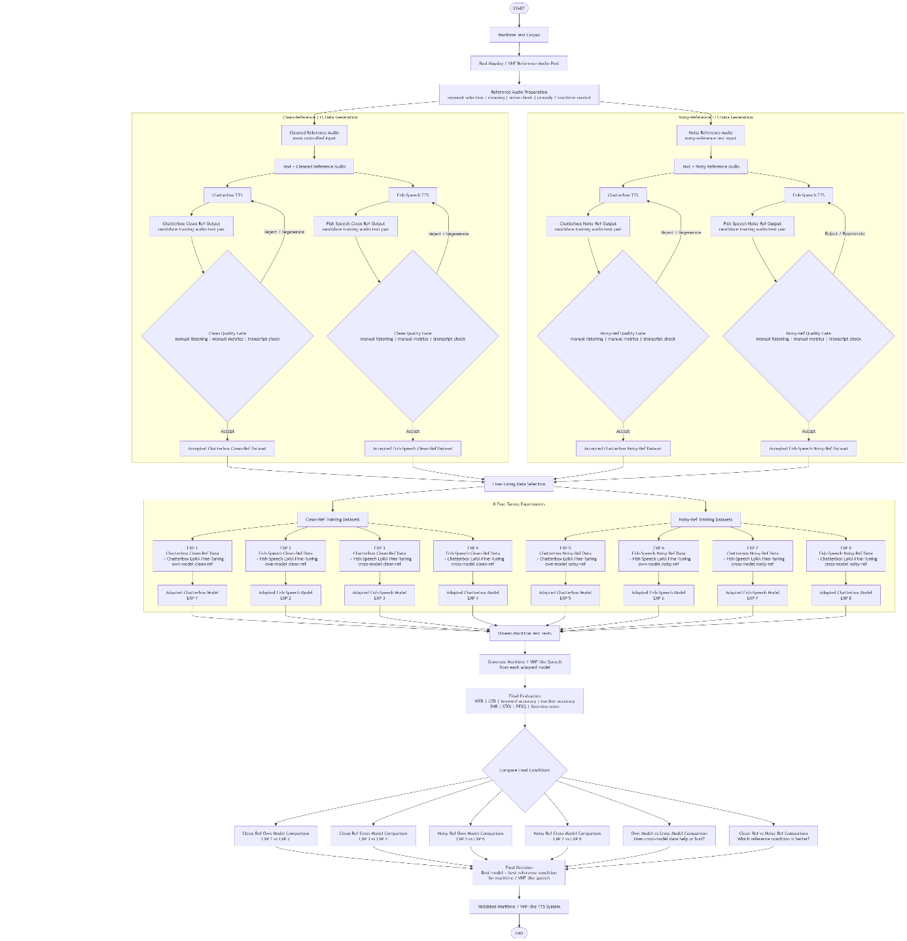

Figure 1: Proposed pipeline for maritime-oriented TTS adaptation and evaluation under simulated VHF radio conditions.

Our research questions are as follows:-

- How reliably can controllable TTS systems generate maritime communication while preserving the intended speaker identity and message content?
- How can an automated multi-stage QC pipeline evaluate generated maritime speech in terms of speaker consistency, signal quality, ASR reliability, speech-rate consistency, and message integrity?
- How do different TTS systems compare in their ability to generate consistent and intelligible maritime communication under the defined evaluation conditions?
- To what extent can reference-based prosody evaluation determine whether generated speech maintains a speaking rate comparable to the reference speaker while avoiding undesirable internal speech-rate changes?
Tasks to do in this thesis:
- Generate maritime speech using different controllable TTS systems and reference speakers.
- Develop an automated QC pipeline for speaker consistency, signal quality, ASR, prosody, and message integrity.
- Evaluate generated speech using ASR-based transcript, timestamp, and speech-rate analysis.
- Compare different TTS systems based on speaker consistency, speech quality, prosody, and message preservation.

References

[1] Liao, Shijia, et al. "Fish Audio S2 Technical Report." arXiv preprint arXiv:2603.08823 (2026).

[2] S. Mangrulkar et al., “PEFT: State-of-the-art Parameter-Efficient Fine-Tuning methods,” Hugging Face, 2022. [Online]. Available: https://github.com/huggingface/peft

[3] E. J. Hu et al., “LoRA: Low-Rank Adaptation of Large Language Models,” arXiv preprint arXiv:2106.09685, 2021.

[4] International Maritime Organization, “Resolution A.803(19): Performance Standards for Shipborne VHF Radio Installations Capable of Voice Communication and Digital Selective Calling,” 1995.

[5] IMO Resolution A.918(22) IMO Standard Marine Communication Phrases (Adopted on 29 November 2001). (n.d.). (C) Copyright 2005. https://www.imorules.com/IMORES_A918.22.html

[6] ITU-R Report M.2530-0, “Digital voice VHF in the maritime mobile service,” 2023.

[7 ] Nakilcioglu, Emin Cagatay, Maximilian Reimann, and Ole John. "Adaptation and optimization of automatic speech recognition (ASR) for the maritime domain in the field of VHF communication." arXiv preprint arXiv:2306.00614 (2023).

[8] “Miipher: Robust Speech Restoration for In-the-Wild Speech Samples,” arXiv preprint / IEEE workshop paper, 2023.

[9] Paul, Dipjyoti, et al. "Enhancing speech intelligibility in text-to-speech synthesis using speaking style conversion." arXiv preprint arXiv:2008.05809 (2020).

[10] X. Tan, T. Qin, F. Soong, and T.-Y. Liu, “A survey on neural speech synthesis,” arXiv preprint arXiv:2106.15561, 2021.

