# Discussion on Outputs

From outputs of the sample prompts, we can evaluate the performance of the 4 methods.

- Base LLM (no RAG):

This method directly answers the user question without any RAG, and the answer is simply based on LLM GPT 3.5’s response.

We can see the answer is very generic and mostly based on common sense, but does not contain specific information in the Sephora Product Reviews dataset.

- Basic RAG (retriever + LLM):

This method answers the user question by using a simple RAG with vector database retriever to augment the LLM response.

We can see the answer has include some specific information retrieved from the database, but it is still not specific enough.

- Advanced agentic RAG with base model (no fine-tuning):

This method incorporates a more advanced agentic RAG workflow. It first uses a query rewriter agent to rewrite user query, then retrieve the related reviews, and uses a base language model prajjwal1/bert-tiny to analyze the sentiment behind these reviews. Finally, it uses a LLM summarizer to summarize the retrieved reviews and the underlying sentiment.

We can see from the outputs that the base model mistakenly classifies many different sentiments, but generally it gives a more specific answer that incorporates the main points in expressed in different sentiments of reviews.

- Advanced agentic RAG with LoRA-finetuned model:

This method incorporates the most advanced agentic RAG workflow. It first uses a query rewriter agent to rewrite user query, then retrieve the related reviews, and uses the LoRA-finetuned language model prajjwal1/bert-tiny to analyze the sentiment behind these reviews. Finally, it uses a LLM summarizer to summarize the retrieved reviews and the underlying sentiment.

We can see from the outputs that the finetuned model can correctly classifies most sentiments, and it gives more accurate summarization answer compared with the base model version of agentic RAG workflow.

Overall, we can see that with the complexity of the RAG workflow, the LLM can generate better, more accurate and more domain-specific responses that better satisfies the user requirements.

# Outputs from the Web App (1 sample)

1. Base LLM (no RAG)

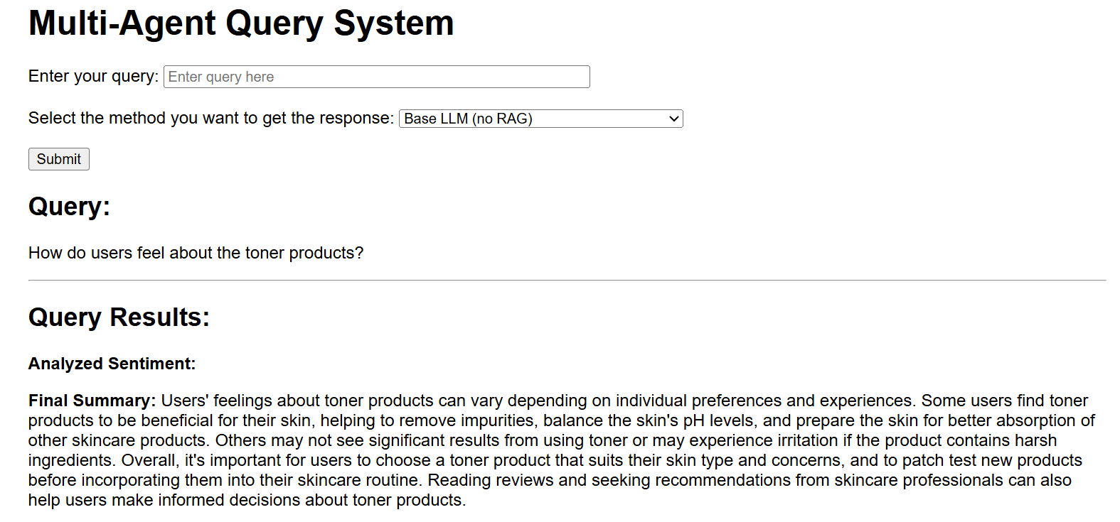

2. Basic RAG (retriever + LLM summarizer)

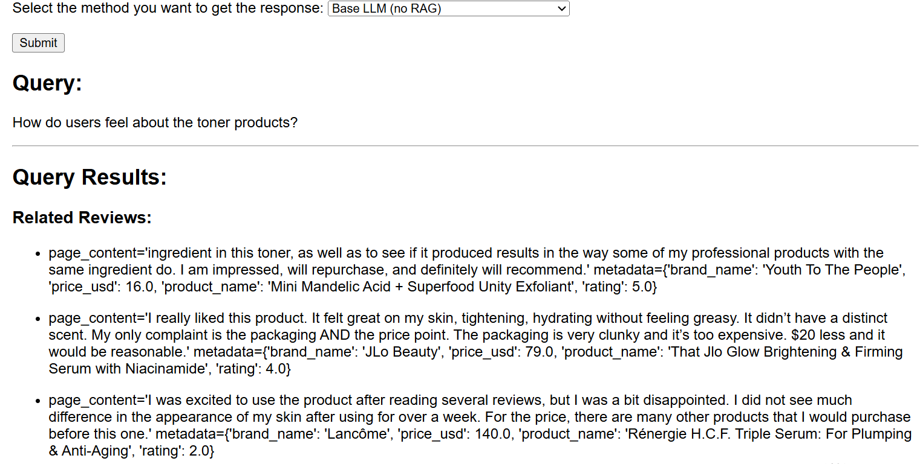

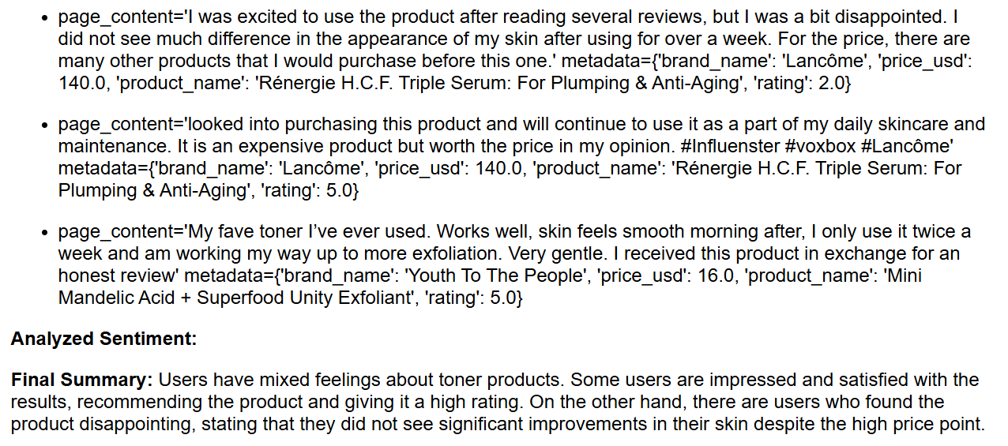

3. Advanced Agentic RAG (base model)

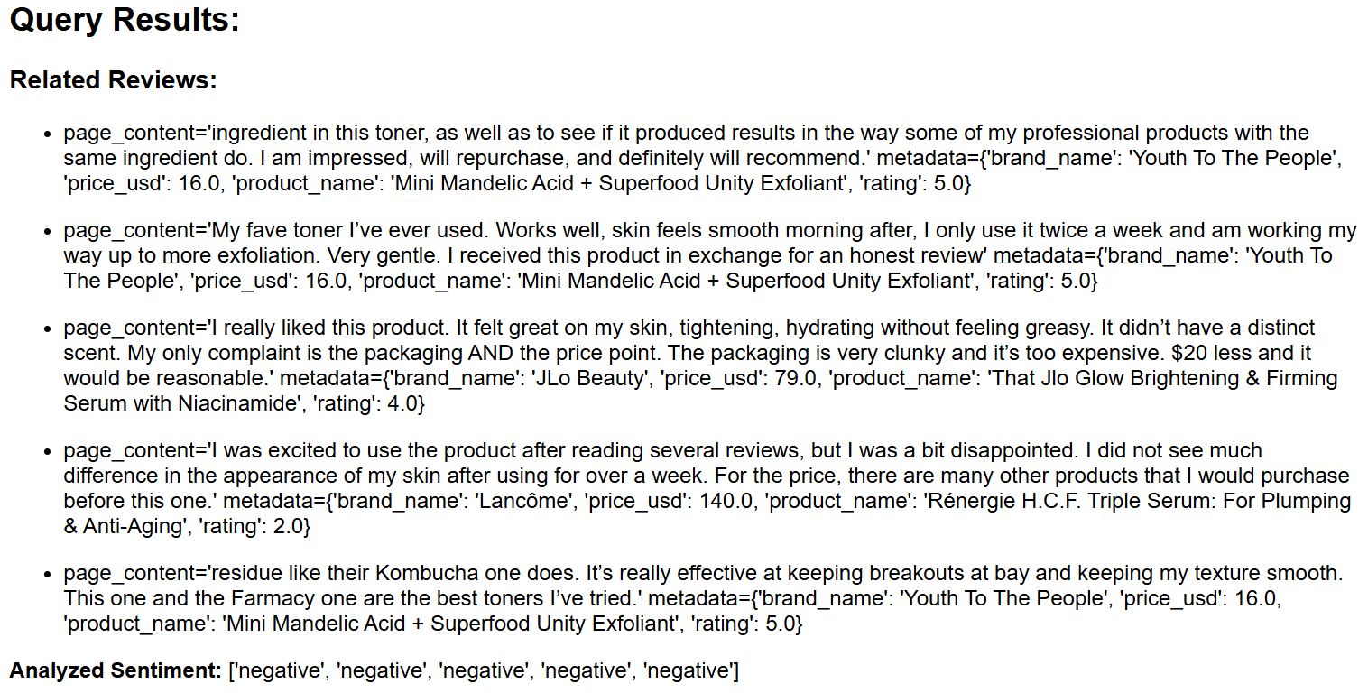

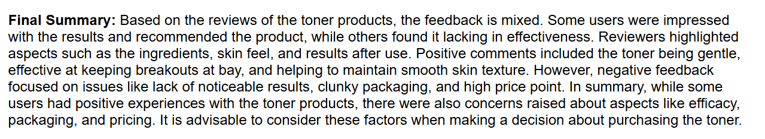

4. Advanced Agentic RAG (LoRA-finetuned)

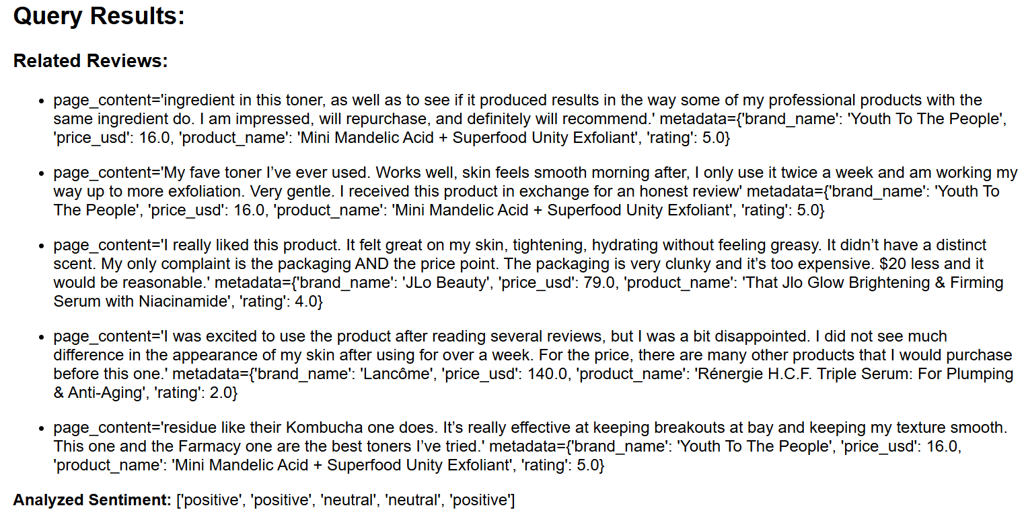

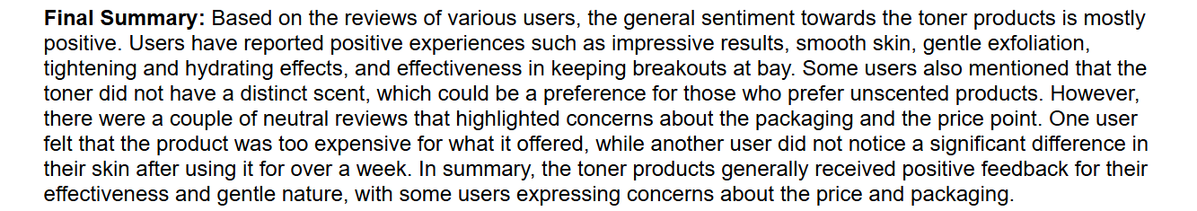

# Outputs from the Test Pipeline (5 samples)

=== Running Test Prompt 1: What is the most suitable sunscreen product for sensitive skin in Sephora? ===

--- Running pipeline a: Base LLM (no RAG) ---

---DECISION: Using pipeline 'a'---

Node 'choose_pipeline' visited. State keys: ['pipeline_choice']

---ANSWER QUERY WITH SIMPLE LLM SUMMARIZER---

Node 'llm_summarize' visited. State keys: ['query', 'pipeline_choice', 'summary']

Final Summary:

('For sensitive skin, a good option for sunscreen at Sephora would be the '

'Supergoop! Unseen Sunscreen SPF 40. This sunscreen is lightweight, oil-free, '

'and fragrance-free, making it suitable for sensitive skin. It also provides '

'broad-spectrum protection and is gentle enough for daily use.')

--- Running pipeline b: Basic RAG (retriever + LLM summarizer) ---

---DECISION: Using pipeline 'b'---

Node 'choose_pipeline' visited. State keys: ['pipeline_choice']

---RETRIEVE REVIEWS---

Node 'base_rag_retrieve' visited. State keys: ['query', 'pipeline_choice', 'reviews']

---ANSWER QUERY WITH RAG+LLM SUMMARIZER---

Node 'rag_llm_summarize' visited. State keys: ['query', 'pipeline_choice', 'reviews', 'summary']

Final Summary:

('The most suitable sunscreen product for sensitive skin at Sephora is the '

'Sunday Riley Juno Antioxidant + Superfood Face Oil.')

--- Running pipeline c: Advanced agentic RAG with base model (no fine-tuning) ---

---DECISION: Using pipeline 'c'---

Node 'choose_pipeline' visited. State keys: ['pipeline_choice']

---REWRITE QUERY---

Node 'rewrite_query' visited. State keys: ['query', 'pipeline_choice']

---RETRIEVE REVIEWS---

Node 'advanced_rag_retrieve' visited. State keys: ['query', 'pipeline_choice', 'reviews']

---ANALYZE SENTIMENT WITH BASE MODEL---

Node 'analyze_sentiment_base' visited. State keys: ['query', 'pipeline_choice', 'reviews', 'sentiment']

---ANSWER QUERY WITH AGENTIC RAG+SENTIMENT SUMMARIZER---

Node 'agentic_rag_llm_summarize' visited. State keys: ['query', 'pipeline_choice', 'reviews', 'sentiment', 'summary']

Final Summary:

('Based on the reviews, a highly recommended sunscreen product for sensitive '

'skin at Sephora is the sunscreen that not only provides sun protection but '

'also helps in making foundation makeup go on smoothly. Users have praised '

'the product for its positive effects on their skin, such as moisturizing, '

'skin renewal, and suitability for sensitive skin and eyes. Additionally, the '

'product has been described as a great addition to skincare routines, with '

'some users particularly appreciating its light fragrance and ease of '

'application. Overall, the sentiment towards this sunscreen product is '

'overwhelmingly positive, making it a top choice for those with sensitive '

'skin looking for effective sun protection.')

--- Running pipeline d: Advanced agentic RAG with fine-tuned model ---

---DECISION: Using pipeline 'd'---

Node 'choose_pipeline' visited. State keys: ['pipeline_choice']

---REWRITE QUERY---

Node 'rewrite_query' visited. State keys: ['query', 'pipeline_choice']

---RETRIEVE REVIEWS---

Node 'advanced_rag_retrieve' visited. State keys: ['query', 'pipeline_choice', 'reviews']

---ANALYZE SENTIMENT WITH LORA MODEL---

/usr/local/lib/python3.11/dist-packages/peft/config.py:162: UserWarning: Unexpected keyword arguments ['corda_config', 'trainable_token_indices'] for class LoraConfig, these are ignored. This probably means that you're loading a configuration file that was saved using a higher version of the library and additional parameters have been introduced since. It is highly recommended to upgrade the PEFT version before continuing (e.g. by running `pip install -U peft`).

warnings.warn(

Node 'analyze_sentiment_lora' visited. State keys: ['query', 'pipeline_choice', 'reviews', 'sentiment']

---ANSWER QUERY WITH AGENTIC RAG+SENTIMENT SUMMARIZER---

Node 'agentic_rag_llm_summarize' visited. State keys: ['query', 'pipeline_choice', 'reviews', 'sentiment', 'summary']

Final Summary:

('Based on the reviews from Sephora customers, the best sunscreen for '

'sensitive skin would be a product that not only provides sun protection but '

'also caters to sensitive skin needs. Customers have highlighted the '

'importance of finding a sunscreen that is gentle on the skin and works well '

'with other skincare products. \n'

'\n'

'Overall, the reviews indicate that the ideal sunscreen for sensitive skin at '

'Sephora should be a versatile product that can also function as a '

'moisturizer and contribute to skin renewal. Customers have praised products '

'that are gentle, effective, and do not cause irritation or dryness. '

'Additionally, users have appreciated sunscreens that help improve skin tone, '

'make the skin softer, and enhance the overall appearance of the skin.\n'

'\n'

'In conclusion, the best sunscreen for sensitive skin at Sephora should be a '

'multi-functional product that is gentle, effective, and suitable for '

'sensitive skin types. Based on the reviews, it is recommended to look for a '

'sunscreen that not only provides sun protection but also offers additional '

'skincare benefits such as moisturization and skin renewal.')

====================================

=== Running Test Prompt 2: How do users feel about lipstick products in Sephora based on the reviews? ===

--- Running pipeline a: Base LLM (no RAG) ---

---DECISION: Using pipeline 'a'---

Node 'choose_pipeline' visited. State keys: ['pipeline_choice']

---ANSWER QUERY WITH SIMPLE LLM SUMMARIZER---

Node 'llm_summarize' visited. State keys: ['query', 'pipeline_choice', 'summary']

Final Summary:

('Based on the reviews from Sephora users, the feelings about lipstick '

'products vary. Some users have expressed positive feedback about the '

'quality, color range, and lasting power of the lipsticks. However, there are '

'also users who have shared negative experiences, such as issues with the '

'formula, pigmentation, or longevity of the products. It is recommended to '

'read a variety of reviews to get a well-rounded understanding of how users '

'feel about lipstick products at Sephora before making a purchase.')

--- Running pipeline b: Basic RAG (retriever + LLM summarizer) ---

---DECISION: Using pipeline 'b'---

Node 'choose_pipeline' visited. State keys: ['pipeline_choice']

---RETRIEVE REVIEWS---

Node 'base_rag_retrieve' visited. State keys: ['query', 'pipeline_choice', 'reviews']

---ANSWER QUERY WITH RAG+LLM SUMMARIZER---

Node 'rag_llm_summarize' visited. State keys: ['query', 'pipeline_choice', 'reviews', 'summary']

Final Summary:

('Based on the reviews, users have mixed feelings about lipstick products in '

'Sephora. Some users are pleased with their purchases, while others are not '

'satisfied with the products they tried.')

--- Running pipeline c: Advanced agentic RAG with base model (no fine-tuning) ---

---DECISION: Using pipeline 'c'---

Node 'choose_pipeline' visited. State keys: ['pipeline_choice']

---REWRITE QUERY---

Node 'rewrite_query' visited. State keys: ['query', 'pipeline_choice']

---RETRIEVE REVIEWS---

Node 'advanced_rag_retrieve' visited. State keys: ['query', 'pipeline_choice', 'reviews']

---ANALYZE SENTIMENT WITH BASE MODEL---

Node 'analyze_sentiment_base' visited. State keys: ['query', 'pipeline_choice', 'reviews', 'sentiment']

---ANSWER QUERY WITH AGENTIC RAG+SENTIMENT SUMMARIZER---

Node 'agentic_rag_llm_summarize' visited. State keys: ['query', 'pipeline_choice', 'reviews', 'sentiment', 'summary']

Final Summary:

('Based on the reviews analyzed, the sentiments regarding lipstick products '

'from Sephora are generally positive. Users appreciate the benefits of the '

'products such as smoothness, moisturization, and ease of application. '

'However, there are also some concerns raised by users regarding fragrance, '

'pricing, and effectiveness compared to other products on the market. '

'Overall, the sentiment is mixed, with some users expressing satisfaction '

'with the products while others have reservations.')

--- Running pipeline d: Advanced agentic RAG with fine-tuned model ---

---DECISION: Using pipeline 'd'---

Node 'choose_pipeline' visited. State keys: ['pipeline_choice']

---REWRITE QUERY---

Node 'rewrite_query' visited. State keys: ['query', 'pipeline_choice']

---RETRIEVE REVIEWS---

Node 'advanced_rag_retrieve' visited. State keys: ['query', 'pipeline_choice', 'reviews']

---ANALYZE SENTIMENT WITH LORA MODEL---

/usr/local/lib/python3.11/dist-packages/peft/config.py:162: UserWarning: Unexpected keyword arguments ['corda_config', 'trainable_token_indices'] for class LoraConfig, these are ignored. This probably means that you're loading a configuration file that was saved using a higher version of the library and additional parameters have been introduced since. It is highly recommended to upgrade the PEFT version before continuing (e.g. by running `pip install -U peft`).

warnings.warn(

Node 'analyze_sentiment_lora' visited. State keys: ['query', 'pipeline_choice', 'reviews', 'sentiment']

---ANSWER QUERY WITH AGENTIC RAG+SENTIMENT SUMMARIZER---

Node 'agentic_rag_llm_summarize' visited. State keys: ['query', 'pipeline_choice', 'reviews', 'sentiment', 'summary']

Final Summary:

('Based on the reviews of lipstick products at Sephora, the general sentiments '

'are mixed. Two reviews expressed positive sentiments towards the product, '

'highlighting benefits such as not causing breakouts, pleasant scent, and '

'positive effects on fine lines. One review had a neutral sentiment, '

'mentioning that the product made their face glowy but was too fragrant for '

'their liking. The remaining two reviews also had neutral sentiments, with '

"one customer feeling disappointed in the product's performance compared to "

'its price and another customer expressing concerns about the packaging and '

'the number of steps in their skincare routine.\n'

'\n'

'Overall, the sentiment towards lipstick products at Sephora seems to be a '

'mix of positive and neutral feedback. Customers appreciate certain aspects '

'of the products, such as their effectiveness and pleasant scent, but there '

'are also concerns raised about the pricing, packaging, and overall '

'performance.')

====================================

=== Running Test Prompt 3: Which are the most trendy types of perfume, and how do users feel about them? ===

--- Running pipeline a: Base LLM (no RAG) ---

---DECISION: Using pipeline 'a'---

Node 'choose_pipeline' visited. State keys: ['pipeline_choice']

---ANSWER QUERY WITH SIMPLE LLM SUMMARIZER---

Node 'llm_summarize' visited. State keys: ['query', 'pipeline_choice', 'summary']

Final Summary:

('Some of the most trendy types of perfume currently are:\n'

'\n'

'1. Floral scents: These are classic and timeless, often associated with '

'femininity and elegance.\n'

'2. Fruity scents: These are popular for their sweet and fresh notes, '

'appealing to a wide range of users.\n'

'3. Woody scents: These are warm and earthy, often considered unisex and '

'suitable for all seasons.\n'

'4. Oriental scents: These are rich and exotic, often featuring spicy and '

'warm notes that make a bold statement.\n'

'\n'

'Users generally have positive feelings towards trendy perfumes as they enjoy '

'staying up-to-date with the latest fragrance trends. Many users appreciate '

'the variety of options available and the opportunity to express their '

'personal style through their choice of perfume. Overall, trendy perfumes are '

'well-received by users who enjoy experimenting with different scents and '

'staying current with the latest fragrance trends.')

--- Running pipeline b: Basic RAG (retriever + LLM summarizer) ---

---DECISION: Using pipeline 'b'---

Node 'choose_pipeline' visited. State keys: ['pipeline_choice']

---RETRIEVE REVIEWS---

Node 'base_rag_retrieve' visited. State keys: ['query', 'pipeline_choice', 'reviews']

---ANSWER QUERY WITH RAG+LLM SUMMARIZER---

Node 'rag_llm_summarize' visited. State keys: ['query', 'pipeline_choice', 'reviews', 'summary']

Final Summary:

('Based on the user feedback provided, it seems that light, pleasant scents '

'are trendy in perfumes. Users generally appreciate fragrances that are not '

'overwhelming and complement their skincare routine without competing with '

'their regular perfume.')

--- Running pipeline c: Advanced agentic RAG with base model (no fine-tuning) ---

---DECISION: Using pipeline 'c'---

Node 'choose_pipeline' visited. State keys: ['pipeline_choice']

---REWRITE QUERY---

Node 'rewrite_query' visited. State keys: ['query', 'pipeline_choice']

---RETRIEVE REVIEWS---

Node 'advanced_rag_retrieve' visited. State keys: ['query', 'pipeline_choice', 'reviews']

---ANALYZE SENTIMENT WITH BASE MODEL---

Node 'analyze_sentiment_base' visited. State keys: ['query', 'pipeline_choice', 'reviews', 'sentiment']

---ANSWER QUERY WITH AGENTIC RAG+SENTIMENT SUMMARIZER---

Node 'agentic_rag_llm_summarize' visited. State keys: ['query', 'pipeline_choice', 'reviews', 'sentiment', 'summary']

Final Summary:

('The most popular perfume types based on user reviews are light and pleasant '

'scents that are not overwhelming. Users have generally expressed positive '

'sentiments towards these perfumes, appreciating their subtle and non-greasy '

'fragrance. While some users found the scent to be too strong for their '

'liking, the majority enjoyed the light and floral fragrances that left their '

'skin feeling smooth, moisturized, and hydrated. Overall, the user reviews '

'indicate that popular perfume types are those with subtle scents that '

'provide a pleasant and refreshing experience for the users.')

--- Running pipeline d: Advanced agentic RAG with fine-tuned model ---

---DECISION: Using pipeline 'd'---

Node 'choose_pipeline' visited. State keys: ['pipeline_choice']

---REWRITE QUERY---

Node 'rewrite_query' visited. State keys: ['query', 'pipeline_choice']

---RETRIEVE REVIEWS---

Node 'advanced_rag_retrieve' visited. State keys: ['query', 'pipeline_choice', 'reviews']

---ANALYZE SENTIMENT WITH LORA MODEL---

/usr/local/lib/python3.11/dist-packages/peft/config.py:162: UserWarning: Unexpected keyword arguments ['corda_config', 'trainable_token_indices'] for class LoraConfig, these are ignored. This probably means that you're loading a configuration file that was saved using a higher version of the library and additional parameters have been introduced since. It is highly recommended to upgrade the PEFT version before continuing (e.g. by running `pip install -U peft`).

warnings.warn(

Node 'analyze_sentiment_lora' visited. State keys: ['query', 'pipeline_choice', 'reviews', 'sentiment']

---ANSWER QUERY WITH AGENTIC RAG+SENTIMENT SUMMARIZER---

Node 'agentic_rag_llm_summarize' visited. State keys: ['query', 'pipeline_choice', 'reviews', 'sentiment', 'summary']

Final Summary:

('Based on the reviews provided, the most popular types of perfume seem to '

'have mixed sentiments among users. While some users appreciate the pleasant '

'scent and skincare benefits of the products, others find the fragrance to be '

'too strong or not to their liking. \n'

'\n'

'Reviewers who enjoyed the perfumes mentioned positive experiences such as '

'smoother, moisturized skin, pleasant scents, and ease of makeup application. '

'They also noted benefits like hydration, plumping effects, and a reduction '

'in fine lines. These users expressed satisfaction with the product and '

'indicated a willingness to repurchase.\n'

'\n'

'On the other hand, reviewers with neutral sentiments pointed out aspects '

'they were not fond of, such as the strong perfume-like smell, concerns about '

'the packaging size versus the actual product amount, and compatibility '

'issues with other fragrances or cosmetics.\n'

'\n'

'In summary, the most popular types of perfume seem to have a diverse range '

'of user sentiments, with some users praising the product for its skincare '

'benefits and pleasant scent, while others have reservations about aspects '

'like fragrance intensity and packaging size.')

====================================

=== Running Test Prompt 4: What oil do users like to use at season transition times? ===

--- Running pipeline a: Base LLM (no RAG) ---

---DECISION: Using pipeline 'a'---

Node 'choose_pipeline' visited. State keys: ['pipeline_choice']

---ANSWER QUERY WITH SIMPLE LLM SUMMARIZER---

Node 'llm_summarize' visited. State keys: ['query', 'pipeline_choice', 'summary']

Final Summary:

('During season transition times, many users prefer to use a multi-grade oil, '

'such as 5W-30 or 10W-30. These oils provide good performance in both cold '

'and warm temperatures, making them suitable for use as the weather changes. '

"It's important to consult your vehicle's owner's manual to determine the "

'recommended oil viscosity for your specific make and model.')

--- Running pipeline b: Basic RAG (retriever + LLM summarizer) ---

---DECISION: Using pipeline 'b'---

Node 'choose_pipeline' visited. State keys: ['pipeline_choice']

---RETRIEVE REVIEWS---

Node 'base_rag_retrieve' visited. State keys: ['query', 'pipeline_choice', 'reviews']

---ANSWER QUERY WITH RAG+LLM SUMMARIZER---

Node 'rag_llm_summarize' visited. State keys: ['query', 'pipeline_choice', 'reviews', 'summary']

Final Summary:

('Users like to use face oils, such as the Sunday Riley Juno Antioxidant + '

'Superfood Face Oil, during season transition times for added hydration and '

'nourishment to the skin.')

--- Running pipeline c: Advanced agentic RAG with base model (no fine-tuning) ---

---DECISION: Using pipeline 'c'---

Node 'choose_pipeline' visited. State keys: ['pipeline_choice']

---REWRITE QUERY---

Node 'rewrite_query' visited. State keys: ['query', 'pipeline_choice']

---RETRIEVE REVIEWS---

Node 'advanced_rag_retrieve' visited. State keys: ['query', 'pipeline_choice', 'reviews']

---ANALYZE SENTIMENT WITH BASE MODEL---

Node 'analyze_sentiment_base' visited. State keys: ['query', 'pipeline_choice', 'reviews', 'sentiment']

---ANSWER QUERY WITH AGENTIC RAG+SENTIMENT SUMMARIZER---

Node 'agentic_rag_llm_summarize' visited. State keys: ['query', 'pipeline_choice', 'reviews', 'sentiment', 'summary']

Final Summary:

('Based on user reviews, the recommended oil for use during seasonal '

'transitions is one that caters to various skin types and concerns. Users '

'have found oils that work well for oily skin, dry skin, sensitive skin, and '

'combination skin during different weather conditions.\n'

'\n'

'1. For oily skin: Users with oily skin have recommended an oil that helps '

'control oiliness, reduces blackheads, and keeps the skin feeling clean and '

'refreshed without being too greasy.\n'

'\n'

'2. For dry skin: Users with dry skin have praised an oil that provides '

'hydration, helps with dryness, and keeps the skin supple during colder '

'weather months. It can be layered over serum or moisturizer for added '

'benefits.\n'

'\n'

'3. For sensitive skin: Users with sensitive skin have appreciated an oil '

'that is gentle, does not sting the eyes, and helps with dryness without '

'causing any irritation.\n'

'\n'

'Overall, the reviews suggest that the ideal oil for seasonal transitions '

'should be versatile, providing hydration, controlling oiliness, and '

'addressing specific skin concerns while being gentle and effective.')

--- Running pipeline d: Advanced agentic RAG with fine-tuned model ---

---DECISION: Using pipeline 'd'---

Node 'choose_pipeline' visited. State keys: ['pipeline_choice']

---REWRITE QUERY---

Node 'rewrite_query' visited. State keys: ['query', 'pipeline_choice']

---RETRIEVE REVIEWS---

Node 'advanced_rag_retrieve' visited. State keys: ['query', 'pipeline_choice', 'reviews']

---ANALYZE SENTIMENT WITH LORA MODEL---

/usr/local/lib/python3.11/dist-packages/peft/config.py:162: UserWarning: Unexpected keyword arguments ['corda_config', 'trainable_token_indices'] for class LoraConfig, these are ignored. This probably means that you're loading a configuration file that was saved using a higher version of the library and additional parameters have been introduced since. It is highly recommended to upgrade the PEFT version before continuing (e.g. by running `pip install -U peft`).

warnings.warn(

Node 'analyze_sentiment_lora' visited. State keys: ['query', 'pipeline_choice', 'reviews', 'sentiment']

---ANSWER QUERY WITH AGENTIC RAG+SENTIMENT SUMMARIZER---

Node 'agentic_rag_llm_summarize' visited. State keys: ['query', 'pipeline_choice', 'reviews', 'sentiment', 'summary']

Final Summary:

('Based on the reviews analyzed, it seems that users prefer using oil-based '

'products during seasonal transitions, particularly those with oily skin. \n'

'\n'

'Review #1 and Review #2 express positive sentiments towards an oil-based '

'product, highlighting its effectiveness in controlling oiliness and '

'improving skin condition, especially for oily skin types. Review #3, '

'although not entirely negative, suggests that the oil-based product may be '

'too drying for those living in a desert climate, but it is still recommended '

'for oily skin types. Review #4 mentions positive results for sensitive, dry '

'skin, indicating that the oil worked well during winter. Review #5 also '

'shows positive feedback on the oil-based product, indicating noticeable '

'improvements in troubled areas.\n'

'\n'

'Overall, the reviews suggest that users prefer oil-based products during '

'seasonal transitions, especially if they have oily skin or sensitive, dry '

'skin. The majority of the reviews express satisfaction with the products, '

'recommending them for various skin types and conditions during seasonal '

'changes.')

====================================

=== Running Test Prompt 5: Which are users complaining about the powder, and why? ===

--- Running pipeline a: Base LLM (no RAG) ---

---DECISION: Using pipeline 'a'---

Node 'choose_pipeline' visited. State keys: ['pipeline_choice']

---ANSWER QUERY WITH SIMPLE LLM SUMMARIZER---

Node 'llm_summarize' visited. State keys: ['query', 'pipeline_choice', 'summary']

Final Summary:

('Users are complaining about the powder mainly due to its poor quality. Some '

'common reasons for complaints include the powder not blending well, uneven '

"coverage, causing skin irritation, or not lasting long enough. It's "

'important to consider these factors before purchasing a powder product to '

'ensure it meets your needs and preferences.')

--- Running pipeline b: Basic RAG (retriever + LLM summarizer) ---

---DECISION: Using pipeline 'b'---

Node 'choose_pipeline' visited. State keys: ['pipeline_choice']

---RETRIEVE REVIEWS---

Node 'base_rag_retrieve' visited. State keys: ['query', 'pipeline_choice', 'reviews']

---ANSWER QUERY WITH RAG+LLM SUMMARIZER---

Node 'rag_llm_summarize' visited. State keys: ['query', 'pipeline_choice', 'reviews', 'summary']

Final Summary:

('Users are complaining about the powder due to issues such as bad texture, '

'stickiness even after a while, glass shards found in the formula, disgusting '

'growth inside the bottle, and a strong scent that they dislike.')

--- Running pipeline c: Advanced agentic RAG with base model (no fine-tuning) ---

---DECISION: Using pipeline 'c'---

Node 'choose_pipeline' visited. State keys: ['pipeline_choice']

---REWRITE QUERY---

Node 'rewrite_query' visited. State keys: ['query', 'pipeline_choice']

---RETRIEVE REVIEWS---

Node 'advanced_rag_retrieve' visited. State keys: ['query', 'pipeline_choice', 'reviews']

---ANALYZE SENTIMENT WITH BASE MODEL---

Node 'analyze_sentiment_base' visited. State keys: ['query', 'pipeline_choice', 'reviews', 'sentiment']

---ANSWER QUERY WITH AGENTIC RAG+SENTIMENT SUMMARIZER---

Node 'agentic_rag_llm_summarize' visited. State keys: ['query', 'pipeline_choice', 'reviews', 'sentiment', 'summary']

Final Summary:

('Based on the reviews analyzed, users are complaining about the powder for '

'various reasons. Some users have expressed dissatisfaction with the texture, '

'stating that it is bad, sticky, and unpleasant even the next morning. Others '

'have reported negative effects on their skin, such as burning and splotches. '

'Furthermore, a faulty bottle issue was raised by a user, causing difficulty '

'in dispensing the product.\n'

'\n'

'In summary, users are complaining about the powder due to its bad texture, '

'negative effects on the skin, and issues with the packaging.')

--- Running pipeline d: Advanced agentic RAG with fine-tuned model ---

---DECISION: Using pipeline 'd'---

Node 'choose_pipeline' visited. State keys: ['pipeline_choice']

---REWRITE QUERY---

Node 'rewrite_query' visited. State keys: ['query', 'pipeline_choice']

---RETRIEVE REVIEWS---

Node 'advanced_rag_retrieve' visited. State keys: ['query', 'pipeline_choice', 'reviews']

---ANALYZE SENTIMENT WITH LORA MODEL---

/usr/local/lib/python3.11/dist-packages/peft/config.py:162: UserWarning: Unexpected keyword arguments ['corda_config', 'trainable_token_indices'] for class LoraConfig, these are ignored. This probably means that you're loading a configuration file that was saved using a higher version of the library and additional parameters have been introduced since. It is highly recommended to upgrade the PEFT version before continuing (e.g. by running `pip install -U peft`).

warnings.warn(

Node 'analyze_sentiment_lora' visited. State keys: ['query', 'pipeline_choice', 'reviews', 'sentiment']

---ANSWER QUERY WITH AGENTIC RAG+SENTIMENT SUMMARIZER---

Node 'agentic_rag_llm_summarize' visited. State keys: ['query', 'pipeline_choice', 'reviews', 'sentiment', 'summary']

Final Summary:

('Based on the reviews analyzed, the complaints about the powder are as '

'follows:\n'

'\n'

'1. Review #2: The user experienced burning and splotches under their eyes '

'after using the powder. They were disappointed with the product and advised '

'others to test it first.\n'

'2. Review #4: Another user disliked the texture of the powder, describing it '

'as bad and sticky, even the next morning.\n'

'\n'

'Overall, users complained about experiencing adverse reactions such as '

'burning and splotches, as well as disliking the texture of the powder. These '

'negative aspects led to disappointment and dissatisfaction among users who '

'left these reviews.')

====================================