SELAb   
IMT2023016

This project implements a RESTful API using Flask to manage a simple library catalog. It applies key REST concepts through five endpoints. The API has two **GET** methods: one lists all books, and another retrieves a book by ID. The **POST** method adds a new book with automatic ID assignment. The **PUT** method updates an existing book’s title or author, preserving old values if empty strings are passed. The **DELETE** method removes a book by its ID. Pydantic models validate inputs, and proper HTTP status codes (200, 201, 404) ensure REST compliance. Though data is stored in-memory, the design is extendable to real databases.

Server is running:

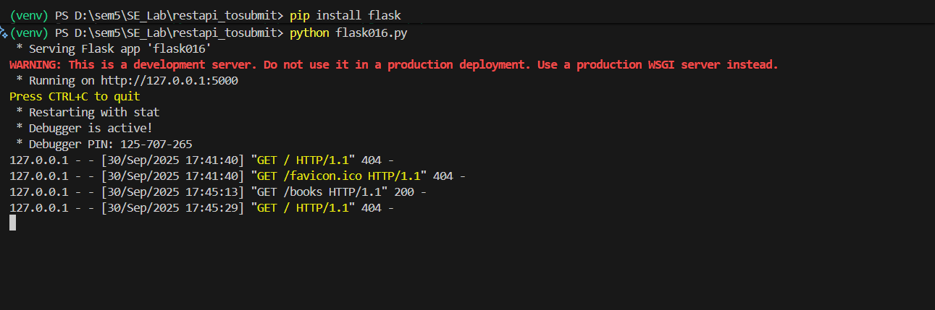

GET : show existing books:

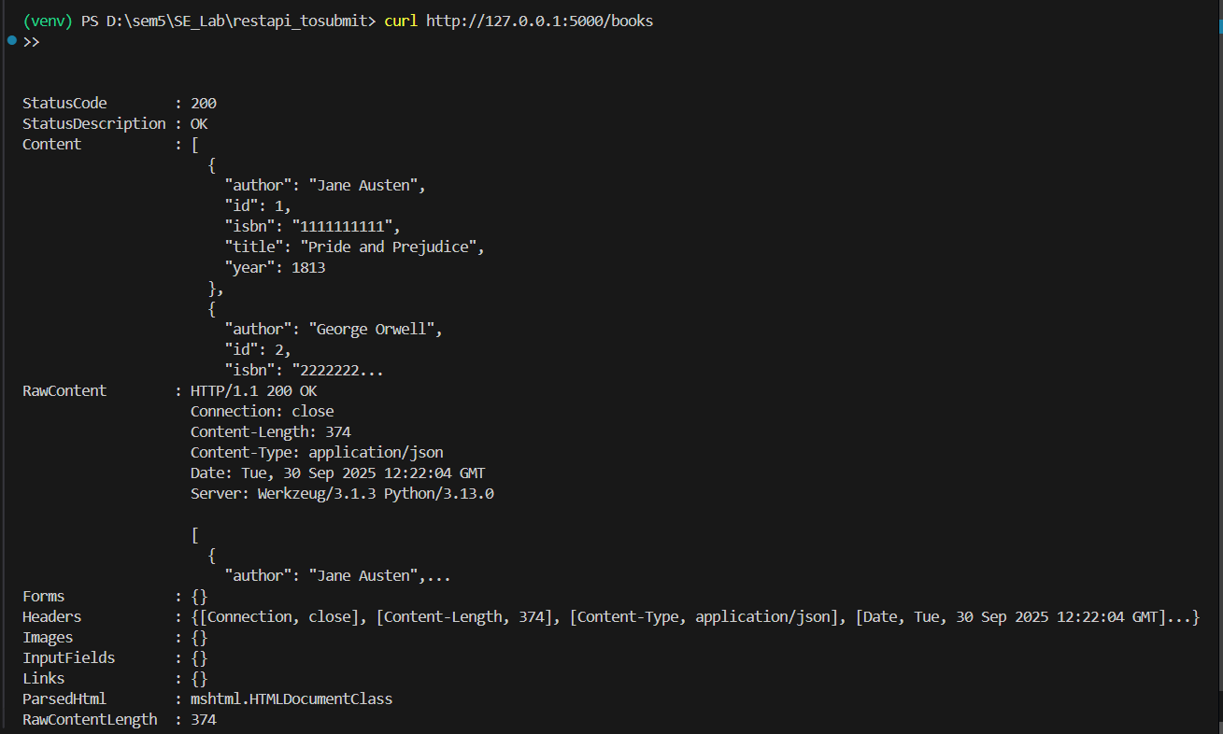

GET Book with ID:

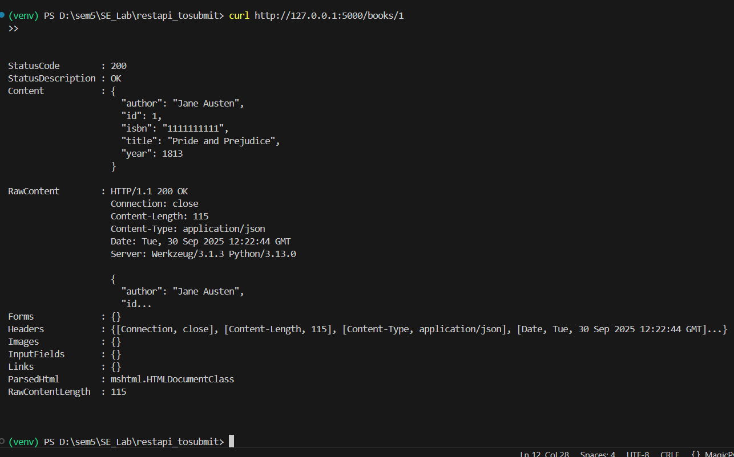

POST : Add a book:

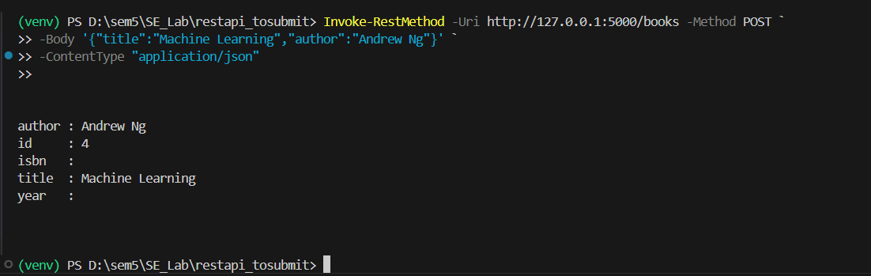

PUT:

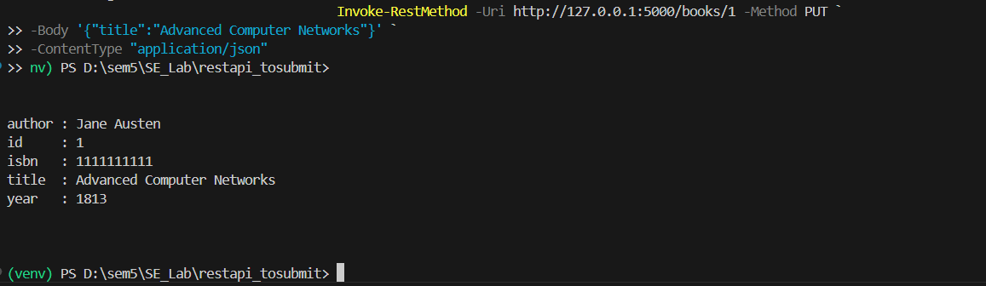

DELETE:

