SE Lab Assignment: RestAPI  
IMT2023016

This project implements a RESTful API using FastAPI to manage a simple library catalog. It applies key REST concepts through five endpoints. The API has two **GET** methods: one lists all books, and another retrieves a book by ID. The **POST** method adds a new book with automatic ID assignment. The **PUT** method updates an existing book’s title or author, preserving old values if empty strings are passed. The **DELETE** method removes a book by its ID. Pydantic models validate inputs, and proper HTTP status codes (200, 201, 404) ensure REST compliance. Though data is stored in-memory, the design is extendable to real databases.

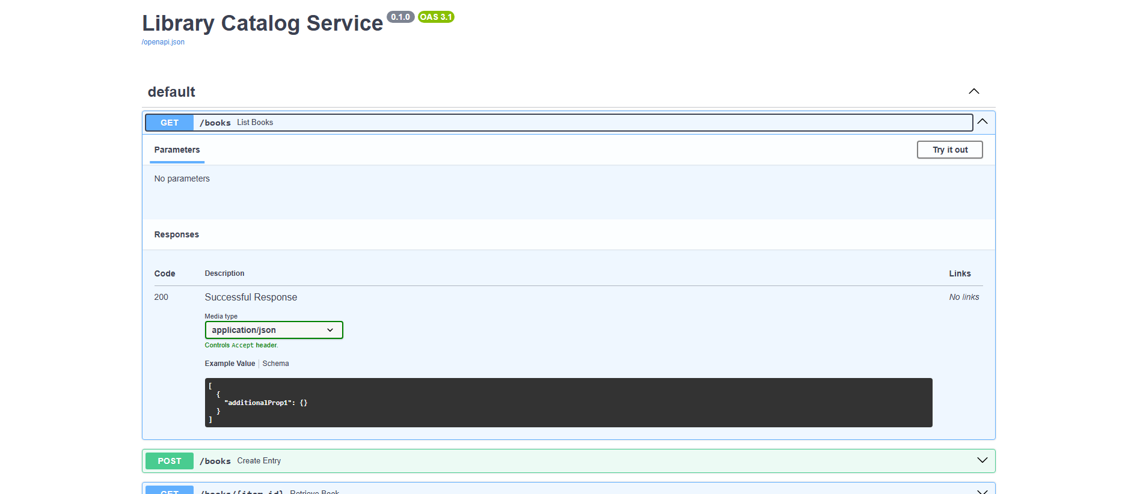

On clicking Try it out :

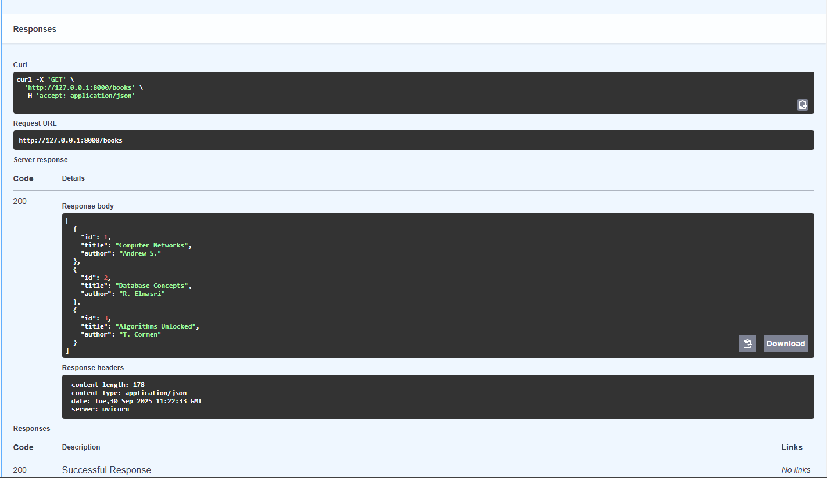

Post: Add a new book:

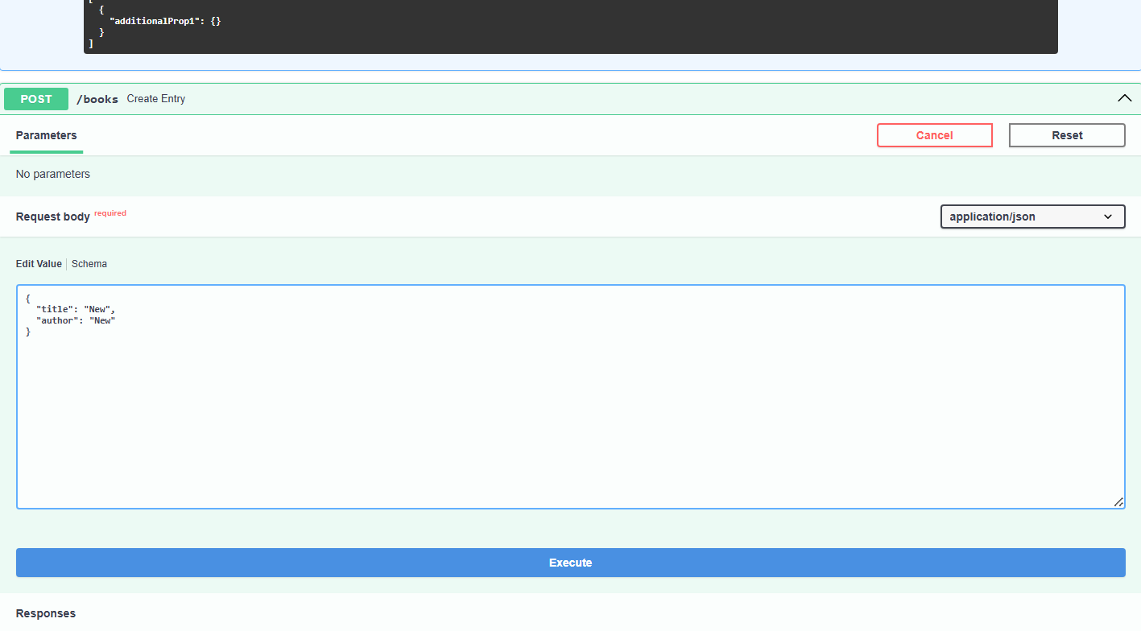

On clicking execute under post:

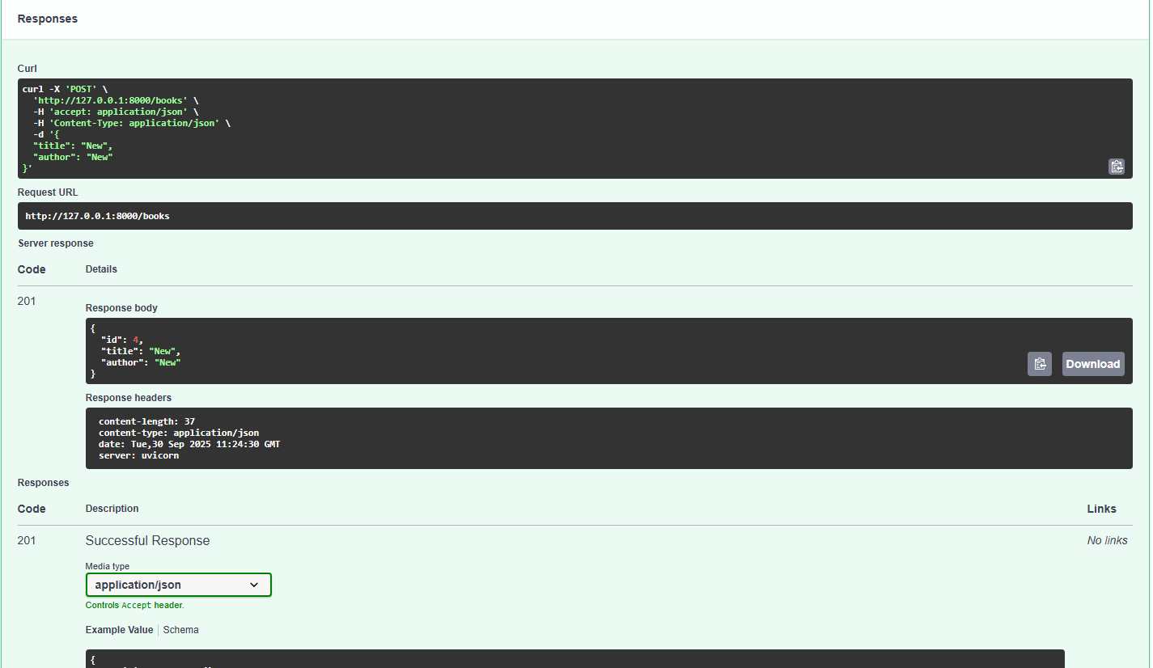

On clicking execute under get to verify if the book is added:

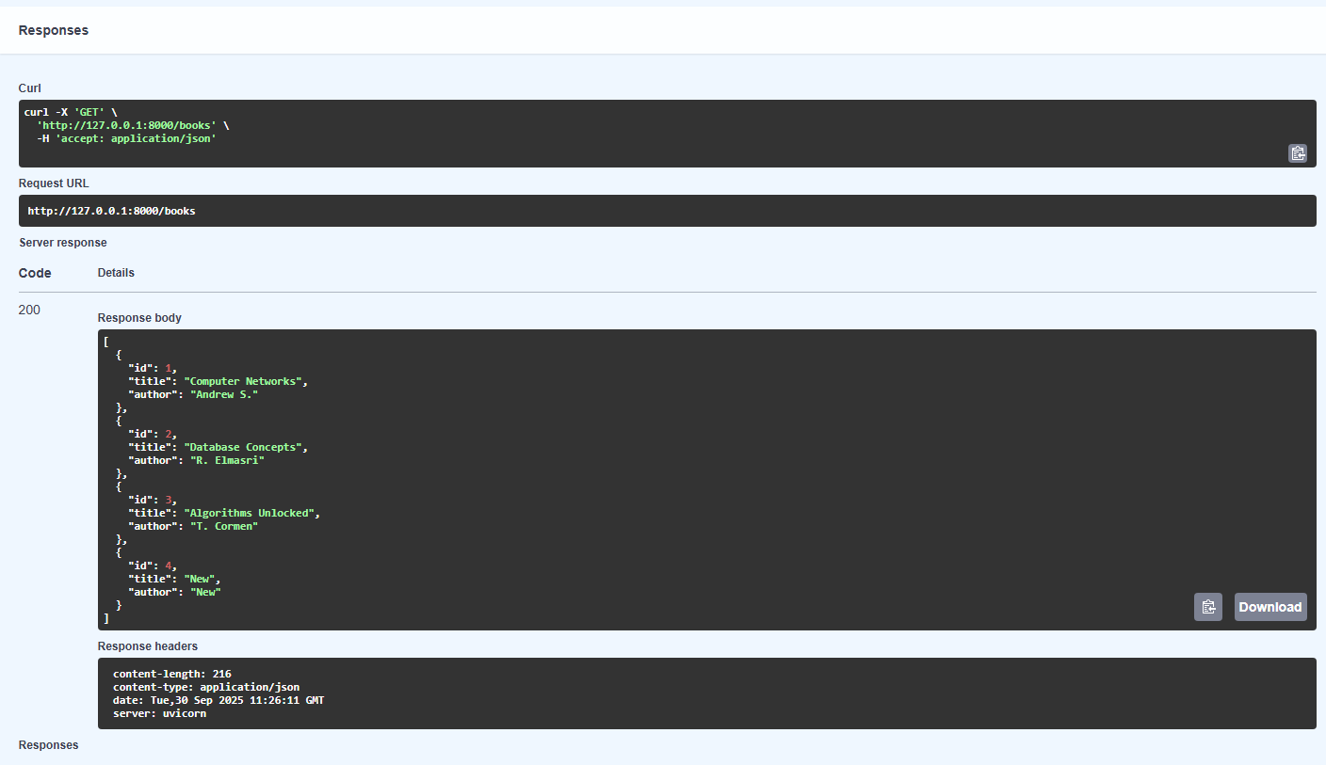

Get (with item_id):

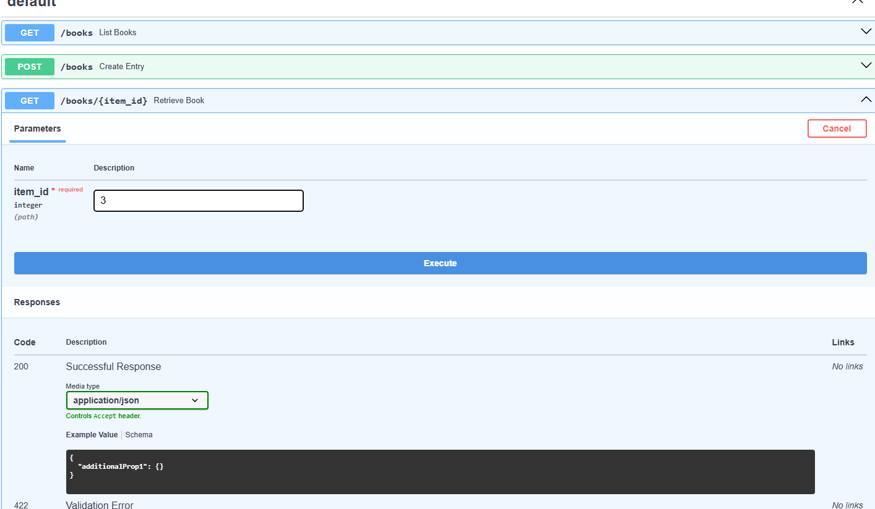

On clicking execute :

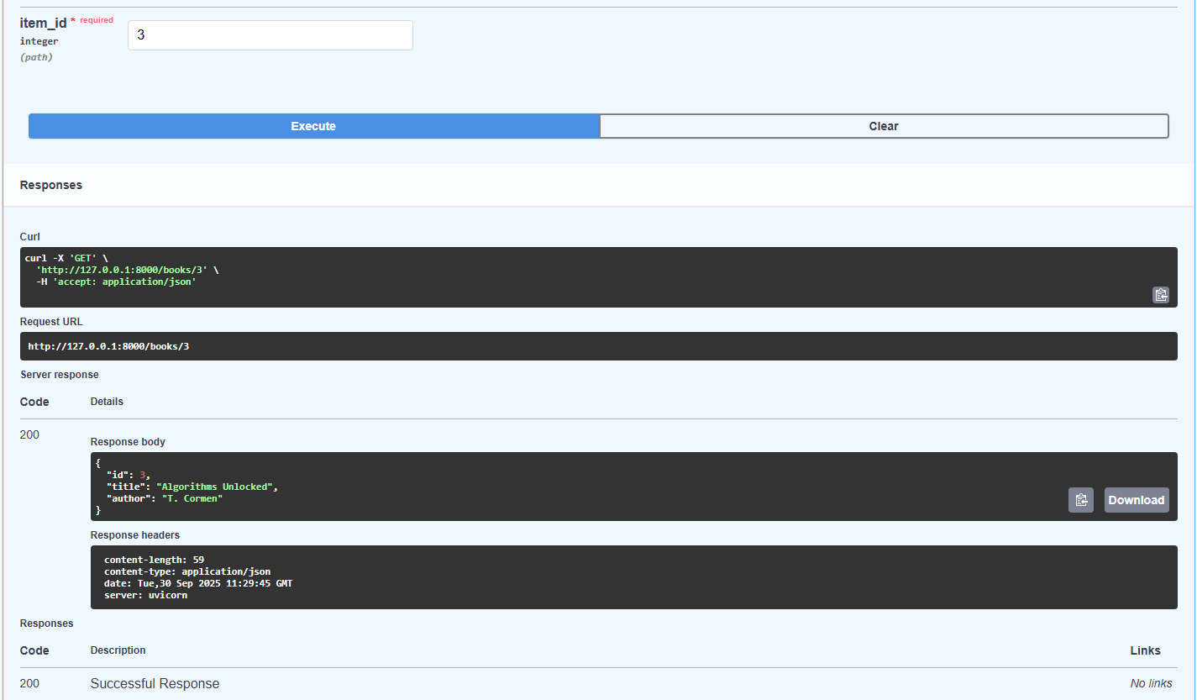

Put:

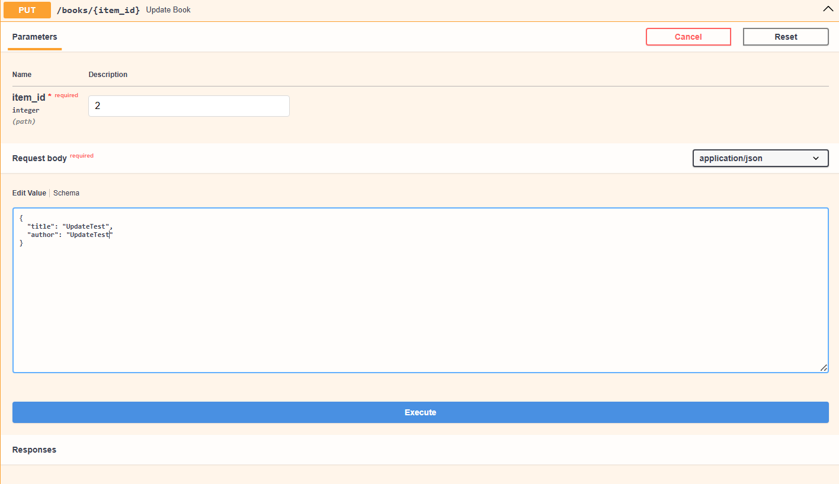

On clicking execute under Put:

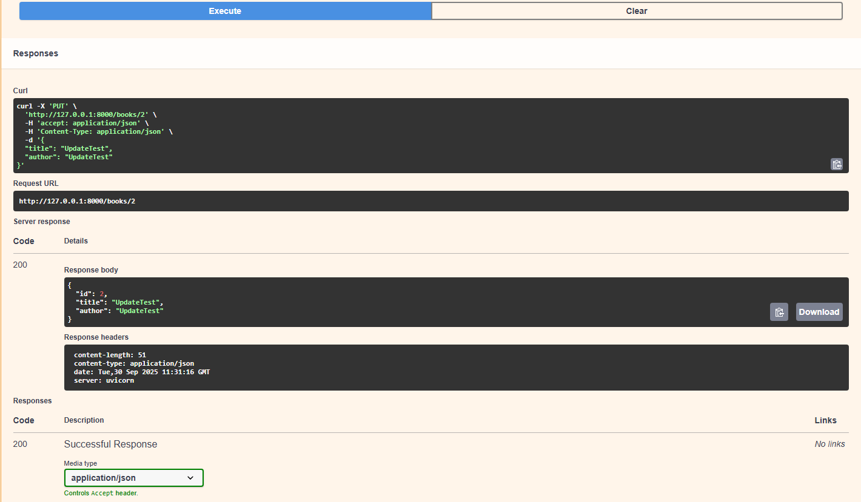

On clicking execute under main get:

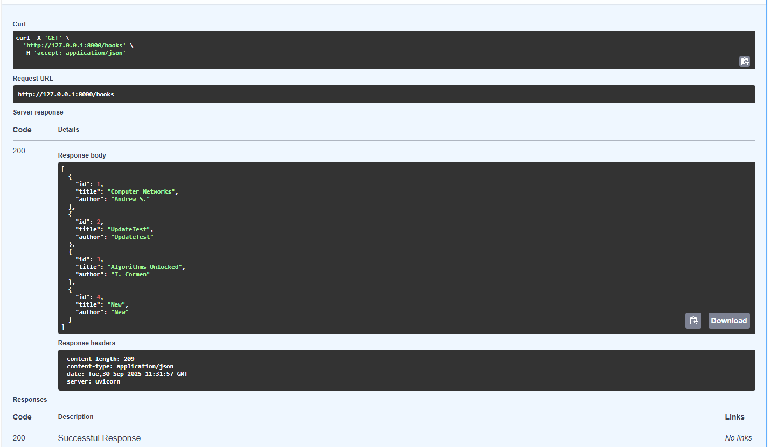

Delete :

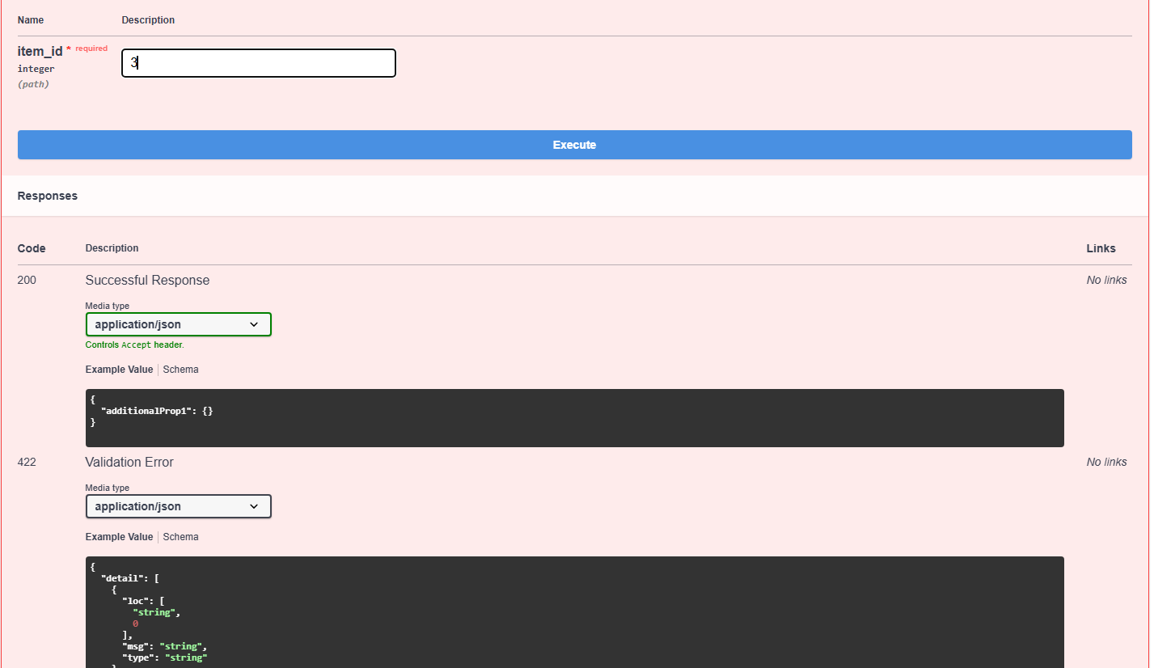

On clicking execute under delete:

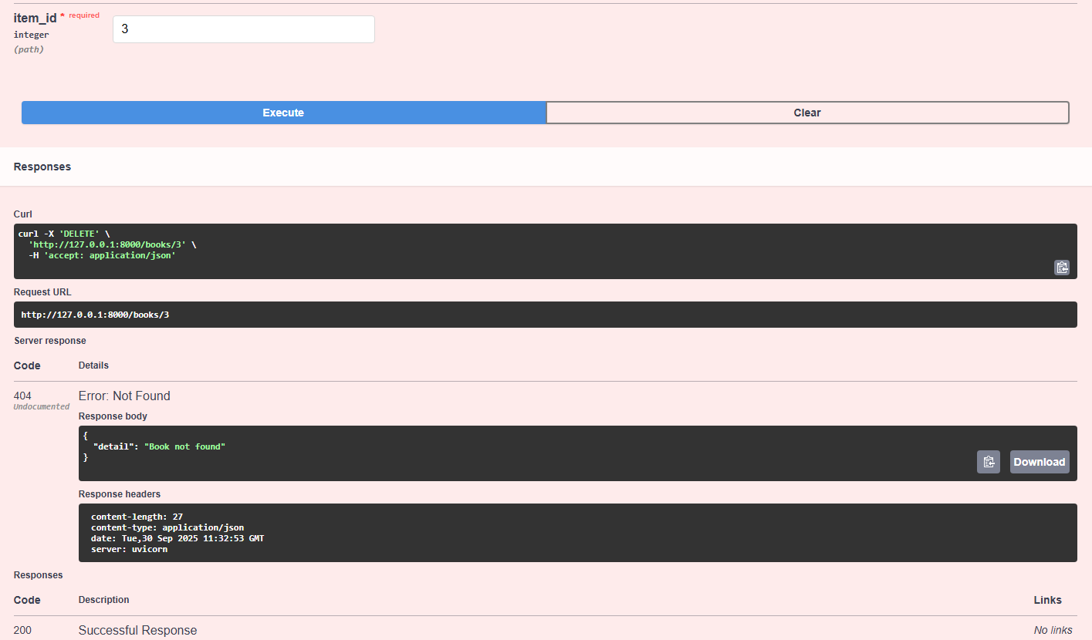

On clicking execute under main get:

