KnowledgeVault: Smart Academic Resource Repository

Course:
MongoDB Database Administrator | FACE Prep
Institution:
VIT Bhopal University

Academic Year:
2026

Submitted By:
Kavya Singh
24BCY10221

ACKNOWLEDGEMENT

I would like to express my profound gratitude to my project guide, Jayanth Velligiri for their invaluable guidance and continuous encouragement throughout the duration of this project. Their expertise and patience were instrumental in the successful completion of this report.
I am also highly indebted to FACE Prep and VIT Bhopal University for providing the necessary facilities and a conducive academic environment.
Finally, I extend my heartfelt thanks to my family, friends, and peers whose moral support and understanding made this endeavour a rewarding experience.

ABSTRACT

KnowledgeVault is a console-based academic resource management system developed using Java and MongoDB. The application allows users to store, view, search, and delete educational resources efficiently. MongoDB serves as the backend database for storing resource information such as title, subject, category, and description.
The project demonstrates the integration of Java with MongoDB and provides a simple menu-driven interface for performing database operations. The system helps organize academic materials in a structured manner and showcases CRUD (Create, Read, Update, Delete) operations using MongoDB.

OBJECTIVES

• To develop a resource management system using Java and MongoDB.
• To implement CRUD operations.
• To provide a menu-driven interface.
• To store academic resources efficiently.
• To demonstrate database connectivity using MongoDB.

TECHNOLOGIES USED

Technology | Purpose
Java 17 | Application Development
MongoDB | Database
MongoDB Compass | Database Visualization
Maven | Dependency Management
VS Code | Development Environment

SYSTEM REQUIREMENTS

Hardware:
- Intel i3 or above
- 4 GB RAM
- 500 MB Free Storage

Software:
- Windows 11
- Java JDK 17
- MongoDB
- MongoDB Compass
- Apache Maven
- Visual Studio Code

PROJECT MODULES

Module 1: Database Connectivity
- Connect Java application to MongoDB.
- Access KnowledgeVault database.
Module 2: Add Resource
- Insert resource details into MongoDB.
Module 3: View Resources
- Retrieve all stored resources.
Module 4: Search Resource
- Search resources by title.
Module 5: Delete Resource
- Remove resources from database.

WORKING METHODOLOGY

Start
↓
Display Menu
↓
User Choice
↓
CRUD Operation
↓
MongoDB
↓
Display Result
↓
Exit

WORKING

Main Menu :
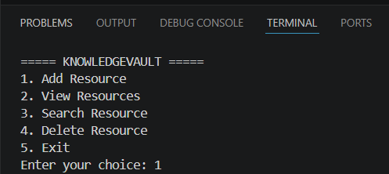

Add Resource :
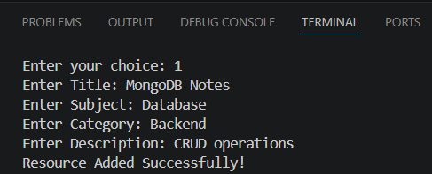

View Resource :
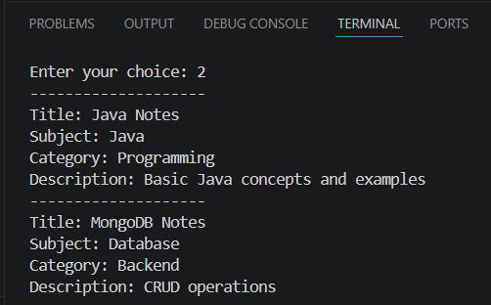

Search Resource :
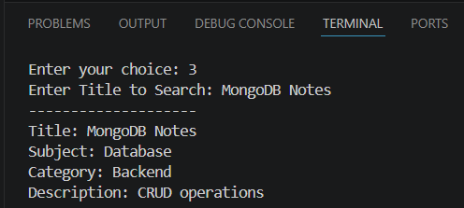

Delete Resource :
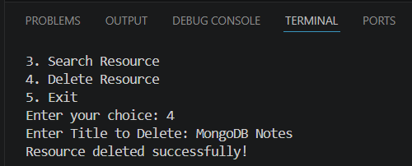

MongoDB Compass showing documents :
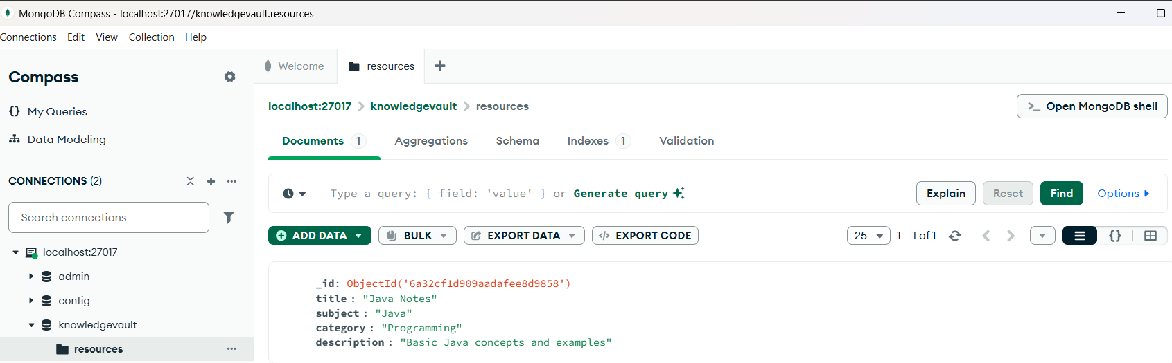
FUTURE SCOPE

• Graphical User Interface (GUI).
• User Authentication.
• Resource Update Feature.
• Cloud Database Integration.
• Web-Based Version.

CONCLUSION

The KnowledgeVault project successfully demonstrates the integration of Java and MongoDB to create an academic resource repository. The system provides functionalities for adding, viewing, searching, and deleting resources through a menu-driven interface. The project enhances understanding of database connectivity, CRUD operations, and backend application development using modern technologies.

REFERENCES

1. MongoDB Documentation
2. Java SE Documentation
3. Apache Maven Documentation
4. MongoDB Compass Documentation

